



**VueJS Basic Document**

**By Phan Dai**

**MY REVIEW** 1

**MY COMPANY PROJECT** 1

**OTHER FRAMEWORK** 2

# **MY REVIEW**

*On May5 , 2021 ; At Lampart Inc ; To join a project with Vue and Laravel*

At the beginning, with small time to approach Vue, it seems easy with starter like me, but I have had a lot of fundamental JavaScript knowledge before. The structure is not much different from React or other JS framework which I haven't heard about. It includes three simple areas:

**1️. Template area :** **< template > </ template >** - for creating DOM just like .JSX, .Handlebars,..

**2. Script area :** **< script > </ script >** - for controlling DOM

**3. Style area : < style > </ style > -** for styling component or which is inside

# **MY COMPANY PROJECT**

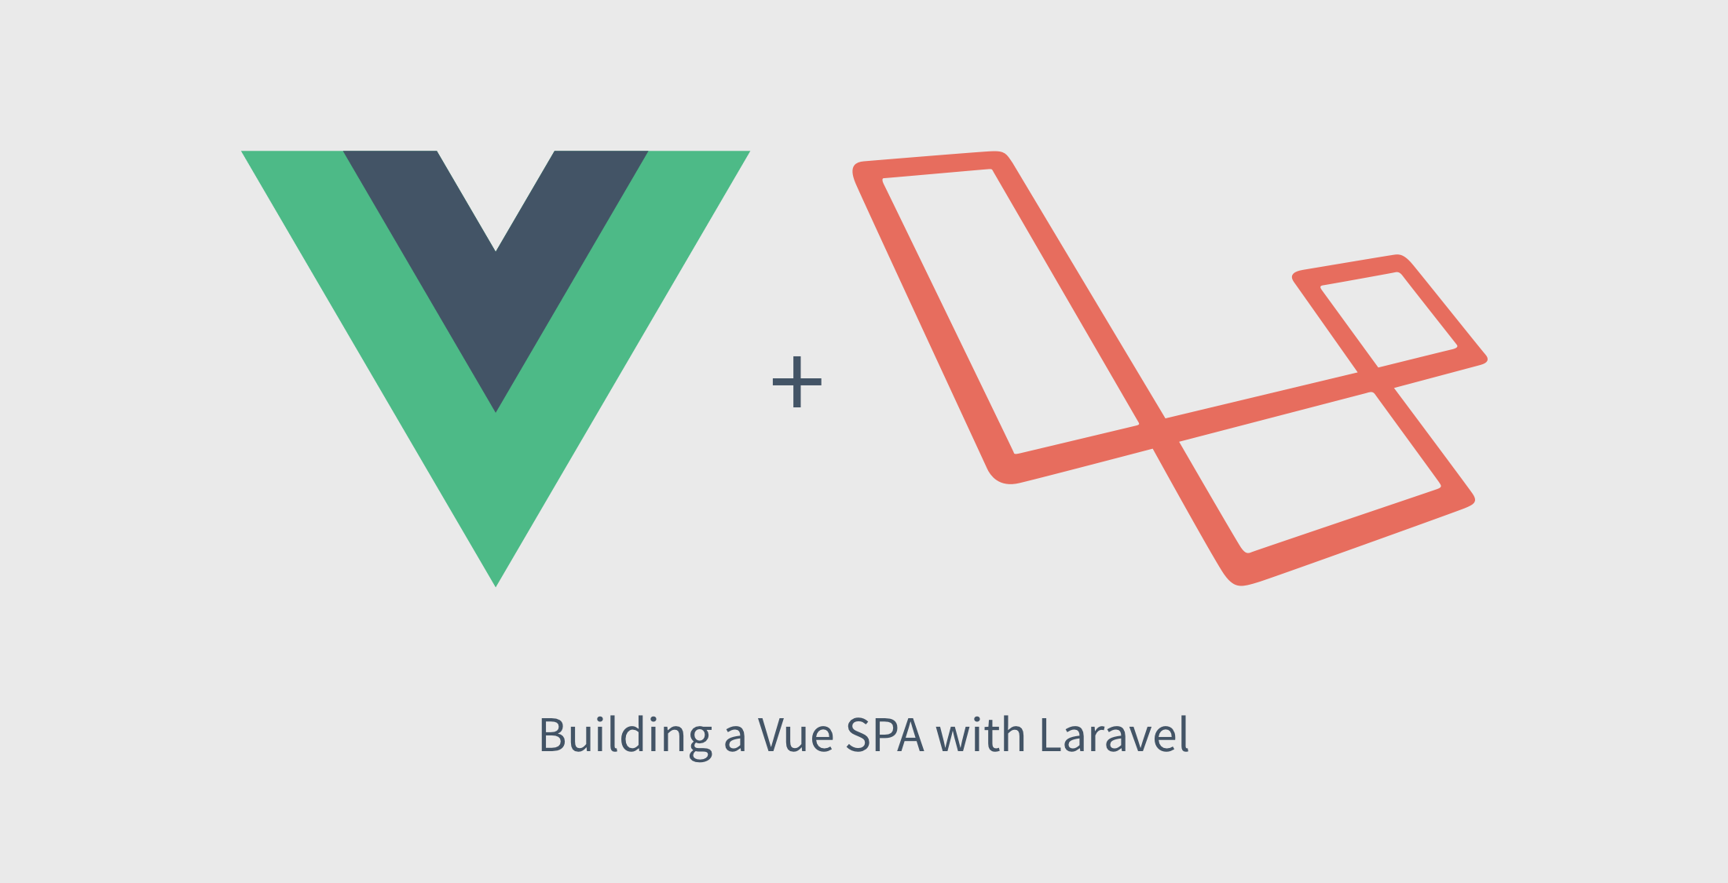

# **OTHER FRAMEWORK**

**NUXT JS**



The Intuitive Vue Framework

Build your next Vue.js application with confidence using NuxtJS. An open source framework making web development simple and powerful.



**VUETIFY**

Material Design Framework

Vuetify is a Vue UI Library with beautifully handcrafted Material Components. No design skills required — everything you need to create amazing applications is at your fingertips.

# **INTRODUCTION**

## [What is Vue.js ?](https://vuejs.org/v2/guide/#What-is-Vue-js)

Vue (pronounced /vjuː/, like **view**) is a **progressive framework** for building user interfaces. Unlike other monolithic frameworks, Vue is designed from the ground up to be incrementally adoptable. The core library is focused on the view layer only, and is easy to pick up and integrate with other libraries or existing projects. On the other hand, Vue is also perfectly capable of powering sophisticated Single-Page Applications when used in combination with [**modern tooling**](https://vuejs.org/v2/guide/single-file-components.html) and [**supporting libraries**](https://github.com/vuejs/awesome-vue#components--libraries).

If you’d like to learn more about Vue before diving in, we [**created a video**](https://vuejs.org/v2/guide/index.html) walking through the core principles and a sample project.

If you are an experienced frontend developer and want to know how Vue compares to other libraries/frameworks, check out the [**Comparison with Other Frameworks**](https://vuejs.org/v2/guide/comparison.html).

## [Getting](https://vuejs.org/v2/guide/#What-is-Vue-js) Started

The easiest way to try out Vue.js is using the [**Hello World example**](https://codesandbox.io/s/github/vuejs/vuejs.org/tree/master/src/v2/examples/vue-20-hello-world). Feel free to open it in another tab and follow along as we go through some basic examples. Or, you can [**create an index.html file**](https://github.com/vuejs/vuejs.org/blob/master/src/v2/examples/vue-20-hello-world/index.html) and include Vue with:

<!-- development version, includes helpful console warnings -->

<script src="https://cdn.jsdelivr.net/npm/vue@2/dist/vue.js"></script>

or:

<!-- production version, optimized for size and speed -->

<script src="https://cdn.jsdelivr.net/npm/vue@2"></script>

The [**Installation**](https://vuejs.org/v2/guide/installation.html) page provides more options of installing Vue. Note: We **do not** recommend that beginners start with vue-cli, especially if you are not yet familiar with Node.js-based build tools.

If you prefer something more interactive, you can also check out [**this tutorial series on Scrimba**](https://scrimba.com/g/gvuedocs), which gives you a mix of screencast and code playground that you can pause and play around with anytime.

## Declarative Rendering

At the core of Vue.js is a system that enables us to declaratively render data to the DOM using straightforward template syntax:

<div id="app">

{{ message }}

</div>

var app = new Vue({

el: '#app',

data: {

message: 'Hello Vue!'

}

})