Exploratory Data Analysis
on the
Automobile Dataset
Report
Written by: Perryn Richardson

Introduction
The Palmer Penguins dataset contains physical measurements for 344 penguins collected at Palmer Station, Antarctica. Three species are represented: Adelie, Chinstrap, and Gentoo. These penguins were observed across three islands in the Palmer Archipelago. The dataset includes seven variables: species, island, culmen length, culmen depth, flipper length, body mass, and sex.

Data Cleaning
The dataset was inspected for structure, data types, and completeness. Column names were consistent and no duplicate rows were found. Two rows were missing all physical measurements and were removed, reducing the dataset to 342 rows. Ten rows had no sex recorded but retained complete physical measurements and were kept for analysis.

Missing Data
The dataset had two types of missing data. Two rows had no physical measurements recorded at all. These were dropped as they could not contribute to any part of the analysis. The sex column was missing values for 10 rows, but all 10 had complete physical measurements. These rows were kept since sex was not a focus of this analysis.

Data Stories and Visualisations

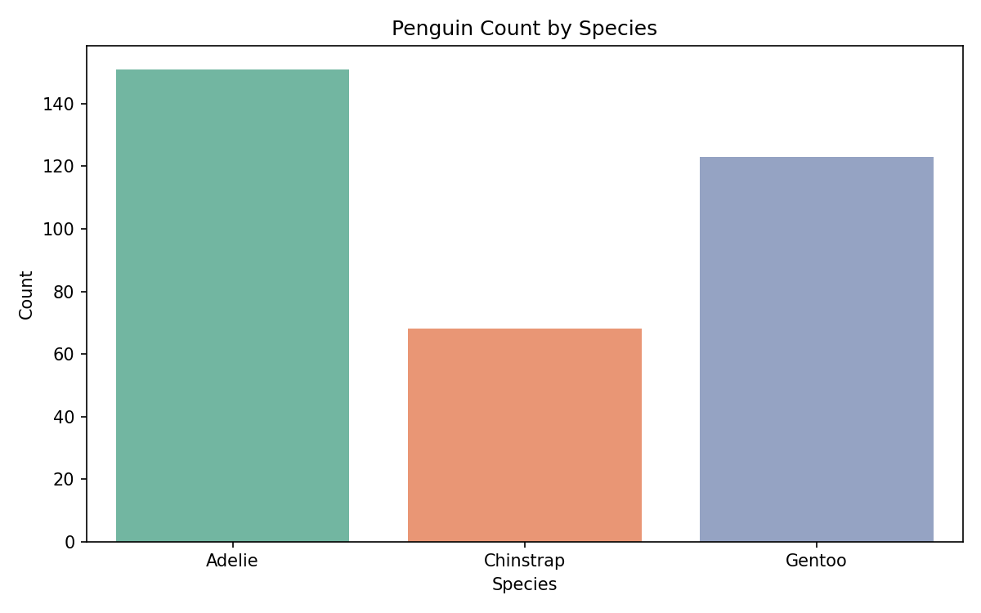
Species Distribution

Adelie is the most common species with 151 individuals, followed by Gentoo with 123 and Chinstrap with 68. Chinstrap is the least represented species, with roughly half the number of Adelie penguins. This uneven distribution is worth keeping in mind when comparing species, as conclusions about Chinstrap are based on a smaller sample.

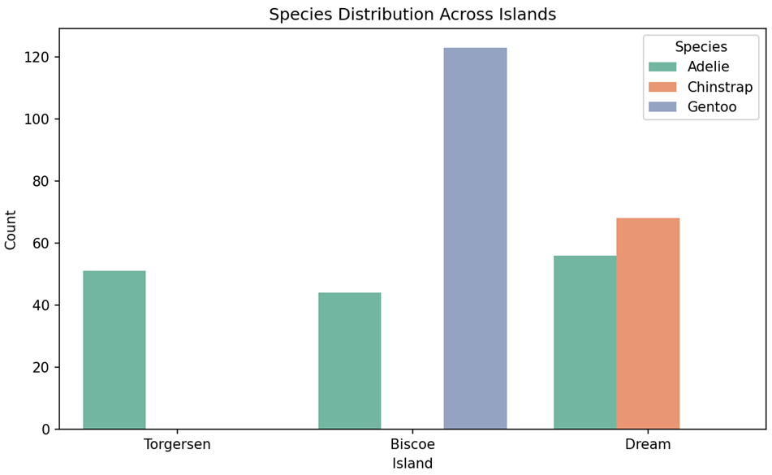
Species Distribution Across Islands

Each species shows a strong island preference. Gentoo penguins are found almost entirely on Biscoe Island, while Chinstrap penguins appear only on Dream Island. Adelie is the only species present on all three islands, making it the most widely distributed of the three. Torgersen Island is home exclusively to Adelie penguins. This pattern suggests the three species occupy distinct geographical areas within the Palmer Archipelago.

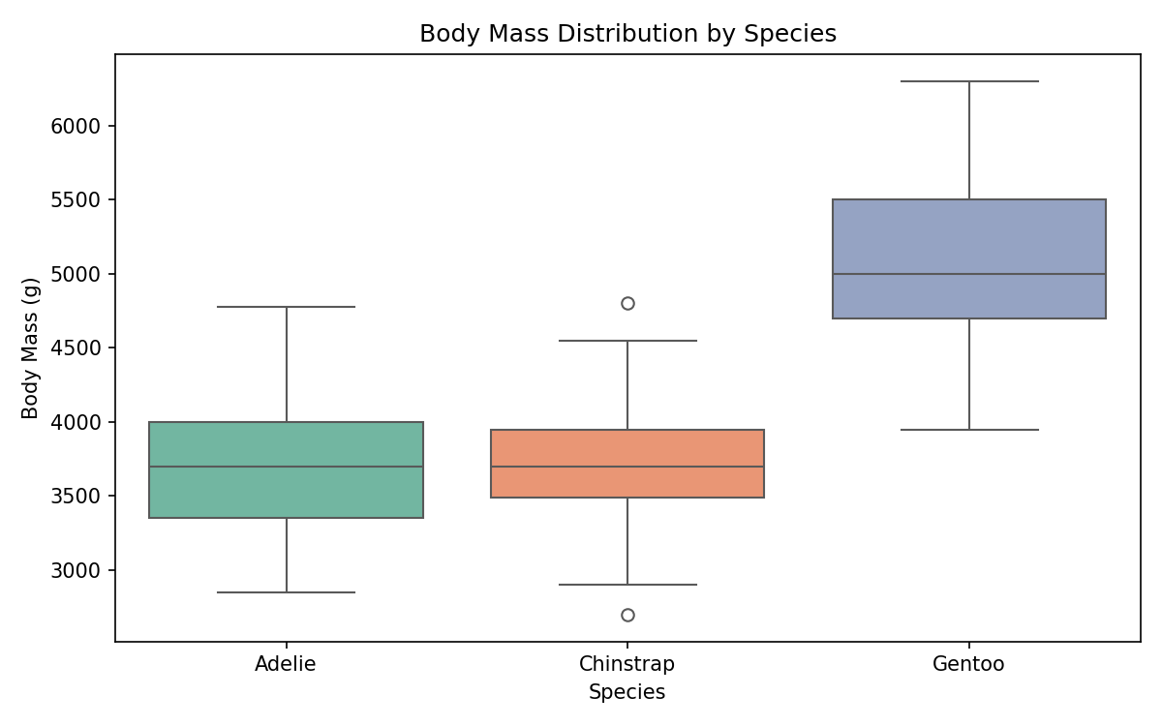
Body Mass by Species

Gentoo penguins are considerably heavier than the other two species, with a median body mass of around 5,000g. Adelie and Chinstrap are similar in weight, both centred around 3,700g. Chinstrap shows two outliers, indicating a small number of individuals that are unusually light or heavy for the species. The size difference between Gentoo and the other two species is clear and consistent across the dataset.

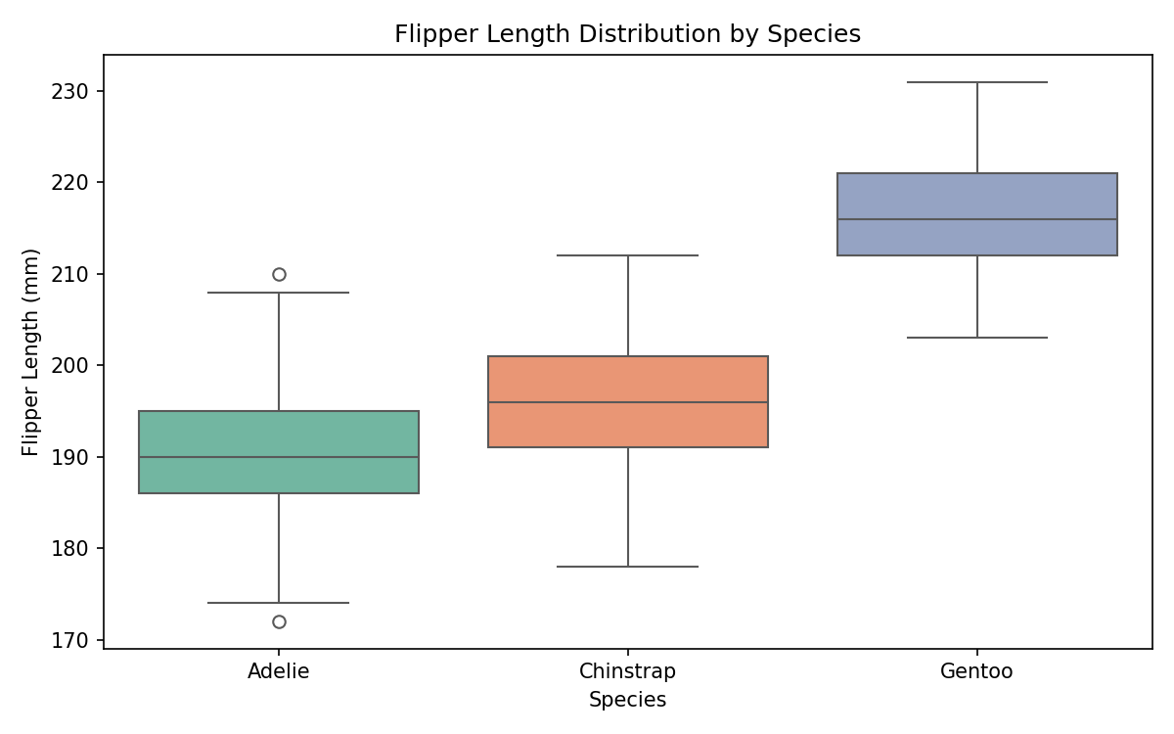
Flipper Length by Species

Gentoo penguins have the longest flippers with a median of around 216mm, consistent with their larger body size. Adelie penguins have the shortest flippers at around 190mm, while Chinstrap sits between the two at roughly 196mm. This pattern mirrors the body mass results, confirming that Gentoo is physically larger than the other two species across all measurements.

Flipper Length vs Body Mass
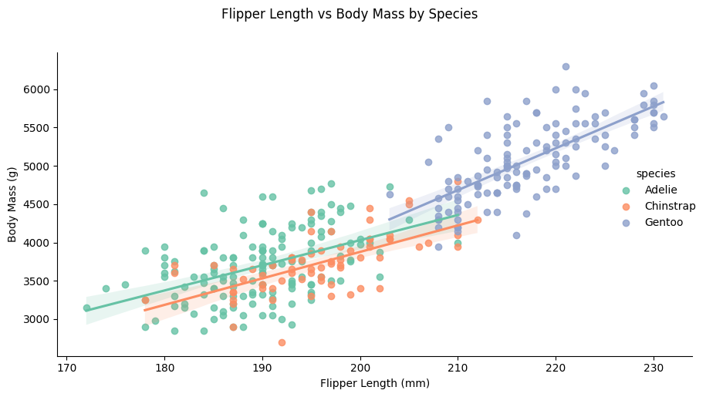

There is a strong positive relationship between flipper length and body mass across all three species. Larger flippers correspond to heavier birds in each case. Gentoo penguins form a distinct cluster in the upper right of the plot, with longer flippers and higher body mass than the other two species. Adelie and Chinstrap overlap considerably, though Chinstrap tends to sit slightly higher for a given flipper length, suggesting a marginally denser build relative to flipper size.

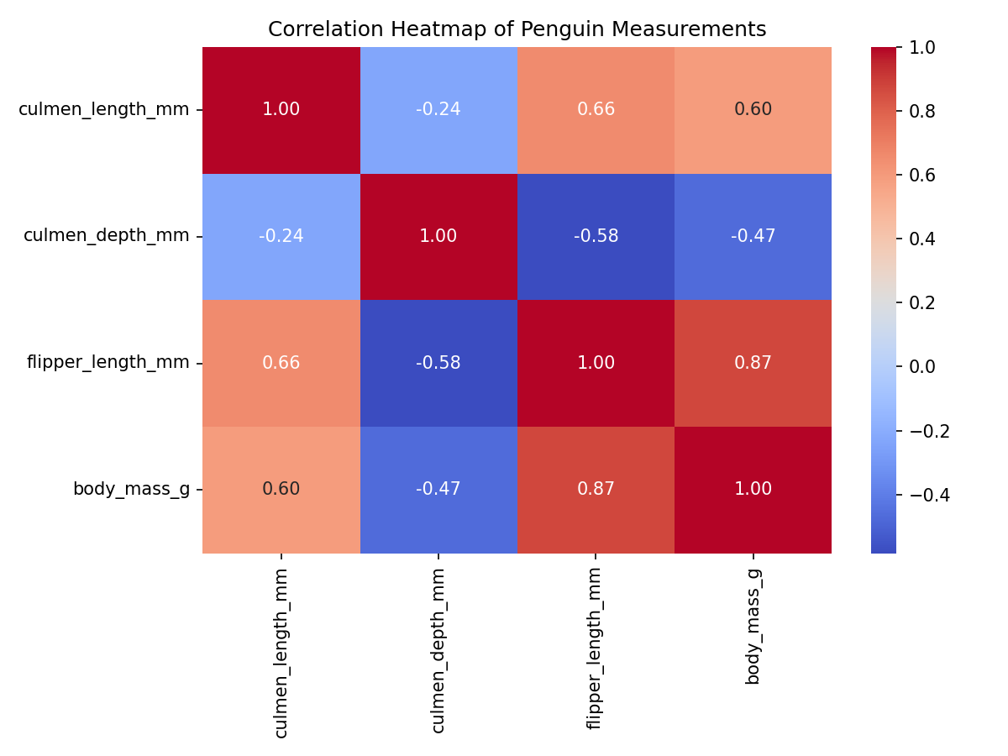
Correlation Between Measurements

Flipper length and body mass show the strongest positive correlation at 0.87, confirming that larger penguins have proportionally longer flippers. Culmen length also correlates positively with both flipper length (0.66) and body mass (0.60), suggesting that beak length grows in line with overall body size. Culmen depth tells a different story, correlating negatively with both flipper length (0.58) and body mass (0.47). This pattern is driven by species differences, as Adelie penguins have the deepest beaks relative to their size but are the smallest species in
the dataset.

Summary of Findings
The analysis of the Palmer Penguins dataset reveals clear physical and geographical differences between the three species.
- Species distribution: Adelie is the most numerous species (151), followed by Gentoo (123) and Chinstrap (68).
- Island habitat: Each species has a strong island preference. Gentoo penguins are found almost exclusively on Biscoe Island, Chinstrap penguins are concentrated on Dream Island, and Torgersen Island is home only to Adelie penguins.
- Body size: Gentoo penguins are notably larger than the other two species, with a median body mass of around 5,000g compared to roughly 3,700g for both Adelie and Chinstrap.
- Flipper length: Gentoo penguins have the longest flippers, consistent with their larger body size. Adelie penguins have the shortest flippers despite being the most numerous species. The scatter plot confirms this visually, with each species forming a distinct cluster and all three showing a consistent upward trend between flipper length and body mass.
- Correlations: Flipper length and body mass show the strongest positive correlation (0.87), confirming that larger penguins have proportionally longer flippers. Culmen depth shows a negative correlation with both flipper length (-0.58) and body mass (-0.47). This pattern reflects that Adelie penguins, which have the deepest beaks, are also the smallest species.
This report was written by: Perryn Richardson

