**SIT314 – Task 4.1P**

**Perry Rose**

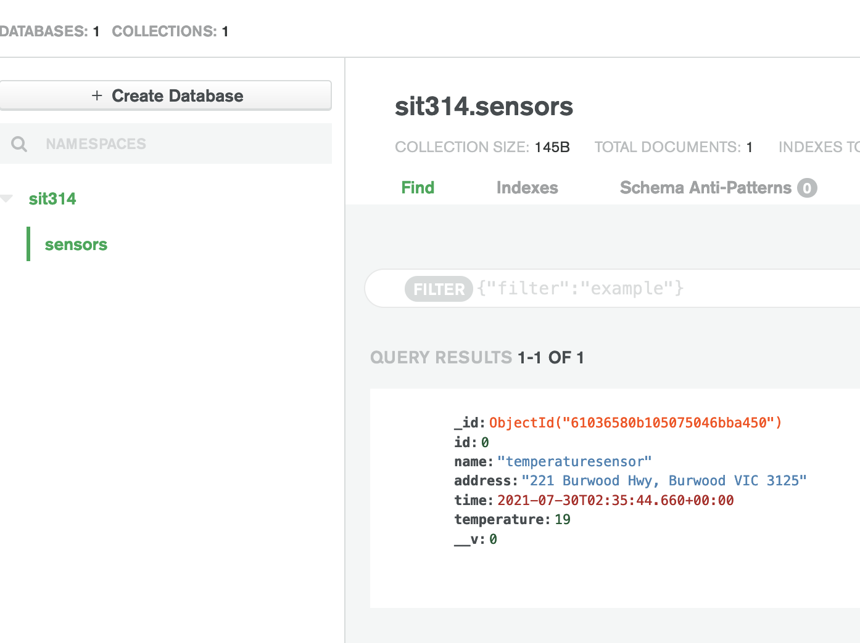**MongoDB Atlas Collection**