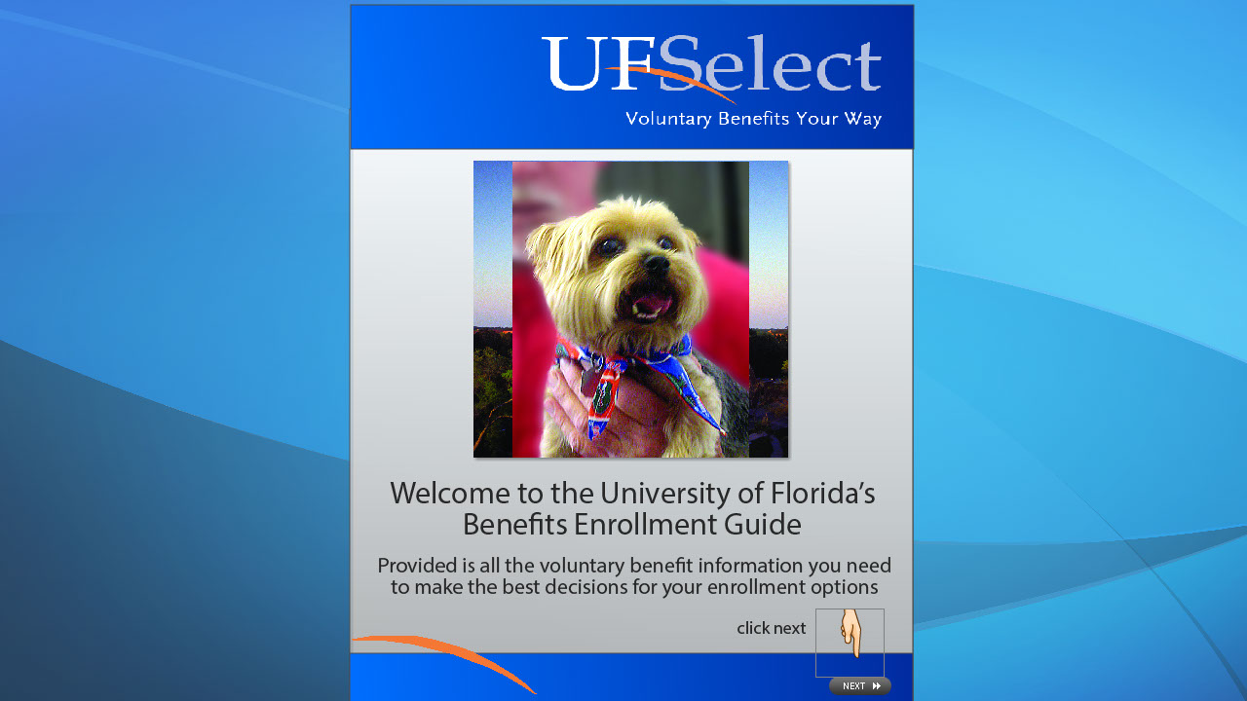
Slide 1-title page
Text Captions: Welcome to the University of Florida’s Benefits Enrollment Guide
Provided is all the voluntary benefit information you need to make the best decisions for your enrollment options

click next

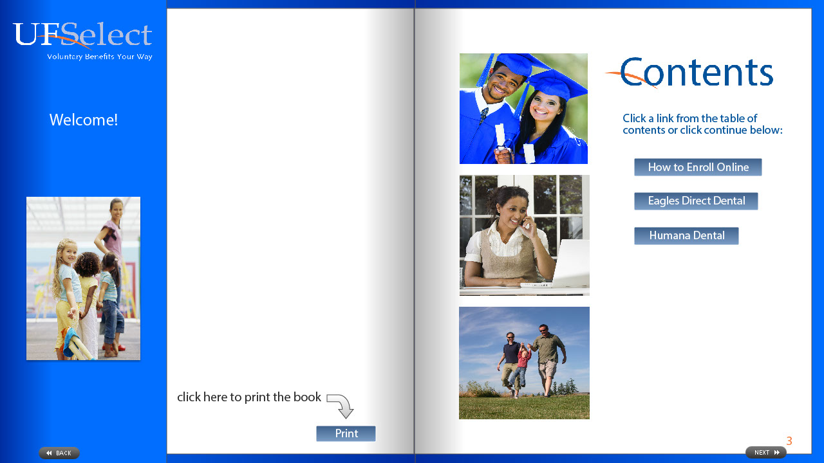
Slide 2-contents
Text Captions: Click a link from the table of contents or click continue below:
Welcome!
3
click here to print the book

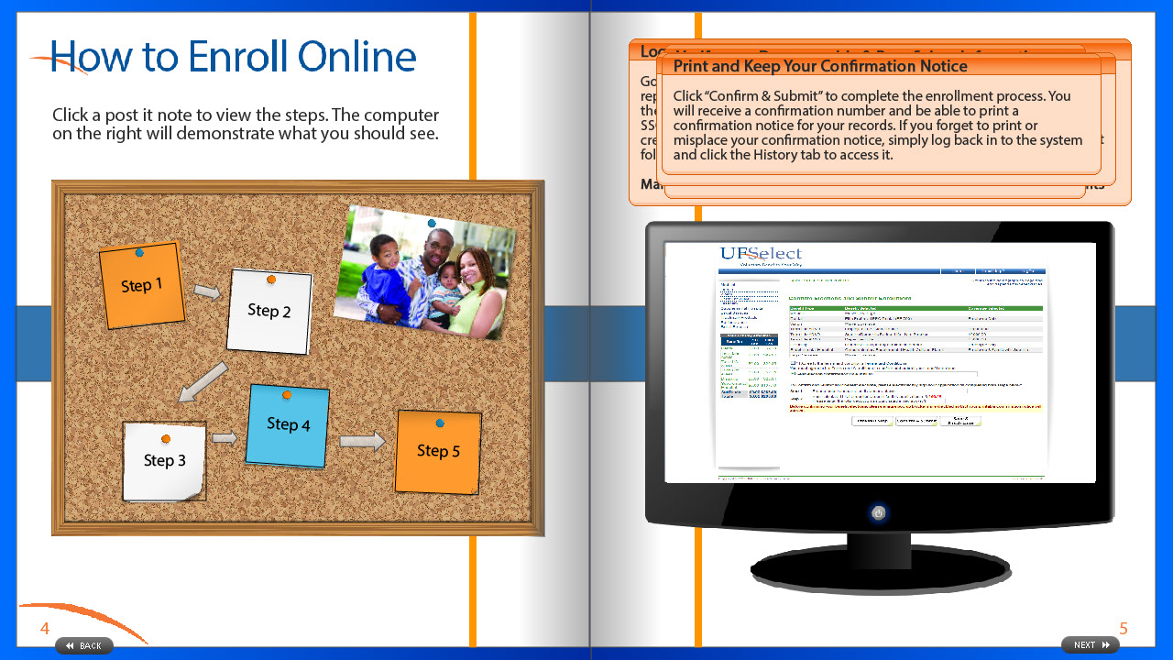
Slide 3-enroll
Text Captions: Click a post it note to view the steps. The computer on the right will demonstrate what you should see.
5
4
Log on

Go to the myUFL portal where you complete daily university tasks as well as report your time worked. Enter your UF username and UF password. Once in the portal, the UFSelect plans are accessed by a Single Sign On (SSO) process. SSO allows you to link to the online enrollment system without having to create another user account or password. After you log into the portal, use the following navigation:

Main Menu > My Self Service > Benefits > UFSelect & GatorCare Benefits
Access your Web Enrollment

Click the “Open Enrollment” link. A second “Open Enrollment 2012” link will then be provided, select this link to access your University of Florida open enrollment application.
Verify your Demographic & Beneficiary Information

All dependents and beneficiaries must be added in this step. During the enrollment process, dependents and beneficiaries will be individually selected from this list. You can add dependent or beneficiary information by clicking on the “+” icon located at the bottom of the screen. You may update dependent or beneficiary information by clicking on the person’s name. You may remove dependents or beneficiaries by clicking on the trash can icon.
Begin the Enrollment Process

For each benefit, choose your coverage level or election amounts and then go to the next benefit. Continue until enrollment is complete.
You may save your enrollment session progress and return later to complete the enrollment at any point once you have started the benefit selections by clicking the “Save & Finish Later” tab at the bottom of the screen.
Print and Keep Your Confirmation Notice

Click “Confirm & Submit” to complete the enrollment process. You will receive a confirmation number and be able to print a confirmation notice for your records. If you forget to print or misplace your confirmation notice, simply log back in to the system and click the History tab to access it.

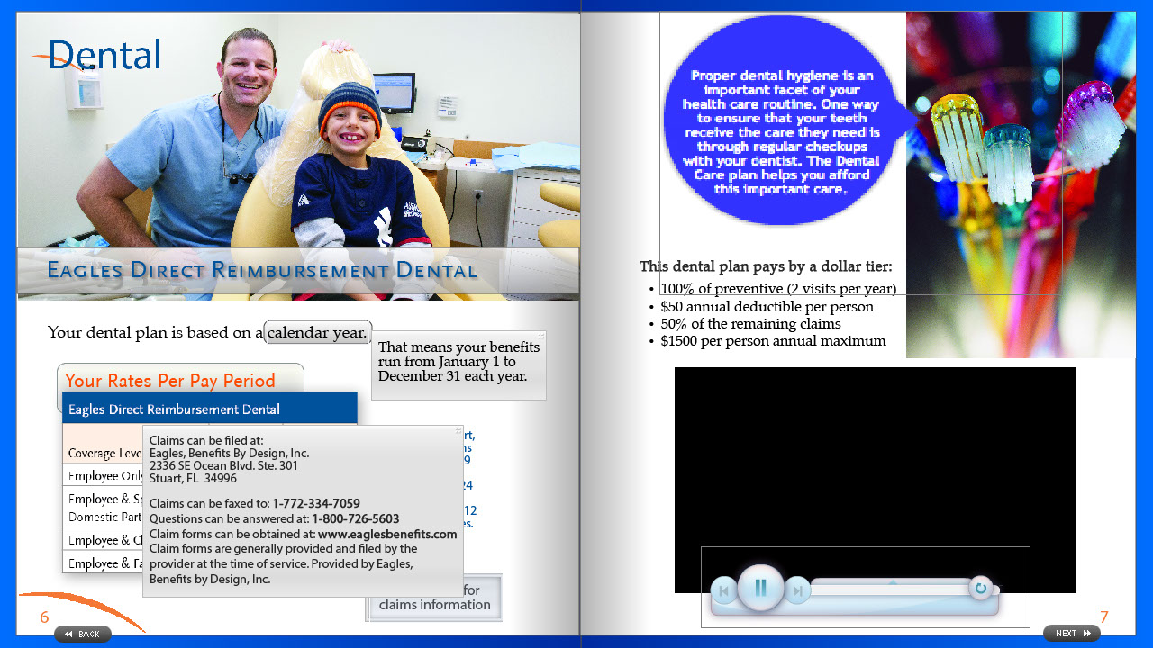
Slide 4-dental
Text Captions: Your Rates Per Pay Period
Your dental plan is based on a calendar year.

This dental plan pays by a dollar tier:
100% of preventive (2 visits per year)
$50 annual deductible per person
50% of the remaining claims
$1500 per person annual maximum

Mouse over for
claims information
\* On the rate chart, the 16 Deductions column refers to 9 & 10 month employees. The 24 Deductions column refers to 12 month employees.
6
7
That means your benefits run from January 1 to December 31 each year.
Eagles Direct Reimbursement Dental
Claims can be filed at:
Eagles, Benefits By Design, Inc.
2336 SE Ocean Blvd. Ste. 301
Stuart, FL 34996

Claims can be faxed to: 1-772-334-7059
Questions can be answered at: 1-800-726-5603
Claim forms can be obtained at: www.eaglesbenefits.com
Claim forms are generally provided and filed by the provider at the time of service. Provided by Eagles, Benefits by Design, Inc.

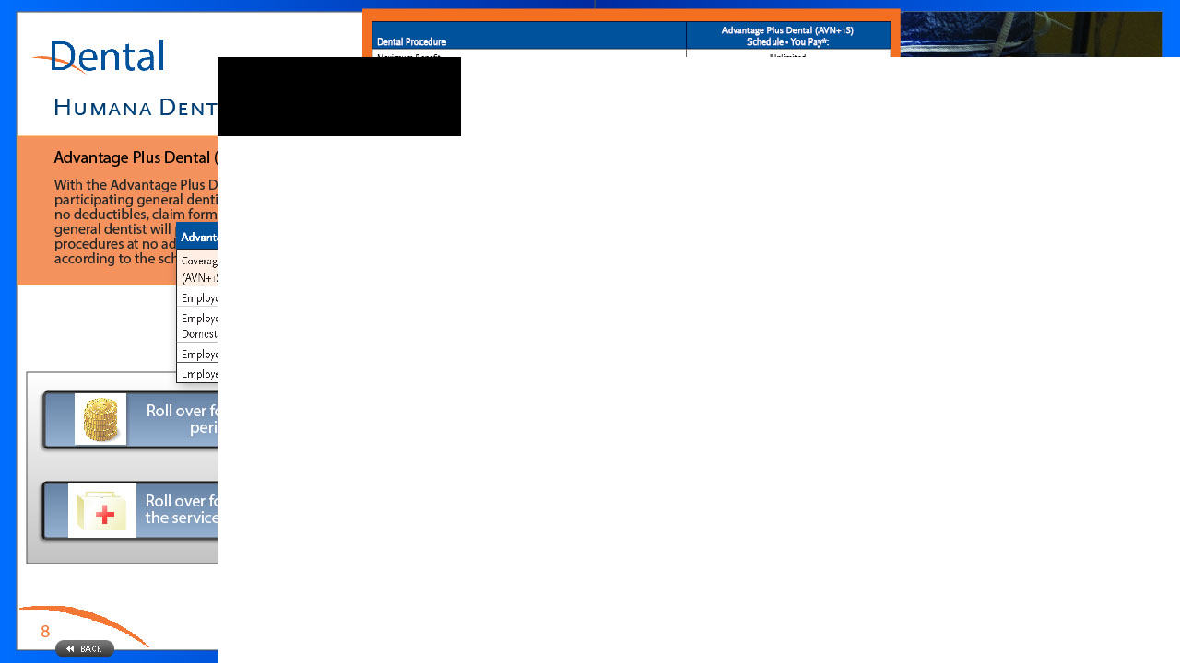
Slide 5
Text Captions: 8
9
Humana Dental Plans
Advantage Plus Dental (AVN+1S) - Prepaid Services
Elite Preferred PPO Dental (EP 700) - Preventive & Basic Services
With the Advantage Plus Dental (AVN+1S), benefits are provided by participating general dentists and participating specialists. There are no deductibles, claim forms or waiting periods. The participating general dentist will perform most preventive and diagnostic procedures at no additional charge with all other services provided according to the schedule of benefits.
The Elite Preferred PPO Dental - (EP 700) plan is similar to traditional dental insurance plans. This plan covers preventive and basic services only (i.e. cleaning, x-rays and fillings). You do not have to pre-select a primary dentist. When you need dental services, simply make your appointment with any dentist.


Slide 6

