Computer Network Laboratory

Assignment-2

Name: P.M. Harshith

Roll No.116CS0185

1.     Get the following details of your own system:

-         IP Address: 192.168.43.107

-         MAC Address: 6C:3B: E5:2A:BF:28

-         Subnet address: 255.255.252.0

-         Gateway address: 192.168.40.1

Command used: ifconfig

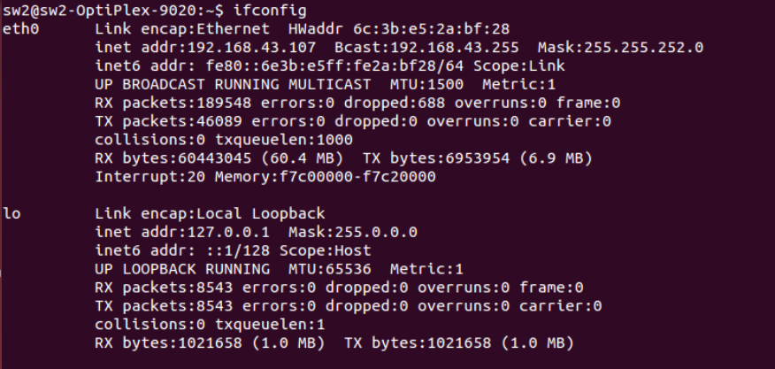

2.     Change your IP address at its 1st, 2nd, 3rd and 4th subfields (once at a time) and note down your observation.

Command used: sudo ifconfig eth0 new_ip_address netmask 255.255.252.0

After Changing the first subfield:

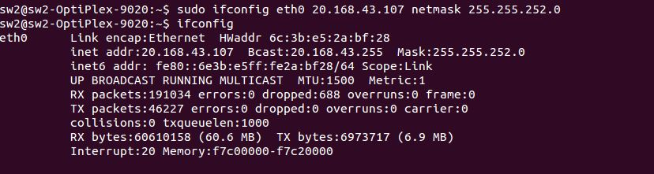

After Changing the second subfield:

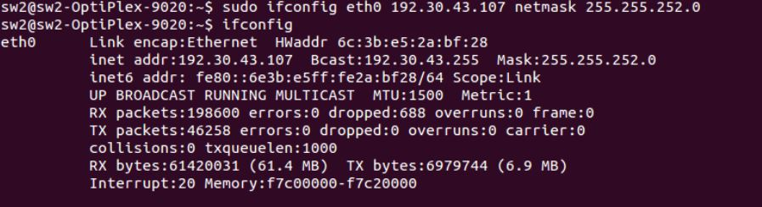

After Changing the third subfield:

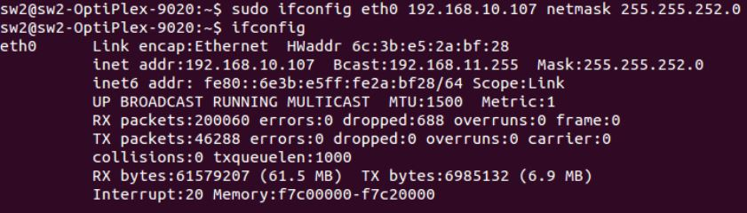

After Changing the fourth subfield:

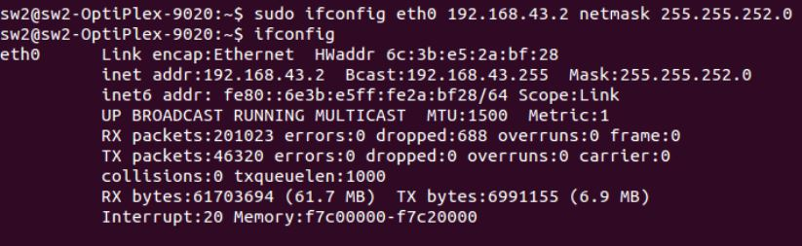

3.     Change the MAC address.

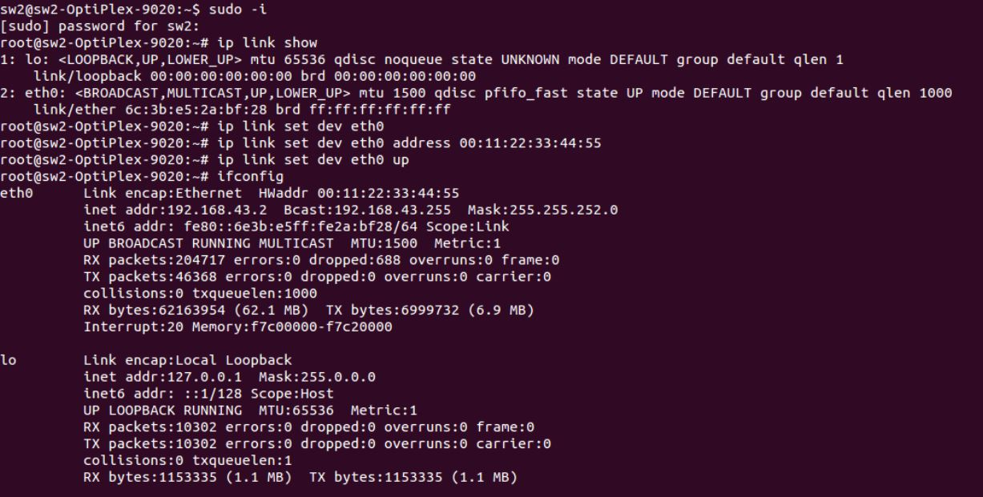

4.     Ping to your gateway and note down the response.

Command Used: ping 192.168.40.1

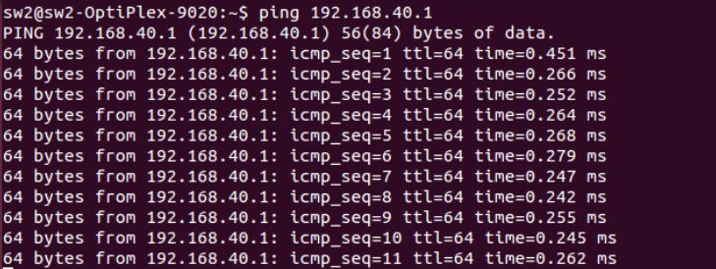

5.      Design a client server program and analyse its operation and performance. Study the port addresses used and the socket programming too.

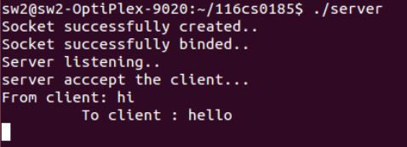

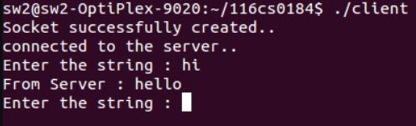

Server-Client program between two computers using the same port Address.

6.     Change the port address and note down the result.

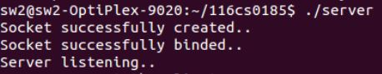

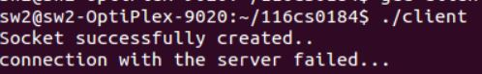

Connection failure after changing the port address in the client.

7.     Test the network connectivity of your system by the loop back address.

Command Used: ping 127.0.0.1

Result :

sw2@sw2-OptiPlex-9020:~$ ping 127.0.0.1

PING 127.0.0.1 (127.0.0.1) 56(84) bytes of data.

64 bytes from 127.0.0.1: icmp_seq=1 ttl=64 time=0.025 ms

64 bytes from 127.0.0.1: icmp_seq=2 ttl=64 time=0.027 ms

64 bytes from 127.0.0.1: icmp_seq=3 ttl=64 time=0.026 ms

64 bytes from 127.0.0.1: icmp_seq=4 ttl=64 time=0.028 ms

64 bytes from 127.0.0.1: icmp_seq=5 ttl=64 time=0.030 ms

64 bytes from 127.0.0.1: icmp_seq=6 ttl=64 time=0.030 ms

64 bytes from 127.0.0.1: icmp_seq=7 ttl=64 time=0.033 ms

64 bytes from 127.0.0.1: icmp_seq=8 ttl=64 time=0.029 ms

.

.

.

.

.

.

.

.

8.     Find the BW of your network

