Researchers have studied human languages for thousands of years but a thousand years of linguistic data rapidly overwhelms traditional analytical methods. We are now developing the capability to analyze the full record of human language – thousands of years of linguistic data from across the world, in far more languages than any human could master and at a scale that was not feasible before we had access to digital collections and computational methods of analysis. We are entering a new age in the study of linguistic data over time and space. Within this larger context, we propose to create a linguistic corpus of 25 million words of linguistic data documenting classical Greek from its earliest attested sources (the Homeric epics c. 750BCE) through the end of the third century CE – a corpus that includes a wide range of linguistic genres including not only literary and historical materials but foundational scientific works attributed to Hippocrates, Euclid, Aristotle, Theophrastus, Archimedes, Ptolemy, and Galen. The corpus will contain varying levels of annotation, with automated annotations of documented precision for the whole corpus, 26 million words of English translations aligned to the Greek, and manually corrected annotation for a one million word subset. This work builds upon decades of research and development, uniting various strands of effort to create a corpus that is unprecedented in chronological scope, enables new avenues of research and will continue to evolve after the grant is complete.

The work proposed here exerts an impact that is broader than corpus and computational linguistics. This corpus will not only enhance the research of those already working with Greek scientific texts but will enable a wider set of researchers to make broader and deeper use of these sources. Equally important, this project expands the fields of corpus and computational linguistics, initiating a transformation in the study of historical languages that is both a major advance and a reaffirmation of the most traditional goals of linguistic scholarship. As corpus and computational linguistics become core practices within the study of historical languages, we have an opportunity to transform education as well as research, expanding the role of scientific analysis within the curriculum. The creation and analysis of linguistic annotation opens up new pathways not only for faculty and professionals but also opportunities whereby our undergraduates and MA level graduate students can, for the first time, contribute to and then conduct meaningful research in historical languages such as Greek and Latin.

Background

Students of historical languages have been developing collections for a generation and, in fields such as classical studies, scholars regularly turn to digitized collections of primary materials in their research. These resources are usually based upon designs from the 1970s – they serve as machine actionable indices to printed source texts and do not encode basic knowledge at a level of granularity needed for many linguistic questions. There is no information with which to distinguish, for example, a prose text ascribed to Aristotle from embedded quotations of epic poetry or to separate documents from varying periods and genres within collections of poetic language. At the same time, our linguistic data varies in precision – all linguistic data preserved in manuscript form is subject to errors in transmission but our existing linguistic collections record single reconstructions of the original source texts and contain no information about the assessed reliability. These resources were designed for domain experts who would refer to print originals and who would rely upon extensive knowledge of each document – an expert in Classical Greek knows that the 5th century BCE text of Aeschylus contains much more noise than that of his near contemporary Pindar but may not have such expertise for Greek data from 500, 1000, or 1400CE. Even if researchers do have such expertise, they will need to apply that expertise on a document by document basis – a practice that does not scale as we work with increasingly complex collections.

Even more important, new forms of linguistic annotation have transformed the questions that we can pose. Linguistic annotation is hardly a new development – the punctuation, diacritical marks, use of upper case to mark proper names, and paragraph breaks that we find in modern editions all constitute linguistic annotations not present in the original. We also possess large bodies of stand-off markup developed over generations of careful analysis. Textual notes link words and phrases in the reconstructed text to variants and allow readers to assess their confidence in the reconstructed text. Back-of-the-book indices provide human readable annotation on semantic classification (e.g., is Washington a person or a place?) and named entity identification (if Washington is a place, which Washington is it?). Traditional lexica assign senses to particular instances of a given word (e.g., the Latin word oratio corresponds to “oration/speech” in passages A, B, and C but to “religious prayer” in passages X, Y, and Z). Grammars assign traditional linguistic categories to particular structures in particular passages. Commentaries on historical documents include a wide range of linguistic annotations including co-reference (e.g., a given pronoun refers to Caesar rather than Cicero).

These print reference works are important for two reasons. First, they provide source materials from which we can mine machine actionable annotations – we have, for example, bootstrapped core services such as morphological analysis and named entity identification with data extracted from print sources. Translations from historical into modern languages, created to support human readers, have proven extraordinarily useful sources for semantic data – analysis of parallel texts allows us, for example, to trace semantic shifts (e.g., the use of Latin oratio as a rhetorical speech in classical Latin to its use as a prayer in Christian authors) and to estimate the original Greek terms in a scientific text that survives only in Arabic translation.

Second, the established tradition of annotation among students of historical languages provides a foundation for sustainability of the work proposed here long after the conclusion of the grant. We propose not only to create something of immediate utility but also to establish new methods by which students of historical language can better pursue their most fundamental practices of analysis. The Greek and Latin treebanks on which this project builds have few direct print antecedents – the interlinear translations of Greek and Latin school texts from the 19th century are the closest. Yet the practice of analyzing every word in every sentence in a dependency grammar is something that Roman schoolchildren learning Greek two thousand years ago would have recognized. Scholars have edited textual sources from the past and added the linguistic annotation suitable for print, both as inline annotation (e.g., punctuation) and as standoff (e.g., reference works). The corpus that we are creating enables the next generation of editorial work and it positions corpus and computational linguistics to draw upon the core energies of intellectual communities that are ancient, international, and are themselves poised to benefit from this new work.

Coverage

The planned corpus will contain a total of 25 million words, with automated annotations of measured precision for the whole and corrected linguistic annotation for a 1-million-word subset.

The overall corpus (25 million words)
The corpus will cover all major texts that survive in manuscript transmission from the Homeric epics (c. 750BCE) through 300CE – a 1,000 year period that includes every major genre of poetry and prose. The overall corpus of textual data that has survived in manuscript tradition and that is available in standard print editions consists of c. 25 million words. Of these, we have 5 million already in a TEI-compliant XML form. We have in hand funding to pay for scanning page images of editions not already available from sources such as the Internet Archive and for the manual correction of 20 million additional words of OCR-generated Greek. We are asking NSF support to convert this general collection of open content source material into a systematically organized corpus of textual data.

Within the 25 million word corpus, we will include foundational works in the history of science ascribed to figures such as Hippocrates, Euclid, Theophrastus, Aristotle, Archimedes, Heron, Ptolemy, and Galen, accounting for c. 25% (6.3 million words) of the whole.

The manually annotated corpus (1 million words)
Support from third parties in Europe and North America has already funded the creation of two manually corrected morphosyntactic treebanks of ancient Greek. The Alpheios project has provided the Perseus Digital Library with support to create a treebank of Ancient Greek that focuses primarily upon poetry. This Treebank currently contains 192,000 words and has funding to reach a total of 400,000 words. European funding has allowed a Norwegian team to create a treebank for the Greek New Testament (c. 175,000 words). NSF support will allow us to extend and to generalize these special purpose treebanks, creating a corpus with more than 1 million Greek words with a range of annotation.

Where the Greek Poetry and New Testament treebanks provide exhaustive coverage for heavily studied canonical works, we will focus in this project in creating sample sets for a range of texts in the corpus as a whole.

Selection criteria for this subset will balance the following goals:

- The generality of a purely random subset designed to represent multiple periods, genres and other features.
- An intellectually coherent anthology of representative works. We want to engage readers of Greek texts to work with and to expand the annotations in this corpus. Creating an anthology of logically coherent work (as opposed to a purely random sampling) would advance this goal.
- Creation of training sets to improve automated analysis of large, linguistically homogenous sources within the corpus (e.g., 1 million words of Aristotle, 350,000 words of Euclid).
- Particular attention to sources for the history of science (c. 50% of the annotations representing explicitly scientific texts, with 50% representing the rest of the prose corpus).

Open source data and corpus design
The Perseus Project has adopted an open source policy. The content that we produce is available under a Creative Commons license to promote free use, re-use and repurposing. This is for us a settled policy: the work proposed here builds on texts and linguistic annotations already published under an open source CC license.

To advance this open source policy, we use the best available public domain editions as the starting point for this corpus. This allows members of the community to augment and improve what we produce over time without restrictions.

Versioning and long term maintenance
Researchers will work with the documents in this collection long after this immediate project is completed and thus versioning information is a core element of the annotation – we need to be able to recover the state of the corpus at any given point in the past. The corpus thus will be stored in the Tufts Digital Library, which will track individual versions of the data over time.

Layers of annotation
We will include several different categories of annotation: document-level metadata for each text, references to page images, character-level transcriptions, variants, word and sentence level segmentation, quotation markup, syntactic, morphological and lexical analysis, named entity analysis (including classification and disambiguation), and word-level aligned translations.

Metadata
Library metadata primarily focuses upon book length documents and does not cover the majority of known Greek texts, most of which are brief elements of larger collections or survive only as quotations in surviving authors.

Classicists have created more comprehensive databases of surviving textual sources but these do not use standard names or identifiers and are thus not compatible with more general library infrastructure. Furthermore, these databases are in effect checklists of editions used by particular reference works and digital collections – they are not structured to represent multiple versions of the same work or variation across versions.

We have therefore created a comprehensive database of authors, works, and editions for all major Greek and Latin texts. This database conforms to the Functional Requirements for Bibliographic Records object model and allows us to represent multiple editions of a single work. Use of the Canonical Text Services Protocol allows us to identify works by book/chapter/line, chapter/verse, and page/page-section citation schemes. We thus have in place the logical framework within which to structure this corpus. The framework is also structured to represent multiple versions of the same work, multiple citations schemes and multiple metadata sets (e.g., different decisions on whether a given work is by Aristotle or not).

References to page images
We provide links that can scalably point to online page images for the source editions that the corpus references. We are not creating links to pages currently available in Google, the Internet Archive, and elsewhere. Rather we are creating a corpus with standards compliant metadata and markup with identifiers for the original source page. The goal is to create a database that can automatically detect digital copies of a source edition as the relevant metadata becomes available.

Transcription
The rise of inexpensive book scanning services has made it possible to create an open content library of Greek editions as image books available at sites such as the Internet Archive. At a scanning cost of $.10/page it has been on the average cheaper to scan books than to acquire used copies (where these are even available).

Improved Optical Character Recognition (OCR) software has made it possible to expand the set of Greek text available under an open content license. Where good, well-printed public domain editions exist, we can provide textual data that approaches the accuracy of manually keyboarded Greek (99.94% vs. 99.95%). Where we want to provide text of greater accuracy, we have outsourced the major correction to a professional data entry firm. Figure 1 illustrates a typical chunk of Greek with words in an ASCII transcription flagged for manual checking after running through the workflow from page image to text currently in place. In most cases, flagged words are very short, common words that can have various accents depending upon their meaning. The TEI CORR tags indicate words where we have automatically inserted a correction that needs verification. The SIC tags flag words that are judged to be probable errors and in need of manual correction. At present, 1-2% of the words in a given text are probable errors. If we also check all automatically inserted corrections, we check 10-12% of the words in the text. We currently outsource the task of adding citation markers and checking for major punctuation. The text also includes links to the page images from the source text (e.g., <pb id=”p.230”> below) so that readers can identify and correct residual errors.

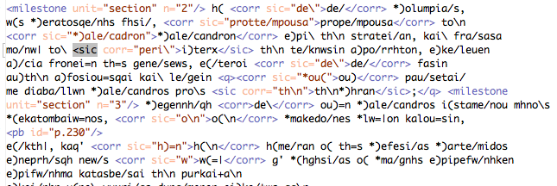
Figure 1: Output of automatic OCR correction

Variants
Virtually all ancient documents contain noise (scribes introduce mistakes as they work, documents are damaged and data lost) but some documents contain more noise than others – the Greek authors Pindar and Aeschylus composed very complex poetry in the early 5th century BCE but the text of Aeschylus contains far more errors and uncertainties than does that of Pindar. Researchers need scalable methods whereby they can evaluate the varying level of uncertainty across this corpus.

We will provide two basic metrics:

- Information about variants recorded within the textual notes: i.e., how many variants are recorded? Even noisy OCR output from the textual notes allows us to measure the ratio of variants to words in the reconstructed text. Where different publication series include different numbers of variants (e.g., Teubner editions contain, on average, about twice as many variants as do Loeb editions), we can include these general tendencies in interpretations of individual source texts.
- Machine collation of the reconstructed texts in multiple editions: i.e., how often do different editions actually differ? Some texts have not been edited since the 19th century and exist in only one reasonable edition, while some canonical works have appeared in many editions since the early 19th century. We will provide metrics for variation for at least one separate edition where these exist. Where page images of second editions are not readily available, we may provide overall scan and OCR sample pages for subsets of alternate editions.

Advanced annotation: For the carefully annotated sub-corpus and where recent editions indicate a major advance, we will correct the collations automatically generated from OCR output. We cannot provide every version of every edition of heavily studied authors, but will provide sample analyses of alternate editions to illustrate the linguistic implications of textual variation.

Sentence and word markup
Many tasks (such as sentence-level syntactic parsing and word-level morphological tagging) require unique identifiers for both individual sentences and individual tokens in a document. The Perseus Digital Library has in the past created these internally – with the results that projects at Chicago, Leipzig, Holy Cross and elsewhere all developed their own methods to identify sentence breaks and to label words to address this problem. We will therefore include sentence and word segmentation in the public corpus.

Quotation markup
General narrative and quoted speech often differ fundamentally in linguistic practice. We will distinguish two categories of quoted speech:

- Quoted speech produced (in its surface form) by the author of the document: e.g., Herodotus 1.30: <name type="pers">Solon</name>, offering no flattery but keeping to the truth, said, <q>O King, it is <name type="pers">Tellus</name> the <name type="ethnic">Athenian</name>.</q>
Here the TEI XML Q tag marks the beginning and end of a quote attributed to Solon but produced in the words of Herodotus.
- Text quoted from an earlier work: e.g., Aristotle, Politics 1.7: And this is what <name type=”pers”>Homer</name> means: <cit> <quote><l met="dactylic">And each one giveth law</l> <l>To sons and each to spouses.</l></quote> <bibl n="Hom. Od. 9.114">Hom. Od. 9.114 f.</bibl> </cit>
Here the TEI XML QUOTE tag marks a passage quoted from Homer by Aristotle. The CIT and BIBL tags indicate the source of this quotation.

Named entity analysis
This entails two tasks: named entity classification and disambiguation.

Named entity classification involves detecting proper nouns and classifying them according to basic categories, many of which are common across domains (e.g., person, place, organization, etc.). The quotations above illustrate one-TEI compliant markup scheme to represent basic semantic classes of person (Solon, Tellus, Homer) and ethnic group (Athenian). In Classical Greek, corporations, street addresses, zip codes and other modern entities do not exist, but the distinction between human and god/goddess is significant.

Named entity classification is relatively straightforward in Greek since there is relatively little overlap between semantic classes (where “Washington” can be a person or a place in English, cities named after Alexander in Greek are named Alexandria). The results vary among the documents in this corpus, but they yield, on average, an F-measure (combining precision and recall) over 95%. Most of our attention has centered on the second and more challenging task of named entity disambiguation.

Named entity disambiguation involves determining the physical referent for a particular instance of a name: e.g., if Washington refers to a place, is it Washington, DC, Washington State, Washington, NC etc? If Alexander describes a person, is it Alexander the Great, the philosopher Alexander of Aphrodisias or one of the dozens of other Alexanders? For Greek texts, we can achieve an F-measure of c. 80%. The overall corpus will include the top five possibilities for each named entity, with estimates of the probability for each.

Within the 1 million word intensive corpus, we will check the output of this automatic classification and disambiguation, and correct any errors that are found.

Syntactic analysis
The resurgence of statistical methods in computational linguistics over the past twenty-five years has given rise to a great investment in the creation of treebanks – large, syntactically annotated corpora. Much of the work has focused on English (Marcus et al. 1993) and other modern languages, including Czech (Hajic 1998), German (Brants et al. 2002), Spanish (Moreno et al. 2000), French (Abeillé et al. 2000), Italian (Montemagni et al. 2000) and Japanese (Kurohashi and Nagao 1998), but several have arisen recently for historical languages as well, including Middle English (Kroch and Taylor 2000), Early Modern English (Kroch et al. 2004), Old English (Taylor et al. 2003b), Medieval Portuguese (Rocio et al. 2000), Ugaritic (Zemánek 2007), and several Indo-European translations of the New Testament (Haug and Jøhndal 2008).

Funding from the National Science Foundation (NSF #0616521: “Automatically Building a Latin Treebank”) allowed us to begin developing a treebank for Classical Latin in 2006. The results of this work directly led to private funding for the development of a 400,000-word treebank for Ancient Greek poetry. As of December 2009, we have publicly released almost 250,000 syntactically annotated words from these two languages (192,204 words of Ancient Greek and 53,143 words of Latin). Since Latin and Ancient Greek are both highly inflected languages with a high degree of variability in word order, we have based our annotation style on the dependency grammar used by the Prague Dependency Treebank (Hajic 1998) for Czech (another non-projective language), which has since been widely adopted by a number of annotation projects for other languages, including Arabic (Hajic et al. 2004), Slovene (Džeroski et al. 2006) and Modern Greek (Prokopidis et al. 2005). Figure 2 illustrates one such dependency tree in the Ancient Greek Dependency Treebank, taken from the first line of Homer’s Iliad.

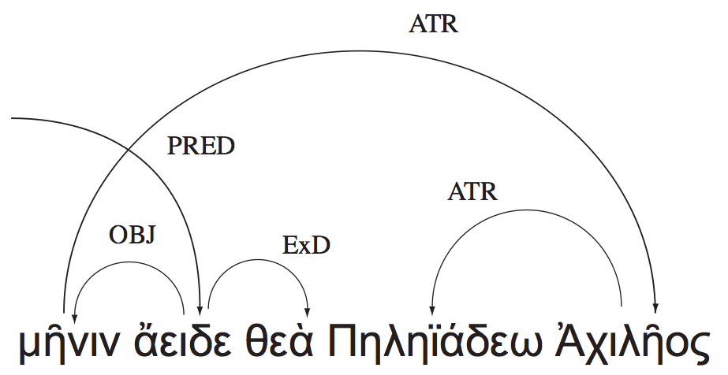

Figure 2: Dependency tree of μῆνιν ἄειδε θεὰ Πηληϊάδεω Ἀχιλῆος (“Sing, goddess, of the rage of Achilles, the son of Peleus”), Homer, Iliad 1.1. Arcs are drawn from heads to their dependents.

The annotators who contribute to our existing Greek and Latin dependency treebanks undergo extensive training with constant feedback on their performance. The backgrounds of these annotators range from advanced undergraduate students to recent PhDs and professors, with the majority being students in graduate programs in Classics. In addition to an initial training period, annotators are actively engaged in new learning by means of an online forum in which they can ask questions of each other and of project editors; this allows them to be kept current on the most up-to-date codifications to the annotation guidelines while also helping bring new annotators up to speed. In the standard model of production two independent annotators annotate every sentence and the differences are then reconciled by a third. This reconciliation (or “secondary” annotation as it is encoded in the XML release) is undertaken by a more experienced annotator/editor, typically a PhD with specialization in the particular subject area (such as Homer).

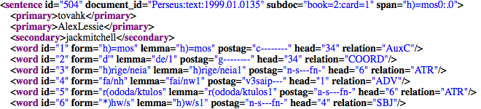
Figure 3: XML fragment from the Ancient Greek Dependency Treebank (Homer, Odyssey 2.1).

As Figure 3 illustrates, all annotations are publicly released with the usernames of the primary and secondary annotators (which are then also associated with real names and institutional affiliations). By publicly acknowledging authorship, we are making our first steps toward an ownership model for annotation and hope to provide a means for students, both graduate and undergraduate alike, to engage in the act of scholarly research and produce scientific data that can be useful to the wider Classics community (Bamman et al. 2009).

Expert analyses, however, are slow and expensive to create, especially given the difficulty and historical distance of Classical texts. The Penn Treebank can report a productivity rate of between 750 and 1000 words per hour for their annotators after four months of training (Taylor et al. 2003a) and the Penn Chinese treebank can report a rate of 240-480 words per hour (Chiou et al. 2001), but there are no native speakers of historical languages such as Greek. Our annotation speeds are therefore significantly slower, ranging from 97 words per hour to 211, with an average of 124. In the actual production lifecycle, soliciting annotations from two independent annotators and then reconciling the differences between them averages out to a final product that costs approximately $1 per word.

While expert annotators provide highly accurate analyses, automatic methods provide a complementary solution: their output is noisy but cheap, and scales well to large datasets. In this phase of research, we will consider several available dependency parsing methods that use our treebank as training material, including the graph-based MSTParser (McDonald et al. 2005), the transition-based MaltParser (Nivre et al. 2007), and belief propagation (Smith and Eisner 2008), and also investigate methods for integrating the output from multiple parsers (Nivre and McDonald 2008; Martins et al. 2008; Sagae and Lavie 2006). To complement the 1-million-word corrected corpus, we will use these trained models to automatically parse the remaining 24 million words, and publish these automatic annotations along with their overall accuracy by author.

Morphological and lexical analysis
Syntactic annotation in the form of treebanking generally also includes concurrent annotations for each word’s morphological and lexical analysis as well (as can be found in Figure 3 above in the “lemma” and “postag” attributes for each word), but annotating a larger subset of the corpus for just these two features can have a powerful downstream effect: in addition to providing a larger hand-annotated corpus for researchers in morphology, a larger foundation of accurate morphological analyses can help improve the performance of automatic syntactic parsers as well.

Separate efforts at the University of Chicago (Dik and Whaling 2009) have used the original output of the Perseus Greek morphological analyzer (Crane 1991) to disambiguate a 40,000 word corpus of Greek literary texts as input for automated part-of-speech tagging of the full Perseus corpus. In addition, the entirety of Homer has been disambiguated in an earlier project. As part of the project at Chicago, accretions due to automatic expansion of the Morpheus database by the use of lexicographic sources (allowing words into the vocabulary that are barely or not at all attested; or allowing multiple variants of a single dictionary entry to exist side by side) have been pruned away in part, so that a new version of the tagger’s lexicon is smaller and more powerful.

Compared to modern language corpora there are relatively few true out-of-vocabulary items in the core texts of the corpus, but this is due to the peculiar history of the field and the genesis of the data: the field of classics has privileged its core texts in lexicography and the Perseus morphological database was first developed to work with those same core texts.

The same coverage and accuracy is not yet available for later texts and for scientific texts generally. As part of this project the Chicago team will focus its lexical and morphological disambiguation efforts on early medical texts (Hippocratic corpus), mathematical texts (Euclid) and later philosophical writers in order to achieve similar levels of accuracy for these texts that have traditionally received less attention. In turn, the revised lexicon and morphological analyses will feed into the syntactic work, providing a foundation for improved automatic parsing of these works in particular and of the larger scientific genre in general.

Aligned Translations
The Perseus Digital Library contains at least one English translation for most of its Latin and Greek prose and poetry source texts and we have already begun to identify additional source texts and translations to use among the scanned and OCR’d texts within the Internet Archive. Many of these translations are encoded under the same canonical citation scheme as their source, which has allowed us to begin exploring aligning a source text with its translation at the level of individual words to provide an automatic semantic annotation for the original texts in the form of word senses.

This work is based on the observation used by Brown et al. (1991), among others, that the differing senses for a word in one language are usually translated by different words entirely in another language (e.g., a financial “bank” in English = French banque, while the “bank” of a river = French rive). Reaching this word-level sense disambiguation requires a cascade of finer and finer alignments beginning at the document level, as shown in Figure 4. In the Latin phrase omnia vincit amor (“love conquers all”), amor would be linked to “love” in the English translation as its most direct equivalent.
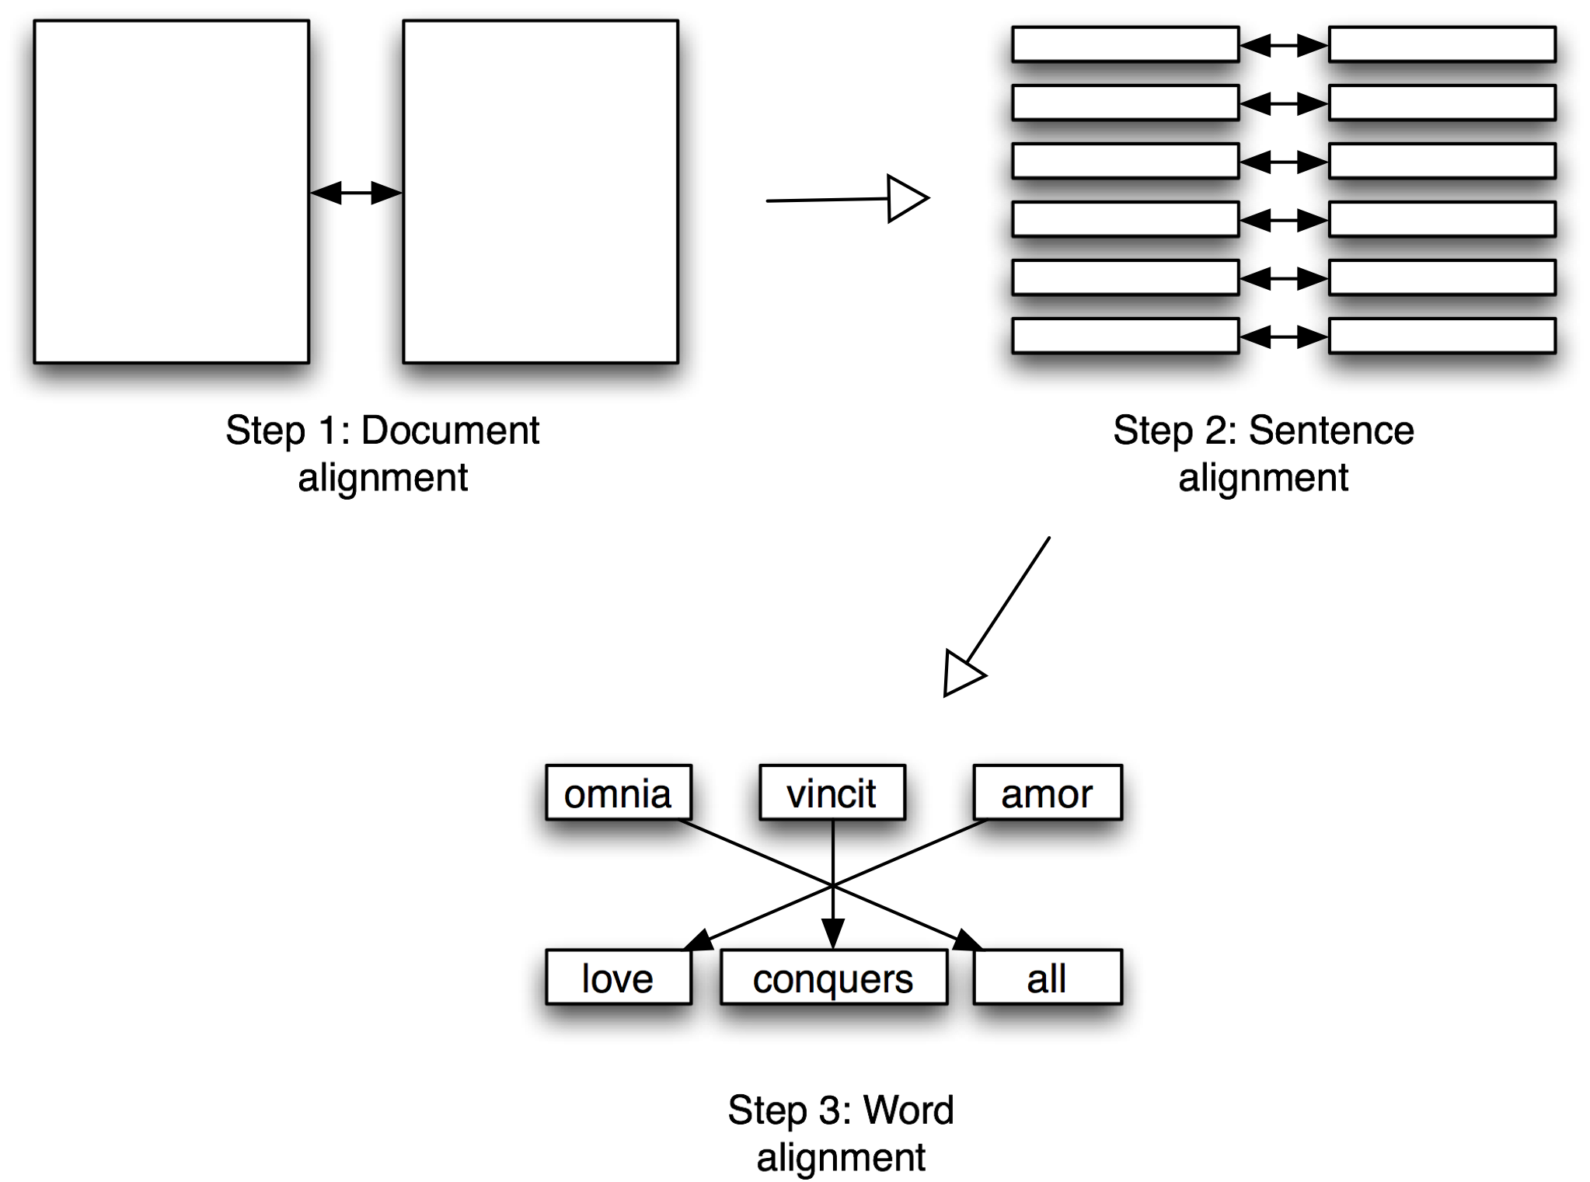
Figure 4: Alignment workflow.

The first step in this workflow produces an initial alignment at the chunk level due to the canonical citation scheme under which classical texts and their translations are universally encoded: “chapter 1, section 1” of Tacitus' Annales is, from the outset, automatically aligned with “chapter 1, section 1” in its English translation (step 1). In our fundamental alignment work on which our NEH-funded Dynamic Lexicon work is based, this initial coarse alignment results in aligned chunks of text that are on average 217 words long. We then align these on a sentence level (step 2) using Moore’s Bilingual Sentence Aligner (Moore 2002), which aligns sentences that are 1-1 translations of each other with a very high precision (98.5% for a corpus of 10,000 English-Hindi sentence pairs (Singh and Husain 2005)). This process aligns approximately 30% of the sentences (since most are not 1-1 translations), but we use those high-precision alignments as anchors for the many-to-many alignments that fall in between.

We then align all of these sentences – both the 1-1 aligned ones and the sentences in between – at the level of individual words (step 3) using MGIZA++ (Gao and Vogel 2008), a multi-threaded version of GIZA++ (Och and Ney 2003), an open-source implementation of the IBM alignment models (Brown et al. 1993). This produces the raw data shown in Figure 5.

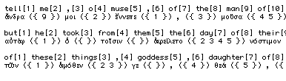
Figure 5: Raw alignment data for Homer's Odyssey.

Our work to date has focused on using these aligned translations to create bilingual dictionaries (and this illustrates one use of such an automatically annotated corpus), but we will focus in this project on using the aligned results as semantically disambiguating information for the original texts, and will publish the alignments themselves as part of the entire corpus.

Annotation Infrastructure

The efficient annotation of Latin and Ancient Greek is hindered by the fact that no native speakers exist and the texts that we have available are typically highly stylized in nature. To help this with problem, we have embedded our annotation environment within the Perseus Digital Library (PDL). Established in 1987 in order to construct a large, heterogeneous collection of textual and visual materials on the archaic and classical Greek world, Perseus today serves as a laboratory for digital library technologies and is also widely used by students, academics and others to access information on the Greco-Roman world (Crane 1987a, Crane 1987b, Crane 1998, Crane et al. 2006, Crane et al. forthcoming).

The scholarship that has attended historical texts since their writing has produced a wealth of contextual materials to help non-native speakers understand them, including commentaries, translations, and specialized lexica. The Perseus reading environment presents the Greek or Latin source text and contextualizes it with these secondary publications along with a morphological analysis of every word in the text and variant manuscript readings as well. Figure 6 presents a screenshot of the digital library with a syntactic annotation tool built into the interface. In the widget on the right, the source text in view (the first chunk of Tacitus’ Annales) has been automatically segmented into sentences; an annotator can click on any sentence to assign it a syntactic annotation. Here the user has clicked on the first sentence (Vrbem Romam a principio reges habuere); this action brings up an annotation screen in which a partial automatic parse is provided, along with the most likely morphological analysis for each word. The annotator can then correct this automatic output and move on to the next segmented sentence, with all of the contextual resources still in view.

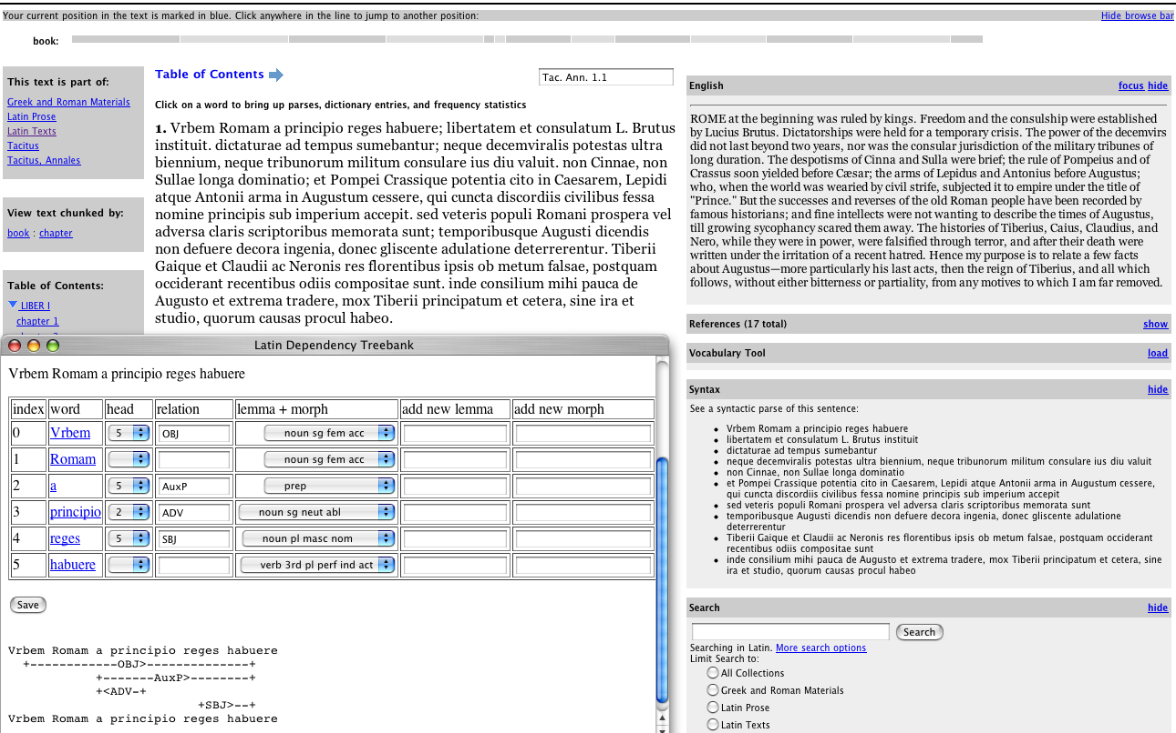
Figure 6: A screenshot of Tacitus’ Annales from the PDL.

Our collaboration with the Alpheios Project has also allowed us to integrate a graphical treebank editor into our annotation process to make the construction of trees more intuitive and to provide annotators with greater flexibility as to their preferred input method. Figure 7 shows a tree in the process of being constructed, with a single word (Romam) being dragged onto its syntactic head.

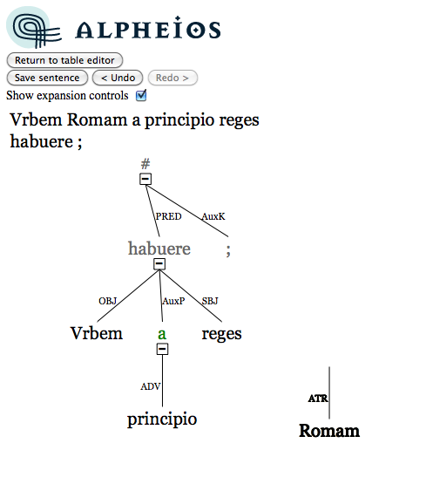
Figure 7: Alpheios graphical treebank editor

By embedding our annotation environment within this online infrastructure, we have been able to build a network of annotators who are distributed not only across the United States but across the world as well (our annotators are based not only at Tufts University, the University of California-Berkeley, the University of Pennsylvania, and many other institutions in between, but are also based in Hungary, the United Kingdom and Australia). Ongoing collaboration with several Classics professors has allowed us to introduce treebanking into classrooms at Tufts University, the University of Missouri-Kansas City, Furman University, The College of the Holy Cross, and the University of Nebraska-Lincoln. This established network of distributed collaborators will provide the source for annotators for this project.

General Plan of Work

We have four basic and largely parallel tasks to complete in order to transform the 5 million words of TEI P4 texts in the Perseus Digital Library and the remaining 20 million words of scanned, OCR’d and corrected texts from the Internet Archive (funded under a separate grant) into a fully annotated corpus:

1) Basic corpus formatting and structure (c. 10% of the requested support). (a) We need to harmonize multiple source documents. Even where we have TEI compliant documents from the same collection, some will use different TEI tags to describe the same phenomena: e.g., <name type=”pers”> vs. <persName> to label a person. (b) We need to convert texts from TEI version 4 to TEI version 5. This is not entirely mechanical. The new version of the TEI Guidelines includes new methods with which to represent named entities and other critical topics. We therefore need to think about how best to exploit such new features.
2) Adding alternate versions and English translations of source data (c. 15%). This primarily includes outsourced correction and formatting of OCR output in Greek and English, with some staff time for preparing and checking this work.
3) Automated analysis of the whole corpus (c. 15%): This includes sentence detection, adding identifiers for words, named entity classification and disambiguation, parallel text analysis with English translations, morphological disambiguation, syntactic analysis, and synthetic visualizations such as the Dynamic Lexicon (which uses parallel text and morphosyntactic analyses to generate lexical data). This also includes integrating third party open source knowledge sources (such as the New Testament Greek Treebank Data, the 200,000 words of morphologically disambiguated Greek Epic poetry etc.)
4) Manual analysis of the 1 million word sub-corpus (c. 60%): Existing projects have produced c. 350,000 words and have funding to produce morphosyntactic analyses for c. 600,000 words for Greek poetry and the Greek New Testament. Most of the support requested here will be focused on adding 400,000 words of additional coverage for Greek prose, with c. 50% of this (200,000 words) dedicated to texts central to the history of science.

Intellectual Merit

The work here integrates different threads of work, carried on at a number of institutions in Europe and North America over the course of more than twenty years. It does not simply transform the questions that we can pose to the study of Greek, but it also enables a new generation of work on linguistic topics over long periods of time. The 1 million word treebank at the heart of the corpus is not only a fundamental new instrument in its own right but also provides training data to enhance research on the other 24 million words. The corpus forms a reinforcing system of which the whole is more than the sum of its constituent parts and which can evolve over time. The corpus constitutes a core knowledge source in an emerging cyberinfrastructure that opens up new avenues of research in the study of historical linguistic data.

Broader Impact

The proposal itself demonstrates that corpus and computational linguistics have begun to expand and to exert an intellectual impact upon new communities. This work, if funded, will enhance the growing role of corpus and computational linguistics among an increasing number of those working with Greek linguistic data. It will also help foster similar development by those working not only in Latin but in other historical languages as well.

Results from Prior Work

#0736476 ($25,000ZZZ): Changing the Center of Gravity in Classical Studies: this led to the collected essays published at http://digitalhumanities.org/dhq/vol/3/1/index.html

#0616521 ($25,000ZZZ): Automatically Building a Latin Treebank. This project allowed us to evaluate the resources required to build a treebank of Latin.

#0205466 ($ZZZ): ITR: A Data Capture Framework and Testbed for Cultural Heritage Materials: A subcontract within this grant supported preliminary work on personalized vocabulary support.

#9817484 ($ZZZ): A Digital Library for the Humanities. This project allowed us to build non-classical testbeds and a broader digital library environment.

Selected Publications

Bamman, D. and G. Crane (2008), “Building a Dynamic Lexicon from a Digital Library, in: Proceedings of the 8th ACM/IEEE-CS Joint Conference on Digital Libraries, pp. 11-20.

Bamman, D. and G. Crane (2008b), “The Logic and Discovery of Textual Allusion,” in: Proceedings of the Second Workshop on Language Technology for Cultural Heritage Data (LaTeCH 2008).

Bamman, D., M. Passarotti and G. Crane (2008), “A Case Study in Treebank Collaboration and Comparison: Accusativus cum Infinitivo and Subordination in Latin,” Prague Bulletin of Mathematical Linguistics 90, pp. 109-122.

Bamman, D., M. Passarotti, G. Crane and S. Raynaud (2007), “Guidelines for the Syntactic Annotation of Latin Treebanks (Draft),” Whitepaper. http://dl.tufts.edu/view_pdf.jsp?urn=tufts:facpubs:dbamma01-2007.00002

Bamman, D. and G. Crane (2007), “The Latin Dependency Treebank in a Cultural Heritage Digital Library,” in: Proceedings of the Workshop on Language Technology for Cultural Heritage Data (LaTeCH 2007), pp. 33–40.

Bamman, D. and G. Crane (2006), “The Design and Use of a Latin Dependency Treebank,” in: Proceedings of the Fifth International Workshop on Treebanks and Linguistic Theories (TLT2006), pp. 67-78.

Crane, G., D. Bamman, L. Cerrato, A. Jones, D. M. Mimno, A. Packel, D. Sculley, G. Weaver (2006), “Beyond Digital Incunabula: Modeling the Next Generation of Digital Libraries,” in: Proceedings of the 10th European Conference on Research and Advanced Technology for Digital Libraries (ECDL 2006), pp. 353-366.

Crane, G., C. E. Wulfman, L. M. Cerrato, A. Mahoney, T. L. Milbank, D. Mimno, J. A. Rydberg-Cox, D. A. Smith, and C. York (2003), “Towards a Cultural Heritage Digital Library,” in: Proceedings of the 3rd ACM/IEEE-CS Joint Conference on Digital Libraries, pp. 75–86.

Note that some Greek linguistic sources have no available translation, while other sources have multiple translations. This includes an existing 5 million words in the Perseus Digital Library plus 7 million words from 54 volumes of English translations of Greek from the Bohn Classics Series and 200 public domain volumes of English translations from Greek in the Loeb Classical Library.
This figure is based on word counts for texts being produced before 300CE as listed in the Thesaurus Linguae Graecae’s Canon of Greek literature.
All data is publicly available at: http://nlp.perseus.tufts.edu/syntax/treebank/
The Latin and Ancient Greek forums can both be found here: http://treebank.alpheios.net/forum/

