360⁰ BALANCED
MASTERING YOUR S.E.L.F
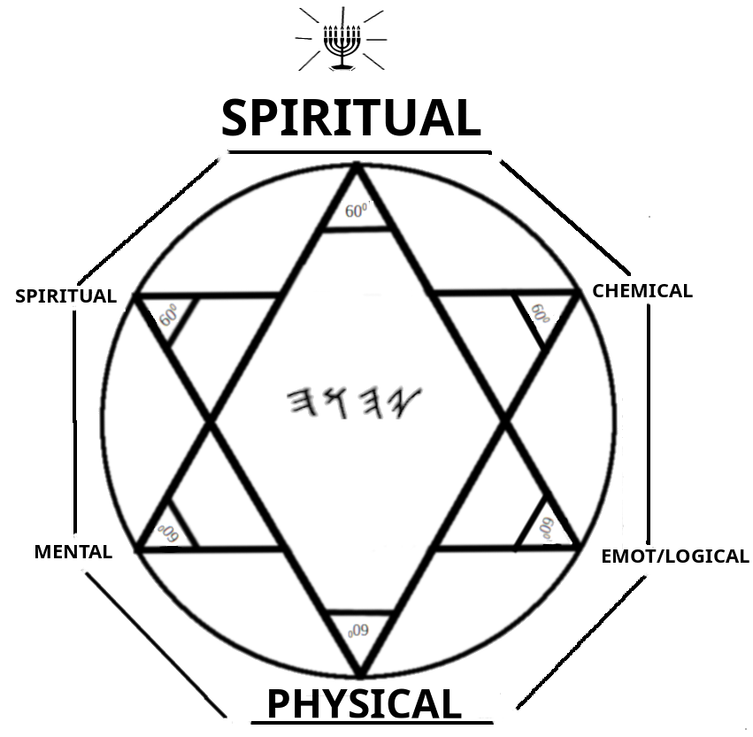
BY: JUS$AYN A.K.A YASHAYAHU LUY BAN YAHUTSADAQ

CONTENTS

PREFACE

DEDICATION

1. C.H.E.C.K. YOUR S.E.L.F. 1

2. THE NATURES AND THEIR COMPONENTS 4

3. THE COMPONENTS: THE LOWER NATURE 7

4. THE COMPONENTS: THE HIGHER NATURE 17

5. BODY, MIND, AND SPIRIT – THE BRIDGING OF THE NATURES 28

6. S.E.L.F. 36

7. FIND PERFECTION AND SEVEN YOURS.E.L.F. 42

8. THE NINE FRUITS OF THE RUWACH 52

A LETTER TO THE HEBREW NATION ( 2ND HEBREWS ) 57

PREFACE

TRUST IN (YAHUAH) WITH ALL YOUR HEART, AND LEAN NOT INTO YOUR OWN UNDERSTANDING; IN ALL YOUR WAYS ACKNOWLEDGE , AND SHALL DIRECT YOUR PATHS.
MIYSHLEY / PRO 3: 5-6

YASHAYAHU LUY BAN YAHUTSADAQ IS A SERVANT OF THE ONE CREATOR AL’ALYUN AL SHADDAY AND A STUDENT OF THE MASTER TEACHER YAHUSHA H’MASHYACH AND THE NAB’YM (THE PROPHETS). HE IS A NAZYRY HEBREW, OF THE TRIBE OF LUY, AND THOUGH HE IS NOT A PART OF ANY SPECIFIC CAMP OR SCHOOL OF THOUGHT, HE EMBRACES ALL OF THE NOW AWAKENED SONS AND DAUGHTERS OF YAAQUB AS ONE FAMILY IN THE LOVE OF .

THIS BOOK IS NOT ASSOCIATED IN ANYWAY WITH THE QABBALAH, THE KABBALAH OR ANY OTHER ‘RELIGIOUS’ WRITINGS OF THAT NATURE. THIS BOOK IS INTENDED FOR THE TRUE AND ORIGINAL HEBREW PEOPLE, WHO WERE PLACED ON SLAVE SHIPS AND SOLD ALL ACROSS THE EARTH AS SLAVES ( SEE DABARYM / DEUT. 28:64, 68 ), THEIR DESCENDANTS, ALSO, TO STRENGTHEN THEIR WALK OF LIFE AND ADD ENRICHMENT TO THEIR WELL BEING.

() THE ORIGINAL HEBRAIC SCRIPT IS PREFERRED TO THE
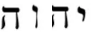
WHICH IS ARAMAIC / CHALD. ALSO, THE HEBRAIC NAME OF THE BOOKS OF SCRIPTURE WILL PRECEDE THE LATIN / GREEK / ENGLISH NAMES. AND YAHUSHA (OR YAHU’ASHA) ARE ANCIENT AND ACCEPTED PRONUNCIATIONS WITHIN THE HEBREW COMMUNITIES.

ALL DEFINITIONS FROM: NEW AMERICAN WEBSTER HANDY COLLEGE DICTIONARY...

DEDICATION

THIS BOOK IS DEDICATED TO AL ALYUN ( MOST HIGH AL ), WHOSE NAME IS RAK HA’ALAHA ( YHUH THE MIGHTY ONE ) AND TO YAHUASHA HA’NABY ( YAHUSHA THE PROPHET ) WHO TAUGHT US THE DYN OF RIGHTEOUSNESS TO BECOME SONS AND DAUGHTERS OF .
SHOTS OUT TO MY NAZYR BROTHERS IN BONDAGE WHO STUDIED THE WAY WITH ME. ELDON BLACK ( Y’BARAKYAHU ), GARRETT BOON ( YAZAK ), JOHN ANDREWS ( DARASH ), CHRISTOPHER “C.J.” ADAMS ( SH’MAYAHU ), ON MY KNOWLEDGE FREEDOM IS COMING. LOVE Y'ALL TO DEATH!
TO ALL THE RIGHTEOUS DISCIPLES WHO STAND ON THE CREATORS LOVE. I PRAY THAT YOU HAVE A GOOD LIFE, AND MAY YOUR FAMILIES, FRIENDS, AND WOMEN SHOW YOU THE LOYALTY THAT YOU DESERVE.
TO MY MOTHER AND FATHER WHO CREATED ME, THANK YOU FOR COMING TOGETHER AT THE PRECISE TIME TO GIVE ME SUBSTANCE. Y’ALL DON’T UNDERSTAND THAT YOU HAVE CREATED A WALKING BLESSING AND THE APPRECIATION I HAVE FOR YOU IS WILL RETURN SEVEN-FOLD.
TO LARRY VEASLEY; TOUGH LOVE MADE ME TOUGH AND SHOWED ME HOW TO SEEK FOR A WAY TO DO THE THINGS I NEEDED TO DO AS A MAN AND I THANK YOU DEARLY FOR THE LESSON.

REST IN BLESSING GLADYS KIRKLAND TILL RESURRECTION, AT THE LAST DAY.

CHAPTER 1: C.H.E.C.K. YOUR S.E.L.F.

SH’MA YASHAR’AL, AL’HAYNU, AYCHAD!
DABARYM / DEUT. 6:4 AND YAHUCHANAN MAQQABA / JN MARK 12:29.
SHALAM ALAYKHA MYSHPAKAH, MAY GIVE YOU INSIGHT AS YOU STUDY YOUR S.E.L.F. IN A WAY THAT YOU PROBABLY NEVER HAVE. NOW TO THE BUSINESS, ITS ABOUT TIME YOU C.H.E.C.K. YOUR S.E.L.F.! AS A MATTER OF FACT, IN EVERY THING THAT YOU DO YOU SHOULD ALWAYS BE IN C.H.E.C.K.. BEFORE YOU MAKE YOUR T’PHYLLUT^{H} ( PRAYERS ), BEFORE YOU EAT, BEFORE YOU RESPOND OR REACT, BEFORE YOU DEAL WITH OTHERS, BEFORE YOU MAKE A DECISION, BEFORE YOU SPEAK. MAKE SURE YOU ARE IN C.H.E.C.K.:


C.H.E.C.K.

CONSIDER

HARMONIZE
ELABORATE
CERTIFY

KNOW

CON-SID’ER v.t. 1.PONDER; STUDY 2. TO MAKE ALLOWANCE FOR 3. HOLD IN ESTEEM 4. BELIEVE; JUDGE. - v.i. REFLECT; MEDIATE.
WE SHOULD ALWAYS MEDITATE ON THE EVENTS OF OUR LIVES. WHEN WE USE OUR HINDSIGHT WE ALWAYS MANAGE TO THINK, “DAMN I SHOULD’VE THOUGHT THAT THROUGH, “OR,” IF I WOULD’VE…” I LIKE THE SAYING-HASTE MAKES WASTE- AS IT APPLIES TO MAKING RASH DECISIONS. THE MANY TIMES I’VE BEEN IN TROUBLE COULD’VE BEEN AVOIDED IF I WOULD’VE MEDITATED FIRST.

1

I’VE LEARNED TO SLOW DOWN AND THINK ABOUT WHAT LIFE PRESENTS BEFORE I GO IN HEADFIRST. “A PRUDENT MAN FORESEES EVIL AND HIDES HIMSELF, BUT THE SIMPLE PASS ON AND ARE PUNISHED.”
MASHALY / PRO 22: 3.

HAR’MO-NIZE” v.t. 1. BRING TO ACCORD OR AGREEMENT.

AFTER MEDITATING OR CONSIDERING THE EVENT, IF YOU DECIDE TO GO FORWARD, YOU SHOULD QUESTION IF WHETHER THE EVENT HARMONIZES WITH YOUR LIFE. AS HEBREWS, WE SHOULD DO EVERYTHING IN HARMONY WITH THE TURAH AND NABY’YM. DOES THIS EVENT AGREE WITH MY WALK? THIS IS LIKE THE SAFETY ON A FIREARM. I’VE CONSIDERED THE EVENT NOW I WANT TO MAKE SURE IT IS ON ACCORD WITH .

E-LAB’O-RATE adj. 1. WORKED OUT WITH GREAT CARE OR EXACTNESS 2. INTRICATE;

INVOLVED – v.i. & I. WORK OUT WITH PRECISION, IN FULL DETAIL: ADD DETAIL.

THIS IS WHERE YOU APPLY THE FORMULA 5 W+H; WHO, WHAT, WHEN, WHERE, WHY, AND HOW. YOU WANT TO GET ALL OF THE INFORMATION ABOUT THE EVENT SO YOU CAN MAKE YOUR CHOICE. THE RESEARCH IS HAPPENING NOW. EVEN THOUGH THE EVENT HARMONIZES WITH YOUR WALK YOU STILL WANT TO HAVE ALL THE FACTS. SOME SITUATIONS WILL STILL CAUSE YOU TO DECLINE AN EVENT EVEN IF NO WICKEDNESS IS INVOLVED. HERE YOU AT LEAST HAVE AN OPPORTUNITY TO MAKE AN INFORMED DECISION. YOUR GOAL IS TO LEARN TO STOP MAKING THOSE LAST MINUTE DECISIONS WHERE YOU END UP INSIDE-OUT AND UPSIDE-DOWN.

2

CER’TI-FY v.t. 1. ATTEST TO THE TRUTH, THE VALIDITY OF.

SO FAR YOU’VE CONSIDERED THE EVENT. YOU’VE MEDITATED ON IT FOR A COUPLE SECONDS. THEN YOU’VE CHECKED TO SEE IF THE EVENT HARMONIZES WITH YOUR WALK. NEXT YOU GATHERED ADDITIONAL INFORMATION BY ASKING SPECIFIC WHO, WHAT, WHEN, WHERE, WHY, AND HOW QUESTIONS. NOW YOU’LL WANT TO VERIFY WHAT YOU’VE LEARNED FROM ANOTHER SOURCE. IF I WAS HUNGRY FIRST I WOULD CONSIDER WHAT I WANT. THEN I WOULD SEE IF THE FOOD DOES OR DOES NOT HARMONIZE WITH THE DIETARY LAW. NEXT I WOULD SEARCH FOR KOSHER SYMBOLS AND READ THE INGREDIENTS. IF I’M STILL NOT CLEAR I’M GOING TO CALL THE 1-800-NUMBER AND CLARIFY THE INGREDIENTS. NOW THAT I FOUND OUT ALL THAT I NEED, I KNOW THAT FROM NOW ON I CAN ENJOY THE FOOD PRODUCT. WHICH BRINGS US TO OUR LAST LETTER.

KNOW v.t. 1.PERCEIVE AS FACT OR TRUTH 2. HAVE INFORMATION OF; BE ACQUAINTED WITH 3. RECOGNIZE OR DISTINGUISH IN COMPARISON. - v.t. 1. HAVE KNOWLEDGE OR INFORMATION 2. HAVE INSIGHT OR PERCEPTION.

AGAIN; I CONSIDER THE EVENT, ASK MYSELF DOES IT HARMONIZE WITH MY WALK, ELABORATE ON IT BY USING FORMULA 5W+H, CERTIFY WHAT I’VE LEARNED USING DIFFERENT SOURCES, AND KNOW THAT I’VE MADE THE PROPER DECISION.
CONSIDER-HARMONIZE-ELABORATE-CERTIFY-KNOW. C.H.E.C.K.!
BY C.H.E.C.K.ING MY S.E.L.F. I’VE HAD MUCH BETTER RESULTS AND I’VE BECOME STRONGER IN MY WALK WITH AL’ SHADDAY. DO IT FOR YOURS.E.L.F. AND SEE IF YOU CAN AVOID TROUBLESOME SITUATIONS.
“...BUT THE ESTEEM OF SOVEREIGNS IS TO SEARCH OUT A MATTER!”
MASHALY / PRO 25: 2^{B}

3

CHAPTER 2: THE NATURES AND THEIR COMPONENTS

WE AS MANKIND ARE MADE UP OF 2 NATURES, THE HIGHER AND LOWER NATURES. THE HIGHER NATURE CONSISTS OF THE INTERNAL, INVISIBLE, ASCENDING COMPONENTS. THE THINGS THAT CANNOT BE DESTROYED BY THE ELEMENTS:
60⁰
SPIRITUAL
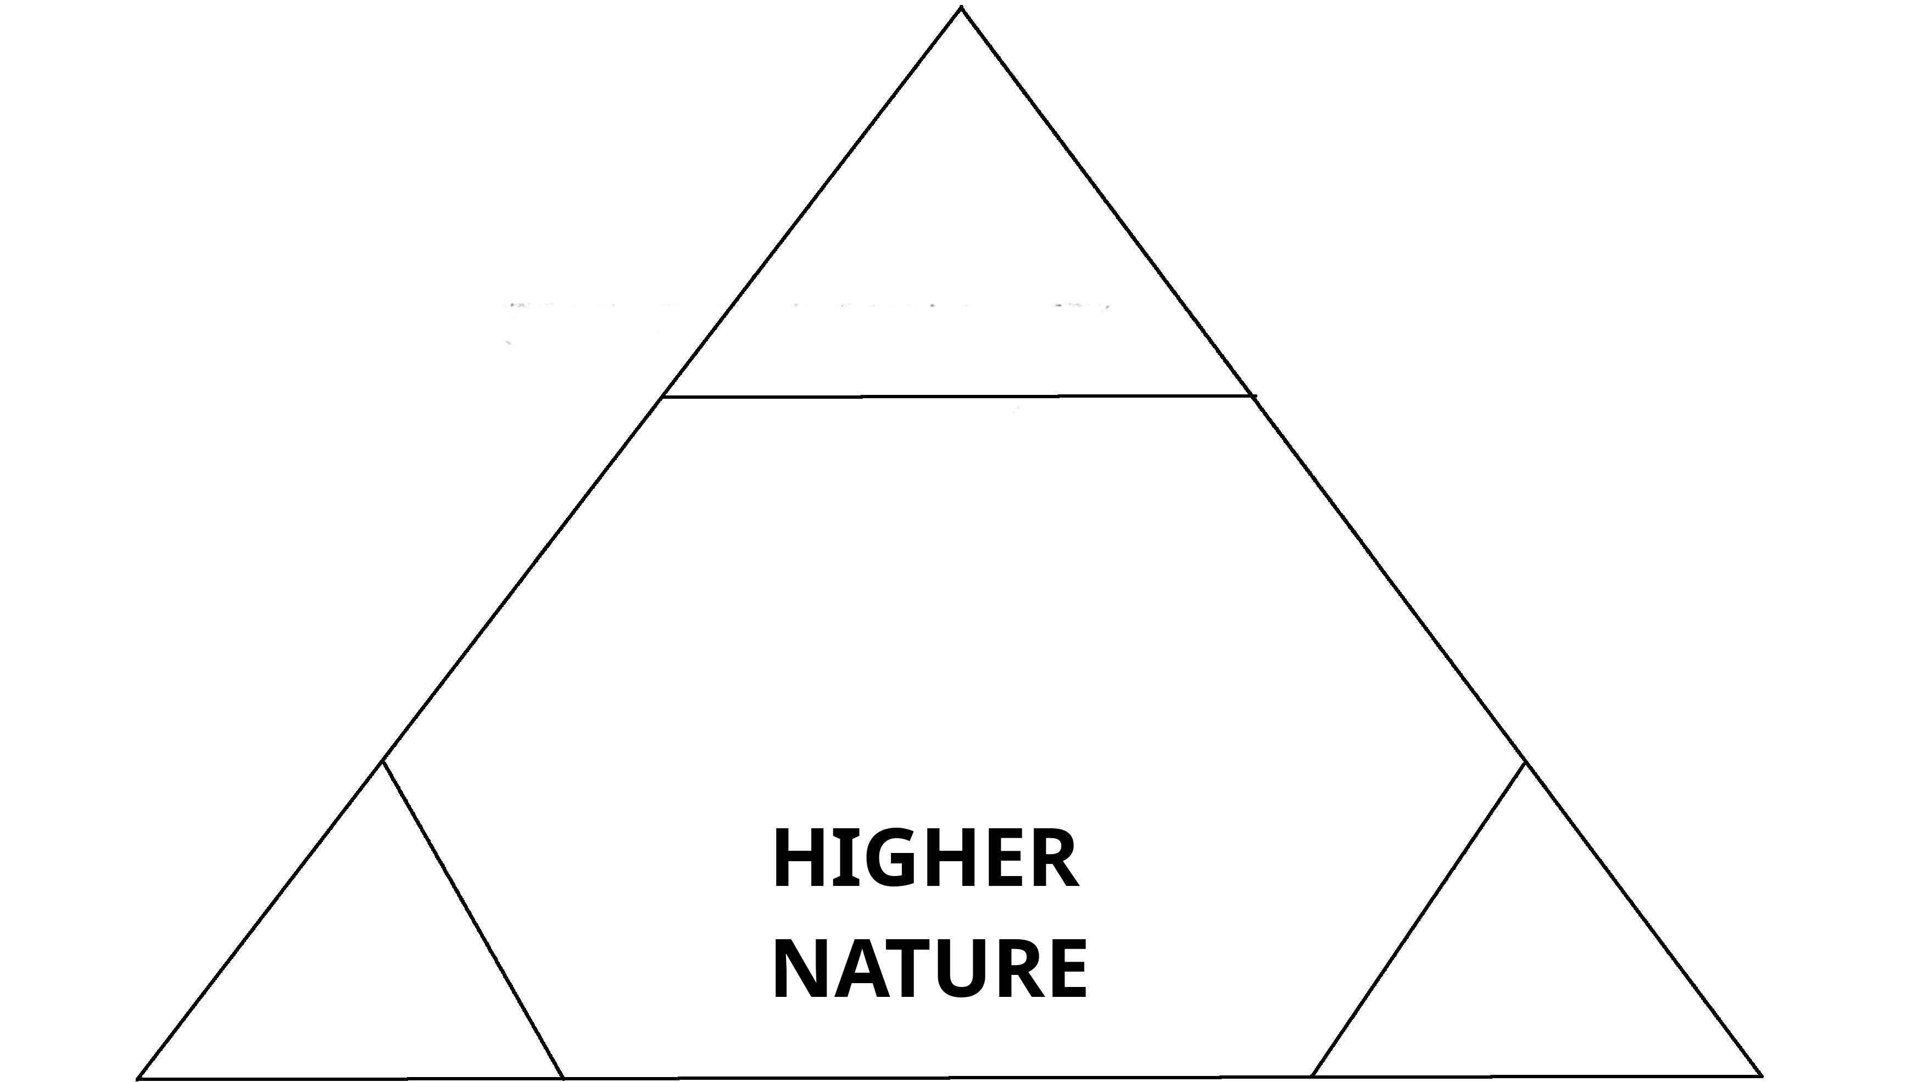
60⁰ 60⁰
MENTAL EMOTIONAL/LOGICAL

THESE ARE COMPONENTS THAT CORRESPOND WITH THE CREATOR AND CANNOT BE INTERFERED WITH BY LOWER NATURE UNLESS YOU ALLOW THEM TO. MORE ON THIS LATER.
SPIRITUAL ( HEAD ) DIRECT CONNECTION TO THE CREATOR. THIS SHOULD BE THE MOST IMPORTANT COMPONENT WHEN SEEKING BALANCE. SPIRITUAL IS DEFINED AS – SPIR’IT-U-AL adj. 1. PERTAINING TO THE SOUL OR SPIRIT. 2. RELATING TO SACRED THINGS.
MENTAL (RIGHT FOOT) FOUNDATION DEALING WITH WHAT YOU THINK; AN INFORMED OR MISINFORMED WAY OF PROCESSING KNOWLEDGE. MENTAL IS DEFINED AS – MEN’TAL adj. PERT. TO, OR PERFORMED BY THE MIND OR INTELLECT.
EMOTIONAL( FEM )/LOGICAL( MASC ) ( LEFT FOOT ) FOUNDATION DEALING WITH HOW YOU THINK, A FEMININE OR MASCULINE WAY OF INTERPRETING KNOWLEDGE. EMOTIONAL IS DEFINED AS – E-MO’TION-AL adj. 1. PERT. TO OR AFFECTING FEELING, SENTIMENT, ATTITUDE OVER COGNITION OR VOLITION. LOGICAL IS DEFINED AS – LOG’I-CAL adj. REASONABLE; PERSUASIVE; TO BE EXPECTED.

4

THE LOWER NATURE CONSIST OF THE EXTERNAL, VISIBLE, DESCENDING COMPONENTS. THE THINGS THAT CAN BE DESTROYED BY THE ELEMENT:

60⁰ 60⁰
SOCIAL CHEMICAL
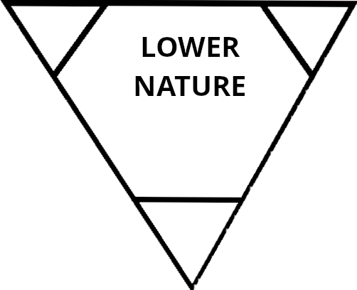

60⁰
PHYSICAL
THESE ARE THE COMPONENTS THAT CORRESPOND WITH THE WORLD AND CAN BE INFLUENCED BY THE HIGHER NATURES WHEN BALANCING ONES SELF. PHYSICAL (PENIS/VAGINA) THIS IS THE MOST DANGEROUS OF THESE COMPONENTS BECAUSE CONNECTS WITH THE WANTS/DESIRES OF THE WORLD. THIS IS NOT EXCLUSIVELY ABOUT SEXUAL DESIRES, BUT ALL WORLDLY DESIRES THAT CAN BRING YOU TO RUIN. PHYSICAL IS DEFINED AS – PHYS’I-CAL adj. 1. PERT. TO THE BODY. 2. PERT. TO NATURE OR TO THE MATERIAL.

SOCIAL ( RIGHT HAND ) THE BALANCE THAT DEALS WITH ALL INTERACTIONS THAT ARE OUTSIDE THE BODY. ASSOCIATED WITH HUMAN RELATIONS. SOCIAL IS DEFINED AS – SO’CIAL adj. 1. PERT. TO COMMUNAL ACTIVITIES; GREGARIOUS; FRIENDLY. 2. PERT. TO OR TENDING TO ADVANCE HUMAN SOCIETY.

CHEMICAL ( LEFT HAND ) THE BALANCE THAT DEALS WITH ALL THINGS INGESTED IN THE BODY. ASSOCIATED WITH THE INTAKE OF FOOD, DRINK, MEDICINE, DRUGS. CHEMICAL IS DEFINED AS – CHEM’I-CAL adj. PERT. TO CHEMISTRY. -n. A SUBSTANCE PRODUCED BY OR USED IN A CHEMICAL PROCESS.

5

THE NATURES CAN BE BALANCED BY MASTERING EACH COMPONENT. A MAN / WOMAN CAN ALSO BE ENSLAVED BY A COMPONENT AS WELL.
LOOK AT ALL OF TH COMPONENTS TOGETHER SO YOU CAN MAP OUT THE BODY AND THE NATURES:
360⁰
HIGHER NATURE ( 180⁰ )
SPIRITUAL
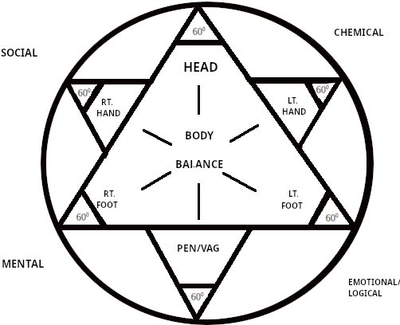

PHYSICAL

LOWER NATURE ( 180⁰ )
NOTICE HOW MENTAL + EMO/LOGICAL ARE THE FOUNDATION OF SPIRITUAL AND SOCIAL CHEMICAL BALANCE OUT OF PHYSICAL. WE WILL EXPLORE DEEPER CONCEPTS A BIT LATER ON HOW THE NATURES CAN AFFECT EACH OTHER BY “BRIDGING,” AND THE FOUNDATION AND BALANCE OF THE NATURES. FOR NOW WE WILL DELVE IN TO THE COMPONENTS INDIVIDUALLY AND APPLY SCRIPTURAL PRECEPTS TO GAIN GREATER OVER-STANDING ON THE PATH TO MASTERING YOUR SELF. WE CAN “SEVEN” OUR SELF, OR BECOME PERFECT, BY MASTERING OUR NATURES.

6

CHAPTER 3: THE COMPONENTS: THE LOWER NATURE

PHYSICAL - PENIS/VAGINA – 60⁰

BARASHYT^{H} / GEN 1: 27 – SO AL’HYM CREATED ADAM IN HIS OWN IMAGE; IN THE IMAGE OF AL’HYM HE CREATED HIM; MALE AND FEMALE HE CREATED THEM.

BARASHYT^{H} / GEN 2: 7^{A} – AND AL’HYM FORMED ADAM OF THE DUST OF THE GROUND…

QURAN’TY’YM / 1 COR 6: 20^{A} - FOR YOU WERE BOUGHT WITH A PRICE; THEREFORE ESTEEM AL’HYM IN YOUR BODY…

OF ALL WARM BLOODED CREATURES, MANKIND DESTROYS HIMSELF ABOVE ALL. HAVE YOU EVER SEEN ANIMALS DESTROY THEMSELVES OF THEIR OWN FREEWILL? WE AS PEOPLE TEND TO DESECRATE WHAT (YAHUAH) HAS GIVEN US AS A VEHICLE TO DO HIS WILL. NOW IS THE TIME TO BREAK THAT CYCLE AND LEARN TO MASTER THE PHYSICAL COMPONENT OF THE LOWER NATURE.
THE PHYSICAL COMPONENT IS THE FLESHLY/WORLDLY ASPECT TO OUR-SELF THAT CONTRASTS WITH THE SPIRITUAL. SHA’UL/PAUL SPEAKS ON THIS AS: “FOR THOSE WHO LIVE ACCORDING TO THE FLESH SET THEIR MINDS ON THE THINGS OF THE FLESH...FOR TO BE CARNALLY MINDED IS DEATH...BECAUSE THE CARNAL MIND IS ENMITY AL’HYM; FOR IT IS NOT SUBJECT TO THE TURAH OF , NOR INDEED CAN BE.” RUMY’YM / ROM 8:5^{A},6^{A},⁷.
APPARENTLY, THIS COMPONENT ON ITS OWN WOULD BRING US THAT DEATH SPOKEN OF BY SHA’UL. WHY? BECAUSE THIS COMPONENT RESPONDS TO THE 5 SENSES; SEE, HEAR, TASTE, TOUCH, SMELL. NOTICE THAT THE HEAD IS THE ONLY PART OF THE BODY THAT CAN ACCOMPLISH ALL 5 SENSES. THAT IS WHY THE PHYSICAL COMPONENT IS THE MOST DANGEROUS, BECAUSE THE PLACE WHERE THE 5 SENSES DWELL IS ALSO THE SEAT OF THE SPIRITUAL COMPONENT OF THE HIGHER NATURE. CAN YOU PICTURE CONFLICT?
RECALL THE, “YOU LET THE LITTLE HEAD CONTROL THE BIG HEAD.” WHEN PHYSICAL IS STIMULATED, IT TAKES ALL 3 COMPONENTS OF THE HIGHER NATURE TO REASON WITH THE PHYSICAL.

7

THE PHYSICAL CAN OVERWHELM THE HIGHER NATURE BY RESPONDING TO MULTIPLE SENSES, FOR INSTANCE; [YOU SEE A MEMBER OF THE OTHER SEX HEADING IN YOUR DIRECTION, THIS IS A VERY ATTRACTIVE PERSON TO YOU. AS THEY ADVANCE, THEY SAY ‘HELLO’, WITH A SOFT SEDUCTIVE VOICE. AS THEY GENTLY PASS, THEY ARE WEARING YOUR FAVORITE FRAGRANCE. AT PASSING THEY GENTLY TOUCH YOUR HAND.] SEEING, HEARING, SMELLING, AND TOUCHING KICK START BACK TO BACK. LEAVING THE PHYSICAL TO ITS OWN DEVICES WOULD SURELY LEAD YOU INTO YOUR FLESHLY DESIRES. NOW, HAVING THESE FLESHLY DESIRES IS NOT WICKEDNESS IN ITSELF, BUT UNCHECKED CAN LEAD TO MANY WOES. AS WE STAND ON THE DIN WE KNOW NOT TO COMMIT ADULTERY BY ASSOCIATING WITH OFF LIMITS INDIVIDUALS. FOR EXAMPLE:
AS A MAN CHOOSES HIS WIVES, OR WIFE (FOR THOSE MONOGAMOUS), HE KNOWS NOT TO CHOOSE A MARRIED WOMAN, JUST AS A MARRIED WOMAN KNOWS TO HAVE NO OTHER THAN HER HUSBAND. THERE ARE MANY EXAMPLES OF HOW TO PROPERLY TEND THE BODY IN THE SCRIPTURES. TO MASTER THE PHYSICAL COMPONENT ASK YOURSELF THESE OR SIMILAR QUESTIONS BEFORE YOU ACT ON AN URGE:

* WILL THIS BE SERVICE TO OR SERVICE TO THE FLESH?
* WILL THIS ACT CAUSE ME TO BE DEFILED BEFORE (YAHUAH) ?
* WILL THIS ACT CAUSE SOMEONE ELSE TO BE DEFILED?
* AS THE H’YKAL/TEMPLE OF , WILL THIS OFFEND HIS SHEKINAH?
* IS THIS ACCORDING TO HIS DYN?
* IS THIS ACT RIGHTEOUS OR WICKED?
* IS THIS AWAY THAT COULD SERVE OR HEYKEL WITH MY BODY?

THERE IS NOTHING WRONG WITH MAKING A CHECKLIST TO TAKE CAUTION IN ANY ACTION THAT YOU PLAN TO PARTICIPATE IN. REMEMBER, THIS IS NOT JUST ABOUT SEXUAL DESIRES, BUT ANY PHYSICAL DESIRE THAT YOUR BODY COULD BE SUBJECT TO. ITS LIKE THE SONG SAYS.”YOU BETTER CHECK YA’SELF, BEFORE YOU WRECK YA’SELF!” KEEP A CHECKLIST HANDY AND USE IT. YOU ARE MASTER OF THE PHYSICAL. THE BODY IS PROPERTY OF (YAHUAH) AND IF YOU USE IT TO DO HIS WILL WHEN YOU ARE USING IT CORRECTLY. IF YOU MAKE THE CREATORS DESIRES YOUR DESIRES, THEN WHERE CAN YOU GO WRONG? IT REALLY IS YOU AGAINST THE WORLD. -
“DO NOT LOVE THE WORLD OR THE THINGS IN THE WORLD, IF ANYONE LOVES THE WORLD THE LOVE OF THE FATHER IS NOT IN HIM.”
YAHUCHANAN / 1 JOHN 2: 15.

8

SOCIAL – RIGHT HAND – 60⁰

QUHALATH / ECC. 10: 2 – A WISE-MAN'S HEART IS AT HIS RIGHT HAND…

QARANTY’YM / I COR 5: 11 – BUT NOW I HAVE WRITTEN TO YOU NOT TO KEEP COMPANY WITH ANYONE NAMED A BROTHER, WHO IS SEXUALLY IMMORAL, OR COVETOUS, OR AN IDOLATER, OR A REVILER, OR A DRUNKARD, OR AN EXTORTIONER- NOT EVEN TO EAT WITH SUCH A PERSON.

APHASY’YM / EPH 5: 6-7 – LET NO ONE DECEIVE YOU WITH EMPTY WORDS, FOR BECAUSE OF THESE THINGS THE WRATH OF AL’HYM COMES UPON THE SONS OF DISOBEDIENCE. THEREFORE DO NOT BECOME PARTAKERS WITH THEM.
DO YOU EVER RECALL THE STATEMENTS: “GUILTY BY ASSOCIATION!” OR “BIRDS OF A FEATHER FLOCK TOGETHER!”? THESE STATEMENTS, EVEN THOUGH BASED ON PERCEPTION ARE SOMEWHAT TRUTHFUL. THE SOCIAL COMPONENTS IS VERY CLOSE TO THE SPIRITUAL COMPONENT IN THE WAY OF PROCLAIMING THE TRUTH OR PREACHING THE LIE. IF AN ASSOCIATE PREACHES A LIE TO YOU, AND YOU EAT THAT FRUIT OF LIES, YOUR SPIRITUAL HEALTH IS IN JEOPARDY JUST LIKE ADAN AND CHUAH, IN ADIN, WHEN DEALING WITH THE SERPENT.

...THE WOMAN SAID, “THE SERPENT DECEIVED ME, AND I ATE.” -
BARASHYT^{H} / GEN 3: 13.

WHAT WAS THE FRUIT THAT THEY ATE?
...YOU HAVE REAPED INIQUITY. YOU HAVE EATEN THE FRUIT OF LIES…”
HUSHA / HOS 10: 13.

THE SOCIAL COMPONENT IS SURROUNDED BY THE MENTAL AND SPIRITUAL FOR THE SAME REASON THAT YOU SHOULD USE SPIRITUAL DISCERNMENT AND SOUND MENTAL JUDGMENT IN YOUR INTERACTIONS WITH OTHERS.

9

THERE ARE 4 ASPECTS OF SOCIAL COMPONENT: RACE, LASS, SEX, RELIGION/BELIEF. MANY PEOPLE USE THE GUIDELINES WHEN SETTING UP THEIR SOCIAL CIRCLES.

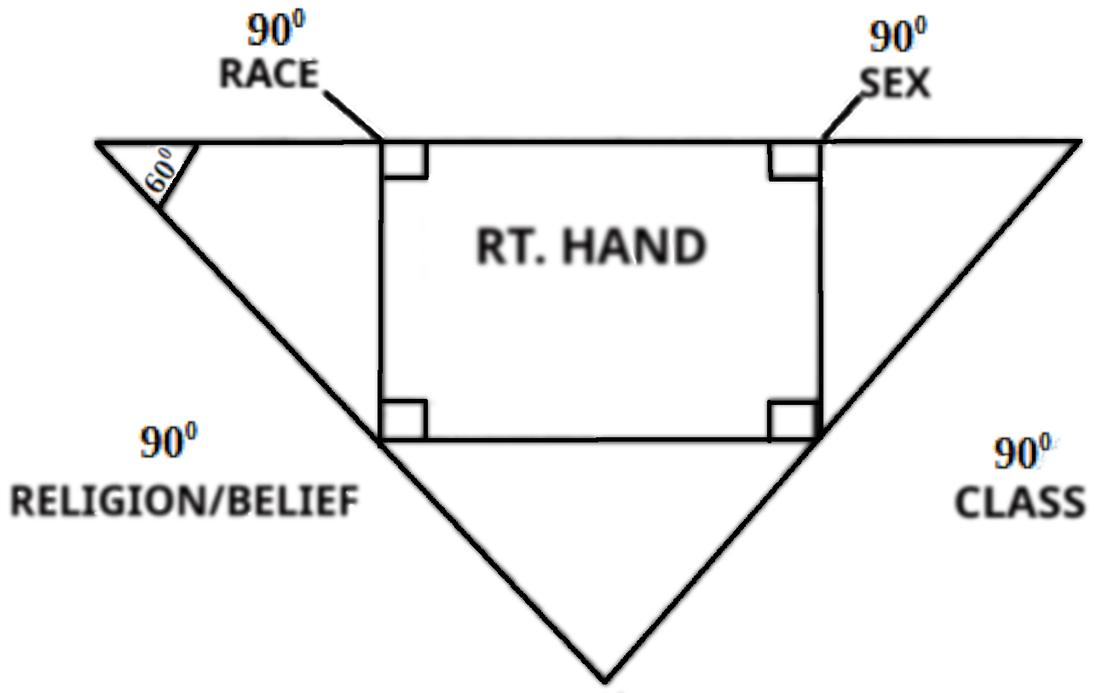

RACE n. 3. AN ETHICAL, TRIBAL, OR NATIONAL STOCK.

CLASS n. 1. ORDER OR RANK, ESP. OF PERSONS; CASTE. 3. A GROUP OF PERSONS WITH A COMMON INTEREST.

SEX n. 2. EITHER MALES OR FEMALES, CONSIDERED COLLECTIVELY.

RE-LI’GION n. 1. A SYSTEM OF FAITH IN AND WORSHIP OF A DEITY. RE-LIEF n. 1. THE ACT OF BELIEVING ; FAITH. 2. AN ACCEPTED OPINION.
I TEND TO BE VERY ACCEPTING OF ANY INDIVIDUAL THAT IS BALANCED. MY REGULAR SOCIAL CIRCLE THOUGH IS: HEBREW, MALE OR FEMALE, POOR TO WEALTHY, YISRAELITE. EVEN THOUGH I CAN SOCIALIZE WITH THIS CIRCLE, I STILL MUST MAKE SURE THESE INDIVIDUALS ARE ON THE PATH TO BALANCING OR SEVENING THEMSELVES. I CAN’T JUST EXPECT A PERSON TO BE RIGHTEOUS, EVEN HEBREWS. “...FOR THEY ARE NOT ALL Y’SHAR’AL WHO ARE OF Y’SHAR’AL” RUMY’YM / ROM 9: 6.
10

SOCIALIZING WITH THE WRONG ONES CAN AFFECT YOU IN MANY WAYS. YOUR WHOLE SCHEDULE CAN CHANGE BY PEER PRESSURE, WHICH IS DEFINED AS –
PEER PRES’SURE n. 1. INFLUENCE EXERTED UPON ONE BY OTHERS OF THE SAME AGE, SOCIAL GROUP, ETC.
THESE ASSOCIATES CAN INFLUENCE ONE TO; GET DRUNK, DO DRUGS, HAVE A FLING, VIOLATE THE DIN, ETC. ‘TRY THIS’ OR ‘DO THAT,’ ARE SIMPLE SUGGESTIONS WHICH IS REALLY JUST GENTLE PRESSURE. ALWAYS LOOK AT WHO YOU ARE AND DECIDE IF YOUR SOCIAL GROUP IS REALLY THE RIGHT GROUP FOR YOU. SHA’UWL SPOKE THIS:

“BEWARE LEST ANYONE CHEAT YOU THROUGH PHILOSOPHY AND EMPTY DECEIT, ACCORDING TO THE TRADITIONS OF MEN, ACCORDING TO THE BASIC BASIC PRINCIPLES OF THE WORLD, AND NOT ACCORDING TO MASHYACH.”
QULASY’YM / COL 2: 8.

ASK YOURSELF THESE OR SIMILAR QUESTIONS:
* DO MY PEERS ACCEPT ME AS “I AM”?
* COULD I ASSOCIATE WITH THIS/THESE PEER(S) ACCORDING TO MY BELIEF?
* ARE THESE PEERS THAT I COULD INVITE INTO MY DWELLING PLACE?
* DO THEY RESPECT THE LAWS OF ?
* CAN I TRUST THEM AROUND MY FAMILY?

MASTERING THE SOCIAL COMPONENT SOMETIMES TAKES FILTERING OUT FAMILY AND SO-CALLED FRIENDS BUT IN THE END IT IS WORTH IT TO BE RID OF THE NEGATIVE INFLUENCES IN YOUR LIFE.

11

CHEMICAL – LEFT HAND – 60⁰

MASHALY / PROV 4: 14^{A} , 17 – DO NOT ENTER THE PATH OF THE WICKED… FOR THEY EAT THE BREAD OF WICKEDNESS, AND DRINK THE WINE OF VIOLENCE.
UY’QARA / LEV 11: 46 – 47 – THIS IS THE TURAH OF THE ANIMALS AND THE BIRDS AND EVERY LIVING CREATURE THAT MOVES ON THE EARTH, TO DISTINGUISH BETWEEN UNCLEAN AND THE CLEAN, AND BETWEEN THE ANIMAL THAT MAY BE EATEN AND THE ANIMAL THAT MAY NOT BE EATEN.
DABARYM / DEUT 14: 3 – YOU SHALL NOT EAT ANY DETESTABLE THING.
HAVE YOU EVER HEARD THE SAYING, “YOU ARE WHAT YOU EAT.” EVERYTHING THAT YOU PUT IN YOUR BODY IS BROKEN DOWN BY THE DIGESTIVE SYSTEM AND ABSORBED INTO THE BLOODSTREAM AND DISTRIBUTED THROUGHOUT THE BODY. WE ARE EVERYTHING THAT WE EAT/CONSUME. THIS MEANS THAT WE SHOULD BE CAUTIOUS WITH WHAT WE EAT. SOME ITEMS CAN MAKE YOU SICK OR EVEN KILL YOU. YOU WOULDN’T EAT SOMETHING LABELED “TOXIC” OR “POISON” WOULD YOU? JUST THE SAME WAY YOU WOULD TAKE HEED TO MANS’ WARNING LABELS, YOU SHOULD DOUBLY HEED THE WARNING THAT THE CREATOR HAS GIVEN YOU.

BUT YOU SHALL NOT EAT FLESH WITH ITS LIFE, THAT IS, IT’S BLOOD.
BARASHYTH / GEN 9: 4.

MANY WILL STILL EAT RARE MEATS AND BLOOD SAUSAGES EVEN THOUGH
GAVE THIS EDICT TO ALL MANKIND. THIS IS JUST A SMALL EXAMPLE OF HOW ONE CAB BE OFF-BALANCED BY THE CHEMICAL COMPONENT.

12

WE CONSUME FOODSTUFFS, LIQUIDS, MEDICINAL/SUPPLEMENTS, AND TOXIN/POISONS. SOME PREFER TO IGNORE THEIR OWN BODILY RESPONSES TO GRATIFY THEMSELVES.
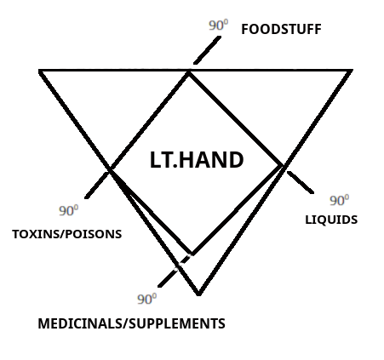

THE CHEMICAL COMPONENT WEIGHS HEAVILY ON BOTH THE SPIRITUAL AND PHYSICAL. THERE ARE CERTAIN HARMFUL DRUGS THAT ARE INGESTED TO COMMUNICATE
WITH DEMONS. OTHER DRUGS LIKE METHAMPHETAMINE'S OR CRACK COCAINE CAN REDUCE THE BODY TO AN EMACIATED STATE. SOME SUBSTANCES CAN KILL YOU IN AN INSTANT LIKE POISON FROM THE WHITE OLEANDER. IN ESSENCE, THE CHEMICAL COMPONENT CAN AFFECT ALL OF THE OTHER COMPONENTS. SOME CHEMICALS CAN; AFFECT THE MIND, CAUSE DEPRESSION, DAMAGE THE BODY, AFFECT RELATIONSHIPS, CONJURE OR INVITE SPIRITS/DEMONS.

TOO MUCH ALCOHOL CAN IMPAIR JUDGMENT AND MOTOR-SKILLS CAUSING POSSIBLE HARM TO YOURSELF OR OTHERS. SOME FOODS CAUSE YOU TO BE UNCLEAN. TOO MUCH OF A PROPER THING SUCH AS VITAMIN C CAN MAKE YOU SICK. YOU HAVE TO MONITOR NOT ONLY CONSUMING THE ACCEPTABLE THINGS, BUT THE AMOUNT AS WELL. CHEMICAL COMPONENT IS LIKE A BALANCE WITHIN A BALANCE.

13

MAINTAINING A PROPER DIET, MONITORING YOUR USE OF NATURAL MEDICINES/SUPPLEMENTS, AND AVOIDING POISONS/TOXINS AND OTHER DETESTABLE THINGS IS THE APPROVED METHOD FOR BALANCE. PERSONALLY, I DO MY BEST TO AVOID ARTIFICIAL INGREDIENTS, ADDITIVES, AND PRESERVATIVES WHEN CHOOSING WHAT I CONSUME. I SUGGEST PURCHASING YOUR MEATS FROM A GOOD BUTCHER, GROW OR BY VEGETABLES FRESH FROM A FARM MARKET, PREPARE MEALS FROM SCRATCH, AVOID MICROWAVES. MY SUGGESTION MEANS NOTHING.
ALSO RESEARCH RECIPE WEBSITES FOR HELP WHEN CONVERTING FROM A BOX OR CAN EATER TO A NATURAL EATER. TO MASTER THE CHEMICAL COMPONENT ASK YOURSELF THESE OR SIMILAR QUESTIONS:

* IS THIS ACCEPTABLE TO ?
* HOW MUCH IS SAFE TO CONSUME?
* WHAT ARE THE INGREDIENTS?
* IS THIS HEALTHY?
* IS THIS TOXIC/POISONS?

MANY ‘RELIGIOUS’ PEOPLE WILL ARGUE ABOUT DIETARY HABITS OR THE USE OF CERTAIN DRUGS. YOU HAVE TO ASK YOURSELF IF THE WORDS OF ARE A GOOD ENOUGH STANDARD OR DOES THE CREATOR HIMSELF NOT UNDERSTAND HIS OWN WORDS AND NEEDS HELP FROM MEN TO INTERPRET.
FOR BY FIRE AND BY HIS SWORD WILL JUDGE ALL FLESH; AND THE STAIN BY SHALL BE MANY. THOSE WHO SANCTIFY THEMSELVES AND PURIFY THEMSELVES, TO GO TO THE GARDENS AFTER AN IDOL IN THE MIDST, EATING SWINE’S FLESH AND THE ABOMINATION AND THE MOUSE, SHALL BE CONSUMED TOGETHER SAYS .

YASHAYAHU / ISA 66: 16-17 THIS PROPHECY WILL BE FULFILLED!

14

THE LOWER NATURE – 180⁰

DO NOT LOOK AT THE LOWER NATURE IN A CONDESCENDING MANNER. BY THIS NATURE YOU RESPOND TO THE STIMULI OF LIFE. ALSO, BEING YOUR WAY TO OF EXISTING IN THIS PLANE. YOU MUST HOLD IT IN HIGH REGARD.

“BEFORE I FORMED YOU IN THE WOMB I KNEW YOU…”
YRMARYAHU / JER 1: 5

“DO YOU NOT KNOW THAT YOU ARE THE H’YKAL OF AL’HYM…”
QURANTY’YM / I COR 3: 16

“OR DO YOU NOT KNOW THAT YOUR BODY IS THE H’YKAL OF THE RUACH QADASH WHO IS IN YOU, WHOM YOU HAVE FROM AL’HYM, AND YOU ARE NOT YOUR OWN.
QURANTY’YM / 1 COR 6: 19

“FOR YOU ARE THE H’YKAL OF THE LIVING AL’HYM…”
QUURANTY’YM / II COR 6: 16

RESPECT THE LOWER NATURE AND ITS COMPONENTS, FOR THESE SCRIPTURES ARE FOR THE TRUE FOLLOWERS OF THE WAY OF ( YAHUAH ) AND STUDENTS OF THE MASHYACH AND THE NABY’YM ( PROPHETS ). BE RIGHTEOUS PHYSICALLY, SOCIALLY, AND CHEMICALLY. BE SURE TO EXPRESS THIS TO OTHERS AND ALWAYS BE VERY CAREFUL CARETAKERS OF THE H’YKAL, THE BODY.
“IF ANYONE DEFILES THE H’YKAL OF AL’HYM, AL’HYM WILL DESTROY HIM. FOR THE H’YKAL OF AL’HYM IS QADASH, WHICH H’YKAL YOU ARE.”
QURANTY’YM / I COR 3: 17.

15

SCRIPTURE REFERENCES FOR THE LOWER NATURE ( CHAPTER 3 )

BARASHYT^{H} 1: 27
BARASHYT^{H} 2: 7
QURAN’TY’YM 6: 20
RUMY’YM 8: 5^{A}, 6^{A}, 7
YAHUC^{H}ANAN 2: 15
QUHALAT^{H} 10: 2
QURAN’TY’YM 5: 11
AP^{H}ASY’YM 5: 6-7
BARASHYT^{H} 3: 13
HUSHA 10:13
RUMY’YM 9: 6
QULASY’YM 2: 8
MASHALY 4: 14^{A} , 17
UY’QARA 11: 6-47
DABARYM 14: 3
BARASHYT^{H} 9: 4
YASHAYAHU 66: 16-17
Y'RMAYAHU 1: 5
QURAN’TY’YM 3: 16
QURAN’TY’YM 6: 19
QURAN’TY’YM 6: 16
QURAN’TY’YM 3: 17

16

CHAPTER 4: THE COMPONENTS: THE HIGHER NATURE

SPIRITUAL – HEAD -60⁰

BARASHYT^{H} / GEN 2: 7^{B} -...AND BREATHED INTO HIS NOSTRILS THE NASHAMA, AND MAN BECAME A LIVING BEING.

BARASHYT^{H} / GEN 4:7 – “IF YOU DO WELL, WILL YOU NOT BE ACCEPTED? AND IF YOU DO NO DO WELL, SIN LIES AT THE DOOR. AND ITS DESIRE IS FOR YOU, BUT YOU SHOULD RULE OVER/ MASTER IT.”

YAHUCHANAN / I JN 3: 8^{A}, 9^{A}, 10^{A} – HE WHO SINS IS OF THE DEVIL, FOR THE DEVIL HAS SINNED FROM THE BEGINNING… WHOEVER HAS BEEN BORN OF AL’HYM DOES NOT SIN, FOR HIS SEED REMAINS IN HIM… IN THIS THE CHILDREN OF AL’HYM AND THE CHILDREN OF THE DEVIL ARE MANIFEST…
MORE DANGEROUS THAN THE WAR BETWEEN SPIRITUAL AND PHYSICAL IS THE SPIRITUAL WAR OF RIGHTEOUSNESS VS. WICKEDNESS. WE HAVE TO HAVE THE SPIRITUAL COMPONENT WELL BALANCED OR IT IS WORTHLESS TO BALANCE THE OTHERS. HEED THE SAYING, “KILL THE HEAD AND THE BODY WILL DIE.” FROM THIS POINT ON I WILL SPECIFICALLY BE ADDRESSING A HEBREW AUDIENCE BECAUSE THE SPIRITUAL COMPONENT FOR US IS LIFE AND DEATH.
FOR WE DO NOT WRESTLE AGAINST FLESH AND BLOOD, BUT AGAINST PRINCIPALITIES, AGAINST POWERS, AGAINST THE RULERS OF THE DARKNESS OF THIS AGE, AGAINST SPIRITUAL HOST OF WICKEDNESS IN THE HIGHER PLACES.
AP^{H}ASY’YM / EPH 6: 12.
BEFORE WE EVEN HAVE AN IDEA OF SPIRIT VS. FLESH, A BATTLE IS BEING CONTINUOUSLY FOUGHT IN THE SPIRITUAL REALM. WE ARE ON THE FRONT LINES AND WE MUST FOLLOW DIRECTIONS AS GOOD SOLDIERS.

17

THERE FORE SUBMIT TO AL’HYM. RESIST THE DEVIL AND HE WILL FLEE FROM YOU.
YA’AQUB / JAS 4: 7

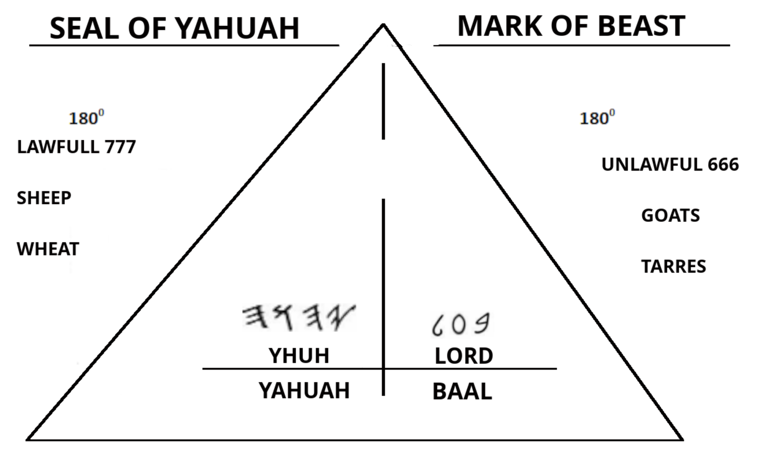

SUB-MIT ‘ v.t. & I 1.YIELD 2. REFER TO ANOTHER.
A. YIELD v.t. & I 3. SURRENDER; RELINQUISH. - v.t. GIVE WAY; ASSENTS; COMPLY
RE-SIST ‘ v.t. 1. OPPOSE; EXERT PHYSICAL OR MORAL FORCE AGAINST 2.WITHSTAND. - MAKE OPPOSITION TO.
“NO ONE CAN SERVE TWO MASTERS; FOR EITHER WILL HATE THE ONE AND LOVE THE OTHER, OR ELSE HE WILL BE LOYAL TO THE ONE AND DESPISE THE OTHER…
MATYT^{H}YAHU LUY / MT 6: 24^{A}
IF WE SUBMIT TO , WE HAVE HIS SEAL UPON US, HIS LAW UPON OUR HEARTS AND MINDS, AND WE WALK ON THE RIGHT HAND PATH. THERE IS NO ROOM FOR HEYKEL (SHATAN) TO MOVE IN ON YOU. WE ARE CONSTANTLY AT WAR WITH SHATAN, RESISTING HIS FORCES. HE CANNOT BREAK OUR TOWER SO HE WILL FLEE FROM US. THE NAME IS A STRONG TOWER; THE RIGHTEOUS RUN TO IT AND ARE SAFE.
MASHALY / PRO 18: 10.

18

THE SPIRITUAL COMPONENT RESTS UPON THE MENTAL AND ‘EMOT-LOGICAL FOUNDATIONS, JUST AS THE PHYSICAL IS STABILIZE BY THE SOCIAL AND CHEMICAL BALANCES. CONSIDER THIS THEN, A MAN WITH A SOUND MIND AND THINKS LOGICALLY WILL HAVE GOOD SPIRITUAL HEALTH. OR, IS IT BECAUSE HE HAS GOOD SPIRITUAL HEALTH THAT HE HAS A LOGICAL SOUND MIND? THE HIGHER NATURE IS NOT AS INDEPENDENT AS THE LOWER. HIGHER COMPONENTS ACT MORE AS A TEAM HELPING EACH OTHER BALANCE. A WICKED INDIVIDUAL’S HIGHER COMPONENTS WILL WORK TOGETHER TO BRING FORTH RESULTS AS A RIGHTEOUS INDIVIDUALS WOULD. FOR US HEBREWS, WE WANT TO MAXIMIZE OUR EXISTENCE BY BEING OBEDIENT CHILDREN OF (YAHUAH) SO WE MUST DO ALL THAT CAN BE DONE TO DO HIS WILL.

TO MASTER THE SPIRITUAL COMPONENT ASK YOURSELF THESE OR SIMILAR QUESTIONS:

* WHAT CAN I DO TO KEEP THE RUACH QUDASH WITHIN ME?

* AM I SEALED WITH THE NAME OF ?

* SHOULD I AVOID THOSE WHO DON’T FEAR ?

* IS IT SAFE TO PARTICIPATE IN AN EVENT THAT HAS NO RESTRICTIONS RECORDED IN THE TURAH?

* WHAT IS MY ULTIMATE SPIRITUAL GOAL?

THE SPIRITUAL COMPONENT HAS NOTHING TO DO WITH RELIGION. IT DOESN’T MATTER WHAT TITLE OR DOCTRINE A MAN FOLLOWS AS THIS APPLIES TO RIGHTEOUSNESS AND WICKEDNESS. AS HEBREWS, OUR RIGHTEOUSNESS IS IN GUARDING THE COMMANDS. “HE WHO SINS COMMITS LAWLESSNESS, AND DIN IS LAWLESSNESS.
YAHUCHANAN / I JN 3: 4.

19

MENTAL – RIGHT FOOT – 60⁰

MASHALY/ PRO 1: 5 – “A WISE MAN WILL HEAR AND INCREASE LEARNING, AND A MAN OF UNDERSTANDING WILL ATTAIN WISE COUNSEL,…”

AYUB / JOB 28: 20 – “FROM WHERE THEN DOES WISDOM COME? AND WHERE IS THE PLACE OF UNDERSTANDING?

QURANTY’YM / I COR 2: 6 -”HOWEVER, WE SPEAK WISDOM AMONG THOSE WHO ARE MATURE, YET NOT THE WISDOM OF THIS AGE, NOR THE RULERS OF THIS AGE, WHO ARE COMING TO NOTHING.”

KNOWLEDGE, WISDOM, AND UNDERSTANDING ARE THE KEYS TO GROWTH OF THE MENTAL COMPONENT.
KNOWL’EDGE n. 1. AWARENESS OF FACTS, TRUTHS, OR PRINCIPLES; COGNIZANCE.
2.ERUDITION.
WIS’DOM n. 1. THE POWER OR FACULTY OF FORMING A SOUND JUDGMENT IN ANY- MANY; SAGACITY; EXPERIENCE. 2. ERUDITION.
UN’DER-STAND’ING n. 1. INTELLIGENCE; MENTAL APPREHENSION AND APPRECIATION.

THE SECOND DEFINITION OF BOTH OF BOTH KNOWLEDGE AND WISDOM IS ERUDITION, WHICH MEANS: KNOWLEDGE GAINED BY STUDY; LEARNING. WE NEED TO ALWAYS APPLY WHAT WE LEARN OR IT IS WASTED SPACE IN THE MIND. WHAT WE THINK IS VERY IMPORTANT TO OUR MENTAL HEALTH AND ALSO SPIRITUAL CONDITION. “GIVE INSTRUCTION TO A WISE MAN, AND HE WILL BE STILL WISER; TEACH A JUST MAN, AND HE WILL INCREASE IN LEARNING. “
MASHALY / PRO 9: 9.

IF WE AS HEBREWS MEDITATE ON THE RIGHT THING, THEN WE WILL ALWAYS HAVE THE CORRECT MENTALITY.

20

WITHIN THE MIND A WAR IS BEING FOUGHT. RIGHTEOUSNESS IS A STRUGGLE TO MAINTAIN EVEN FOR THE SERVANTS OF .
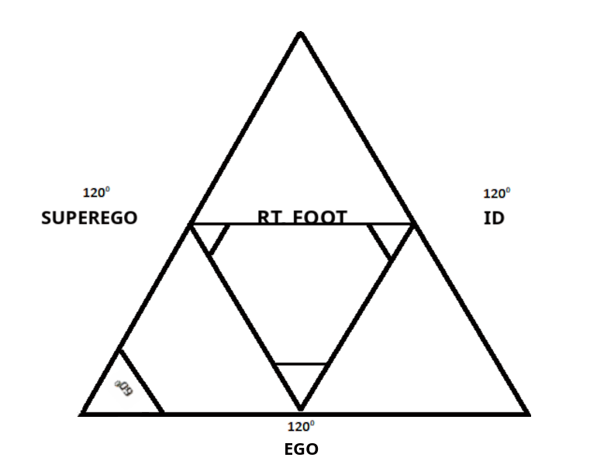

E’GO n. 1. THE “I”, THAT WHICH FEELS, ACTS, AND THINKS; THE SELF.
SU’PER-E’GO n. 1. A MORAL CONSCIENCE THAT REGULATES THE EGO.
ID n. 1. A PERSON IS URGE TO PLEASURE AND THE EXERCISE OF THE LIBIDO.

A TELEVISION SHOW PORTRAYS A MAN WITH A DEVIL AND A ANGEL ON OPPOSITE SHOULDERS. THEY REPRESENT HIS CONSCIENCE. WHILE THE MAN PONDERS ON THE SITUATION, THE DEVIL AND THE ANGEL EXPLAIN THE BENEFITS AND ADVANTAGES OF FOLLOWING ONE WAY OR THE OTHER. THE MAN LISTENS FOR A WHILE AND WHEN ONE OF THEM HAPPENS TO PEAK HIS INTEREST, HE SWATS THE OTHER ONE AWAY. THIS IN REALITY IS THE WAR BETWEEN THE SUPPRESSED EGO AND THE ID, EXCEPT THERE IS NO OUTSIDE INFLUENCE. THIS MENTAL CONFLICT IS ALL INTERNAL. WE DO NOT NEED A DEVIL TO TELL US TO DO WRONG! THE DEVIL MADE ME DO IT? NO! WE CAN DO WRONG ALL ON OUR OWN ACCORD.

21

BUT EACH ONE IS TEMPTED WHEN HE IS DRAWN AWAY BY HIS OWN DESIRES AND ENTICED. THEN, WHEN DESIRE HAS CONCEIVED, IT GIVES BIRTH TO SIN; AND SIN, WHEN FULL-GROWN, BRING FORTH DEATH.
YAAQUB / JAS 1: 14-15.

YOU ALREADY KNOW DESIRE, ESPECIALLY IF ITS WHAT YOU KNOW YOU ARE NOT SUPPOSED TO HAVE. A DEMON DOESN’T NEED TO CONVINCE YOU TO GET IT. JUST LIKE IF A MAL’AKH OF CAME IN TO YOUR PRESENCE, I GUARANTEE THAT YOU WOULDN’T SWAT HIM AWAY. TO MASTER THE MENTAL COMPONENT ASK YOURSELF THESE OR SIMILAR QUESTIONS:

* DO MY THOUGHTS REFLECT THE RIGHTEOUSNESS OF ?
* IS THIS TYPE OF THINKING SAFE?
* CAN I MEDITATE ON THIS AND HONOR AT THE SAME TIME?
* IS THIS IN ACCORD WITH, “...LOVE WITH ALL YOUR MIND?”
* WILL LEARNING THIS ALTER MY WAY OF THINKING FOR THE GOOD?

WE AS ABARYM MUST HONOR ABOVE ALL THINGS! ALL OF OUR DECISIONS SHOULD BE WEIGHED UPON – WILL THIS PLEASE MY FATHER ?
REMEMBER THIS: “BLESSED IS THE MAN WHO WALKS NOT IN THE COUNSEL OF THE UNRIGHTEOUS, NOR STANDS IN THE PATH OF SINNERS, NOR SITS IN THE SEAT OF THE SCORNFUL; BUT HIS DELIGHT IN IN THE LAW OF , AND IN HIS LAW HE MEDITATES DAY AND NIGHT.
T’HYLLYM / PSA 1: 1-2.

22

EMOTIONAL- LOGICAL – LEFT FOOT – 60⁰

MASHALY / PRO 3: 3 – ”HAPPY IS THE MAN WHO FIND WISDOM, AND THE MAN WHO GAINS UNDERSTANDING.”

MASHALY / PRO 6: 16-19 – “THESE SIX THINGS HATES, YES, SEVEN ARE AN ABOMINATION TO HIM: A PROUD LOOK, A LYING TONGUE, HANDS THAT SHED INNOCENT BLOOD, A HEART THAT DEVISES WICKED PLANS, FEET THAT ARE SWIFT IN RUNNING TO EVIL, A FALSE WITNESS WHO SPEAKS LIES, AND ONE WHO SOWS DISCORD AMONG BRETHREN.

APHASY’YM / EPH 4: 26 – “BE ANGRY, AND DO NOT SIN, DO NOT LET THE SUN GO DOWN ON YOUR WRATH,…”

HAVE YOU EVER HEARD ANYBODY SAY, “ I LET MY EMOTIONS TAKE ME OVER. “ I’M SURE MANY OF US HAVE RIDDEN ON THE EMOTIONAL ROLLER-COASTER. I WAS SO MAD AT SOMEONE THAT I WENT OUT OF MY WAY TO SEE THEM TAKE A FALL. THE EMOTION ANGER WAS MY MASTER FOR A LONG TIME. I HAD TO CHANGE BEFORE MYSELF OR SOMEONE ELSE GOT HURT. SO I MADE A LIFE DECISION, I MADE MY FIRST LOVE AND CHANGED ALL OF MY DESIRES TO ALL OF HIS DESIRES. I READ THE TURAH AND NABY’YM TO SEE WHAT ALL MAKES HAPPY; WHAT DOES HE SAY HE LOVES. I RID MYSELF OF THE PEOPLE AND THINGS THAT MADE ME FEEL ANGRY. DO I STILL GET ANGRY, YES. I AM FLESH. BUT I NO LONGER REACT THE WAY I USED TO, I MEDITATE ON THE SITUATION AND THEN I RESPOND. IS IT DIFFICULT, YES, VERY. BUT I NO LONGER HAVE THE PROBLEMS THAT I USED TO.

“BE ANGRY, AND DO NOT SIN. MEDITATE WITHIN YOUR HEART ON YOUR BED, AND BE STILL. SELAH “ T’HYLLYM / PSA 4: 4.

23

WE HAVE TO DECIDE HOW WE ARE GOING TO RESPOND OR REACT TO SITUATIONS IN LIFE.
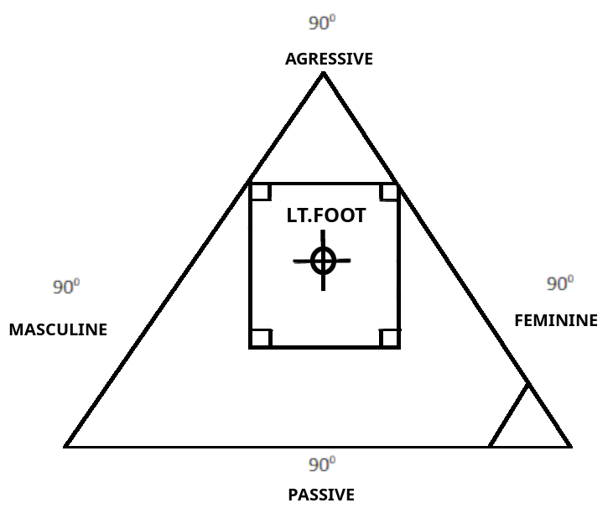

AG-GRES’SIVE adj 1. TENDING TO ATTACK OR BE HOSTILE 2. VIGOROUS.
AS-SER-TIVE adj 1. POSITIVE; OVERBEARING.
PAS’SIVE adj 1. UNRESISTANT; NOT OPPOSING. 2. NOT ACTING BUT ACTED UPON.
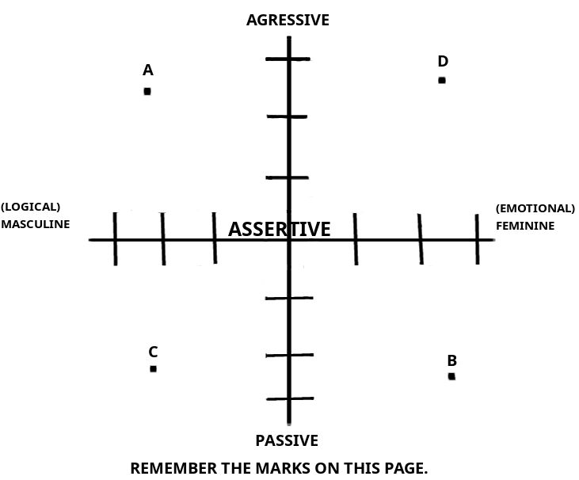
24

THESE MARKS ARE THE 4 EXTREMES IN THE UNBALANCED INDIVIDUAL.
(NOTE): MASCULINE AND FEMININE DOES NOT REPRESENT MALE AND FEMALE. A MAN CAN BE FEMININE JUST AS A WOMAN CAN BE MASCULINE.

MARK ”A” – THIS INDIVIDUAL IS VIOLENT, AN EVIL GENIUS. THEY CAN PLOT REVENGE OVER A LONG PERIOD OF TIME BEFORE THEY UNLEASH THE RAGE.

MARK “B” – THIS ONE WILL MOST LIKELY CRY OR WHINE OVER EVERYTHING. THEY WILL NEVER SEEK ANY AUTHORITY OVER THEMSELVES, BUT WILL HAPPILY JUMP TO SERVE ANOTHER.

MARK “C” – THIS ONE WILL HAVE AN IMMEDIATE VIOLENT RESPONSE. THIS IS THE ONE THAT WOULD KILL SOMEONE BEFORE REALIZING WHAT THEY DID.
(NOTE): THESE ARE JUST EXAMPLES!!!
WE HAVE TO FIND A CENTER IN OUR EMOTIONS AND LOGIC. NOBODY WANTS TO BE AROUND AN EMOTIONAL WRECK, OR, ONE WHO IS VOID OF ANY EMOTION. LEARN TO EXPRESS EXACTLY HOW YOU FEEL, WHY, AND WHAT IS THE DESIRED RESULT. LEARN HOW TO EXPRESS YOUR EMOTIONS LOGICALLY. ASSERT YOURSELF. TO MASTER THE EMO-LOGICAL COMPONENT ASK YOURSELF THESE OR SIMILAR QUESTIONS:

* ARE MY FEELINGS IN HARMONY WITH ?

*IF I RESPOND NOW, HOW WILL I FEEL LATER?

* IS THIS THE BEST PLAN TO GET THE MOST RIGHTEOUS RESULT?

* HOW WILL THIS REACTION AFFECT OTHERS?

* WHAT IS THE BEST CASE SCENARIO IN THIS SITUATION?

25

EMOTIONAL AND LOGICAL STABILITY CAN BE SUMMED UP AS THIS: MIND OVER MATTER. OF COURSE EVERYTHING WONT GO ACCORDING TO YOUR PLANS. ASK YOURSELF, IS YOUR PLAN THE SAME AS THE PLAN HAS FOR YOU? LET THE WILL OF BE DONE!

FOR OUR BOASTING IS THIS: THE TESTIMONY OF OUR CONSCIENCE THAT WE CONDUCTED OURSELVES IN THE WORLD IN SIMPLICITY AND RIGHTEOUS SINCERITY, NOT WITH FLESHLY WISDOM BUT BY THE MERCY OF AL’HYM, AND MORE ABUNDANTLY TOWARD YOU.
QURANTY’YM / II COR 1: 12.

THE HIGHER NATURE 180⁰
THE BATTLE GROUND OF THE ABARY AC^{H}YM AND ACHAYUTH. WE ARE PRESSED EVERY SECOND TO THE FRONT LINES OF WARFARE. WHILE WE ARE ALIVE WE FIGHT ON TWO FRONTS, THE HIGHER AND LOWER NATURES.

“HOWEVER, THE SPIRITUAL IS NOT FIRST, BUT THE NATURAL, AND AFTERWARD THE SPIRITUAL.
QURANTY’YM / I COR 15: 46.

“THE RU^{A}CH HIMSELF BEARS WITNESS WITH OUR SPIRIT THAT WE ARE CHILDREN OF AL’HYM.
RUMY’YM / ROM 8:16.

THE HIGHER NATURE IS WHO YOU ARE. THIS IS HOW YOU ARE PERCEIVED IN THIS LIFE. YOU ARE A REPRESENTATIVE OF BECAUSE HE PUT HIS NASHAMA WITHIN YOU. LIVE LIKE YOU KNOW THIS. BE ONE OF THE BEST BY LETTING LEAD YOU. YOU HAVE A SOLID SPIRITUAL, MENTAL AND EMO-LOGICAL FOUNDATION BY BUILDING IT UPON THE ROCK!
“ IS MY ROCK AND MY FORTRESS AND MY DELIVERER; MY AL’HYM, MY STRENGTH, IN WHOM I WILL TRUST; MY SHIELD AND THE HORN OF MY DELIVERANCE, MY STRONGHOLD.
T’HYLLYM / PSA 18: 2

26

CHAPTER 5: BODY, MIND, AND SPIRIT: THE BRIDGING OF THE NATURES

BODY – PHYSICAL + CHEMICAL; LOWER NATURE. 120⁰
MIND – MENTAL + EMOT/LOGICAL; HIGHER NATURE. 120⁰
SPIRIT – SPIRITUAL + SOCIAL; HIGHER & LOWER NATURES. 120⁰

WE ARE A 3 PART BEING. EASY TO OVER-STAND. THE DIFFICULT PART IS UNDERSTANDING THE RELATIONSHIP BETWEEN THE PARTS. NO, WE ARE NOT A TRINITY. THIS IS CLEAR;
“ AL’HYM FORMED MAN OF THE DUST OF THE GROUND; AND BREATHED INTO HIS NOSTRILS THE NASHAMAH / BREATH OF LIFE; AND MAN BECAME A LIVING BEING.” BARASHYTH / GEN 2:7.
WE ARE TWO-NATURE; DUST OF THE GROUND = LOWER; BREATH OF LIFE = HIGHER. DON’T LET THIS CONCEPT BE A SOURCE OF CONFUSION.

LOWER ---------- COMMUNICATE ---------- HIGHER
BODY MIND SPIRIT

THE MIND IS WHERE THE SPIRIT AND THE BODY COMMUNICATE. YES, THE MIND IS MADE OF COMPONENTS OF THE HIGHER NATURE BECAUSE THE MIND IS THE MANIFESTATION OF THE SPIRIT. WHEN THE NASHAMAH IS REMOVED, A DEAD, NON-THINKING BODY IS LEFT. DOES THAT MAKE IT CLEAR? SO, WHILE WE HAVE THE NASHAMAH WITHIN WE CAN THINK AND BEWARE OF LIFE. THE MIND IS TERRIBLE THING TO WASTE.

27

BODY = PHYSICAL + CHEMICAL

WE ARE EARTH AND WATER. YOU CAN CALL IT MUD IF YOU WANT. WE ARE SO COMPLEX THOUGH. THERE ARE 100’s OF TYPES OF DOCTORS THAT SPECIALIZE IN SPECIFIC FIELD OF STUDY. THE BODY IS A VEHICLE FOR THE RU^{A}CH AND IT TAKES THE RIGHT TYPE OF MAINTENANCE TO PRESERVE IT. THE BODY IS A SUBJECT THAT COULD FILL MILLIONS OF PAGES WITH INFORMATION OF DNA, CELLS, ORGANS ETC.

THE PHYSICAL AND CHEMICAL COMPONENTS AFFECT EACH OTHER DIRECTLY. CHEMICAL CONSUMPTION CAUSES VARIOUS PHYSICAL STATES. PHYSICAL EXERTION PROMOTES CHEMICAL REACTIONS.

AS WE ARE THE IMAGE AND THE TEMPLE/HEYKAL OF WE HAVE TO CONSTANTLY REPAIR AND MAINTAIN THE BODY. HOW YOU APPEAR IS YOUR REPRESENTATION OF NOT ONLY YOURSELF, BUT YOUR CREATOR, AND HOW YOU SERVE HIM. BALANCE THE BODY AND YOU WILL WIN WORLDLY BATTLE AGAINST THE FLESH.
“HE WHO LOVES PLEASURE WILL BE A POOR MAN…”
MASHALY / PRO 21: 17

28

MIND = MENTAL + EMOT/LOGICAL
A FOOL VENTS ALL HIS FEELINGS, BUT A WISE MAN HOLDS THEM BACK.
MASHALY / PRO 29: 11

THE MENTAL AND EMOT/LOGICAL COMPONENTS ARE THE FOUNDATION OF THE SPIRITUAL COMPONENT AS STATED EARLIER. SO THE MIND IS THE BASE OF THE SPIRIT. THIS IS A HEAVY THING. YOUR ATTITUDE WEIGHS HEAVILY ON YOUR THOUGHTS. IF I AM ANGRY, I WILL FOCUS ON NEGATIVE THOUGHTS; WHAT TYPE OF SPIRIT WILL THAT ATTRACT? THE GOAL IS TO THINK LOGICALLY, CONTROL MY EMOTIONS, HAVE AN OVER-ALL RIGHTEOUS MENTALITY . WHATEVER I FEEL WILL BE EXPOSED TO THE WORLD. “ AS IN WATER FACE REFLECTS FACE, SO A MANS HEART REVEALS A MAN. MASHALY / PRO 27: 19.

THE MIND IS LIMITLESS IN ITS CAPACITY. BUT YOU WANT TO BE VERY AWARE OF WHAT YOU STORE IN IT. WHATEVER YOU THINK ABOUT WILL AFFECT YOUR EMOTIONS WHETHER FOR RIGHTEOUS OR WICKED. THEN, HOWEVER YOU FEEL CAN AFFECT WHAT YOU DO. MASTER THE MIND, USE LOGIC. CONTROL YOUR EMOTIONS AND WATCH HOW MUCH BETTER YOU INTERACT WITH OTHERS. THE MIND IS THE COMMUNICATION LINK BETWEEN THE BODY AND THE SPIRIT. MANY BATTLES ARE FOUGHT HERE. YOUR ATTITUDE AND MENTAL HEALTH CAN AND DO DICTATE THE RESULTS OF THESE BATTLES. EX. - A PERSON WHO IS SAD AND THINKING NEGATIVE, COULD BE A CANDIDATE TO ABUSE DRUGS AND /OR ALCOHOL. ALL THAT FROM THE MIND ALSO AFFECTED THE BODY.
“ FOR AS HE THINKS IN HIS HEART, SO IS HE. “ MASHALY / PRO 23: 7.

29

SPIRIT = SPIRITUAL + SOCIAL

“ YOU SHALL TEACH THEM DILIGENTLY TO YOUR CHILDREN, AND SHALL TALK OF THEM WHEN YOU SIT IN YOUR HOUSE, WHEN YOU WALK BY THE WAY, WHEN YOU LIE DOWN, AND WHEN YOU RISE UP. ‘DABARYM / DEUT 6: 7

THIS HIGHER/LOWER NATURE CROSSOVER IS UNIQUE. EVERY SINGLE RELIGION/BELIEF SPEAKS GENERALLY ABOUT SPREADING THIS OR THAT CONCEPT FOR THE BENEFIT OF SPIRITUAL GROWTH. “ AND YAHUASHA SAID TO THEM. ‘GO INTO ALL THE WORLD AND PROCLAIM THE BESORAH TO EVERY CREATURE. ‘ “ MARAQUS / MARK 16: 15.

THE SOCIAL COMPONENT, THOUGH IT IS OF THE LOWER NATURE, IS HOW WE COMMUNICATE WITH MAN AND . HIMSELF IS THE SPOKEN WORD. “.AND THE WORD WAS AL’HYM.”
YAHUCHANAN / I JN 1: 1.
OUR COMMUNICATION SHOULD BE RIGHTEOUS INDEED. WE SHOULD ALWAYS SPEAK ON THE ESTEEM OF ESPECIALLY TO THE LOST SHEEP. OUR WHOLE SOCIAL COMPONENT SHOULD BE LINKED TO SPIRITUAL ENDEAVORS. AS A HEBREW MY SOCIAL CIRCLE IS REPRESENTATION OF MY WORDS AND DEEDS. THE ONES AROUND ME APPROVE OF MY CONVERSATIONS AND MY LIFESTYLE. “ LET YOUR HEART RETAIN MY WORDS, KEEP MY COMMANDS AND LIVE. “ MASHALY / PRO 4:4^{B}. A CHILD OF SHATAN WOULDN’T WANT TO SIT AROUND AND HEAR THE ABOMINATIONS OF THE WICKED WOULD THEY?

“ SUBMIT YOURSELVES TO AL’HYM, RESIST THE DEVIL AND HE WILL FLEE FROM YOU. “
YA’AQUB / JAS 4: 7

30

THE BRIDGE OF THE NATURES
HIGHER – LOWER RELATIONSHIPS.

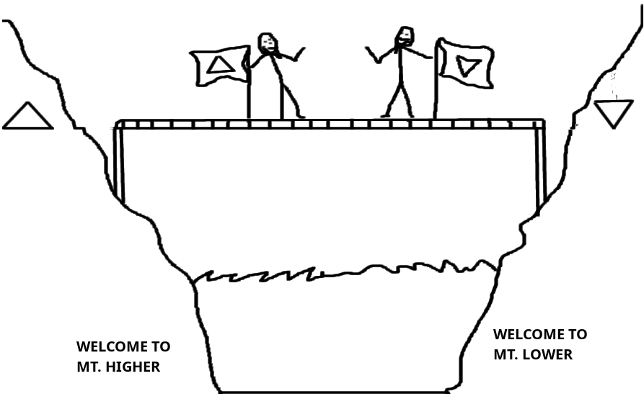

MENTAL – SOCIAL: RIGHT SIDE
DOES YOUR SOCIAL CIRCLE HAVE THE SAME MENTALITY THAT YOU DO? I BELIEVE THAT MOST PEOPLE LIKE TO ASSOCIATE WITH LIKE MINDED INDIVIDUALS. I, MYSELF TEND
TO HANG AROUND WITH THOSE WHO CAN HAVE AN INTELLIGENT CONVERSATION. AT THE SAME TIME, IT IS HARD FOR ME TO BE AROUND THOSE WHOSE MINDS ARE FOCUSED ON FASHION TRENDS, MUSIC VIDEOS, SPORTS, ETC... (NOT THAT THOSE ARE BAD THINGS).
PEOPLE TEND TO FLOCK TO LIKE MINDS. EVERYONE HAS HEARD THE SAYING, “ GREAT MINDS THINK ALIKE! “ IN TRUTH, I’VE HAD FEWER DISPUTES WHEN I SPEAK WITH PEOPLE WHO THINK LIKE I DO. I AM VERY CLOSE TO MY ASSOCIATES FOR A GOOD REASON, BECAUSE I RESPECT THEIR MIND AND THEY RESPECT MINE. WE DON’T HAVE TO WORRY ABOUT BECOMING IRATE WITH EACH OTHER BECAUSE MENTALLY AND SOCIALLY WE ARE BALANCED.

31

EMOTIONAL / LOGICAL – SOCIAL: LT.FOOT + RT. HAND

THERE ARE SOME WHO ARE HAPPY WHEN SURROUNDED BY ASSOCIATES, (EXTROVERT), AND SOME WHO ARE HAPPY ALONE, (INTROVERT). YOU HAVE TO KNOW WHO YOU ARE AND WHO YOU LIKE TO BE ASSOCIATED WITH. REMEMBER THE OLD INTERNET CHAT ROOMS. SOME WERE VERY SPECIFIC. YOU COULD CHOOSE THE AGE GROUP, TOPIC AND SOMETIMES SUBTOPIC. YOU KNEW WHAT TYPE OF CROWD THAT YOU WANTED TO CHAT WITH. YOU CHOSE SPECIFICALLY WHAT ROOM WOULD BE THE MOST COMFORTABLE FOR YOU.
LIFE IS SIMILAR. WE CAN BE LOGICAL AND CHOOSE TO ASSOCIATE WITH THOSE WHOM MAKE US COMFORTABLE, IT IS OUR CHOICE AFTER ALL. HOW MANY HEBREWS WOULD GO TO A KLAN RALLY AND NOT GET EMOTIONAL? BE REALISTIC WHEN YOU SOCIALIZE WITH OTHERS. WHY HOP IN A FIRE IF YOU’RE COVERED IN GASOLINE? IF I KNOW SOMETHING IS GONNA MAKE ME FURIOUS I WILL DO MY BEST TO AVOID IT AT ALL COST.

MENTAL – CHEMICAL: RT.FOOT + LT HAND
WE KNOW AS HEBREWS WHAT TO AVOID. WE KNOW BECAUSE ITS WRITTEN IN THE TURAH. SOME THINGS AREN’T WRITTEN BUT ARE JUST PLAIN OLE’ SOUND JUDGMENT. WOULD YOU DRINK CAUSTIC ACID? WOULD YOU BATHE IN FIRE? WOULD YOU EAT ASBESTOS? WOULD YOU TAKE AN UNIDENTIFIED PILL THAT WASN’T SUBSCRIBED TO YOU? MOST PEOPLE WOULD SAY NO. BUT THESE ALL SOUND NEGATIVE. HOW ABOUT; WOULD YOU TAKE 5 TIMES THE DOSAGE OF A HEALTH SUPPLEMENT? WOULD YOU EAT (6), 12_{OZ} STEAKS JUST BECAUSE THEY WERE AVAILABLE? WOULD YOU RUB A HALF GALLON OF OLIVE OIL ON YOUR SKIN JUST BECAUSE IT IS HEALTHY?

WHEN DEALING WITH THE CHEMICAL COMPONENT YOU WANT TO BE MENTALLY SOUND. YOU NEED TO BE ABLE TO MAKE PROPER DECISIONS WHEN CONSUMING OR APPLYING CHEMICALS TO THE BODY. I CAN’T BELIEVE AFTER SEEING WHAT IT HAS DONE TO OTHERS.

32

EMOTIONAL / LOGICAL – CHEMICAL: LEFT-SIDE

THERE SEEMS TO BE A CONNECTION HERE BETWEEN THE MIND AND THE CONSUMPTION OR IMMERSION OF THE CHEMICAL COMPONENT. WHY DO THOSE WHO NEED TO RELAX THEIR NERVES DESIRE A CIGARETTE? SOME WHO ARE DEPRESSED TURN TO LIQUOR OR DRUGS SOME EVEN TURN TO FOOD WHEN SAD OR LONELY. THIS DANGEROUS COMBINATION CAN CAUSE SEVERE DAMAGE TO THE BODY IF UNBALANCED.
IF YOU ARE ONE OF THE PEOPLE WHO HAVE THE ABOVE OR SIMILAR ISSUES, FOCUS ON FINDING ALTERNATIVE METHODS. MASSAGE THERAPY, AROMATIC PATHS, JOGGING, EXERCISE, FELLOWSHIP WITH THE ACHYM AND ACHAYUTH. BALANCE YOUR EMOTIONS AND THINK ABOUT A SOLUTION INSTEAD OF KEEPING YOUR MIND ON THE PROBLEM. WE NEED TO SLOW DOWN, CALM DOWN AND FIND A SOLUTION. ONCE WE START USING LOGIC, WE WON’T NEED TO IMMEDIATELY RELIEVE STRESS THAT WE CREATED BY JUMPING TO CONCLUSIONS.
THEREFORE STRENGTHEN THE HANDS WHICH HANG DOWN, AND THE FEEBLE KNEES, AND MAKE STRAIGHT PATHS FOR YOUR FEET, SO WHAT IS LAME MAY NOT BE DISLOCATED BUT MAY BE HEALED. PURSUE PEACE WITH ALL PEOPLE, AND QUDASHAH, WITHOUT WHICH NO ONE WILL SEE THE ADUN. ABARYM / HEB 12: 12-14.
IT IS VERY POSSIBLE FOR THE BODY, MIND, & SPIRIT TO BE ON ONE ACCORD. THIS IS THE CONCEPT OF MASTERING YOURS.E.L.F.. KEEPING YOUR NATURES IN TUNE WITH AL’HYM. “ YOU SHOULD LOVE YOUR AL’HYM WITH ALL YOUR HEART, WITH ALL YOUR BEING, AND WITH ALL YOUR STRENGTH. “ DABARYM / DEUT 6:5 AND AGAIN IN MARAQUS / MRK 12: 30


* (STRENGTH) – SPIRIT
* (BEING - MIND
* (HEART) - BODY

33

WHEN WE BECOME 360⁰ BALANCED, WE ARE READY TO RECOGNIZE THE TRUE S.E.L.F.. WE HAVE MASTERED OUR NATURES AND THE COMPONENTS. WE HAVE TRULY SET OURSELVES ASIDE TO SERVE YADH-HEH-UAU-HEH. OUR DESIRE IS ONLY TO PLEASE THE MOST HIGH, TO LET HIS WILL BE DONE. WE HAVE SUBMITTED OUR WHOLE BEING TO THE RIGHTEOUSNESS OF ! NOW WE ARE READY TO LEARN OUR PURPOSE, OUR GIFT, OUR SERVICE TO THE CREATOR. ONLY AFTER WE CAN SHOW HIM OUR MOST HUMBLE SELF WILL BE EXALTED WITH THE POWER OF HARUACH HAQUDASH!

34

CHAPTER 6 S.E.L.F.

99% OF THE TIME WHEN I ASK SOMEONE, “ WHO ARE YOU? “, THEY TELL ME THEIR NAME. “ OH, I’M SUCH-N-SUCH. “ SO I SAY, “ NO, I DIDN’T ASK YOUR NAME, I ASKED WHO ARE YOU. “ SOME LOOK AT ME WEIRD OR WALK AWAY. SOME GET MAD OR THINK I AM PLAYING A GAME. IT’S BECAUSE MOST PEOPLE IDENTIFY THEMSELVES WITH THE CERTIFICATE OF LIVE BIRTH NAME AND NOT WHO THEY ARE IN “ ESSENCE “.

ES’SENCE n. 1. THE DISTINCTIVE CHARACTERISTIC OF SOMETHING. 2. THE INWARD NATURE OR TRUE SUBSTANCE OF SOMETHING.

“ HE WHO IS IN YOU IS GREATER THEN HE WHO IS IN THE WORLD. “
YAHUCHANAN / I JN 4: 4

THOSE 99% HAVEN’T SEEN THAT THIS SYSTEM OF THINGS IS NOT GOING TO LAST. THEY HAVEN’T RECOGNIZED THIS TEMPORARY CONDITION WHERE WE DAILY DECAY; SLOWLY LEAN TOWARD SHE’OL. UNTIL THEY, THEIR TRUE S.E.L.F. WILL REMAIN ABSENT.
BEFORE WE GET TO THIS S.E.L.F., LET US LOOK AT HUE-MAN AND WOMB-MAN. IN THEIR OWN CAPACITIES AS MALE AND FEMALE. GET A SCRIPTURAL VIEW OF THE POSITIONS AND THE DIFFERENCE BETWEEN THEM. THIS WILL HELP US OUT LATER ON IN THE CHAPTER WHEN WE UNDERSTAND WHO WE ARE. NEXT TIME YOU ARE ASKED, “ WHO ARE YOU?, “ YOU’LL BE ABLE TO ANSWER THEM ACCORDINGLY. NOT ONLY DO WE HAVE THE DUTY OF BALANCING THE NATURES, WE ALSO HAVE A DUTY TO BE A HUSBAND OR WIFE. “ A MAN SHALL LEAVE HIS FATHER AND MOTHER AND BE JOINED TO HIS WIFE…“
BARASHYTH / GEN 2: 24^{A}

35

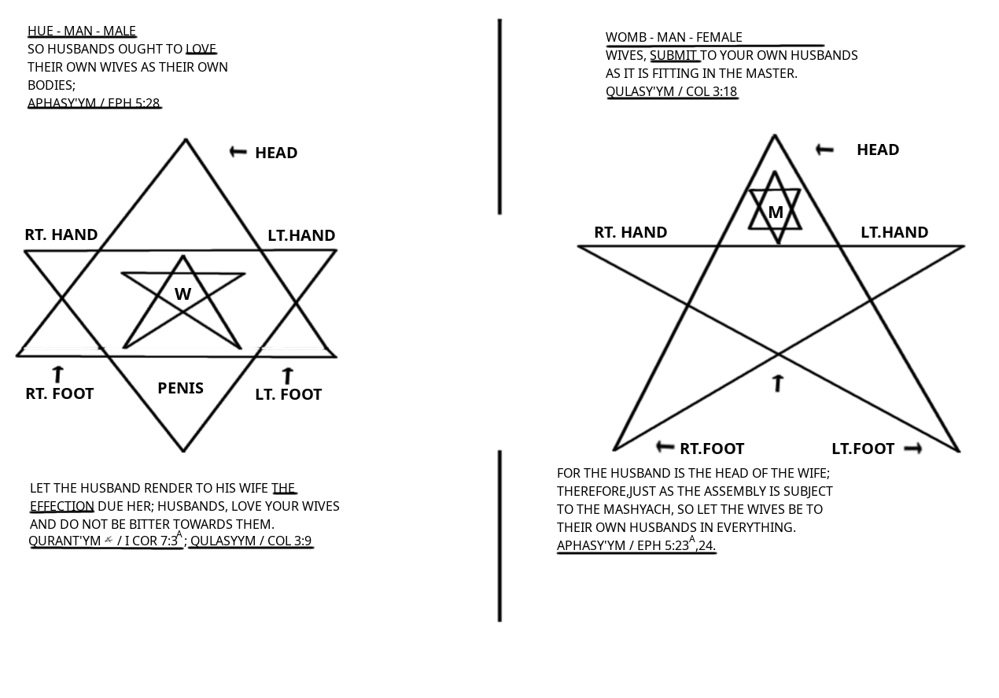

WOMB-MAN RESTS WITHIN THE MANS HEART AS HIS WISDOM; JUST AS THE MAN RESTS WITHIN A WOMB-MANS HEAD AS HER KNOWLEDGE. NOW, SHE IS HIS EMOTION, HE IS HER LOGIC. THE DUTY TO THE SIGNIFICANT OTHER(S), IT ALSO SERVICE TO THE CREATOR. HE DID CREATE MALE AND FEMALE AS A PART OF HIS PERFECT PLAN.

36

WE ARE ALL ADAM ( AH – DAHM ) WHICH MEANS MANKIND. AS THE MOST HIGH CREATED US, HE PLANNED THE DIVIDING OF MANKIND INTO MALE ( HUE-MAN ) AND FEMALE ( WOMB-MAN ).
SO, ADAM WAS MOLDED INTO THE DESIRED FORM AND GAVE ADAM THE NASHAMA, THE BREATH OF LIFE. IT WAS BREATHED INTO ADAMS NOSTRILS. THIS DIVINE BREATH STAYS WITHING HIS NOSTRILS AND LUNGS CAUSING THE RED EARTH TO BECOME A LIVING BEING. EVERY CHILD BORN INHALES THE BREATH OF LIFE. THIS IS NOTHING SHORT OF A MIRACLE, YET BREATHING IS TAKEN FOR GRANITE.
AS A LIVING BREATHING BEING, WE OWE OUR WHOLE EXISTENCE TO THE CREATOR . IF WE DEVOTE ALL SIX COMPONENTS TO THE MOST HIGH, HE WILL ADD A COMPONENT THAT WILL ELEVATE US TO OUR HIGHEST POTENTIAL IN THIS LIFE. HE WILL GIVE US THE RUACH QUDASH.

“ BUT YOU SHALL RECEIVE POWER WHEN THE RUACH QUDASH HAS COME UPON YOU; AND YOU SHALL BE MY WITNESS IN Y’RUSHALAYM, AND IN ALL YAHU’ADAH AND SHAMARUN, AND TO THE END OF THE EARTH. “
MA’ASHEH / ACTS 1: 8

THAT IS WHEN WE WILL KNOW TRUE S.E.L.F., OUR INTENDED LIFE IN THIS ERA. OUR TRUE SERVICE TO CAN BEGIN. ALL OF OUR OLD WAYS AND DISTRACTIONS HAVE BEEN CAST ASIDE. SERVICE TO SELF IS NO MORE. “ LET US HEAR THE CONCLUSION OF THE WHOLE MATTER; FEAR AL’HYM AND GUARD HIS COMMANDS, FOR THIS IS MANS ALL.”
QUHALATH / ECC 12: 13.

S.E.L.F.

* SUBLIME

* ETHEREAL

* LIVE

* FORCE

37

SUB-LIME adj 1. EXALTED; LOFTY.
IF THIS ISN’T CLEAR ENOUGH, LOOK AT THE VERB TRANSITIVE:
SUB’LI-MATE vt. 1. ELEVATE; PURIFY. 2. TURN INTO, OR REPLACE WITH, MORE WHOLESOME INTERESTS OR ACTIVITIES.
- WHOLE’SOME adj 1. CONTRIBUTING TO THE HEALTH OF HEALTH OF BODY, MIND, OR CHARACTER.

THIS IS THE WHOLE CONCEPT OF OUR WORSHIP, TO BE BETTER MINISTERS OF . OUR FOREFATHERS DESTROYED THE NATION BY VIOLATING THE TURAH. OUR GENERATION CAN BE THE EXAMPLE OF RIGHTEOUSNESS AND SEE PROPHECY FULFILLED:
“ AND IT SHALL COME TO PASS AFTERWARD THAT I WILL POUR OUT MY RUACH ON ALL FLESH; YOUR SONS AND DAUGHTERS SHALL NABU, YOUR OLD MEN SHALL DREAM DREAMS, YOUR YOUNG MEN SHALL SEE VISIONS. AND ALSO ON MY MENSERVANTS AND MY MAIDSERVANTS I WILL POUR OUT MY RUACH IN THOSE DAYS.“
YAHU’AL / JOEL 2: 28-29.

EVERY HEBREW SHOULD WANT TO ELEVATE HIMSELF AND BECOME ONE WITH .

E-THE’RE-AL adj 1. AIRY; LIGHT; INTANGIBLE 2. HEAVENLY. ALSO SEE:
HEAV’EN-LY adj 1. BLISSFUL; SUBLIME. AND HEAV’EN n. 3. STATE OF BLISS; SUPREME HAPPINESS OR EXALTATION.

THE RUACH QUASH IS THE GIFT FROM TO HIS CHILDREN; THE POWER ENTRUSTED TO HIS OWN CHOSEN THAT WALK IN HIS WAY. MANY OF THE NEBIY’IM LIKE CHANUK / ENOCH, AL’YAHU / ELIJAH, AND AL’YASHA / ELISHE HAD GIFTS OF POWER FROM THE FATHER. YAHU’ASHA ( BARAK HU )
SHYM’ UN KEPHA, AND SHA’UL COULD HEAL AND RAISE THE SLEEPING. THIS WASN’T SOMETHING VISIBLE THAT OTHERS COULD SEE.
IN THIS DEFINITION ETHEREAL LEADS US BACK TO SUBLIME. WHEN WE HUMBLE OURSELVES TO , HE WILL EXALT US. HE WILL LIFT US UP IN TRUTH WITH HIS RUWACH

38

LIVE ( LIV ) adj 1. HAVING LIFE; ALIVE; ENERGETIC. 3. CONTINUE IN EXISTENCE, OPERATION, ETC… 4. DWELL; RESIDE. 5. HAVE EXPERIENCE

THIS FROM THE MOST HIGH IS DEFINITELY LIVE. SEE, THE RU^{A}CH DOES THE WILL OF THE FATHER AND IS ONLY COMPATIBLE WITH THOSE WHO LOVE TO DO THE WILL OF . AS MALAK DA’UD STATED: “ I DELIGHT TO DO YOUR WILL MY AL’HYM, YES, YOUR TURAH IS WITHIN MY HEART.” T’HYLLYM / PSA 40: 8. OUR LIFESTYLE IS OUR PROOF OF OUR LOVE.

“ FOR THIS IS THE LOVE OF AL’HYM, THAT WE GUARD HIS COMMANDS AND HIS COMMANDS ARE NOT BURDENSOME. “
YAHUCHANAN / I JN 5: 3.
NOW WE ARE LIVE, WE ARE READY TO GO OUT AND SERVE WITHOUT WORRYING ABOUT THE OPINIONS OF OTHERS.

FORCE n. 1. THE CAPACITY FOR EXERTING STRENGTH; POWER; MIGHT. 2. THE POWER TO COERCE, PERSUADE, CONVINCE, ETC… vt. 1. COMPEL BY PHYSICAL, MENTAL, OR MORAL MEANS. 3. EFFECT BY EFFORT. 5. HASTEN THE GROWTH OF.

AS STATED EARLIER, THIS IS THE POWER OF . REMEMBER WHAT YAHU’ASHA ( BARAK HU ) SAID TO THE TALMYDYM IN MA’ASHEH / ACTS 1:8 “ BUT YOU SHALL RECEIVE THE POWER WHEN THE RU^{A}CH QUDASH HAS COME UPON YOU… “ ALL THROUGH THE BOOK OF MA’ASHEH YOU CAN READ ABOUT VARIOUS HEALING BY LAYING OF HANDS, TOUCHING CLOTHING OR EVEN A SHADOW CROSSING OVER. THIS IS ALL ! NONE OF OUR NABY’YM WERE ABLE TO DO ANYTHING WITHOUT AL’HYM. JUST AS WE ARE WORTHLESS IF WE DON’T HAVE AS OUR STRENGTH. HE IS OUR FORCE, OUR ALL. A HEBREW WITHOUT IS LIKE A OCEAN WITHOUT WATER.

NOW MAY THE AL’HYM OF HOPE FILL YOU WITH ALL JOY AND PEACE BELIEVING THAT YOU MAY ABOUND IN HOPE BY THE POWER OF THE RU^{A}CH QUDASH.
RUMY’YM / ROM 15: 13.

39

FOR ALL AL’HYM DID NOT CALL US TO UNCLEANNESS, BUT IN QUDASHAH. THEREFORE HE WHO REJECTS THIS DOES NOT REJECT MAN, BUT AL’HYM, WHO ALSO GIVES US HIS RU^{A}CH QUDASH.
TAS’LUNYQYM / I THES 4: 7-8.

THE SUBLIME – ETHEREAL – LIVE – FORCE, THE TRUE S.E.L.F.. IS WHAT EVERY HEBREW SHOULD PRAY FOR. WE NOT ONLY WANT TO BALANCE WHAT WE HAVE BUT WHAT WE WANT TO MASTER, WHATEVER WE INVOLVE OURSELVES WITH. MASTERY AT A SKILL IS GREAT SPECIFICALLY FOR BEING RECOGNIZED FOR YOUR TRADE. MASTERY IN YOUR WALK OF LIFE IS EXPONENTIALLY GREATER. JUST AS OUR FATHER ABARYM WAS COMMANDED TO BE PERFECT, AND AYUB WAS SAID TO BE PERFECT, WE ARE COMMANDED TO BE PERFECT AS WELL. WE AS THE HEBREW Y’SHARALY NATION, THE CHILDREN OF , HAVE AN OBLIGATION TO THE MOST HIGH; A COVENANT AS YOU WILL. OUR FATHERS ABARYM, Y’TSC^{H}AQ, AND YA’AQUB ( YASHAR’AL ) INDEED SEALED US WITH AL’HYM FOREVER. NOW WE MUST HONOR THAT COVENANT.

“O’ SEED OF ABARYM HIS SERVANT, YOU CHILDREN OF YA’AQUB, HIS CHOSEN ONES! HE IS AL’HYNU; HIS RIGHT-RULINGS ARE IN ALL THE EARTH. HE REMEMBERS HIS COVENANT FOREVER, THE WORD WHICH HE COMMANDED, FOR A THOUSAND GENERATIONS, THE COVENANT WHICH HE MADE WITH ABARYM, AND HIS OATH TO Y’TSC^{H}AQ, AND CONFIRMED IT TO YA’AQUB FOR A STATUE, TO YASHAR’AL AS AN EVERLASTING COVENANT.”
T’HYLLYM / PSA 105: 6-10.

“FOR I WILL POUR WATER ON HIM WHO IS THIRSTY, AND FLOODS ON THE DRY GROUND; I WILL POUR MY RU^{A}CH ON YOUR DESCENDANTS, AND MY BARAKAH ON YOUR OFF SPRING.
YASHAYAHU / ISA 44: 3

40

CHAPTER 7: FIND PERFECTION AND SEVEN YOUR S.E.L.F.

BARASHYTH / GEN 4: 7 - “ IF YOU DO WELL, WILL YOU NOT BE ACCEPTED? AND IF YOU DO NOT WELL, SIN LIES AT THE DOOR. AND ITS DESIRE IS FOR YOU, BUT YOU SHOULD MASTER IT. “

“ WHOEVER COMMITS SIN ALSO COMMITS LAWLESSNESS, AND SIN IS LAWLESSNESS. “
YAHUCHANAN / I JN 3: 4 -

SIN; THE VIOLATION OF THE LAWS OF . THIS IS WHAT KEEPS YOU SEPARATE FROM THE FATHER. YOUR LIFE IS A REFLECTION OF HOW YOU SERVE THE CREATOR. IF YOU SIN, YOUR LIFE WILL BE THE RESULT OF THE CHOICES THAT YOU HAVE MADE. IT WILL BE A LIFE WITHOUT WHICH IS VERY HORRIBLE.
“ BEHOLD THE HAND OF IS NOT SHORTENED, THAT IT CANNOT SAVE; NOR HIS EAR HEAVY, THAT IT CANNOT HEAR. BUT YOUR INIQUITIES HAVE SEPARATED YOU FROM AL’HAYKHA; AND YOUR SINS HAVE HIDDEN HIS FACE FROM YOU, SO THAT HE WILL NOT HEAR. “
YASHAYAHU / ISA 59: 1-2.
WHEN YOU VIOLATE THE DYN YOU ARE JUDGED AS UNWORTHY. YOU HAVE SEPARATED YOURSELF FROM . YOU HAVE DECIDED TO SERVE YOURSELF INSTEAD OF THE MOST HIGH. EVEN IF YOUR TEACHING IS THAT THE MASHYACH HAS CLEANSED ALL OF YOUR SINS, DO YOU THINK THAT YOU CAN CONTINUE TO VIOLATE THE COMMANDS OF ? “ FOR HE WHO LACKS THESE THINGS IS SHORTSIGHTED, AND HAS FORGOTTEN THAT HE WAS CLEANSED FROM HIS OLD SINS . KAPHA / II PETER 1: 9. SO WHEN YOU SIN AGAIN, WHO IS GOING TO CLEANS YOU THEN. WILL THE MASHYACH BE YOUR OFFERING AGAIN?
“ FOR IF WE SIN WILLFULLY AFTER WE HAVE RECEIVED THE KNOWLEDGE OF THE TRUTH, THERE NO LONGER REMAINS A SLAUGHTER OFFERING FOR SIN, BUT A CERTAIN FEARFUL EXPECTATION OF JUDGMENT, AND FIERY INDIGNATION WHICH WILL DEVOUR THE ADVERSARIES.

41

ANYONE WHO HAS REJECTED THE TURAH OF MUSHAH DIES WITHOUT MERCY ON THE TESTIMONY OF TWO OR THREE WITNESSES. OF HOW MUCH WORSE PUNISHMENT, DO YOU SUPPOSE, WILL BE THOUGHT WORTHY WHO HAS TRAMPLED THE BAN OF AL’HYM UNDERFOOT, COUNTED THE BLOOD OF THE COVENANT BY WHICH HE WAS SET-APART A COMMON THING, AND INSULTED THE RU^{A}CH OF MERCY?
ABARYM / HEB 10: 26-29.
FOR THOSE WHO DON’T UNDERSTAND:
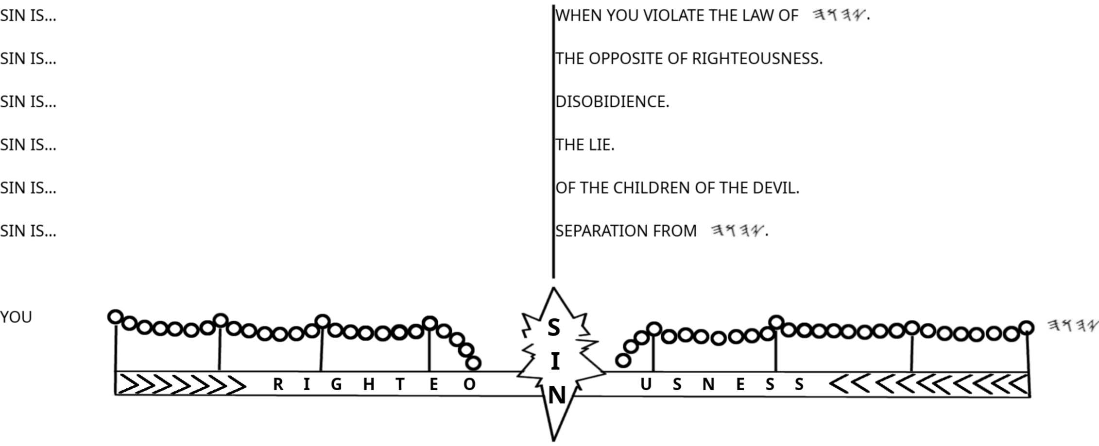
SIN IS TRANSGRESSION OF THE LAW YA’HN / I JN 3:4 (KJV), SO TO PARAPHRASE YASHAYAHU / ISA 59:2, “ BUT YOUR “ TRANSGRESSION OF THE LAW “ HAS SEPARATED YOU FROM AL’HAYKA…” THOSE WHO CHOOSE TO REMAIN LAWLESS AND EXPECT TO INHERIT THE SOVEREIGNTY OF NEED TO READ WHAT MASHYACH SAID.

“ AND I WILL DECLARE TO THEM, ‘ I NEVER KNEW YOU; DEPART FROM ME, YOU WHO PRACTICE LAWLESSNESS. “
MATYT^{H}YAHU / MATT 7: 23.
42

“ THE BAN OF ADAM WILL SEND OUT HIS MAL’AKHYM, AND THEY WILL GATHER OUT OF HIS SOVEREIGNTY ALL THINGS THAT OFFEND, AND THOSE WHO PRACTICE LAWLESSNESS, AND WILL CAST THEM INTO THE FURNACE OF FIRE. THERE WILL BE WAILING AND GNASHING OF TEETH. “
MATYT^{H}YAHU / MATT 13: 41-42.

SO HOW IS IT THAT THE LAW WAS NAILED TO THE TORTURE STAKE AND IS VOID, BUT IN THE END THE LAWLESS WILL BE CAST INTO FIRE? MANY WHO READ ENGLISH MISINTERPRETATIONS OF THE SCRIPTURES MISTAKE WHAT SHA’UL MEANT. KEPHA EVEN SAID: “ …AS ALSO OUR BELOVED BROTHER BROTHER SHA’UL, ACCORDING TO THE WISDOM GIVEN TO HIM, HAS WRITTEN TO YOU, AS ALSO IN ALL HIS EPISTLES, SPEAKING IN THEM OF THESE THINGS, IN WHICH ARE SOME THINGS HARD TO UNDERSTAND, WHICH UNTAUGHT AND UNSTABLE PEOPLE “ TWIST TO THEIR OWN DESTRUCTION, AS THEY DO THE REST OF THE SCRIPTURES. “
KEPHA / II PET 3:15-16.

LAW’LESS adj 1. CONTRARY OR DEFIANT OF LAW 2. NOT REGULATED BY LAW.
NOW IF THERE IS NO LAW, THEN THERE IS NO SIN. SHA’UL STATED:
“ FOR UNTIL THE LAW ( TURAH ) SIN WAS IN THE WORLD, BUT SIN IS NOT IMPUTED WHEN THERE IS NO LAW. “
RUMY’YM / ROM 5:13
“WHAT SHALL WE SAY THEN? IS THE LAW SIN? CERTAINLY NOT! ON THE CONTRARY, I WOULD NOT HAVE KNOWN SIN EXCEPT THROUGH THE LAW. FOR I WOULD NOT HAVE KNOWN COVETOUSNESS UNLESS THE LAW HAD SAID, ‘ YOU DO NOT COVET.’ “
RUMY’YM / ROM 7:7
WHEN SHA’UL WAS ON TRIAL, HE RESPONDED TO THE PROSECUTOR / ORATOR TERTULLUS IN THE MANNER:
“ BUT THIS I CONFESS TO YOU, THAT ACCORDING TO THE WAY IN WHICH THEY CALL A SECT, SO I WORSHIP THE AL’HYM OF MY FATHERS. BELIEVING ALL THINGS WHICH ARE WRITTEN IN THE LAW ( TURAH ) AND IN THE NABY’YM.”
MA’ASHEH / ACTS 24: 14

43

THIS WAS AFTER THE MASHYACH WAS IMPALED, WHY WOULD SHA’UL STILL BELIEVE “ALL THINGS” IN THE LAW WAS VOID? HE ALSO SAID; “ DO WE THEN MAKE THE LAW VOID THROUGH BELIEF? CERTAINLY NOT! ON THE CONTRARY, WE ESTABLISH THE LAW. “RUMY’YM / ROM 3: 31.” THEREFORE THE LAW IS QUDASH, AND THE COMMAND QUDASH AND JUST AND GOOD. “
RUMY’YM / ROM 7: 12.

ES-TAB’LISH vt. 1. SET UP ON A FIRM BASIS; FOUND; FIX 2. INSTALL, AS IN A POSITION. 3. SHOW TO BE VALID; PROVE.

FINALLY, MASHYACH YAHU’ASHA ( BARAK HU ) MADE IT CLEAR. “ DO NOT THINK I CAME TO DESTROY THE LAW ( TURAH ) OR THE PROPHETS. I DID NOT COME TO DESTROY BUT TO FULFILL. FOR ASSUREDLY, I SAY TO YOU, TILL SHAMAYM AND ARATS PASS AWAY, ONE YADH OR ONE TITTLE WILL BY NO MEANS PASS FROM THE LAW TILL ALL IS FULFILLED. “

DE-STROY’ vt. 1. TOTALLY DEMOLISH; RUIN; SPOIL. 2. ANNIHILATE; SLAY.

HAS HEAVEN AND EARTH PASSED AWAY YET? HAS ALL BEEN FULFILLED? THERE ARE MANY PROPHECIES THAT HAVE NOT BEEN FULFILLED YET AND, APPARENTLY, HEAVEN AND EARTH HAVE NOT PASSED AWAY. THIS IS NOT A HARD THING TO UNDERSTAND. THE LAW HAS NOT BEEN DESTROYED, THE LAW IS NOT VOID. THE LAW IS QADASH AND JUST AND GOOD. SHOULD WE ESTABLISH IT? SHOULD WE BELIEVE ALL THINGS WRITTEN IN THE LAW ( TURAH ) AND NABY’YM?

FOR THE RENEWED SHAMAYM AND RENEWED ARATS WHICH I WILL MAKE SHALL REMAIN BEFORE ME SAYS , SO SHALL YOUR DESCENDANTS AND YOUR NAME REMAIN. AND IT SHALL COME TO PASS THAT FROM ONE NEW MOON TO ANOTHER, AND FROM ONE SHABBATH TO ANOTHER, ALL FLESH SHALL COME TO WORSHIP BEFORE ME, SAYS . AND THEY SHALL GO FORTH AND LOOK UPON THE CORPSES OF THE MEN WHO HAVE TRANSGRESSED AGAINST ME. FOR THEIR WORM DOES NOT DIE, AND THEIR FIRE IS NOT QUENCHED. THEY SHALL BE AN ABHORRENCE TO ALL FLESH.
YASHAYAHU / ISA 66: 22-24.

44

TRANS-GRESS vt. & i 1. GO BEYOND A LIMIT, ETC. 2. BREAK OR VIOLATE A LAW OR RULE.

WHAT DID THEY TRANSGRESS TO GET THROWN INTO THE FIRE? DIDN’T THE MASHYACH SAY THE SAME THING ABOUT’ THOSE WHO PRACTICE LAWLESSNESS’ IN MATT 13: 41-42?

YAHUCHANAN / JOHN SAW THIS AFTER THE GREAT WHITE THRONE RULING: “ NOW I SAW A RENEWED SHAMAYM AND A RENEWED ARATS, FOR THE FIRST SHAMAYM AND THE FIRST ARATS HAD PASSED AWAY.
CHAZAN / REV 21: 1.

IT SEEMS THAT HEAVEN AND EARTH WILL PASS AWAY AFTER THE GREAT WHITE THRONE RULING. THE MASHYACH TOLD US THAT TILL HEAVEN AND EARTH PASS AWAY NOTHING WOULD PASS FROM THE LAW, BY NO MEANS! UNTIL THE GREAT WHITE THRONE RULING THE LAW WILL STAND AS IT IS.
I PRAY THAT THIS IS EASY TO GRASP SO THAT YOU CAN BALANCE YOURSELF AND BE ON ONE ACCORD WITH . WHY DO RELIGIONIST TRY TO MAKE IT SEEM LIKE WE ARE DOING WRONG BY OBEYING AND LIVING BY, “...EVERY WORD THAT PROCEEDS FROM THE MOUTH OF ? “
DABARYM / DEUT 8: 3; MATYTHYAHU / MATT 4: 4. MASHYACH HAD QUOTED MUSHAH, WHO QUOTED .

EV’ER-Y adj 1. EACH WITHOUT EXCEPTION; ALL ( OF AN AGGREGATE TAKEN ONE BY ONE ). 2. THE GREATEST POSSIBLE, IN EXTENT OR DEGREE.

WE CAN’T BE LIKE THE SALAD BAR RELIGIONIST THAT PICK AND CHOOSE WHICH PRECEPTS THE WANT TO FOLLOW. ITS EITHER COVER TO COVER OR ITS NOTHING. THE SAME ONES WHO CLAIM TO HAVE A RELATIONSHIP WITH DON’T WANT TO LIVE BY “ EVERY WORD “ THAT COMES FROM HIS MOUTH.

HE WHO SAYS, “ I KNOW HIM, “ AND DOES NOT GUARD HIS COMMANDS, IS A LIAR, AND THE TRUTH IS NOT IN HIM.
YAHUCHANAN / I JN 2: 4.
45

“...AND ALL LIARS SHALL HAVE THEIR PART IN THE LAKE WHICH BURNS WITH FIRE AND BRIMSTONE, WHICH IS THE SECOND DEATH. “
CHAZAN / REV 21: 8.
THE LAW OF IS PERFECT, CONVERTING THE BEING; THE TESTIMONY OF IS SURE, MAKING WISE THE SIMPLE; THE STATUTES OF ARE RIGHT, REJOICING THE HEART; THE COMMAND OF IS PURE; ENLIGHTENING THE EYES; THE FEAR OF IS CLEAN, ENDURING FOREVER; THE RIGHT-RULINGS OF ARE TRUE AND RIGHTEOUS ALTOGETHER.
T’HYLLYM / PSA 19: 7-9.
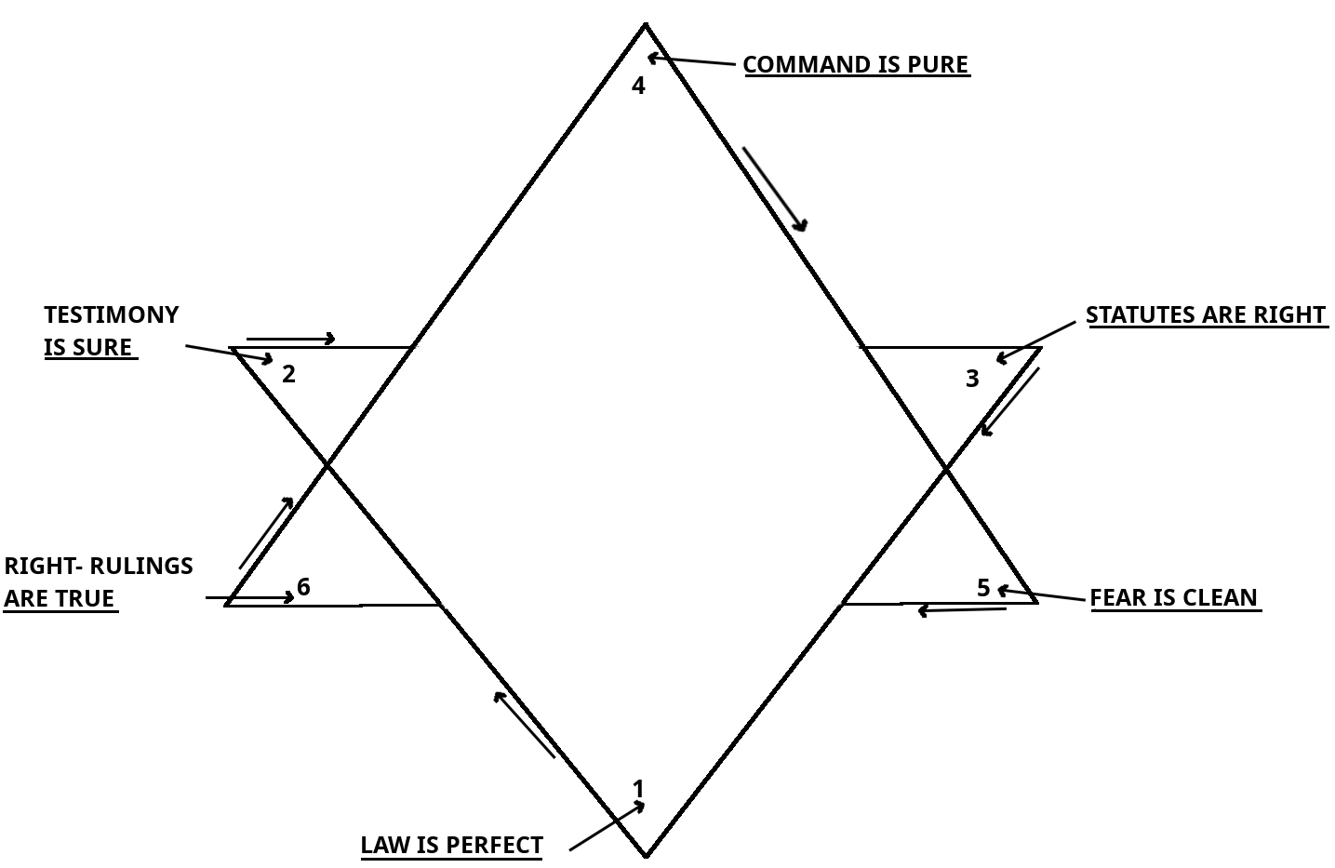
WHY DO ALL OF THE RELIGIONIST PREACH ABOUT NOBODY BEING PERFECT? WHAT IS PERFECTION? CAN WE BE PERFECT? IF SOMEONE TOLD YOU THAT YOU COULD BE PERFECT WOULD YOU BELIEVE THEM OR CALL THEM A LIAR? WELL, WE KNOW THAT THE LAW OF IS PERFECT.

PER’FECT adj 1. COMPLETE IN EVERY DETAIL. 2. WITHOUT DEFECT; FLAWLESS. 4. EXACT PRECISE. 5. THOROUGHLY LEARNED OR SKILLED. 6. UTTER; COMPLETE.
THEREFORE YOU SHALL BE PERFECT, JUST AS YOUR FATHER IN HEAVEN IS PERFECT.
MATYT^{H}YAHU / MATT 5: 48.
46

PHYSICAL - LAW
SOCIAL - TESTIMONY
CHEMICAL - STATUTE
SPIRITUAL - COMMAND
EMOT / LOGICAL - FEAR
MENTAL - JUDGMENT

WHEN BODY, MIND, AND SPIRIT ARE ON ONE ACCORD, WHEN THE HIGHER AND LOWER NATURES ARE BALANCED, YOU ARE READY TO SERVE IN ALL SUBMISSION. YOU ARE READY TI RECEIVE THE POWER OF THE RUWACH QUDASH, YOU ARE READY TO SEVEN YOUR S.E.L.F.

RUWACH QUDASH
360⁰
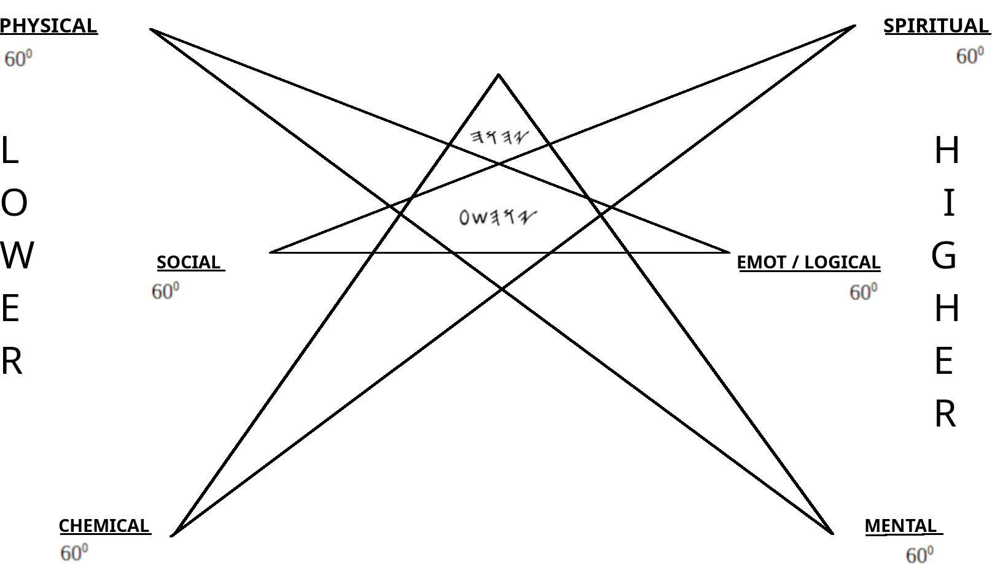
“ BUT HE WHO IS JOINED TO THE ADUN IS ONE RUACH WITH HIM. “
QURANTY’YM / I COR 6: 17
47

MASHYACH TOLD US TO BE PERFECT AND THE LAW OF IS PERFECT, ITS VERY CLEAR ON WHAT IT TAKES TO BE PERFECT. IT TAKES SOUND JUDGMENT TO SEE AND HEAR THIS TEACHING. IF THE LAW IS PERFECT AND I WALK IN THAT PERFECT LAW, WOULDN’T I BE, ACCORDING TO THE SCRIPTURES, PERFECT? WE SHOULD ALL WANT TO BE LIKE THE MOST HIGH IN EVERY WAY WE ARE ABLE. OUR HAPPINESS SHOULD STEM FROM OUR CLOSENESS TO THE FATHER. EARLIER WE SEEN THAT SIN I TRANSGRESSION OF THE LAW – SEPARATES US FROM , ( YASHAYAHU / ISA 59.2 ), SO WOULD THE OPPOSITE JOIN US TO HIM?

THE OPPOSITE OF SIN IS RIGHTEOUSNESS. SIN IS EQUIVALENT TO HATE JUST AS RIGHTEOUSNESS IS EQUIVALENT TO LOVE.

RIGHT’EOUS adj 1. VIRTUOUS; DEVOUT.
- VIR’TU-OUS adj 1. MORAL; UPRIGHT; CHASTE.
- UP’RIGHT adj 2. HONEST; RIGHTEOUS.

RIGHT adj 1. IN CONFORMITY WITH THE MORAL LAW OR STANDARDS; JUST; GOOD. 2. IN CONFORMITY WITH THE TRUTH, FACT, OR REASON; CORRECT; ALSO ORDERLY. n. 1. CONFORMITY TO AN AUTHORITATIVE STANDARD.

RIGHTEOUSNESS IS… WHEN YOU GUARD THE LAW OF .
RIGHTEOUSNESS IS… THE OPPOSITE OF SIN.
RIGHTEOUSNESS IS… OBEDIENCE.
RIGHTEOUSNESS IS… THE TRUTH.
RIGHTEOUSNESS IS... OF THE CHILDREN OF AL’HYM.
RIGHTEOUSNESS IS… BEING ONE WITH .

“ THEN HE TOOK THE BOOK OF THE COVENANT AND READ IN THE HEARING OF THE PEOPLE. AND THEY SAID, “ ALL THAT HAS SAID WE WILL DO, AND BE OBEDIENT. “
SHAMUTH / EXO 24: 7.

48

“ AND WHAT GREAT NATION IS THERE THAT HAS SUCH STATUS AND RIGHTEOUS JUDGMENTS AS ARE IN ALL THE LAW WHICH I SET BEFORE YOU THIS DAY. “
DABARYM / DEUT 4: 8.
“ THEN IT WILL BE RIGHTEOUSNESS FOR US, IF WE ARE CAREFUL TO OBSERVE ALL THESE COMMANDMENTS BEFORE AL’HYNU, AS HE HAS COMMANDED US
DABARYM / DEUT 6: 25.

CLEARLY, WE HAVE A BLUE PRINT FOR OUR SERVICE TO . SIN IS THE BREAKING OF THE LAW, WHILE RIGHTEOUSNESS IS OBSERVING THE LAW. SO, WHILE WE ARE RIGHTEOUS, WE ARE SHOWING OUR LOVE FOR .

“...BUT SHOWING MERCY / GRACE TO THOUSANDS, TO THOSE WHO LOVE ME AND KEEP MY COMMANDMENTS. “
DABARYM / DEUT 5: 10.

“ IF YOU LOVE ME, YOU WILL KEEP MY COMMANDMENTS.
YAHUCHANAN / JN 14: 15

“ FOR THIS IS LOVE OF AL’HYM, THAT WE KEEP HIS COMMANDMENTS…”
YAHUCHANAN / 1 JN 5: 3.

PERFECTION IS OBSERVING, WALKING IN, AND GUARDING THE TURAH OF . PERFECTION IS LOVING WITH ALL YOUR HEART, MIND, BEING, AND STRENGTH AND LOVING YOUR NEIGHBOR AS YOURSELF. ( MARQUS / MK 12: 29-31 )PERFECTION IS SEPARATING YOURSELF FROM WORLDLY DESIRES TO SERVE .
( MATYTHYAHU / MT 19: 21 )

49

AL’HYM – AL – ALYUN – AL’SHADDAY
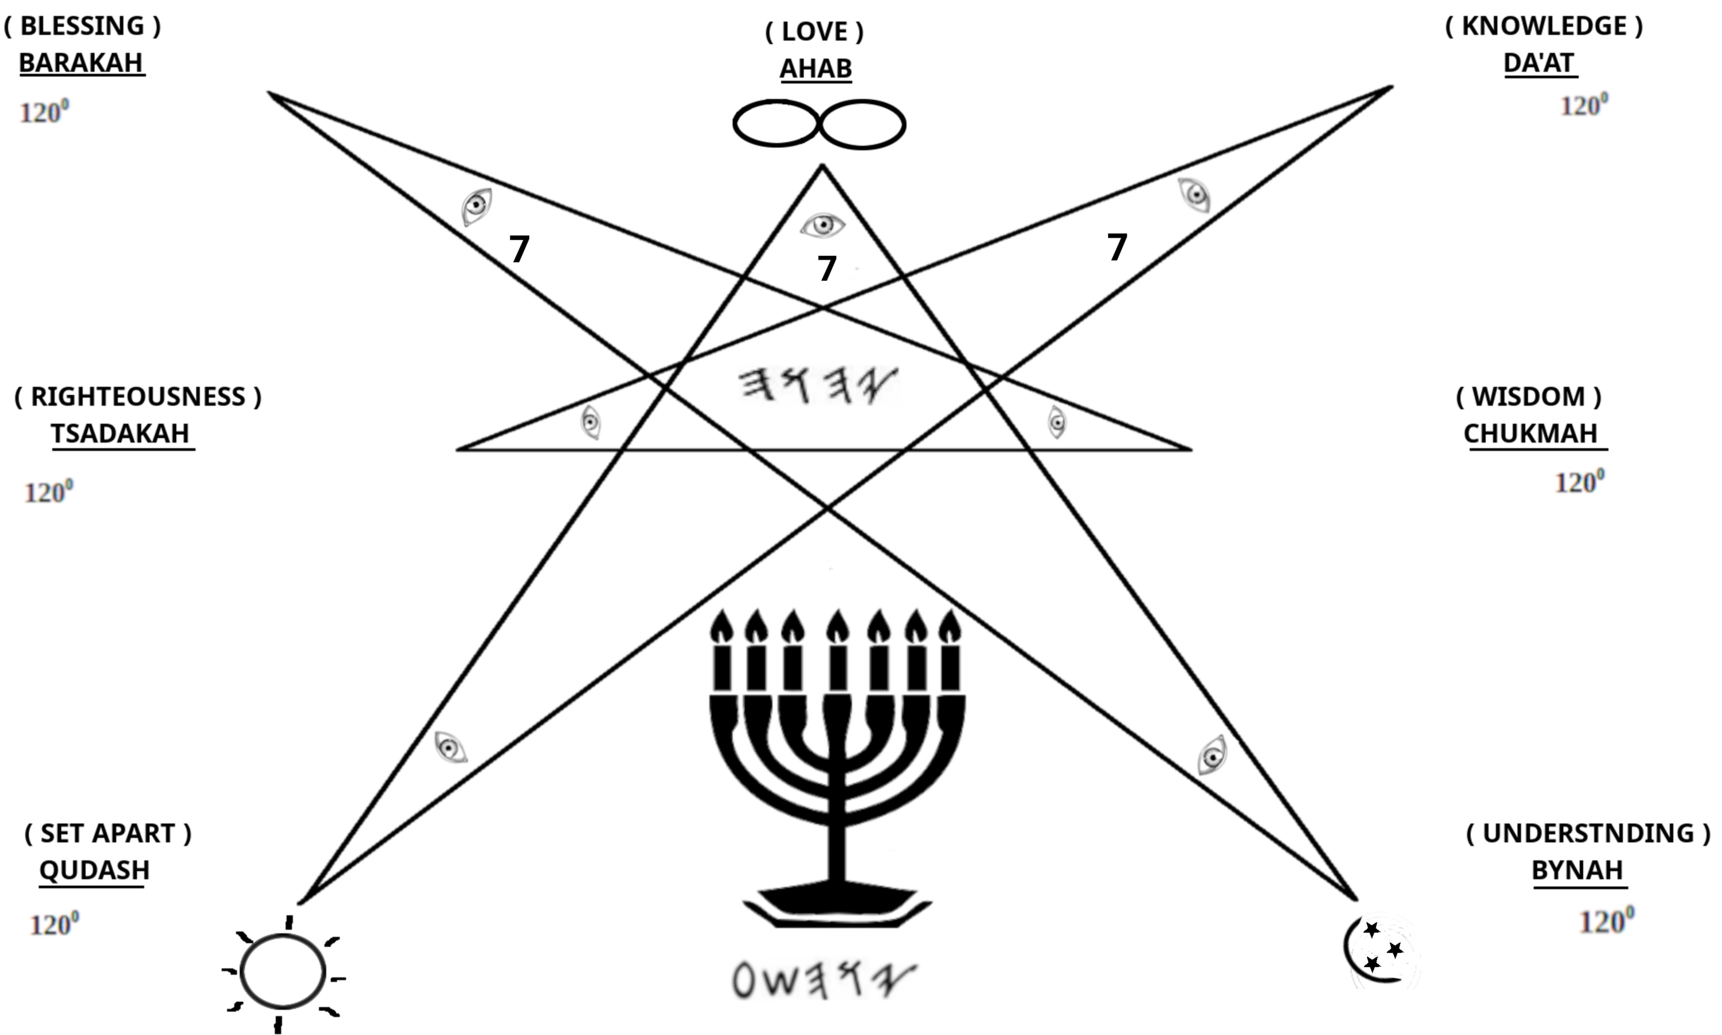
“HE SHALL DELIVER YOU IN SIX TROUBLES, YES, IN SEVEN NO EVIL SHALL TOUCH YOU.”
AYUB / JOB 5: 19.
SEVEN LAMPS OF FIRE WERE BURNING BEFORE THE THRONE, WHICH ARE SEVEN RUWACHYM OF AL’HYM.
CHAZAN / REV 4: 5^{B}.
AND I LOOKED, AND BEHOLD… STOOD A LAMB AS THOUGH IT HAD BEEN SLAIN HAVING SEVEN HORNS AND SEVEN EYES, WHICH ARE SEVEN RUWACHYM OF AL’HYM SENT OUT INTO ALL THE EARTH.
CHAZAN / REV 5: 6 ^{PARA}.

50

WE ARE THE IMAGE OF AL’HYM; HIS CHILDREN, WE SHOULD LIVE AND LOVE AS OUR FATHER COMMANDS US.

TO “ SEVEN “ YOUR S.E.L.F. IS TO REST IN . THE HEBREW WORD SHABA MEANS “ SEVEN “ OR SOMETIMES “ OATH “. SHABA IS ALSO THE ROOT OF THE WORD SHABATH ( SABBATH ), WHICH IS THE SEVENTH DAY, THE DAY OF REST. WHEN WE SEVEN OURSELVES , WE ARE AT REST FROM THE THINGS OF THE WORLD AND ONE WITH OUR FATHER .
FROM THE BEGINNING: “ AND ON THE SEVENTH DAY AL’HYM ENDED HIS WORK WHICH HE HAD DONE, AND HE RESTED ON THE SEVENTH DAY FROM ALL HIS WORK WHICH HE HAD DONE. THEN AL’HYM BARAK THE SEVENTH DAY AND SET IT APART…
BARASHYTH / GEN 2: 23.
TO THE ENDING: “ THEREFORE THE CHILDREN OF YASHAR’AL SHALL GUARD THE SABBATH, TO OBSERVE THE SHABBATH THROUGHOUT THEIR GENERATIONS AS A PERPETUAL COVENANT. IT IS A SIGN BETWEEN ME AND THE CHILDREN OF YASHAR’AL FOREVER;… “
SHAMUTH / EXO 31: 16-17.

PER-PET’U-AL adj 1. EVERLASTING. 2. CONTINUOUS.
COV’E-NANT n. 1. A SOLEMN AGREEMENT. -vt.& I. PROMISES.

A PERPETUAL COVENANT IS AN EVERLASTING SOLEMN AGREEMENT. WE ARE TO OBSERVE THE SEVENTH DAY, THE DAY OF REST, TILL THE END OF THIS AGE. THAT DOESN’T MEAN TO SEPARATE YOUR S.E.L.F. FROM ON THE OTHER SIX DAYS.

“ LET US THEREFORE BE DILIGENT TO ENTER THAT REST, LEST ANYONE FALL ACCORDING TO THE SAME EXAMPLE OF DISOBEDIENCE. “
ABARYM / HEB 4: 11.

51
CHAPTER 8: THE NINE FRUITS OF THE RUACH

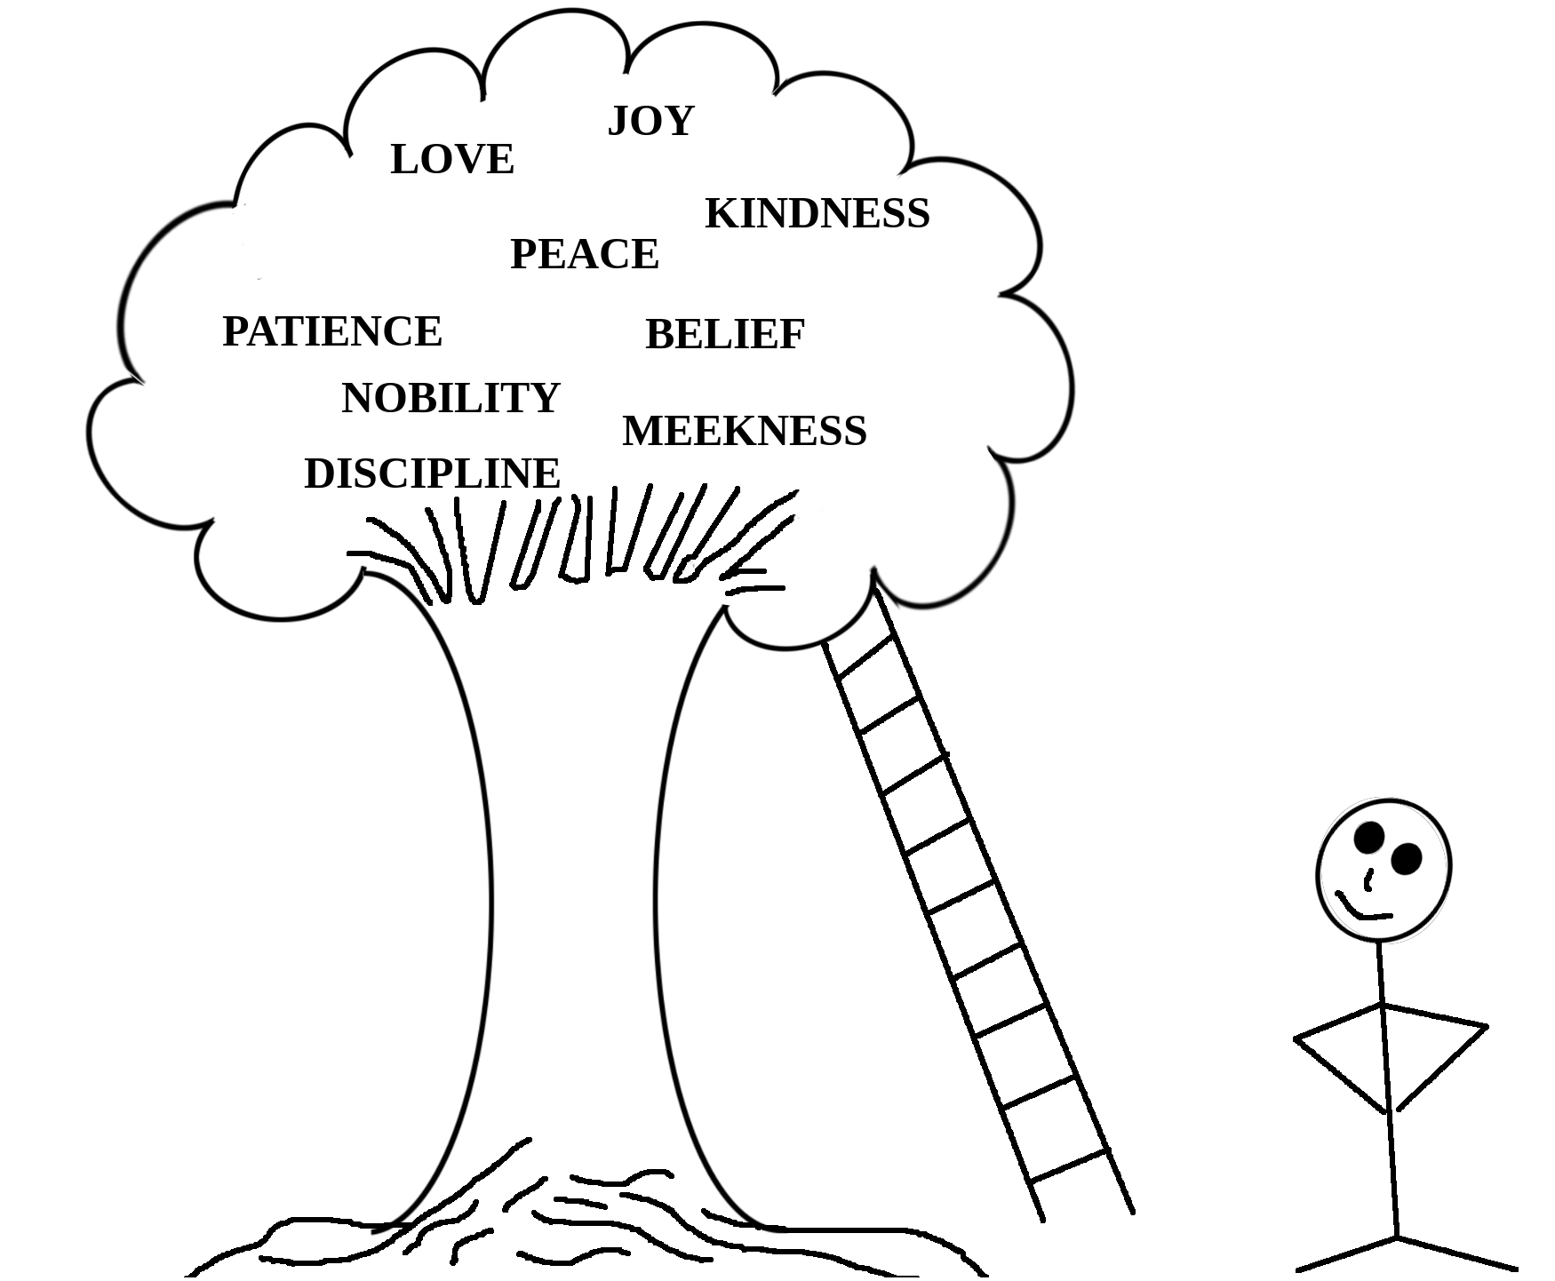
BUT THE FRUIT OF THE RUACH IS LOVE, JOY, PEACE, PATIENCE, DISCIPLINE, NOBILITY, KINDNESS, FAITH AND MEEKNESS. AGAINST THESE THERE IS NO TURAH.
GALATY’YM / GALATIANS 5:22 -23.
BY THESE FRUITS ONE CAN EASILY IDENTIFY AN INDIVIDUAL WHO HAS SEVENED THEMSELVES AND HAVE BECOME ONE WITH . I’M NOT TALKING ABOUT ONE OR TWO OF THE FRUITS, BUT ALL 9 OF THE FRUITS IN HARMONY.

LOVE ( AHABAH ) - n. DEEP AFFECTION AND WARM FEELINGS FOR ANOTHER.
JOY( SHYMCHA ) - n. INTENSE OR ELATED HAPPINESS.
PEACE ( SHALAM ) - n. THE ABSENCE OF WAR OR OTHER HOSTILITIES.
PATIENCE ( ARAK ) - n. ADJ. ENDURING PAIN OR DIFFICULTY WITH CALMNESS TRAINING.
NOBILITY ( NADYBA ) - n. HIGH MORAL CHARACTER.
KINDNESS ( CHASAD ) - n. SHOWING A GENEROUS OR WARM HEARTED
NATURE.

52

BELIEF ( AMUNAH ) - n. TRUST OR CONFIDENCE IN ANOTHER.
MEEKNESS ( ANAUAH ) - n. PATIENCE AND HUMILITY.

IN TOTAL, THE ONE WITH THE INDWELLING OF THE RUACH IS AN INDIVIDUAL THAT:

SHOWS DEEP AFFECTION TOWARDS OTHERS, SHOW ELATED HAPPINESS, IS VERY PEACEFUL AND REMAINS CALM THROUGH HARD TIMES, SHOWS TURAH LIKE CHARACTERISTICS, WITH MORAL APTITUDE, IS WARM HEARTED AND BELIEVE IN THE IN YOU, AND IS HUMBLE.

LET US SEARCH THE SCRIPTURES:
* AND YOU SHALL LOVE YOUR AL’HYM WITH ALL YOUR HEART, AND WITH ALL YOUR BEING, AND WITH ALL YOUR MIGHT. AND YOU SHALL LOVE YOUR NEIGHBOR AS YOURSELF.
DABARYM / DEUT 6: 5; UYQARA / LEV 19: 18^{B}
* FOR HE GIVES WISDOM AND KNOWLEDGE AND JOY TO A MAN WHO IS GOOD IN HIS EYES.
QUHALATH / ECC 2: 26^{A.}
*GREAT PEACE HAVE THOSE LOVING YOUR TURAH- T’HYLLYM / PSALM 119: 165.
* THE PATIENT IS RUACH IS BETTER THAN THE PROUD IN RUACH. - QUHALATH / ECC 7: 8^{B}.
* AND HE WHO OPENS THEIR EAR FOR DISCIPLINE, AND COMMANDS THAT THEY TURN FROM WICKEDNESS. - AYUB / JOB 36:10.
*BY ME PRINCESS RULE, AND NOBILITY, ALL THE JUDGES OF THE EARTH. - MASHALY / PRO 8: 16.
*FOR HS KINDNESS IS MIGHTY OVER US, AND THE TRUTH FROM IS EVERLASTING. PRAISE YAH! - T’HYLLYM / PSA 117: 2.
* BELIEVE IN AND BE STEADFAST, TRUST HIS NABY’YM AND PROSPER. - DYBRA HAYAMYM / 2 CHRON 20: 20^{B.}
* SEEK RIGHTEOUSNESS, SEEK MEEKNESS, IF SO BE THAT YOU ARE HIDDEN IN THE DAY OF WRATH OF . TSAP^{H}ANYAH 2: 3^{B}.

53

SEEING THAT THE 9 FRUITS OF THE RUACH ARE FROM , WE MUST CONCLUDE THAT SERVICE TO YAH IS THE STEPPING STONE OF THE PATH TO ACHIEVE THEM. SAYS: “ MY FRUIT IS BETTER THAN GOLD AND FINE GOLD…”
MASHALY / PRO 8: 19.

WHEN YOU SEVEN YOURSELF AND FIND PERFECTION YOU CAN ENJOY A LIFE LONG EXPERIENCE OF BEING ONE WITH THE MOST HIGH. THE RUACH IS READY TO DWELL WITHIN US AND WE ONLY HAVE TO SET OURSELVES ASIDE AND DO THE PERFECT WILL OF . WHEN WE CAN LOVE AND OUR NEIGHBOR AND NOT HAVE “ I ” ON THE BRAIN, IT IS EASIER TO BECOME THE LIVING TURAH. WE WERE SCATTERED ACROSS THE EARTH BECAUSE WE WANTED TO OUR OWN WILL, AND NOW IT IS TIME FOR US TO EVOLVE INTO A NEW THING.
EAT THESE FRUITS, BUT MAKE SURE YOU RID YOURSELVES OF ALL UNDESIRABLE WAYS FIRST. LOOK AT YOURSELF AND WEIGH YOUR MIND. WHATEVER ISN’T IN LINE WITH THE 9 FRUITS MUST BE DESTROYED. THE ENEMY WILL NEVER SLEEP, WILL NEVER GIVE UP, SO YOU MUST SUBMIT TO AL’HYM AND RESIST THE SHATAN. YOU KNOW THE REST.

“ AND I SAY: WALK IN THE RUACH, AND YOU SHALL NOT ACCOMPLISH THE LUST OF THE FLESH FOR THE FLESH LUSTS AGAINST THE RUACH, AND THE RUACH AGAINST THE FLESH. AND THESE ARE OPPOSE TO EACH OTHER, SO THAT YOU DO NOT DO DO WHAT YOU DESIRE TO DO. BUT IF YOU ARE LED BY THE RUACH, YOU ARE NOT UNDER TURAH.
AND THE WORKS OF THE FLESH ARE WELL KNOWN WHICH ARE THESE:

ADULTERY ( NY’AP )
WHORING ( ZANUT^{H} )
UNCLEANNESS ( TUMAH )
IDOLATRY ( ZYMAH )
DRUG SORCERY ( RYSHUP^{H} )
HATRED ( AYBUTH )
QUARRELS ( MYSTUTH )
JEALOUSIES ( QYNAH )

54

FITS OF RAGE ( RAGAZ )
SELFISH AMBITIONS ( M’RY-BUTH )
DISSENSIONS ( M’CHALUQUTH )
FACTIONS ( KY’T^{H}UT^{H} )
ENVY ( TSARUT^{H} AYN )
MURDERS ( SH’PYKU’T^{H} DAMYM )
DRUNKENNESS ( SHYKKARUN )
WILD PARTIES ( ZULALUTH ), AND THE LIKE – OF WHICH I FOREWARN YOU, EVEN AS I ALSO SAID BEFORE, THAT THOSE WHO PRACTICE SUCH AS THESE SHALL NOT INHERIT THE REIGN OF AL’HYM. “
GALATY’YM / GAL 5: 16-21.
- SHALAM ALAYKHEM -

55

SCRIPTURE REFERENCES FOR THE HIGHER NATURE ( CHAPTER 5 )

BARASHYT^{H} 2: 7
BARASHYT^{H} 4: 7
YAHUCHANAN 3: 8^{A}, 9^{A}, 10^{A}
AP^{H}ASY’YM 6:12
YA’AQUB $: 7
MATYT^{H}YAHU 6: 24^{A}
MASHALY 18: 10
YAHUCHANAN 3: 4
MASHALY 1: 5
AYUB 28: 20
QURANTY’YM 2: 6
MASHALY 9: 9
YA’AQUB 1: 14 – 15
T’HYLLYM 1: 1 – 2
MASHALY 3: 13
MASHALY 6: 16 – 19
AP^{H}ASY’YM 4: 26
T’HYLLYM 4: 4
QURANTY’YM 1: 12
QURANTY’YM 15: 46
QURANTY’YM 6: 20
RUMY’YM 8: 16
T’HYLLYM 18: 2

56
THE LETTER OF YASHAYAHU LUY NAZYR TO THE HEBREWS OR SECOND HEBREWS / HASHANYT^{H} ABARYM

YASHAYAHU LUY, A PRISONER IN CUSTODY OF BABEL, A SERVANT OF YAHUAH - , NOW CALLED SON OF AL’HYM, BELIEVER OF ALL THAT HAS BEEN WRITTEN IN TURAH AND THE NABY’YM.
2. A STUDENT OF MASHYACH YAHUSHA BN YAHUSAP^{H} WHO WAS BORN OF THE SEED OF DA’UD ACCORDING TO THE FLESH, THIS SAME MASHYACH YAHUSHA WHO BECAME THE EXAMPLE OF WHAT ALL OF US OF Y’SHAR’AL SHOULD BE IN RIGHTEOUSNESS,
3. A LOVER OF CHAKAMUAT^{H} , WISDOM, WHO IS DECLARED RIGHT BY ALL HER CHILDREN, OUR MOTHER, IF YOU BELIEVE.
4. I SPEAK SHALAM TO ALL OF THE LOST AND SCATTERED TRIBES OF Y’SHAR’ALAH, THOSE WHO LOVE YAHUAH - , AND DO HIS TURAH, WHILE PROCLAIMING THE BASURAH OF YAHUSHA.
5. MANY GENERATIONS HAVE PASSED SINCE THE CURSES OF THE TURAH SPOKEN BY MASHAH, FROM YAHUAH - , HAVE BEEN POURED OUT UPON US BECAUSE OF OUR DISOBEDIENCE TO DO WHAT WAS PLEASING IN HIS SPIRIT.
6. AS YAHUAH - SPOKE, “ AND YAHUAH - SHALL BRING YOU BACK TO MATSARYM IN SHIPS, “ I BEAR WITNESS TO THIS, AS Y’SHAR’AL HAS BEEN, ‘PLUCKED OFF OF THE LAND,‘ AND ‘SCATTERED AMONG THE GENTILES,‘ AS A WITNESS AGAINST US AND AS A WITNESS FOR US.
7. A WITNESS AGAINST US, I SAY, AS DANY’AL HA'NABY SPOKE TRULY, IN SAYING, “ AND ALL Y’SHAR’AL HAVE TRANSGRESSED YOUR TURAH, AND TURNED ASIDE, SO AS NOT TO OBEY YOUR VOICE. SO THE CURSE AND THE OATH WRITTEN IN THE TURAH OF MASHAH THE SERVANT OF AL’HYM HAS BEEN POURED OUT ON US, FOR WE HAVE SINNED AGAINST HIM, “AND,
8. A WITNESS FOR US, I SAY, AS MASHAH ABAD AL’HYM SPOKE TRULY, IN SAYING, “AND ALL THESE CURSES SHALL COME UPON YOU… AND THEY SHALL BE UPON YOU FOR A SIGN AND FOR A WONDER, AND ON YOUR SEED, FOREVER.”
9. THESE SAME CURSES ARE STILL UPON Y’SHAR’AL TO THIS DAY, AS A SIGN, A WITNESS, TO WHO THE TRUE SEED OF YA’AQUB ARE.
57

10. YAHUAH - HAS GIVEN US AN OPPORTUNITY TO WALK IN HIS TURAH BY ALLOWING US TO ENTER IN HIS COVENANT THAT STANDS FOREVER. AS DA’UD PRAYED, “HE HAS COMMANDED HIS COVENANT FOREVER,
11. THAT WE MAY STAND IN THE ASSEMBLY WHEN HE SAYS, “SEE I MAKE ALL THINGS CHADASH, “CHADASH, MEANING RENEWED. AND THIS IS WHEN WE WILL SEE EVERYTHING THAT HE CREATED BEING RENEWED, INCLUDING HIS COVENANT WITH US, THAT AFTER, HE HAS GATHERED US OUT OF THE LANDS TO WHERE WE WERE SENT IN BONDAGE SHALL WE BE CALLED TO LIBERTY UNDER A RENEWED COVENANT.

MANY OF THE ABARYM MAKE A WIDE MOUTH AND STICK OUT THE TONGUE AT YAHUAH - AND SET UP IDOLS IN THEIR HEARTS. THEY HEAP UP FOR THEMSELVES TEACHERS, HAVING ITCHING EARS, WORSHIPING THE CREATED RATHER THAN THE CREATOR, WHO IS BARAK FOREVER.
2. THIS BEING THE STUMBLING BLOCK OF THOSE AWAKENED, THAT Y’SHAR’AL BE SEPARATED BY THE DOCTRINES OF MEN SPEAKING CONVINCING WORDS, WHILE MISUSING THE TURAH AND NABY’YM TO SUPPORT THEIR UNDERSTANDING,
3. IN THAT ALL THAT WE HAVE BEEN GIVEN IN THE FREEDOM OF MASHYACH YAHUSHA HAS BEEN STRIPPED AWAY BY THE CHAINS OF BONDAGE BY MEN WHO APPOINT THEMSELVES AS AMBASSADORS OF AL ALYUN.
4. HE IS THE CASE, THAT AN ALREADY DIVIDED NATION, THE TWO STICKS OF Y’CHAZAQ’AL HAVE BEEN BROKEN INTO SPLINTERS BY DISPUTES OUR PRECEPTS.
5. THESE FACTIONS, THESE CAMPS, FULL OF SELF-EXALTED ACHYM AND ACHAYUTH, THOUGH NOT ALL, FOR SOME HAVE ONLY COME TO THE KNOWLEDGE OF OUR CULTURE IN THIS MANNER,
6. I SPEAK OF THEY WHO OPPOSE ANY WHO REFUSE TO SALUTE THEIR TEACHER, AS IF THEIR TEACHER HELD THE FULLNESS OF THE BASHURAH OF THE RUACH QADASH ALONE,

58

7. WHO PROCLAIM TO BE THE VOICE OF YAHUAH - , TO BRING
MANY OF THE PEOPLE TO SIN BY SETTING ASIDE THE COMMANDS OF AL’HYM TO GUARD THEIR OWN TRADITIONS.
8. AS YARABA’AM SINNED AGAINST THE MOST HIGH WHEN HE MADE A FESTIVAL ON THE FIFTEENTH DAY OF THE EIGHTH MOON, “ WHICH HE HAD DEVISED IN HIS OWN HEART.”
9. AND AS AHARAN SAID TO THE PEOPLE, “ TOMORROW IS A FESTIVAL TO YAHUAH - , “ AFTER HE MADE THE MOLDED CALF,
10. THESE MEN OF CARNAL MINDS PROVOKE YAHUAH - TO JEALOUSY BY TEACHING THE SHEEP THE WAY OF THE WOLF. TODAY BY THE LAWS OF MEN, Y’SHAR’AL FOLLOWS AFTER THE SUN AND THE CRESCENT MOON, TO ESTABLISH THE FESTIVALS OF YAHUAH - .
11. AS DANY’AL HA’NABY SPOKE, “ IT SHALL THINK TO CHANGE THE APPOINTED TIMES AND TURAH, “ SO Y’SHAR’AL FOLLOWED AFTER THE CUSTOMS OF THE HEATHEN, MARVELING AFTER THE SIGNS OF THE SHAMAYM, AS AL’HYM GAVE THEM OVER TO WORSHIP THE HOST OF SHAMAYM.
12. ALL OF THIS FROM THE HEARTS AND MINDS OF MEN WHO SEEK AFTER POWER, NOT THE POWER OF THE RUACH, BUT THE POWER RECEIVED FROM THE PRAISES OF MEN AND WOMAN THAT REVERE THE MESSENGER RATHER THAN THE MESSAGE,
13. THE WORD OF YAHUAH - , THE MESSAGE OF CHAY AND SHALAM TO ALL BELIEVERS OF THE TRUTH.
14. MASHYACH YAHUSHA SAID TO AL’HYM, “ QADASH THEM IN YOUR TRUTH, YOUR WORD IS TRUTH. “ AND WE MUST EMBODY THIS WORD BY DOING ALL THAT WE ARE INSTRUCTED TO DO, AS IT IS WRITTEN, “ AND THESE WORDS WHICH I AM COMMANDING YOU TODAY SHALL BE IN YOUR HEART, “
15. SO, THEN, MY PEOPLE IF YOU CONSIDER YOURSELVES WISE, AND NOT ENSLAVED TO THE MEN OF PROUD HEARTS, REMEMBER THAT THE ONE WHO TAUGHT YOU THE TRUTH OF YOUR IDENTITY AND CULTURE, IS NOT THE MASTER OF HIMSELF, BUT ALSO A SERVANT OF AL’HYM, AND WHO WILL ALSO STAND BEFORE THE THRONE TO GIVE ACCOUNT FOR ALL THAT HAS BEEN SAID AND DONE IN THE BODY THAT BELONGS TO THE ONE WHO CREATED IT.
59

16. DID YOUR TEACHER CREATE HIMSELF? DID HE TEACH HIMSELF ABOUT THE MYSTERIES OF YAHUAH - ? DID HE DELIVER HIMSELF FROM HIS SINS?
17. NOT EVEN MASHYACH COULD DELIVER HIMSELF FROM THE GRAVE, AS KAPHA SAID, “ YAHUAH - RAISED HIM UP, HAVING LOOSED THE PANGS OF DEATH.”
18. HOW CAN YOU, WHO KNOWS THAT MASHYACH IS THE FIRST RISEN, AND COULD NOT RAISE UP HIMSELF, PUT YOURSELF INTO SUBJECTION TO A MAN WHO HASN’T TASTED DEATH NOR RESURRECTION BUT CLAIMS THE AUTHORITY TO DICTATE YOUR LIFE?
19. IF YOU PUT YOUR TRUST IN MEN YOU WILL DO THE DESIRE OF MEN, BUT IF YOU TRUST IN YAHUAH - , YOU WILL ENTER INTO THE HOUSE OF AL’HYM.
CONCERNING MASHYACH, MEANING: ANOINTED ONE, OUR PEOPLE HAVE FALLEN INTO DISPUTE, SEPARATING THEMSELVES INTO SMALLER FACTIONS. FOR THERE ARE THOSE WHO BELIEVE THAT THERE IS A MASHYACH WHO WAS SLAIN AND RISEN, AND THOSE WHO BELIEVE THAT MASHYACH HAS NOT COME.
2. TO THOSE WHO BELIEVE THAT MASHYACH HAS COME, AMONG THEM IS DIVISION, CONCERNING THE MANNER OF HIS BIRTH, HIS NAME, AND WHETHER HE DIED ON THE TREE OR IN A FARAWAY LAND. TO THESE I ASK, DOES THIS MATTER BEAR WITNESS AGAINST YOU?
3. FOR IF MASHYACH IS THE SOURCE OF YOUR DIVISION THEN BY WHAT ARE YOU UNITED?
4. IF THERE INDEED CAME ONE WHOSE NAME MEANT YAHUAH - DELIVERS, HOWEVER YOU PRONOUNCE IT, IS NOT THE POINT BEING THAT YAHUAH - WHO DELIVERS US IS GREATER THAN THE ONE HE HAS SENT?
5. AS AL’HYM SPOKE THROUGH ALL OF THE NABY’YM, DID ANY ONE OF THEM IN THEIR OWN NAME? HAVE NOT ALL OF THEM SAID, “ THUS SAID YAHUAH - ? “ EVEN MASHYACH SAID, “ I AM COME IN MY FATHERS NAME… “ AS WHO, SPOKE A WORD FROM WHAT WAS COMMANDED HIM,
60

6. THEN THE FULLNESS OF THE MESSAGE OF DELIVERANCE COMES BY YAHUAH - , NOT THE FLESH OF THE ONE HE HAS SENT, AS YAHUAH - SPOKE THROUGH YASHAYAHU HA’NABY, SAYING, “ I, EVEN I AM YAHUAH, AND BESIDES ME THERE IS NO SAVIOR. “
7. AL’HYM CONTINUES , “ I, I HAVE DECLARED AND SAVED… “ AGAIN, IT IS WRITTEN, “ Y’SHAR’AL SHALL BE SAVED BY YAHUAH - WITH AN EVERLASTING DELIVERANCE.
8. IF MASHYACH IS YOUR SAVIOR THEN WHO IS YAHUAH - ? BUT WE ALL AGREE IN KNOWLEDGE, THAT THE NAME OF MASHYACH IN ITS SIMPLEST FORM. ‘YAH SAVES, ‘ TO WHICH WE SEE THAT THE SAVIOR AND DELIVERER IS YAHUAH - , REGARDLESS OF THE VESSEL USED FOR HIS PURPOSE.
9. OR, WHICH OF YOUR TEACHERS ARE BOLD ENOUGH TO SPEAK AGAINST YAHUAH - AS HE CALLED A GENTILE MASHYACH?
10. AS HE SPOKE THROUGH YASHAYAHU HA’NABY SAYING, “ THUS SAID YAHUAH - TO HIS ANOINTED, TO KURASH…. “ THIS KURASH OF MADAY AND PARAS, OF NO DESCENT FROM THE LOINS OF YA’AQUB, WAS CALLED MASHYACH BY THE AL’HYM OF Y’SHAR’AL,
11. WHOM AL’HYM GAVE AUTHORITY TO REBUILD THE CITY AND LET THE EXILES GO. ARE WE ARROGANT IN OUR HEARTS TO STRIVE WITH OUR ACHYM AND ACHAYUTH WHO TRUST IN YAHUAH - AND DO HIS COMMANDS, ALL BECAUSE OF OUR SINGLE MINDEDNESS ON THE FLESHLY SUBJECTS OF MASHYACH.
12. FLESHLY, MEANING: THE MANNER OF HIS BIRTH, THE SOUNDS OF HIS NAME, AND THE PROCESS OF HIS DEATH.
13. IF YAHUAH - SENT AN ASS TO DELIVER HIS MESSAGE WOULD WE ARGUE THAT HE SENT A DONKEY OR A MULE?
14. WHAT OF THE MESSAGE? AND IF YAHUAH - HAS SPOKEN FROM THE MOUTH OF AN ASS, THE ASS DIED BUT THE MESSAGE STILL LIVES AS YAHUAH - LIVES!

61

IF MASHYACH HAS NOT COME THEN WHO ARE YOU, Y’ SHAR’AL
2. IF NONE OF YOU HAS BEEN ANOINTED THEN WHO DOES YAHUAH - SPEAK OF WHEN HE SAYS, “ DO NOT TOUCH MY ANOINTED ONES… “? OR WHO ARE THESE SPOKEN OF BY Y’RMEYAHU HA’NABY, AS HE LAMENTS FOR YAHUDAH, SAYING, “ THE BREATH OF OUR NOSTRILS THE ANOINTED OF YAHUAH - , WAS CAUGHT IN THEIR PITS…
3. IF MASHYACH HAS NOT COME, THEN YOU, O’ Y’SHAR’AL, FORSAKE THE CALLING.
4. FOR MASHAH SAVE YOU THE WORDS OF AL’HYM, WHICH YOU AGREED TO DO ALL THAT WAS COMMANDED, CONSIDERING THIS, “ AND YOU SHALL BE TO ME A REIGN OF KAHANYM, A QUDASH NATION… “ THAT EVERY KAHAN IS ANOINTED, EVERY KAHAN IS MASHYACH!
5. Y’SHAR’AL, WHO ALWAYS LOOKS TO THE FLESH IS QUICK TO CONDEMN THAT WHICH IS HARD TO UNDERSTAND. IF ONE OF THE ACHYM IS ESTEEMED FOR HIS OBEDIENCE TO TURAH, HIS COMPASSION UPON THE FATHERLESS AND THE WIDOW, AND HIS KNOWLEDGE AND LABOR IN THE CULTURE, DO YOU LOOK TO HIM FOR GUIDANCE IN THE TRUTH OF OUR HERITAGE?
6. THIS MAN, BEING JUST A MAN AS ALL OTHERS BEFORE HIM, WHO DOES WHAT HE IS REQUIRED OF BY AL’HYM, HE RECEIVES PRAISE FOR HIS DEDICATION TO THE CALLING OF AL’HYM. YOU ESTEEM HIM AS A TEACHER AND AN ELDER. THERE IS NO FAULT IN THIS!
7. WHERE DOES THE SCRIPTURE FAIL THEN, WHEN DA’UD SAY THIS, “YAHUAH - SAID TO MY ADUN, SIT AT MY RIGHT HAND… “ AND DA’UD BEING MALAK IN Y’SHAR’AL AND YAHUDA, WHO HAD NO EQUAL IN EMINENCE THROUGHOUT THE LANDS, WHO DID HE SPEAK OF AT THIS TIME?
8. WHO WAS THE ADUN OF DA’UD THAT AL’HYM COMMANDED TO SIT AT HIS RIGHT HAND?
9. DA’UD WAS A NABY, A MAN OF YAHUDAH, A MAN WHO CAME IN THE NAME OF YAHUAH - , A MAN WHO ALSO, AS ALL OTHER MEN, HAD TRESPASSED AGAINST AL’HYM IN THE MATTER OF URYAH, BY THE ACHAH BATHSH’BA.
62

10.IS THIS THE ONE SPOKEN OF BY YASHAYAHU HA’NABY WHEN HE SAID, “ BUT HE WAS PIERCED FOR OUR TRANSGRESSIONS, HE WAS CRUSHED FOR OUR WICKEDNESS. THE CHASTISEMENT FOR OUR SHALAM WAS UPON HIM, AND BY HIS STRIPES WE ARE HEALED.”?
11. AND IF SO, WHEN DID DA’UD BEAR ALL THE FOR US? WHICH OF THE NABY’YM WITNESSED THIS?
12. AGAIN, YASHAYAHU HA’NABY DECLARES, “ AND HE WAS APPOINTED A GRAVE WIT THE WICKED, AND WITH THE RICH AT HIS DEATH, BECAUSE HE HAD DONE NO VIOLENCE, NOR WAS DECEIT IN HIS MOUTH… “
13. DA’UD, OUR GREAT MALAK, HAS BOTH DONE VIOLENCE AND HAS HAD DECEIT IN HIS MOUTH.
14. YAHUAH - SAID TO DA’UD, “ YOU SO NOT BUILD A HOUSE FOR MY NAME, BECAUSE YOU HAVE BEEN A MAN OF BATTLE AND HAVE SHED BLOOD. “
15. DA’UD DID DECEIVE URYAH AFTER COMMITTING ADULTERY AGAINST HIM AND SENDING HIM TO THE FRONT LINE TO DIE.
16. I DO NOT ACCUSE THIS GREAT NABY AND MALAK! ACHYM AND ACHAYUTH, THESE WORDS ARE WRITTEN IN OUR HISTORY!
17. NO, THESE THINGS WERE SAID AND DONE AS A WITNESS. WHAT IS THE PURPOSE OF THE DABAR IF NOT FOR EDIFICATION?
18. DA’UD WAS GIVEN A PROMISE BY YAHUAH - , “ I SHALL RAISE UP YOUR SEED AFTER YOU… HE BUILDS ME A HOUSE… I AM TO BE HIS FATHER, AND HE IS TO BE MY SON. “
19. YES, SHALAMAH DID BUILD A HOUSE. HE TRESPASSED AS WELL, AND THAT HOUSE WAS DESTROYED. YAHUAH - GAVE DA’UD A PROMISE, AND THOUGH THE PHYSICAL HOUSE WAS DESTROYED, THE BLOOD AND THE RUACH REMAINED. THEREFORE, THE PROMISE IS STILL VALID.
20. BY THE SEED OF DA’UD, A SPIRITUAL HOUSE WAS BUILT, AND THIS BLOODLINE REMAINS, A RIGHTEOUS HOUSE OF THOSE CALLED THE SONS OF OF AL’HYM. THIS HOUSE SHALL STAND FOREVER AND ONE OF DA’UD SHALL REIGN FOREVER.
21. AGUR BN YAQAH ASKED AYTHY’AL AND AKAL, “ WHAT IS HIS NAME AND WHAT IS THE NAME OF HIS BAN, IF YOU KNOW?”
63

22. TAKE HEED Y’SHAR’AL AND KNOW THIS, WHETHER YOU BELIEVE THAT MASHYACH HAS COME OR IS COMING, THERE IS NOTHING NEW UNDER THE SUN, TO WHOEVER YOU CLAIM MASHYACH IS OR WILL BE, THE ESTEEM AND HONOR ALL GOES TO YAHUAH - , NOT TO WHO IS SENT.

IN ESTEEM WE SAY, “ KAL HALAL L’AL ALYUN, “ OR, IN THE GENTILE LANGUAGE, “ ALL PRAISE TO THE MOST HIGH! “ BUT ALL PRAISES HAVEN’T BEEN TO AHBA IN THIS GENERATION.
2. THIS GENERATION IS CONCERNED WIT BOASTING IN THEIR OWN WAY.
3. I MEET AN ACH OR ACHUTH AND I AM GREETED WITH, “ HOW IS YOUR HEALTH? OR, “ IS THERE A B’RAKAH IN THE LAND?” NO, MYSHPACHAN, I AM ASK, “ WHAT CAMP AM I FROM? “ OR,“ WHO IS MY ELDER? “ OR,” WHOSE TEACHINGS AM I UNDER?”
4. DID NOT YASHAYAHU HA’NABY SAY, “ AND ALL YOUR CHILDREN TAUGHT BY YAHUAH - ? DOES TURAH SUPPORT YOUR KNOWLEDGE?
5. IF YOU ASK, I HAVE NO CAMP! I AM THE SEED OF ABRAHAM! I HAVE NO ELDER, FOR YAHUAH - GAVE US THE TURAH FOR ALL, NOT FOR ONE! I AM UNDER THE TEACHING OF THE WORD OF AL’HYM! NO MAN IN THIS AGE CAN STRAIGHTEN WHAT IS CROOKED!
6. WHICH ONE OF YOU INTERPRETS FOR YAHUAH - ?
7. BE OBEDIENT TO THE EVERLASTING COVENANT! ENTER IN IF YOU HAVEN’T YET! HOW CAN YOU BE A PART OF WHAT WILL BE RENEWED, IF YOU AREN’T A PART OF WHAT IS CURRENT? OR, HOW CAN YOU RENEW WHAT YOU NEVER HAD?
8. DID NOT YAHUAH - SAY TO Y’RMEYAHU HA’NABY, “ I HAD PUT HER AWAY AND GIVEN HER A CERTIFICATE OF DIVORCE… “ AND, “ BUT INDEED AS AN ASHAH BETRAYS HER HUSBAND, SO YOU HAVE BETRAYED ME, O HOUSE OF Y’SHAR’AL… “ ALSO, “ IF A MAN PUTS AWAY HIS ASHAH, AND SHE GOES FROM HIM AND BECOMES ANOTHER MAN’S, DOES HE RETURN TO HER AGAIN? WOULD NOT THE LAND BE MADE GREATLY UNCLEAN? “
9. AND MASHAH AGREES AND SAYS, “ AND HE SHALL WRITE HER A CERTIFICATE OF DIVORCE, AND PUT IT IN HER HAND, AND SEND HER OUT OF HIS HOUSE…”
64

10. AS WE KNOW, YAHUAH - HAS INDEED SENT US OUT OF HIS HOUSE! HE SCATTERED US AMONG THE HEATHEN AND GAVE US TO OUR MANY LOVERS.
11. WHEN AND HOW DID YOU REESTABLISH YOUR VOW? HOW DID YOU BECOME ONE WITH AL’HYM AGAIN? WITH YOUR MOUTH? BECAUSE YOU RE-LEARNED YOUR IDENTITY? BECAUSE YOU CHANGED YOUR NAME?
IT IS THAT SIMPLE FOR YOU TO FORCE YOUR WAY BACK IN?
12. IF SO, MAKE ROOM FOR THE GENTILES! CONSTANTINE AND HIS DEATHBED CONFESSION SHOULD BE APPROVED AS WELL!
13. FOOLISH Y’SHAR’AL. THE COVENANT MADE WITH ABRAHAM, THEN WITH Y’TSCHAQ AND YA’AQUB IS THE SAME COVENANT THAT MUST BE ESTABLISHED AFTER THE DIVORCE, IF YOU WISH TO RETURN.
14. FOR AL’HYM SAID WORDS SUCH AS, “ THROUGHOUT THEIR GENERATIONS, “ FOREVER, “ “ EVERLASTING COVENANT, “ TO ABRAHAM IN THE DAY HE COMMANDED HIM TO BE PERFECT.
15. WE BROKE OUR PART OF THE COVENANT. HIS WORD CONTINUED ON AS WE WERE SHACKLED AND CHAINED. HIS COVENANT STOOD FROM THE DAY HE ESTABLISHED IT TO THIS VERY HOUR.
16. “ HE REMEMBERS HIS COVENANT FOREVER, “ DA’UD WROTE.
17. WHILE THE BREACH IS BEFORE US, DO WE IN BOLDNESS PRESENT OURSELVES TO YAHUAH - AS IF IT IS NO BREACH? OR DO WE REPAIR THE BREACH BY REPENTANCE OF SIN, CONFESSING ALL OF OUR FAULTS WITH HUMILITY AND FEAR?
18. PRAYING THAT WE ARE FOUND WORTHY TO SPEAK THE NAME THAT ALL MUST CALL UPON TO BE DELIVERED. MERCY IS A GIFT TO US WHO HAVE RECALLED THE SINS OF OUR FATHERS BEFORE US. THEN, OUR OWN SINS WE MUST RECOUNT AND PRAY TO THE MOST MERCIFUL FOR HIS LOVE AND COMPASSION.
19. PRIDE AND STUBBORNNESS OF HEART WILL PREVENT US FROM ENTERING INTO THE COVENANT OF OUR FATHERS. BUT, IF WE HUMBLE OURSELVES AND ENTER INTO HIS COVENANT, TO DO IT WITH OUR ALL, WHEN ALL THINGS BECOME RENEWED, WE TO SHALL BE RENEWED, NOT INTO DIVISION OF CAPS, BUT INTO A HOUSE, ONE HOUSE IN THE RUACH OF TRUTH.

65

IN OUR CAPTIVITY, WE AS A PEOPLE HAVE FOUND COMFORT IN THE CUSTOMS OF THE GENTILES.
2. THEIR BELIEFS WE PRACTICE, THEIR CLOTHING WE LUST AFTER, THEIR FOOD WE EAT, THEIR LANGUAGE WE HAVE PERFECTED, THEIR WOMEN WE MARRY, AND MANY OTHER ABOMINABLE ACTS WHICH Y’SHAR’AL WILL EXCUSE TO SUIT OUR DESIRES.
3. TRULY, AS IT IS WRITTEN, “ THE LANDS OF OUR ENEMIES HAVE SWALLOWED US UP… “ WE HAVE COMPROMISED OUR RIGHTEOUSNESS FOR THE ACCEPTANCE OF STRANGERS.
4. IN THE CITIES, LOOK TO THE LEFT AND RIGHT AND COUNT THE WAYS OF PERVERSION ON UNCLEANNESS! EVERY MARKET SELLS THE FILTH OF THE SWINE, THE IMAGES OF IDOLS, AND EVERY UNNATURAL FLESHLY DESIRE OF MANS HEART.
5. YET, WE STILL ABIDE WITHIN THE BOUNDARIES OF THESE PLACES KNOWING FULL WELL THE ATROCITIES BEING COMMITTED ALL AROUND. IF ONE IS UNCLEAN, IS HE NOT SEPARATED FROM THE COMMUNITY UNTIL HE IS PRONOUNCED BEING CLEAN?
6. BUT YOU, WHO KNOW THE TURAH, KNOWING THE WICKEDNESS OF THE CITY THAT YOU DWELL IN, CONTINUE TO DWELL THERE FOR YOUR COMFORT AND ACCESS TOY YOUR DESIRES.
7. LISTEN, AND TAKE CARE TO ACT! PURCHASE A PLOT OF LAND AWAY FROM THESE CITIES OF FILTH. GATHER YOURSELVES TOGETHER AND SEEK SAFETY AMONG YOUR OWN.
8. FOR YAHUAH - HIMSELF COMMANDED US TO, “ COME OUT FROM AMONG THEM AND BE SEPARATE… “
9. THE MAL’AHK ALSO SPOKE FROM THE SHAMAYM SAYING. “ COME OUT OF HER, MY PEOPLE, LEST YOU SHARE IN HER SINS, AND LEST YOU RECEIVE OF HER PLAGUES, BECAUSE HER SINS HAVE PILED UP TO REACH THE SHAMAYM, AND AL’HYM HAS REMEMBERED HER UNRIGHTEOUSNESS.
10. OR WILL YOU BE LIKE LUTS ‘ ASHAH, WHOSE HEART STAYED WITH THAT WICKED PLACE, AND DISOBEYING THE COMMAND SHE LOOKED BACK?
11. GET OUT OF THESE CITIES, MYSHPACHAH. COME TOGETHER, GATHER UP YOUR WAGES AS ONE BODY, PURCHASE THE FIELD AWAY FROM THE

66

TEMPTATIONS OF THE HEATHEN, PLANT AND GROW CROPS, MAKE YOUR OFFERINGS YAHUAH - ,
12. FOLLOW THE TURAH OF THE UNCIRCUMCISED YEAR AND THE SEVENTH YEAR SH’MYTAH. WHAT IS HOLDING YOU BACK BESIDES YOUR OWN SELF?
13. HAVE YOU COME TO LOVE THEIR WAYS? THE WAY? THE WAY THEY ENTERTAIN THEMSELVES? THEIR GAMES AND CELEBRATIONS?
14. YET YOU CALL YOUR SELVES ABARYM! HOW DID ABRAHAM SERVE? DO THAT! HOW DID HE EAT? DO THAT! HOW DID HE DRESS, TALK, WALK, WORK? ACHYM AND ACHAYUTH, AS MASHYACH YAHUSHA PLAINLY SAID, “ IF YOU WERE ABRAHAM'S CHILDREN YOU WOULD DO THE WORKS OF ABRAHAM. “
15. BELIEVE THIS, IF NOTHING ELSE; WHOEVER YOUR FATHER IS, YOU WILL DO AS HE DOES. IF YAHUAH - , THEN YOU WILL DO HIS WORK, AND IF HA’SHATAN, YOU WILL DO HIS.
16. YOU, BEING QUDASH, SHOULD NOT LIVE AMONG THOSE WHO FORSAKE THE ONE YOU CALL AHBA. HOW CAN YOU HATE THE WICKEDNESS OF THE

SOME OF YOU WILL ACCUSE ME. SOME WILL ASK HOW I, A PLAIN AND POOR MAN OF LOW STATION, A PRISONER EVEN, HAS A RIGHT TO SPEAK A WORD.
2. TRULY, I AM LOWLY, AND MY ASHAH SUFFERS WHILE, IN THIS IMPRISONMENT SUFFERS AS WELL. AND THERE ARE DAYS WHEN I DO ARGUE AGAINST MY CALLING, RUNNING AWAY FROM THE RUACH HAS ASKED ME TO DO.
3. AND IN MY WEAKNESS, MY ASHAH WOULD VISIT ME AND RENEW THE VIGOR THAT SET ASIDE. I WAS CHASTISED FOR MY WEAKNESS BY THE RUACH AND COMMANDED TO SPEAK TO MY PEOPLE.
4. HERE I AM, A MAN OF Y’SHAR’AL, JUST LIKE YOU ALL. I FALL AS YOU FALL, AND I RISE AS YOU RISE. I WAS NOT BORN IN WEALTH OR DID I RECEIVE A WESTERN EDUCATION.5. AGAIN, I WRITE TO YOU ALL FROM THIS PRISON TO BE REMIND YOU OF A CULTURE AND A HERITAGE THAT HAS BEEN FORGOTTEN.

67

6. THE RUACH SPEAKS TO US AS YAHUAH - SPOKE TO TO US BEFORE AND WE DO NOT HEAR BECAUSE OF OUR MANY DISTRACTIONS. A NATION DIVIDED WE ARE, DISTRACTED BY OUR OWN WAYS.
7. FROM WHAT I WITNESSED, HERE ARE SOME OF THE WAYS THAT WE DIVIDE OURSELVES: PRONUNCIATION OF NAMES, WHETHER THERE IS A MASHYACH OR NOT YET, USING ONLY TANAKH OR BRYTH CHADASH AS WELL, POLYGYNY OR MONOGAMY, WEARING TSYSYUTH OR NOT, WEARING OF CULTURAL GARMENTS OR NOT, WHAT TEACHER IS BEING HEARD, WHAT DOCTRINE IS TAUGHT, Y’SHAR’AL FROM ONE RACE OR MANY, THE NEW MOON OR THE CRESCENT, THE 7TH DAY PERPETUAL SHABATH OR LUNAR SHABATH,
8. SHALL I CONTINUE? WE AS A PEOPLE FORGOTTEN THE CREED THAT BEGINS OUR WAY, THAT IS; SH’MA Y’SHAR’AL, YAHUAH - AL’HYNU, YAHUAH - ACHAD! AND IF HE IS ONE, THEN OUR UNITY SHOULD BE ESTABLISHED ON ONE, NOT MANY, FOR THERE IS ONLY ONE AL’HYM OF Y’SHAR’AL,
9. THE AL’HYM OF ABRAHAM, YTS’CHAQ, AND YA’AQUB. OR DOES THE SOUND OF YOUR SPEECH CONFUSE YOU AS THOSE AT BABEL WERE CONFUSED?
10. ONE SAYS, THEN “ THUS SAID AHAYAH -
11. ONE SAYS; “ THUS SAID YA’OH - !”
12. ONE SAYS; “ THUS SAID YAHAWAH - !”
13. ONE SAYS; “ THUS SAID YAHWEH - !”
14. ONE SAYS; “ THUS SAID YEHOWAH - !”
15. ONE SAYS; “ THUS SAID YAHUAH - !”
16. ALL HAVE SAID, “ THE SELF EXISTING ONE, “ IN A MANNER OF WHAT THEY WERE TAUGHT, YET, WHICH OF THESE SOUNDS COMMANDS YOU TO SIN? HAS ANY OF THESE THAT YOU PRONOUNCE LED YOU TO EAT SWINE? TO SODOMIZE? TO MURDER?
17. BUT YOU JUDGE ONE ANOTHER AS BLASPHEMERS OVER SOUNDS OF SPEECH! IF AN ACH OR ACHUTH WAS MUTE, AND UNABLE TO UTTER ANY OF THESE, BUT HE GUARDS THE TURAH IN FULL, WILL YOU STONE TO DEATH THIS ONE WHO DOES THE WORKS OF AL’HYM?

68

18. IF AN ACH OR ACHUTH IS DEAF, AND HAS NEVER HEARD ANY OF THESE SOUNDS, BUT WAILS AN UNINTELLIGIBLE SOUND IN THEIR DAY OF NEED, DO YOU CAST HIM DOWN AND SLAY HIM FOR SINNING?
19. YOU WHO HATE THE CHILDREN OF AL’HYM HAVE BECOME JUDGES THAT JUDGE BY YOUR OWN KNOWLEDGE. I AM NOT AFRAID TO DIE AS I HAVE NO CAMP TO DEFEND ME. I KNOW SOME OF YOU THIS VERY HOUR SPEAK AGAINST THIS MESSAGE.
20. DID NOT YAHUAH - SAY, “ CRY ALOUD, SPARE NOT…”?

WE SHOULD NOT BE OFFENDED BY STRAIGHTENING OR REPROOF AS THESE SAVE US FROM FAILURE. CORRECTION IS LOVE FOR A RIGHTEOUS ONE. IF AN ACH PREVENTS ME FROM FALLING INTO A PIT, OR BURNING IN A FLAME, SHOULD I SLAP HIM IN THE MOUTH?
2. THE VOICE WAS HIS, BUT THE MESSAGE WAS FROM YAHUAH - ,
3. THE MESSAGE WAS THE WARNING TO TURN AWAY FROM WICKEDNESS AND LIVE ACCORDING TO THE WAY THAT WAS PROCLAIMED BY NABY’YM IN EVERY GENERATION.
4. I AM PLEADING, OR IF YOU CAN RECEIVE THIS, THE RUACH THROUGH ME, THAT YOU GO TO THE MOST HIGH AND SUBMIT YOURSELF FULLY, AND ASK HIM, NOT YOUR TEACHER OR YOUR ELDER, TO REVEAL HIS WILL IN YOUR LIFE.
5. YOU HAVE DONE YOUR OWN WILL FOR LONG ENOUGH, AND WHAT HAS IT GAINED YOU?
6. YAHUAH - SET A CHOICE BEFORE YOU, CHAY OR DEATH. IF YOU CHOOSE CHAY, THEN ARE YOU NOT ALSO CHOOSING OBEDIENCE TO HIS WORD AND DOING HIS TURAH? DO YOU CONTINUE TO ASSEMBLE ON QUDASH DAYS IN AN UNCLEAN PLACE? DO YOU PRACTICE HIS TURAH IN ALL YOUR WAYS? DO YOU WORK ON SHABATH FOR A GREAT WAGE AND CALL YOURSELF BARAK, AND SAY YAHUAH - WILL FORGIVE ME, HE PROVIDED THIS WORK FOR ME, HE HAS BARAK ME IN MY SIN.”
7.YOU WHO KNOW THE TURAH AND THE TRUTH OF YAHUAH - KNOWS THAT THERE IS NO PENALTY WITH AL’HYM. BECAUSE YOU DESIRE

69

TO STAY IN THE COMFORT OF THE GENTILES, AND BE NEIGHBORS WITH THE ABOMINABLE, DO NOT SAY, “ YAHUAH - HAS GIVEN ME THIS BIG HOUSE, RICHES, AND MATERIAL GAIN!”
8. THIS IS THE GOLD RING IN THE PIG’S SNOUT. WHAT WILL YOUR BIG HOUSE, RICHES, AND MATERIAL GAIN DO WHEN THE CITIES ARE MADE INTO RUINS? WHERE WILL THE RICHES SPEND?
9. SIS NUACH WAIT FOR THE RAIN TO COME TO BUILD THE ARCH, OR WAS HE WARNED FIRST, 120 YEARS BEFORE, THAT MANKIND WOULD BE DESTROYED FROM THE EARTH?
10. ARE YOU WAITING TO SEE SMOKE BEFORE YOU GATHER YOUR HOUSE AND FLEE THE BURNING CITIES? WHEN WILL YOU LISTEN TO AL’HYM AS HE CALLS OUT? YASHAYAHU HA’NABY WARNED US, “ FOR YOU SHALL MAKE A CITY A HEAP, A WALLED CITY A RUIN, A PALACE OF FOREIGNERS TO BE A CITY NO MORE – NEVER TO BE REBUILT. “ ALSO, “ THE CITY IS LEFT IN RUINS, AND THE GATE IS STRICKEN WITH DESTRUCTION. “
11. THESE CAME AFTER THE WARNING THAT, “ THE INHABITANTS OF THE EARTH SHALL BE BURNED… “
12. MAKE OF THIS WHAT YOU WILL. IF YOU WISH TO REMAIN IN THE LAND OF CAPTIVITY AND REMAIN A SLAVE, AND REMAIN UNCLEAN BY THE UNCLEANNESS AROUND YOU, YOU ARE BOLD IN YOUR FOOLISHNESS. YOU WILL SHARE IN HER SINS AND RECEIVE OF HER PLAGUES.

TO MY ACHYM AND ACHAYUTH, AND TO THE CONVERTS FROM THE LANDS OF THE FOREIGNERS, ALL WHO ESTEEM THE MAKER AND THE GIVER OF CHAY,
2. WE WHO HAVE WITNESSED THE AWAKENING OF THE DRY BONES, OR, THE RESURRECTION OF THE DEAD. THE DEAD, WHO Y’SHAR’AL WAS ACCORDING TO THE FLESH, WHO NOW LIVE ACCORDING TO THE RUACH OF TRUTH,
3. BE AWARE WHO YOU CALL ACHY OR ACUTHY, AS ALL WHO CALL THEMSELVES ABARYM ARE NOT THE CHILDREN OF THE INHERITANCE.
4. IF ALL WERE, WOULD THEY NOT DISPLAY THE FRUITS OF THE RUACH? AND OF THEY WHO DO NOT DISPLAY THESE FRUITS, DO YOU SHOW PARTIALITY TOWARD THEM ACCORDING TO THEIR OWN DESIGNATION? 70

5. SIMPLY STATED, THE CHILDREN OF YAHUAH - OBEY THE TURAH THE CHILDREN OF THE FLESH DO NOT.
6. AS SHA’UL SAID, “ FOR AS MANY AS ARE LED BY THE RUACH OF AL’HYM THESE ARE THE SONS OF AL’HYM.”
7. THE SEED OF ABRAHAM ARE RELATED BY FLESH AND BLOOD, BUT THE CHILDREN ARE RELATED BY RUACH. MASHYACH YAHUSHA SAID, “ THOSE WHO DO THE WILL OF MY AHBA ARE MY ACH, ACHUTH, AND AMAH.” BUT HE REJECTED THOSE OF HIS FLESH AND BLOOD, PREFERRING THE OBEDIENT TO AL’HYM IN THEIR STEAD,
8. THIS IS A WITNESS TO US, THAT WE ALSO SHOULD NOT SHOW ANY RESPECT TO PERSONS, REGARDLESS OF THEIR STATIONS, BUT PERFECT LOVE TOWARD THE RIGHTEOUS IN HEART TOWARD AL’HYM.
9. SOME IN Y’SHAR’AL PREFER THE COMPANY OF THE UNRIGHTEOUS MEN AND WOMEN WHO OPENLY TRANSGRESS TURAH, WHO REFUSE TO SUBMIT TO THE WILL OF YAHUAH - , YOU WOULD RATHER FELLOWSHIP WITH THESE RATHER THAN ONE OF YOUR OWN HAS COME TO THE TRUTH DIFFERENTLY.
10. THEN YOU KNOW THAT IF YOU APPROVE OF A MAN THEN YOU ALSO APPROVE OF HIS WORKS? OR CAN YOU SAY OF A MAN, “ I ACCEPT YOU BUT NOT WHAT YOU DO. “ IF SO, YOU SHOW PARTIALITY.
11. AS A CITIZEN OF Y’RUSHALAYM, WHO WILL YOU INVITE INTO YOUR HOUSE? WHO WILL YOU INTRODUCE TO YOUR AMAH, CHAKAMUATH, AND YOUR AHBA, YAHUAH - ? WILL YOU SAY TO THEM, “ THIS IS MY FAVORITE ABOMINATION, ONE WHO DOES NOT DO YOUR WILL, “
12. INSTEAD OF EMBRACING ONE WHO LIVES TO PLEASE YAHUAH - HOW HE WAS TAUGHT ACCORDING TO TURAH?
13. IF ONE SAYS,” I DO NOT MIX WOOL AND LINEN, AS TURAH READS, “ AND ONE SAYS, “ I DO NOT WEAR DIVERS FABRICS OF ANY KIND, AS TURAH READS, “ WHY ARGUE AMONGST EACH OTHER?
14. SOME OF YOU WOULD REJECT THE OTHER AND PREFER THE SINNER WHO DOES NEITHER OF THESE OR ANY OTHER COMMAND.15. IF THE RUACH OF YAHUAH - IS WITHIN YOU, AND YOU ARE ONE OF THE CHILDREN, LET GO OF PRIDE AND EMBRACE THE ONE WHO BELIEVES. HE BELIEVES BECAUSE HE HAS LEARNED OF HIS CULTURE AND HAS FOUND A WAY TO REPENT OF HIS SINS AND DO THE WILL OF AL’HYM.
71

16. YAHUAH - IS GREATER THAN ALL OF THE FACTIONS, DOCTRINES, TEACHERS, ELDERS, AND DIVISIONS. IF ALL SERVE THEN ALL ARE SERVANTS TO ONE, NOT MANY. AND AL’HYM IS ONE, AN EXAMPLE OF WHAT WE SHOULD BE IN THE RUACH.


TO THE MEN OF Y’SHAR’AL, ACHYM, B’NAY AL’HYM, TO YOU I PLEAD WITH FIRST. AS THE IMAGE AND LIKENESS OF AL’HYM, YOU ARE THE RULERS IN YOUR HOMES, IN YOUR FAMILIES, AND IN YOUR COMMUNITIES.
2. THAT, BY YOUR WORDS AND DEEDS WILL YOUR NASHYM, BANYM, AND BANUTH LIVE. AS YOU ARE KAHAN TO THEM AND THE SOURCE OF ALL RIGHT RULING IN YOUR HOUSEHOLDS.
3. THEREFORE, AS EXAMPLES OF RIGHTEOUSNESS, YOU ARE RESPONSIBLE FOR EVERY THOUGHT, WORD AND ACTION IN YOUR LIFE. WHATEVER YOU MAKE MANIFEST BEFORE THEM, YOU BEING THE NABY TO THEM, THEY WILL SEE AS HONORABLE AND PROPER.
4. SO REMEMBER, “ NOT TO GIVE THE APPEARANCE OF EVIL, “ BUT DO ALL THINGS EXPECTING A QUESTION FROM THOSE WHO REVERE YOU. FOR YOUR SEED WILL ASK THEIR AMAH, “ WHY DOES AHBA DO THIS OR THAT? “ 5. AN ASH WITH BANYM NO LONGER LIVES FOR HIMSELF, BUT AS THE TURAH SAYS, “ TO LEAVE AN INHERITANCE FOR HIS CHILDREN AND HIS CHILDREN’S CHILDREN, “ SO THAT THEY MAY CONTINUE IN THE WAY OF YAHUAH - THE DAY YOU SLEEP WITH YOUR FATHERS.
6. YOU MUST TEACH THEM AS MEN, NOT AS CHILDREN, AS THEY WILL NOT GROW INTO CHILDREN BUT INTO MEN THAT WILL HAVE THE MIND OF HOWEVER THEY WERE TAUGHT. AS I LEARNED TO SEW A GARMENT, I LEARNED TO SEW AS ALL MEN SEW, THAT THE TEAR IS MINDED AND THE GARMENT READY TO WEAR.
7. IS THERE A SEPARATE TURAH FOR YOUTH AND AGE OR SHOULD WE DO AS
SHALAMAH TAUGHT, “ TRAIN UP UP A CHILD IN THE WAY THAT HE SHOULD GO. “ AND WHAT WAY IS THAT? FOR, IF WHEN HE IS OLDER HE WON’T DEPART FROM IT, THEN HIS TRAINING THAT HE RECEIVED IS THE TRAINING OF A MAN, AS BEING A MAN HE CONTINUES IN IT.

72

8. IN BUILDING THE NATION, I APPEAL TO YOU ACHYM TO CONSIDER THE ACHAYUTH THAT HAVE CHILDREN. FOR SOME NASHYM OF Y’SHAR’AL HAVE SEED FROM THEIR PREVIOUS WAY OF LIVING. AND OF THEM, THE MEN HAVE ABANDONED THESE NASHYM AND THEIR OWN SEED AS MASHAH SAID,
9. “ THE MAN AMONG YOU WHO IS TENDER, AND WHO IS VERY DELICATE, HIS EYE IS EVIL AGAINST AN ACH, AGAINST THE ASHAH OF HIS BOSOM, AND AGAINST THE REST OF HIS CHILDREN WHOM HE LEAVES BEHIND. “
10. DO YOU HOLD THE ASHAH AND THE SEED AT FAULT FOR THE WAY OF THEIR PAST?
11. THESE SHOULDN’T BE SHUNNED, FOR THE SEED HAVE NO FAULT IN THEIR MANNER OF BIRTH, AND THE ASHAH WHO HAS COME TO KNOWLEDGE, AFTER HER INDISCRETIONS, IS SHE UNWORTHY?
12. ACHYM, YOU WHO ARE UNMARRIED, OR WHO HAVE THE MEANS AND HEART TO UNDERSTAND THAT THESE NASHYM AND YALADYM ARE IN NEED OF COVERING, BUILD WITH THEM.
13. BE AN EXAMPLE OF AHBA TO THEIR SEED, COMFORT THESE NASHYM WHO ARE DAUGHTERS OF YAHUAH - , VISIT THE FATHERLESS AND THE WIDOW IN THEIR AFFLICTION.
14. EVEN THE ACHYM WHO HAVE MORE THAN ONE ASHAH, WHERE IS THE SHAME OF DOING RIGHTEOUSNESS BY RAISING UP RIGHTEOUS SEED TO AL’HYM? THE NASHYM SHOULD HAVE A NOBLE MINDED HEAD WHO WON’T FORSAKE THEM THEIR SEED BUT RAISE THEM UP INTO A BETTER STATE, THAT NOW THEY ARE REDEEMED IN YAHUAH - BY A QUDASH ONE OF MORALITY AND DISCIPLINE.
15. THOUGH MANY WILL SHUN AN ASHAH WITH SEED, BE MINDFUL OF THE FACT THAT ALL MEN DIE. AND IF YOU FALL, WOULD YOU DESIRE AN ACH TO BE A REDEEMER TO YOUR MYSHPACHAH, SO THEY DON’T SUFFER A DOUBLE LOSS?
16. AND YAHUAH - WILL REMEMBER YOUR WIDOW AND YOUR YALADYM SO THEY WILL BE BARAK, BECAUSE YOU, HAVING LOVE AND COMPASSION, DID NOT DESPISE THE FATHERLESS AND THE WIDOW BUT
VISITED THEM IN THEIR AFFLICTION AS DID AL’YAHU HA’NABY.

73

TO THE WOMEN OF Y’SHAR’AL, ACHAYUTH, B’NUTH AL’HYM, TO YOU I BRING A REMINDER; THAT BY YOU AN ASH MAY FIND FAVOR FROM YAHUAH - .
2. AND TO YOU, IT WAS WRITTEN AN EXAMPLE OF THE ASHATH CHAYL, THAT YOU MAY ALWAYS BE THAT CROWN OF UNDERSTANDING TO THE ASH OF WHOM YOU BECAME A EYZER.
3. ACHAYUTH, THOUGH YOU ARE CALLED THE WEAKER VESSEL, IT MAY BE THAT YOU ARE THE ONLY VESSEL, IF YOU HAVE AN ASH WHO FLEES FROM HIS DUTIES OF HOUSEHOLDS.
4. AT TIME, BY THE DISOBEDIENCE OF YOUR ASH, THAT YOU MAY HAVE TO SUFFER LONELINESS BECAUSE OF HIS IMPRISONMENT, AND BE THE ONLY STRENGTH AND SUPPORT FOR YOUR YALADYM, IF ANY,
5. NOT FOR A REASON OF ACCUSATION AGAINST HIS HEADSHIP, AS YOU WELL KNOW THAT THE MEN OF Y’SHAR’AL ARE QUICKLY IMPRISONED IN THIS LAND, BUT THE LOVE THAT YOU HAVE FOR YAHUAH - FIRST AND THEN FOR YOUR ASH, THAT YOU BE A STRONG VESSEL FOR YOU BOTH, KNOWN THAT THERE IS A GREAT REWARD FOR YOUR QADASHAH.
6. UNMARRIED ACHAYUTH, EXAMINE YOURSELVES AND LOOK AT THE MANNER OF ASHAH THAT YOU ARE. WHAT AREAS IN YOUR WALK DO YOU NEED STRENGTHENED? IS THERE AN ASH THAT COMPLIMENTS YOUR WALK?
7. DO YOU DESIRE TO BEAR SEED FOR YAHUAH - ? IF SO, THEN KNOW AND UNDERSTAND THAT BEING FRUITFUL IS A BARAKAH, IF IT IS DONE ACCORDING TO TURAH.
8. I BEGAN WITH THIS MATTER OF MARRIAGE BECAUSE TURAH DOES THIS AS WELL. BUT WE KNOW THAT THE DAUGHTERS OF YAHUAH - ARE MORE THEN JUST WIVES AND HELP-MEETS.
9. MAY ACHAYUTH HAVE THE WISDOM OF DABURAH, WHO CAN GIVE A RIGHT RULING TO THE PEOPLE. MANY ARE LIKE YA’EL, WHO LURED A WICKED MAN TO HIS DEATH AND POUNDED THE NAIL THROUGH HIS HEAD AND NEVER FORGET THE DAUGHTER OF Y’PTHAH, WHO, AT HER FATHERS VOW BECAME A BURNT OFFERING TO YAHUAH - WITHOUT COMPLAINT.

74

10. SHALL I SPEAK ON CHADASAH, ABYGAYL, HUDAH, PRICILLA, THE WOMAN OF SHUNEN, EVEN THE WIDOW WITH THE TWO MITES?
11. THESE WERE MORE THAN WIVES. THEY WERE WARRIORS, RULERS, STATESWOMEN, BUSINESS WOMEN, NABYUTH, MARTYRS, AND OTHER ROLES OF PRESTIGE AND PROMINENCE.
12. I SALUTE YOU, ACHAYUTH! STILL TODAY, SOME OF YOU ARE EXAMPLES OF MODESTY AND HUMILITY, AS WELL AS BRAVERY AND STRENGTH, YOU ARE INDUSTRIOUS AS I SEE ALL MANNER OF WARE FROM YOUR HANDS. AND YOU CONTINUE TO DO THE WILL OF AL’HYM WHILE YOU DO YOUR TRADES, RAISE YOUR YALADYM, AND GOVERN YOUR HOMES.
13. ACHAYUTH, YOU AS BEING WISE MUST ALSO DO YOUR PART TO PUSH FOR UNITY AMONG THIS NATION. FOR WE ARE A NATION OF PEOPLE WITHOUT A LAND TO CALL OUR OWN AT THIS TIME.
14. WHAT WE DO HAVE IS AN INHERITANCE. IN THE RUACH WE CAN UNITE, AND BY YOUR WISE WORDS YOU CAN SPEAK TO YOUR HEADS AND SHOW THEM THE BENEFITS OF A UNITED HOUSE.
15. WHAT WOULD BE THE DISADVANTAGE IN ONENESS? WHERE IS THE SIN IN GATHERING OURSELVES INTO A QAHAL OF YAHUAH - ?
16. BUT THERE IS SIN IN HATRED. HOW CAN YOU LOVE YOUR NEIGHBOR AS YOURSELF IF YOU SEPARATE FROM YOUR NEIGHBOR THAT FOLLOWS THE SAME TURAH AS YOU DO?
17. I APPEAL TO YOU ACHAYUTH, TO BE AS CHAKAMUATH HERSELF, AND TEACH YOUR DAUGHTERS AND KINSWOMEN TO BE BOLD IN THE BELIEF AND PRESENT THE UNITY OF Y’SHAR’AL, THE ONENESS IN THE MOST HIGH, TO THEIR ACHYM, ANASHYM, AND ABUTH, THAT,
18. THE WEALTH OF OUR COMING TOGETHER IN THE RUACH IS GREATER THAN THE DIVISION IN THE FLESH OVER DOCTRINAL DISPUTES THAT NEITHER ESTEEM THE MOST HIGH OR SHOW COMPASSION IN ONES LACK OF EDUCATION.
19. THUDAH, ACHAYUTH!

MY PEOPLE, I WANT TO ASK A QUESTION THAT ALREADY HAS BEEN ASKED, AND ANSWERED, BUT STILL REMAINS A MYSTERY TO ME,

75

2. HERE IT IS: DOES ONES UNDERSTANDING OF TURAH VALIDATE TURAH OR DOES TURAH VALIDATE ONES UNDERSTANDING?
3. BEFORE YOU SHOUT YOUR ANSWER, ALLOW ME TO PRESENT MY CASE TO YOU AND IT’S RELEVANCE TO THE QUESTION, AND AN OPPOSING CASE, SO YOU CAN BE FIRM IN YOUR RESPONSE.
4. I READ THE TURAH AND SEE CLEARLY THE CREATION OF ALL THAT THE MOST HIGH YAHUAH - HAS MADE. ON THE FIRST DAY, WHEN THERE WAS ONLY DARKNESS, AND CHAKAMUATH WAS MOVING OVER THE DEEP WATERS, YAHUAH - MADE LIGHT COME TO BE.
5. ON THE SECOND DAY, YAHUAH - PLACED A RAQYA BETWEEN THE WATER SO THAT WATER WAS ABOVE AND BELOW THE RAQYA, AND HE CALLED THE RAQYA, SHAMAYM.
6. ON THE THIRD DAY, YAHUAH - STILLED THE WATER UNDER THE RAQYA AND MADE DRY LAND, ON EARTH, APPEAR, CALLING THE WATERS, YAMYM. THEN HE MADE TO GROW ALL THE GREEN THINGS AND TREES BEARING FRUIT.
7. ON THE FOURTH DAY, YAHUAH - CREATED HASHAMASH, HAYARACH, AND HAKUKABYM. THE TURAH SAYS THREE TIMES THAT HE PLACED THEM, “ IN THE RAQYA OF THE SHAMAYM TO SEPARATE THE YUM FROM THE LAYLAH…” “ IN THE RAQYA OF THE SHAMAYM TO GIVE LIGHT ON THE EARTH, AND TO RULE OVER THE DAY AND OVER THE NIGHT.”
8.BEING THAT HE PLACED THEM “IN” THE RAQYA OF THE EARTH, IT IS RIGHTEOUS TO SAY THAT SINCE THERE IS WATER ABOVE THE RAQYA THEN THERE IS WATER ABOVE THE SHAMASH, YARACH AND KAUKABYM,
9, AND IT IS CONFIRMED IN THE T’HYLLAH, WHICH READ, “ PRAISE HIM SHAMAYM OF SHAMAYM, AND YOU WATERS ABOVE THE SHAMAYM, “ AND WE KNOW THAT MASHAH, WROTE, “ AND HE CALLED THE RAQYA, SHAMAYM.
10. SO, KNOWING THAT AL’HYM PLACED WHAT IS CALLED SUN, MOON, AND STARS BETWEEN THE WATERS, IN THE RAQYA OF THE EARTH, WE ALSO KNOW THAT IT IS IMPOSSIBLE FOR THE EARTH TO ROTATE OR ORBIT AROUND A SELF CONTAINED SUN.
11. WHERE AS, MY ADVERSARY IN DISPUTE, WHO STUDIES THE SCIENCES OF THE GENTILES, CLAIMS THAT THIS CREATION ACCOUNT IS FACTUAL NONETHELESS, THE SUN BEING 93 MILLION MILES AWAY, THE EARTH MUST
76

ORBIT THIS SUN TO RECEIVE IT’S HEAT.
12. IN ORBIT, AT TIMES WE WOULD BE PLACED IN DIVERS POSITIONS SUCH AS; ABOVE, OR NEXT TO, THE SUN, WHEREAS, THE SCRIPTURES ONLY REFERENCE NUMEROUS TIMES, “ UNDER THE SUN. “
13. WHETHER I BELIEVE THAT THE SUN IS 10 OR SO MILES AWAY, AND HE BELIEVES THAT THE SUN IS 93 MILLION MILES AWAY, HAS NOTHING TO DO WITH, “ YOU DO NOT MURDER, “ OR “ HAVE NO OTHER MIGHTY ONES, “ OR “ DO NOT EAT BLOOD. “
14. FOR THE TURAH IS ABOVE THE BELIEF OF ONE ANOTHER, AND THE TURAH IS THE TRUTH.
15. NO MATTER HOW CLOSE OR FAR THE SUN IS, I WILL REMEMBER THE SHABAT AND QADUSH IT! NO MATTER HOW CLOSE OR FAR THE SUN IS, I WILL NOT EAT ANYTHING UNCLEAN!
16. WHETHER WE WEAR FRINGES AROUND OUR ROBES OR IN THE FOUR CORNERS OF THE GARMENT, I, AS A MAN, WILL NEVER WEAR THAT WHICH PERTAINS TO A WOMAN.
17. THE POINT BEING, NO ONES PERSONAL UNDERSTANDING OR BELIEF IS GREATER THAN THE TURAH, THE VERY WORDS OF YAHUAH - . IF YOU HAVE A KNOWLEDGE THAT ANOTHER MAN DOESN’T HAVE, OR HASN’T UNDERSTOOD, THIS DOESN’T EXCUSE YOU FROM OBEDIENCE.
18. WHETHER A MAN IS LEARNED OR IS LEARNING, YOU DO NOT MURDER APPLIES TO ALL.
19. WHETHER YOU PERCEIVE THE TURAH AS PHYSICAL OR SPIRITUAL, IT SHOULD BE DONE! FOR YAHUAH - CREATED ALL THINGS FOR HIS ESTEEM, BOTH PHYSICAL AND SPIRITUAL.
20. QAHALATH SAID, “ REVERE AL’HYM AND GUARD HIS COMMANDS, FOR THIS IS THE WHOLE DUTY OF MAN. “ DO YOUR DUTY, YOUR, WORK, AND DO IT WITH LOVE AND COMPASSION,
21. FOR, “ HE WHO IS SLACK IN HIS WORK IS AN ACH OF THE MASTER DESTROYER. “
22. Y’SHAR’AL, I CONCLUDE THIS WITH A WARNING, NOT I, BUT THE RUACH OF YAHUAH - , “ THE ONE WHO SAYS, “ I KNOW HIM,” AND DOES NOT GUARD HIS COMMANDS, IS A LIAR, AND THE TRUTH IS NOT IN HIM, “ BUT AS FOR THE COWARDLY, AND UNTRUSTWORTHY, AND ABOMINABLE,

77

AND MURDERERS, AND THOSE WHO WHORE, AND DRUG SORCERERS, AND IDOLATERS, AND ALL THE LIARS, THEIR PART IS IN THE LAKE WHICH BURNS WITH FIRE AND SULFUR, WHICH IS THE SECOND DEATH. “
23. ACHYM AND ACHAYUTH, WHETHER YOU DESIRE TO IDENTIFY THEM OR CONCEAL THEM, YOU KNOW THAT THERE ARE SOME AMONG YOU THAT SIN, EITHER OPENLY OR IN SECRET, AND THIS IS NOT ONLY AGAINST THE MOST HIGH BUT AGAINST YOU AS WELL,
24. CAST THEM PUT OF YOUR COMMUNITY! AS YAHUCHANAN SAID, AND YOU SHOULD AGREE, THAT, “ IF ANYONE COMES TO YOU AND DOES NOT BRING THIS TURAH, DO NOT RECEIVE HIM INTO YOUR HOUSE NOR BID TO HIM SHALUAM, FOR HE WHO WHO BIDS TO HIM SHALUAM SHARES IN HIS WORKS OF WICKEDNESS. “
25. AS THE TURAH SAYS, “ DO NOT AGREE WITH HIM OR LISTEN TO HIM, NOR SHALL YOUR EYE PARDON HIM, NOR SPARE HIM OR CONCEAL HIM, THIS PERTAINS TO THE ONE WHO, “ SOUGHT TO ENTICE YOU AWAY FROM YAHUAH - YOUR AL’HYM. “
26. BELOVED MYSHPACHAH, IF YOU LOVE YAHUAH - , HOW CAN YOU BE IN THE COMPANY OF THOSE WHO HATE HIM? DA’UD, OUR GREAT MALAK SAID, “ O YAHUAH - , DO I NOT HATE THEM, WHO HATE YOU? AND DO I NOT LOATHE THOSE WHO RISE UP AGAINST YOU? WITH A PERFECT HATRED I HATE THEM; THEY HAVE BECOME MY ENEMIES. “
27. AND OF YAHUAH - , HE SAID, “ THE BOASTERS DO NOT STAND BEFORE YOUR EYES; YOU HATE ALL WORKERS OF WICKEDNESS, “ AGAIN, “ YAHUAH - TRIES THE RIGHTEOUS, BUT HIS BEING SHALL HATE THE WICKED AND THE ONE WHO LOVES VIOLENCE. “
28. BE QUDASH TO YAHUAH - AT ALL TIMES, FOR THE VERY BREATH THAT YOU DRAW BELONGS TO HIM, AND IT SHOULDN’T BE WASTED ON ANY FRUITLESS TALK, BUT USED TO EDIFY THE BELIEVERS AND FOR THE GIVING OF SEED AND LIGHT TO THE LOST AND THE STARVED IN THIS AGE.
29. MAY THE LOVE OF YAHUAH - BE UPON THE ELECT AND ON THE ONE-THIRD, AS WE WALK IN THE EXAMPLE OF YAHUSHA MASHYACH,
SPEAKING AND DOING AS COMMANDED IN THE TURAH AND THE NABY’YM.
30. HALALUYAH! HALALUYAH! HALALUYAHUAH HAQADASH BARAK HU.
78

