Applying a low-pass filter, which removes detail occurring at high spatial frequencies, is perceived as a blurring effect. A Gaussian blur is a filter that makes use of a Gaussian kernel.

A kernel can be used to implement a filter on an image. A kernel, in this context, is a small matrix which is combined with the image using a mathematical technique: convolution = verknüpft zwei Funktionen gleicher Dimensionalität, kontinuierlich oder diskret.
The width and height of the kernel must be an odd number, so that the pixel being worked on is always in its centre.
To apply the kernel to the current pixel, an average of the colour values of the pixels surrounding it is calculated, weighted by the values in the kernel. In a Gaussian blur, the pixels nearest the centre of the kernel are given more weight than those far away from the centre. The rate at which this weight diminishes is determined by a Gaussian function, hence the name Gaussian blur.
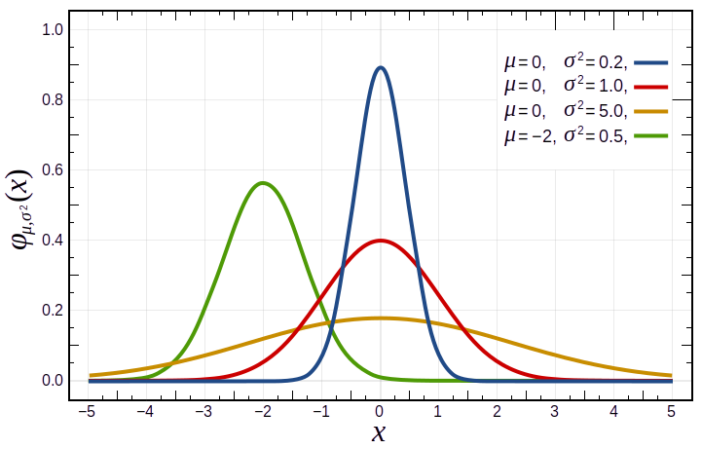
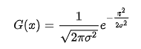
The values located between +/- σ account for 68% of the set, while two standard deviations from the mean account for 95%, and three standard deviations account for 99.7%
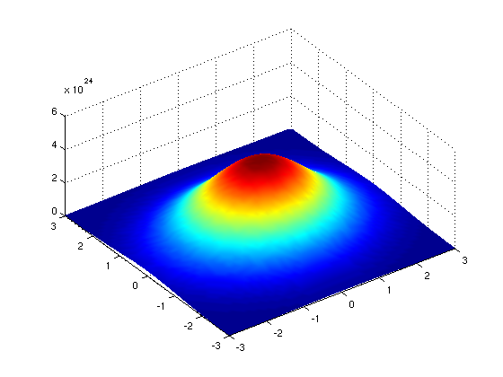
In fact, when using Gaussian functions in Gaussian blurring, we use a 2D Gaussian function to account for X and Y dimensions, but the same rules apply. The mean μ is always 0, and represents the middle of the 2D kernel. Increasing values of σ² in either dimension increases the amount of blurring in that dimension.

The averaging is done on a channel-by-channel basis, and the average channel values become the new value for the pixel in the filtered image. Larger kernels have more values factored into the average, and this implies that a larger kernel will blur the image more than a smaller kernel.
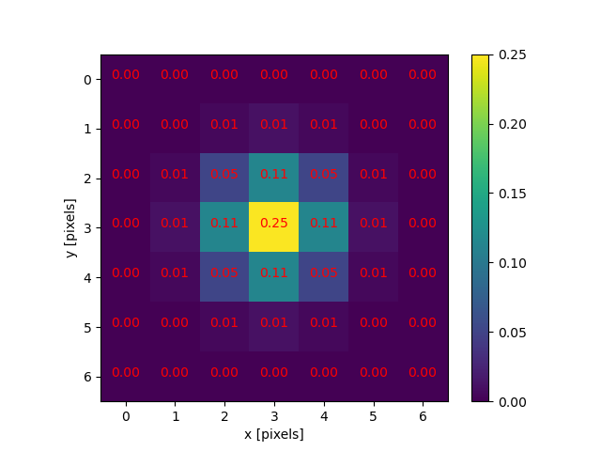

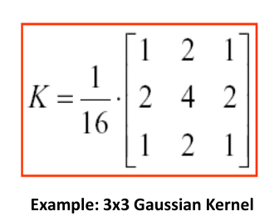
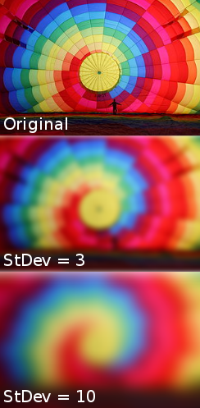
7

StDev für x/y Achse konnte in gimp ausgewählt werden (ca 60) wurde gewält

