Water Quality Decision Support Tool
Project Plan and Design Document

Daniel Nease, Cecilia Jeong, Hector Djiechieu, James Stallings

APTC 495: Applied Technology Capstone
University of Maryland Global Campus

Professor Munoz

November 3, 2026

1. Project Description and Objectives

1.1 Purpose, Scope, and Target Audience
The Water Quality Decision Support Tool is a small web application that helps people understand home water test results. Homeowners, especially those on private wells, often receive a list of numbers with no explanation of what they mean or what to do next. Federal drinking water rules do not cover private wells, so no one interprets those results for the owner. This tool fills that gap.

A user enters four to five test values (hardness, iron, pH, total dissolved solids, and optionally manganese), household size, and whether the water comes from a private well or a public supply. The tool validates the entries, compares each value to the EPA secondary drinking water standards, shows a red, yellow, or green status, explains the result in plain language, and recommends a treatment from a fixed set of rules. It produces a one-page summary the user can print. A separate Power BI dashboard shows how public water quality data varies by area, so a user can see their numbers in context.

The tool covers secondary standards only, meaning the parameters that affect taste, odor, staining, and plumbing. It does not test for health contaminants such as lead, arsenic, nitrates, bacteria, or PFAS, and every result directs the user to certified lab testing for those. The primary users are homeowners, and the field technicians and sales staff at water treatment companies who explain results to them.

1.2 Major Functions
- Accept test values, household size, and water source through a simple form.
- Check that each value is a valid number within a possible range.
- Compare each value to its EPA secondary standard, or to USGS hardness categories.
- Show a red, yellow, or green status with a plain-language explanation for each value.
- Recommend a treatment based on fixed rules and state which result caused it.
- Generate a printable one-page summary.
- Display a lab-testing warning on every results screen and report.
- Show a Power BI dashboard of public water data by area for context.

1.3 Reference Standards by Measurement
The tool compares each measurement to a published reference. Four of the five come from the EPA National Secondary Drinking Water Regulations, which set secondary maximum contaminant levels (SMCLs). An SMCL is a non-enforceable guideline for taste, odor, color, staining, and corrosion, not a health limit. Hardness has no EPA standard, so the tool uses the USGS hardness classification instead. The table below states the reference for every measurement, so there is no ambiguity about which standard applies.

Measurement | Reference | Value | Source
Iron | EPA SMCL | 0.3 mg/L | EPA (2026a)
Manganese | EPA SMCL | 0.05 mg/L | EPA (2026a)
Total dissolved solids | EPA SMCL | 500 mg/L | EPA (2026a)
pH | EPA SMCL | 6.5 to 8.5 | EPA (2026a)
Hardness | USGS classification (no EPA standard) | Soft 0 to 60; moderately hard 61 to 120; hard 121 to 180; very hard over 180 mg/L as CaCO3 | USGS (n.d.)

Throughout this document, "secondary standard" and "SMCL" mean the EPA values above, "guideline" is used only for those EPA values, and "classification" refers to the USGS hardness categories. The tool does not use any EPA primary (health-based) standard.

1.4 Project Objectives
The system has five objectives, each traceable to the requirements document (FR-1 through FR-9, NFR-1 through NFR-6):
- Objective 1: Turn raw test values into a status and explanation a non-technical homeowner can understand in one reading (FR-3, FR-4, FR-6, NFR-1).
- Objective 2: Produce consistent treatment suggestions from a fixed, documented rule set so that every user with the same results gets the same advice (FR-5, NFR-3, NFR-6).
- Objective 3: Give the user a clean, printable record they can keep or hand to a professional (FR-7).
- Objective 4: Never overstate what the tool can do: every output carries the lab-testing warning, and the tool stores no personal data (FR-8, NFR-4).
- Objective 5: Provide regional context through a dashboard of public water quality data (FR-9).

1.5 Risks Identified
The team identified seven risks during planning. Section 3.4 analyzes them with mitigation strategies. In summary: one of four members was unavailable for Weeks 1 through 3 and rejoined at the end of Week 3, so the team worked short-handed through the proposal and requirements documents, and all members work remotely with full-time jobs; scope could grow beyond the requirements; public water quality data may be inconsistent across areas; Streamlit and Power BI are new to parts of the team; the threshold values for yellow status are team judgment calls, not EPA values; the eight-week schedule leaves no slack for rework; and a user could mistake a green result for proof that water is safe.

2. System Design

2.1 System Architecture
The system is a three-layer application with a separate reporting component. The architecture diagram is in Appendix A.

- Presentation layer (browser): A single Streamlit web page containing the input form, the results screen, and the print summary. Streamlit renders the page from the Python application, so there is no separate front-end codebase.
- Application layer (Python): Four components. The Validator checks entries against required fields and allowed ranges. The Classifier compares each valid entry to its threshold and assigns a color, label, and explanation. The Recommender applies the rule set to the classified results and produces suggestions with reasons. The Print Summary Generator formats the current results into a one-page report.
- Data layer (files): Three read-only CSV files. parameters.csv holds one row per measurement with its unit, reference source, reference values, color boundaries, and explanation text. recommendations.csv holds one row per treatment rule. public_water_data.csv holds cleaned EPA and USGS sample records for the dashboard. There is no database and no write path from the application to disk.
- Reporting component (Power BI): A dashboard that imports the public data file and displays median values, a map, a bar chart, and sample records filtered by area. It is linked from the results screen but runs independently of the Python application.

Component descriptions:
Component | Responsibility | Requirements
Input Form | Collects five measurements, household size, and water source; shows units and required markers | FR-2
Validator | Checks required fields, numeric type, and allowed ranges; returns correction messages | FR-1
Rule Files | parameters.csv holds thresholds, reference values, and explanations; recommendations.csv holds the treatment rules. Both are editable without code | NFR-6
Classifier | Compares each value to its threshold; assigns color, label, comparison text, and explanation | FR-3, FR-4, FR-6
Recommender | Applies rules to classified results; returns suggestions with the result that caused each | FR-5
Results Screen | Displays the results table, suggestions, and the lab-testing warning | FR-4, FR-8
Print Summary Generator | Formats the current results into a one-page printable report | FR-7, FR-8
Power BI Dashboard | Shows public water data by area with filters, map, tiles, chart, and records | FR-9

Data flow, step by step:
- The user enters values in the browser and selects "Assess."
- The Validator checks the entry. If anything fails, it returns messages and the form redisplays with the other entries intact. Nothing else runs.
- If the entry is valid, the Classifier reads the thresholds and explanations from the rule set (loaded once at startup) and produces one Result per entered parameter.
- The Recommender reads the Results and the household details, applies each rule whose condition matches, and produces Suggestions.
- The Results Screen renders the Results and Suggestions with the warning.
- If the user selects "Print summary," the Print Summary Generator formats the same Results and Suggestions for the browser print dialog. No new calculation happens.

Data flows in one direction. The user enters values; the Validator returns correction messages or passes a clean entry forward; the Classifier and Recommender read the rule files and produce results; and the results screen displays them. The application loads the rule files once at startup and never modifies them. This design was chosen because it is the simplest structure that satisfies every requirement, it keeps the rules editable without code changes (NFR-6), and it makes testing straightforward: each component has one input and one output.

The application will keep the current submitted entries, results, and suggestions temporarily in the individual user's session so they remain available for viewing and printing. "Start over" will clear this assessment. Editing inputs will require reassessment before an updated report is produced. User entries will not be saved to application files or placed in a shared application cache.

2.2 UML Diagrams
Three UML diagrams in the appendix describe the design from different angles.

- Use case diagram (Appendix B): Two actors, homeowners and field technicians, who use the tool the same way. The main use case, assessing water test results, includes four use cases that always run as part of it: validating entries, viewing the color status and explanation, viewing the treatment suggestion, and viewing the lab-testing warning. Printing the one-page summary extends the assessment because it is optional. The Power BI dashboard also supports a separate use case: viewing public water data by area. Maintaining the rule files is not an application use case; it is done in the repository, as described in Section 2.5.
- Class diagram (Appendix C): Fifteen classes in four groups. Input classes (InputForm, TestEntry, Validator, ValidationResult) collect and check entries. Rule classes (RuleFile, RuleSet, Threshold, Rule, Explanation) load and hold the rule files; RuleSet is composed of the other three. Processing classes (Classifier, Result, Recommender, Suggestion) do the work. Output classes (ResultsScreen, PrintSummary) display it. Because Streamlit applications are typically written as function modules rather than class hierarchies, the team will implement these as Python dataclasses for the data holders and as plain functions for Validator, Classifier, and Recommender. The diagram still accurately describes the structure.
- Sequence diagram (Appendix D): A one-time startup step where the page loads the rule files into memory, then the main flow from the user selecting "Assess" through validation, classification, recommendation, and display, with the alternate path when validation fails and the optional path when the user prints. This single sequence covers FR-1 through FR-8.

2.3 User Interface Design
The Streamlit application has three screens and one Power BI dashboard. Wireframes are in Appendix G.

- Screen 1, input form: Five numeric fields with units shown beside each, a household size field, and a two-option water source selector. Required fields are marked. A validation message area appears below the fields only when an entry needs correction, and it keeps the other entries intact. One "Assess" button. The lab-testing warning appears at the bottom so the user sees it before results.
- Screen 2, results screen: A table with one row per measurement showing the entered value, a colored status cell with a written label (so color is never the only signal), and a plain-language explanation. Below the table, a suggested next steps panel lists each treatment suggestion with the result that caused it. The lab-testing warning repeats in a highlighted box. Three buttons: print summary, start over, and view public data for my area.
- Screen 3, printable summary: A one-page layout with household details, a results table that adds the EPA guideline column, suggested next steps, reference sources, and the warning. It is generated through the browser print function, so the user can print it or save it as a PDF without an extra library.
- Power BI dashboard: A first working draft exists (Figure G-4). The layout is a choropleth map of the United States shaded by state, an "at a glance" summary panel, a criteria/area toggle, and one card per measurement showing the median value and summary statistics for the selected area. Before the Week 4 check-in the metrics on the cards will be aligned to FR-9: median hardness, iron, pH, and TDS by area, the data source, units, and sampling dates, with missing values shown as "No data," never as zero. The dashboard will not describe water as safe or unsafe, consistent with the lab-testing warning in the tool; secondary standards are not safety standards. The draft currently uses placeholder figures while the cleaned public data file is being prepared.

Design principles: plain language throughout, no technical term without a definition, color always paired with text, and the warning visible on every screen. These follow NFR-1 and FR-8.

2.4 Data Design and Database Schema
The application does not use a database. This is a deliberate decision, not an omission. The tool stores no user data (NFR-4), the rule set is small and changes rarely, and a non-programmer can edit a CSV file (NFR-6). A database would add setup, hosting, and security work with no user benefit. The data still has a defined structure, shown in the entity-relationship diagram in Appendix F, and the CSV files follow it exactly.

Rule file entities:
- PARAMETER: one row per measurement (parameter_id, display_name, unit, required, reference_source). Five rows: hardness, iron, pH, TDS, manganese.
- THRESHOLD: one row per parameter. It holds two kinds of values that are kept separate on purpose: the published comparison limit (reference_low and reference_high, which are the EPA SMCL or USGS boundary and may be blank where none applies) and the color boundaries the tool displays (green_max, yellow_max, and for pH the low-side low_yellow_below and low_red_below). This lets the tool show the user the official limit while using the team's display rules for color, without confusing the two.
- EXPLANATION: one row per parameter with the plain-language text for what it measures, the within-range message, the above-range message, and the below-range message (used for pH).
- RULE: one row per recommendation rule (rule_id, parameter_id, condition, suggestion_text, reason_text). About ten rows. A parameter can trigger several rules.

Public data entities:
- AREA: one row per geographic area (area_id, area_name, state).
- PUBLIC_SAMPLE: one row per measurement record (sample_id, area_id, parameter_id, value, sample_date, data_source). This is the only large table and it feeds the dashboard only.

When parameters.csv is loaded, PARAMETER, THRESHOLD, and EXPLANATION are merged into one Threshold object per parameter, which is why the Threshold class in Appendix C carries the unit and source fields that the ER diagram (Appendix F) keeps on PARAMETER. The stored form is normalized; the in-memory form is flattened for convenience.

The design will use three read-only CSV files. parameters.csv will contain one row for each measurement, including its unit, reference source, reference values, color boundaries, and explanation text. recommendations.csv will contain one row for each treatment rule. public_water_data.csv will contain the cleaned public measurements used by Power BI. The ER diagram describes the logical relationships between these data items; related items may be combined into one CSV row. User entries will not be saved in these files.

Published reference values will be stored separately from the project's color boundaries. Each measurement will identify its reference source and any applicable lower or upper reference value. Hardness will use the documented USGS categories instead of an EPA limit. Comparison messages will use the published reference values, while colors will use the separately defined display rules. The design will specify whether each boundary includes or excludes the boundary value.

Every public measurement record will include its unit. Before records are combined, the team will check that their units and measurement meanings match. Original source identifiers will be retained where available. Missing results will remain missing rather than becoming zero. Values reported as below a detection limit will be identified separately from exact measurements. The loading process will check for duplicate identifiers and references to unknown parameters or areas.

2.5 Authentication
The application has no authentication. There are no accounts, no login, and no roles. This follows directly from NFR-4: the tool collects no personal information and keeps no record between sessions, so there is nothing to protect with a login. The only privileged action is editing the rule files, which is done outside the application by a team member with access to the project repository. If the tool were deployed for a company, access to the rule files would be controlled through repository permissions, not through the application.

2.6 API Design Considerations
The prototype exposes no external API. All processing happens inside one Python process, and Streamlit handles the browser connection. The team did consider the internal interfaces carefully, because they are what the test plan will exercise. Each processing component is a function with a defined input and output:
- validate(entry) returns ValidationResult (is_valid, messages)
- load_rules(parameters_path, recommendations_path) returns RuleSet (thresholds, rules, explanations)
- classify(entry, ruleset) returns a list of Result (parameter, value, status_color, status_label, explanation, comparison)
- recommend(results, entry, ruleset) returns a list of Suggestion (text, caused_by)
- generate_summary(results, suggestions, entry) returns the printable report

Validation, classification, and recommendation functions will receive defined inputs and return results without saving user data. File loading will be handled separately. The loader will check required columns, identifiers, numeric values, and rule conditions before assessment is allowed. Recommendation conditions will use supported comparisons rather than executable Python expressions. Missing or invalid reference files will stop assessment and produce a clear error message.

Keeping these as pure functions with no side effects means each can be tested on its own with fixed inputs, which is how the test cases in FR-1 through FR-6 are written. If a future version needed a REST API, for example so a technician's mobile app could call the classifier, these same functions could be wrapped in a small web framework without changing their logic. Power BI does not call the application; it imports the public data CSV directly.

2.7 Review of Performance, Security, and Scalability Requirements
- Performance (NFR-2): Results must appear within five seconds. The rule files are loaded once at startup and held in memory; classification is a handful of comparisons; no network call is made. On a standard laptop the expected response is well under one second. The only slow step is Streamlit's page rerender, which is typically under two seconds.
- Security and privacy (NFR-4): The application accepts six numbers and one selection, and nothing else. No personal fields exist, no data is written to disk, and no third-party service is called. Input validation (FR-1) rejects non-numeric and out-of-range values before they reach any logic. The rule files are read-only to the application. For the prototype, the application runs locally or on Streamlit Community Cloud over HTTPS. There is no attack surface beyond the form itself.
- Reliability (NFR-3): The rules contain no randomness and no time dependence, so identical inputs give identical outputs. If the application cannot load the rule files, it stops and shows the error message defined in the requirements document rather than guessing.
- Scalability: The prototype is designed for one user at a time on one page. Streamlit Community Cloud supports light concurrent use, which is enough for a class demonstration and a small company. Because the processing functions are stateless, the application could scale by running more instances behind a load balancer if needed. The public data file is the only component that grows; at tens of thousands of rows, it remains well within what Power BI handles comfortably.
- Compatibility (NFR-5): Streamlit renders standard HTML, so the application runs in current Chrome, Edge, Firefox, and Safari with no installation. The print summary uses the browser print dialog, which works on all four.
- Maintainability (NFR-6): All thresholds, reference values, text, and rules live in the two editable CSV files. The system picks up changes at the next restart, with no code edit.

2.8 Design Decisions and Adjustments from Prior Work
Several decisions in this document refine what was proposed in Weeks 1 and 2:
- Water source field: Added during requirements writing. It lets the recommender and warning text differ for private wells, where the owner is responsible for lab testing.
- Hardness thresholds: The EPA has no secondary standard for hardness, so the classifier uses USGS hardness categories for that parameter and says so on screen. This was clarified in FR-3 and is reflected in the class and ER diagrams through the reference_source field.
- Results screen naming: In an early draft, the results screen was briefly called a dashboard. It is now the "results screen" everywhere, and "dashboard" refers only to the Power BI component.
- No database: The proposal left data storage open. After writing NFR-4 and NFR-6, the team settled on read-only CSV files, which together make a database unnecessary.
- Rule files: The requirements document described one editable rule file. The design splits it into parameters.csv (measurements, reference values, color boundaries, explanations) and recommendations.csv (treatment rules), because the two change for different reasons. Both remain editable without code, which is what NFR-6 requires.
- Team structure: The fourth member, James Stallings, was unavailable through Week 3 and rejoined on October 31. Build deliverables stayed with the three members who scoped them so no build item depends on catch-up. James takes the lead on the test plan document and the final presentation, and supports public data cleaning. Hector leads test execution, with everyone testing and fixing their own components. The roster is the same four names on the title page, the deliverables table, and the responsibilities list.

Adjustments from instructor feedback on the proposal:
- Reference standards: The proposal referred to EPA secondary standards for all measurements. Section 1.3 now states the exact reference and value for each measurement, identifies hardness as a USGS classification with no EPA standard, and defines the terms used.
- Primary EPA sources: The EPA secondary drinking water standards page and the EPA private wells page are now cited directly rather than through secondary sources.
- Team roster: The title page, responsibilities, and deliverables now list the same four members.
- Timeline: The deliverables table and Gantt chart now begin at Week 1.

2.9 Version Control
The team will use Git with a private GitHub repository created in Week 4. The repository will hold the Python source, the two rule files, the cleaned public data file, the Power BI file, and the project documents. Practices:
- The main branch always holds a working version. No one commits directly to main.
- Each feature is built on its own branch named for the requirement it implements (for example, fr-1-validation, fr-5-recommender). The team merges the branch into main through a pull request reviewed by one other team member.
- Commit messages state what changed and why, in one line.
- The rule files are versioned like code. Any change to a threshold goes through the same pull request review, so the team can see who changed a number and when.
- We keep documents in a docs folder in the repository, in addition to the shared OneDrive, so the final submission has one source of truth.
- Tags mark each milestone: v0.1 for the Week 4 check-in prototype, v0.5 for feature-complete in Week 6, and v1.0 for the final presentation.

Daniel owns the repository and merges pull requests. Hector and Daniel share the Python code. Cecilia commits the Power BI file and the cleaned data. James commits the test plan, test record sheets, and presentation files to the docs folder.

3. Project Scope, Timeline, and Budget

3.1 Scope and Deliverables
In scope: a working Streamlit prototype that implements FR-1 through FR-8; rule files (parameters.csv and recommendations.csv) with thresholds, explanations, and about ten recommendation rules, reviewed by a team member with water treatment lab experience; a Power BI dashboard implementing FR-9 using cleaned public data for at least one state; the course documents (this design document, the test plan, and the final presentation); and the individual personal portfolios.

Out of scope: health contaminant interpretation of any kind; live sensor or IoT input; machine learning or predictive models; user accounts; data storage; a mobile application; integration with any company system; and hosting beyond Streamlit Community Cloud or a local machine. These are listed as future extensions, not as gaps.

Deliverables breakdown:
# | Deliverable | Owner | Due
D0 | Team formation, topic selection, proposal, and requirements document (Weeks 1 and 2, complete) | All | Oct 27
D1 | Project plan and design document (this document) | Daniel, all review | Nov 3
D2 | Rule files v1 (parameters.csv and recommendations.csv) | Daniel, Hector | Nov 7
D3 | Cleaned public water data CSV for at least one state | Hector, Cecilia, James | Nov 10
D4 | Streamlit prototype: input form and validation (FR-1, FR-2) | Hector | Nov 10
D5 | Streamlit prototype: classifier and recommender (FR-3 to FR-6) | Daniel, Hector | Nov 14
D6 | Streamlit prototype: results screen, print summary, warning (FR-7, FR-8) | Daniel | Nov 17
D7 | Power BI dashboard (FR-9) | Cecilia | Nov 20
D8 | Test plan document | James leads, all contribute | Nov 24
D9 | Test results and defect fixes | All | Dec 1
D10 | Final presentation | James leads, all present | Dec 8

3.2 Timeline
The Gantt chart in Appendix E covers the full eight-week term, beginning with team formation and topic selection in Week 1, and shows all phases, overlaps, and the three milestones: Check-in 2 on November 7, prototype feature-complete on November 24, and the final presentation on December 8. The build phase runs in parallel tracks so that the Python work (Hector and Daniel) and the dashboard work (Cecilia) do not block each other. The rule files are the first build deliverable because both tracks depend on them: the classifier reads them and the dashboard uses the same parameter definitions. Testing starts the day the prototype is feature-complete and leaves one week for fixes before presentation preparation begins.

3.3 Budget
The project has no monetary cost. Every tool is free, open source, or already licensed to the team through UMGC. The table below lists each resource and what it would cost if the free tier were not available, so the reader can see the value of the choices made.

Resource | Purpose | Cost to team | Alternative cost
Python 3 and standard libraries | Application logic | $0 (open source) | n/a
Streamlit | Web interface | $0 (open source) | n/a
Streamlit Community Cloud | Hosting for demonstration | $0 (free tier) | ~$20/month for a basic cloud host
Power BI Desktop | Dashboard | $0 (free) | Power BI Pro ~$14/user/month
GitHub private repository | Version control | $0 (free tier) | n/a
EPA and USGS public data | Dashboard data | $0 (public domain) | n/a
Microsoft 365 (Word, OneDrive) | Documents and file sharing | $0 (UMGC license) | ~$7/user/month
Discord | Team communication | $0 | n/a
Team labor | Approx. 8 to 10 hours per member per week for 6 weeks | Unpaid (coursework) | n/a
Total |  | $0

3.4 Risk Analysis and Mitigation
Risk | Likelihood | Impact | Mitigation
Team capacity: one member was unavailable for Weeks 1 to 3 and rejoined at the end of Week 3; all members have full-time jobs and one has military drill weekends | Occurred | High | Work was redistributed in Week 2 and the instructor was notified. The returning member took deliverables that start later in the term (test plan, presentation) so nothing in the build depends on catch-up. Deliverables have two owners where possible. Drafts are due 48 hours before deadlines.
Scope creep: adding parameters, rules, or features beyond the requirements | Medium | High | The requirements document is the contract. Any addition must be written as a new FR with a test before it is built. The out-of-scope list in Section 3.1 is explicit.
Public data quality: EPA or USGS data may be incomplete or inconsistent across areas | High | Medium | Target one state first and expand only if time allows. Display "No data" rather than zero (FR-9). Document the data source and sampling dates on the dashboard.
Streamlit learning curve or deployment problems | Medium | Medium | Build the input form first (Week 4) to surface problems early. An Excel calculator implementing the same rules is the documented fallback.
Threshold accuracy: yellow boundaries are team judgment, not EPA values | Medium | Medium | Thresholds are labeled as display choices, not standards. A team member with water treatment lab experience reviews the rule files before the Week 4 check-in. Thresholds live in parameters.csv so they can be corrected without code changes.
Schedule: eight weeks with no slack for rework | High | High | Feature-complete is set for Nov 24, two weeks before the presentation, leaving a full week for testing and fixes. Weekly deliverables (D2 to D7) make slippage visible early.
Overclaiming: a user treats a green result as proof the water is safe | Low | High | The lab-testing warning appears on every screen and report (FR-8) and is tested with all-green inputs. The tool never uses the word "safe."

References
Streamlit Inc. (n.d.). Streamlit documentation. https://docs.streamlit.io/

U.S. Environmental Protection Agency. (2026a, May 26). Secondary drinking water standards: Guidance for nuisance chemicals. https://www.epa.gov/sdwa/secondary-drinking-water-standards-guidance-nuisance-chemicals

U.S. Environmental Protection Agency. (2026b, August 25). Private drinking water wells. https://www.epa.gov/privatewells

National Water Quality Monitoring Council. (2021). Water Quality Portal [Data set]. U.S. Geological Survey and U.S. Environmental Protection Agency. https://doi.org/10.5066/P9QRKUVJ

U.S. Geological Survey. (n.d.). Hardness of water. https://www.usgs.gov/water-science-school/science/hardness-water

Zhuang, Y., Albertin, A., & Hornsby, A. G. (2022). Private well 101: Drinking water standards. EDIS, 2022(3). https://doi.org/10.32473/edis-SS297-2022

Appendix

Appendix A: System Architecture
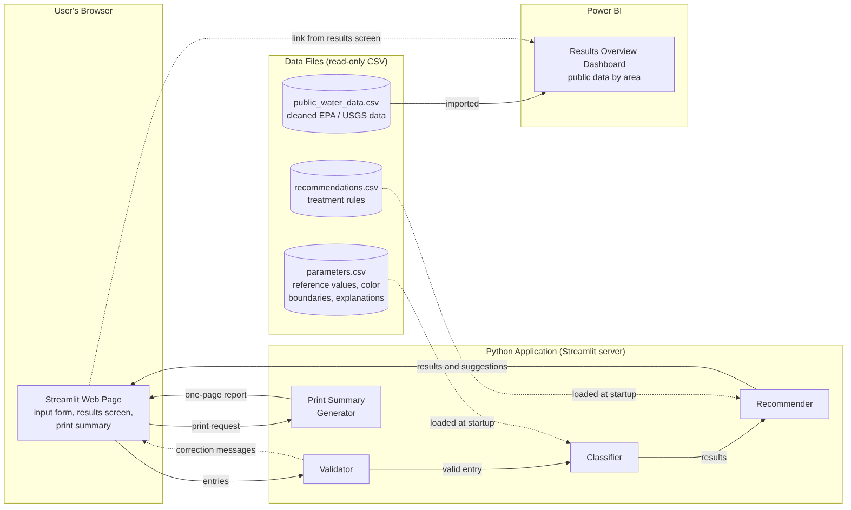
Figure A-1. System architecture showing the browser, Python application, data files, and Power BI components.

Appendix B: Use Case Diagram
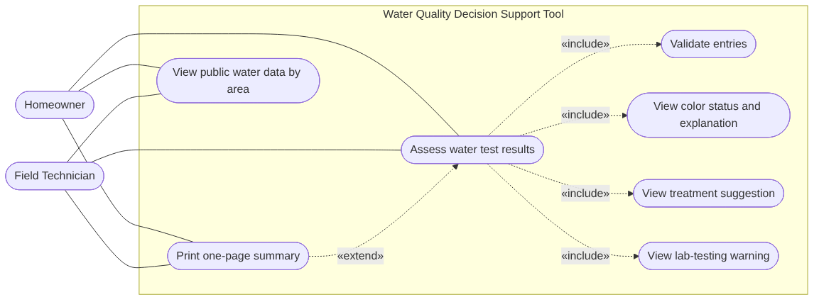
Figure B-1. Use case diagram. Two actors share the same use cases; validation, status, suggestion, and warning are included in every assessment.

Appendix C: Class Diagram
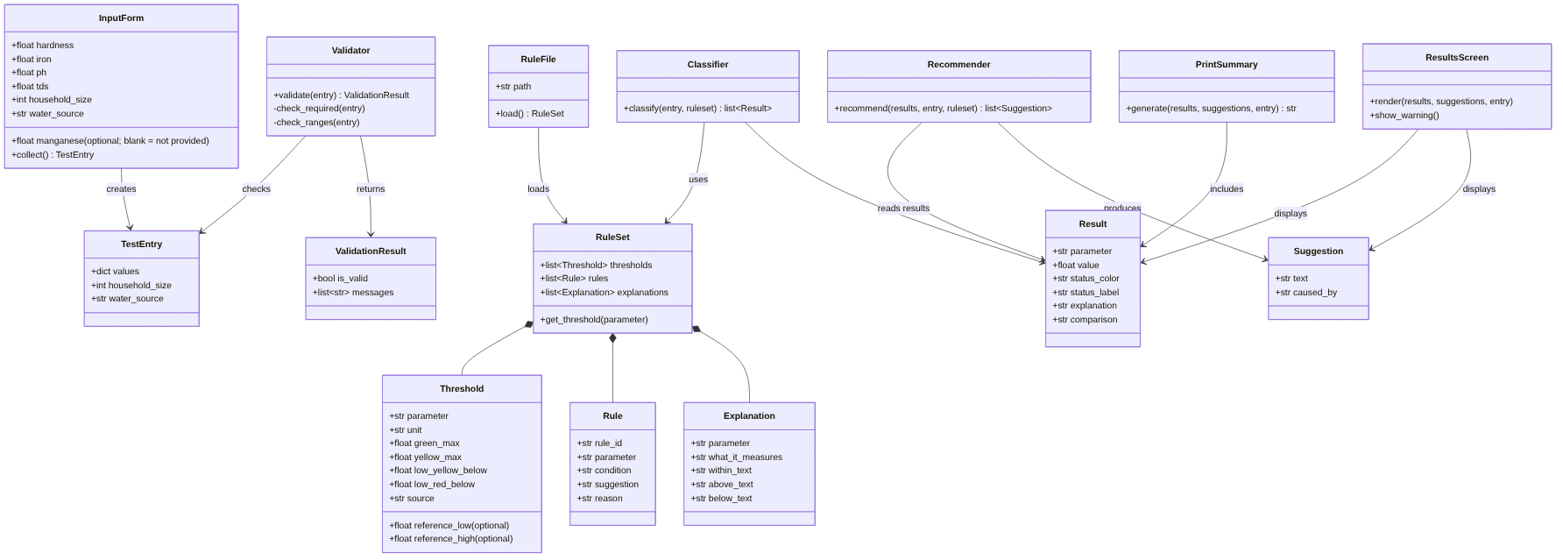
Figure C-1. Class diagram. Data holders will be implemented as Python dataclasses; Validator, Classifier, and Recommender as functions.

Appendix D: Sequence Diagram
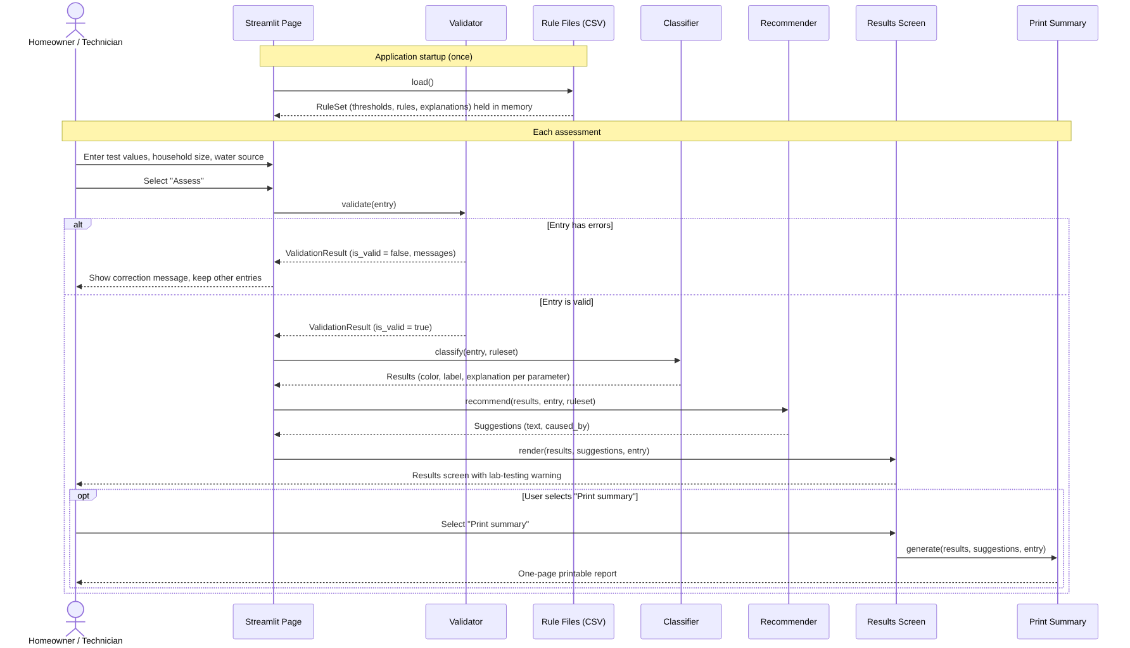
Figure D-1. Sequence diagram for startup and the main assessment flow, with the validation failure and print paths.

Appendix E: Gantt Chart
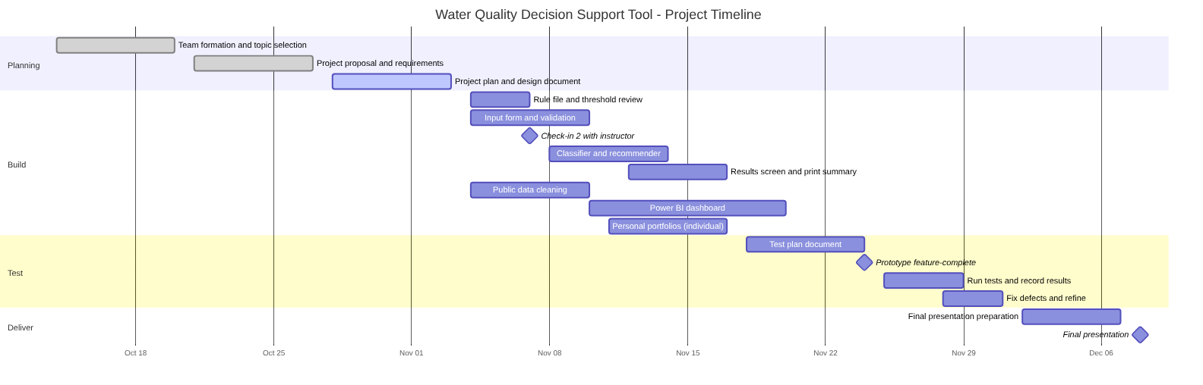
Figure E-1. Project timeline from team formation in Week 1 through the final presentation, with three milestones.

Appendix F: Entity Relationship Diagram
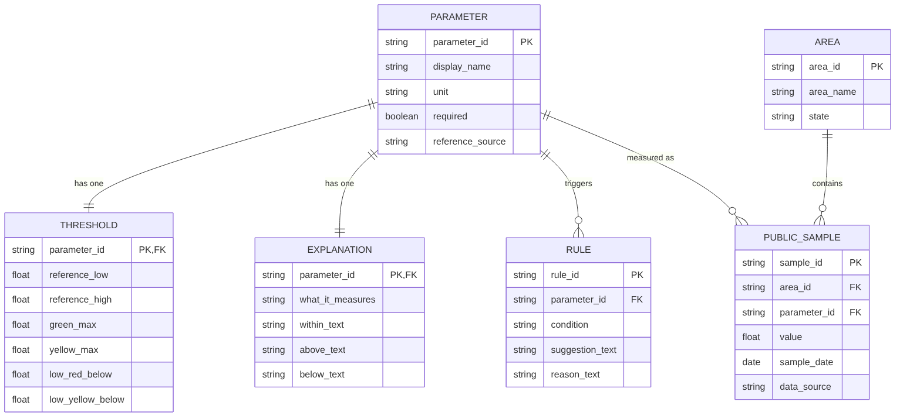
Figure F-1. Entity relationship diagram for the rule files and public data file. No database is used; the CSV files follow this schema.

Appendix G: User Interface Wireframes
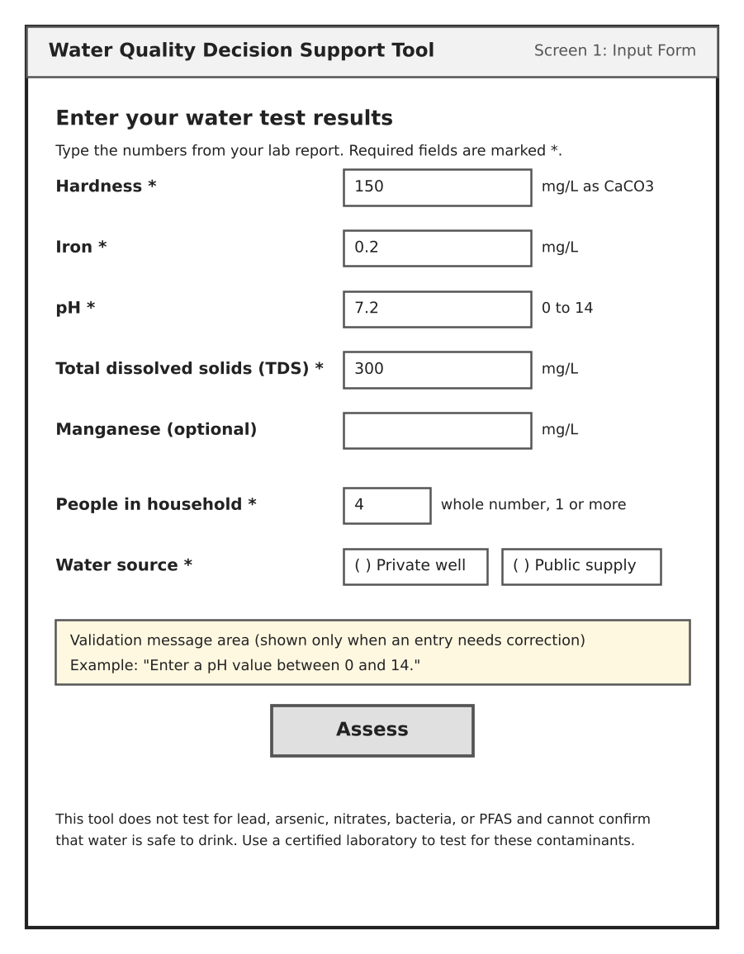  Figure G-1. Screen 1, input form. | 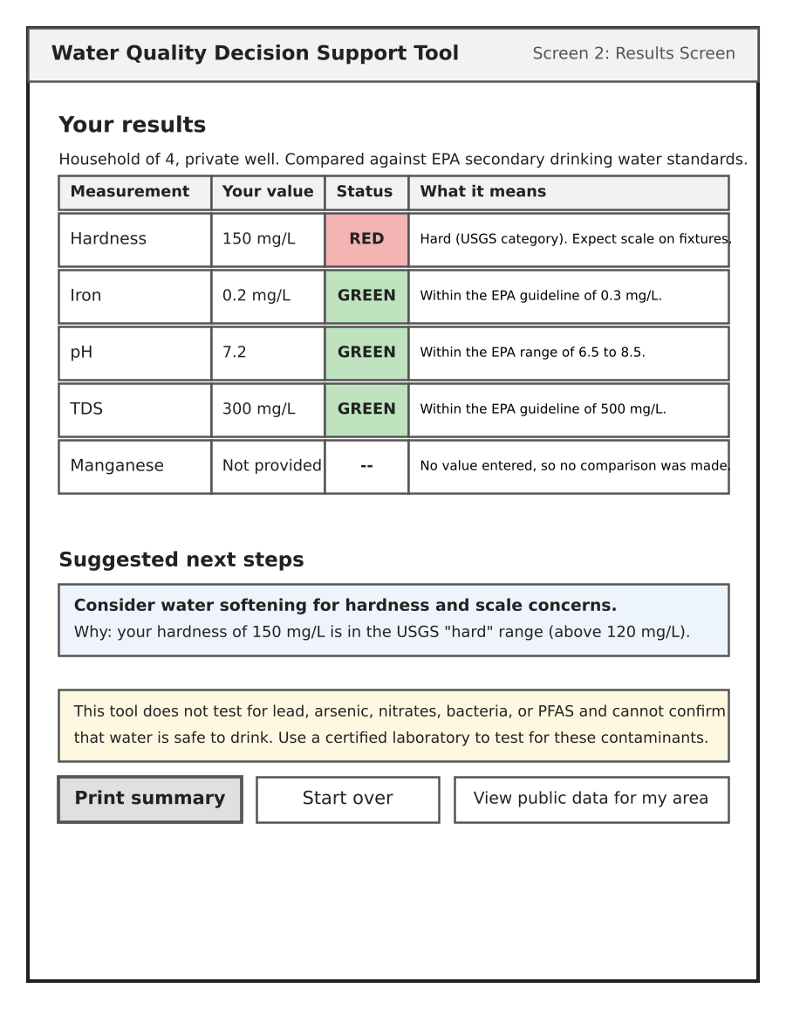  Figure G-2. Screen 2, results screen.

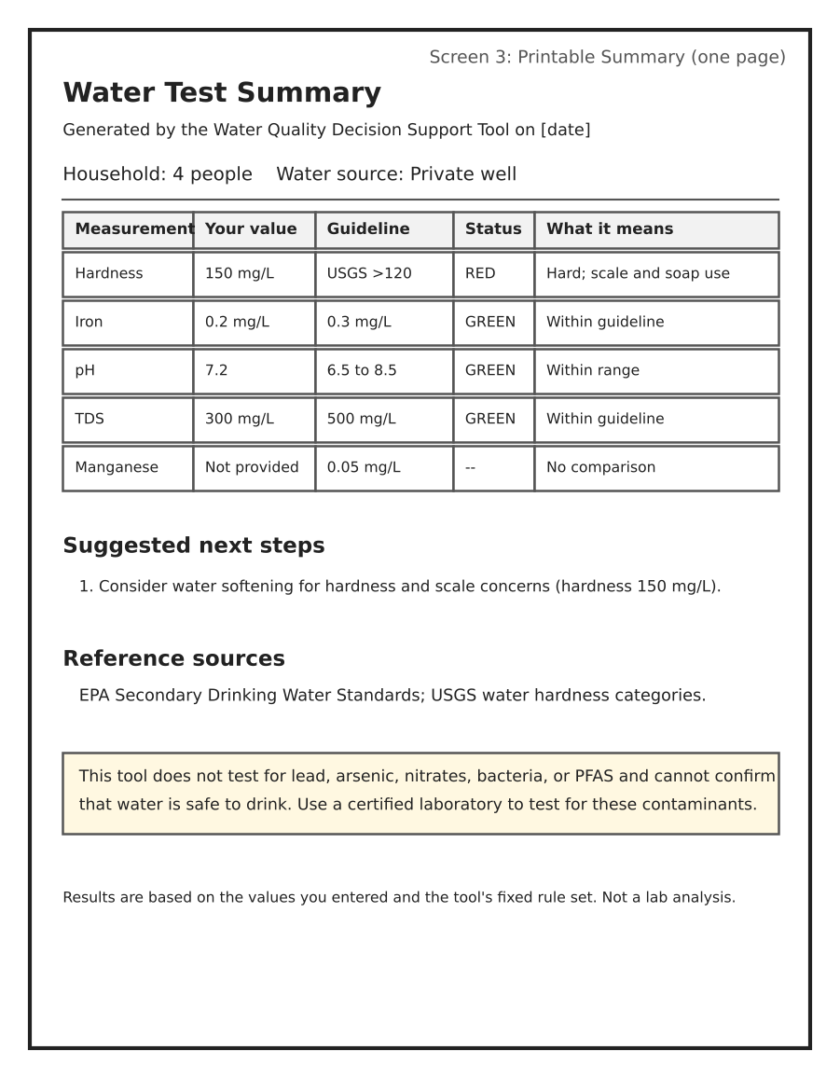
Figure G-3. Screen 3, printable one-page summary.
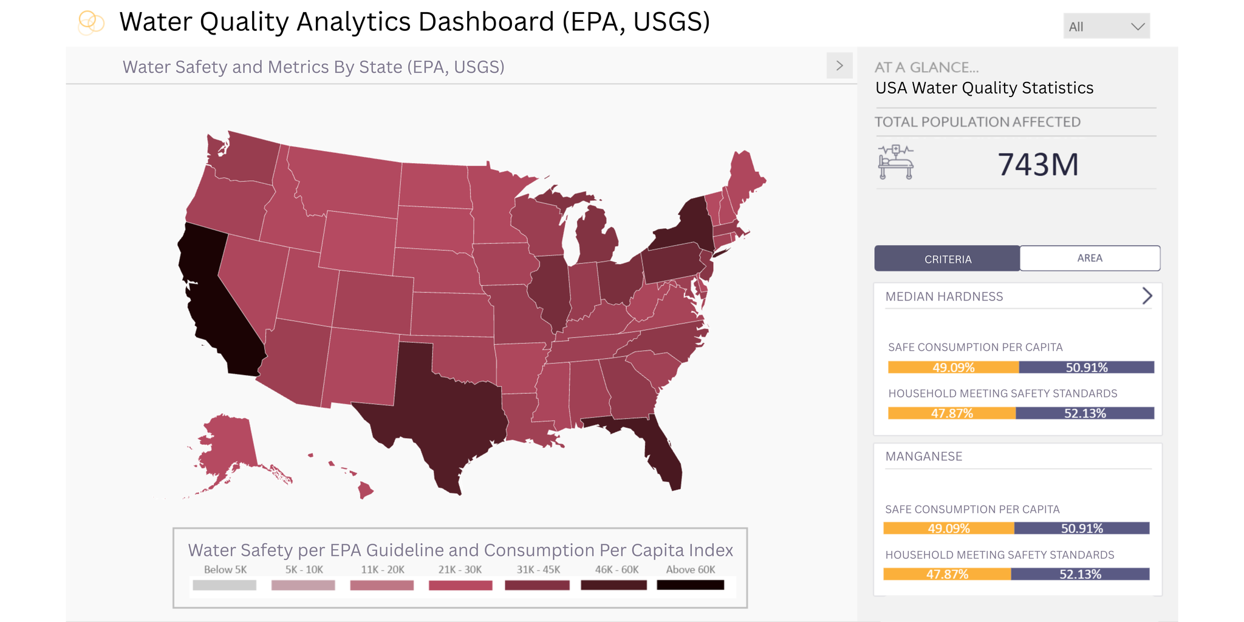
Figure G-4. Power BI dashboard, first working draft (Cecilia Jeong). Figures shown are placeholders; metrics will be aligned to FR-9 before the Week 4 check-in.

