Java OOPS
Hands-on Practice Set
Inheritance · Overloading · Overriding · Abstraction
3 Problems · Progressive Difficulty
Employee Management → Banking System → Supermarket Billing
Prepared for classroom practice

How to use this handout
This packet contains three progressive problems designed to build your grip on Java OOP concepts one layer at a time. Solve them in order — each one assumes the previous is comfortable.

The progression
- Problem 1 — Employee Management: basic inheritance with constructor overloading. No stub code — you design the skeleton yourself.
- Problem 2 — Banking System: inheritance with method overloading and overriding. Stubs are provided; fill in the logic.
- Problem 3 — Supermarket Billing: inheritance with abstraction and polymorphism. Stubs are provided; the abstract contract is your guide.

What you need
- JDK 17 or above installed
- Any editor / IDE (IntelliJ IDEA Community, VS Code with Java extensions, or Eclipse)
- One Java file per class, or a single file with multiple classes — your choice

How you will be evaluated
- Does the code compile and run without errors?
- Does the output match the sample output (values and formatting)?
- Are the OOP concepts actually applied (not simulated with if-else)?
- Is your code readable — sensible names, no dead code, consistent indentation?
Ground rule
You must demonstrate the OOP concept named in each problem. Using a single God class with if-else branches on a "type" string will earn zero marks even if the output matches — the point is to practise the concept, not to shortcut around it.

Problem 1 · Employee Management System
Difficulty  Easy | Concepts  Inheritance, Constructor Overloading | Classes  4 (1 parent, 2 children, 1 driver)

Scenario
A company wants a simple system to store employee details. Every employee has an ID, a name, and a base salary. The company employs two types of people:
- Full-time employees — receive a fixed monthly bonus in addition to their base salary.
- Interns — have a fixed internship duration in months and are paid a stipend instead of a base salary.
Your job is to model this hierarchy using a parent Employee class and two child classes. Each class must demonstrate constructor overloading — multiple constructors that let the caller create objects with different levels of detail.

Class diagram
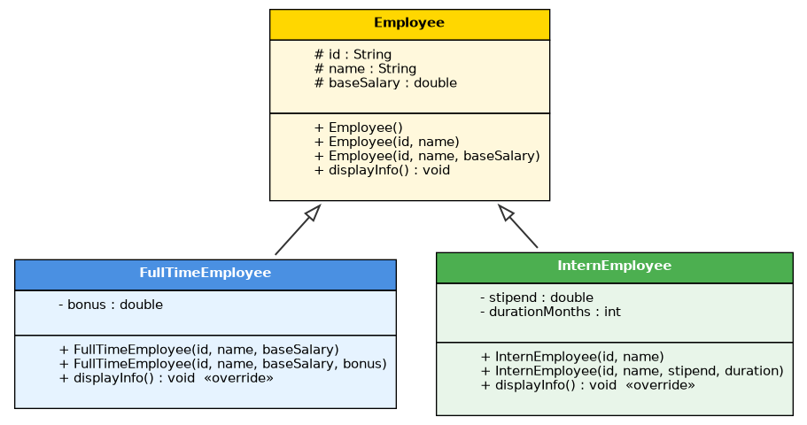
Fig 1.1 — Employee hierarchy. Hollow arrows denote inheritance (child → parent).

Requirements

Employee (parent)
Provide at least three constructors:
- No-arg constructor → sets ID to "E000", name to "Unknown", base salary to 0.
- Constructor with ID and name only → base salary defaults to 15000.
- Constructor with ID, name, and base salary → all values provided.
Include a displayInfo() method that prints the employee's details.

FullTimeEmployee (extends Employee)
Provide at least two constructors:
- Constructor with ID, name, and base salary → bonus defaults to 5000.
- Constructor with ID, name, base salary, and bonus → all values provided.
Override displayInfo() to also print the bonus and total salary (base + bonus). Use super appropriately.

InternEmployee (extends Employee)
Provide at least two constructors:
- Constructor with ID and name → stipend defaults to 8000, duration defaults to 3 months.
- Constructor with ID, name, stipend, and duration → all values provided.
Override displayInfo() to print intern-specific details (stipend and duration in months instead of base salary).

CompanyDemo (driver)
Create at least one object of each type using different constructors, and call displayInfo() on each.

Sample object creation
// -- calls Employee no-arg constructor
Employee e1 = new Employee();

// -- calls Employee(id, name) — baseSalary defaults to 15000
Employee e2 = new Employee("E101", "Ravi");

// -- calls FullTimeEmployee(id, name, baseSalary) — bonus defaults to 5000
FullTimeEmployee f1 = new FullTimeEmployee("E201", "Meena", 40000);

// -- calls FullTimeEmployee(id, name, baseSalary, bonus)
FullTimeEmployee f2 = new FullTimeEmployee("E202", "Karthik", 50000, 8000);

// -- calls InternEmployee(id, name) — stipend & duration default
InternEmployee i1 = new InternEmployee("E301", "Divya");

// -- calls InternEmployee(id, name, stipend, duration)
InternEmployee i2 = new InternEmployee("E302", "Suresh", 12000, 6);

Expected output
ID: E000 | Name: Unknown | Base Salary: 0.0
ID: E101 | Name: Ravi | Base Salary: 15000.0
ID: E201 | Name: Meena | Base Salary: 40000.0 | Bonus: 5000.0 | Total Salary: 45000.0
ID: E202 | Name: Karthik | Base Salary: 50000.0 | Bonus: 8000.0 | Total Salary: 58000.0
ID: E301 | Name: Divya | Stipend: 8000.0 | Duration: 3 months
ID: E302 | Name: Suresh | Stipend: 12000.0 | Duration: 6 months

Concepts you will practise
- Single-level inheritance using the extends keyword
- Constructor overloading in both parent and child classes
- Constructor chaining using this(...) within the same class
- Calling the parent constructor using super(...) from the child
- Method overriding with displayInfo()
- Optional: using super.displayInfo() inside the overridden method to reuse parent logic
Reflect before you submit
1. If two constructors in the same class do overlapping work, how do you avoid duplicating code?
2. When you write super(id, name), which constructor of the parent gets called — and how does Java decide?
3. What happens if you forget to call super(...) from the child constructor? Try it and observe.

Problem 2 · Banking Application
Difficulty  Medium | Concepts  Inheritance, Overloading, Overriding | Classes  4 (1 parent, 2 children, 1 driver)

Scenario
Design a mini banking system that supports two account types: Savings and Current. Both share common behaviour — deposit, withdraw, view details — inherited from a base Account class. Each type has its own withdrawal rules and interest logic.

Business rules
- SavingsAccount — minimum balance of ₹1,000 must always be maintained; earns 4% p.a. interest.
- CurrentAccount — overdraft limit of ₹10,000 (balance can drop to −10,000); no interest.

Overloading requirement
The deposit() method must be overloaded three ways in the Account class:
- deposit(double amount) — treats it as cash by default.
- deposit(double amount, String mode) — mode can be "Cash", "Cheque", or "UPI".
- deposit(double amount, String mode, String reference) — with a transaction reference number.

Overriding requirement
The following methods must be overridden by each subclass with its own logic:
- withdraw(double amount) — enforces the account-specific rule.
- calculateInterest() — Savings computes interest; Current returns 0 with a note.
- displayDetails() — each type prints its own extra fields (min balance vs overdraft).

Class diagram
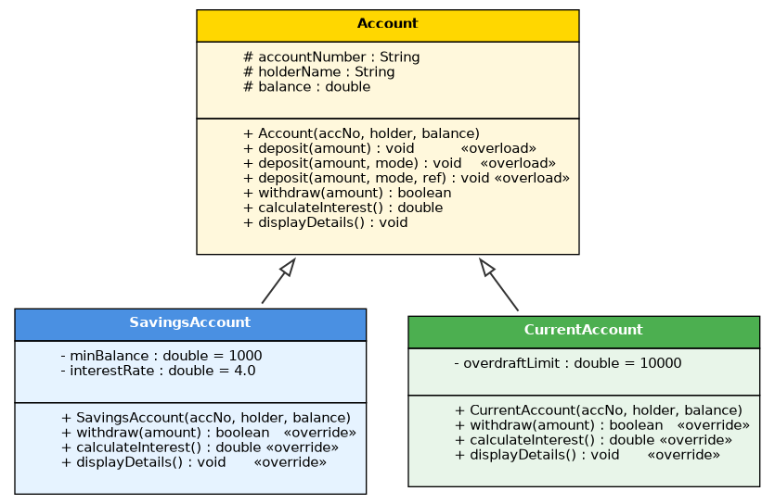
Fig 2.1 — Banking hierarchy. Note the three overloaded deposit signatures on Account.

Sample scenario (as actions in main)
Create SavingsAccount SB001, "Arul", initial balance 5000
Create CurrentAccount CA001, "Priya", initial balance 20000

deposit(2000) on SB001
deposit(5000, "UPI") on CA001
deposit(3000, "Cheque", "CHQ12345") on SB001

withdraw(9500) on SB001 // FAILS — breaks minimum balance rule
withdraw(30000) on CA001 // PASSES — overdraft used

calculateInterest() on both
displayDetails() on both

Expected output
Deposit successful. SB001 balance: 7000.0
Deposit via UPI successful. CA001 balance: 25000.0
Deposit via Cheque (Ref: CHQ12345) successful. SB001 balance: 10000.0

Withdrawal denied. Minimum balance of 1000.0 must be maintained.
Withdrawal successful (overdraft used). CA001 balance: -5000.0

Interest for SB001: 400.0
Interest not applicable for Current Account CA001.

Account: SB001 | Holder: Arul | Balance: 10000.0 | Type: Savings | Min Balance: 1000.0
Account: CA001 | Holder: Priya | Balance: -5000.0 | Type: Current | Overdraft Limit: 10000.0

Stub code — Account.java
public class Account {
protected String accountNumber;
protected String holderName;
protected double balance;

public Account(String accountNumber, String holderName, double balance) {
// TODO: initialize fields
}

// ---- Overloaded deposit methods ----
public void deposit(double amount) {
// TODO: delegate to deposit(amount, "Cash")
}

public void deposit(double amount, String mode) {
// TODO: validate amount > 0, add to balance,
// print "Deposit via <mode> successful. <accNo> balance: <bal>"
}

public void deposit(double amount, String mode, String reference) {
// TODO: validate amount > 0, add to balance,
// print "Deposit via <mode> (Ref: <ref>) successful. ..."
}

// ---- Methods intended to be overridden ----
public boolean withdraw(double amount) {
// TODO: default deducts if balance >= amount; return success
return false;
}

public double calculateInterest() {
return 0;
}

public void displayDetails() {
// TODO: print base details (accNo, holder, balance)
}
}

Stub code — SavingsAccount.java
public class SavingsAccount extends Account {
private double minBalance;
private double interestRate;

public SavingsAccount(String accountNumber, String holderName, double balance) {
// TODO: super(...); minBalance = 1000; interestRate = 4.0;
}

@Override
public boolean withdraw(double amount) {
// TODO: allow only if (balance - amount) >= minBalance
// else print "Withdrawal denied. Minimum balance of <min> must be maintained."
return false;
}

@Override
public double calculateInterest() {
// TODO: return balance * interestRate / 100
return 0;
}

@Override
public void displayDetails() {
// TODO: print with Type=Savings and minBalance
}
}

Stub code — CurrentAccount.java
public class CurrentAccount extends Account {
private double overdraftLimit;

public CurrentAccount(String accountNumber, String holderName, double balance) {
// TODO: super(...); overdraftLimit = 10000;
}

@Override
public boolean withdraw(double amount) {
// TODO: allow if (balance - amount) >= -overdraftLimit
// print "Withdrawal successful (overdraft used)." when balance goes negative
return false;
}

@Override
public double calculateInterest() {
// TODO: print "Interest not applicable ..." and return 0
return 0;
}

@Override
public void displayDetails() {
// TODO: print with Type=Current and overdraftLimit
}
}

Stub code — BankDemo.java
public class BankDemo {
public static void main(String[] args) {
// TODO:
// 1. Create one SavingsAccount and one CurrentAccount.
// 2. Call all three overloaded deposit() forms.
// 3. Trigger a failing withdraw() on Savings and a
// successful (overdraft) one on Current.
// 4. Store both in an Account[] and loop — call
// calculateInterest() and displayDetails() on
// Account references (runtime polymorphism).
}
}
Reflect before you submit
1. When you store objects in an Account[] and loop through them, why does Java pick the child's version of displayDetails() at runtime? What is the technical name for this?
2. What is the difference between overloading and overriding — can you state each in one sentence?
3. Could you have solved this with a single Account class and an accountType string? Why is the inheritance approach considered better design?

Problem 3 · Supermarket Billing System
Difficulty  Medium – Hard | Concepts  Inheritance, Abstraction, Polymorphism | Classes  5 (1 abstract, 3 children, 1 manager)

Scenario
Build a supermarket billing system where different product categories are priced differently — each carries its own GST rate, and some carry discounts. Since no generic "product" can exist on its own — every real product must belong to a category with its own pricing rule — model Product as an abstract class with an abstract calculateFinalPrice() method.

Category rules
- Grocery — 5% GST; if quantity > 10 units, apply an additional 5% bulk discount before GST.
- Electronics — 18% GST; carries a warranty (in months) that must appear on the bill.
- Clothing — 12% GST; flat 20% seasonal discount applied before GST.
The Bill class holds a list of products and generates the printed bill using polymorphism — it stores everything as Product references and calls calculateFinalPrice() without knowing the concrete type.

Class diagram
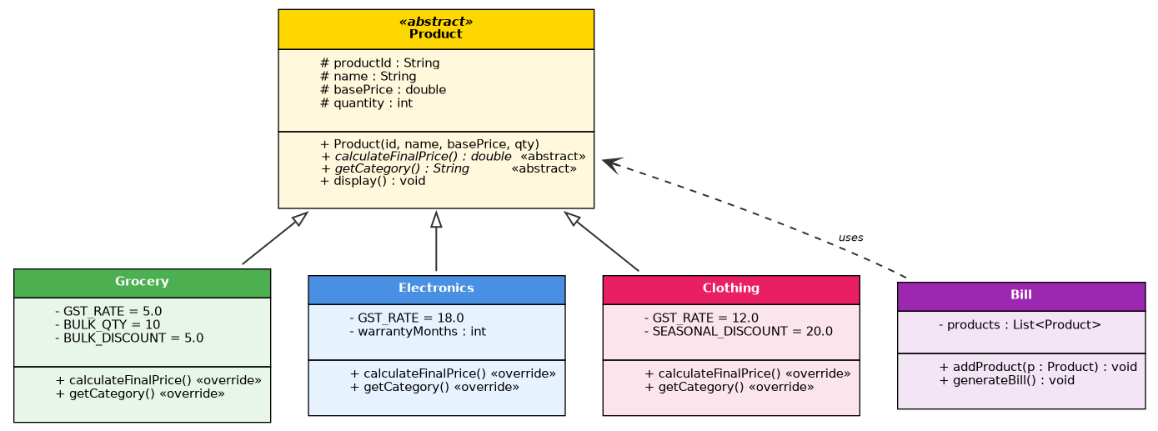
Fig 3.1 — Product hierarchy. Abstract Product cannot be instantiated. Bill uses Product polymorphically.

Sample scenario
Add Grocery G001 "Rice 5kg", basePrice 300, qty 3
Add Electronics E001 "Headphones", basePrice 2000, qty 1, warranty 12 months
Add Clothing C001 "T-Shirt", basePrice 800, qty 2
Add Grocery G002 "Sugar 1kg", basePrice 50, qty 15
Generate bill

Expected output
===== SUPERMARKET BILL =====
G001 | Rice 5kg | Grocery | Qty: 3 | Base: 900.0 | Final: 945.00 (5% GST)
E001 | Headphones | Electronics | Qty: 1 | Base: 2000.0 | Final: 2360.00 (18% GST, Warranty: 12 months)
C001 | T-Shirt | Clothing | Qty: 2 | Base: 1600.0 | Final: 1433.60 (20% discount, 12% GST)
G002 | Sugar 1kg | Grocery | Qty: 15 | Base: 750.0 | Final: 748.13 (5% bulk discount + 5% GST)
============================
Total Items: 4
Grand Total: 5486.73
Math check
Sugar (bulk): 750 × 0.95 × 1.05 = 748.125 → rounded 748.13
T-Shirt: 1600 × 0.80 × 1.12 = 1433.60
Rice: 900 × 1.05 = 945.00 | Headphones: 2000 × 1.18 = 2360.00

Stub code — Product.java
public abstract class Product {
protected String productId;
protected String name;
protected double basePrice; // per unit
protected int quantity;

public Product(String productId, String name, double basePrice, int quantity) {
// TODO: initialize fields
}

// Each category MUST implement its own pricing logic
public abstract double calculateFinalPrice();

// Each category returns its label ("Grocery", "Electronics", "Clothing")
public abstract String getCategory();

// Concrete method reused by all subclasses
public void display() {
// TODO: print productId | name | category | qty | base | final
}
}

Stub code — Grocery.java
public class Grocery extends Product {
private static final double GST_RATE = 5.0;
private static final int BULK_QTY = 10;
private static final double BULK_DISCOUNT = 5.0;

public Grocery(String productId, String name, double basePrice, int quantity) {
// TODO: super(...)
}

@Override
public double calculateFinalPrice() {
// TODO: gross = basePrice * quantity
// if quantity > BULK_QTY, apply BULK_DISCOUNT
// apply GST_RATE and return
return 0;
}

@Override
public String getCategory() { return "Grocery"; }
}

Stub code — Electronics.java
public class Electronics extends Product {
private static final double GST_RATE = 18.0;
private int warrantyMonths;

public Electronics(String productId, String name, double basePrice,
int quantity, int warrantyMonths) {
// TODO: super(...); this.warrantyMonths = warrantyMonths;
}

@Override
public double calculateFinalPrice() {
// TODO: (basePrice * quantity) with 18% GST
return 0;
}

@Override
public String getCategory() { return "Electronics"; }

public int getWarrantyMonths() { return warrantyMonths; }
}

Stub code — Clothing.java
public class Clothing extends Product {
private static final double GST_RATE = 12.0;
private static final double SEASONAL_DISCOUNT = 20.0;

public Clothing(String productId, String name, double basePrice, int quantity) {
// TODO: super(...)
}

@Override
public double calculateFinalPrice() {
// TODO: gross = basePrice * quantity
// apply 20% seasonal discount, then 12% GST
return 0;
}

@Override
public String getCategory() { return "Clothing"; }
}

Stub code — Bill.java
import java.util.ArrayList;
import java.util.List;

public class Bill {
private List<Product> products = new ArrayList<>();

public void addProduct(Product p) {
// TODO: add to list
}

public void generateBill() {
// TODO: print header
// loop over products — call display() (polymorphic)
// sum calculateFinalPrice() (polymorphic)
// print grand total formatted to 2 decimals
}

public static void main(String[] args) {
// TODO:
// 1. (Teaching moment) Uncomment the line below and observe the
// compile error — abstract classes cannot be instantiated:
// // Product p = new Product("X", "Y", 100, 1);
//
// 2. Create Grocery, Electronics, and Clothing instances
// matching the sample input.
// 3. Add all products to a Bill.
// 4. Call bill.generateBill().
}
}
Reflect before you submit
1. Why is Product declared abstract? What would break if you removed the abstract keyword and gave calculateFinalPrice() an empty body instead?
2. In Bill.generateBill() you loop over a List<Product>, yet each product prints its own category-specific price. Which OOP concept makes that possible?
3. If tomorrow you had to add a "Furniture" category with its own GST rate, how many existing files would you need to modify? Compare this with the same feature added to an if-else based design.

