MILESTORIES  Latest News and Bulletin Updates |  | 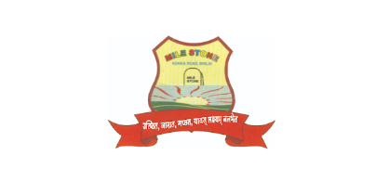
Every time I look up to something. It's always the same place suffocating. A confined cube completely dark dimness, Lies abroad, a twilight luminousness. This shiny curtain coloured as blacks, foolish-ness never it lacks. Leading the dreading way, you going to give this dream away? Were asked to dream and aim, Now, living manipulated is the real game. That's the way you live in this world. There's no change, and no reverse. It's the dark abyss covered with a silk quilt prepossessing; With greed's Raas fetters and endless chasing, behind something which never even existed to cease; Cruelty inside, is this world confessing. It's a proverb to love from the moon and back, But oh! How's this melodrama;  The chasing you're after, is your behind too. I'll go with simple 'Competition', identified as karma by few. The much you run, the more strangled you get, Is this life or some death-chase bondage? If you don't die, you're stuck I bet. It's so fucking, get me out this cage!  Every time I look up to something. It's always the same place suffocating. A confined cube...completely dark dimness Lies abroad, a twilight luminousness.  Written by Soumya Soni 9th A |   Festival of Lights  The Diwali festival is one of the most important festivals. It is called to be a festival of light. It comes after the month of rainy season. The crop of rice is ready. The farmers are so happy. All people are busy in cleaning and decorating the houses. In this day, Ram Chandra returns to Ayodhya after 14 years. So, the people of Ayodhya decorate the city to welcome him and show their joy. Thus, the festival is celebrated in the memory of Ram. The children are so happy on this day. The women prepare many kinds of sweets and other food for the festival of Diwali. People worship the goddess Lakshmi and offer sweets to her. The prasad is given to children and other people. They pray to goddess Lakshmi to bring them good luck all year round. This is how Diwali festival is celebrated.

SHORT STORY  Once there was a cricket he loved to sing and dance he was lazy too throughout the summer he enjoyed a lot singing and dancing and did not collect any food for himself and spent the summer enjoying when winters came he got nothing to eat and he was too hungry bot got nothing to eat so he went to ant thinking they are going help him but when he reached there the cricket told them everything what he had done and why he had not collected anything for winters. The ant understood everything what he wanted to say the ant replied the cricket friend we don’t borrow anything from any one and we also don’t give anything to anyone and so as you have spent summers enjoying (singing and dancing.  Spend winters dancing and singing as well. The ant did not help him and directly denied to help him.  Ashutosh Sahu  8th D  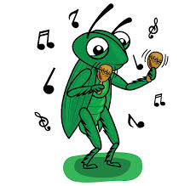 | RECKLESS DRIVING  Reckless driving is a term used to describe a person's behaviour while operating a vehicle in a manner that shows a blatant disregard for the safety of others or themselves. It involves a conscious disregard for the consequences of their actions which can put others at risk of injury or death.  Several hut and run cases occur every day. Reckless drives hit other vehicles and people then fled from the scene with the victims bleeding. Screaming in pain, calling for help or even dying. Reckless and rash drivers are a menace and highly dangerous to public safely.  Traffic rules prohibit over speeding driving on the wrong lane. Parking in no parking zones, without helmets, car drivers without seat belt and driving under influence of intoxicant.  
 | International woman’s day is celebrated on March 8 every year. It is a day to recognize and celebrate the social economic cultural and political achievement of women around the world on international woman day people often make pledges to support woman’s right and gender equality and to take action to create a more equal and just society for all.
POEMS
FLOWERS  You are like the winter flower that smile at me under the brightest sun and my lowest sum.  The flowers that always smiles back at the sky.  An ever-green arm over my soul. The prettiest flower hidden by vast of weeds.  Grinning back at the once stagnant and grey sky that turned bright and blinding.  But don't you thrive in the shallow my dear rose.  Why greets the sky so deep? When it drowned you in the light, water, and breeze?  You are grateful for something hurtfully extreme.  Why adjust your needs? Why not ask the stubborn sun to try and not exceed?  "It thrives in clear winker but blooms all year. It loathes in the guilt of all dead weeds, but it turns a shadow once the sun peeks.  Aysha Ahd  8 C  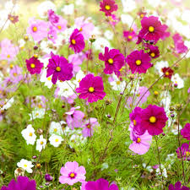 | 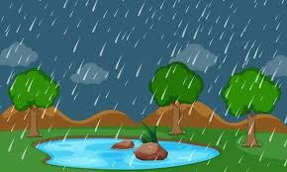  Rain  You see the rain; you think of nothing.  You see it again; you think of nothing.  Now think it might not be ones again.  It could be the last could be the second.  It is a sapling's first dew.  It could be a woman's last view.  The rain revolves all over.  It's there on your lows and your summers.  It's a disappointment, it's a relief.  It's the same drop you saw on your palm. It could be the same one on your wet clothes a year ago. Once in your life you are drunken that drop.  Walls have ears, potatoes have eyes.  Rain has memories, Rain has known you for a while.  One day, or hidden in another  Rain has been in your gutter.  It has also been in your coffee look at it in a way. It is in your car, walls it's in your pen ink.  Rain is the most dangerous weapon.  Yet rain is loyal to us all.  But still, it chatters it all out the leaves and wood Poarch.  I don't understand how open the rain is. Has it never cried?  Aysha Ahd  8 D

Rain  Pitter-patter, gentle sound,  Raindrops kiss the thirsty ground.  Nature's tears, a cleansing sight,  Washing worries, day and night.  A symphony of silver grace,  Painting dreams across the space.  Srishti Patel  7 B | Rain  How lovely the rain is!  How beautiful its sound is!  The sound that it's make, tip and tap, Pit and pat. Every time when it rain, I lie on my bed, Recollecting thousands of memories, in my head.  Prachi Navin  9 A
Dreams  Hold fast to dreams  For if dreams die  Life is a broken-winged bird  That cannot fly.  Hold fast to dreams  For when dreams go  Life is a barren field  Frozen with snow.   | Happiness  A constant touch of sweetness linked all hearts. The throb of one adoration’s single bliss. In a rapt ether of undying love.  An inner happiness abode in all,  A sense of universal harmonies,  A measureless secure eternity  Of truth and beauty and good and joy made one.  
Rain  The sky is cloudy  and the rain is coming.  We are getting wet  and playing in rain. Jumping in mud,  singing with words.  The sound of rain Making us happy.  Akansha  7 B | 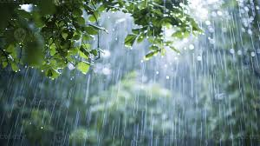

OUR SCHOOL
Daan Utsav 2024
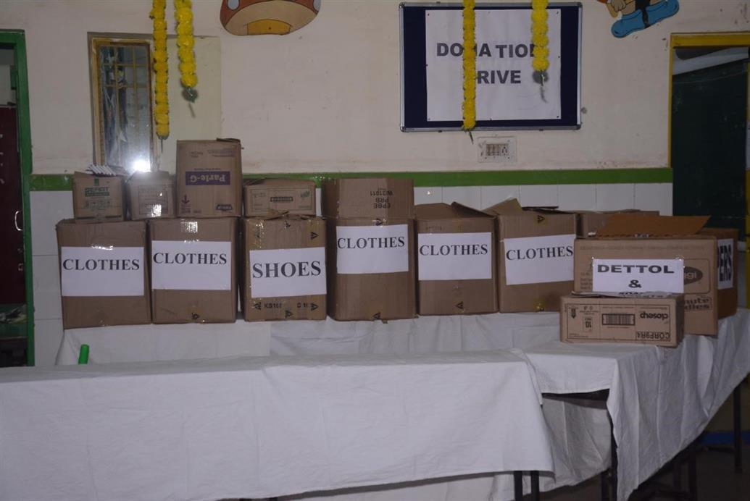 | 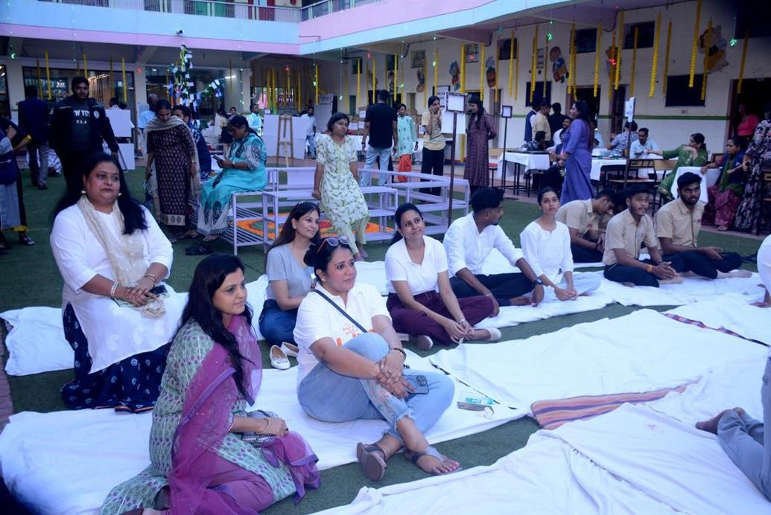
QUIZ Competition
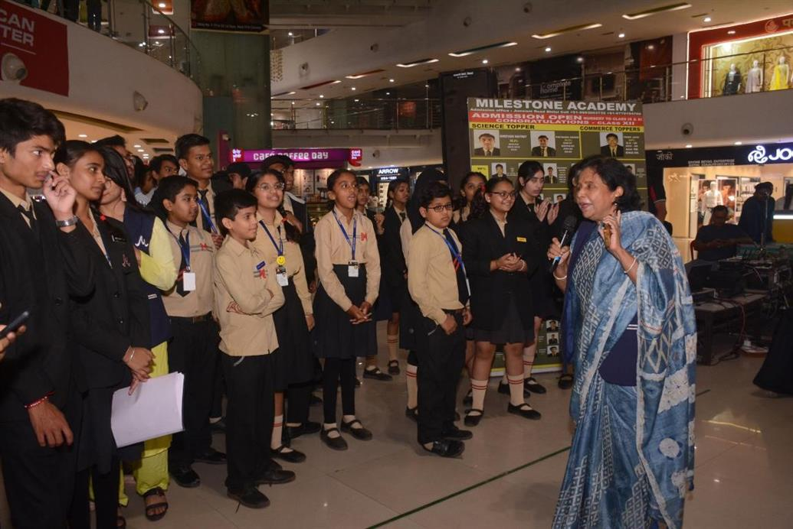 | 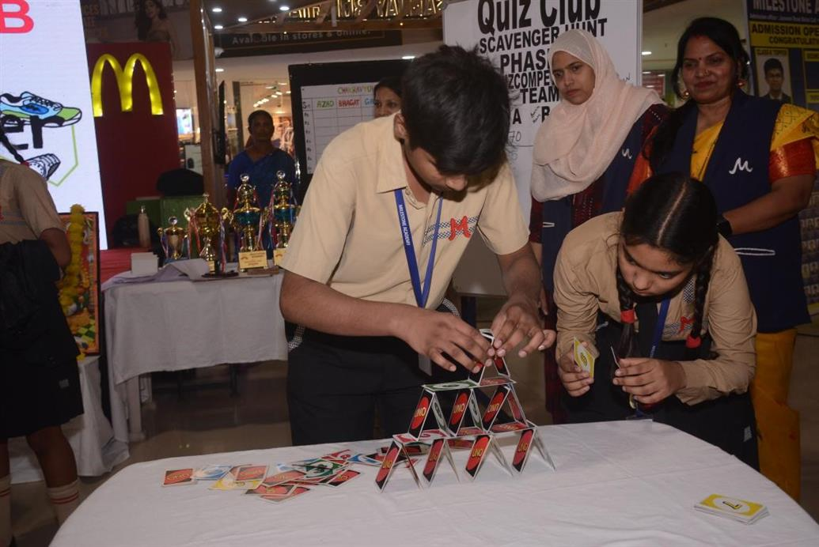
Annual Club Exhibition
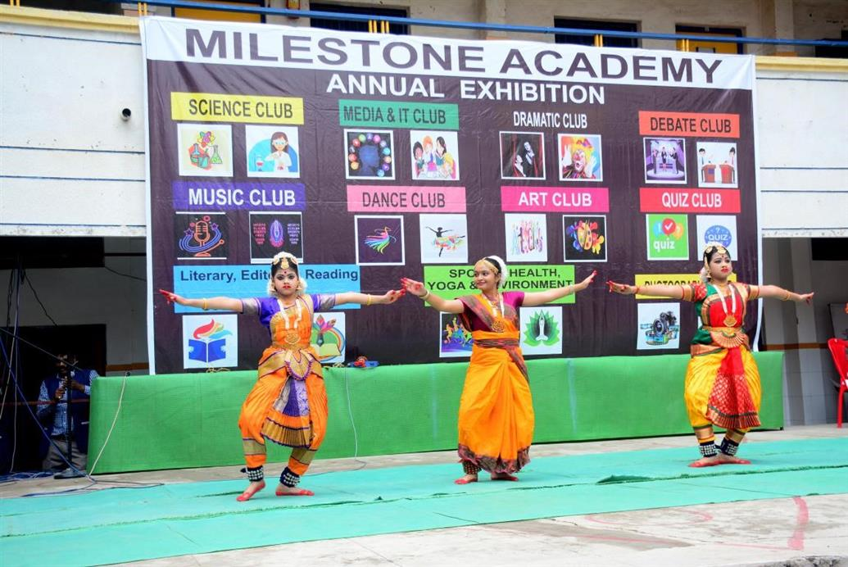 | 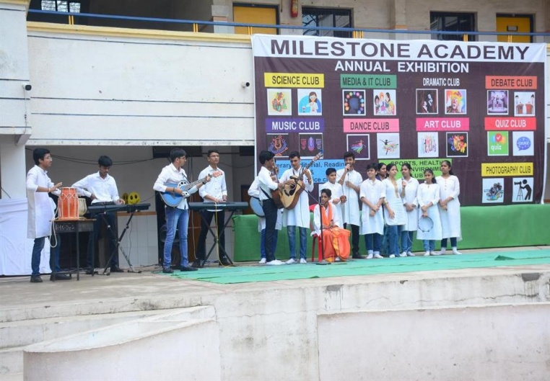
Media & IT Club
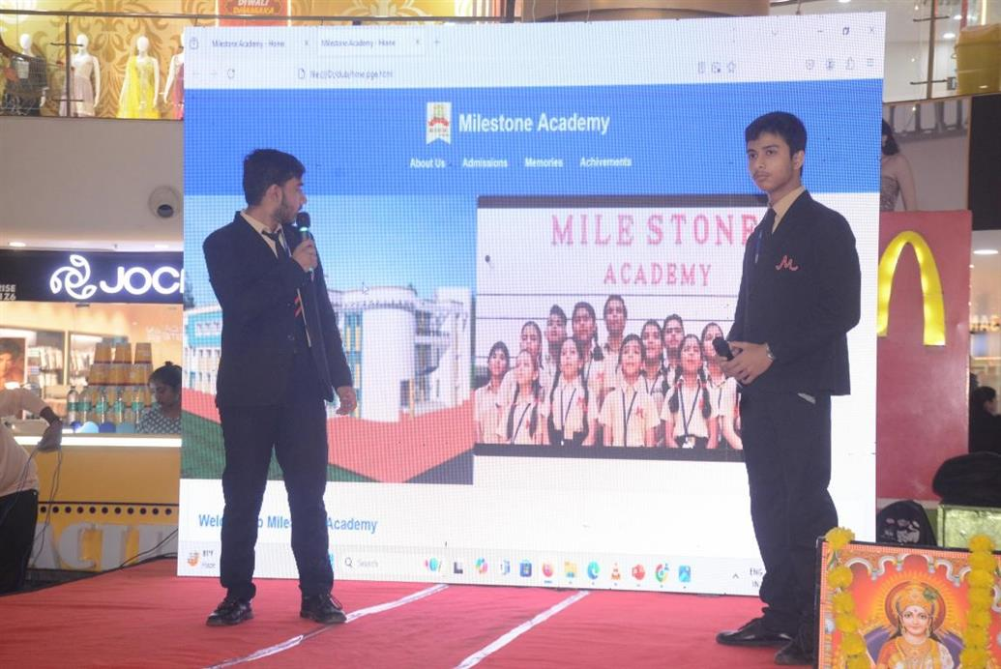 | 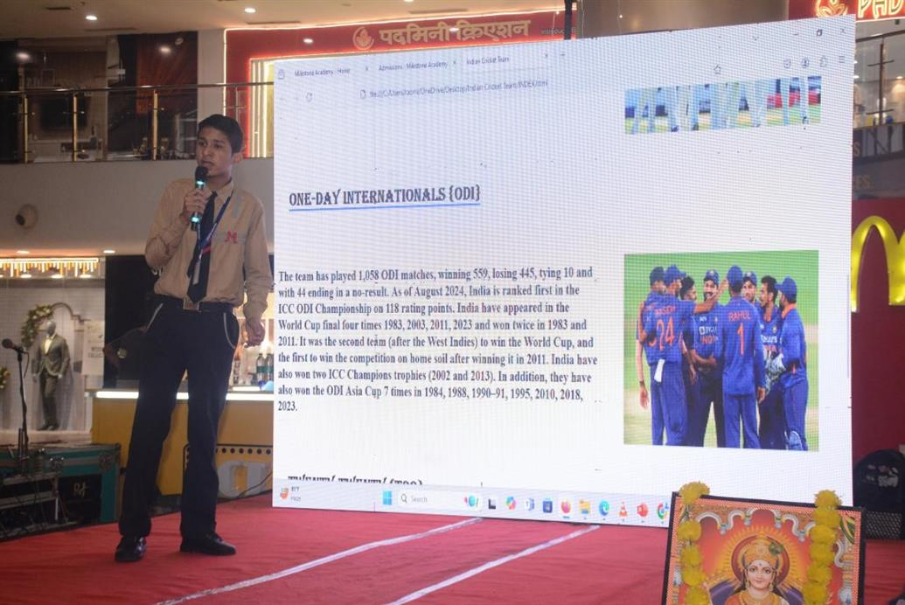
Independence Day
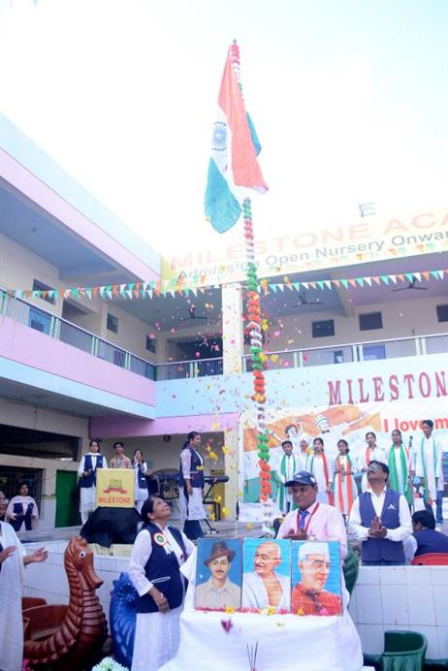 | 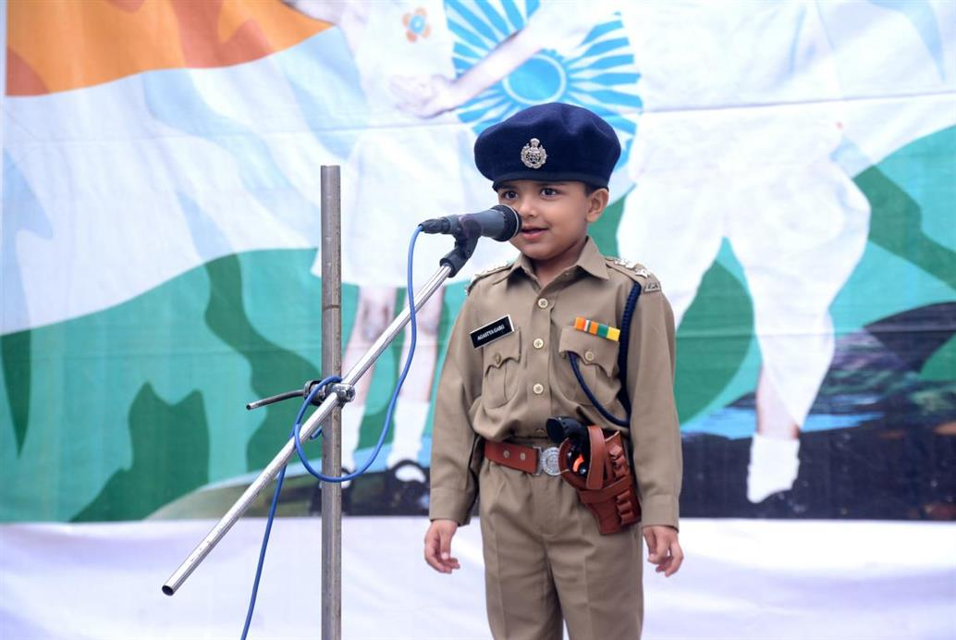
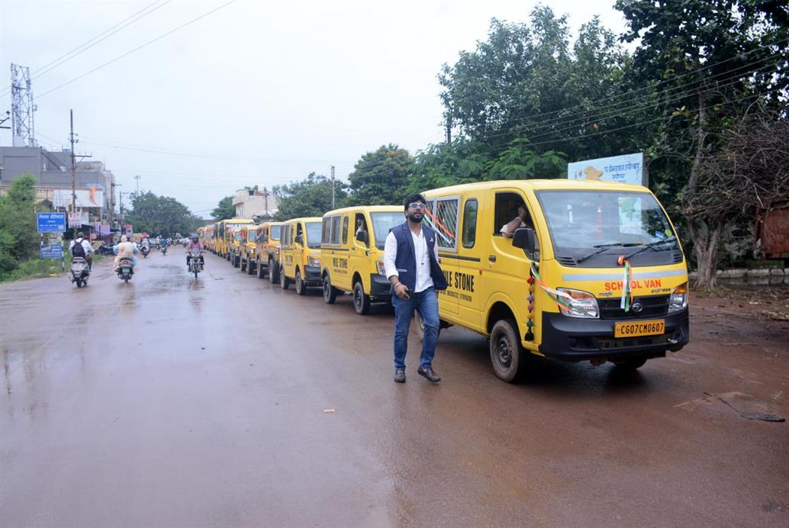 | 