|  |
| --- |
| Office Use Only  Assignment Received  Before due date & time  Late Submission |



|  |  |
| --- | --- |
| **PROGRAMME** | DIPLOMA TEKNOLOGI MAKLUMAT |
| **SUBJECT CODE &**  **NAME** | KCS1313 PENGATURCARAAN BERORIENTASIKAN OBJEK |
| **TUTOR NAME** | PUAN NOORZANILA BINTI MOHD NOR |
| **ASSIGNMENT TITLE** | TUAGASAN 2 |

Please note that it is your responsibility to retain copies of your assignment. Copying someone else’s work is plagiarism, and is unacceptable. The college may impose severe penalties for plagiarism. All work must be submitted by the due date. If an extension of work is granted, this must be specified with the signature of the lecturer/tutor.

**INDIVIDUAL ASSIGNMENT**

|  |  |  |
| --- | --- | --- |
| **STUDENT NAME** | **MATRIX NUMBER** | **SIGNATURE** |
| MITHILESWARAN A/L RATHAKRISHNAN | 1052023070002 |  |

**OFFICE USE ONLY**

|  |  |
| --- | --- |
| Tutor Name | PUAN NOORZANILA BINTI MOHD NOR |
| Marking Comment & Feedback |  |
| Result/Grade |  |

**Output**

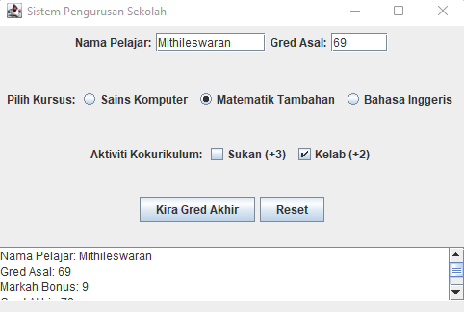

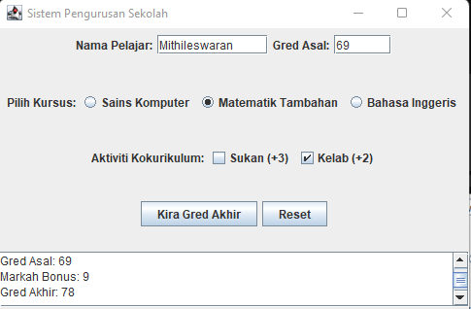

**CODING**

