**Login with Twitter and Facebook**

**Description**

This application prints the user's twitter and facebook profile details.

After seletion of one of the services from the pool mainly facebook and twitter.   
User is redirected to facebook or twitter website to get authenticated.  
After authentication is done, service prompts user whether to allow access to application or not. After allowing the access to application, this application accesses the information with the help of APIs.(This process is nothing but OAuth.)

**Technical Description**

To use this application you must create facebook and twitter application  
For specifying callback URL give your domain name and

* For twitter give callback URL as http://domain/twitter-details.php
* For facebook give callback URL as http://domain/login-facebook.php

Set configuration details such as consumer key, secret key and API keys in the files specified in README.txt

**Flow of code**

1. When application is run, it checks whether session is set or not, if session is not set then user will be prompt to choose twitter or facebook.
2. After clicking on any of the link, *querystring i.e. oauth_provider* is set and is passed to URL index.php
3. Depending upon the *querystring i.e. oauth_provider* user is redirected

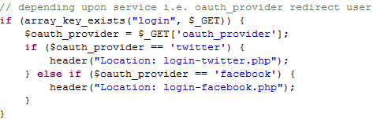

1. For twitter,
   1. Authentication is done. And some information is posted on that URL by twitter  
        
      Following is the code for that.  
      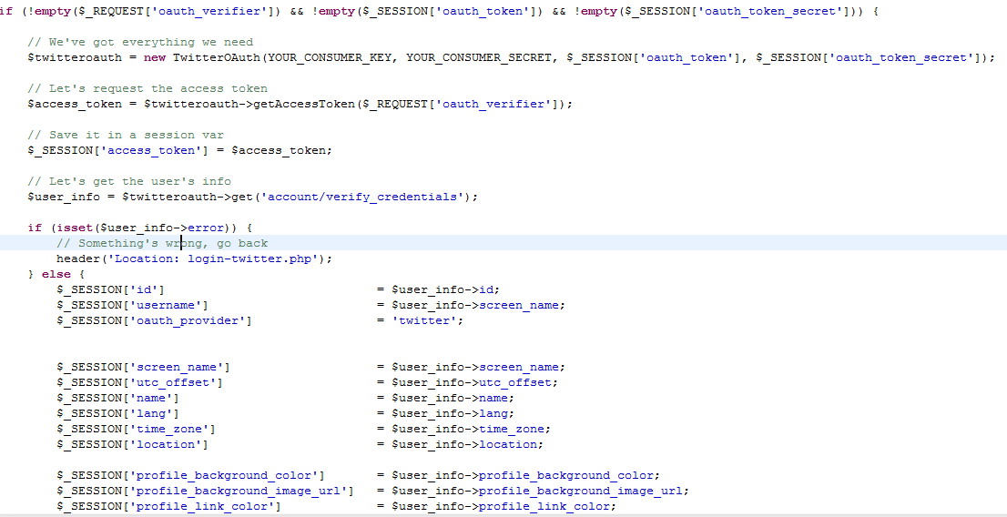
   2. Get all the information, store it in session.

Show on home page.

1. For facebook,
   1. Authentication is done. And some information is posted on that URL by Facebook  
      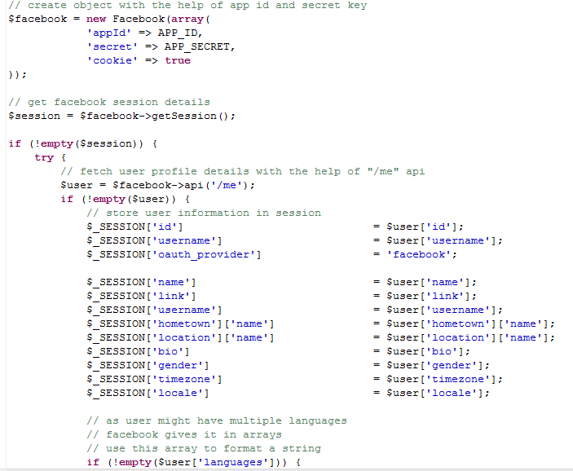
   2. Store this information in session for displaying purpose.
2. Display this information on home page.
3. **Logout**

User will be logged out of the system if user is clicking on logout link.

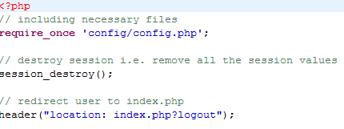

That’s it!! Simple to use!!! Simple to understand!!