System Analysis And Design

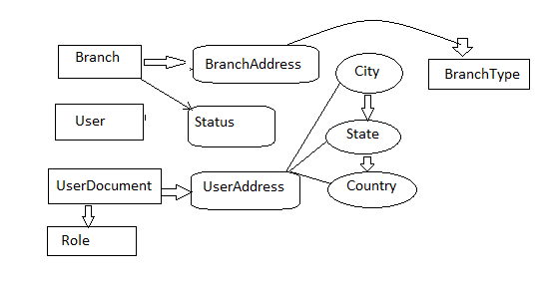

Fig 1:-Activity Diagram

User Use Case:-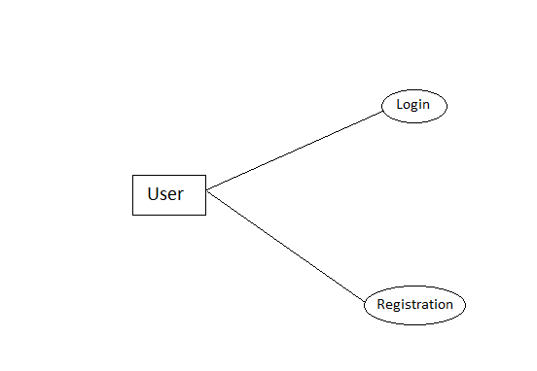

Fig 2: User Use Case

Use Case Diagram(Admin):-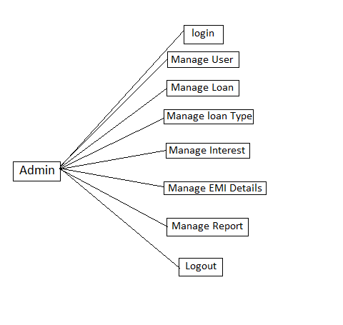

Fig 3: Use Case Diagram(Admin)