**Batch: A3 Roll No.: 16010123085**

**Experiment / assignment / tutorial No.____**

**Grade: AA / AB / BB / BC / CC / CD /DD**

**Signature of the Staff In-charge with date**

|  |
| --- |
| Title: Set up the Flutter development environment and run a basic app. |

**AIM:** To set up the **Flutter development environment** and run a basic Flutter application.

**Objective:**

**Problem Statement**

Install Flutter SDK, configure the development environment, and create a simple "Hello World" Flutter application that runs on an emulator or physical device.

**Tools Required**

* **Flutter SDK** (latest stable version)
* **Dart SDK** (bundled with Flutter)
* **Android Studio / VS Code**
* **Android Emulator** / **Physical Device (USB debugging enabled)**

## Theory

Flutter is a **cross-platform UI toolkit** by Google that uses **Dart language**. It allows building apps for Android, iOS, web, and desktop with a single codebase.

Steps to set up Flutter environment:

1. Download & install Flutter SDK.
2. Add Flutter to system PATH.
3. Install IDE (VS Code/Android Studio) with Flutter & Dart plugins.
4. Configure Android SDK / emulator.
5. Verify installation using flutter doctor.

## Procedure

1. **Install Flutter SDK**
   * Download from https://flutter.dev

**flutter doctor**

•**Set Up IDE**

* Install **Android Studio** or **VS Code**.
* Add **Flutter** and **Dart** extensions.

• **Create New Project**

**flutter create my_app**

**cd my_app**

**Run the App**

* Launch on Android Emulator / physical device

**______________________________________**

**Expected OUTCOME of Experiment:**

**CO 2: Configure system for Flutter Development and Understand Android studio, Android UI**

**design.**

**___________________________________________________________________**

**Books/ Journals/ Websites referred:**

1. Shelly Powers Learning Node O’ Reilly 2 nd Edition, 2016.

**Implementation Details:**

Flutter Doctor:

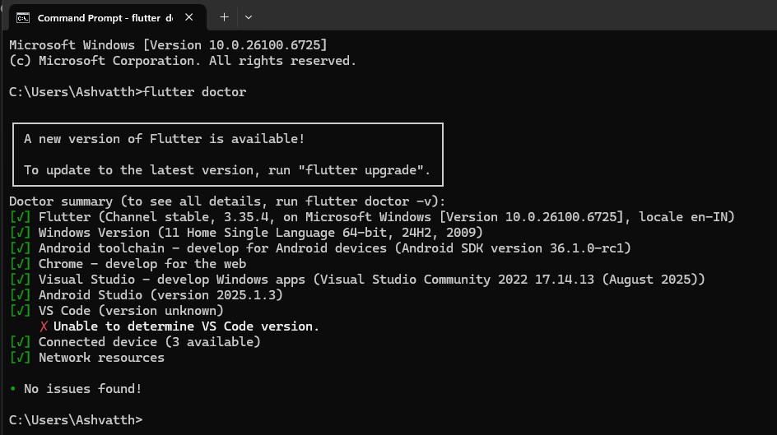

Create Flutter App & Run via Emulators:

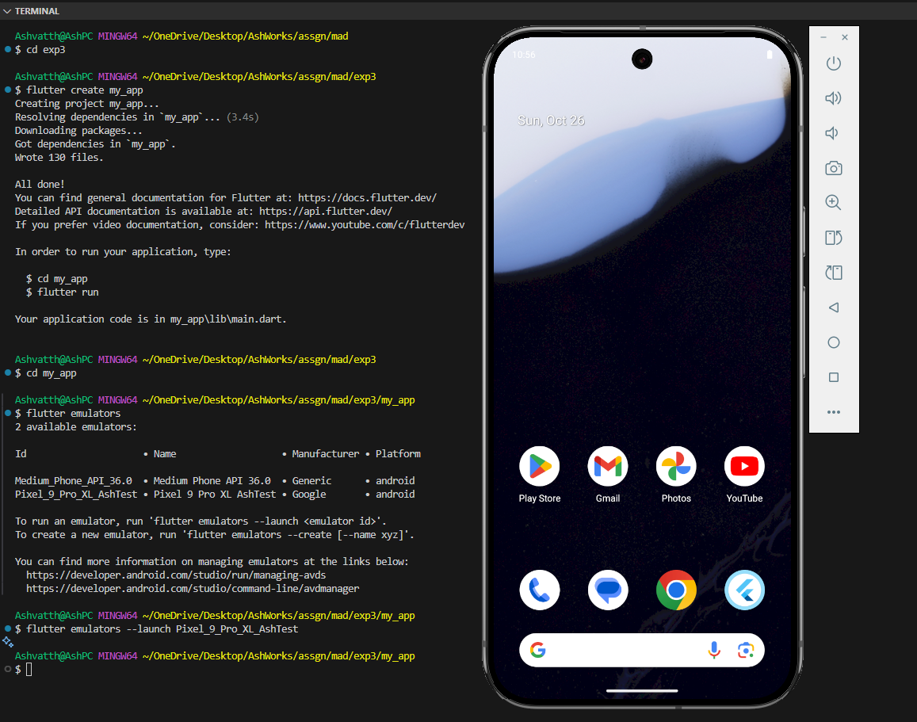

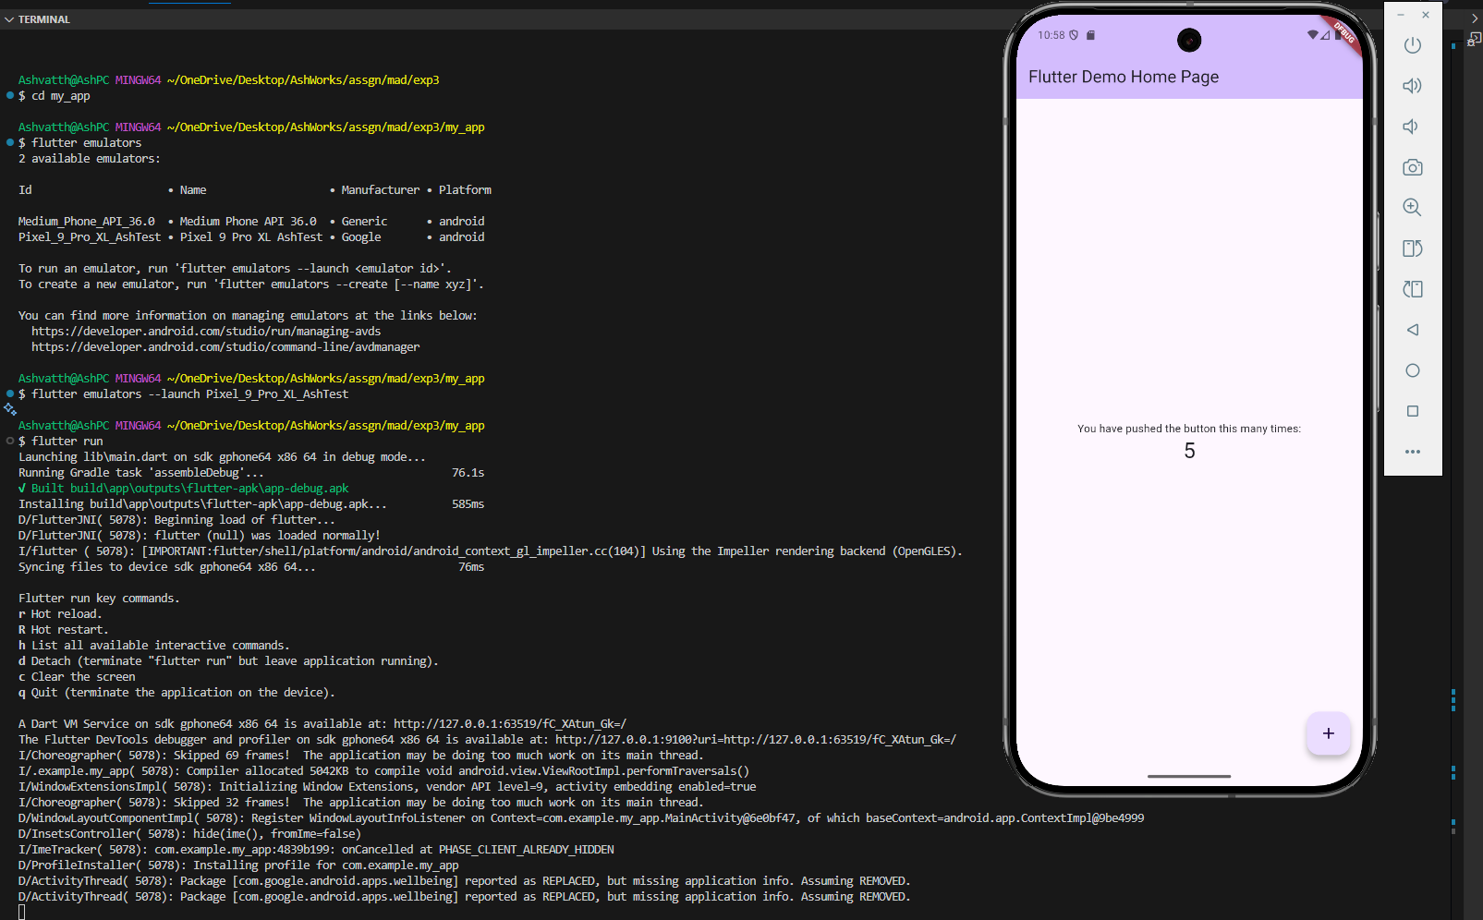

**Steps for execution:**

**Conclusion:**

### Students have to write in their own words.