**Batch: A3 Roll No.: 16010123085**

**Experiment / assignment / tutorial No.____**

**Grade: AA / AB / BB / BC / CC / CD /DD**

**Signature of the Staff In-charge with date**

|  |
| --- |
| Title: Build UI using core Flutter widgets and layouts. |

**AIM:** To build user interfaces using **core Flutter widgets** by implementing **Stateless** and **Stateful** widgets.

**Theory**

Dart is an object-oriented, general-purpose programming language developed by Google. It is widely used in **Flutter** for mobile and web app development.  
Key features include:

* Strong typing and null safety
* Support for OOP principles (classes, objects, inheritance)
* Functions and arrow syntax
* Control structures (if-else, loops, switch-case)
* Collections (lists, sets, maps)

**Problem Statement**

**Title:** *Travel Destination Card with Icons and About Us Page*

**Description:**  
Create a **Flutter** application that showcases a **travel destination highlight card** using only a **StatelessWidget** for the main UI.  
The card should display:

* Destination image (use Image.network or Image.asset)
* Destination name (e.g., "Norway")
* Country flag/icon
* Best season (with a seasonal icon)
* Rating (with a star icon)

Additionally, the app should include:

* **Navigation bar** or **Icon buttons** for "Home" and "About Us".
* An **About Us** page that describes the app's purpose and includes developer details (name, email, etc.), styled using Text, Text.rich, and Container widgets.

**Widgets to Use:**

* StatelessWidget for both Home and About Us screens
* Container for styling the card
* Text & Text.rich for labels and descriptions
* Icon for visual cues (stars, season, location)
* Image for destination picture
* Scaffold & AppBar for layout structure

**______________________________________**

**Expected OUTCOME of Experiment:**

**CO 1: Understand basics, object-oriented programming concepts and Null safety in Dart & Flutter**

**___________________________________________________________________**

**Pre Lab/ Prior Concepts:**

**Implementation Details:**

Code:  
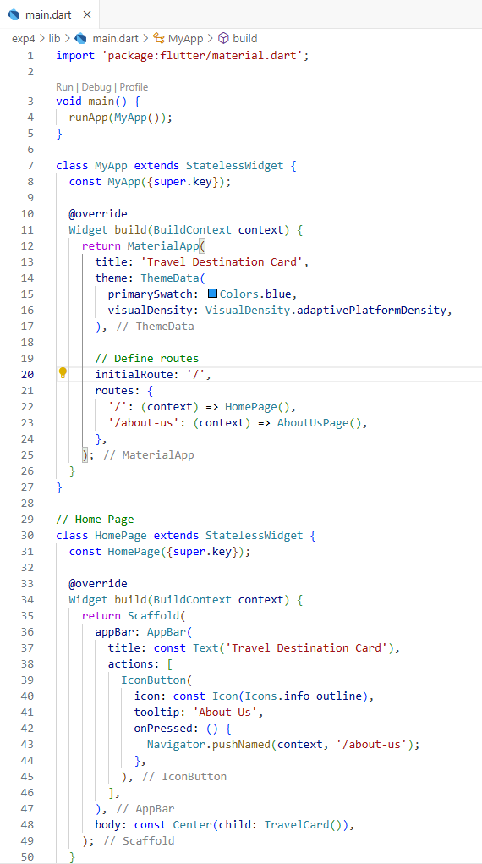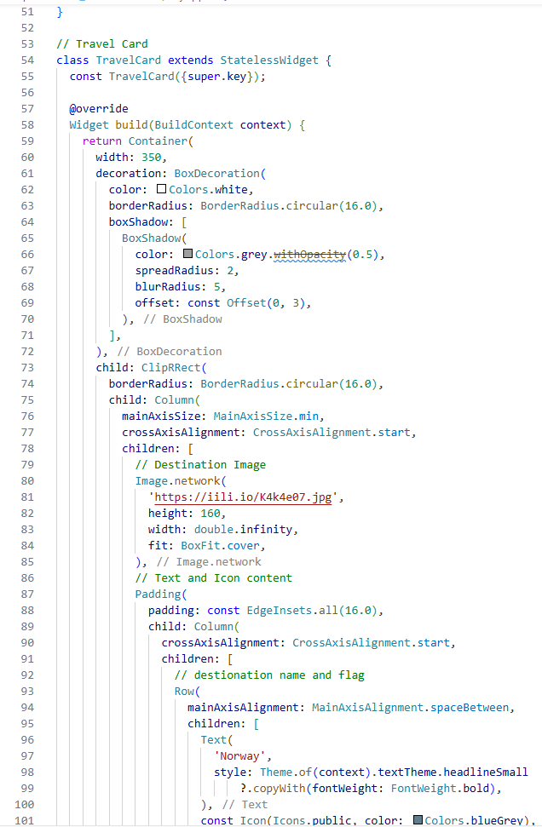

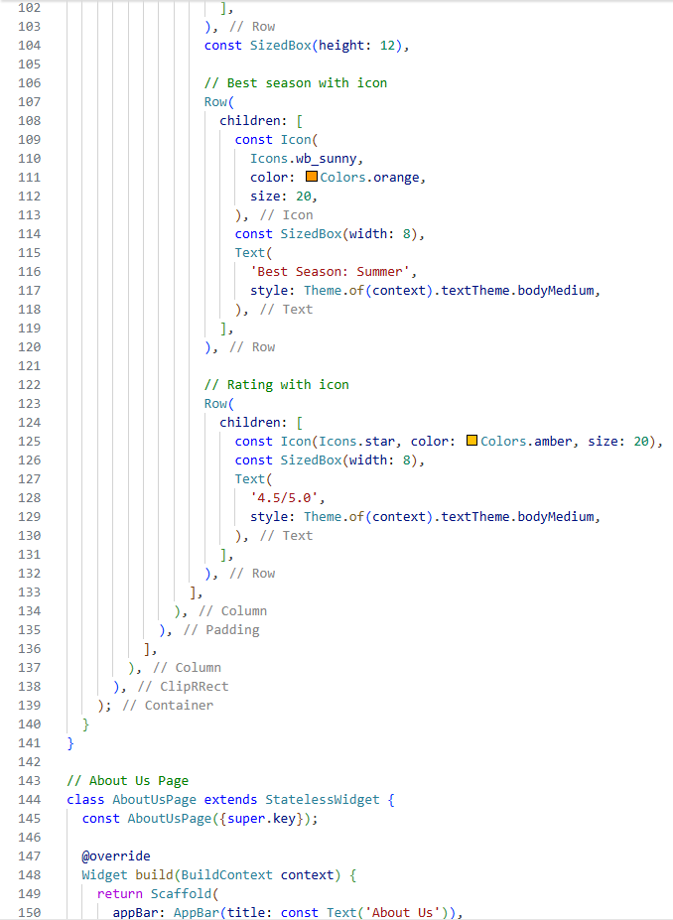

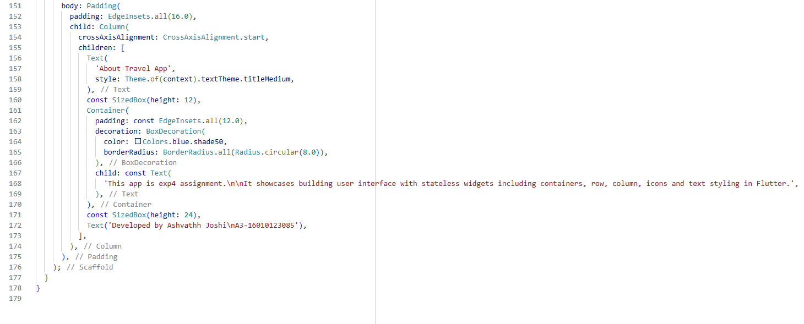

Output:  
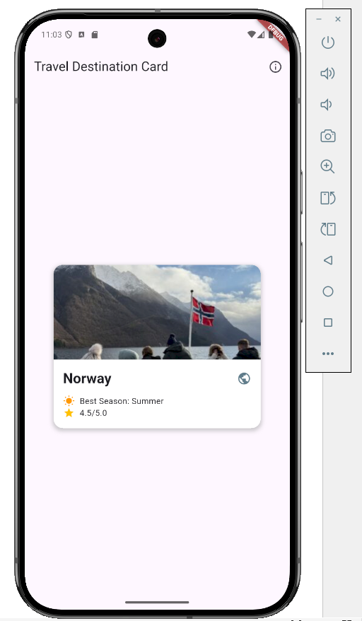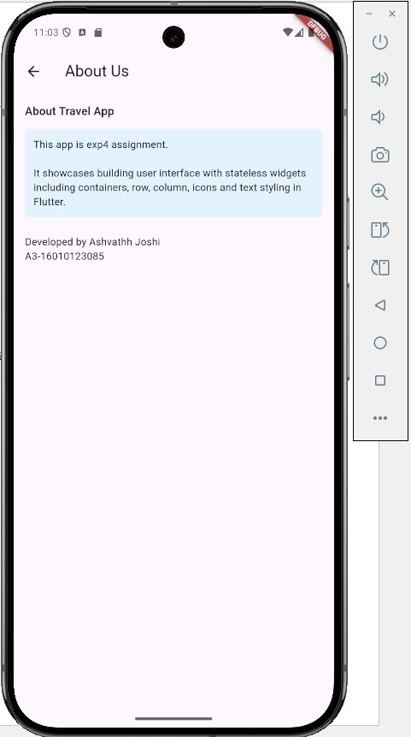

Students have to write stepwise details of implementation.

* 1. Main App: Created a stateless widget inside MaterialApp
  2. Navigation routes: defined two routes in materialapp: ‘/’ home route pointing to homepafe and ‘/about-us’ pointing to Aboutuspage
  3. Homepage: built another stateless widget using scaffold. An app bar was added with an icon button for navigation to about us page
  4. Navigation action: iconbutton’s on pressed event was coded to open aboutus page
  5. Travel card: another stateless widget was build using container styled box decoration to create the cards rounded corners and shadow
  6. About us: a second stateless widget screen was built, using column, container to display apps purpose and developer details

**Conclusion:**

Learned and implemented stateless widgets, navigation between pages, used containers, styling for rounded corners and shadow, image displaying and many other things