**Batch: A3 Roll No.: 16010123085**

**Experiment / assignment / tutorial No.____**

**Grade: AA / AB / BB / BC / CC / CD /DD**

**Signature of the Staff In-charge with date**

|  |
| --- |
| Title: Implementation of Gesture Recognition in Flutter |

**AIM:** To design and implement a Flutter-based Photo Viewer application that demonstrates gesture recognition by enabling users to interact with photos using tap, double tap, long press, and swipe gestures.

**Objective:**

* To apply gesture recognition in a real-world app scenario.
* To understand how gestures can enhance user experience in multimedia applications.
* To implement photo navigation and actions using GestureDetector..

**Theory**

Dart is an object-oriented, general-purpose programming language developed by Google. It is widely used in Flutter for mobile and web app development.  
Key features include:

* Strong typing and null safety
* Support for OOP principles (classes, objects, inheritance)
* Functions and arrow syntax
* Control structures (if-else, loops, switch-case)
* Collections (lists, sets, maps)

**Problem Statement:**

In multimedia applications, users expect smooth and intuitive interaction with visual content. Traditional navigation buttons for browsing and interacting with photos can feel less natural and slow. A modern photo viewer application should allow users to engage with photos using simple gestures like tapping, swiping, or long pressing, which mimic real-world interactions.

The challenge is to implement a Flutter-based photo viewer app that recognizes multiple gestures—such as tap to toggle details, double tap to zoom, long press to mark favourites, and swipe to navigate between photos—while ensuring responsiveness, smooth transitions, and an engaging user experience.

**______________________________________**

**Expected OUTCOME of Experiment:**

**CO3: Implement UI components, Widgets and Navigation using Flutter**

**________________________________________________________________**

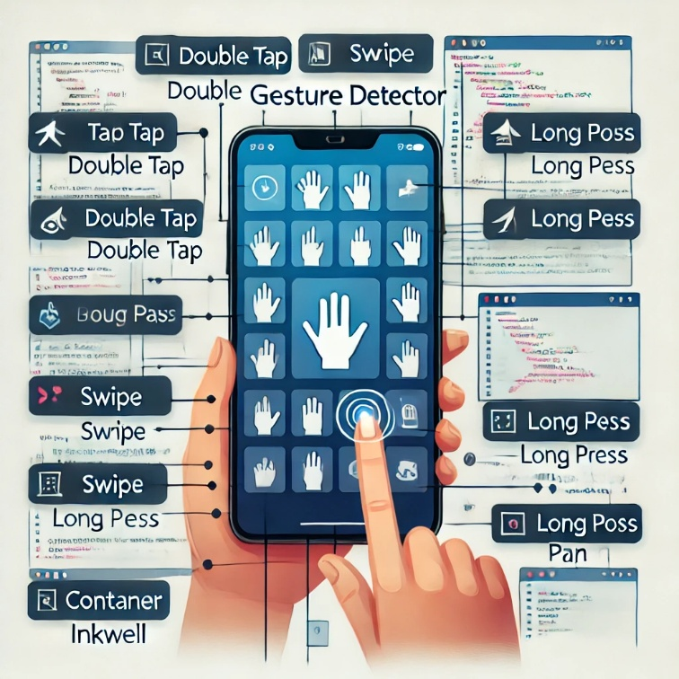

**Pre Lab/ Prior Concepts:**

**Implementation Details:**

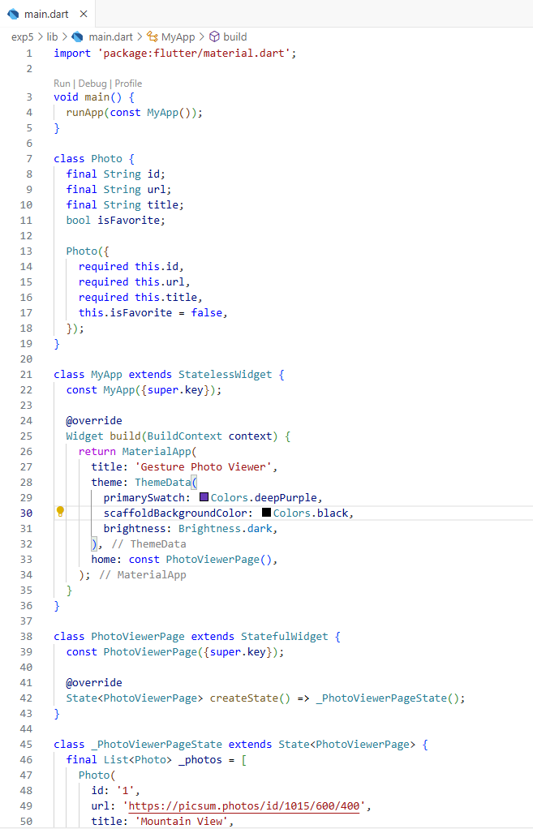

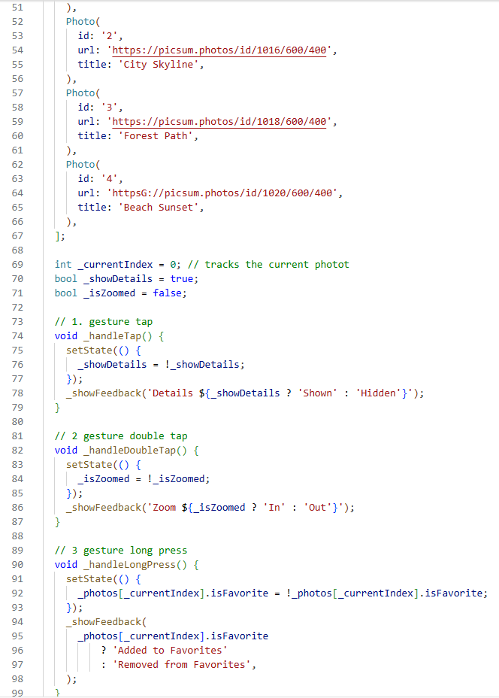

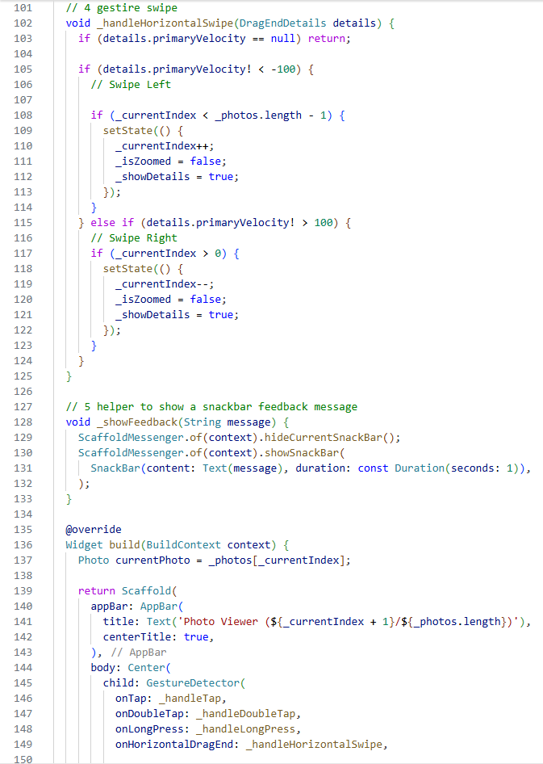

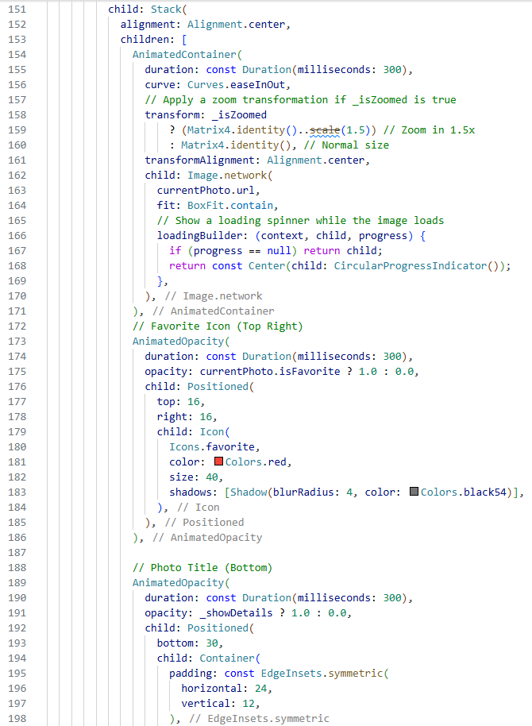

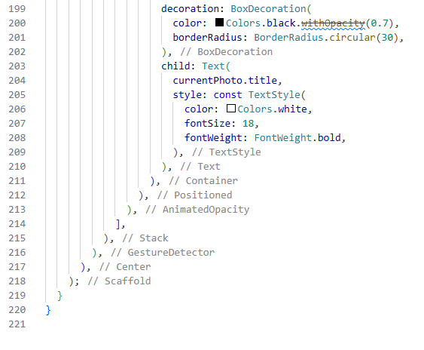

**Output:**

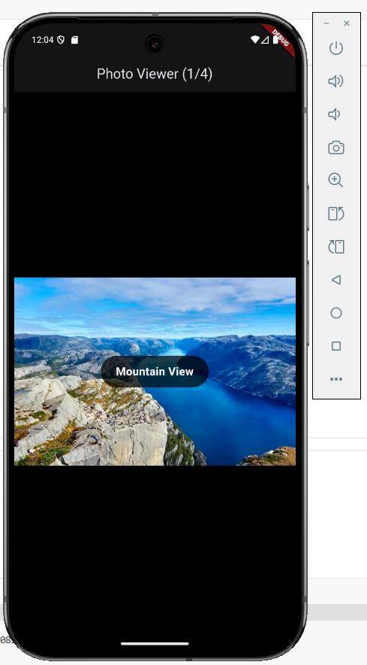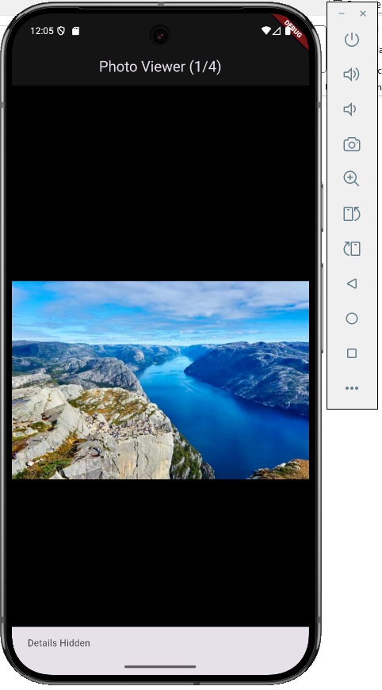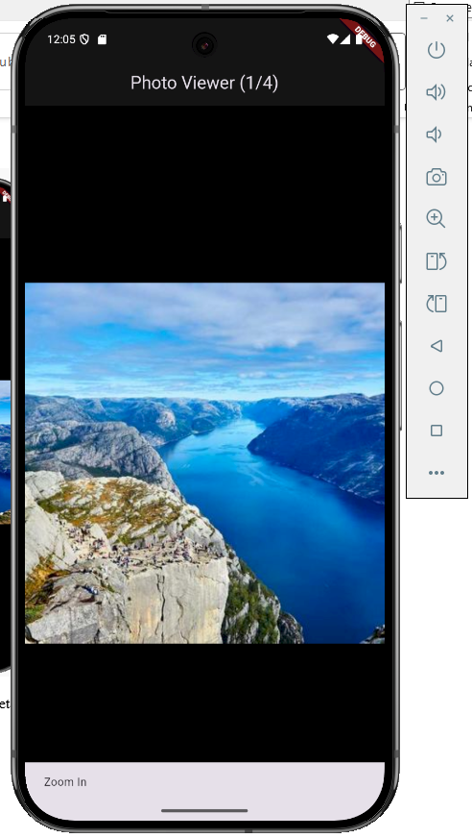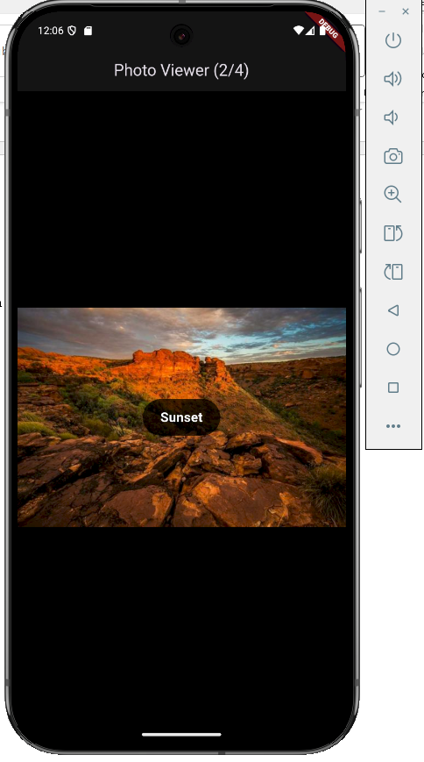

Students have to write stepwise details of implementation.

1. **Used stateful widget to display states**
2. **Used gesture control to detect gestures and act accordingly**
3. **Loaded images**

**Steps for execution:**

1. Copy code
2. Run flutter app
3. Use gesture controls with feedback system

**Conclusion:**

Implemented stateful widget in flutter using gesturedetector widget whhich was the main point here, also used animatedcontainer and animatedopacity