**Batch: A3 Roll No.: 16010123085**

**Experiment / assignment / tutorial No.____**

**Grade: AA / AB / BB / BC / CC / CD /DD**

**Signature of the Staff In-charge with date**

|  |
| --- |
| Title: Implementation of Navigation and Route Management in Flutter |

**AIM:** To implement navigation and route management in a Flutter application using both named and anonymous routes for switching between multiple screens.

**Objective:**

• To understand navigation concepts in Flutter.

• To implement anonymous routes using Navigator.push() and Navigator.pop().

• To implement named routes for structured navigation.

• To manage transitions between multiple screens effectively.

**Theory:**

In Flutter, **navigation** is the process of moving from one screen (route) to another. A **route** is equivalent to a screen or page. Flutter provides:

* **Anonymous Routes:** Using Navigator.push() and Navigator.pop() to move between pages directly.
* **Named Routes:** Pre-defining routes in MaterialApp and navigating using route names.
* **Navigator Stack:** Routes are managed in a stack-like structure; pushing adds a new screen, popping removes the top screen.

**Problem Statement:**

Most mobile applications consist of multiple screens (pages) such as home, profile, settings, or details pages. Without proper navigation and route management, user experience becomes confusing and inconsistent. Therefore, it is necessary to implement a mechanism to move between screens in an organized and manageable way, ensuring smooth transitions and state management.

Design and implement a Flutter application that features a Navigation Drawer with user profile information and a list of menu options such as Dashboard, Contacts, Events, Notes, Settings, Notifications, Privacy Policy, and Send Feedback.

The app should:

* Display user information (profile picture, name, email) at the top of the drawer.
* Provide a clean and user-friendly drawer menu with icons and labels.
* Enable users to navigate to different sections/screens by selecting items from the drawer.
* Highlight the selected menu item to indicate the current active screen.

**______________________________________**

**Expected OUTCOME of Experiment:**

**CO3: Implement UI components, Widgets and Navigation using Flutter**

**____________________________________________________________________________________**

**Implementation Details:**

**Code:**

main.dart:

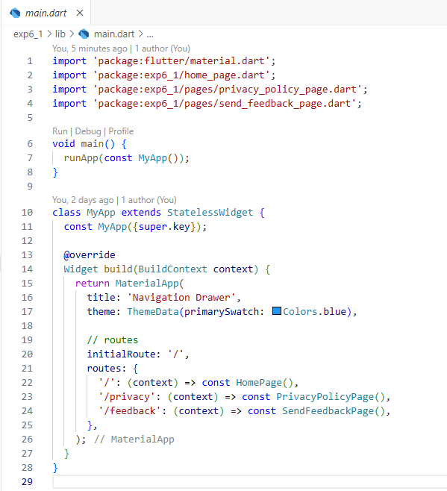

Home_page.dart

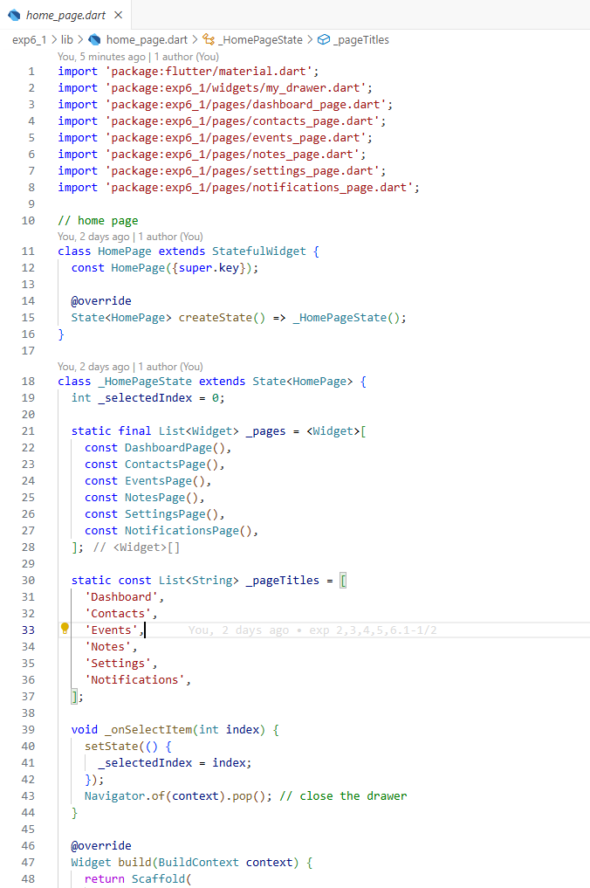

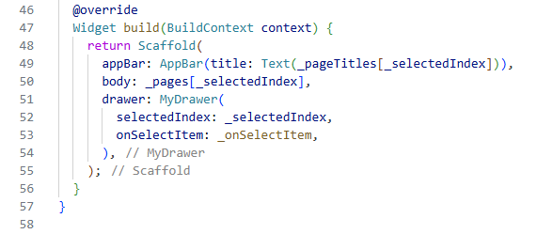

My_drawer.dart:  
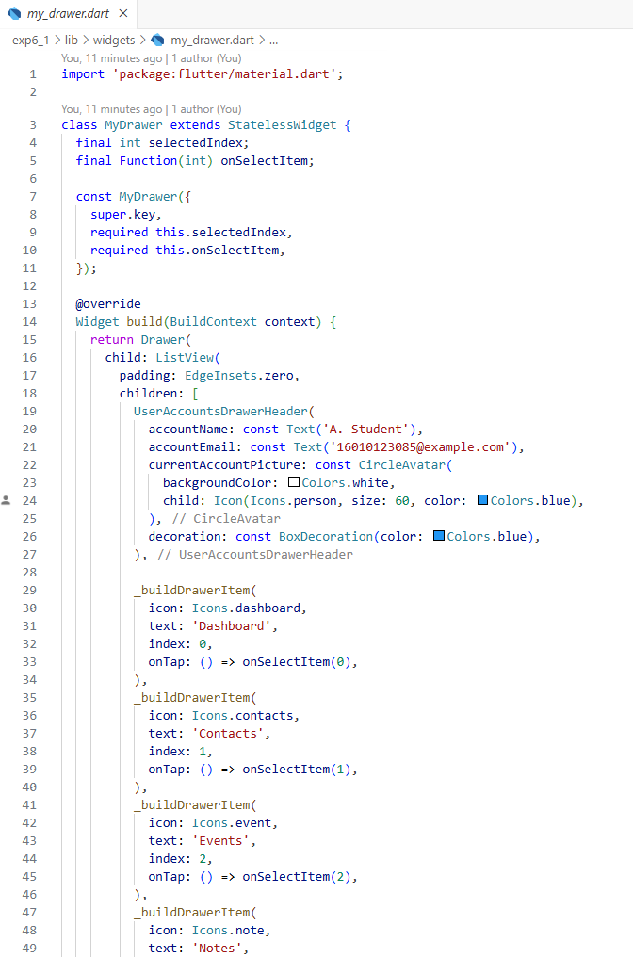

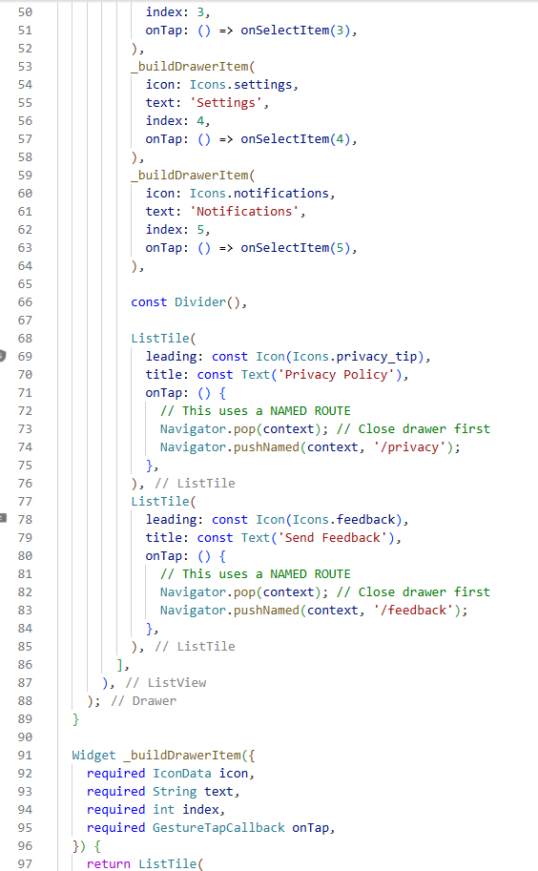

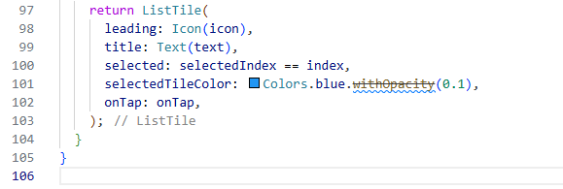

Contacts_page.dart:  
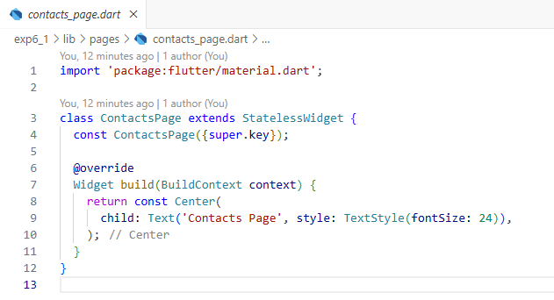

Dashboard_page.dart:

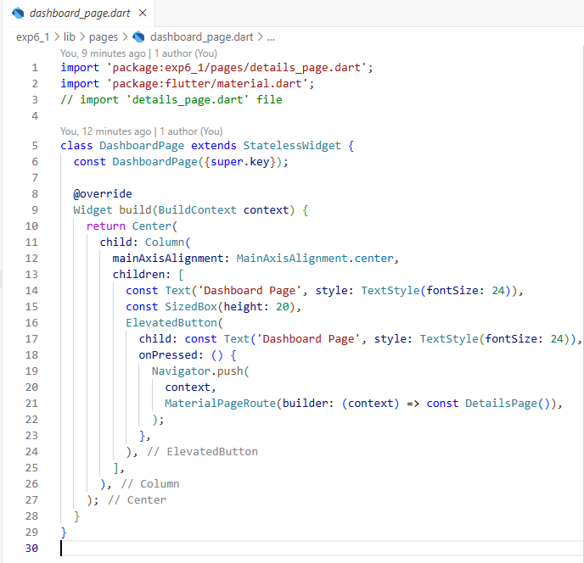

Details_page.dart:  
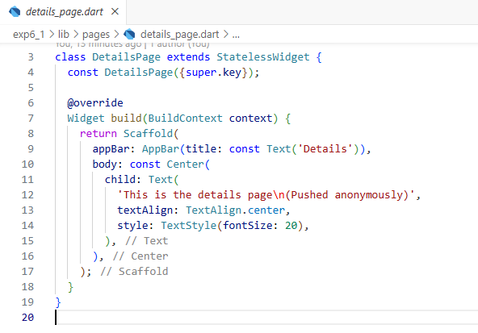

Events_page.dart:  
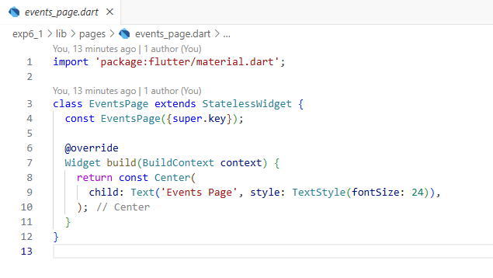

Notes_page.dart:  
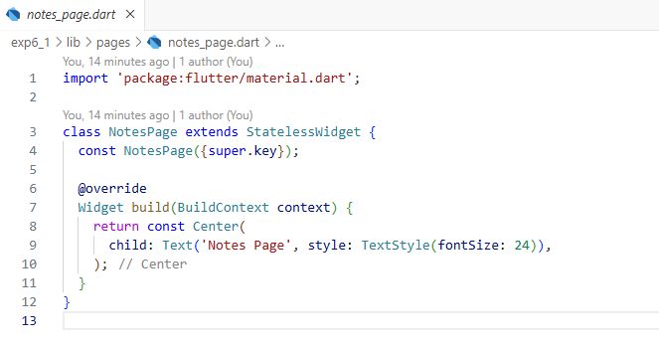

Notifications_page.dart:  
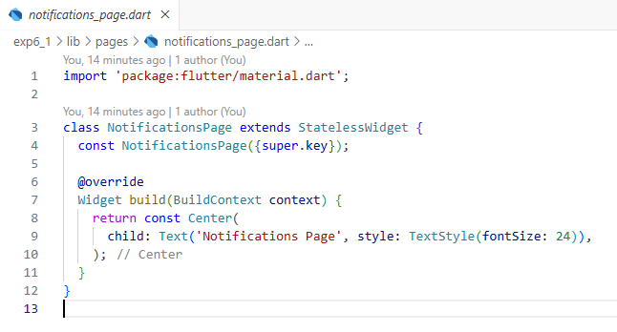

Privacy_policy_page.dart:  
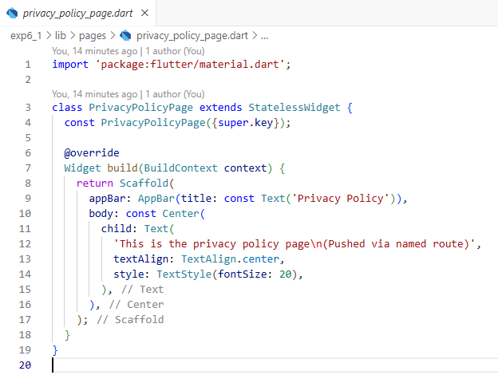

Send_feedback_page.dart:  
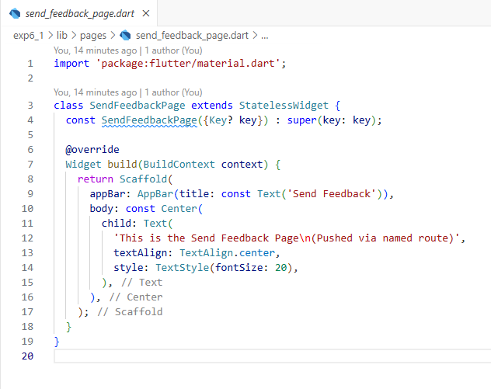

Settings_page.dart:  
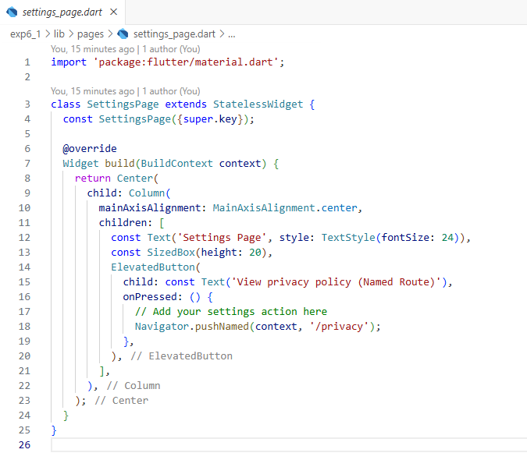

**Output:**

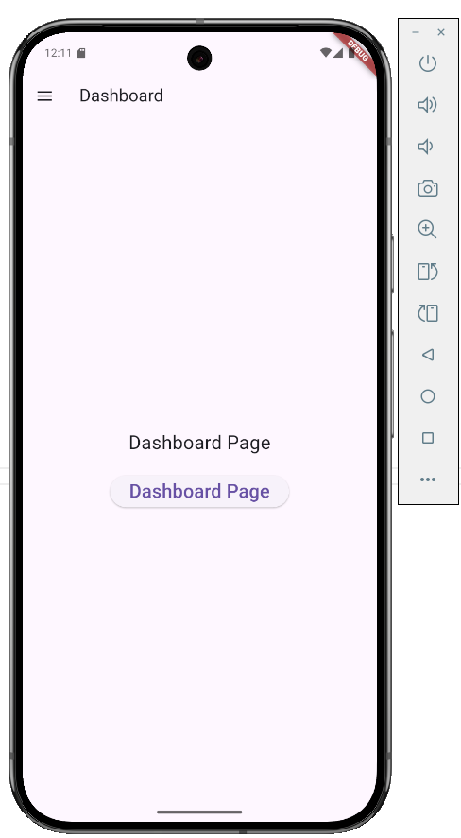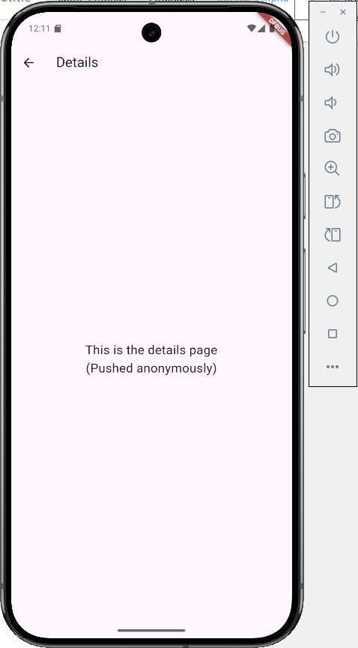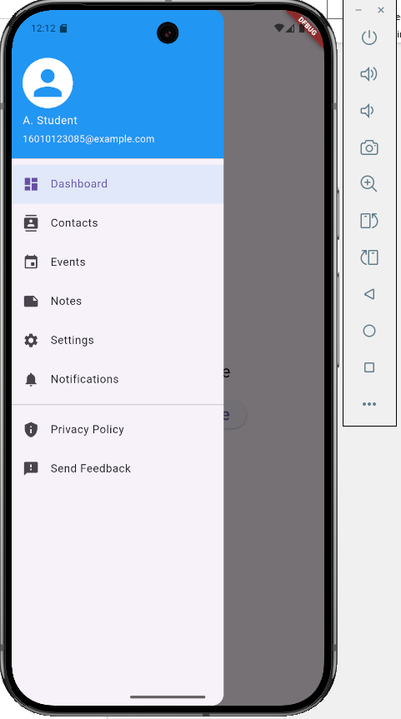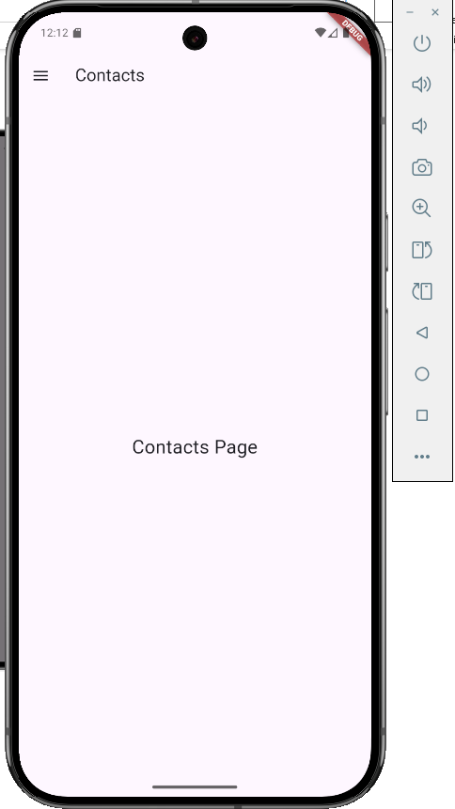

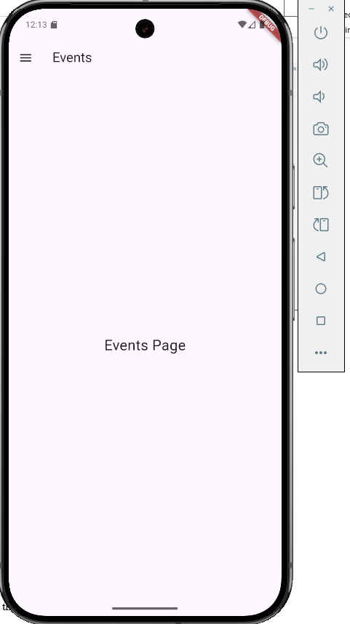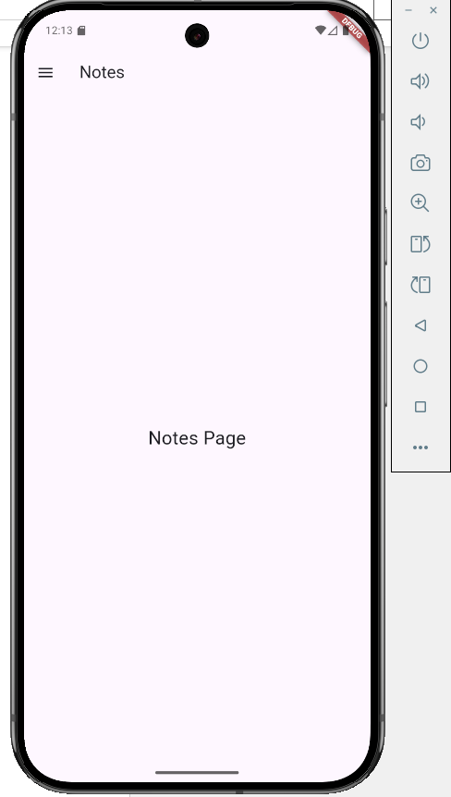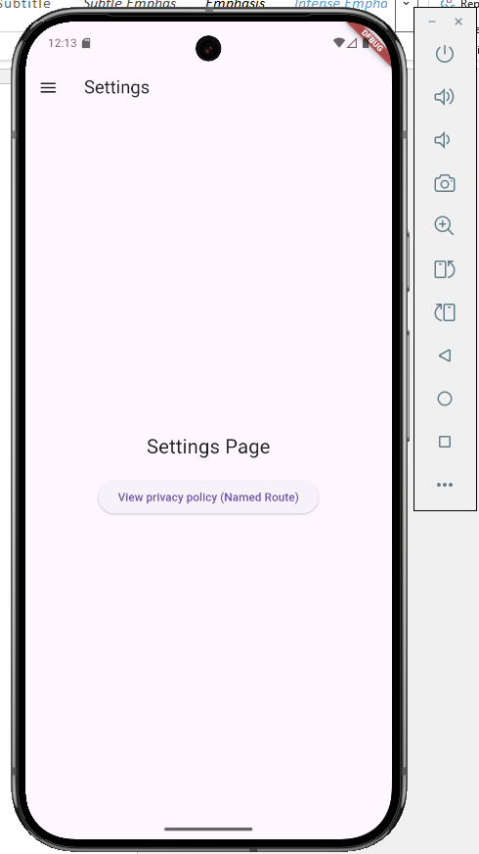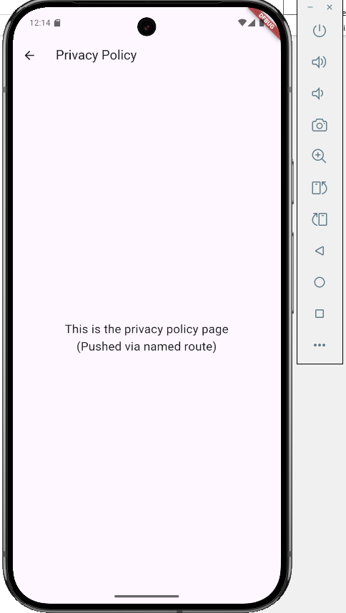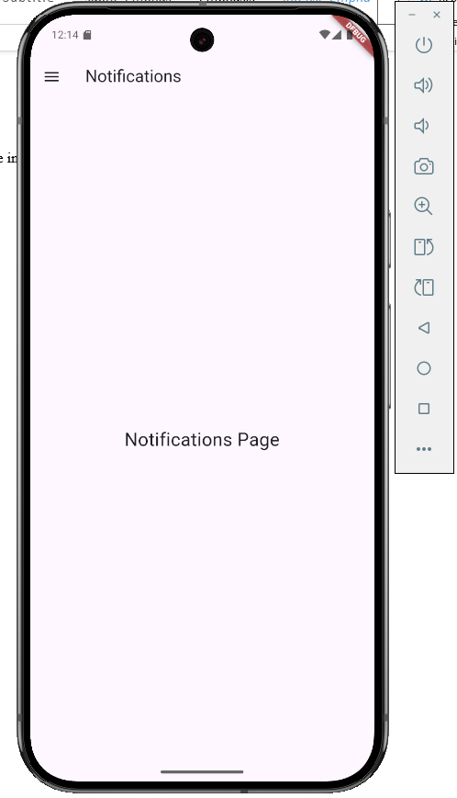

**Conclusion:**

In this experiment we successfully implemented a multi screen flutter application with stateful navigation drawer that highlights the currently active page. Learned to manage navigation using;

Anonymous routes and named routes