**Batch: A3 Roll No.: 16010123085**

**Experiment / assignment / tutorial No.____**

**Grade: AA / AB / BB / BC / CC / CD /DD**

**Signature of the Staff In-charge with date**

|  |
| --- |
| Title: Implementation of MediaQuery in Flutter |

**AIM:** To implement responsive UI design in a Flutter application using MediaQuery to adapt layouts dynamically based on device screen size and orientation.

**Objective:**

• To understand the concept of responsive UI in Flutter.

• To use MediaQuery for fetching screen width, height, and orientation.

• To implement a layout that changes its design based on device size and orientation.

**Theory:**

MediaQuery is a Flutter widget that provides information about the current device's screen size, pixel density, orientation, and text scaling factor.

Commonly used properties:

* MediaQuery.of(context).size.width → Screen width.
* MediaQuery.of(context).size.height → Screen height.
* MediaQuery.of(context).orientation → Portrait or landscape.
* MediaQuery.of(context).textScaleFactor → Scaling for text.

Using these, developers can build UIs that adapt to different devices.

**Problem Statement:**

Consider the experiment no 6.1 and apply the MediaQuery concept from flutter on the same.

Modern mobile applications run on devices with varying screen sizes, resolutions, and orientations. Without responsiveness, the UI may look distorted or cramped on certain devices. Flutter provides MediaQuery to obtain information about the current device’s screen dimensions and orientation. The challenge is to design a layout that adjusts itself gracefully across different devices using MediaQuery.

**______________________________________**

**Expected OUTCOME of Experiment:**

**CO3: Implement UI components, Widgets and Navigation using Flutter**

**____________________________________________________________________________________**

**Implementation Details:**

**Code:**Modified home_page.dart:

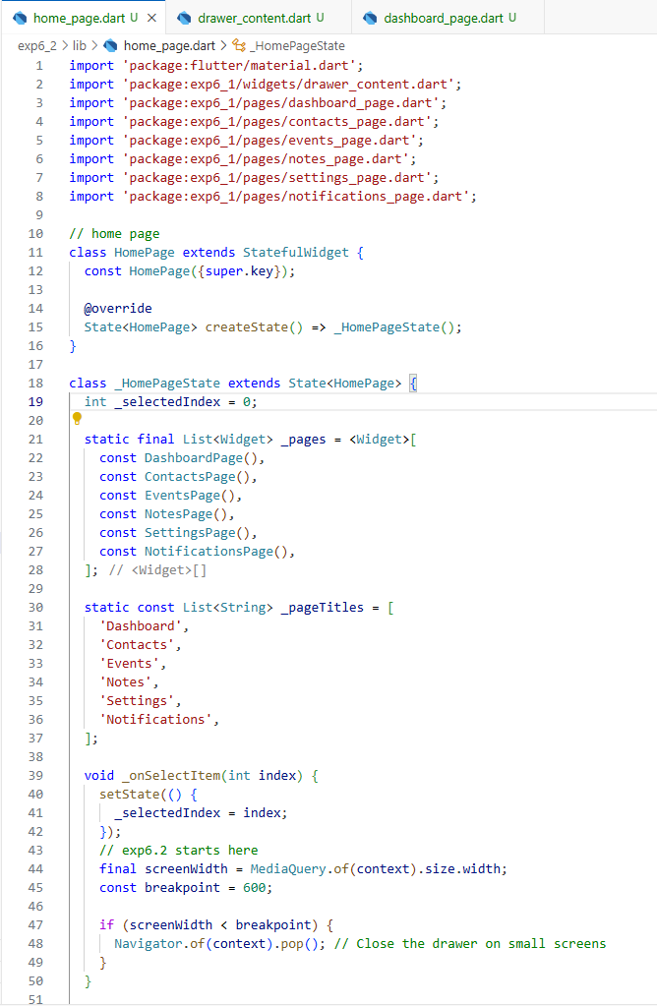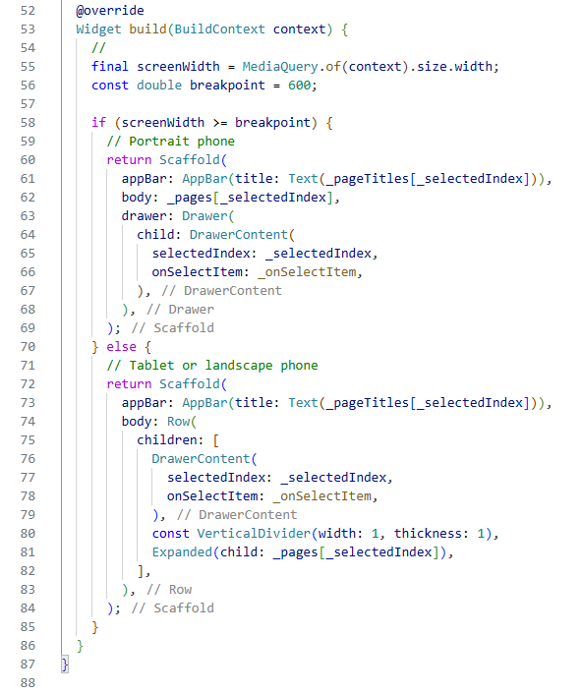

Renamed lib/widgets/my_drawer.dart to drawer_content.dart:

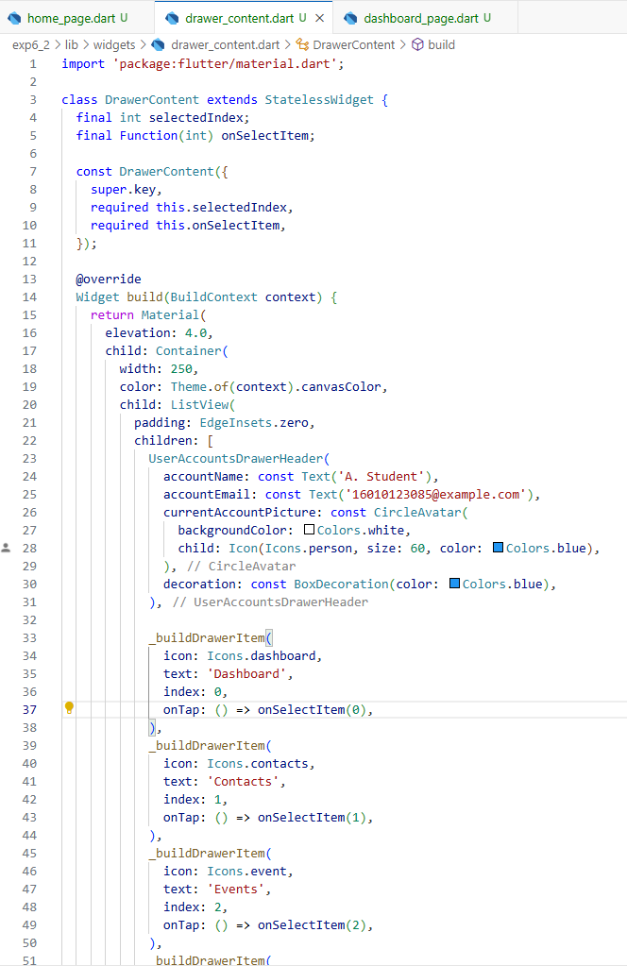

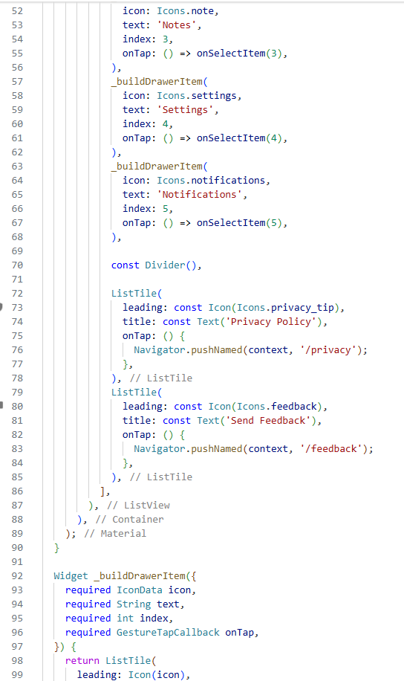

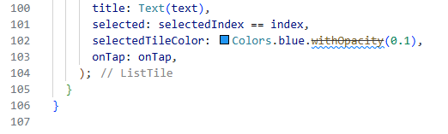

Modified dashboard_page.dart:

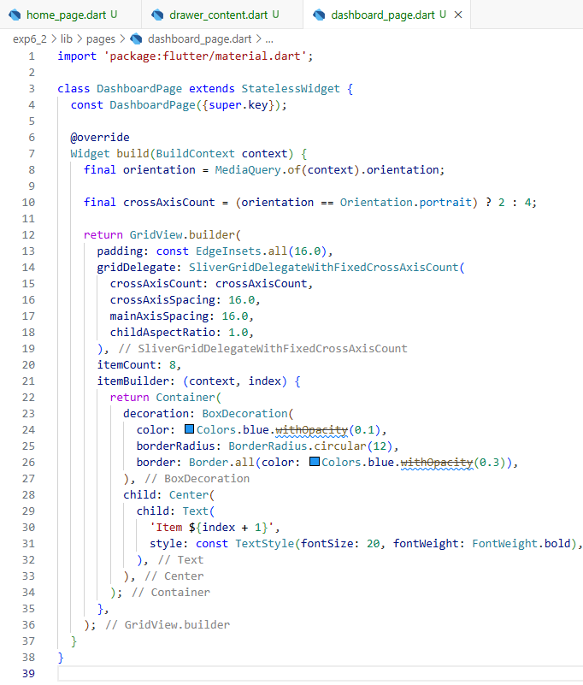

**Output:**

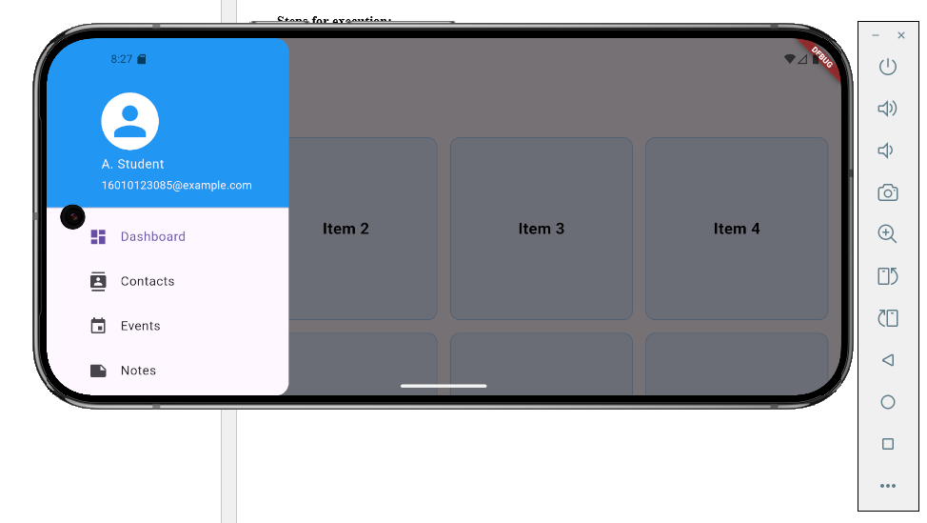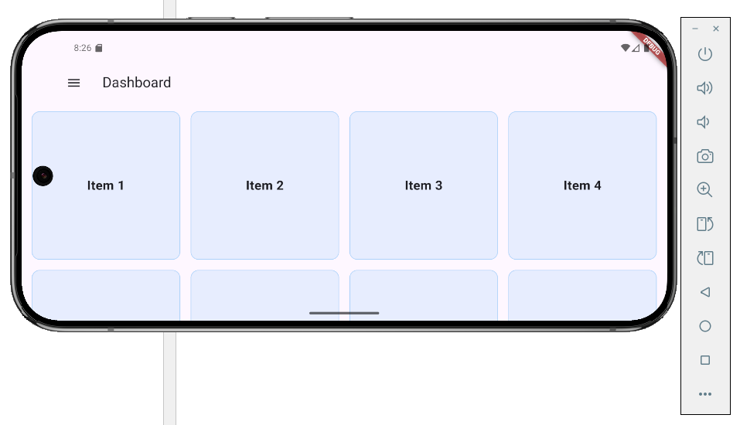

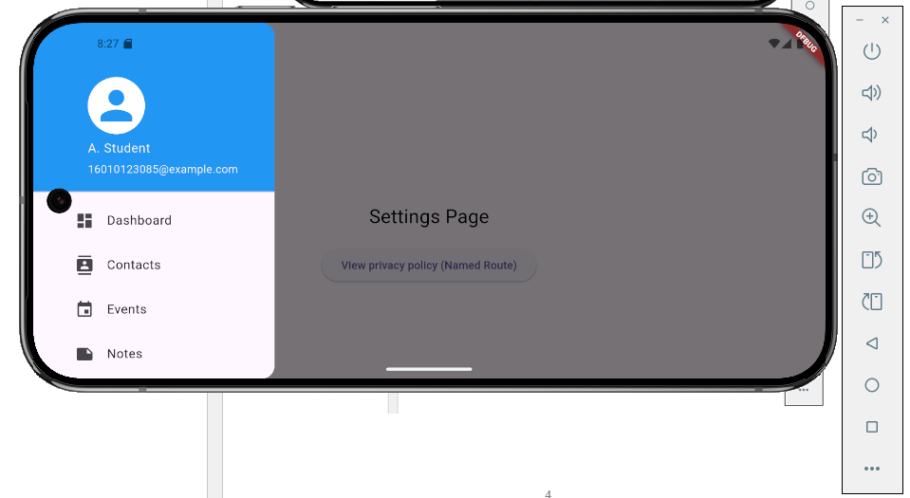

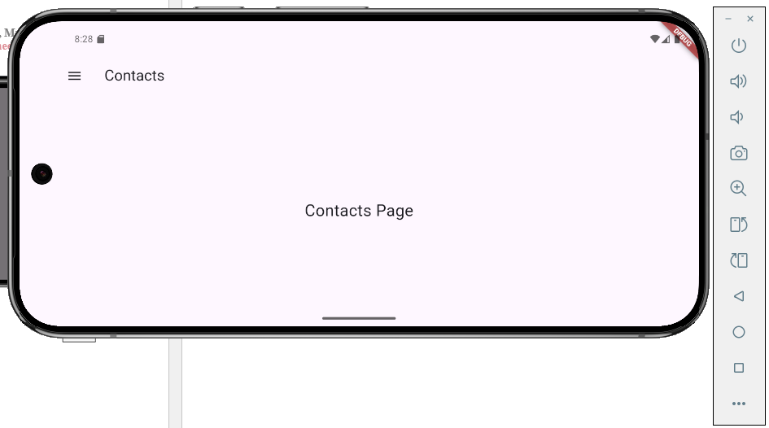

**All other pages are in similar manner**

**Conclusion:**

Implemented responsive UI design in a Flutter application using MediaQuery to adapt layouts dynamically based on device screen size and orientation.