30 x resistor: 390 ohm
(Orange, White, Black, Black, Brown)

- Use as load resistor to limit current through Arduino output pins to about 12mA when driving LED’s and other moderate loads.

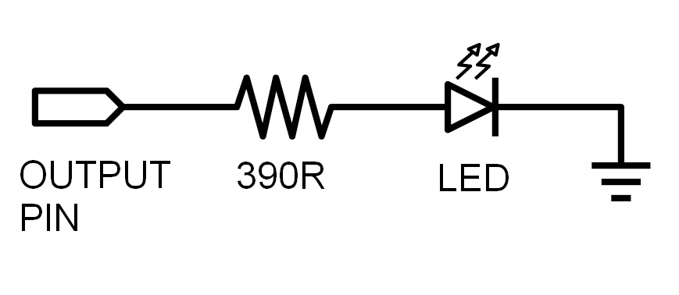
(1)

30 x resistor: 1000 ohm (1k ohm)
(Brown, Black, Black, Brown, Brown)

- Use as load resistor to limit current through Arduino output pins to about 5mA when driving a transistor base (see below) or to save battery power when driving LED’s (but they will be dimmer…).

4 x BC337 transistor

- Used to run loads that require higher voltages or more current than the 25mA that can be supplied by an Arduino output pin. (2)
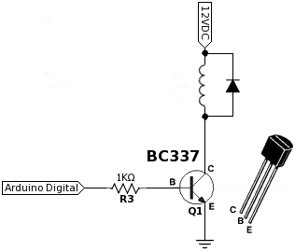
30 x resistor: 10000 ohm (10k ohm)
(Brown, Black, Black, Red, Brown)

- Use as “pull down” resistor to keep digital and analogue input pins low when no signal is present.

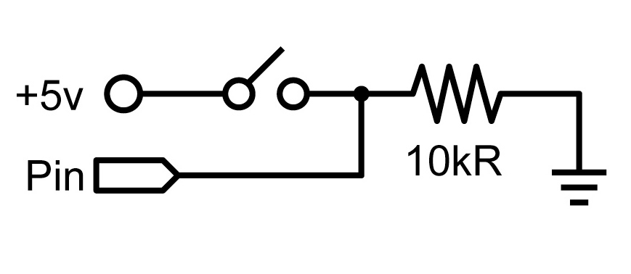
(1)

1 x LDR
(Light Dependant Resister)

- Resistance varies depending on the amount of light that hits the front of the device.
- Approx 50k ohms in darkness
- Approx 100 ohms in full sunlight.

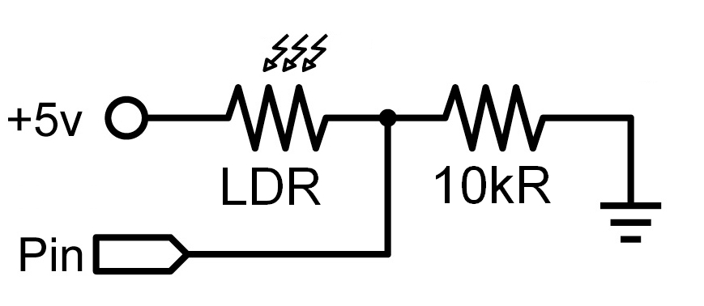

(1)

Images modified from:

(1) Arduino Programming Notebook
(1st edition) by Brian Evans
(2) Original attribution unknown.
Found at http://www.tdpe.co.uk/
(3) Manufacturer data sheet.

5 x LED - Red

- Long lead is Anode (+ connection)
- Short lead is Cathode (- / 0V connection)

5 x LED - Yellow

- Long lead is Anode (+ connection)
- Short lead is Cathode (- / 0V connection)

5 x LED - White

- Long lead is Anode (+ connection)
- Short lead is Cathode (- / 0V connection)

5 x LED - Green

- Long lead is Anode (+ connection)
- Short lead is Cathode (- / 0V connection)

5 x LED - Blue

- Long lead is Anode (+ connection)
- Short lead is Cathode (- / 0V connection)

3 x Three Colour LED

- Red, Blue and Green LED’s in one package.
- Common cathode (negative / zero volt ) (3)
