Artifactory Basic Arduino Kit V1.0

Thanks for purchasing one of our Basic Arduino kits. $10 of the purchase price goes to keeping your local makerspace open.

There is no “instruction manual” included with this kit. Links to some online resources can be found at the following link:

http://wiki.artifactory.org.au/doku.php?id=arduino_basic_starter:resources

Copies of this sheet and the other basic documentation included in this kit can be found here.

Your kit contains the following items:

1 x Chinese Arduino clone + USB cable.
1 x 9V battery clip
1 x Breadboard
25 x 20cm jumper wires M-M
15 x 20cm jumper wires M-F
1 x 40 pin header
1 x coil of solid core hook up wire
30 x 390 ohm resistors
30 x 1k ohm (1000 ohm) resistors
30 x 10k ohm (10000 ohm) resistors
5 x Red 5mm LEDs
5 x Green 5mm LEDs
5 x Yellow 5mm LEDs
5 x Blue 5mm LEDs
5 x White 5mm LEDs
3 x Three colour (RGB 5mm) LEDs
8 x Pushbuttons
1 x 10k ohm potentiometer
2 x Light Dependent Resistors (LDRs)
4 x BC337 NPN transistors
1 x 5V relay
1 x 74HC595 serial in / parallel out shift register IC
1 x 4 digit 7 segment display
1 x Ultrasonic Sensor
1 x 9g hobby servo
Arduino Clone

This is more or less identical to an official UNO but it is most definitely NOT an official Arduino.

We chose one where the main Atmel ATMEGA328 chip is replaceable, so if you damage one or more of the inputs or outputs, you can replace it.
These chips (with or without the Arduino “bootloader” installed) are a few dollars each from various online vendors.
The Artifactory intends to carry a stock of replacement chips with the UNO bootloader installed.

You can mount your Arduino on the acrylic sheet included in your kit. This makes it easier to avoid short circuits by protecting the soldered points on the base of the device.
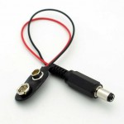

9V battery clip

This makes a handy way of powering your Arduino when it is not connected to USB.

Breadboard
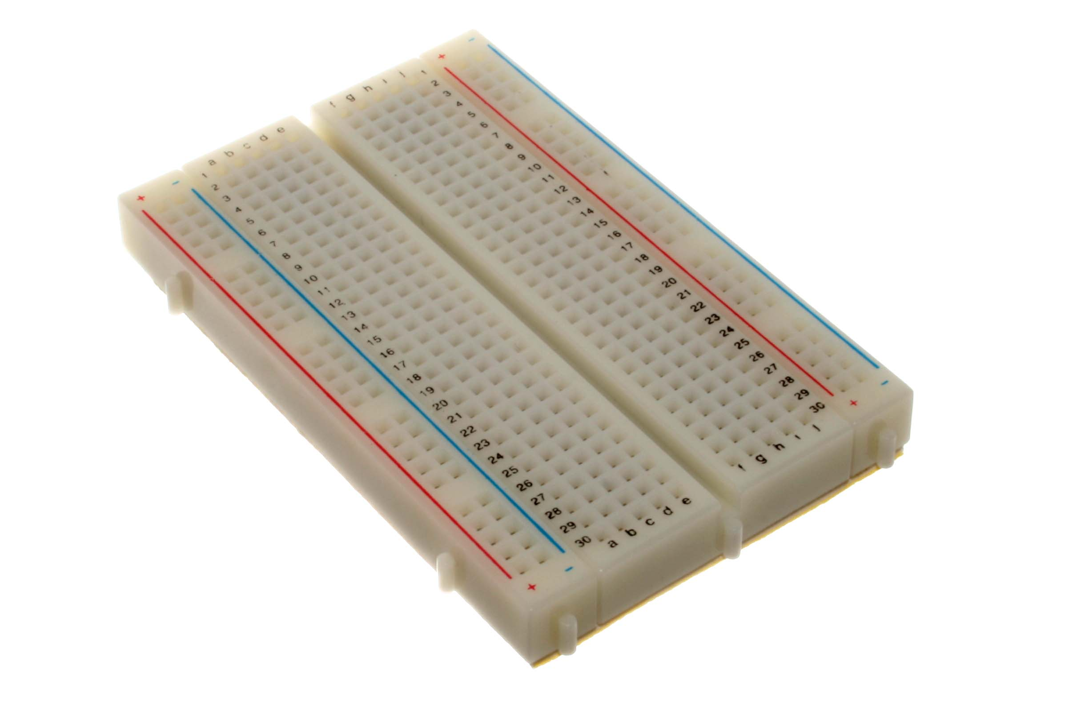
This is used for construction of temporary circuits without using solder and circuit boards. You can mount your breadboard on the acrylic sheet included in your kit by peeling off the film over the double sided tape and sticking it place. This makes it easier to manage the wiring and components of your circuits by giving you a stable base to work on.

Components for the circuit are inserted into the holes on the breadboard and connected together using wires. Each of the holes contains a spring-loaded connector. A wire inserted into the hole will make an electrical connection and be physically retained in place by the spring.

The holes on each side marked by coloured stripes are connected vertically. All the holes marked by the same colour are connected together. Note that the two sides are not connected together. These are most commonly used as “power rails” or “bus rails”, with 5V connected to red and 0V (ground) connected to blue.
The other holes are connected horizontally. Each group of five holes in a row is connected.

There is a gap running vertically down the centre of the breadboard. There is no electrical connection across this centre gap.

Jumper wires, 40pin header and solid core hook-up wire

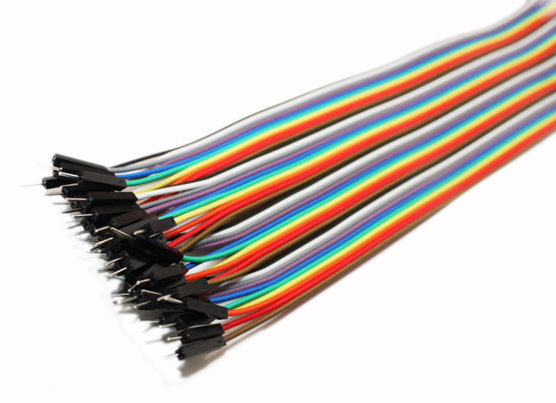
The male – male (M-M) jumper wires are used to connect components together on the bread board and connect the bread board to the Arduino pins. They are also used to connect devises with socket connections (like the servo). BE CAREFUL! Try to avoid having M-M pins only connected at one end when the circuit is energised, as it is easy to “short” the live ends to each other or to parts of the Arduino. This can cause damage.

The male – female (M-F) jumper wires are used to connect devices with pins (like the ultrasonic sensor) to the Arduino or bread board.

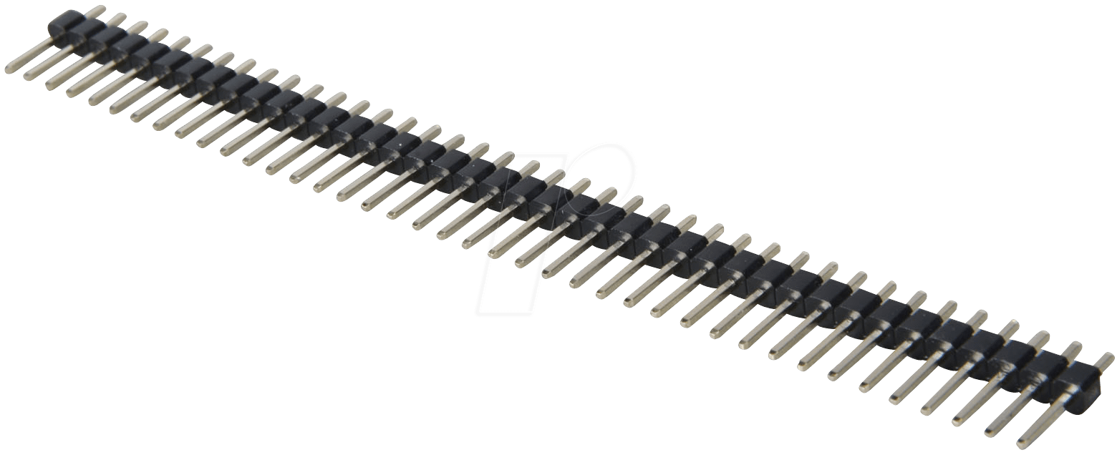
The 40 pin header is very useful for making a “semi permanent” bread board connection. If you construct the circuit so that all the Arduino connections are grouped together on adjacent breadboard rows, you can snap off a piece of the header with enough pins to use as a “breakout”. This is a useful way of avoiding making mistakes when repeatedly connecting and disconnecting the circuit.

The small coil of insulated solid core wire is also useful for creating “semi permanent” breadboards. Sections can be cut to length and the insulation stripped off the ends to make shorter connections that are less likely to be knocked out than the longer jumper wires.
This wire is stripped from blue “Cat 5e” data cabling which can be salvaged in large quantities from skip bins around Perth or can be purchased in short lengths from Jaycar and Altronics (amongst others) . Note that RJ45 “patch leads” look similar but use stranded, flexible wire which is not useful for this purpose.

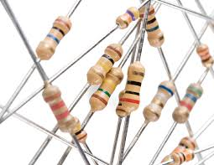
Resistors

Resistors are most commonly used to limit the amount of current flowing through a circuit (load limiting) or to hold a circuit to a default value when not otherwise energised (pull down/up).
Resistor values are shown by the coloured bands painted on them. Google “resistor colour codes” for charts and aps that allow you to decode the values. The three resistance values included in the kit will cover most common applications that a beginner is likely to come across.

LEDs

We’ve provided lots of Light Emitting Diodes in the kit because they are cheap, colourful and easy to use.
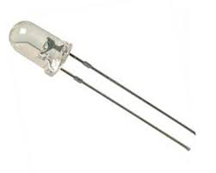
Do not try to run an LED without using a resistor to limit the amount of current flowing through it and the Arduino output pin it is attached to. Use a 390 ohm resistor provided. You can go as low as 220 ohms without problems. Using higher values like 1k ohm will also work, but the LED’s will be dimmer.

Most LED’s have 2 pins and produce light of one colour. The longest pin (anode) goes to positive and the short pin (cathode) goes to negative. Most commonly, the anode is connected to an Arduino pin via a resistor and the cathode is connected to “ground” – the GND pins on you Arduino.
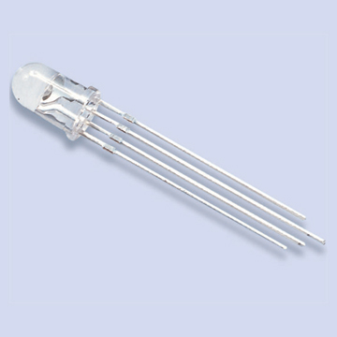
Also included in the kit are some three colour “RGB” LED’s. These have 4 pins. The longest is the cathode. The others go to the anode of a red, green and blue LED. You can switch any combination of these on and by varying the brightness of each primary colour, a multitude of colours can be produced.

There is a simple circuit for both types of LED included on the parts sheet they are attached to.

Pushbuttons

These push buttons are commonly referred to as “tactile switches”.
Note that there are 4 pins on each pushbutton. The pins furthest apart on each side are connected together.

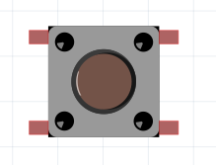
1
1
2
2
3
3
4
4

Note also that the pushbutton doesn’t quite fit perfectly into the holes of the breadboard. The legs are just a bit too short to let the spring-loaded terminals really get a good hold. It might need to be poked back into place from time to time.

Potentiometer

A potentiometer or “pot” is a variable resistor. It can be used in a circuit to provide any voltage between zero and 5V to an Arduino analogue input.
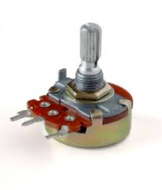
GND
5V
Arduino Analogue Input
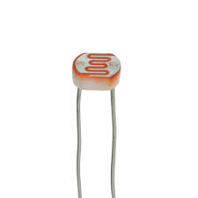
Light Dependent Resistor (LDR)

This is another variable resistor, but in this case the resistance changes depending on the amount of light that hits the top surface of the device. Used in conjunction with a fixed resistor around 10k ohms, it can be used in a circuit to provide a variable voltage to an Arduino analogue input.

Note that the response to light is not linear. That is, the change in resistance changes at different rates as the light level increases steadily. With trial and error, you can select the value of the fixed resistor to select the part of this range that is most useful to your application.

There is a simple circuit for using an LDR on the parts sheet they are attached to.

Transistors
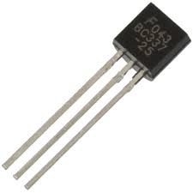
Transistors are the fundamental building blocks of digital electronics. At VERY a basic level, it is helpful to think of them as “electronic switches” useful for switching currents and voltages higher than the 25 Milliamps at 5 Volts limit of Arduino output pins.

Note that this is view is EXTREMELY simplistic and fundamentally incorrect. There is a vast array of information on transistors and their kin, how they work and how to construct simple circuits with them available online.

The BC337 transistors suppled are very common and cheap. There is a simple circuit for their use included on the parts sheet they are attached to. Note that these transistors are “NPN type” and must be connected between the load and ground. Trying to put them between 5V and the load (where you would normally put a switch) will generally not work very well. To do this, you need to use a “PNP type” transistor, but the control circuit is slightly more complex and somewhat less intuitive.

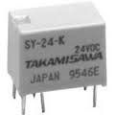
Relay

Relays are another way to switch higher currents and voltages with an Arduino. They consist of an electromagnet and a mechanical switch which closes when the electromagnet is energised with the correct voltage.
While some very small “read switch” relays can be run directly from an Arduino output, this one cannot and should be run using a transistor circuit.
In any case, relays should best be used with a transistor to protect the output pin from potential damage from high voltage “spikes” which are generated when the relay coil is de-energised.

The main advantage of relay is that there is no electrical connection at all between the control circuit driving the relay coil and the load being switched by the relay. For example, you could use this relay to switch the 24V AC used to supply a standard sprinkler solenoid. This is not possible with a simple transistor based circuit.
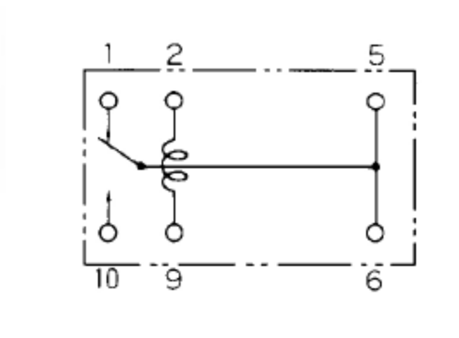
Relay - bottom view

As shown in the diagram, the relay coil is between pins 2 and 9.
Pins 5 and 6 are connected together (“common”). When the relay coil is not energised, Common is connected to pin 1 (“normally closed contact”). When the coil is energised, Common is connected to pin 10 (“normally open contact”)

Shift Register (74HC595)

This common integrated circuit is a simple way of getting more output pins from your Arduino, especially where it is useful to control 8 outputs together as a group, such is in a 7 segment display or an 8 x 8 LED matrix.
There are basic commands included in the core Arduino code that make using Shift Registers relatively easy.
Multiple shift registers can be linked together to run 100 or more outputs of just a few Arduino pins – although there are speed and power limits to this!
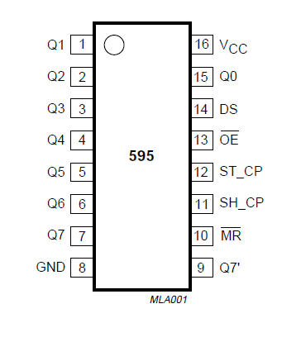
Pins 2-7, 15 | Q0 – Q7 | Output Pins
Pin 8 | GND | Ground (Vss)
Pin 9 | Q7” | Serial Out
Pin 10 | MR | Master reset (active low)
Pin 11 | SH_CP | Clock pin
Pin 12 | ST_CP | Latch pin (active low)
Pin 13 | OE | Output Enable (active low)
Pin 14 | DS | Serial Data Input
Pin 16 | Vcc | Positive supply (5V)
Seven Segment Display

Actually 8 segments, as each digit includes a decimal point.
In a single digit display, each segment is a separate LED with one wire to each anode and all the cathodes brought together on 1 pin (a “common cathode” display). Digits and some letters are displayed by supplying voltage to the appropriate anodes to make the correct shape.

This is a common cathode, 4 digit display. In this case all the same segments on each digit are connected together, so that supplying the anode for the LED on one segment will supply that segment on all 4 digits. The digit to be lit is determined by which of the 4 cathodes is then connected to ground.
When this is done very fast, it is possible to display a different digit on each position using a process called “multiplexing”.

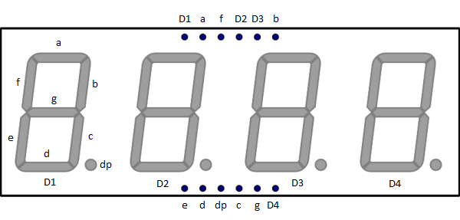
4 digit / 7 Segment Pin functions

Segment pins a – g are the Anodes.
Digit pins D1 – D4 are the Cathodes.

Remember that only 25mA can flow through an Arduino output, so it’s not a good idea to connect the Cathodes direct to Arduino pins as the current would be too high if all 8 segments are lit. Instead, use transistors as shown below.
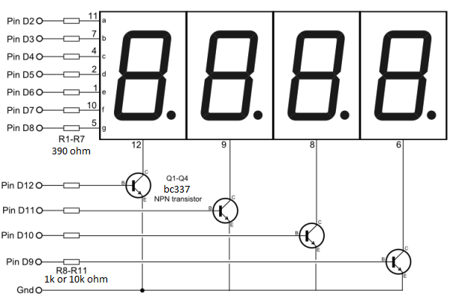

4 digit / 7 segment – example circuit

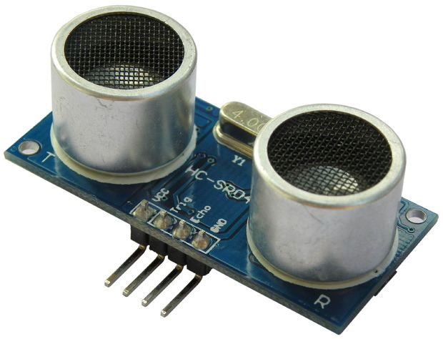
Ultrasonic sensor

This device senses distance by sending out ultrasonic “clicks” and measuring how long it takes for the echo to return.
The Arduino “Ping” example shows how to use it.
Note that the Arduino example uses a version of this device where the same pin is used for triggering the “click” and for detecting the return.
The device supplied uses separate pins for these purposes, so you need to modify the example slightly to use 2 different pins for “trig” and “echo”. A modified version of the example is included in the resources at the link included in this document.

Servo

A servo is a geared motor which moves a specific angle depending on the length of a control pulse sent to it.

A common colour code is used for the servo supplied in this kit:

Red = supply (5v)
Brown = ground (0V)
Orange = control (any PWM pin).

It is good practice to include a current limiting resistor (390 ohms) between the Arduino PWM output pin and the servo to protect the output pin.

The Arduino servo library (which comes with the standard Arduino programming environment) makes it very easy to use up to 8 servos by simply commanding each servo to move to the required angle.

Note that you MUST use an Arduino PWM output pin for each servo.
Note also that with some combinations of servos and Arduino Servo libraries, commanding an angle of less than 2 degree’s causes a glitch which forces the servo to continue driving. You will hear this as continuous “clicks” from the servo.
If this occurs do not command an angle less than 2 degrees.

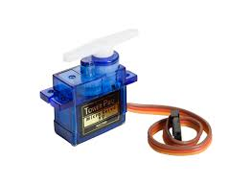
A modified version of one of the standard examples is included in the resources at the link included in this document. This version will move the servo to the angle entered in the serial monitor.

