Create new connection, click the below Icon
ICON 
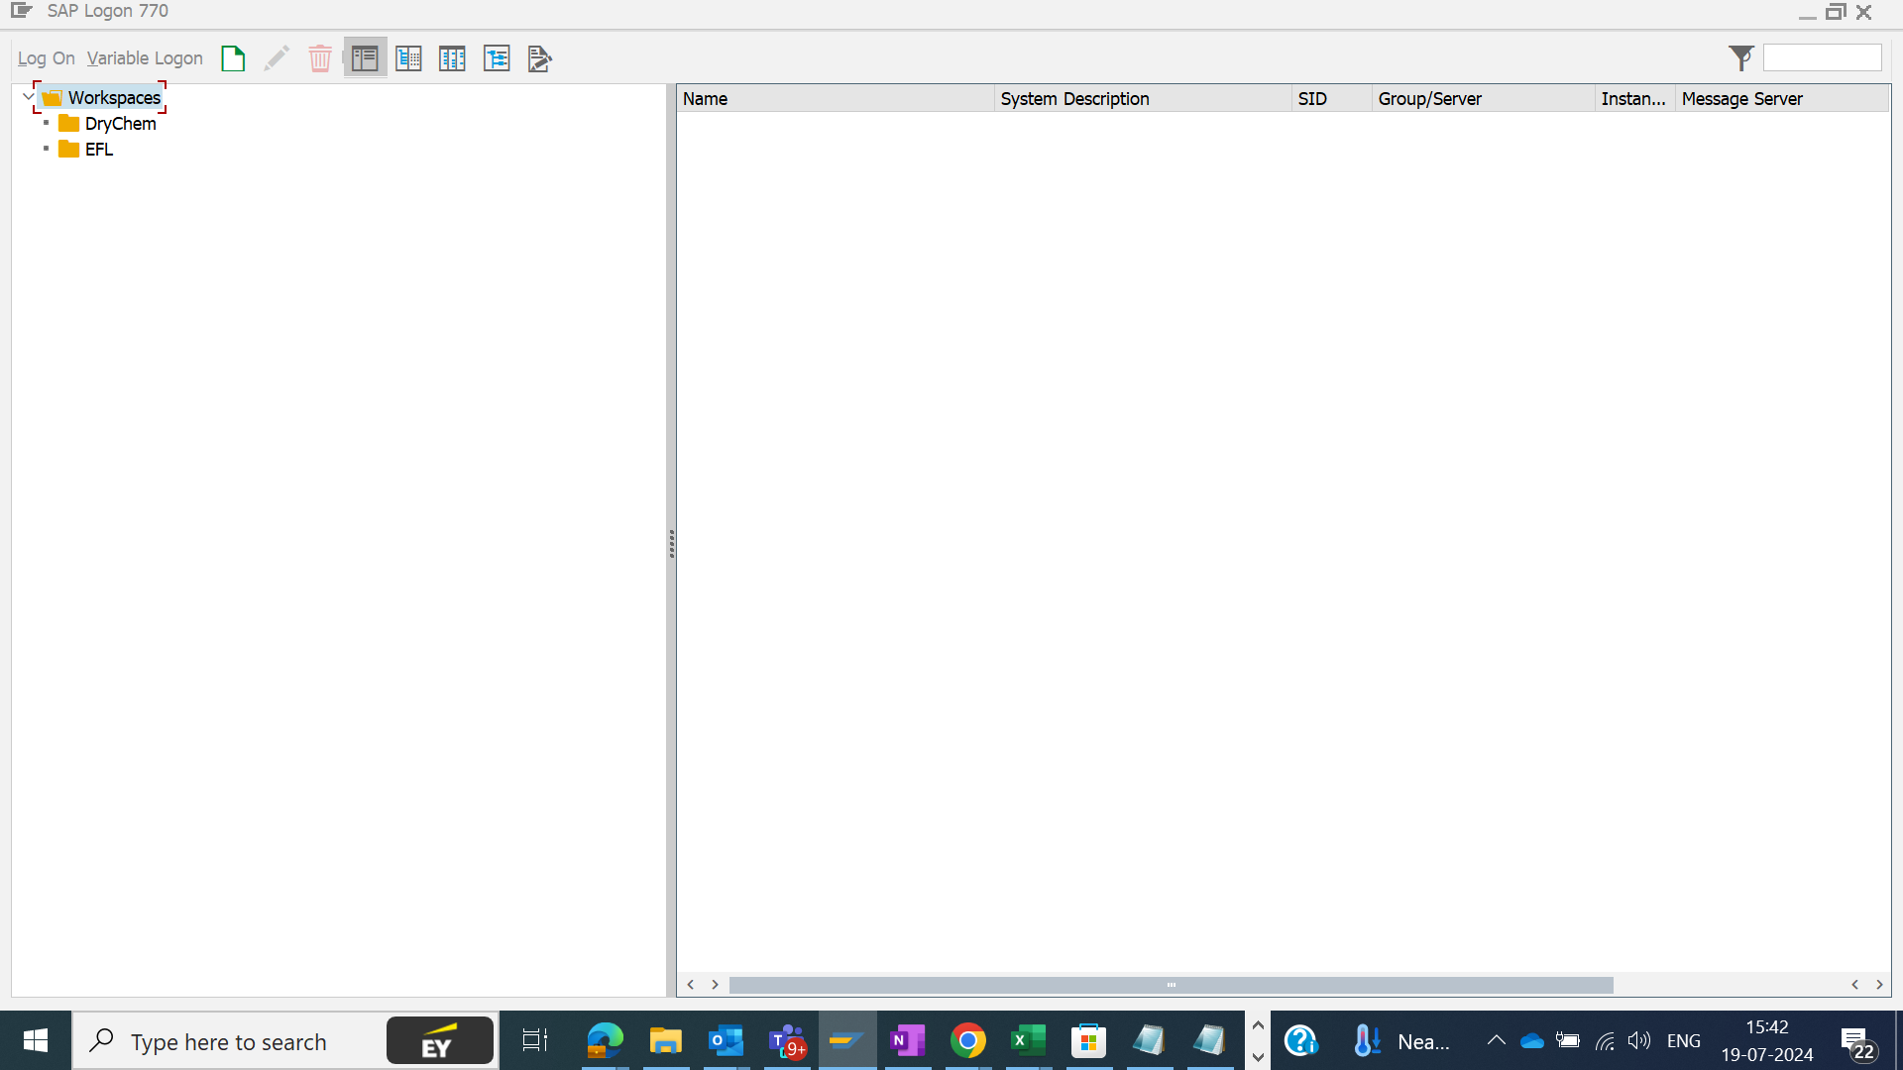
Click on Connection
Then click on User Specified System and then next as show below
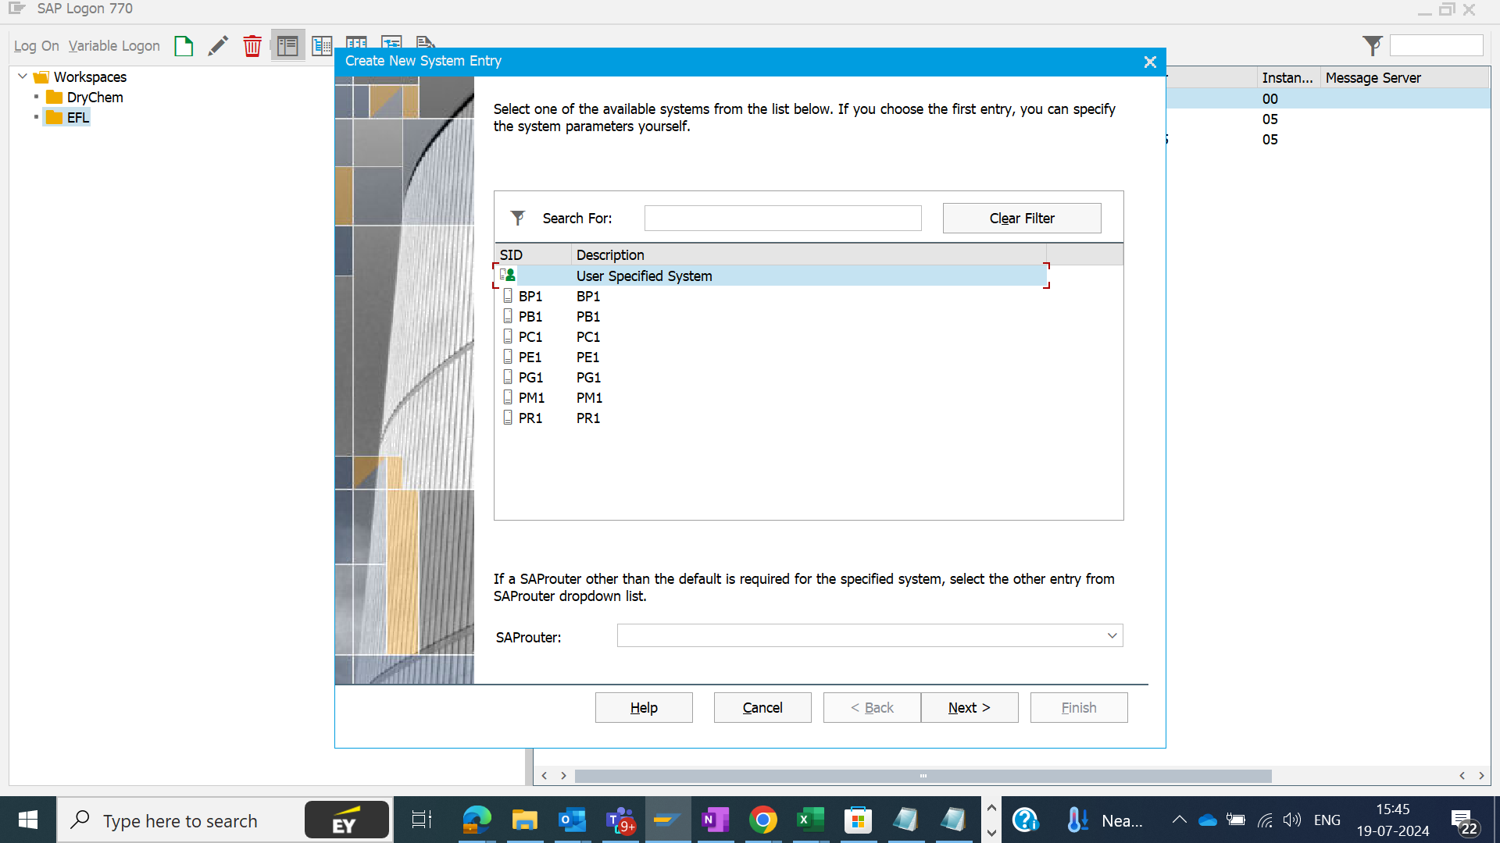

Fill the same details as below.
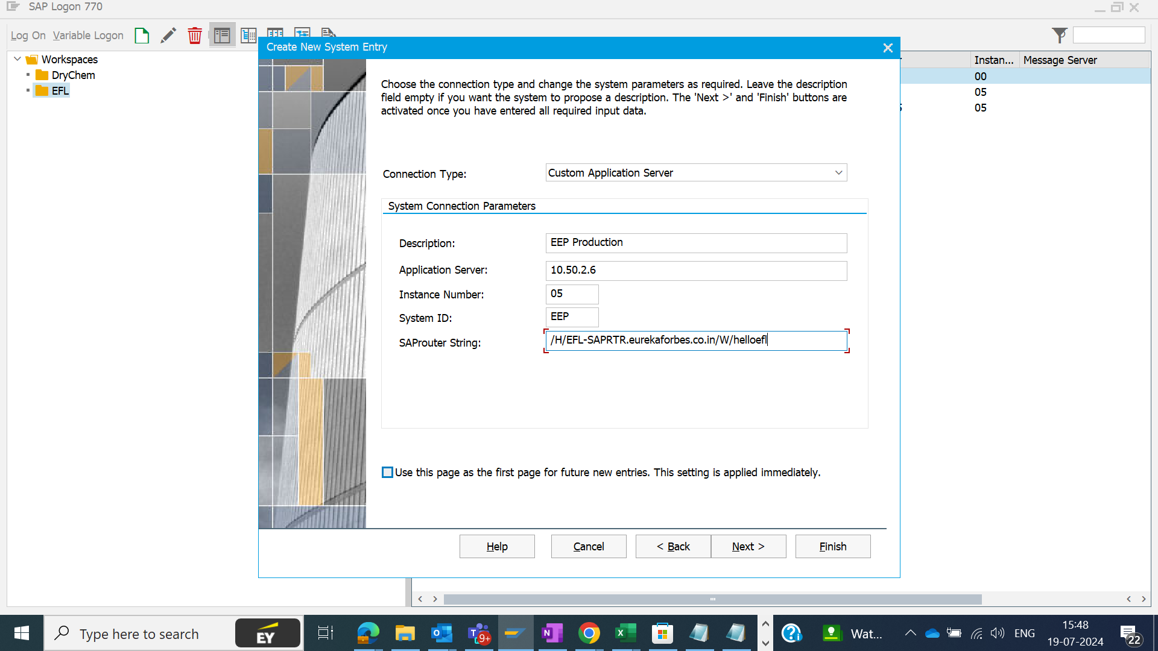
SRouter String –
/H/EFL-SAPRTR.eurekaforbes.co.in/W/helloefl
Then click on Finish.
