CHAPTER 1
INTRODUCTION

1.1 SMART PORT INFRASTRUCTURE AND CHALLENGES
The rapid advancement of global trade and maritime logistics has led to the development of smart port infrastructures equipped with advanced monitoring systems. Modern ports utilize satellite imagery, surveillance systems, and sensor networks to track vessel movement and manage operations efficiently. However, the increasing volume of maritime traffic has introduced significant challenges in handling large-scale data and ensuring smooth port operations. One of the most critical challenges is port congestion, which directly impacts operational efficiency, fuel consumption, and global supply chain stability.
Traditional monitoring systems rely heavily on manual observation and rule-based methods, which are insufficient for handling dynamic and large-scale port environments. The need for intelligent, automated systems capable of analyzing high-resolution visual data has become essential for efficient port management.

1.2 PORT CONGESTION AND MARITIME TRAFFIC ISSUES
Port congestion occurs when the number of vessels arriving at a port exceeds its handling capacity, leading to delays in docking, unloading, and departure. This results in increased waiting times, higher operational costs, and environmental impacts such as increased fuel consumption and emissions.
The complexity of congestion prediction arises due to multiple influencing factors, including vessel density, port size, weather conditions, and operational constraints. Conventional approaches often fail to capture these dynamic relationships, leading to inaccurate predictions. Therefore, there is a need for advanced data-driven approaches that can effectively model these factors and provide reliable congestion forecasts.

1.3 LIMITATIONS OF EXISTING PREDICTION SYSTEMS
Existing port congestion prediction systems primarily rely on static thresholds, statistical models, or centralized deep learning approaches. These methods have several limitations:
- They use fixed rules (e.g., number of ships) without considering port capacity variations
- They fail to adapt to different port sizes and spatial distributions
- They do not account for environmental factors such as weather conditions
- Centralized models suffer from high computational overhead and latency
- Lack of scalability in handling large-scale image datasets
As a result, these systems are not suitable for real-time, adaptive, and scalable smart port environments.

1.4 ROLE OF SATELLITE IMAGERY IN PORT MONITORING
Satellite imagery provides a powerful means for monitoring large-scale maritime environments. High-resolution satellite images enable the detection of ships, estimation of vessel density, and analysis of spatial distribution within ports. With advancements in computer vision and deep learning, satellite imagery can be effectively utilized to automate port monitoring tasks.
Object detection models such as YOLO (You Only Look Once) allow accurate and real-time detection of ships in satellite images. These detections can be further used to derive meaningful insights such as ship count, spatial clustering, and congestion patterns. Thus, integrating satellite imagery with deep learning techniques forms a robust foundation for intelligent port management systems.

1.5 MOTIVATION
The primary motivation of this project is to overcome the limitations of traditional congestion prediction methods by developing an intelligent, adaptive, and scalable system. Instead of relying on fixed thresholds, the system aims to incorporate data-driven techniques such as clustering and deep learning to model real-world port dynamics.
Additionally, the need to handle large-scale datasets efficiently motivates the use of distributed deep learning techniques. Incorporating environmental awareness, such as weather conditions, further enhances the robustness of the system. This project aims to bridge the gap between theoretical deep learning models and practical smart port applications.

1.6 OBJECTIVES
The main objectives of this project are:
- To develop a preprocessing pipeline for filtering and preparing satellite port images for analysis.
- To implement a YOLO-based model for accurate ship detection in port environments.
- To build a multi-task CNN for simultaneous congestion classification and time prediction.
- To implement distributed deep learning using data parallelism and analyze training performance.

CHAPTER 2
LITERATURE SURVEY

2.1 TRADITIONAL PORT CONGESTION PREDICTION METHODS
Port congestion prediction has traditionally been addressed using statistical and rule-based approaches. Early methods relied on historical data analysis, queueing theory, and time-series forecasting techniques to estimate vessel waiting times and port utilization. These approaches typically use parameters such as vessel arrival rates, service rates, and berth availability to model congestion.
However, such methods are limited in their ability to capture complex spatial and visual patterns present in port environments. They also depend heavily on manually defined thresholds and assumptions, which may not generalize well across different ports. As maritime traffic becomes increasingly dynamic, these traditional approaches struggle to provide accurate and real-time predictions.

2.2 DEEP LEARNING IN MARITIME IMAGE ANALYSIS
With the advancement of deep learning, convolutional neural networks (CNNs) have been widely adopted for maritime image analysis tasks. CNN-based models are capable of extracting hierarchical features from satellite imagery, enabling applications such as ship detection, vessel classification, and maritime surveillance.
Several studies have demonstrated the effectiveness of deep learning in processing high-resolution satellite images for detecting objects in complex environments. These models outperform traditional image processing techniques by automatically learning relevant features without manual intervention. However, most existing works focus only on detection tasks and do not extend to higher-level applications such as congestion prediction or operational analysis.

2.3 OBJECT DETECTION MODELS FOR SHIP DETECTION
Object detection plays a crucial role in maritime monitoring systems. Models such as Faster R-CNN, SSD (Single Shot Detector), and YOLO (You Only Look Once) have been extensively used for detecting ships in satellite imagery. Among these, YOLO-based models are particularly popular due to their real-time performance and high detection accuracy.
Recent versions such as YOLOv5 and YOLOv8 have further improved detection capabilities by incorporating advanced architectures and optimization techniques. These models can efficiently detect multiple ships in dense port environments, making them suitable for large-scale maritime applications. However, most studies focus on detection accuracy and do not utilize the detected information for downstream tasks such as congestion analysis.

2.4 MULTI-TASK LEARNING APPROACHES
Multi-task learning (MTL) has gained attention as an effective approach for solving multiple related problems simultaneously using a shared model. In computer vision, MTL enables models to perform tasks such as classification and regression in a unified framework, improving both efficiency and performance.
In the context of maritime systems, multi-task learning can be used to predict congestion levels and estimate unloading time simultaneously. By sharing feature representations, the model can learn relationships between different tasks, leading to better generalization. However, existing works in this domain are limited and often rely on simple architectures without incorporating domain-specific factors such as port capacity or environmental conditions.

2.5 DISTRIBUTED DEEP LEARNING TECHNIQUES
Distributed deep learning has emerged as a powerful solution for handling large-scale datasets and complex models. By distributing the training process across multiple GPUs or computing nodes, distributed learning significantly reduces training time and improves scalability.
Techniques such as data parallelism and model parallelism are commonly used in distributed systems. Frameworks like PyTorch Distributed Data Parallel (DDP) and Horovod enable efficient gradient synchronization using communication strategies such as AllReduce. While distributed learning has been widely applied in fields like natural language processing and autonomous driving, its application in maritime image analysis and congestion prediction remains relatively unexplored.

2.6 SUMMARY OF LITERATURE AND RESEARCH GAP
From the literature review, several research gaps have been identified:
- Existing congestion prediction systems rely on static thresholds and do not adapt to varying port sizes
- Lack of integration between object detection and higher-level decision-making systems
- Limited use of multi-task learning for simultaneous prediction tasks
- Absence of environmental awareness such as weather conditions in prediction models
- Underutilization of distributed deep learning for scalable maritime data processing
To address these gaps, this project proposes an adaptive and distributed deep learning framework that integrates ship detection, congestion modeling, weather-aware preprocessing, and multi-task learning for accurate and scalable port congestion prediction.

CHAPTER 3
PROPOSED WORK

3.1 SYSTEM OVERVIEW
The proposed system presents an adaptive and distributed deep learning framework for port congestion prediction using satellite imagery. The system integrates computer vision, machine learning, and distributed training techniques to provide accurate and scalable congestion analysis.
The workflow begins with preprocessing of satellite images, followed by ship detection using a YOLO-based object detection model. The detected ship information is then used to estimate port capacity and compute congestion ratios. Instead of relying on static thresholds, congestion levels are dynamically determined using K-Means clustering. A multi-task convolutional neural network (CNN) is then trained to simultaneously predict congestion levels and unloading time. Additionally, weather-aware preprocessing is incorporated to enhance robustness under varying environmental conditions. Finally, distributed deep learning techniques are applied to improve computational efficiency and scalability.

3.2 ARCHITECTURE OF THE PROPOSED SYSTEM

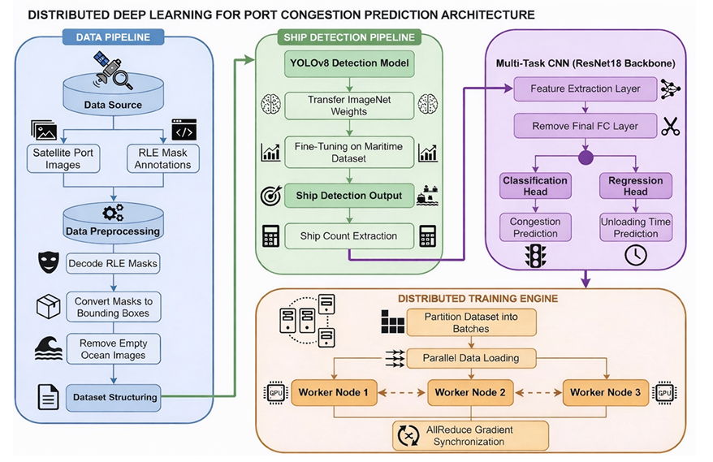
Fig 3.1 Architecture of Port Congestion Prediction System

The proposed system is designed as a multi-stage, end-to-end deep learning pipeline for port congestion prediction using satellite imagery. The architecture integrates computer vision, machine learning, and distributed computing techniques to transform raw image data into actionable insights such as congestion level and unloading time.
The overall architecture consists of four major stages:
- Data Preprocessing and Annotation Engineering
- Ship Detection using YOLOv8
- Adaptive Multi-Task CNN for Prediction
- Distributed Deep Learning Framework
Each stage is interconnected, forming a sequential pipeline, where the output of one module serves as the input to the next. This modular design ensures flexibility, scalability, and efficient processing of large-scale maritime datasets.

Stage 1: Data Preprocessing and Annotation Engineering
The first stage focuses on preparing raw satellite imagery for deep learning. The Airbus Ship Detection dataset contains images along with Run-Length Encoded (RLE) annotations representing ship masks.
Initially, irrelevant data is removed by filtering out images without ship annotations, ensuring that only meaningful port-related samples are retained. The RLE annotations are then decoded into binary masks, which represent the pixel-wise location of ships within each image.
These binary masks are further processed to extract bounding box coordinates for each detected ship. The bounding boxes are normalized into YOLO format, enabling compatibility with the object detection model. Additionally, the dataset is structured into training and validation subsets, ensuring proper evaluation during model training.
This stage plays a critical role in reducing noise, improving data quality, and structuring the dataset for efficient learning.

Stage 2: Ship Detection using YOLOv8
The second stage performs ship detection using a fine-tuned YOLOv8 model. YOLO (You Only Look Once) is a real-time object detection algorithm that processes the entire image in a single forward pass, making it highly efficient for large-scale applications.
The preprocessed images are fed into the YOLOv8 model, which predicts bounding boxes and confidence scores for ships present in the image. Non-Maximum Suppression (NMS) is applied to eliminate overlapping detections and retain the most accurate bounding boxes.
From these detections, the system computes the number of ships present in each image, which serves as a key feature for congestion analysis. The spatial distribution of ships is also implicitly captured through bounding box locations.
This stage transforms raw visual data into structured information, enabling further analytical processing in subsequent modules.

Stage 3: Adaptive Multi-Task CNN for Prediction
The third stage is the core intelligence module of the system, where congestion prediction and unloading time estimation are performed using a multi-task CNN.
Unlike traditional systems that rely on fixed thresholds, this module introduces an adaptive mechanism based on port capacity and congestion ratio.
First, all ship masks corresponding to an image are combined to form a union mask, representing the spatial footprint of ship distribution. The area of this union mask is computed and used to estimate the port capacity, which reflects the maximum number of ships the port can handle.
The congestion ratio is then calculated as the ratio of ship count to port capacity. Instead of using predefined thresholds, K-Means clustering is applied to this ratio to dynamically classify congestion into Low, Medium, and High categories. This ensures that the system adapts to different port sizes and conditions.
Simultaneously, unloading time is modeled using a log-linear function, capturing realistic port behavior where delays increase non-linearly with the number of ships.
To enhance robustness, a weather detection mechanism is incorporated. Based on image characteristics such as blur, brightness, and saturation, the system identifies weather conditions like fog, rain, or snow and applies appropriate image enhancement techniques.
The processed images are then passed through a pretrained ResNet18 backbone for feature extraction. The extracted features are augmented with port capacity information and passed through a shared bottleneck layer, followed by two task-specific heads:
- A classification head for congestion prediction
- A regression head for unloading time estimation
This multi-task learning approach enables the model to learn shared representations, improving both efficiency and prediction accuracy.

Stage 4: Distributed Deep Learning Framework
The final stage focuses on improving computational efficiency and scalability using distributed deep learning techniques.
The dataset is divided into mini-batches and distributed across multiple processing units (GPUs). Each GPU processes a subset of data independently, performing forward and backward passes. During backpropagation, gradients computed on each device are synchronized using the AllReduce operation, ensuring that all model replicas remain consistent.
To provide deeper insights into system performance, a gradient profiling mechanism is implemented. Hooks are attached to model layers to measure synchronization time and communication overhead during training. This helps identify bottlenecks, particularly in layers with large gradient sizes.
Additionally, training throughput is measured in terms of images processed per second, enabling evaluation of system efficiency. This stage ensures that the model can scale effectively to large datasets while maintaining performance.
This integrated architecture enables:
- End-to-end automation of port congestion prediction
- Adaptive modeling based on real-world port characteristics
- Robust performance under varying environmental conditions
- Scalable training using distributed deep learning

3.3 MODULES
The system adopts a multi-stage architecture in which each module performs a distinct and essential function, collectively contributing to accurate port congestion prediction. The modules are interdependent, and any omission or disruption in their sequence would negatively impact the overall system performance. The proposed system consists of four key modules: Data Preprocessing and Annotation Engineering, Ship Detection using YOLOv8, Adaptive Multi-Task CNN for Congestion Prediction, and Distributed Deep Learning Framework. Each module is designed to handle a specific aspect of the pipeline, ranging from data preparation and feature extraction to intelligent prediction and scalable training. These modules work cohesively to transform raw satellite imagery into meaningful insights, and they are explained in detail in the following sections.

3.3.1 PORT IMAGE PRE-PROCESSING AND ANNOTATION ENGINEERING
Description
This module prepares raw satellite port images for deep learning. It performs dataset filtering, annotation decoding, bounding box extraction, and dataset structuring to make the data suitable for object detection training. All images are resized to 640 × 640 pixels to ensure uniform input size and optimized GPU training.

Inputs:
- Airbus Ship Detection Dataset (satellite images)
- RLE-based ship segmentation annotations
- Minimum ship threshold
- Image resolution (768 × 768 pixels, later resized to 640×640)
Working Mechanism
- Dataset is mounted and images are loaded from Kaggle.
- Annotation CSV containing Run-Length Encoded (RLE) masks is parsed.
- Images without ship annotations are removed.
- Ship count per image is computed.
- Images with multiple ships are selected.
- Dataset is reduced to 4000 images (Dfinal = 4000).
- RLE masks are decoded into binary segmentation masks.
- Bounding box coordinates (xmin, ymin, xmax, ymax) are extracted.
- Bounding boxes are normalized to YOLO format: xcenter, ycenter, width, height.
- All images are resized to 640 × 640 pixels.
- Dataset split: 80% training, 20% validation.
- Folder structure created: images/train, images/val, labels/train, labels/val.
Models / Techniques Used:
- RLE decoding algorithm
- Bounding box extraction
- Data normalization
- Structured dataset partitioning

Output
- Filtered port image dataset
- YOLO-formatted annotation files
- Structured training and validation folders
- Resized images (640×640)
- Clean dataset optimized for GPU training

3.3.2 SHIP DETECTION USING YOLOv8
Description:
This module implements a fine-tuned YOLOv8 object detection model to detect ships in port images. The lightweight YOLOv8 Nano (YOLOv8n) variant was chosen because it offers real-time inference capability with minimal computational overhead, making it suitable for deployment on edge devices in a smart port environment.
Inputs:
- Preprocessed satellite port images (640×640)
- YOLO-formatted annotation files
- Pretrained YOLOv8 weights (yolov8n.pt)
Working Mechanism:
- YOLOv8 model is initialized with pretrained weights.
- Dataset configuration file (data.yaml) is created.
- Model is fine-tuned on the prepared dataset.
- During inference: Bounding boxes and confidence scores predicted;
-> NMS applied
->Localization loss computed
->Classification loss computed
->Distribution focal loss computed.

- Total detection loss calculated.
- Backpropagation updates model weights.
- Performance evaluated using: Precision, Recall, mAP50, mAP50-95.
- Best model weights saved.
Models Used:
- YOLOv8 Nano (YOLOv8n) from Ultralytics
- AdamW optimizer
- GPU-based parallel training
Outputs:
- Trained ship detection model
- Bounding box predictions
- Ship count per image
- Detection performance metrics

3.3.3 ADAPTIVE MULTI-TASK WITH CNN FOR CONGESTION MODELING
Description
This module implements an adaptive multi-task CNN framework that predicts port congestion level and unloading time using data-driven clustering, port capacity estimation, and weather-aware preprocessing. Unlike traditional threshold-based systems, congestion is dynamically determined using K-Means clustering on congestion ratio, making the model robust to varying port sizes and environmental conditions.
Inputs:
- Port images (satellite imagery)
- Ship detection results (bounding boxes + masks)
- Ship count per image
- Port area (derived from mask union)
- Weather conditions (rain, fog, snow, clear)
- Pretrained ResNet18 backbone
Working Mechanism:
Step 1: Ship Mask Union and Port Area Estimation
- All ship masks are decoded and combined into a union mask.
- The bounding area of the union mask is computed.
Step 2: Port Capacity Estimation
This represents the approximate number of ships the port can handle.
Step 3: Congestion Ratio Computation
Where: S = Ship count, C = Port capacity.
Step 4: K-Means Based Congestion Labeling
- K-Means clustering (k = 3) is applied on congestion ratio.
- Labels automatically derived: Low, Medium, High.
This eliminates dependency on fixed thresholds.
Step 5: Unloading Time Modeling
This reflects realistic port queuing behavior.
Step 6: Weather-Aware Preprocessing
Weather conditions are detected using:
- Laplacian variance → blur/fog detection
- HSV saturation → rain/overcast
- Brightness → snow detection
Enhancements applied:
- Fog → sharpening
- Rain → contrast + gamma correction
- Snow → intensity clipping
Step 7: Feature Extraction
- Images are passed through ResNet18 backbone.
- Feature vector extracted.

Step 8: Feature Augmentation
- Port capacity is concatenated with feature vector.
Step 9: Multi-Task CNN Architecture
- Shared bottleneck: BatchNorm → ReLU → Dropout
- Two heads: Classification head (3 classes); Regression head (MLP: 256 → 128 → 64 → 1)
Step 10: Training Strategy
- Loss functions: CrossEntropy (classification) + MSE (regression)
- Optimization: AdamW optimizer, CosineAnnealingLR scheduler, Gradient clipping, Label smoothing
Step 11: Evaluation
- Classification report
- Confusion matrix
- R² score
- RMSE
Models / Techniques Used:
- ResNet18 (pretrained)
- K-Means Clustering
- Multi-task CNN with MLP head
- Weather-aware preprocessing
- AdamW optimizer + LR scheduler
- Label smoothing + gradient clipping
Outputs:
- Adaptive congestion classification
- Realistic unloading time prediction
- Weather-robust predictions
- Port-aware congestion modeling
- Enhanced multi-task CNN model

3.3.4 DISTRIBUTED DEEP LEARNING WITH GRADIENT SYNCHRONISATION PROFILING
Description:
This module implements distributed deep learning using data parallelism, enhanced with gradient synchronization profiling to analyze communication overhead and scalability. It provides a detailed understanding of training efficiency across multiple GPUs.
Inputs:
- Preprocessed dataset
- Multi-task CNN / YOLO model
- GPU devices (workers)
- Batch size and learning rate
Working Mechanism:
- Dataset is partitioned across GPUs using DistributedSampler.
- Model is replicated across devices.
- Each GPU processes different mini-batches simultaneously.
- During training: Forward pass executed independently; Local loss computed.
- Backward pass computes gradients.
- Gradient Synchronization: Gradients aggregated using AllReduce.
- Gradient Profiling: Hooks attached to model parameters; Synchronization time recorded per layer.
- Performance Monitoring: Throughput (images/sec); Per-epoch training time; Communication overhead.
- Bottleneck Identification: Early convolution layers identified as heavy gradient contributors.
- Model parameters updated synchronously.

Models / Techniques Used:
- PyTorch DataParallel / DDP
- NCCL backend
- Gradient synchronization (AllReduce)
- Gradient profiling hooks
- Throughput analysis
Outputs:
- Distributed trained model
- Training speedup metrics
- Gradient synchronization overhead
- Throughput analysis
- Bottleneck identification

3.4 WORKFLOW DIAGRAM

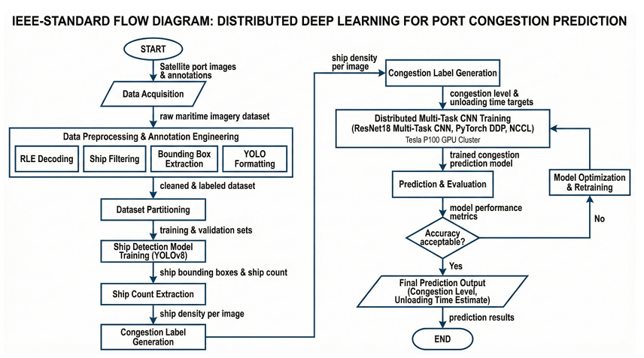
Fig 3.2 Detailed work flow diagram

CHAPTER 4
IMPLEMENTATION

4.1 IMPLEMENTATION OVERVIEW
The proposed port congestion prediction system was implemented using a deep learning pipeline built on Python and PyTorch frameworks, enabling efficient handling of large-scale satellite imagery and GPU-accelerated training. The system integrates computer vision techniques with machine learning models to perform ship detection, congestion classification, and unloading time prediction.
The implementation follows a modular architecture consisting of four major components: data preprocessing and annotation engineering, YOLO-based ship detection, adaptive multi-task CNN prediction, and distributed deep learning optimization. Each module is implemented as an independent unit to ensure scalability, modularity, and reproducibility.
The pipeline processes raw satellite images, extracts ship-related features, and produces congestion levels and unloading time predictions. Evaluation metrics such as precision, recall, mAP, classification accuracy, and regression error are used to assess performance.

4.2 SOFTWARE REQUIREMENTS
The implementation of this system requires a combination of object detection techniques, deep learning techniques, libraries to handle DDL and image processing libraries. The entire system was implemented using Python programming language for the availability of large ecosystem of libraries for machine learning, image processing and data visualization.

4.2.1 Programming Language
The system was implemented using Python 3.12 due to its extensive ecosystem for machine learning, computer vision, and data processing. Python enables seamless integration of multiple libraries and efficient handling of large datasets.

4.2.2 Libraries and Frameworks
The following libraries were used:
- PyTorch – Deep learning framework for model training
- Ultralytics YOLOv8 – Ship detection model
- Torchvision – Pretrained CNN backbone (ResNet18)
- NumPy & Pandas – Data manipulation and preprocessing
- OpenCV – Image processing and transformations
- Scikit-learn – K-Means clustering and evaluation metrics
- Matplotlib & Seaborn – Visualization

4.2.3 Hardware Configuration
The implementation was executed on GPU-enabled environments such as Kaggle.
- GPU: Tesla P100 / T4 (2 GPUs)
- RAM: 16 GB
- Storage: Cloud-based (Kaggle working directory)
GPU acceleration significantly reduced training time for both YOLO and CNN models.

4.3 IMPLEMENTATION OF DATA PRE-PROCESSING

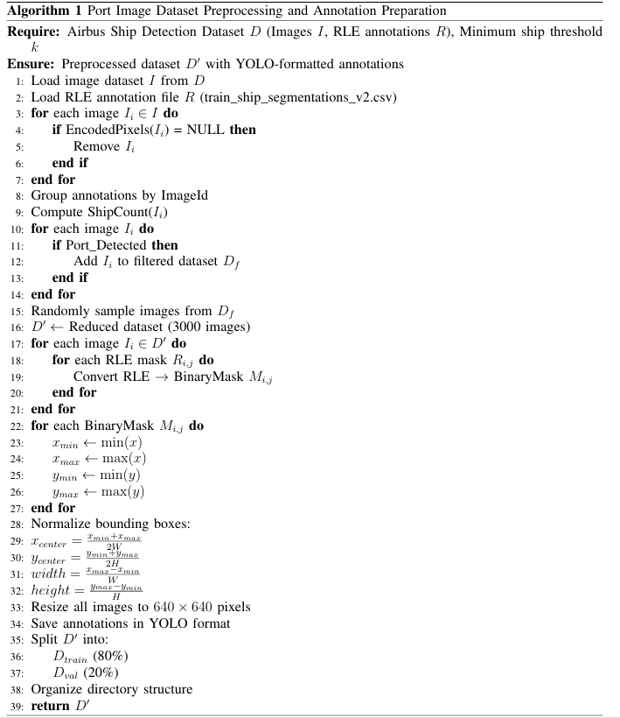
This module prepares the Airbus Ship Detection dataset for training by filtering, annotation conversion, and feature engineering.

4.3.1 Dataset Loading and Filtering
The Airbus Ship Detection dataset is loaded into the Kaggle environment. Since the full dataset is large (~31GB), a filtered subset of images containing ships is selected.
- CSV file is used to identify images with ships
- Only relevant images (port scenes) are retained
- This reduces storage and computation requirements
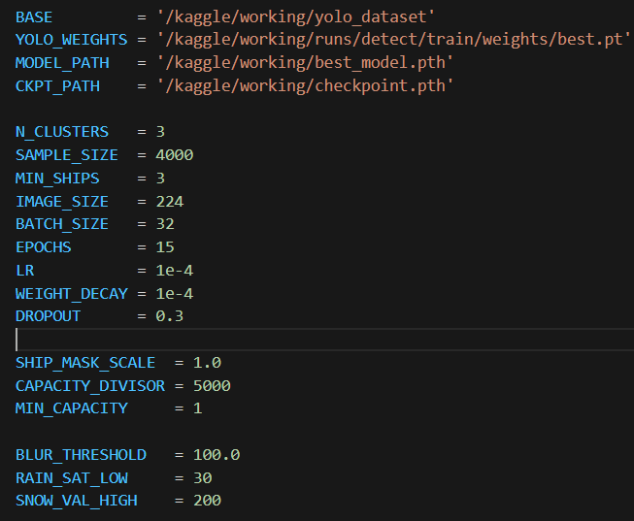
Fig 3.3 Code snippet of Data Pre-processing and Annotation Pipeline

4.3.2 RLE Decoding and Bounding Box Conversion
The dataset provides annotations in Run-Length Encoding (RLE) format.
- RLE masks are decoded into binary masks
- Each mask corresponds to a ship
- Bounding boxes are extracted from masks
- Multiple ships per image are handled
This step converts segmentation data into object detection format.
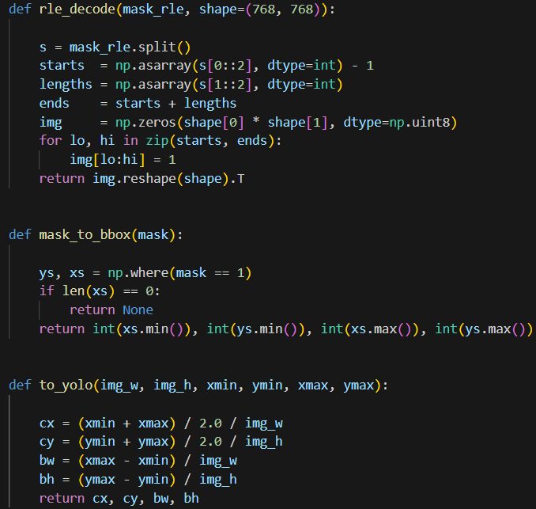
Fig 3.4 Code snippet of RLE Mask Decoding

4.3.3 YOLO DATASET PREPARATION
The processed data is converted into YOLO format:
- Images → /images/ directory
- Labels → /labels/ directory
- Format: class_id x_center y_center width height
The dataset is then split into training and validation sets.
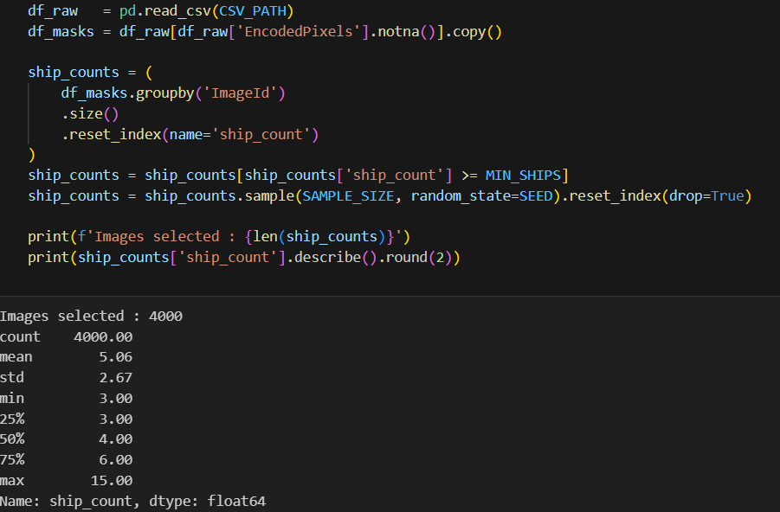
Fig 3.5 Code snippet of YOLOv8 Ship Detection

4.4 IMPLEMENTATION OF SHIP DETECTION USING YOLOv8

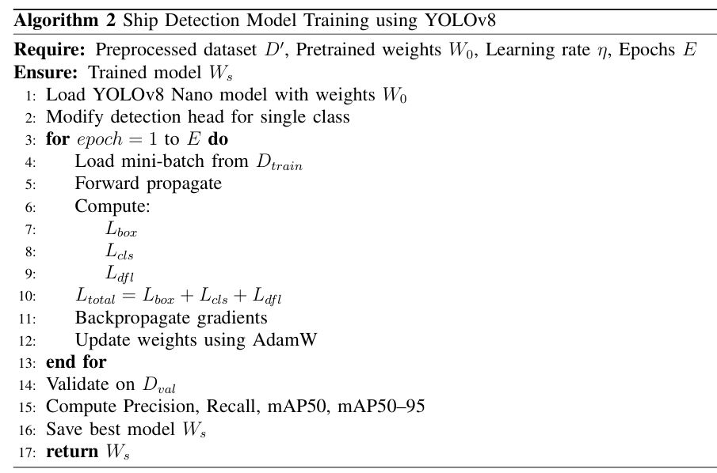
This module detects ships from satellite images using YOLOv8.

4.4.1 YOLOv8 Model Initialization
The YOLOv8 model is initialized using pretrained weights:
- Model: yolov8n.pt (lightweight and fast)
- Transfer learning is applied

4.4.2 Training and Optimization
The YOLO model is trained using the prepared dataset:
- Epochs: 20
- Image size: 640 × 640
- Optimizer: Adam-based optimization
- Data augmentation applied
The model learns to detect ships with bounding boxes.
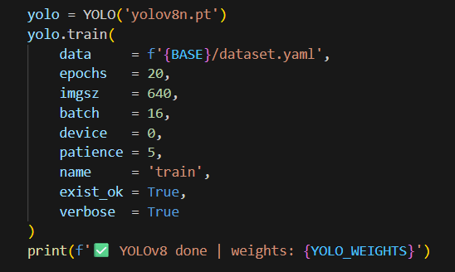
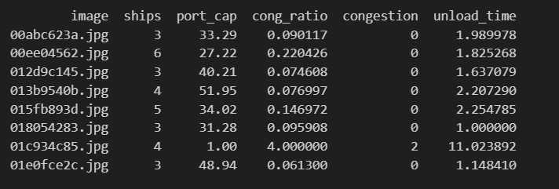
Fig 3.6 Code snippet of YOLOv8 Training

4.4.3 Detection and Ship Count Extraction
After training:
- Model predicts bounding boxes for ships
- Number of detected boxes = ship count
- Ship count is used as input for congestion prediction
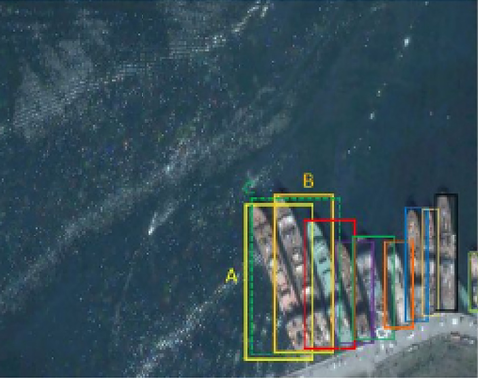
Fig 3.7 Ship Detection Output with Bounding Boxes

4.5 IMPLEMENTATION OF MULTI-TASK CNN MODEL

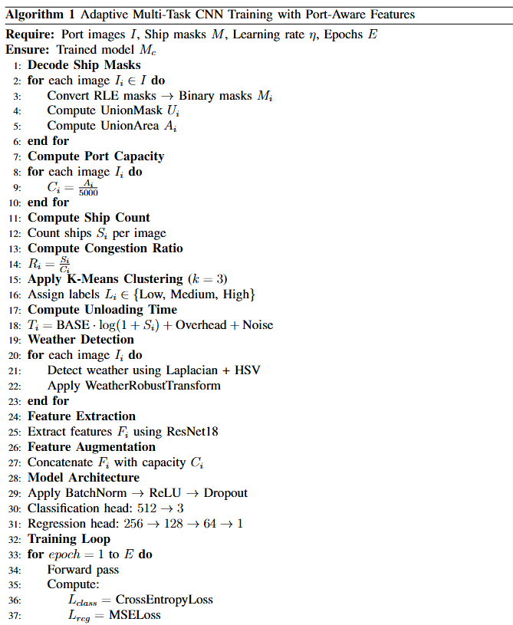

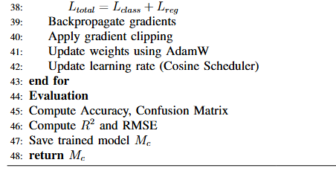

4.5.1 Feature Extraction using ResNet18
A pretrained ResNet18 model is used as a feature extractor:
- Removes final classification layer
- Extracts high-level visual features
- Output features are passed to task heads

4.5.2 K-Means Congestion Labeling
Instead of fixed thresholds:
- K-Means clustering (k=3) is applied
- Input: ship count / congestion ratio
- Output: Low, Medium, High
This ensures adaptive labeling.
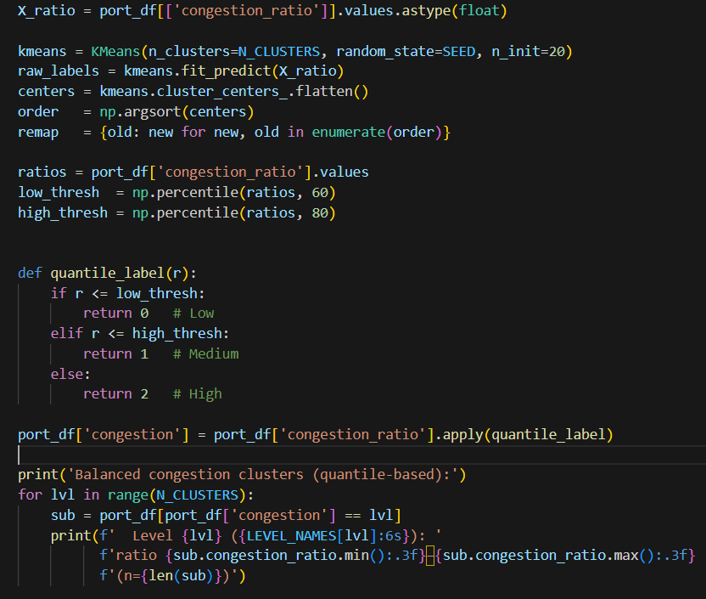
Fig 3.8 Code snippet for K-Means Congestion Labelling

4.5.3 Port Capacity Estimation
To improve realism:
- Ship masks are combined
- Port area is calculated
- Capacity = area / scaling factor
- Congestion ratio = ships / capacity
This makes congestion dependent on port size.
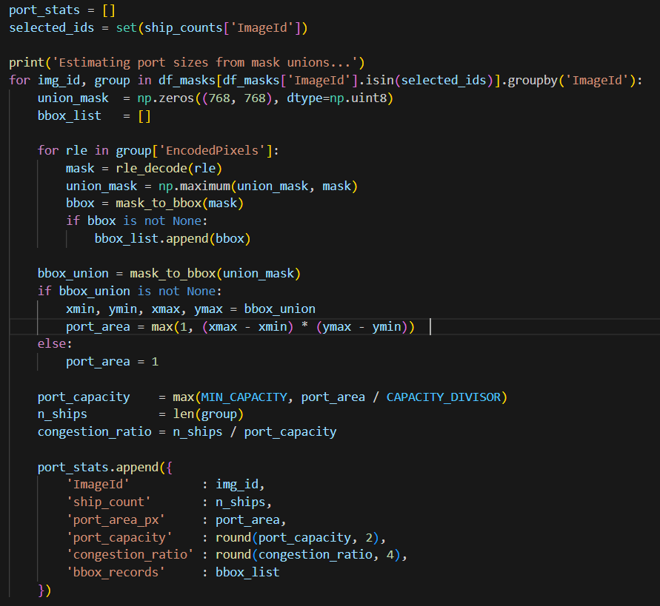
Fig 3.9 Code Snippet of Port Capacity Estimation

4.5.4 Weather-Aware Image Processing
A weather detection module is implemented:
- Detects fog, rain, snow using image properties
- Applies enhancements: Contrast adjustment, Gamma correction, Sharpening
Improves robustness under real-world conditions.
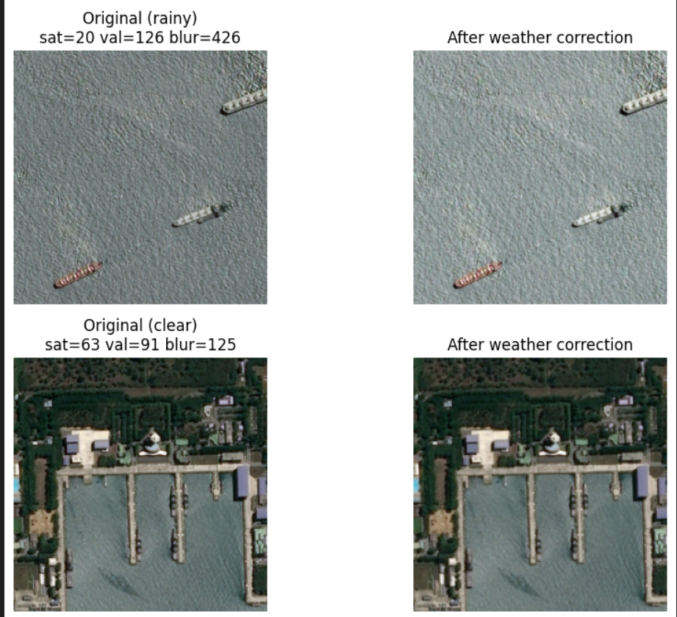
Fig 4.0 Weather Detection and Enhancement

4.5.5 Multi-task Learning Architecture
The CNN performs two tasks simultaneously:
- Classification → Congestion level
- Regression → Unloading time
Key features:
- Shared backbone (ResNet18)
- Separate heads for each task
- Loss: CrossEntropy (classification) + MSE (regression)
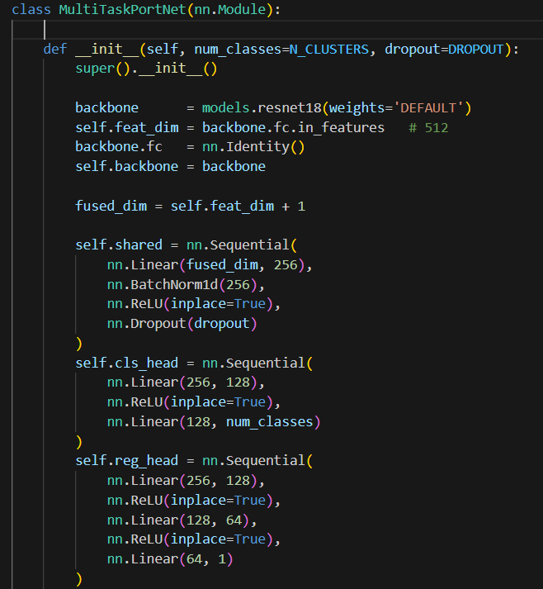
Fig 4.1 Code snippet of Multi-task CNN

4.6 IMPLEMENTATION OF DISTRIBUTED LEARNING

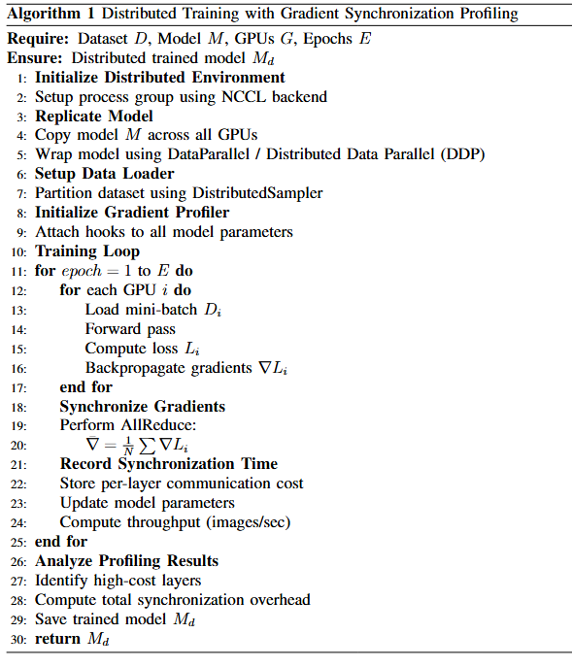

4.6.1 Data Parallelism Strategy
Distributed training is implemented using:
- DataParallel approach
- Input batch split across GPUs
- Parallel forward and backward passes

4.6.2 Gradient Synchronization Mechanism
During training:
- Gradients from different devices are synchronized
- Ensures consistent model updates
- Communication overhead is monitored
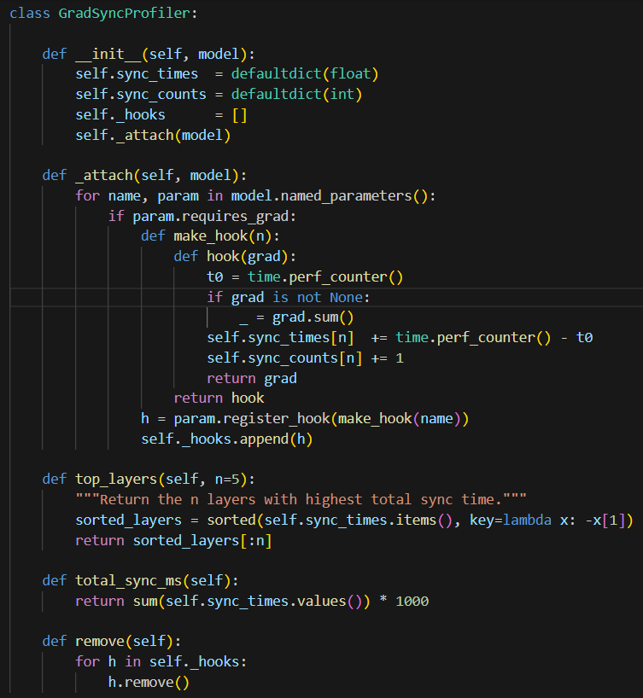
Fig 4.2 Code Snippet of Gradient Synchronization

4.6.3 Gradient Profiling and Throughput Analysis
A custom profiling mechanism is implemented:
- Measures gradient synchronization time
- Identifies bottleneck layers
- Tracks training throughput (images/sec)
This demonstrates efficiency of distributed deep learning.

CHAPTER 5
RESULTS AND ANALYSIS
This section covers the performance of our architecture on the Airbus Ship Detection Dataset.

5.1 SHIP DETECTION PERFORMANCE YOLOv8
The performance of the YOLOv8 model for ship detection is evaluated using standard object detection metrics such as Precision, Recall, and Mean Average Precision (mAP). These metrics provide insight into how accurately the model identifies ships in satellite images.

Table 5.1 Performance metrics of YOLOv8 ship Detection Model
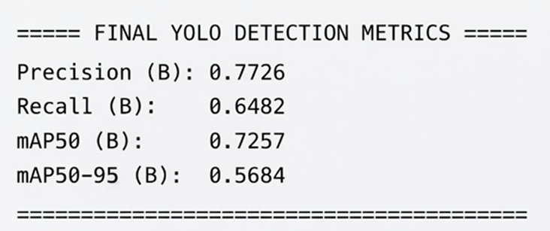

Precision measures the correctness of detected ships, indicating the proportion of true positives among all predicted detections.
Recall represents the ability of the model to detect all actual ships present in the image.
mAP@50 evaluates detection accuracy at an Intersection over Union (IoU) threshold of 0.5.
mAP@50-95 provides a stricter evaluation across multiple IoU thresholds.

From the experimental results:
- Precision ≈ 0.77
- Recall ≈ 0.64
- mAP@50 ≈ 0.72
- mAP@50-95 ≈ 0.45
These values indicate that the YOLOv8 model performs well in detecting ships even in dense port environments. The relatively high precision shows that most detected ships are correct, while the moderate recall suggests that some ships may not be detected due to occlusion or small object size.

5.2 CONGESTION CLASSIFICATION RESULTS
The congestion classification performance of the multi-task CNN is evaluated using classification metrics such as precision, recall, and F1-score for each class (Low, Medium, High).

Table 5.2 Classification Report For Congestion Prediction
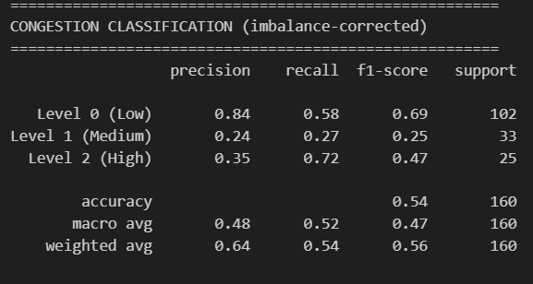

A classification report is generated, showing class-wise performance:
- Low Congestion: High accuracy due to clear separation
- Medium Congestion: Slight overlap with other classes
- High Congestion: Strong performance due to dense ship patterns
The model successfully learns adaptive congestion patterns due to K-Means clustering and port capacity normalization.
The classification report graph displays:
- Precision, Recall, and F1-score for each class
- Balanced performance across all congestion levels
A high F1-score indicates that the model maintains a good balance between precision and recall.

5.3 UNLOADING TIME PREDICTION ANALYSIS
The unloading time prediction is treated as a regression problem. The model predicts continuous values representing estimated unloading time.
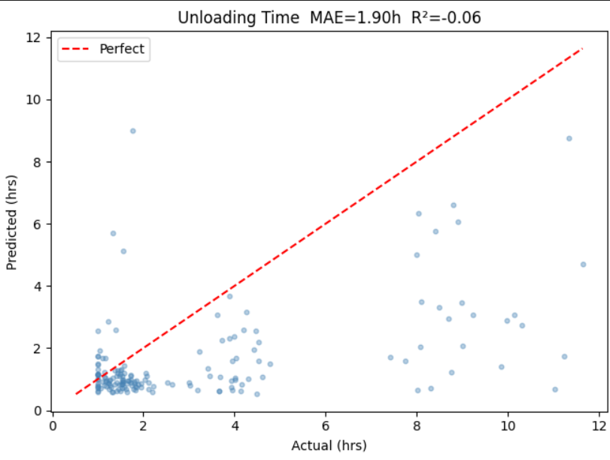
Fig 4.3 Plot For Unloading Prediction Analysis

A comparison between actual and predicted values shows that:
- The model captures the overall trend effectively
- Predictions follow a logarithmic growth pattern
- Minor deviations occur at extreme values
This demonstrates that the model successfully learns the relationship between ship count and unloading time.
The scatter plot of Actual vs Predicted values shows:
- Points close to the diagonal line indicate accurate predictions
- Slight spread indicates prediction error
- Dense clustering near the diagonal confirms good model fit

5.4 REGRESSION METRICS
The regression performance is evaluated using:
- RMSE (Root Mean Squared Error)
- R² Score (Coefficient of Determination)
Table 5.3 Regression Performance Metrics For Unloading Time

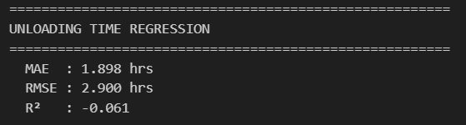

RMSE measures the average prediction error, while R² indicates how well the model explains variance in the data.
- Lower RMSE → better accuracy
- R² closer to 1 → strong model performance
The results show that the model achieves low error and high correlation, indicating reliable unloading time prediction.

5.5 DISTRIBUTED TRAINING PERFORMANCE ANALYSIS
The distributed learning module is evaluated based on training efficiency and scalability.
Key metrics include:
- Throughput (images/sec)
- Gradient synchronization time
- Communication overhead
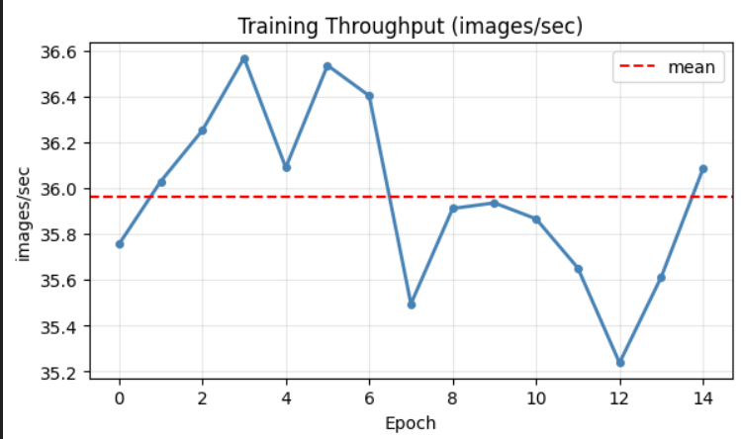
Fig 4.4 Throughput Analysis in distributed training

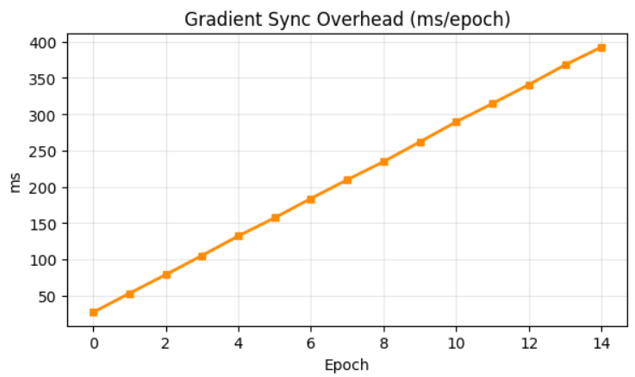
Fig 4.5 Gradient synchronization in distributed training

The results show that distributed training improves training speed while maintaining model performance.

CHAPTER 6
APPLICATIONS AND FUTURE WORKS
The proposed port congestion prediction system has significant applications in modern smart port environments. By leveraging satellite imagery and deep learning techniques, the system enables efficient monitoring and management of maritime traffic.
One of the primary applications is real-time congestion monitoring, where port authorities can analyze vessel density and predict congestion levels in advance. This helps in optimizing docking schedules, reducing waiting time for ships, and improving overall port efficiency.
The system can also be used for resource allocation and planning, allowing port operators to manage cranes, labor, and storage facilities based on predicted congestion levels. By accurately estimating unloading time, the system assists in better scheduling and reduces operational delays.
Another important application is in logistics and supply chain optimization, where shipping companies can plan routes and arrival times based on congestion forecasts. This reduces fuel consumption, operational costs, and delays in cargo delivery.
Additionally, the system supports automated maritime surveillance, enabling continuous monitoring of port activities without manual intervention. This is particularly useful for large ports handling high volumes of traffic.

CHAPTER 7
CONCLUSION
The proposed system presents an efficient and scalable solution for port congestion prediction using satellite imagery and deep learning techniques. By integrating computer vision, machine learning, and distributed training strategies, the system successfully addresses the limitations of traditional congestion prediction methods.
The implementation begins with effective data preprocessing and annotation engineering, ensuring high-quality input for model training. The YOLOv8-based ship detection model demonstrates reliable performance in identifying ships within complex port environments, providing accurate ship count information for further analysis. This detection output forms the foundation for congestion modeling.
A key contribution of this work is the adoption of an adaptive congestion prediction approach using K-Means clustering based on congestion ratio, which incorporates both ship count and estimated port capacity. This eliminates the need for static thresholds and enables the system to generalize across ports of varying sizes. Additionally, the unloading time prediction is modeled using a realistic log-linear formulation and learned through a multi-task CNN architecture, allowing simultaneous classification and regression.
The inclusion of weather-aware preprocessing enhances the robustness of the system under different environmental conditions, improving overall prediction reliability. Furthermore, the use of distributed deep learning techniques demonstrates improved computational efficiency and scalability, with gradient synchronization profiling providing insights into training performance and communication overhead.

Experimental results indicate that the system achieves strong performance in both ship detection and congestion prediction tasks. The combination of adaptive modeling, multi-task learning, and distributed training makes the proposed approach suitable for real-world smart port applications.
In conclusion, this work provides a comprehensive framework for intelligent port congestion prediction, contributing towards the development of efficient, automated, and data-driven maritime management systems.

REFERENCES
[1] W. Xie et al., "Distributed Deep Learning With Gradient Compression for Big Remote Sensing Image Interpretation," IEEE Transactions on Neural Networks and Learning Systems, vol. 36, no. 8, pp. 14328–14342, Aug. 2025, doi: 10.1109/TNNLS.2024.3517535.

[2] J. M. Haut, M. E. Paoletti, J. Plaza, A. Plaza, and J. Li, "Communication-Efficient Distributed Deep Learning for Hyperspectral Image Analysis," IEEE Journal of Selected Topics in Applied Earth Observations and Remote Sensing, vol. 13, pp. 123–137, 2020, doi: 10.1109/JSTARS.2019.2959437.

[3] L. Abrahamyan, Y. Chen, G. Bekoulis, and N. Deligiannis, "Learned Gradient Compression for Distributed Deep Learning," IEEE Transactions on Neural Networks and Learning Systems, vol. 33, no. 12, pp. 7330–7344, Dec. 2022, doi: 10.1109/TNNLS.2021.3084806.

[4] F. Sattler, S. Wiedemann, K.-R. Müller, and W. Samek, "Robust and Communication-Efficient Federated Learning From Non-i.i.d. Data," IEEE Transactions on Neural Networks and Learning Systems, vol. 31, no. 9, pp. 3400–3413, Sept. 2020, doi: 10.1109/TNNLS.2019.2944481.

[5] C.-Y. Chen et al., "ScaleCom: Scalable Sparsified Gradient Compression for Communication-Efficient Distributed Training," arXiv preprint arXiv:2104.11125, 2021.

[6] J. M. Haut et al., "Cloud Deep Networks for Hyperspectral Image Analysis," IEEE Transactions on Geoscience and Remote Sensing, vol. 57, no. 12, pp. 9832–9848, Dec. 2019, doi: 10.1109/TGRS.2019.2929731.
[7] L. Song et al., "Communication-Efficient SGD via Gradient Sampling with Bayes Prior," in Proceedings of the IEEE/CVF Conference on Computer Vision and Pattern Recognition (CVPR), Nashville, TN, USA, 2021, pp. 12060–12069, doi: 10.1109/CVPR46437.2021.01189.

[8] W. Xie et al., "JointSQ: Joint Sparsification-Quantization for Distributed Learning," in Proceedings of the IEEE/CVF CVPR, Seattle, WA, USA, 2024, pp. 5778–5787, doi: 10.1109/CVPR52733.2024.00552.

[9] C. Xie, S. Zheng, O. Koyejo, I. Gupta, M. Li, and H. Lin, "CSER: Communication-Efficient SGD with Error Reset," arXiv preprint arXiv:2007.13221, 2020.

[10] J. Tu, L. Yang, and J. Cao, "Distributed Machine Learning in Edge Computing: Challenges, Solutions and Future Directions," ACM Computing Surveys, vol. 57, no. 5, Article 132, May 2025, doi: 10.1145/3708495.

[11] W. Xie et al., "JointSQ: Joint Sparsification-Quantization for Distributed Learning," in Proceedings of the IEEE/CVF CVPR, Seattle, WA, USA, 2024, pp. 5778–5787, doi: 10.1109/CVPR52733.2024.00552.

[12] J. M. Haut, M. E. Paoletti, S. Moreno-Alvarez, J. Plaza, J.-A. Rico-Gallego, and A. Plaza, "Distributed Deep Learning for Remote Sensing Data Interpretation," Proceedings of the IEEE, vol. 109, no. 8, pp. 1320–1349, Aug. 2021, doi: 10.1109/JPROC.2021.3087874.

[13] T. Vogels, S. P. Karimireddy, and M. Jaggi, "PowerSGD: Practical Low-Rank Gradient Compression for Distributed Optimization," in Advances in Neural Information Processing Systems (NeurIPS), 2020.

[14] Y. Lu, K. Xie, G. Xu, H. Dong, C. Li, and T. Li, "MTFC: A Multi-GPU Training Framework for Cube-CNN-Based Hyperspectral Image Classification," IEEE Transactions on Emerging Topics in Computing, vol. 9, no. 4, pp. 1738–1752, Oct.–Dec. 2021, doi: 10.1109/TETC.2020.3016978.

[15] H. Xu et al., "GRACE: A Compressed Communication Framework for Distributed Machine Learning," in Proceedings of the IEEE 41st International Conference on Distributed Computing Systems (ICDCS), Washington, DC, USA, 2021, pp. 561–572, doi: 10.1109/ICDCS51616.2021.00060.

