A generic current source inversion algorithm for Mise-à-la-masse prospection : application on case studies

Tentatively in Computer and Geosciences

*Benjamin Mary1,2, Giorgio Cassiani, Jacopo Boaga?, Luca Peruzzo? Yuxin Wu ? Florian Wagner? Guillaume Blanchy?, Andrew Binley?*

1*Dipartimento di Geoscienze, Università degli Studi di Padova, Via G. Gradenigo, 6–35131 Padova, Italy*

2*Earth and Environmental Sciences, Lawrence Berkeley National Laboratory, Berkeley, California 94720, USA.*

Core ideas

* Propose an open source and generic algorithm to invert current source density in Mise-à-la-Masse prospection
* Model appraisal and uncertainties
* Show the application of the algorithm on three different contexts: plant root imaging, landfill leakage and salt intrusion monitoring
* Address pip to download the open source python package “pyMALM”: coming soon

Abstract

*Keywords:* Mise-à-la-masse, inversion, ERT, curent density

1. Introduction

* MALM Fundamentals: Parasnis 1973, Schlumberger, Stierman 1984
* Landfill MALM : (Binley et al., 1997), (Colucci et al., n.d.), (Binley et al., 1999), (De Carlo et al., 2013)
* MALM applied to tracer injection/ contamination plume delineation: (Perri et al., 2018)
* Roots imaging MALM : (Mary et al., 2020, 2019, 2018), Peruzzo et al. in Plant and Soil
* Inversion MALM : (Shao et al., 2018), (Binley et al., 1997), (Colucci et al., n.d.), (Binley et al., 1999), (Wondimu et al., 2018), (Hatanaka et al., n.d.)
* Recent python library nversion codes (Blanchy et al., 2020), (Rücker et al., 2017)
* Model appraisal: (Binley and Kemna, 2005), gars cours venice , (Ren and Kalscheuer, 2020)
  1. Background
  2. Potential of MALM for environmental studies
  3. Existing approaches for MALM inversion

1. Structure of the code
   1. Linear formulation of the problem
   2. Model appraisal and uncertainties
2. Applications
   1. Case of root system imaging
   2. Case of landfill leakage
3. Conclusion

Acknowledgements

This project has received funding from the European Union’s Horizon 2020 research and innovation programme under the Marie Sklodowska-Curie grant agreement No 842922

Figures

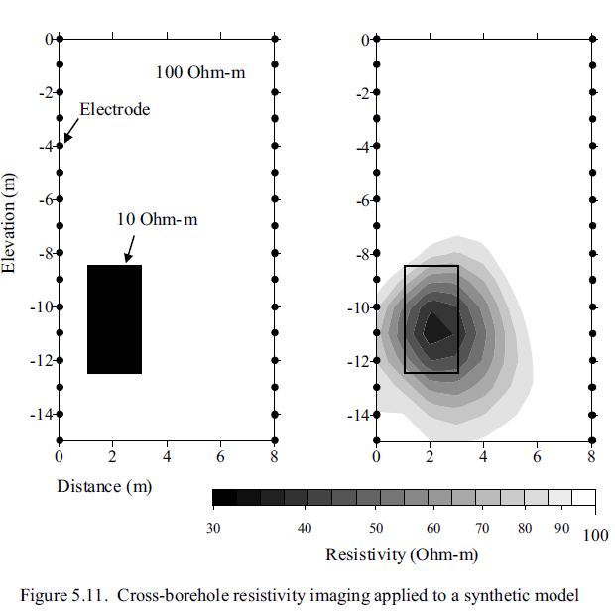 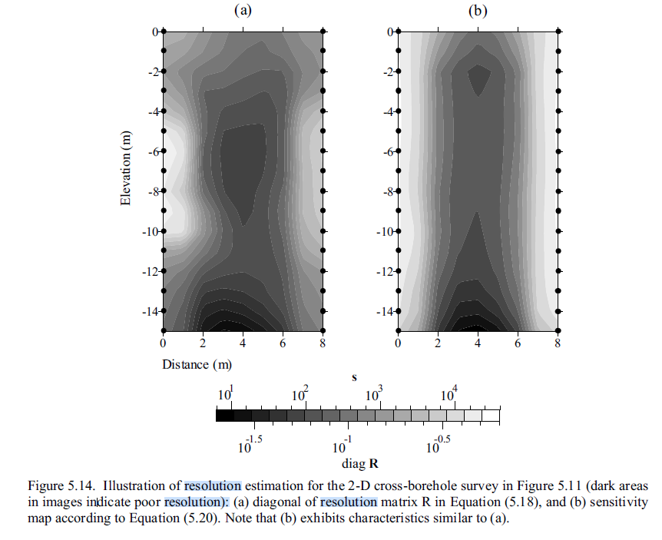

Figure 1: model appraisal and uncertainties

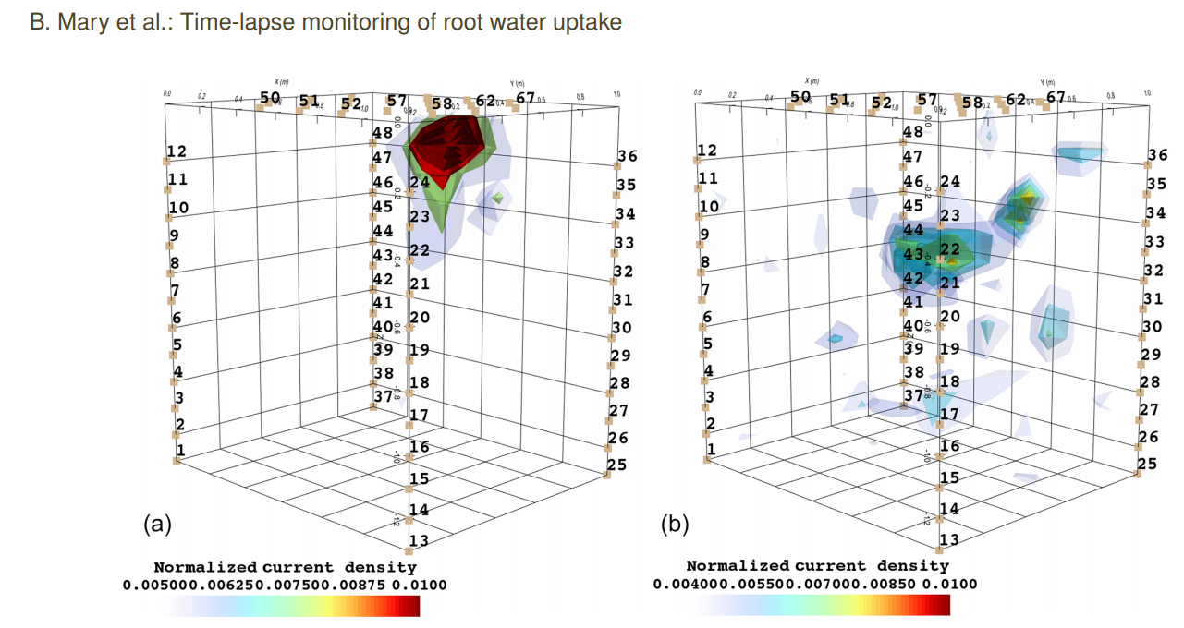

Figure 2: application of MALM on plants (ref Mary et al. 2020) and identifications of active roots areas after current inversion. The figure shows (a) the current distribution aftera single-source injection into the soil, (b) the current distribution for a stem injection.

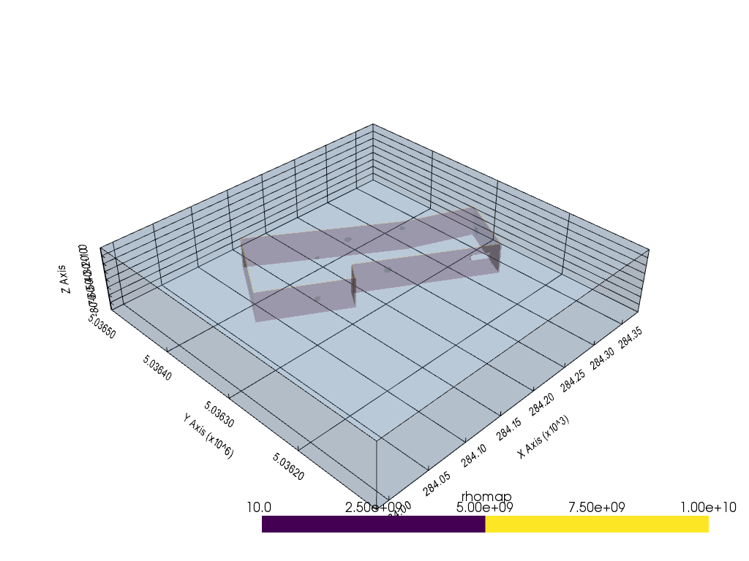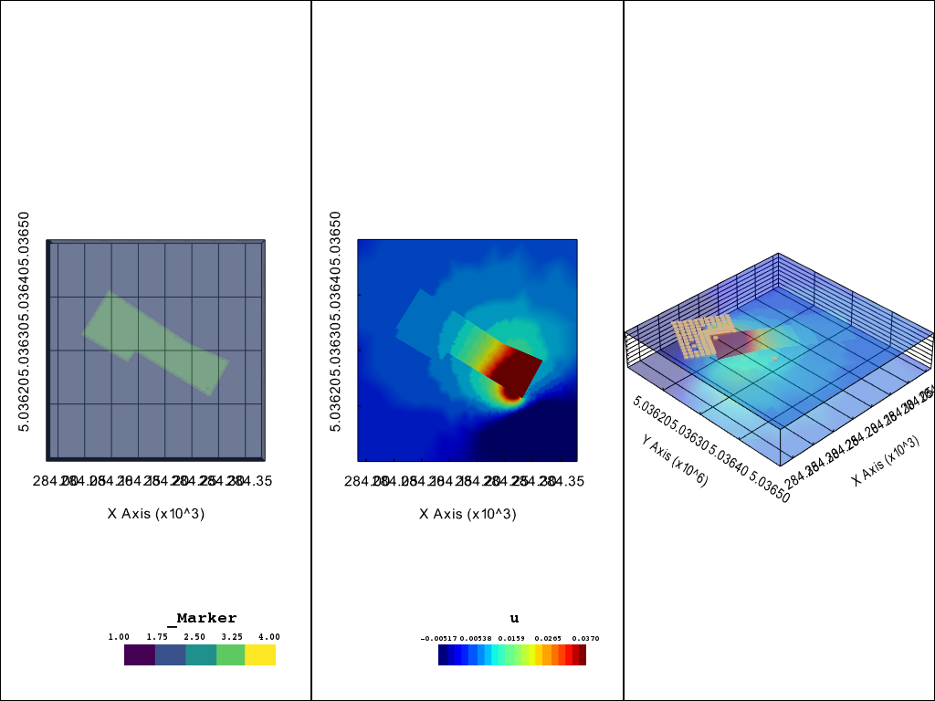

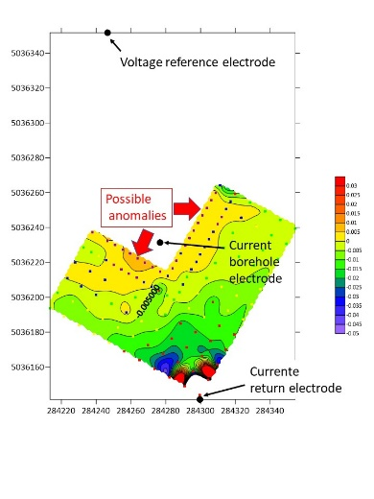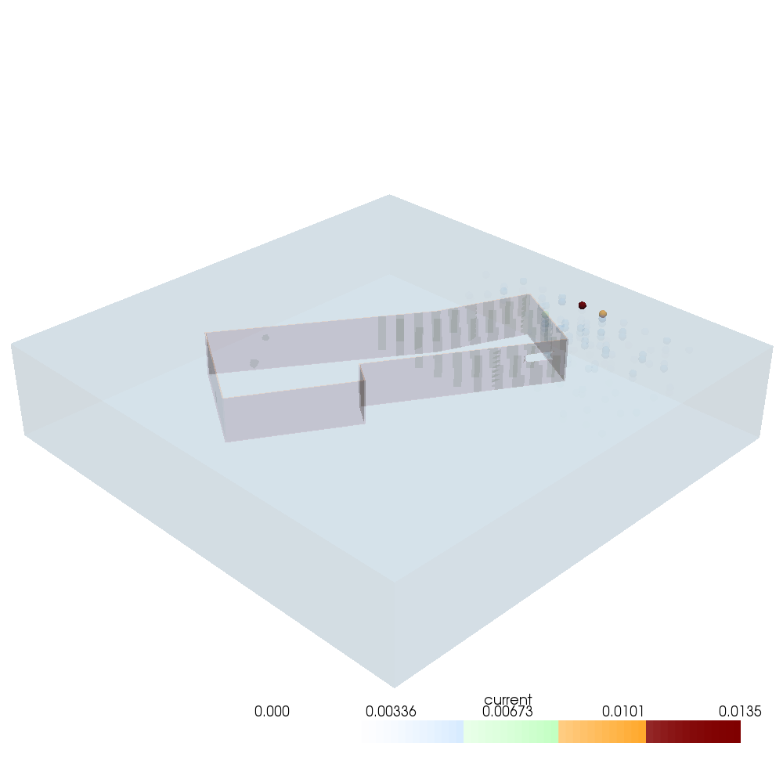

Figure 2: Application of the algorithm on a 3d landfill leakage (Landfill Porto Marghera). (a) initial map of resistivity showing the landfill delineation and the presence of a hole in the liner. (b) result of potential field u for the MALM simulation (c) voltage distribution from field acquisition (d) source current density after inversion of synthetic data. The ICSD shows here all its usefulness when the remote electrodes are not enough distant and pollute the signal and interpretation of equipotential.

References

Binley, A., Daily, W., Ramirez, A., 1999. Detecting Leaks from Waste Storage Ponds using Electrical Tomographic Methods 8.

Binley, A., Daily, W., Ramirez, A., 1997. Detecting Leaks from Environmental Barriers Using Electrical Current Imaging. JEEG 2, 11–19. https://doi.org/10.4133/JEEG2.1.11

Binley, A., Kemna, A., 2005. DC Resistivity and Induced Polarization Methods, in: Rubin, Y., Hubbard, S.S. (Eds.), Hydrogeophysics. Springer Netherlands, Dordrecht, pp. 129–156. https://doi.org/10.1007/1-4020-3102-5_5

Blanchy, G., Saneiyan, S., Boyd, J., McLachlan, P., Binley, A., 2020. ResIPy, an intuitive open source software for complex geoelectrical inversion/modeling. Computers & Geosciences 137, 104423. https://doi.org/10.1016/j.cageo.2020.104423

Colucci, P., Darilek, G.T., Laine, D.L., Binley, A., n.d. LOCATING LANDFILL LEAKS COVERED WITH WASTE 5.

De Carlo, L., Perri, M.T., Caputo, M.C., Deiana, R., Vurro, M., Cassiani, G., 2013. Characterization of a dismissed landfill via electrical resistivity tomography and mise-à-la-masse method. Journal of Applied Geophysics 98, 1–10. https://doi.org/10.1016/j.jappgeo.2013.07.010

Hatanaka, H., Aono, T., Mizunaga, H., Ushijima, K., n.d. Three-Dimensional Modeling and Inversion of the Mise-a-la-masse Data Using a Steel- Casing Borehole 6.

Mary, B., Peruzzo, L., Boaga, J., Cenni, N., Schmutz, M., Wu, Y., Hubbard, S.S., Cassiani, G., 2020. Time-lapse monitoring of root water uptake using electrical resistivity tomography and mise-&amp;#224;-la-masse: a vineyard infiltration experiment. SOIL 6, 95–114. https://doi.org/10.5194/soil-6-95-2020

Mary, B., Peruzzo, L., Boaga, J., Schmutz, M., Wu, Y., Hubbard, S.S., Cassiani, G., 2018. Small-scale characterization of vine plant root water uptake via 3-D electrical resistivity tomography and mise-&amp;#224;-la-masse method. Hydrol. Earth Syst. Sci. 22, 5427–5444. https://doi.org/10.5194/hess-22-5427-2018

Mary, B., Vanella, D., Consoli, S., Cassiani, G., 2019. Assessing the extent of citrus trees root apparatus under deficit irrigation via multi-method geo-electrical imaging. Sci Rep 9, 9913. https://doi.org/10.1038/s41598-019-46107-w

Perri, M.T., De Vita, P., Masciale, R., Portoghese, I., Chirico, G.B., Cassiani, G., 2018. Time-lapse Mise-á-la-Masse measurements and modeling for tracer test monitoring in a shallow aquifer. Journal of Hydrology 561, 461–477. https://doi.org/10.1016/j.jhydrol.2017.11.013

Ren, Z., Kalscheuer, T., 2020. Uncertainty and Resolution Analysis of 2D and 3D Inversion Models Computed from Geophysical Electromagnetic Data. Surv Geophys 41, 47–112. https://doi.org/10.1007/s10712-019-09567-3

Rücker, C., Günther, T., Wagner, F.M., 2017. pyGIMLi: An open-source library for modelling and inversion in geophysics. Computers & Geosciences 109, 106–123. https://doi.org/10.1016/j.cageo.2017.07.011

Shao, Z., Revil, A., Mao, D., Wang, D., 2018. Finding buried metallic pipes using a non-destructive approach based on 3D time-domain induced polarization data. Journal of Applied Geophysics 151, 234–245. https://doi.org/10.1016/j.jappgeo.2018.02.024

Wondimu, H.D., Mammo, T., Webster, B., 2018. 3D joint inversion of Gradient and Mise-à-la-Masse borehole IP/Resistivity data and its application to magmatic sulfide mineral deposit exploration. Acta Geophys. 66, 1031–1045. https://doi.org/10.1007/s11600-018-0199-x

Borehole-to-surface electrical resistivity monitoring of a salt water injection

Experiment 🡪 modelling in MALM Bevc

Recent paper of Blanchy and pygimli team

Paper Revil

Papier Maria Theresa

Papier Abdoulsamad et al 2019 leak in a dam