*Tentatively in Computer and Geosciences*

Core ideas

* Propose an open source and generic algorithm to invert current source density in Mise-à-la-Masse prospection
* Model appraisal and uncertainties
* Show the application of the algorithm on three different contexts: plant root imaging, landfill leakage and salt intrusion monitoring
* Address pip to download the open source python package “pyMALM”: *coming soon*

**A generic current source inversion algorithm for Mise-à-la-masse prospection**

Benjamin Mary1,2, Luca Peruzzo ? Yuxin Wu ? Giorgio Cassiani? Florian Wagner? Guillaume Blanchy?, Andrew Binley?

1Dipartimento di Geoscienze, Università degli Studi di Padova, Via G. Gradenigo, 6–35131 Padova, Italy

2Earth and Environmental Sciences, Lawrence Berkeley National Laboratory, Berkeley, California 94720, USA.

Correspondence to: Benjamin Mary ([benjamin.mary@unipd.it](mailto:benjamin.mary@unipd.it))

1. [Keywords](https://www.sciencedirect.com/science/article/pii/S0098300419308192#kwrds0010): Mise-à-la-masse, inversion, ERT, curent density

[Abstract](https://www.sciencedirect.com/science/article/pii/S0098300419308192#abs0010)

INtroduction

2. Structure of the code

3. Applications

## Root system imaging case

## A landfill leakage case

## Salt intrusion monitoring case

4. Conclusion

Acknowledgments

This project has received funding from the European Union’s Horizon 2020 research and innovation programme under the Marie Sklodowska-Curie grant agreement No 842922

References

All binley’s old contributions

Recent paper of Blanchy and pygimli team

Paper Revil

Papier Maria Theresa

Papier Abdoulsamad et al 2019 leak in a dam

FIGURES

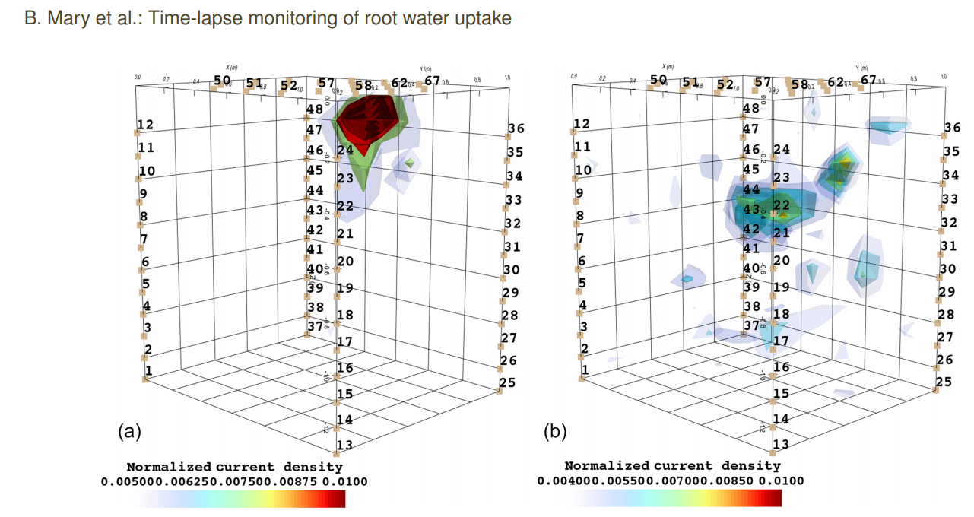

Figure

Figure 1: application on root system

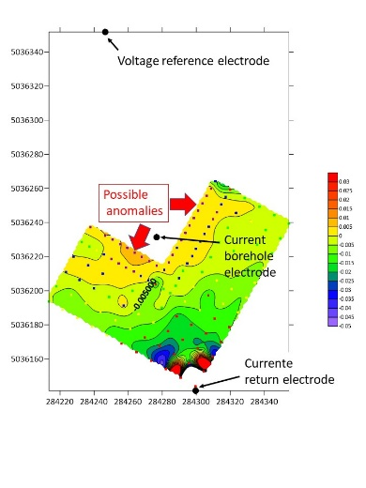

Figure 2: application on a 3d landfill leakage (*Landfill Porto Marghera – keep the field site confidential)*. The ICSD shows all its usefulness when the remote electrodes are not enough distant and pollute the signal

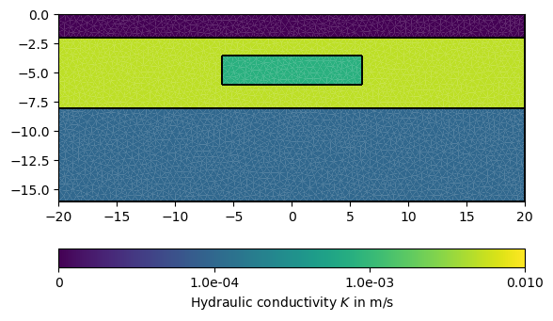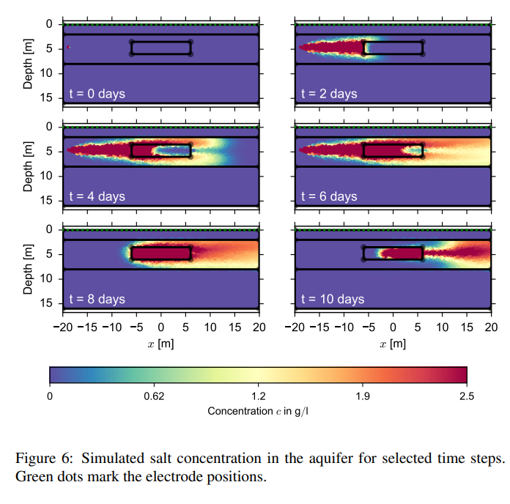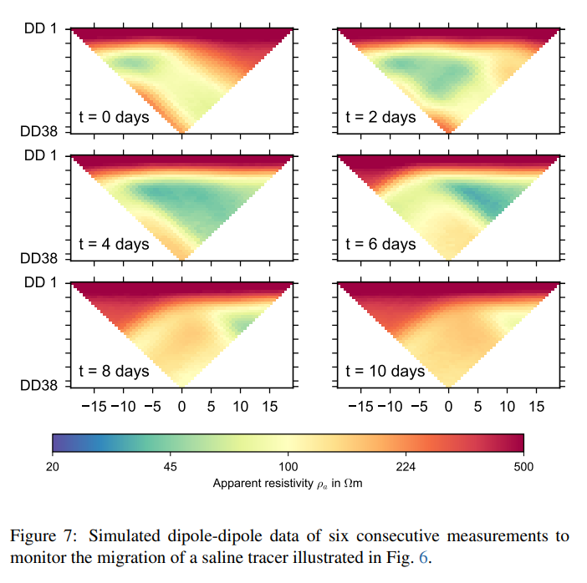

Figure 3 : Time-lapse ERT simulation measurements During a Saline Tracer Injection. *(figure 2d synthetic generated with pygimli – see article pygimli)*

|  |  |  |  |
| --- | --- | --- | --- |
|  | Initial resistivity model | Votage distribution | Current density |
| T1 |  |  |  |
| T3 |  |  |  |
| T6 |  |  |  |

Figure 4 : Time-lapse MALM Measurements During a Saline Tracer Injection.