A generic current source inversion algorithm for Mise-à-la-masse prospection : application on case studies

Tentatively in Computer and Geosciences

*Benjamin Mary1,2, Giorgio Cassiani, Jacopo Boaga?, Luca Peruzzo? Yuxin Wu ? Florian Wagner? Guillaume Blanchy?, Andrew Binley?*

1*Dipartimento di Geoscienze, Università degli Studi di Padova, Via G. Gradenigo, 6–35131 Padova, Italy*

2*Earth and Environmental Sciences, Lawrence Berkeley National Laboratory, Berkeley, California 94720, USA.*

Core ideas

* Propose an open source and generic algorithm to invert current source density in Mise-à-la-Masse prospection
* Model appraisal and uncertainties
* Show the application of the algorithm on three different contexts: plant root imaging, landfill leakage and salt intrusion monitoring
* Address pip to download the open source python package “pyMALM”: coming soon

Abstract

*Keywords:* Mise-à-la-masse, inversion, ERT, curent density

1. Introduction

* MALM Fundamentals: Parasnis 1973, Schlumberger, Stierman 1984

Survey using MALM

* Landfill/reservoir leakage MALM : (Binley et al., 1997), (Colucci et al., n.d.), (Binley et al., 1999), (De Carlo et al., 2013), (Ling et al., 2019b, 2019a)
* MALM applied to tracer injection/ contamination plume delineation: (Perri et al., 2018)
* Geotermal
* Deposit: (Bhattacharya et al., 2001)
* Karst: (Guérin et al., 2009), (Beasley and Ward, n.d.), (Chalikakis et al., 2011)
* Roots imaging MALM : (Mary et al., 2020, 2019, 2018), Peruzzo et al. in Plant and Soil

Processing of MALM

* Topography correction: (Oppliger, n.d.)
* Correction en 1/r ?
* (Ronczka et al., 2015) and (Heagy, 2018): explores using simulations the relation between the conductivity, the distribution of current density, the charge density and the electric field distribution for direct current resistivity with steel-cased wells Figure 4.14 (see also <https://em.geosci.xyz/index.html> )

Inversion in geophysics

* Inversion of streaming potentials: (Soueid Ahmed et al., 2013)
* Inversion current TDIP (without injection into the body): (Shao et al., 2018)
* Recent python library inversion codes of induced field:
  + ERT: (Blanchy et al., 2020), (Cockett et al., 2015) (Rücker et al., 2017)
* Recent python library inversion codes of natural potential field:
  + SP: (Soueid Ahmed et al., 2013)
  + Gravity: (Fedi, 2007; Florio and Fedi, 2018)
* Model appraisal: (Binley and Kemna, 2005), gars cours venice , (Ren and Kalscheuer, 2020)
* Inversion MALM : (Shao et al., 2018), (Binley et al., 1997), (Colucci et al., n.d.), (Binley et al., 1999), (Wondimu et al., 2018), (Hatanaka et al., n.d.), (Ling et al., 2019b, 2019a)
* The use of a-priori information in the form of:
  + (de Villiers et al., 2019)
  + Model depth-weighting: (Cella and Fedi, 2012), (Oldenburg and Li, n.d.)

Image appraisal and experimental design in MALM

* (Wagner, 2016) discussed experimental design against image appraisal.
* (Ronczka et al., 2015)
* How to use jacobian matrice to interpret sensitivity of model parameters (see eq. 5.20 from Binley and Kemna 2005)
  1. Background
  2. Potential of MALM for environmental studies
  3. Existing approaches for MALM inversion

1. Structure of the code
   1. Linear formulation of the problem

### drawSparseMatrix pygimli

* 1. Inversions routines

**Data and model misfit**

Smoothness

Smallness

Anisotropy

**Optimization methods**

* 1. Model appraisal and uncertainties
  2. Simple implementation within Resipy

1. Applications
   1. Initial model m0 estimation
   2. TDIP inversion

Relaxation of Wr

* 1. Time-lapse inversion

1. Case studies
   1. Impact of ??
   2. Case of root system imaging
   3. Case of landfill leakage
2. Conclusion

Acknowledgements

This project has received funding from the European Union’s Horizon 2020 research and innovation programme under the Marie Sklodowska-Curie grant agreement No 842922

Figures

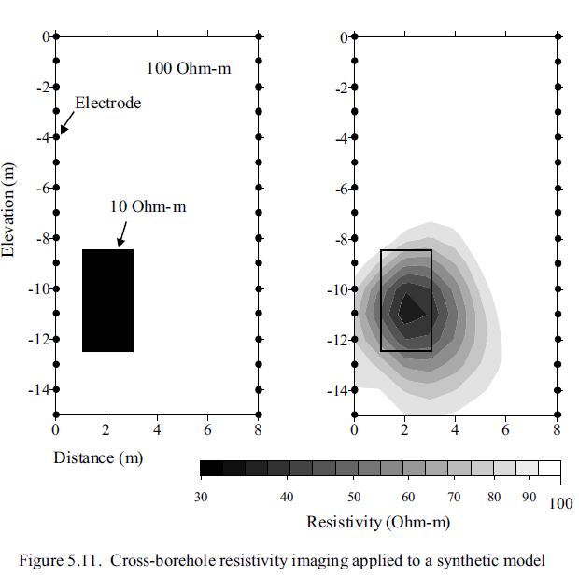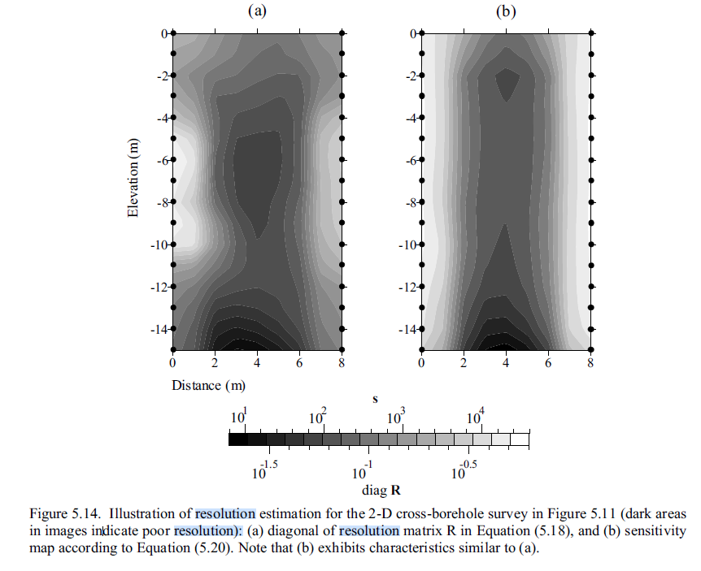

Figure 1: model appraisal and uncertainties

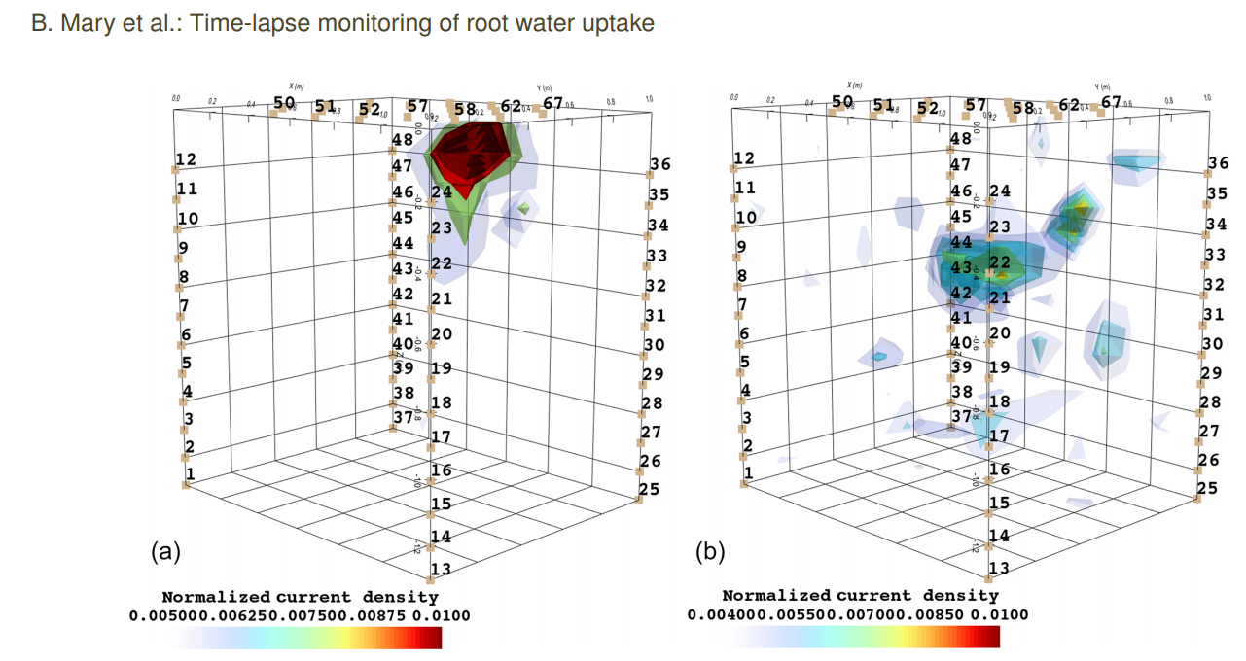

Figure 2: application of MALM on plants (ref Mary et al. 2020) and identifications of active roots areas after current inversion. The figure shows (a) the current distribution aftera single-source injection into the soil, (b) the current distribution for a stem injection. 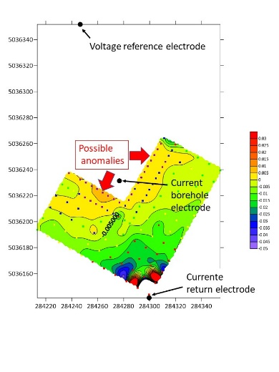

Figure 3: voltage distribution from field acquisition

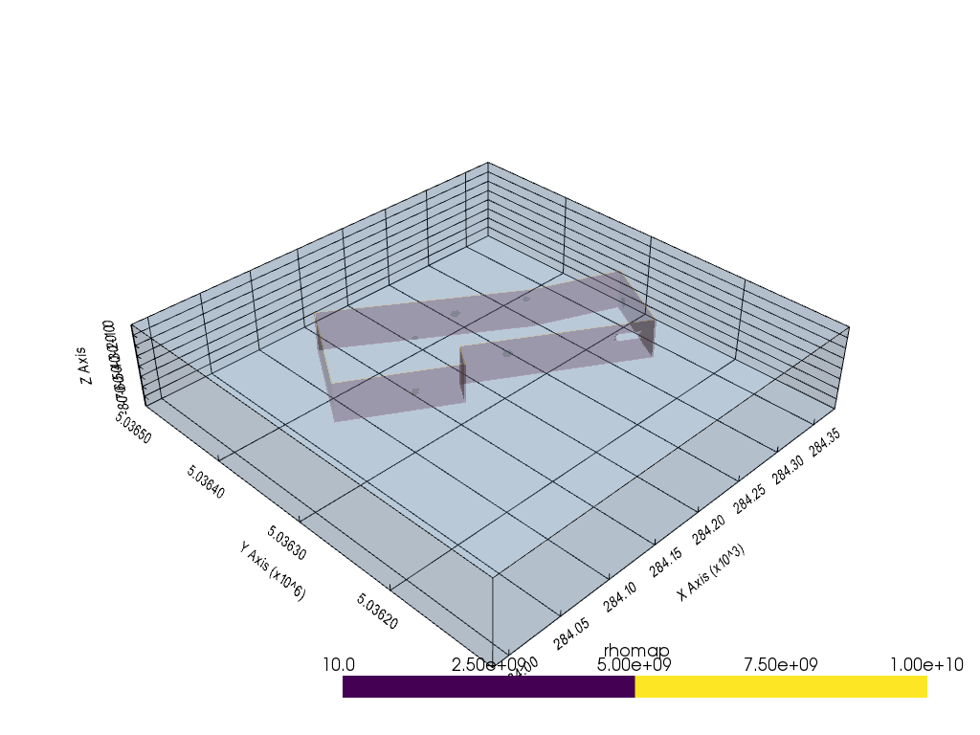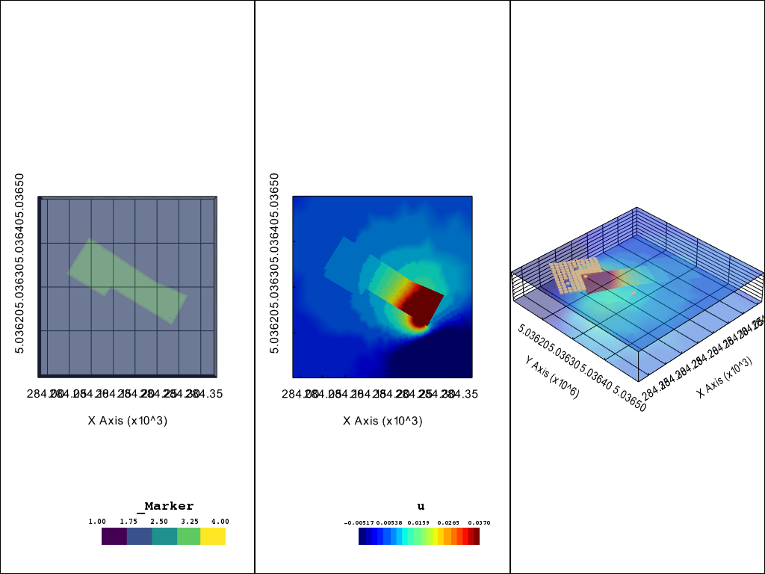

Figure 4: Application of the algorithm on a 3d landfill leakage (Landfill Porto Marghera). (a) initial map of resistivity showing the landfill delineation and the presence of a hole in the liner. (b) result of potential field u for the MALM simulation

Figure 5: Application of the algorithm on a 3d landfill leakage (Landfill Porto Marghera). Current density distribution: left without anomaly, right with anomaly.

References

Beasley, C.W., Ward, S.H., n.d. Three‐dimensional mise‐à‐la‐masse modeling applied to mapping fracture zones 16.

Bhattacharya, B.B., Gupta, D., Banerjee, B., Shalivahan, 2001. Mise‐a‐la‐masse survey for an auriferous sulfide deposit. GEOPHYSICS 66, 70–77. https://doi.org/10.1190/1.1444924

Binley, A., Daily, W., Ramirez, A., 1999. Detecting Leaks from Waste Storage Ponds using Electrical Tomographic Methods 8.

Binley, A., Daily, W., Ramirez, A., 1997. Detecting Leaks from Environmental Barriers Using Electrical Current Imaging. JEEG 2, 11–19. https://doi.org/10.4133/JEEG2.1.11

Binley, A., Kemna, A., 2005. DC Resistivity and Induced Polarization Methods, in: Rubin, Y., Hubbard, S.S. (Eds.), Hydrogeophysics, Water Science and Technology Library. Springer Netherlands, Dordrecht, pp. 129–156. https://doi.org/10.1007/1-4020-3102-5_5

Blanchy, G., Saneiyan, S., Boyd, J., McLachlan, P., Binley, A., 2020. ResIPy, an intuitive open source software for complex geoelectrical inversion/modeling. Computers & Geosciences 137, 104423. https://doi.org/10.1016/j.cageo.2020.104423

Cella, F., Fedi, M., 2012. Inversion of potential field data using the structural index as weighting function rate decay: Inversion of potential field data. Geophysical Prospecting 60, 313–336. https://doi.org/10.1111/j.1365-2478.2011.00974.x

Chalikakis, K., Plagnes, V., Guerin, R., Valois, R., Bosch, F.P., 2011. Contribution of geophysical methods to karst-system exploration: an overview. Hydrogeol J 19, 1169–1180. https://doi.org/10.1007/s10040-011-0746-x

Cockett, R., Kang, S., Heagy, L.J., Pidlisecky, A., Oldenburg, D.W., 2015. SimPEG: An open source framework for simulation and gradient based parameter estimation in geophysical applications. Computers & Geosciences 85, 142–154. https://doi.org/10.1016/j.cageo.2015.09.015

Colucci, P., Darilek, G.T., Laine, D.L., Binley, A., n.d. LOCATING LANDFILL LEAKS COVERED WITH WASTE 5.

De Carlo, L., Perri, M.T., Caputo, M.C., Deiana, R., Vurro, M., Cassiani, G., 2013. Characterization of a dismissed landfill via electrical resistivity tomography and mise-à-la-masse method. Journal of Applied Geophysics 98, 1–10. https://doi.org/10.1016/j.jappgeo.2013.07.010

de Villiers, G.D., Ridley, K.D., Rodgers, A.D., Boddice, D., 2019. On the use of the profiled singular-function expansion in gravity gradiometry. Journal of Applied Geophysics 170, 103830. https://doi.org/10.1016/j.jappgeo.2019.103830

Fedi, M., 2007. DEXP: A fast method to determine the depth and the structural index of potential fields sources. GEOPHYSICS 72, I1–I11. https://doi.org/10.1190/1.2399452

Florio, G., Fedi, M., 2018. Depth estimation from downward continuation: An entropy-based approach to normalized full gradient. GEOPHYSICS 83, J33–J42. https://doi.org/10.1190/geo2016-0681.1

Guérin, R., Baltassat, J.-M., Boucher, M., Chalikakis, K., Galibert, P.-Y., Girard, J.-F., Plagnes, V., Valois, R., 2009. Geophysical characterisation of karstic networks – Application to the Ouysse system (Poumeyssen, France). Comptes Rendus Geoscience 341, 810–817. https://doi.org/10.1016/j.crte.2009.08.005

Hatanaka, H., Aono, T., Mizunaga, H., Ushijima, K., n.d. Three-Dimensional Modeling and Inversion of the Mise-a-la-masse Data Using a Steel- Casing Borehole 6.

Heagy, L.J., 2018. Electromagnetic methods for imaging subsurface injections (PhD Thesis). Electronic Theses and Dissertations (ETDs) 2008+. University of British Columbia. https://doi.org/10.14288/1.0374170

Ling, C., Revil, A., Abdulsamad, F., Qi, Y., Soueid Ahmed, A., Shi, P., Nicaise, S., Peyras, L., 2019a. Leakage detection of water reservoirs using a Mise-à-la-Masse approach. Journal of Hydrology 572, 51–65. https://doi.org/10.1016/j.jhydrol.2019.02.046

Ling, C., Revil, A., Qi, Y., Abdulsamad, F., Shi, P., Nicaise, S., Peyras, L., 2019b. Application of the Mise-à-la-Masse method to detect the bottom leakage of water reservoirs. Engineering Geology 261, 105272. https://doi.org/10.1016/j.enggeo.2019.105272

Mary, B., Peruzzo, L., Boaga, J., Cenni, N., Schmutz, M., Wu, Y., Hubbard, S.S., Cassiani, G., 2020. Time-lapse monitoring of root water uptake using electrical resistivity tomography and mise-&amp;#224;-la-masse: a vineyard infiltration experiment. SOIL 6, 95–114. https://doi.org/10.5194/soil-6-95-2020

Mary, B., Peruzzo, L., Boaga, J., Schmutz, M., Wu, Y., Hubbard, S.S., Cassiani, G., 2018. Small-scale characterization of vine plant root water uptake via 3-D electrical resistivity tomography and mise-&amp;#224;-la-masse method. Hydrol. Earth Syst. Sci. 22, 5427–5444. https://doi.org/10.5194/hess-22-5427-2018

Mary, B., Vanella, D., Consoli, S., Cassiani, G., 2019. Assessing the extent of citrus trees root apparatus under deficit irrigation via multi-method geo-electrical imaging. Sci Rep 9, 9913. https://doi.org/10.1038/s41598-019-46107-w

Oldenburg, D.W., Li, Y., n.d. 3-D inversion of gravity data 11.

Oppliger, G.L., n.d. Three-dimensional terrain corrections for mise-k-la-masse and magnetometric resistivity surveys 12.

Perri, M.T., De Vita, P., Masciale, R., Portoghese, I., Chirico, G.B., Cassiani, G., 2018. Time-lapse Mise-á-la-Masse measurements and modeling for tracer test monitoring in a shallow aquifer. Journal of Hydrology 561, 461–477. https://doi.org/10.1016/j.jhydrol.2017.11.013

Ren, Z., Kalscheuer, T., 2020. Uncertainty and Resolution Analysis of 2D and 3D Inversion Models Computed from Geophysical Electromagnetic Data. Surv Geophys 41, 47–112. https://doi.org/10.1007/s10712-019-09567-3

Ronczka, M., Rücker, C., Günther, T., 2015. Numerical study of long-electrode electric resistivity tomography — Accuracy, sensitivity, and resolution. GEOPHYSICS 80, E317–E328. https://doi.org/10.1190/geo2014-0551.1

Rücker, C., Günther, T., Wagner, F.M., 2017. pyGIMLi: An open-source library for modelling and inversion in geophysics. Computers & Geosciences 109, 106–123. https://doi.org/10.1016/j.cageo.2017.07.011

Shao, Z., Revil, A., Mao, D., Wang, D., 2018. Finding buried metallic pipes using a non-destructive approach based on 3D time-domain induced polarization data. Journal of Applied Geophysics 151, 234–245. https://doi.org/10.1016/j.jappgeo.2018.02.024

Soueid Ahmed, A., Jardani, A., Revil, A., Dupont, J.P., 2013. SP2DINV: A 2D forward and inverse code for streaming potential problems. Computers & Geosciences 59, 9–16. https://doi.org/10.1016/j.cageo.2013.05.008

Wagner, F.M., 2016. New developments in electrical resistivity imaging with applications to geological CO₂ storage. ETH Zurich. https://doi.org/10.3929/ETHZ-A-010636965

Wondimu, H.D., Mammo, T., Webster, B., 2018. 3D joint inversion of Gradient and Mise-à-la-Masse borehole IP/Resistivity data and its application to magmatic sulfide mineral deposit exploration. Acta Geophys. 66, 1031–1045. https://doi.org/10.1007/s11600-018-0199-x