Generic inversion of current density

*Code changes, version of April 2019*

Table of Contents

1. Structure of the code 1

2. Tests 4

2.1. 3d landfill Porto Marghera leakage 4

2.2. 3d landfill corigliano 5

# Structure of the code

Test the code under different MALM field and synthetic data.

* Root Water Uptake
* Landfill leakage

Current density inversion can be expressed linearly such as:

Where **A** is a matrix, its columns are the simulated VRTe R sequences; **x** is a vector containing the unknown VRTe weights; **b** is a vector containing the measured sequence of resistance. Each row in **A** corresponds to the relative R in the acquisition sequence, e.g., **A**1,1 is the first resistance extracted from the potential field simulated with injection at the first VRTe.

**Including Constraints**

* The charge conservation is implemented by appending a row of 1’s to **A** and a corresponding 1 to the vector **b**. This forces the sum of the VRTe weights to be equal to 1.

**Relative smallness constraint and spatial regularization**

* For the 2d case, since the problem is undetermined we can apply:
  + a first order spatial regularization is added (Menke, 1989). Rows are added to express the differences between adjacent VRTe, e.g., the row is the difference between the first two VRTe weights. The differences are added for the entire VRTe grid and set to 0 by adding corresponding 0’s to **b**.
  + NEW: a second order spatial regularization with differentiation between x and y directions to obtain to different matrices (of the same size) such as and
* NEW: For the 3d case, a k-mean with 4 (or more) neighbors sources regularization can be used. In that case each source is weighted so the sum is equal to 0.

We used a linear solver from Python library, using a least square inversion which in the current version minimized the following objective function:

where m0 is a reference model to which we believe the physical property distribution should be close. Often m0 is chosen to be a constant average value. In that case the initial model m0 vector is implemented using the simple misfit between a single source current and the measured data:

Equation (2) also contains the coefficients controlling weight of the relative smallness , and the regularization anisotropy wieigth and respectively in x and y directions.

Equation (2) can be rewritten as:

Where

(Luca’s version: )

New version:

The trade-off between data misfit and solution regularization is controlled by. The numerical routine includes a “pareto” functionality wherein regularization and model-to-measurement fit are traded off while changing the regularization weight. The obtained set of solutions can be used to construct the “pareto front” (L-curve), which is a widely accepted way to estimate the optimum regularization weight (Hansen and Dianne, 1993).

The solution is further constrained by forcing the linear solver to seek only positive VRTe weights (i.e., inequality constraint), as the negative source of current is known to correspond uniquely to the return electrode.

The following equation can be use to solve the inversion problem:

by solving the system Am=b, with:

**Model appraisal (not yet implemented)**

The general solution to the spatially distributed linear inverse problem given by equation (11) can be rewritten in the following form

Equation above states that we can view the estimated distribution of model parameters as some linear combination of the true parameters m plus a vector that depends only on the reference model m0.

# Tests

## 3d landfill Porto Marghera leakage

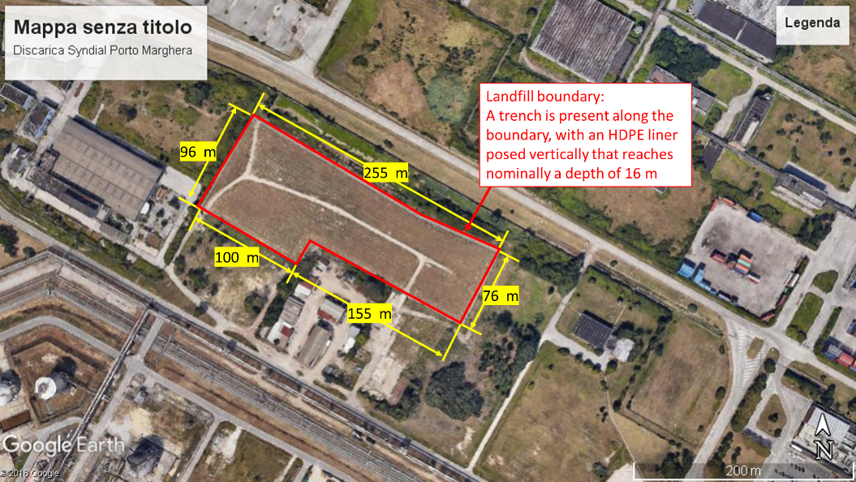

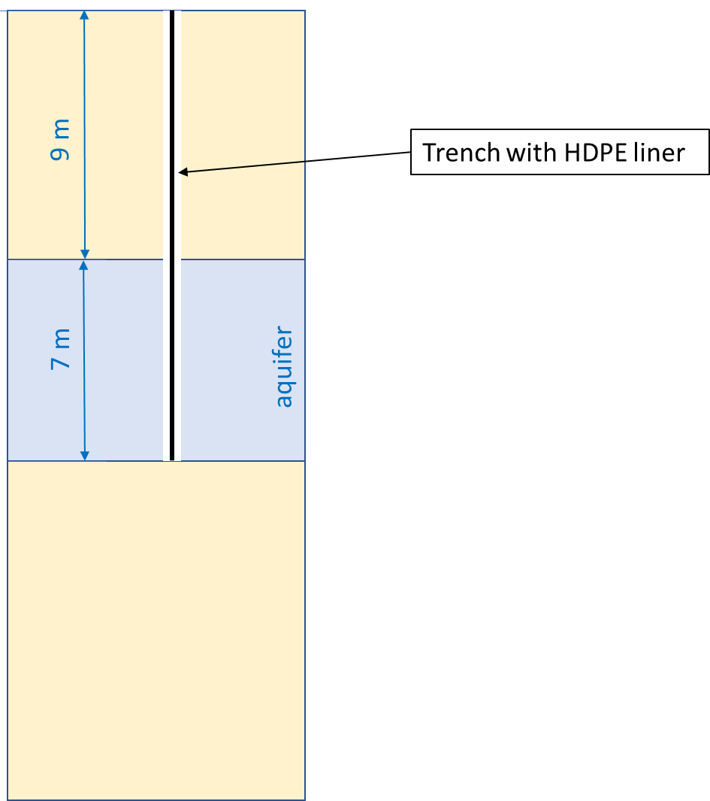

The water table is practically at the ground surface. The sediments are silty, and fully saturated with backish water (assume 10 g/l NaCl, so probably 0.5 S/m of electrical conductivity of water; if formation factor is say 5 then the electrical conductivity of the formation is 0.1 S/m (10 Ohm m of electrical resistivity). This applies to all formations, as a first assumption.

## 3d landfill corigliano