MEDBOT
An Intelligent Medical Question-Answering Assistant using Fine-Tuning, RAG and Tool Integration

Course: 21CSE658T – Large Language Models

Submitted by
PERVIN PETER P. [RA2512049015027]
Assessment: Life Long Learning Assessment (LLT), Set B

MASTER OF TECHNOLOGY
in
ARTIFICIAL INTELLIGENCE

FACULTY OF ENGINEERING AND TECHNOLOGY
SCHOOL OF COMPUTING
SRM INSTITUTE OF SCIENCE AND TECHNOLOGY
KATTANKULATHUR – 603203
OCTOBER 2026

Declaration
I, Pervin Peter P. (Register Number RA2512049015027), a student of the M.Tech programme at the School of Computing, SRM Institute of Science and Technology, hereby declare that this report, titled “MedBot: An Intelligent Medical Question-Answering Assistant using Fine-Tuning, RAG and Tool Integration”, is a record of the work carried out by me for the course 21CSE658T – Large Language Models (Life Long Learning Assessment, Set B).
The work reported here, including the dataset preparation, fine-tuning, retrieval-augmented generation pipeline, tool integration and Streamlit application, was implemented by me. Public datasets, models, libraries and web sources used are acknowledged in the References. The optional RLHF/GRPO phase was not implemented and is not claimed.
MedBot is an educational prototype and is not intended for clinical use.

Date: ____________________
Signature: ____________________
Pervin Peter P.
RA2512049015027

Table of Contents
Abstract 4
1. Problem Statement and Objectives 4
2. System Architecture 4
3. Dataset Preparation — Phase 1 4
4. Fine-Tuning and Evaluation — Phase 2 5
5. Retrieval-Augmented Generation — Phase 3 5
5.1 History-aware retrieval 6
5.2 Grounded answers, citations and refusal 6
6. Tool Integration and Streamlit UI — Phases 5–6 6
7. Testing Summary 6
8. Limitations, Safety and Future Work 7
9. Conclusion 7
References 7
Appendix A — Assignment Requirement Mapping 8
Appendix B — Application Screenshots 9
Appendix C — Project Files and How to Run 12

List of Figures
Figure 1. Diabetes symptoms answer with a MedlinePlus source citation. 9
Figure 2. Retrieved evidence cards showing source names and similarity scores. 9
Figure 3. Asthma symptoms answer with a MedlinePlus source link and a high-similarity evidence card. 10
Figure 4. Unsupported question (migraine): the application refuses and displays no evidence. 10
Figure 5. BMI tool with tool-call trace: 70 kg and 170 cm yields BMI 24.2, displayed as Normal weight. 10
Figure 6. Medical tools section: BMI calculator and the FDA drug-information search form. 11

Abstract
MedBot is an educational medical-information assistant built to demonstrate an end-to-end large language model workflow. It combines MedQuAD dataset preparation, QLoRA fine-tuning of Qwen2.5-1.5B-Instruct, retrieval-augmented generation (RAG) with FAISS, history-aware query rewriting for follow-up questions, source-linked answers, a refusal path for unsupported conditions, and two tools: a local BMI calculator and an openFDA drug-label lookup. A Streamlit interface displays answers, retrieved passages, source links, similarity indicators and a medical disclaimer. The prototype is not a diagnostic system and must not replace professional medical advice. The optional RLHF/GRPO phase was not implemented.

1. Problem Statement and Objectives
General-purpose language models can produce plausible but unsupported medical statements. This project builds a small domain-adapted assistant that retrieves public medical information, grounds its answers in source passages, handles short follow-up questions, and declines questions outside its currently supported topics.
- Prepare MedQuAD as instruction-style JSONL and split it 80:20 into training and validation sets.
- Fine-tune a compact instruction model using QLoRA within the available GPU memory.
- Index public medical documents from MedlinePlus, WHO and CDC using sentence embeddings and FAISS.
- Resolve follow-up questions using conversation context without carrying an old condition into unrelated questions.
- Provide a Streamlit interface with evidence cards, citations, a disclaimer, a BMI calculator and an FDA drug-label lookup.

2. System Architecture
Pipeline: MedQuAD preparation → QLoRA adapter training → public document collection → heading/paragraph-aware chunking → embedding windows → sentence embeddings → FAISS retrieval → history-aware query resolution → evidence-aware answer generation → Streamlit UI and tool outputs.
Component | Implementation | Purpose
Dataset | MedQuAD; instruction-style JSONL | Prepare QA training examples
Fine-tuning | Qwen2.5-1.5B-Instruct; 4-bit QLoRA with Hugging Face PEFT | Adapt answer style to medical Q&A
Embeddings | all-MiniLM-L6-v2; 384 dimensions | Semantic passage retrieval
Vector index | FAISS IndexFlatIP with normalized embeddings | Rank candidate evidence
Query rewriting | History-aware helper (make_history_aware_query) | Resolve short follow-up questions
Interface | Streamlit (app.py) | Chat/Q&A, evidence, sources, tools
Tools | Local BMI calculation; openFDA drug-label API | Demonstrate tool integration

3. Dataset Preparation — Phase 1
MedQuAD records (AnonymousSub/MedQuAD_47441_Question_Answer_Pairs) were cleaned by excluding rows with missing answers and duplicate question–answer pairs. Valid records were formatted as instruction-style JSONL and split 80:20 with seed 42. The full dataset was used.
Measure | Result
Source rows | 47,441
Excluded: missing answers | 31,034
Duplicate pairs removed | 48
Unique valid records after cleaning | 16,359
Training records | 13,087
Validation records | 3,272

Outputs (in medbot_phase1_output): medquad_cleaned.jsonl, medquad_train.jsonl, medquad_validation.jsonl, preprocessing_summary.json and the preprocessing report.

4. Fine-Tuning and Evaluation — Phase 2
The base model was Qwen/Qwen2.5-1.5B-Instruct, loaded as a 4-bit NF4 quantized model with LoRA adapters on q_proj, k_proj, v_proj and o_proj. Settings: rank 8, alpha 16, dropout 0.05, maximum sequence length 768, one epoch, batch size 1, gradient accumulation 4, learning rate 1e-4, FP16 and gradient checkpointing.
Training measure | Observed result
Training examples | 13,087
Validation examples | 3,272
Optimizer steps | 3,272
Training loss | 1.1681
Evaluation (validation) loss | 1.1514
Perplexity (derived: exp of evaluation loss) | ≈ 3.16
Runtime | About 5,407 seconds (approximately 90 minutes)

The adapter is saved in medbot_phase2_full/lora_adapter and results in training_results.json. A model-loading and generation smoke test succeeded. Loss and perplexity measure language-modelling fit on held-out data; they do not establish clinical accuracy or safety, and no task-specific generation metric (for example ROUGE or BERTScore) was run.

5. Retrieval-Augmented Generation — Phase 3
Five public documents from MedlinePlus, WHO and CDC cover diabetes, high blood pressure and asthma. Text was extracted and split with heading/paragraph-aware chunking; smaller overlapping embedding windows accommodate the embedding model’s input length.
RAG configuration | Value
Source documents | 5 (MedlinePlus, WHO, CDC)
Document chunks | 41
Embedding windows indexed | 81
Document chunk setting | 800 tokens; 100-token overlap
Embedding window setting | 180 tokens; 30-token overlap
Embedding model | sentence-transformers/all-MiniLM-L6-v2 (384 dimensions)
Index | FAISS IndexFlatIP; normalized vectors

5.1 History-aware retrieval
The helper make_history_aware_query rewrites short follow-up questions using the latest user question, and leaves explicit or unrelated questions unchanged. Tested behaviour:
Conversation | Result
Previous: “What are the symptoms of asthma?” → “How can I prevent it?” | Resolved to “How can I prevent asthma?”
Previous: asthma question → unrelated question about a rare condition “XYZ-123” | Preserved; not rewritten using the asthma context
Previous: asthma question → “What are the symptoms of diabetes?” | Preserved as an explicit question

The rewriting function is called before evidence retrieval, and the chat history is stored in Streamlit session state. In a multi-turn test in the Streamlit interface, the user asked about diabetes symptoms, switched to asthma symptoms and then asked “How can I prevent it?”; the app resolved the pronoun and used “How can I prevent asthma?” as the FAISS retrieval query. The retrieved MedlinePlus asthma passage discussed avoiding triggers and following a care plan. This confirms the demonstrated scenario only; it does not establish robust behaviour for all conversations.

5.2 Grounded answers, citations and refusal
For each question the app retrieves candidate passages, displays source names, similarity indicators, previews and source links, and generates an answer with citations. A fixed supported-condition safeguard makes the assistant refuse questions about conditions not covered by the knowledge base; the XYZ-123 question was refused in both a direct Python call and the Streamlit UI. The refusal path for a question without supporting evidence is shown in Figure 4. The defined automated RAG answer tests reported six passed and zero failed/check results.

6. Tool Integration and Streamlit UI — Phases 5–6
The Streamlit application (app.py) provides a medical question field, the answer, retrieved evidence cards, source URLs, similarity indicators and a medical disclaimer. Two tools are available from the interface:
- BMI calculator — a local Python function; 70 kg and 170 cm returned BMI 24.2, displayed as Normal weight. The interface shows a tool-call trace with the tool name, inputs and execution status (Figure 5).
- Drug information (openFDA) — calls https://api.fda.gov/drug/label.json; an ibuprofen lookup displayed label information and a source URL during testing (the search form is shown in Figure 6). FDA label output is not individualized dosing advice.
Both tools are invoked from interface forms rather than selected automatically by the language model, and the optional DiseaseInfo (Disease.sh) tool was not implemented. Conversation history is kept in Streamlit session state for follow-up rewriting. Screenshots are provided in Appendix B.

7. Testing Summary
Test | Observed result | Status
Dataset preparation | Counts and JSONL outputs verified | Pass
Adapter loading / generation | Smoke test completed | Pass
Defined automated RAG tests | 6 passed; 0 failed/check | Pass (defined set)
Diabetes symptoms | MedlinePlus and WHO evidence displayed | Pass
Asthma symptoms | MedlinePlus asthma evidence displayed | Pass
History-aware asthma follow-up | Query resolved to “How can I prevent asthma?” | Pass
Unsupported XYZ-123 question | Refusal displayed in the app | Pass
BMI tool | 70 kg, 170 cm → BMI 24.2, Normal weight | Pass
FDA drug-label lookup | Ibuprofen label data displayed | Pass
Evidence relevance filtering | Low-similarity passages can still be displayed beside a refusal | Needs improvement
Asthma-prevention answer alignment | A treatment-oriented answer may be returned | Needs improvement

Testing was scenario-based and limited to the cases listed; it is not a clinical validation.

8. Limitations, Safety and Future Work
- The medical corpus is small (five documents) and supports a limited set of conditions.
- Similarity is not a clinical confidence score; low-similarity passages may be irrelevant even when displayed.
- The unsupported-topic safeguard uses a fixed condition list and is not a comprehensive medical-topic classifier.
- The tools are invoked from UI forms; a unified, model-directed tool-call trace was not implemented.
- Some answers may not match the question intent; evidence filtering, citation validation and answer-grounding evaluation should be strengthened.
- The model has not been clinically validated. Users must consult healthcare professionals for diagnosis, treatment and urgent symptoms.
- RLHF/GRPO was optional in the assignment and was not implemented in this version.
- Future work: a broader corpus, calibrated relevance thresholds, retrieval precision/recall evaluation, more regression tests, model-directed tool selection, stronger citation validation and optional preference/reward-model training.

9. Conclusion
MedBot demonstrates an end-to-end workflow covering dataset preparation, QLoRA fine-tuning, FAISS retrieval, history-aware query rewriting, source-linked answers, refusal for an unsupported condition, and tool integration through Streamlit. The project also illustrates key medical RAG challenges: correct query rewriting does not guarantee relevant retrieval, and fluent answers are not necessarily grounded. The stated limitations should be considered during demonstration and evaluation.

References
- MedQuAD dataset: https://huggingface.co/datasets/AnonymousSub/MedQuAD_47441_Question_Answer_Pairs
- Qwen2.5-1.5B-Instruct: https://huggingface.co/Qwen/Qwen2.5-1.5B-Instruct
- all-MiniLM-L6-v2: https://huggingface.co/sentence-transformers/all-MiniLM-L6-v2
- MedlinePlus: https://medlineplus.gov/
- World Health Organization: https://www.who.int/
- Centers for Disease Control and Prevention: https://www.cdc.gov/
- openFDA drug labeling API: https://api.fda.gov/drug/label.json
- FAISS: https://github.com/facebookresearch/faiss
- Hugging Face PEFT: https://huggingface.co/docs/peft/
- Streamlit: https://docs.streamlit.io/

Appendix A — Assignment Requirement Mapping
Mapping of the assignment phases (Set B) to what this submission contains.
Phase / requirement | Delivered in this submission | Status
1. Clean, instruction JSONL, 80:20 split, preprocessing report | medquad_cleaned.jsonl, train/validation JSONL, preprocessing summary and report (Section 3) | Done
2. LoRA/QLoRA fine-tuning with PEFT; adapter weights | Qwen2.5-1.5B-Instruct 4-bit QLoRA adapter (Section 4) | Done
2. Evaluate with appropriate metrics | Training/evaluation loss and derived perplexity; smoke test. ROUGE-L/BERTScore not run | Partial
3. Collect WHO / CDC / NIH documents | 5 documents from MedlinePlus, WHO and CDC | Done (small corpus)
3. Chunks of about 600–1000 tokens with overlap | Configured 800-token chunks, 100-token overlap; 41 chunks, 81 embedding windows (Section 5). Actual lengths vary with heading/paragraph boundaries | Done (configuration)
3. Embeddings and FAISS index | all-MiniLM-L6-v2; FAISS IndexFlatIP with normalized vectors | Done
3. Use LangChain or LlamaIndex | Sentence Transformers and FAISS used directly | Not met literally
3. History-aware retrieval | make_history_aware_query called before retrieval; history in session state (Section 5.1) | Done (tested scenarios)
3. Grounded answers, citations, refusal | Source-linked answers; refusal for unsupported questions (Section 5.2, Figure 4) | Done (prototype checks)
4. RLHF / GRPO (optional) | Not implemented | Not done (optional)
5. BMI calculator | Local function; tested (Figure 5) | Done
5. DrugInfo (FDA API) | openFDA label lookup; ibuprofen tested (form in Figure 6) | Done
5. DiseaseInfo (Disease.sh) | Not implemented (example API) | Not done
6. Streamlit app: chat/Q&A, evidence, disclaimer | app.py (Section 6; Figures 1–6) | Done
6. Tool-call trace | Trace panel (tool, inputs, status) shown for the BMI tool (Figure 5); tools are not model-selected | Partial
6. Demo video / screenshots | Screenshots in Appendix B; separate demo video not confirmed | Screenshots only
6. 4–5 page report | Report body is about 4 pages; front matter and appendices are additional | Done
Notebooks finetune_medbot.ipynb, rag_medbot.ipynb, medbot_agent.ipynb | Implemented as Python scripts and app.py; notebook files not confirmed | Scripts provided

Appendix B — Application Screenshots
Screenshots captured from the working Streamlit application during development; Figure 6 shows the tool input forms. They document representative test paths and are not a clinical validation.
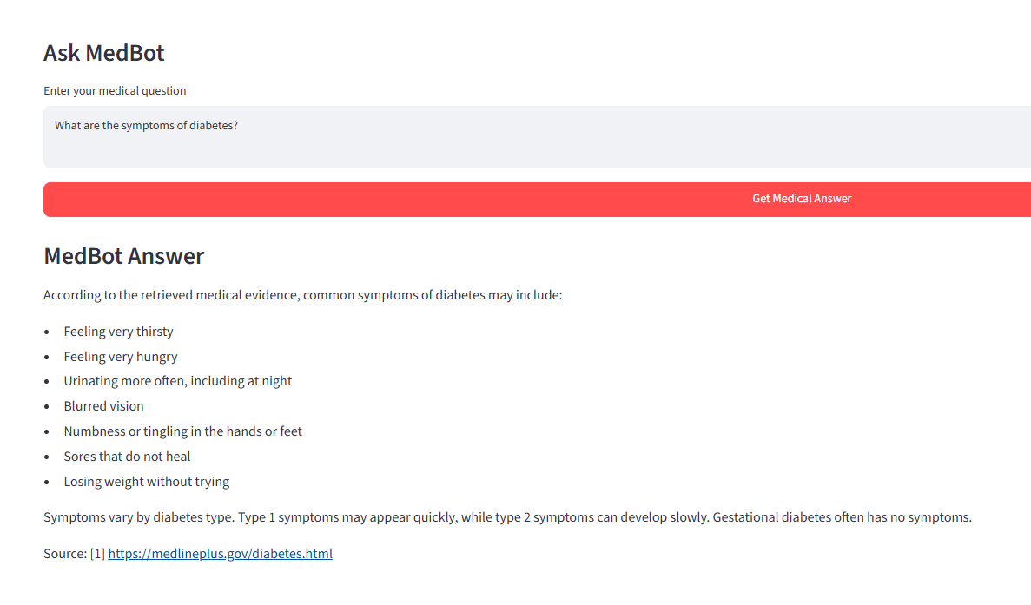
Figure 1. Diabetes symptoms answer with a MedlinePlus source citation.
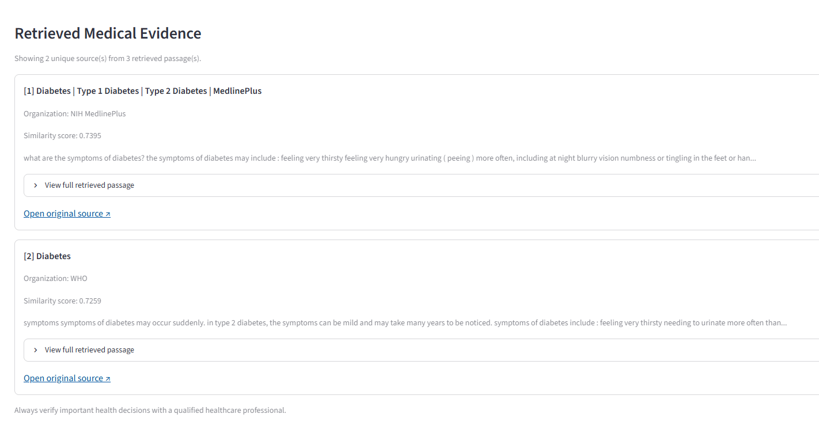
Figure 2. Retrieved evidence cards showing source names and similarity scores.
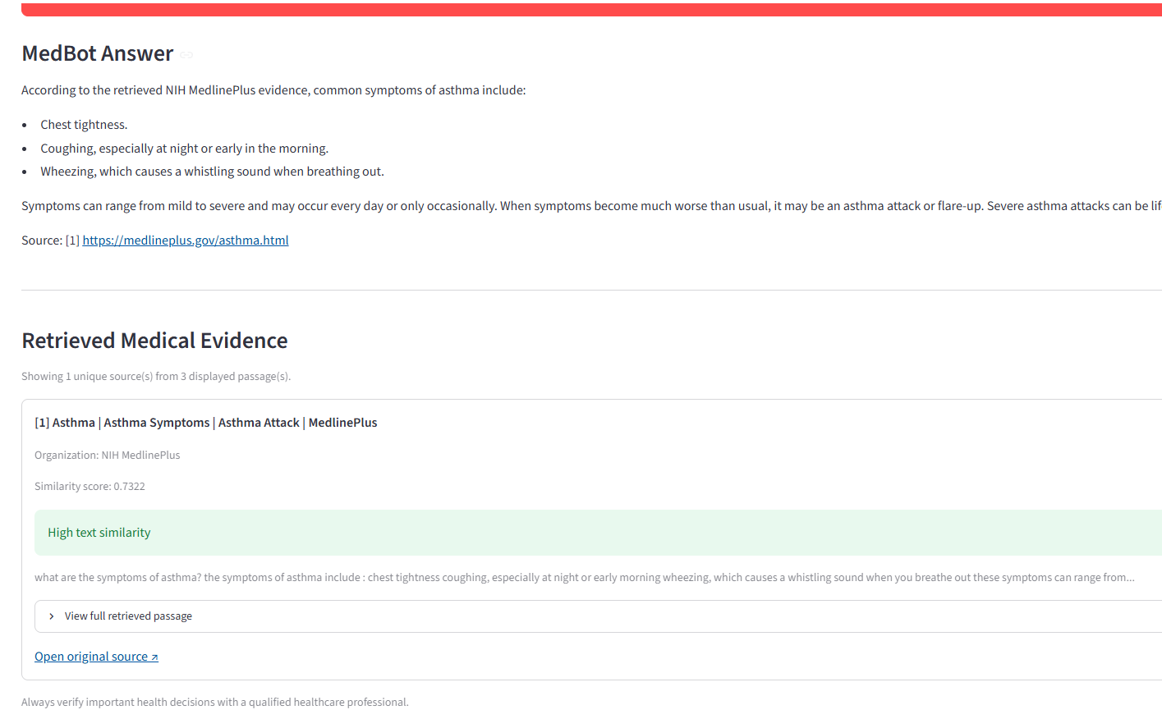
Figure 3. Asthma symptoms answer with a MedlinePlus source link and a high-similarity evidence card.
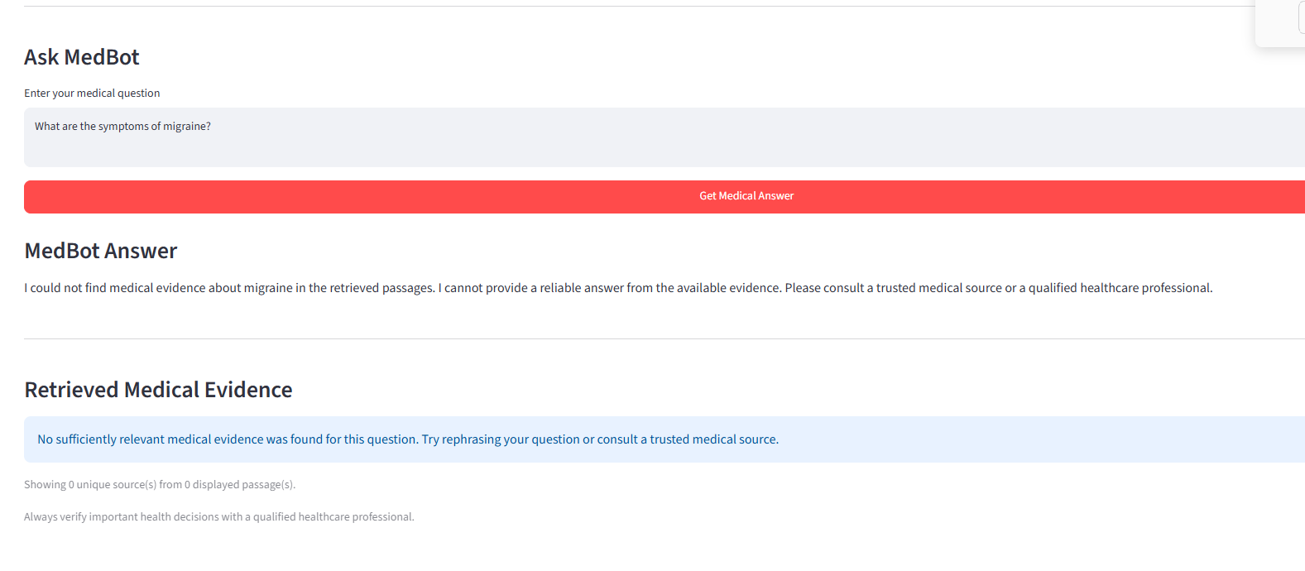
Figure 4. Unsupported question (migraine): the application refuses and displays no evidence.
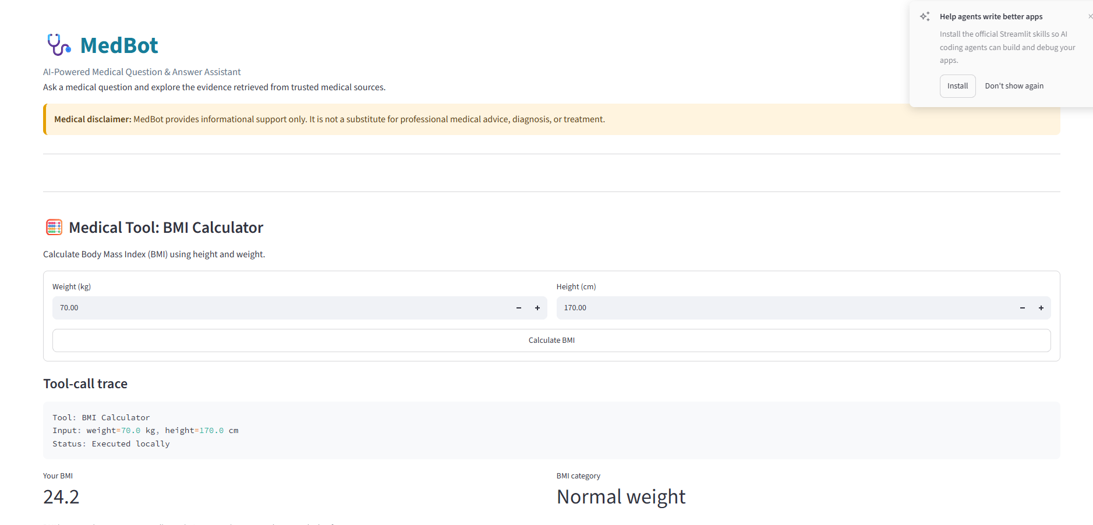
Figure 5. BMI tool with tool-call trace: 70 kg and 170 cm yields BMI 24.2, displayed as Normal weight.
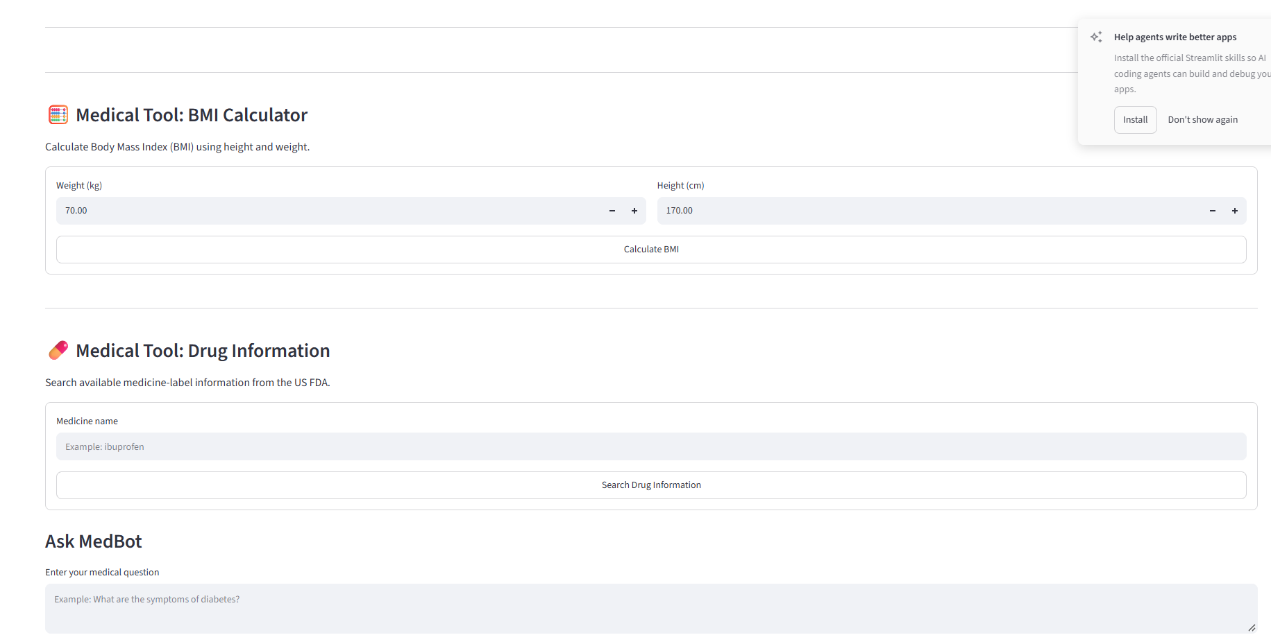
Figure 6. Medical tools section: BMI calculator and the FDA drug-information search form.

Appendix C — Project Files and How to Run
File / folder | Purpose
app.py | Streamlit application and user interface
medbot_rag_answer.py | Retrieval, history-aware rewriting and answer generation
preprocess_medquad.py | Prepares the MedQuAD JSONL files
train_medbot_full.py | QLoRA fine-tuning script
collect_medical_documents.py | Collects the selected public medical pages
build_medbot_vector_index.py | Chunks, embeds and builds the FAISS index
test_medbot_retrieval.py, test_medbot_rag_answers.py | Retrieval and answer-path tests
medbot_phase1_output/ | Cleaned, train and validation JSONL; summary
medbot_phase2_full/lora_adapter/ | Adapter weights and configuration
medbot_phase3_rag/ | Documents, processed chunks and vector_index (medical.index, metadata.json)

Run from the project root with the virtual environment active:
.venv\Scripts\Activate.ps1
python -m streamlit run app.py
Open the local URL printed by Streamlit (usually http://localhost:8501). History-aware query test:
python -c "from medbot_rag_answer import make_history_aware_query as f; h=[{'role':'user','content':'What are the symptoms of asthma?'}]; print(f('How can I prevent it?',h))"
Expected output: How can I prevent asthma?
Tested environment: Python 3.13.13, PyTorch 2.11.0+cu128, Transformers 5.20.1, PEFT 0.21.2, Accelerate 1.15.0, bitsandbytes 0.50.2, datasets 5.1.0, sentence-transformers 6.1.0, faiss-cpu 1.15.1. Installed versions may differ on other machines.

