AI Assisted Coding
Week2 – Wednesday

Name: Sathyendra Varma Pesaru
Batch: 07
Roll No.: 2303A51916

Lab 4: Advanced Prompt Engineering – Zero-shot, One-shot, and Fewshot Techniques
Lab Objectives
- To explore and apply different levels of prompt examples in AI-assisted code generation
- To understand how zero-shot, one-shot, and few-shot prompting affect AI output quality
- To evaluate the impact of context richness and example quantity on AI performance
- To build awareness of prompt strategy effectiveness for different problem types Week2 - Wednesday
Lab Outcomes (LOs)
After completing this lab, students will be able to:
- Use zero-shot prompting to instruct AI with minimal context • Use one-shot prompting with a single example to guide AI code generation
- Apply few-shot prompting using multiple examples to improve AI responses
- Compare AI outputs across different prompting strategies

Task 1: Zero Leap Year Check
Scenario
Zero-shot prompting involves giving instructions without providing examples. Task Description
Use zero-shot prompting to instruct an AI tool to generate a Python function that:
- Accepts a year as input
- Checks whether the given year is a leap year
- Returns an appropriate result
Note: No input-output examples should be provided in the prompt.
Expected Output
- AI-generated leap year checking function
- Correct logical conditions
- Sample input and output
- Screenshot of AI-generated response (if required)

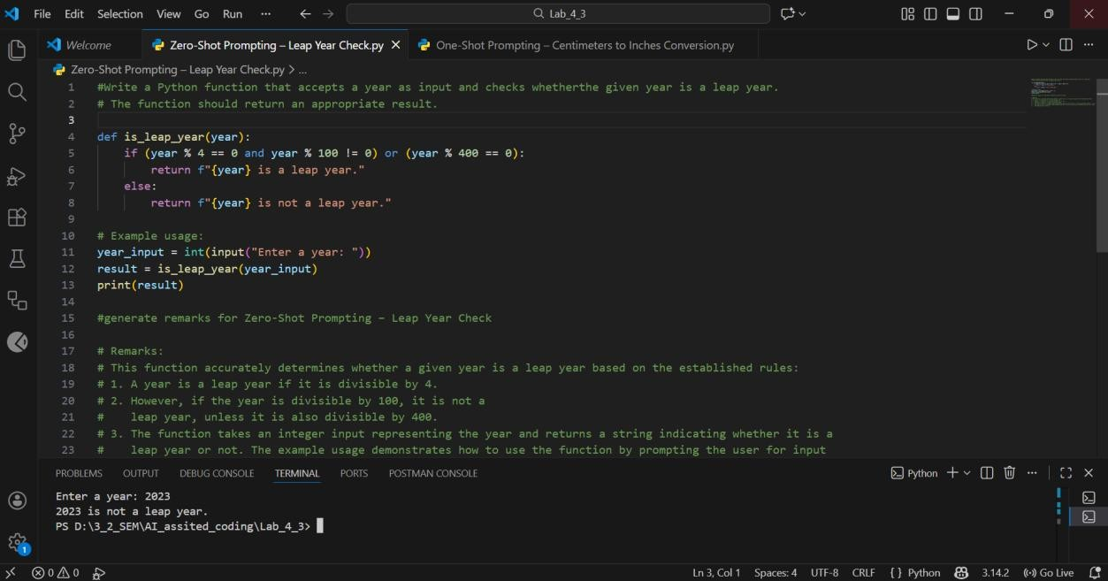

Task 2: One Centimeters to Inches Conversion
Scenario
One-shot prompting guides AI using a single example.
Task Description
Use one-shot prompting by providing one input-output example to generate a Python function that:
- Converts centimeters to inches • Uses the correct mathematical formula Example provided in prompt:
Input: 10 cm → Output: 3.94 inches
Expected Output
- Python function with correct conversion logic
- Accurate calculation
- Sample test cases and outputs

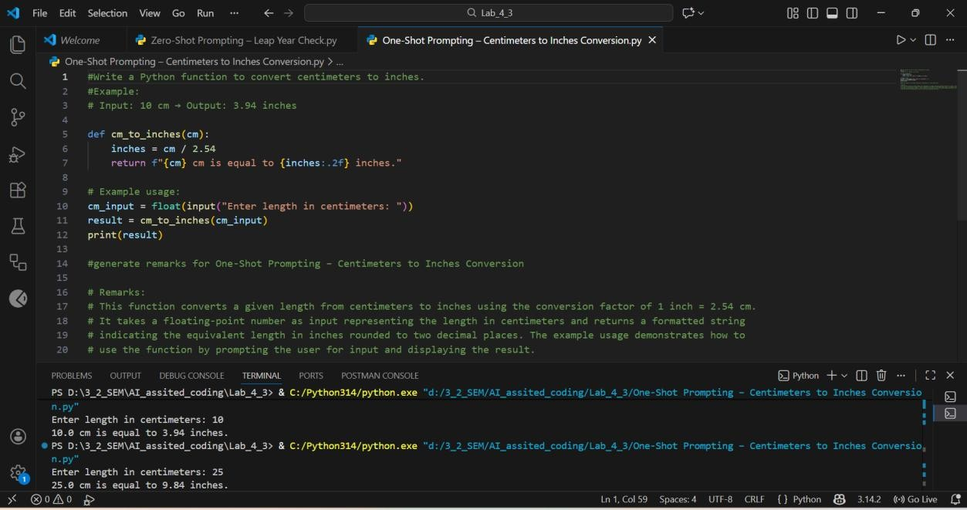

Task 3: Few Name Formatting
Scenario
Few-shot prompting improves accuracy by providing multiple examples.
Task Description
Use few-shot prompting with 2–3 examples to generate a Python function that:
- Accepts a full name as input
- Formats it as “Last, First” Example formats:
- "John Smith" → "Smith, John"
- "Anita Rao" → "Rao, Anita"
Expected Output
- Well-structured Python function
- Output strictly following example patterns
- Correct handling of names
- Sample inputs and outputs

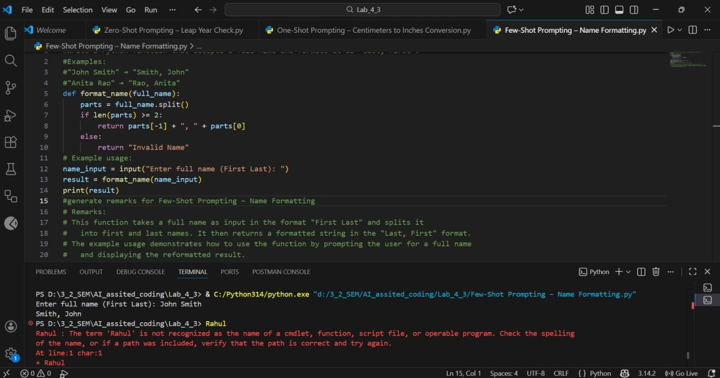

Task 4: Comparative Analysis – Zero-Shot vs Few-Shot
Scenario
Different prompt strategies may produce different code quality.
Task Description
- Use zero-shot prompting to generate a function that counts vowels in a string
- Use few-shot prompting for the same problem • Compare both outputs based on: o Accuracy o Readability o Logical clarity
Expected Output
- Two vowel-counting functions
- Comparison table or short reflection paragraph
- Conclusion on prompt effectiveness

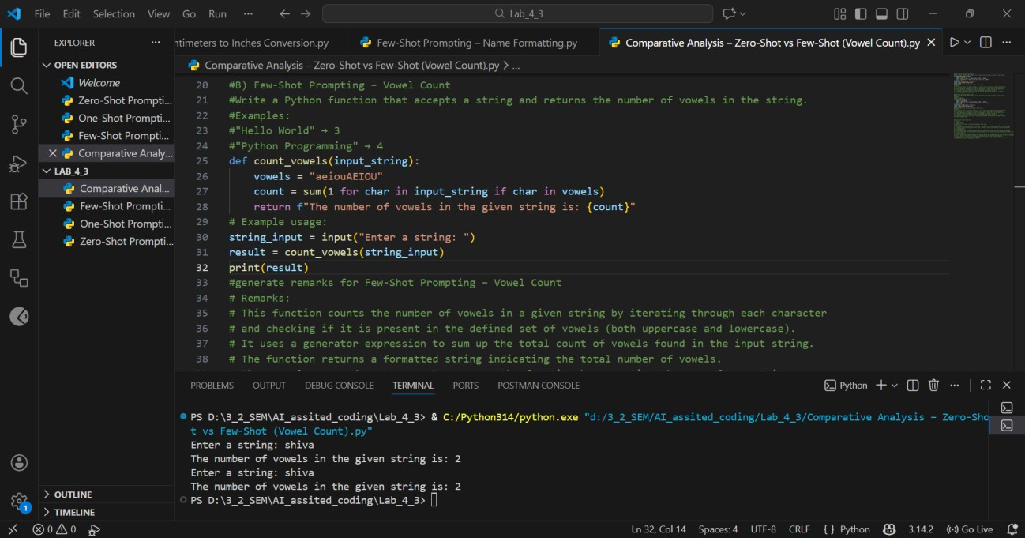

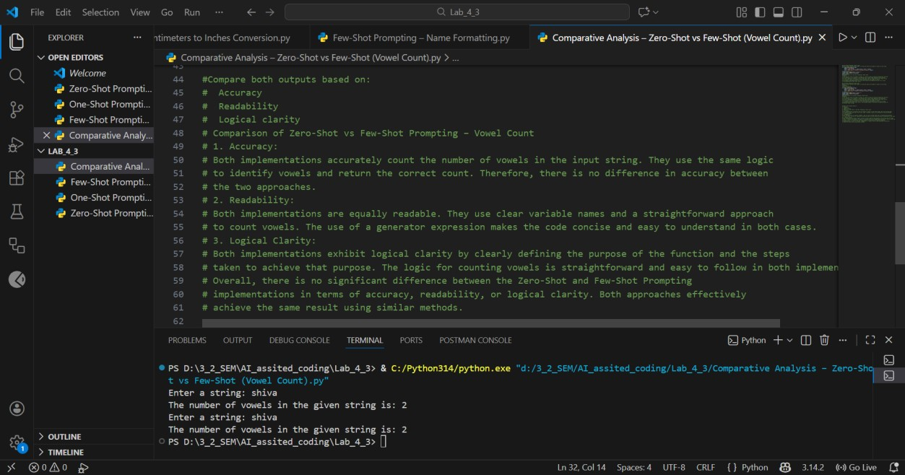

Task 5: Few-Shot Prompting – File Handling
Scenario
File processing requires clear logical understanding.
Task Description
Use few-shot prompting to generate a Python function that:
- Reads a .txt file
- Counts the number of lines in the file
- Returns the line count
Expected Output
- Working Python file-processing function
- Correct line count
- Sample .txt input and output
- AI-assisted logic explanation

