SmartPost: AI-Based Automated Social Media Content Generation and Publishing System

Team
Peter Abboud – 119894 - Fr
Toufik Dawaliby – 120279 - En

Brief Description
SmartPost is a full-stack web application that enables users to connect their social media accounts (e.g., X, Instagram, Telegram) and automate content generation using Artificial Intelligence.
The system allows users to:
- Generate AI-based posts after analyzing trending discussions on a specific topic.
- Automatically schedule recurring AI-generated posts.
- Review, edit, approve, or delete posts before publication.
- Manage connected social media accounts.
- View full posting history.
The application combines AI-powered content generation, scraping-based research, scheduling automation, and multi-platform publishing into a unified dashboard.

Core Features
A) User Management
- User registration & login (JWT-based authentication)
- Secure password hashing (bcrypt)
- Role system (Users with different privileges)
- Profile management

B) Social Media Account Integration
- OAuth 2.0 login for the social media platforms
- Store encrypted access tokens
- Allow multi-platform posting
- Revoke/disconnect accounts

C) AI Research-Based Post Generation
Workflow:
- User enters a theme
- AI scrapes public discussions on connected platforms
- AI generates:
  - Analytical report
  - Suggested response post
  - Optional image/video generation
- User reviews and approves before publishing
Media Types:
- Text
- Image (AI-generated)
- Short video (AI-generated)

D) Scheduled Auto-Posting
- User defines:
  - Topic
  - Interval (e.g., every 24 hours)
  - Target platforms
- AI generates content periodically
- Automatic publishing
- Logs every execution
- Sends email to user if an error occurs

E) Post Management Dashboard
- View post history
- Filter by:
  - Platform
  - Date
  - Status (draft / scheduled / posted)
- Edit post before publishing
- Delete post
- View AI-generated research report

Technology Stack
Frontend
- React.js
- Axios
- CSS / TailwindCSS
- React Router

Backend
- Node.js
- Express.js
- JWT Authentication
- OAuth 2.0 integration
- Cron jobs for scheduling
- Python

Database
- MySQL
- Prisma ORM

AI & External Services
- Text Generation
- OpenAI API (GPT models)
- Image Generation
- DALL·E API / Stable Diffusion API
- Video Generation
- RunwayML API or similar AI video APIs
- Web Scraping / Research
- Puppeteer
- Cheerio
- Official APIs when possible
- Task Scheduling
- node-cron
- BullMQ (Redis-based queue for scalability)

System Architecture Overview
User
↓
React Frontend
↓
Express API (Node.js)
↓
Service Layer
├── AI Service
├── Social Media Service
├── Scheduler Service
└── Research Scraper
↓
Prisma ORM
↓
MySQL Database

Database Design (Main Entities)
User
- id
- email
- password (hashed)
- role
- createdAt

SocialAccount
- id
- userId
- platformId
- accessToken (encrypted)
- refreshToken (encrypted)
- expiresAt

Platform
- id
- platformName
- apiBaseUrl
- isActive

Post
- id
- socialAccountId
- content
- mediaUrl
- type (text/image/video)
- status (draft/scheduled/posted)
- extrenalPostId
- deleted (bool)
- scheduledAt
- createdAt

ResearchReport
- id
- postId
- topic
- generatedReport
- createdAt

ScheduledTask
- id
- topic
- intervalHours
- nextExecution
- isActive
- socialAccountId
- createdAt
- updatedAt

UML Diagrams

A) Use Case Diagram
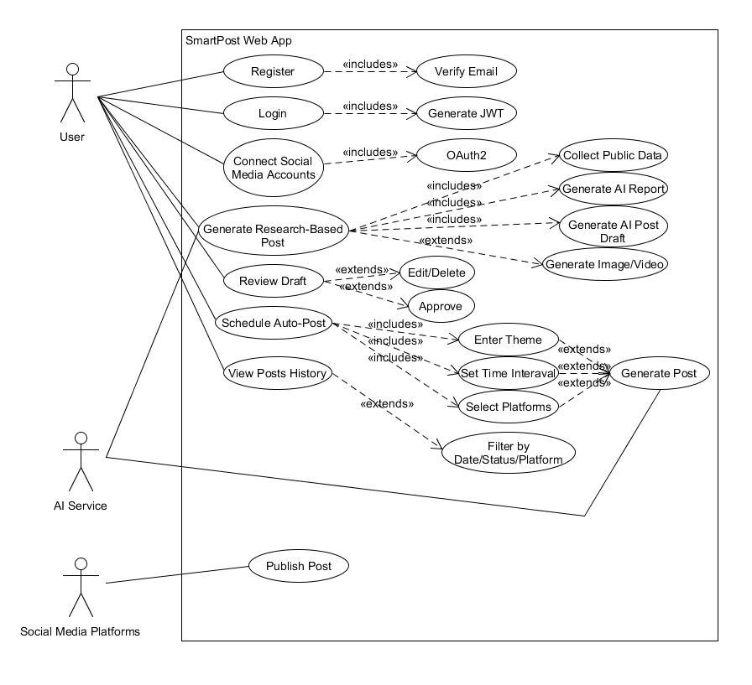

B) Class Diagram
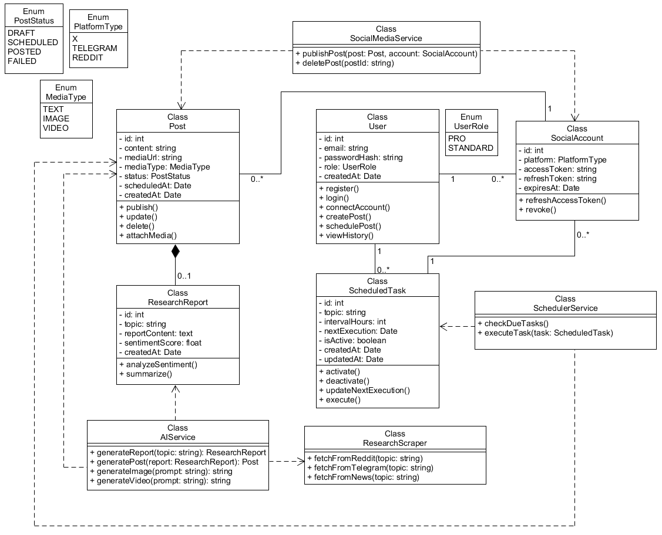

C) Sequence Diagram
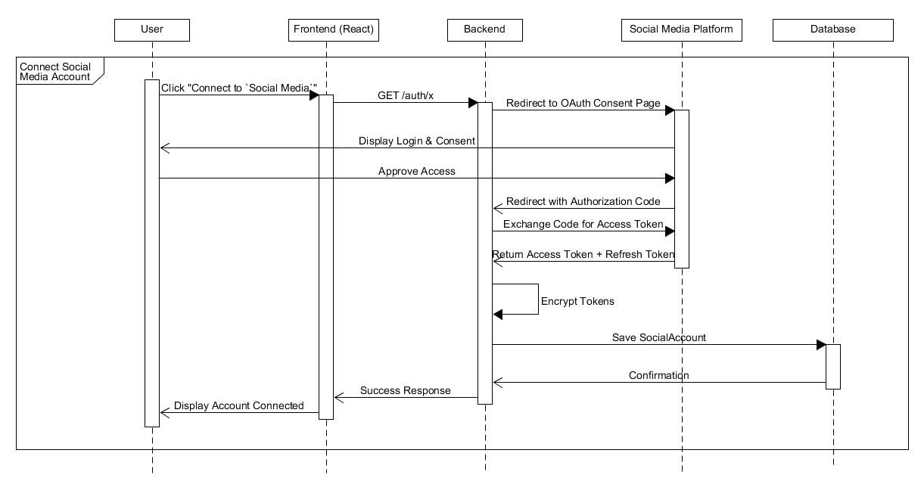

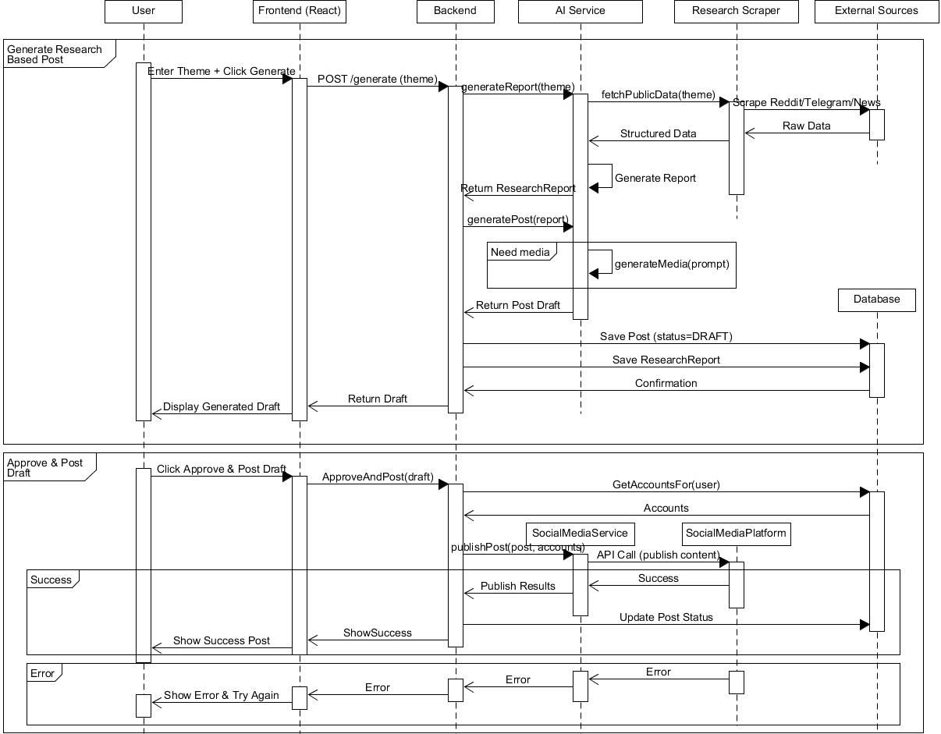

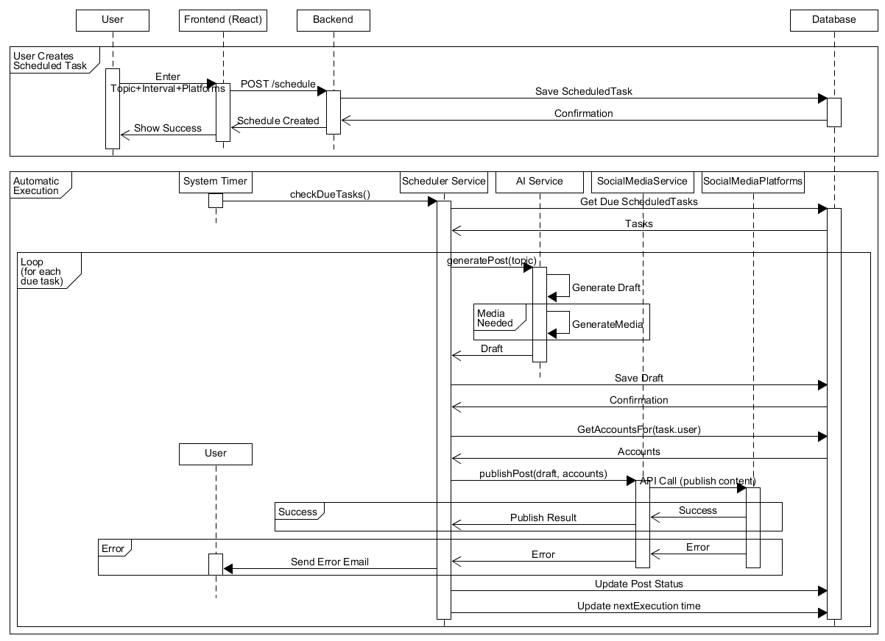

D) Flowchart

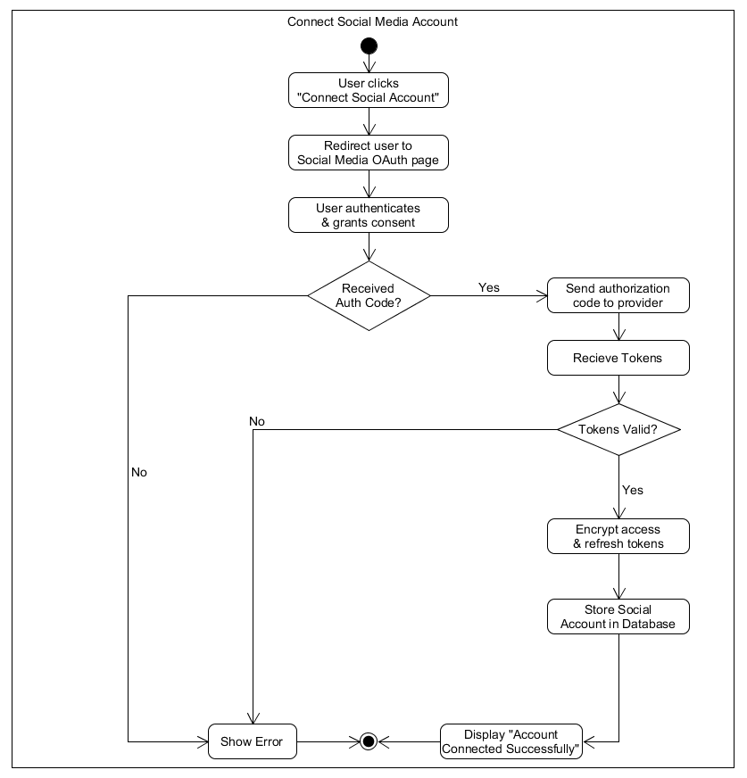

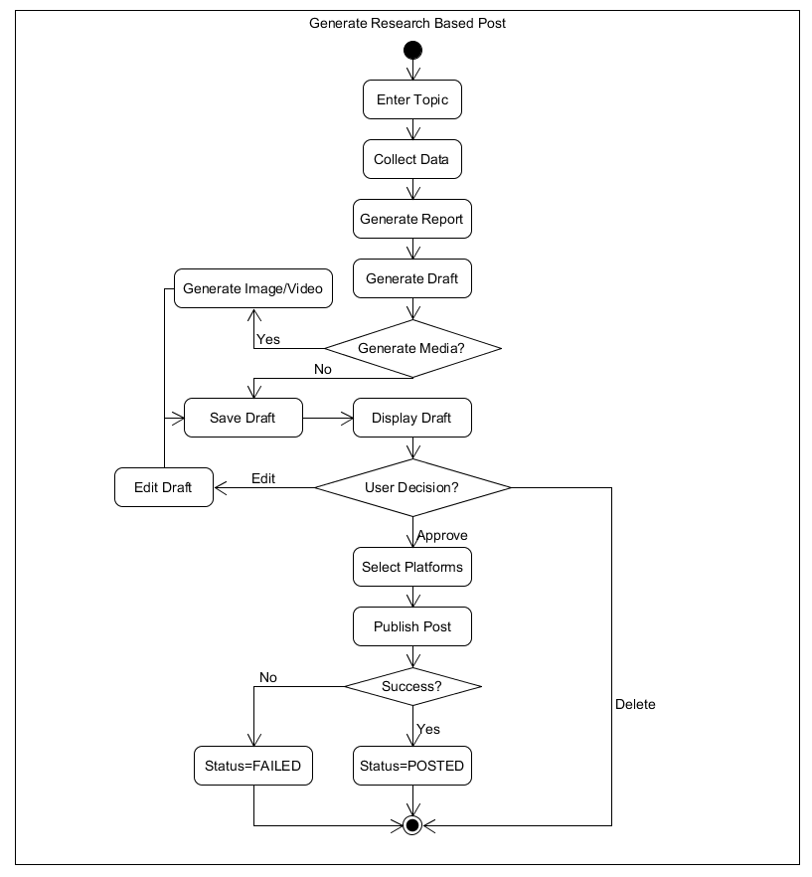

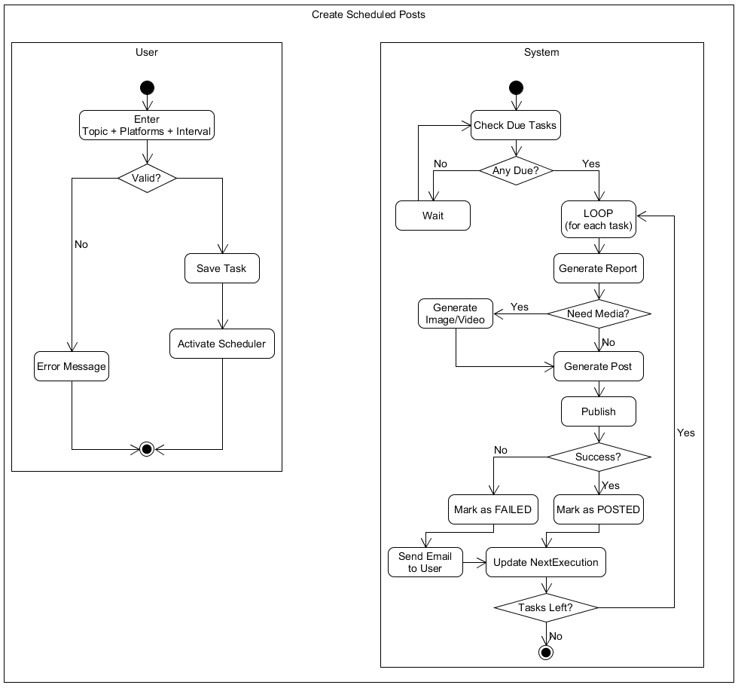

Security Considerations
- Encrypt OAuth tokens (AES-256)
- Use HTTPS only
- Rate limiting
- Role-based access control
- Validate AI-generated content before posting
- Avoid illegal scraping (use official APIs where possible)

Challenges & Risks
- Social media API rate limits
- Platform restrictions (Instagram is strict)
- AI cost management
- Content moderation risks
- Ethical concerns (misinformation automation)

Future Improvements
- Analytics dashboard (engagement tracking)
- Multi-language support
- AI tone customization (formal, aggressive, neutral)
- Smart trending detection

