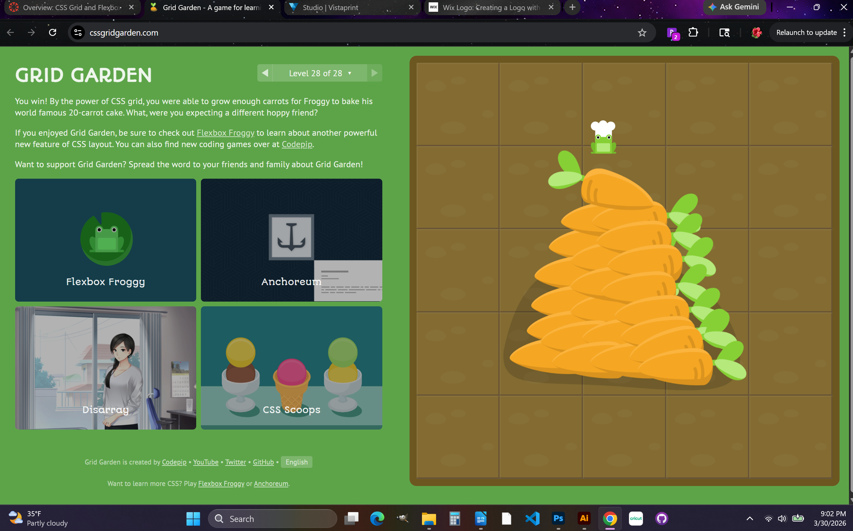

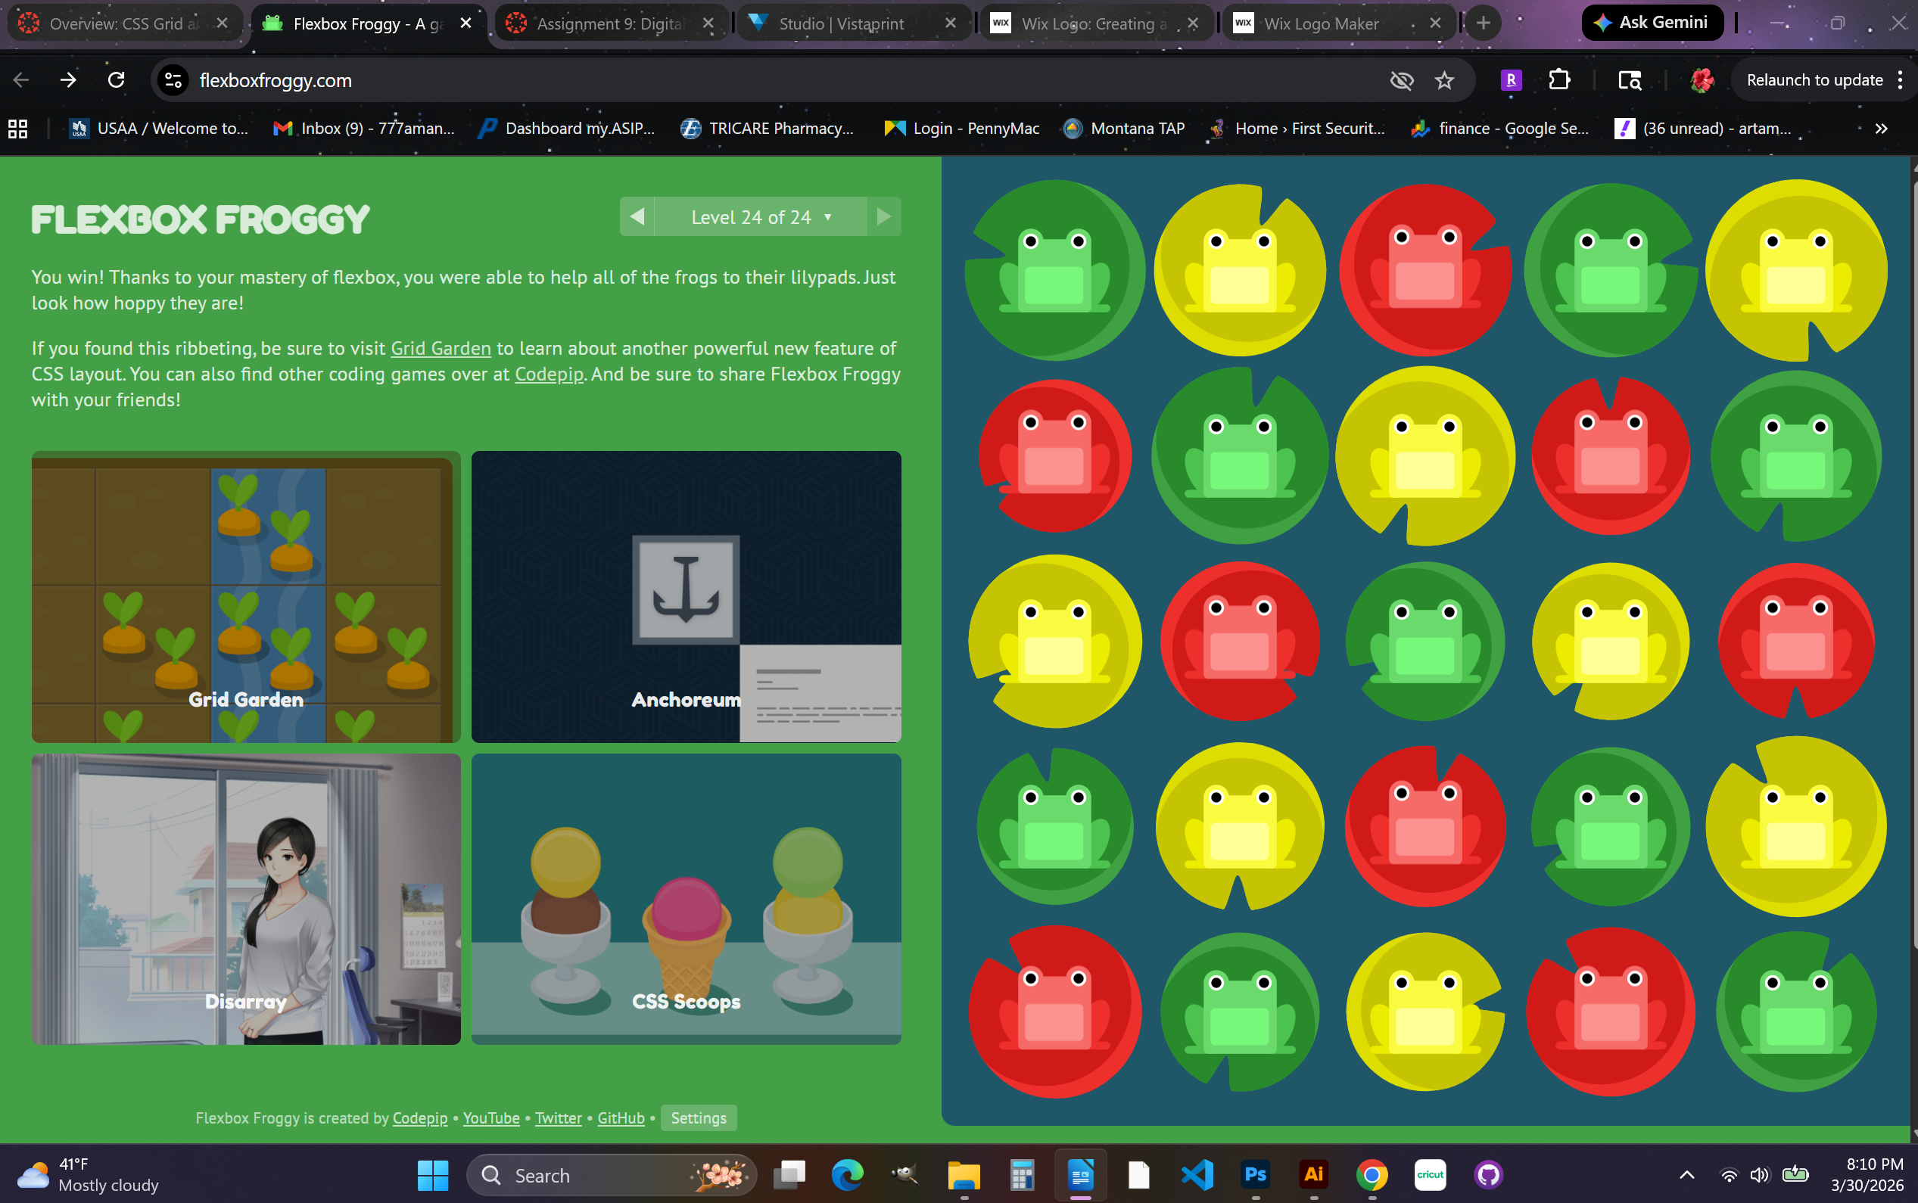
This week has been good and busy. I liked this assignment because it was like a brain workout and I was seeing the differences in the code immediately. I was catching on. I am getting more comfortable with the CSS Flexbox and CSS Grid.

