My website was about my favorite book. The site was supposed to share with viewers the feeling and atmosphere the book provides. I chose colors that represented the antagonists to the story. In this particular story the antagonists, was a book belonging to Professor Snape, Malfoy and Professor Snape. All belonging to Slytherin House. The house colors for Slytherin are green and gray. This lead me to choose green as my background. I didn’t want to go completely bright green or hunter green because that can be very bright and hard to read from. I chose a lighter green with a teal hint.

For text, I tried to go with fonts that were easy to read. I added a bit of flare to the title of the book on the home page but other than that I keep the fonts simple. I wanted colors for the text to stand out so I went with black for most things but an off-white/light green for text to headers. This slight variation I think added depth and interest.

For the Hero video, I picked something simple and mysterious. Just like the book. The green really pops. I did get feedback to change my background and header colors to a greener green to match the video. I tried some darker greens but it seemed to wash everything together. I did change my background to be a bit darker and it matches the green outline on the emblem in the video. The contrast in the green colors, helps keep the site visually interesting.

For the images, I picked images that went with wizards and witchcraft. Candles, quills, potions and books. I also found a broom. They are in a cartoon style but I thought that was fun and goes along with the youthful age range of the books. If I was making the site with adults in mind I may have gone with different images. Maybe something more realistic.

After reading feedback from peers, I made changes to the spacing of the quote. Which I did think needed it. I was having a bit of trouble with layout and getting the coding just right. After many attempts I did get the wording to shift to the center. I was so excited it centered I didn’t think to add padding at the bottom of the text. So, later I added padding to the bottom and now there is space between the quote and the title header. It looks much better. I have learned to slow down and double check. I also learned to set real expectations around my skill set. I should embrace what I am able to do and attempt to learn more but keep it realistic.

Spacing and size seemed to be areas I always second guessed myself about. I wanted enough space so it didn’t look crowded, but not too much space because I don’t want my viewers scrolling forever. For this, I think it is a good idea to take a small break and look at the site with fresh eyes.

I have also become a pro at control+s and refresh on the website. Save, Save, Save. Checking work, as I work, has kept me from losing my place. I also know the changes I have made worked right away.

Good feed back about adding “#” in front of color numbers and “px” after font sizes. I went back through and updated all my code.

I also think big changes can be scary at first, like changing colors. I changed colors for one header and liked it, so I had to go through and make all the others match. It was a bit of work but it was also well worth it. I will make these sort of changes earlier and not be so afraid of extra work.

I enjoyed using my site. I may try something different with the navigation bar but otherwise I’m happy. More space around elements makes me happy. I might also try a different font. I’ll never know if I like it, if I don’t try it.

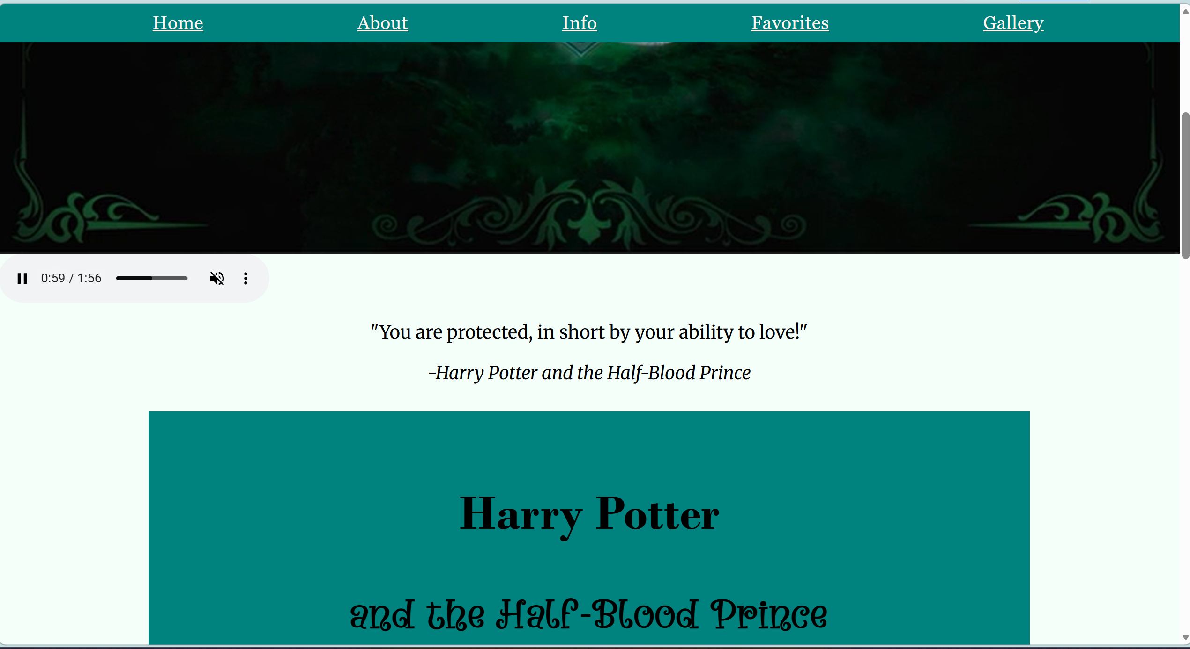
Home Page – Like the spacing around the quote and cite.
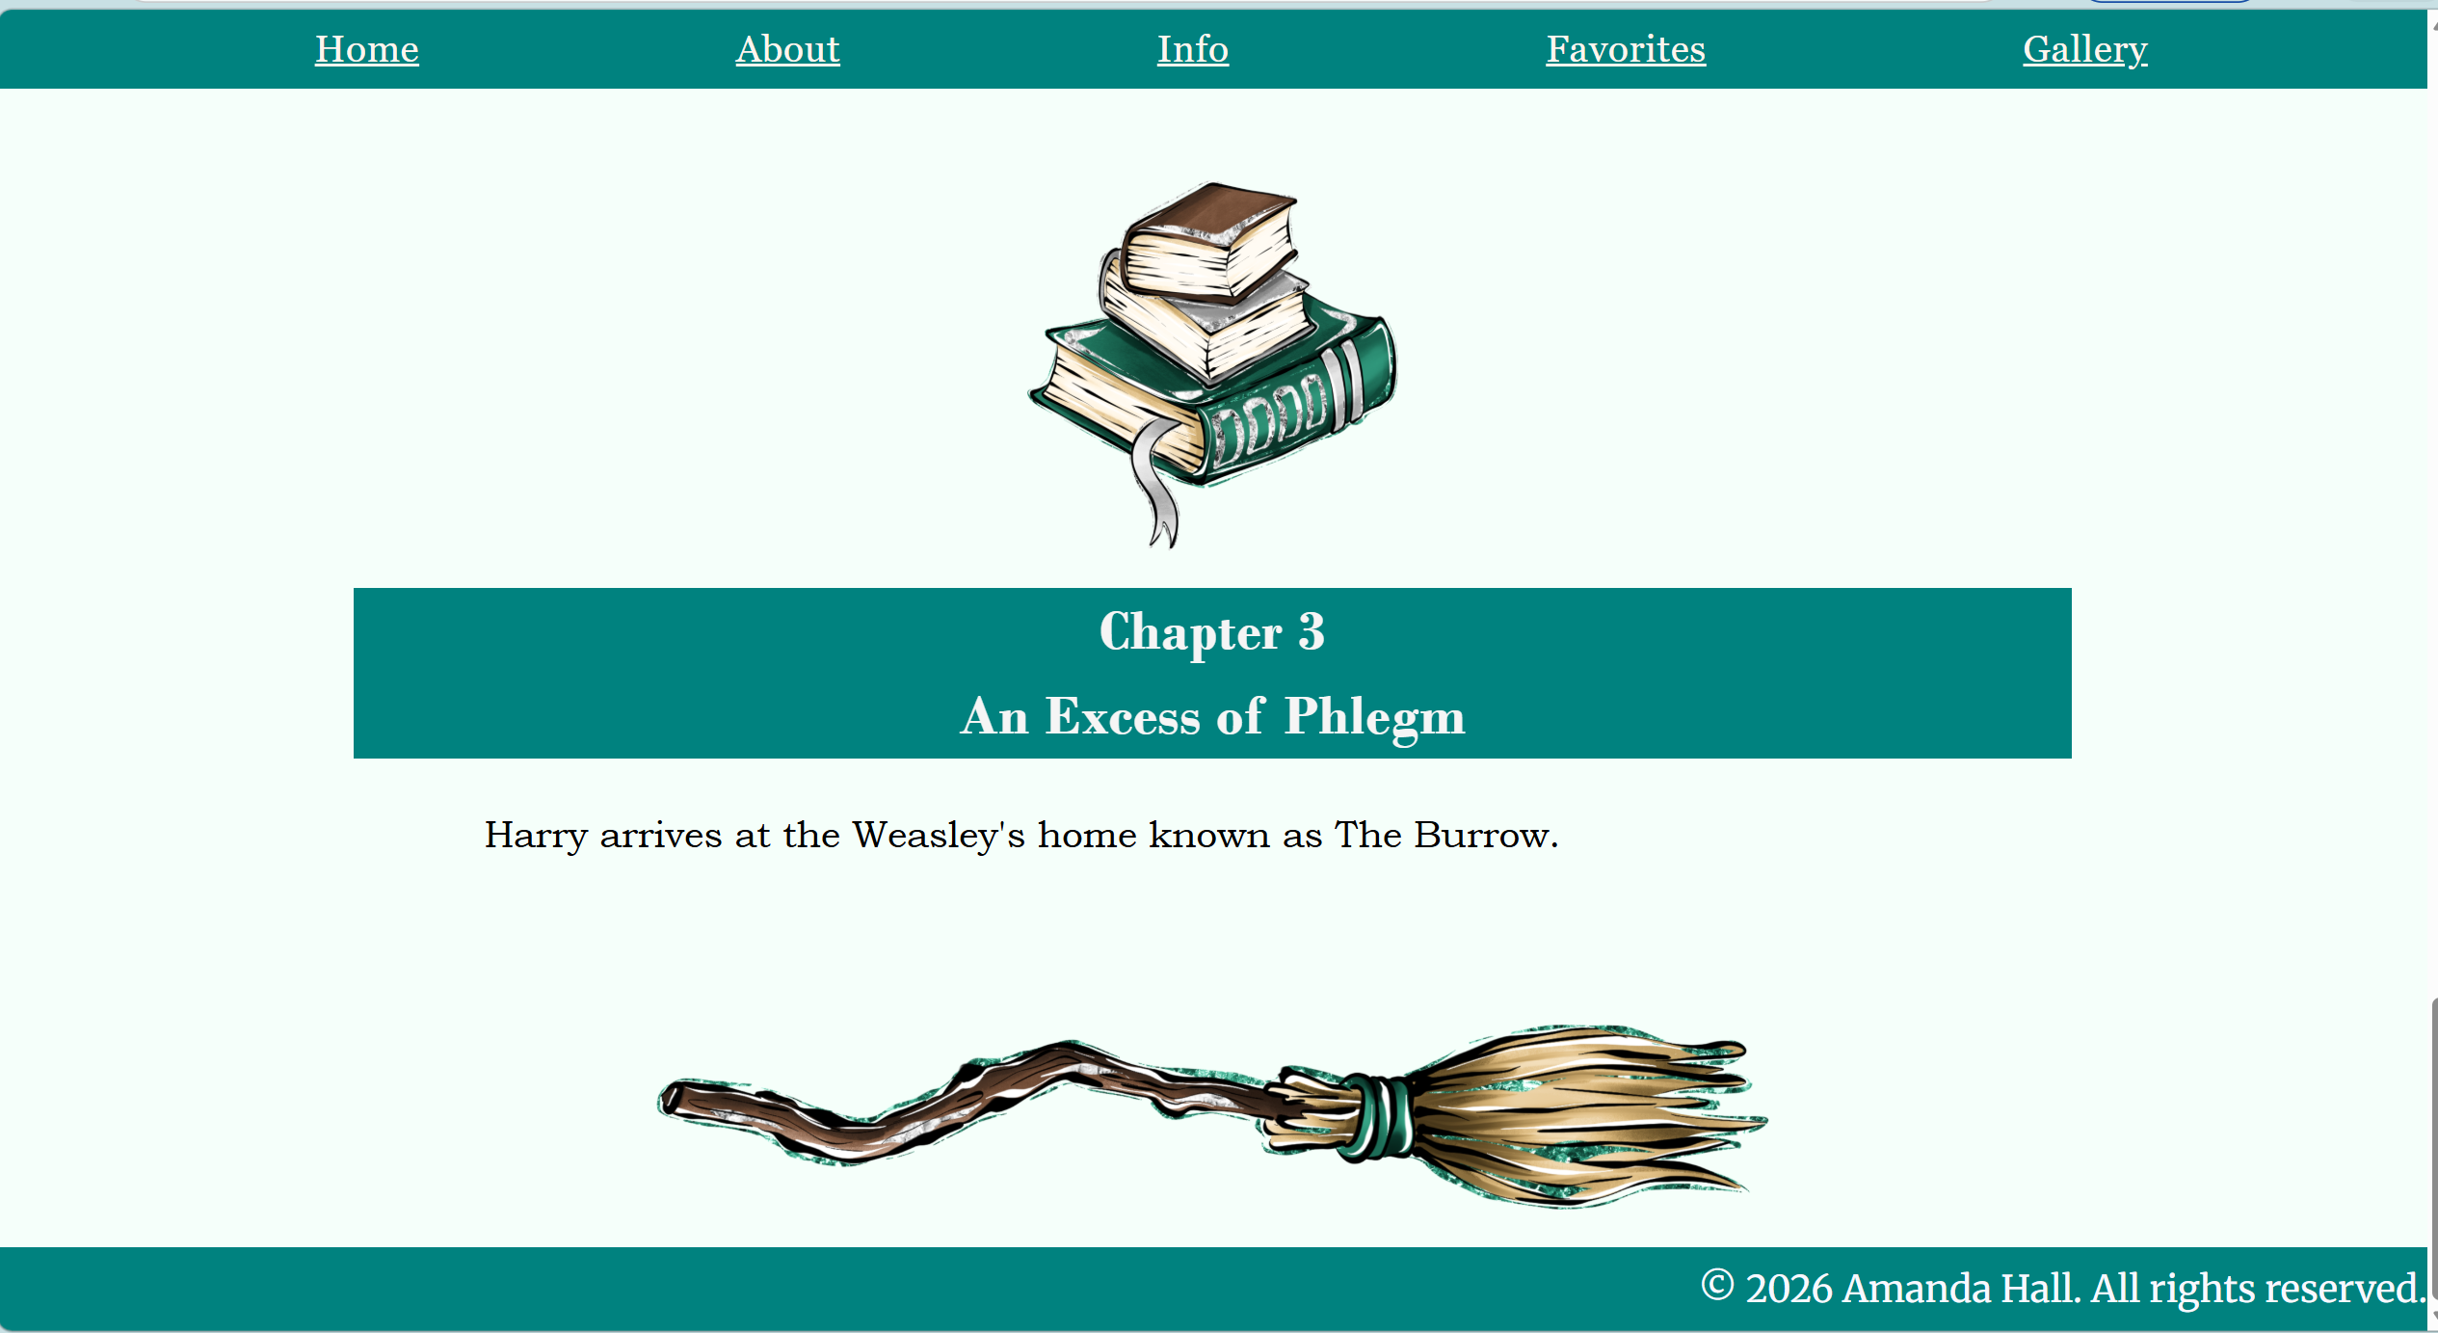
I added the broom image to the bottom of the page to give it an ending instead of blank space.
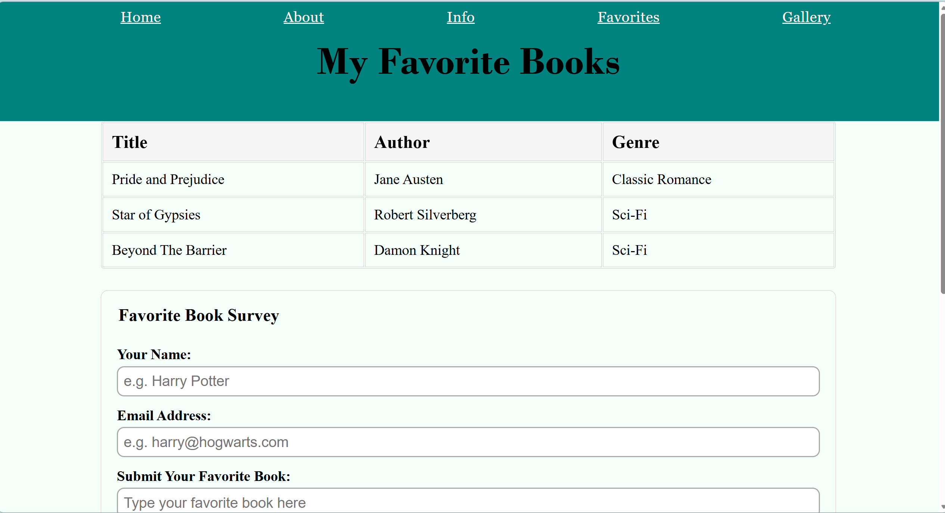
I really enjoyed learning the tables and fill in boxes. Even the drop down box was fun. I like how clean a crisp it looks.

