SPI interface using MPSoC SPI controller

References
https://www.kernel.org/doc/Documentation/devicetree/bindings/spi/
http://www.wiki.xilinx.com/SPI+Zynq+driver
https://www.kernel.org/doc/html/v4.9/driver-api/spi.html
http://elixir.free-electrons.com/linux/latest/source/Documentation/spi/spi-summary

SPI I/O settings
- In order to use SPI in ZCU102, we need to export SPI interface into FPGA pinout, by set the interface to EMIO.
- SPI EMIO have several pins with different functionality, we will use the relevant pins according to our SPI mode (Master or Slave):

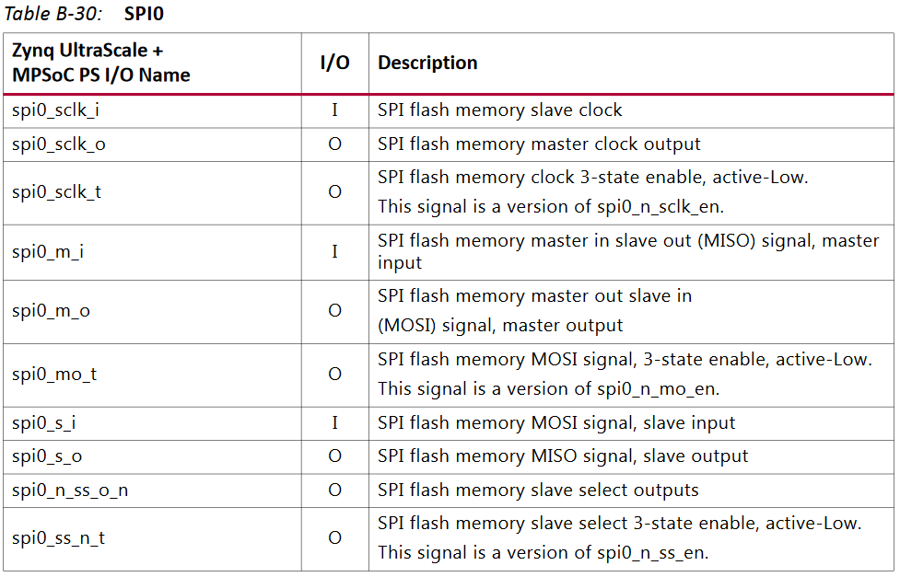

- In this example we will use the SPI as Master, our pinout connection based on:
https://www.xilinx.com/support/documentation/user_guides/ug585-Zynq-7000-TRM.pdf
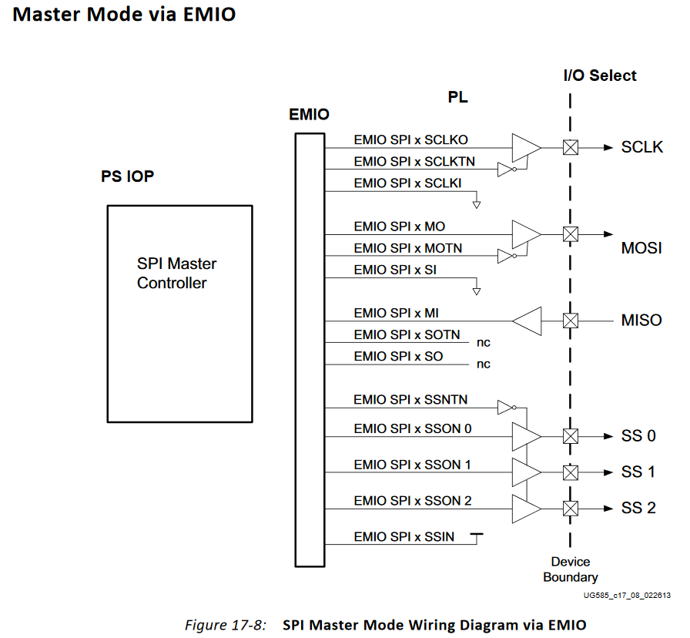
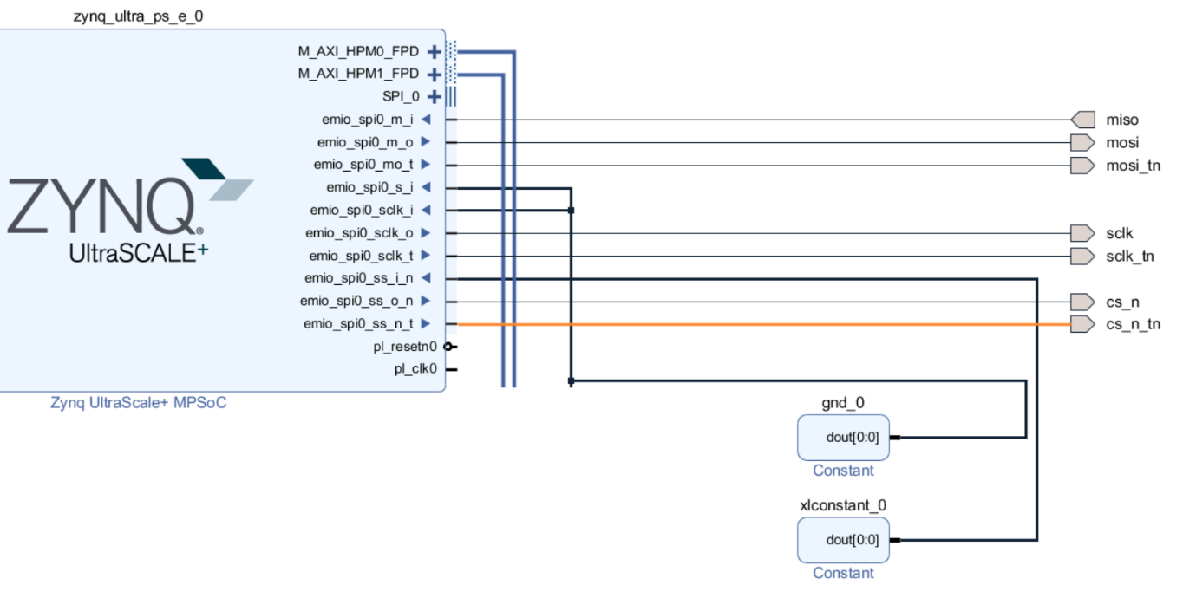
- Export the SPI interface to J55 of ZCU102 EVB:
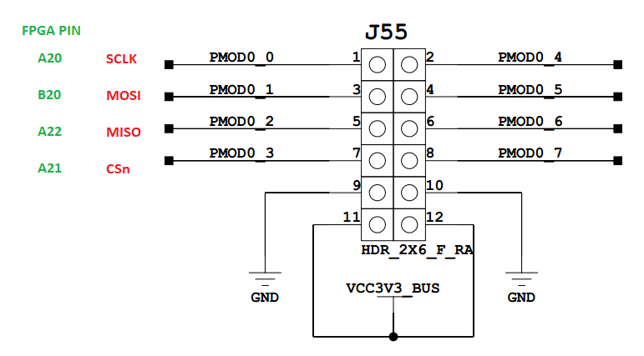

Add SPI support in Linux kernel
  - Run kernel configuration
cd ~/workspace/peta-builds/bsp/xilinx-zcu102-2017.2
petalinux-config -c kernel

  - In the menu go to: “Device Drivers--->”

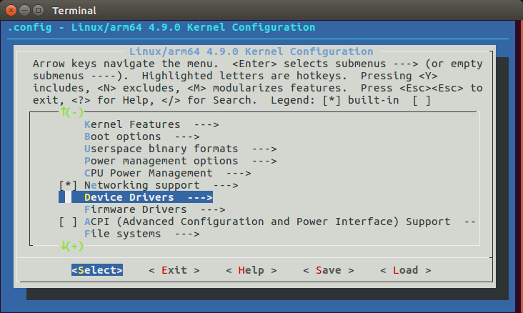

  - In the “Device Drivers” menu scroll down to the "SPI support --->".
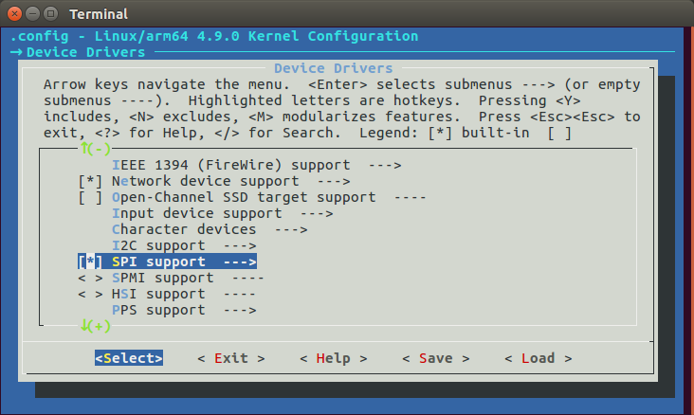

  - Make sure that the follow settings are set:

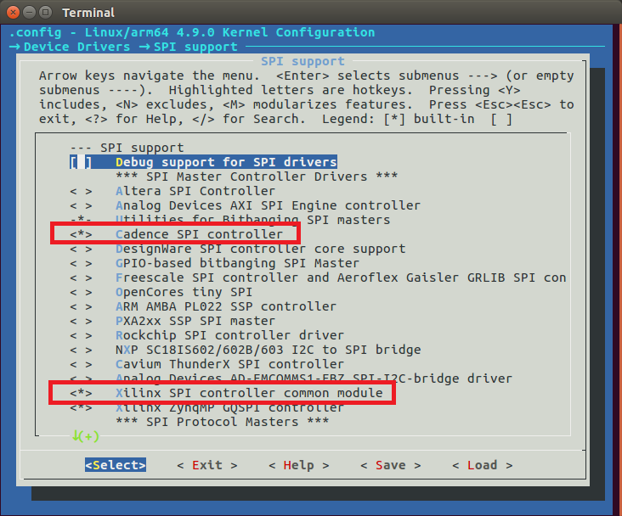

  - Important Note!!!
  - In order to see SPI device in /dev/ set “User mode SPI device driver support” !

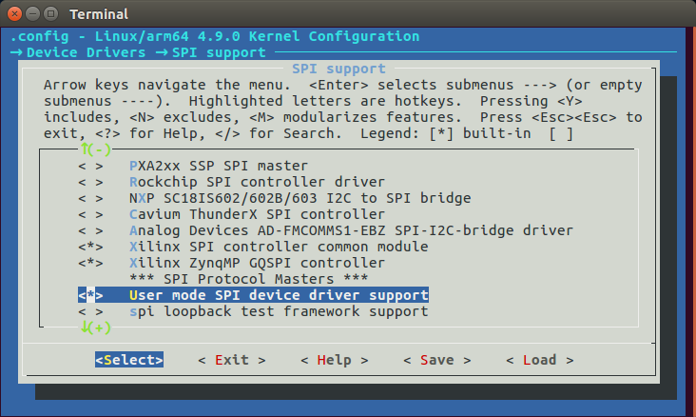

  - Exit the kernel “menuconfig” and save the configuration.

Verify SPI address in device-tree
  - In this example we use PS-SPI0
Before changing system-user.dtsi device tree, view the settings in plnx_aarch64-system.dts, under amba section

Important Note, this is the SPI order!
  - PS-QSPI mapped to SPI0
  - PS-SPI0 mapped to SPI1
  - PS-SPI1 mapped to SPI2

  - Addresses of plnx_aarch64-system.dts & system-user.dsti must be identical.
although system-user.dsti override settings of plnx_aarch64-system.dts after complication
  - Note: In order to view plnx_aarch64-system.dts, you need to compile the whole project.

  - For example, our device tree generation (.dts) is :
~/workspace/peta-builds/bsp/xilinx-zcu102-2017.2/components/plnx_workspace/device-tree-generation/plnx_aarch64-system.dts
amba {
spi@ff040000 {
compatible = "cdns,spi-r1p6";
status = "okay";
interrupt-parent = <0x4>;
interrupts = <0x0 0x13 0x4>;
reg = <0x0 0xff040000 0x0 0x1000>;
clock-names = "ref_clk", "pclk";
#address-cells = <0x1>;
#size-cells = <0x0>;
power-domains = <0x27>;
clocks = <0x3 0x3a 0x3 0x1f>;
is-decoded-cs = <0x0>;
num-cs = <0x1>;
};
spi@ff050000 {
compatible = "cdns,spi-r1p6";
status = "okay";
interrupt-parent = <0x4>;
interrupts = <0x0 0x14 0x4>;
reg = <0x0 0xff050000 0x0 0x1000>;
clock-names = "ref_clk", "pclk";
#address-cells = <0x1>;
#size-cells = <0x0>;
power-domains = <0x28>;
clocks = <0x3 0x3b 0x3 0x1f>;
};
};

aliases {
ethernet0 = "/amba/ethernet@ff0e0000";
serial0 = "/amba/serial@ff000000";
serial1 = "/amba/serial@ff010000";
spi0 = "/amba/spi@ff0f0000";
spi1 = "/amba/spi@ff040000";
spi2 = "/amba/spi@ff050000";
};

Update SPI settings in system-user.dtsi
  - Edit system-user.dtsi
nano ~/workspace/peta-builds/bsp/xilinx-zcu102-2017.2/project-spec/meta-user/recipes-bsp/device-tree/files/system-user.dtsi

  - Add SPI sub-Node

Important Note!
In order to avoid spidev.c patch, use the follow compatible device:
compatible = "rohm,dh2228fv";

/include/ "system-conf.dtsi"
/ {
amba {
spi@ff040000 {
slave0@0 {
compatible = "rohm,dh2228fv";
spi-max-frequency = <100000>;
reg = <0>;
};
};
};
};

Verify SPI settings
- Run the system console and type
Find . -name “*spi*”
PS-QSPI is mapped to SPI 0,
PS-SPI0 is mapped to SPI 1,
PS-SPI1 is mapped to SPI 2 (in our case we don’t use it)
root@xilinx-zcu102-2017_2:/# find . -name "*spi*"

./sys/class/spi_master
./sys/class/spi_master/spi0
./sys/class/spi_master/spi1
./sys/firmware/devicetree/base/power-domains/pd-spi1
./sys/firmware/devicetree/base/power-domains/pd-qspi
./sys/firmware/devicetree/base/power-domains/pd-spi0
./sys/firmware/devicetree/base/amba/spi@ff040000
./sys/firmware/devicetree/base/amba/spi@ff040000/spidev@0x00
./sys/firmware/devicetree/base/amba/spi@ff040000/spidev@0x00/spi-max-frequency
./sys/firmware/devicetree/base/amba/spi@ff0f0000
./sys/firmware/devicetree/base/amba/spi@ff0f0000/flash@0/spi-rx-bus-width
./sys/firmware/devicetree/base/amba/spi@ff0f0000/flash@0/spi-tx-bus-width
./sys/firmware/devicetree/base/amba/spi@ff0f0000/flash@0/spi-max-frequency
./sys/firmware/devicetree/base/amba/spi@ff050000
./sys/firmware/devicetree/base/aliases/spi0
./sys/firmware/devicetree/base/aliases/spi1
./sys/bus/platform/devices/ff0f0000.spi
./sys/bus/platform/devices/ff040000.spi
./sys/bus/platform/drivers/zynqmp-qspi
./sys/bus/platform/drivers/zynqmp-qspi/ff0f0000.spi
./sys/bus/platform/drivers/cdns-spi
./sys/bus/platform/drivers/cdns-spi/ff040000.spi
./sys/bus/platform/drivers/xilinx_spi
./sys/bus/spi
./sys/bus/spi/devices/spi0.0
./sys/bus/spi/devices/spi1.0
./sys/bus/spi/drivers/wl1271_spi
./sys/bus/spi/drivers/m25p80/spi0.0
./proc/irq/35/ff0f0000.spi
./proc/irq/39/ff040000.spi
./dev/spidev1.0

