Create UIO Driver with IRQ

Vivado IRQ pin and Interrupt ID
  - For example, Our UIO module connect to pl_ps_irq0[0]:
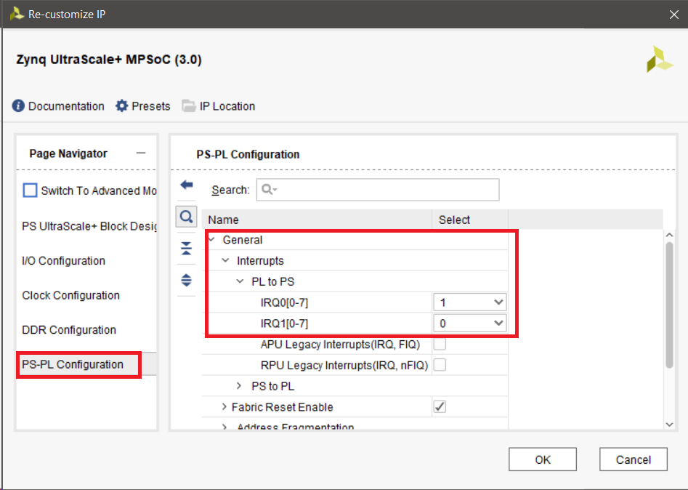

MPSoC Xilinx Pin mapping to Interrupt ID:
(Ref:https://www.xilinx.com/support/documentation/ip_documentation/zynq_ultra_ps_e/v3_0/pg201-zynq-ultrascale-plus-processing-system.pdf)

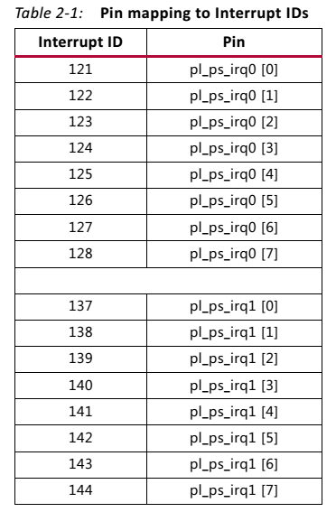

  - In our example case pl_ps_irq0[0] mapped to Interrupt ID is 121

UIO support in Linux kernel
  - Run kernel configuration
cd ~/workspace/peta-builds/bsp/xilinx-zcu102-2017.2
petalinux-config -c kernel

  - In the menu go to: “Device Drivers--->”
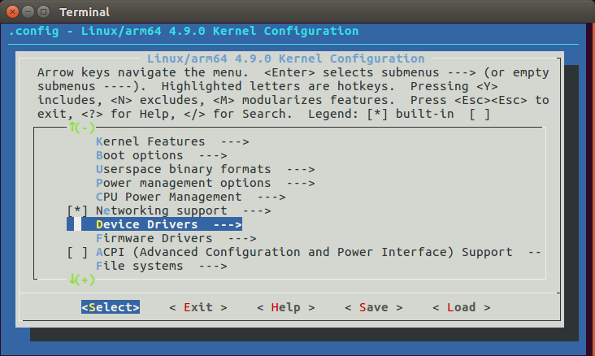

  - In the “Device Drivers” menu scroll down to the "Userspace I/O drivers --->".
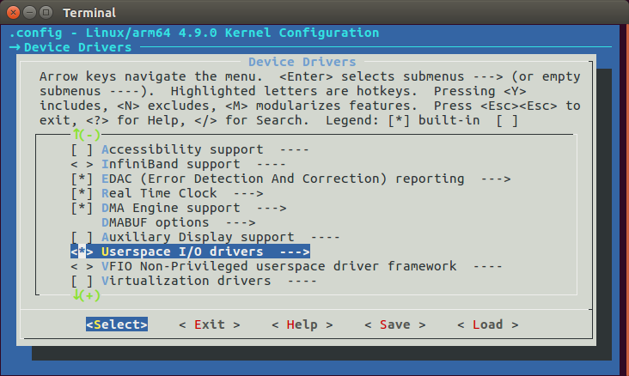

  - The kernel is configured to support loadable modules by default, for those loadable device drivers, we can select it as built-it or module. "<*>" means built-in and "<M>" means module.

  - If a driver is selected as a module, it will not be loaded when booting Linux. We can load it after Linux boots by using the modprobe command (see below).

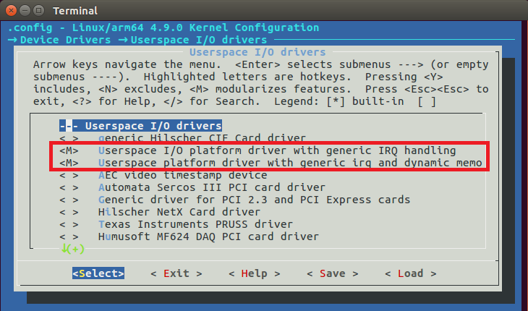

  - Exit the kernel “menuconfig” and save the configuration.

IRQ Configuration of interrupts and interrupt-parent
  - The "interrupt-parent" property is used to specify the controller to which
interrupts are routed and contains a single phandle referring to the interrupt
controller node. This property is inherited, so it may be specified in an interrupt client node or in any of its parent nodes.
  - Interrupts listed in the
"interrupts" property are always in reference to the node's interrupt parent.
  - (ref:https://www.kernel.org/doc/Documentation/devicetree/bindings/interrupt-controller/interrupts.txt)

  - The “interrupt” property contains 3 values:

- The first value is a flag indicating if the interrupt is an SPI (shared peripheral interrupt). A nonzero value means it is an SPI.
- The second value is the interrupt number. The translate function adds 16 to SPIs and 32 to non-SPIs, so for interrupts generated by fabric logic in a Zynq, the number in the DTS file should be the hardware number (as shown in Xilinx Vivado) minus 32.

- The third value is the type of interrupt, which is ANDed with IRQ_TYPE_SENSE_MASK (= 0x0f), which is defined in include/linux/irq.h.
Refer to the values in the “enum” clause: IRQ_TYPE_LEVEL_HIGH is 4 and IRQ_TYPE_EDGE_RISING is 1

  - For example, our hw interrupt number is 121, and we need rising edge irq
The first value is 0, it’s declared as a non-SPI.
The second value should be the hardware number minus 32, which is 89, or 0x59. The third value says IRQ_TYPE_EDGE_RISING

we will get:
interrupts = <0x0 0x59 0x1>

IRQ Settings according to irq.h:
/*
* IRQ line status.
* Bits 0-7 are the same as the IRQF_* bits in linux/interrupt.h
* IRQ_TYPE_NONE - default, unspecified type
* IRQ_TYPE_EDGE_RISING - rising edge triggered
* IRQ_TYPE_EDGE_FALLING - falling edge triggered
* IRQ_TYPE_EDGE_BOTH - rising and falling edge triggered
* IRQ_TYPE_LEVEL_HIGH - high level triggered
* IRQ_TYPE_LEVEL_LOW - low level triggered
* IRQ_TYPE_LEVEL_MASK - Mask to filter out the level bits
* IRQ_TYPE_SENSE_MASK - Mask for all the above bits
* IRQ_TYPE_PROBE - Special flag for probing in progress
*
* Bits which can be modified via irq_set/clear/modify_status_flags()
* IRQ_LEVEL - Interrupt is level type. Will be also
* updated in the code when the above trigger
* bits are modified via irq_set_irq_type()
* IRQ_PER_CPU - Mark an interrupt PER_CPU. Will protect
* it from affinity setting
* IRQ_NOPROBE - Interrupt cannot be probed by autoprobing
* IRQ_NOREQUEST - Interrupt cannot be requested via
* request_irq()
* IRQ_NOTHREAD - Interrupt cannot be threaded
* IRQ_NOAUTOEN - Interrupt is not automatically enabled in
* request/setup_irq()
* IRQ_NO_BALANCING - Interrupt cannot be balanced (affinity set)
* IRQ_MOVE_PCNTXT - Interrupt can be migrated from process context
* IRQ_NESTED_TRHEAD - Interrupt nests into another thread
* IRQ_PER_CPU_DEVID - Dev_id is a per-cpu variable
*/
enum {
IRQ_TYPE_NONE = 0x00000000,
IRQ_TYPE_EDGE_RISING = 0x00000001,
IRQ_TYPE_EDGE_FALLING = 0x00000002,
IRQ_TYPE_EDGE_BOTH = (IRQ_TYPE_EDGE_FALLING | IRQ_TYPE_EDGE_RISING),
IRQ_TYPE_LEVEL_HIGH = 0x00000004,
IRQ_TYPE_LEVEL_LOW = 0x00000008,
IRQ_TYPE_LEVEL_MASK = (IRQ_TYPE_LEVEL_LOW | IRQ_TYPE_LEVEL_HIGH),
IRQ_TYPE_SENSE_MASK = 0x0000000f,
IRQ_TYPE_PROBE = 0x00000010,
IRQ_LEVEL = (1 << 8),
IRQ_PER_CPU = (1 << 9),
IRQ_NOPROBE = (1 << 10),
IRQ_NOREQUEST = (1 << 11),
IRQ_NOAUTOEN = (1 << 12),
IRQ_NO_BALANCING = (1 << 13),
IRQ_MOVE_PCNTXT = (1 << 14),
IRQ_NESTED_THREAD = (1 << 15),
IRQ_NOTHREAD = (1 << 16),
IRQ_PER_CPU_DEVID = (1 << 17),
};

Verify amba_pl address in device-tree
  - Before changing system-user.dtsi device tree, view amba_pl settings in pl.dtsi

  - Addressesof pl.dsti & system-user.dsti must be identical.
although system-user.dsti override settings of pl.dtsi after complication

Note: In order to view pl.dtsi, you need to compile the whole project.

  - For example, our device tree generation (.dtsi) is :
~/workspace/peta-builds/bsp/xilinx-zcu102-2017.2/components/plnx_workspace/device-tree-generation/pl.dtsi

{
amba_pl: amba_pl@0 {
#address-cells = <2>;
#size-cells = <2>;
compatible = "simple-bus";
ranges ;
axi_lite_ipif_danr_0: axi_lite_ipif_danr@a0000000 {
compatible = "xlnx,axi-lite-ipif-danr-1.0";
reg = <0x0 0xa0000000 0x0 0x4000000>;
xlnx,ard-addr-range-array-high = <0x00000000A3FFFFFF>;
xlnx,ard-addr-range-array-low = <0x00000000A0000000>;
xlnx,ard-num-ce-array-0 = <0x1>;
xlnx,ard-num-ce-array-1 = <0x0>;
xlnx,dphase-timeout = <0xa>;
xlnx,s-axi-min-size = <0x03FFFFFF>;
xlnx,use-wstrb = <0x0>;
};
psu_ctrl_ipi: PERIPHERAL@ff380000 {
compatible = "xlnx,PERIPHERAL-1.0";
reg = <0x0 0xff380000 0x0 0x80000>;
};
psu_message_buffers: PERIPHERAL@ff990000 {
compatible = "xlnx,PERIPHERAL-1.0";
reg = <0x0 0xff990000 0x0 0x10000>;
};
};
};

Update UIO system-user.dtsi
  - Edit system-user.dtsi
nano ~/workspace/peta-builds/bsp/xilinx-zcu102-2017.2/project-spec/meta-user/recipes-bsp/device-tree/files/system-user.dtsi

- Copy pl.dtsi content and modify the “compatible” value to
compatible = "xlnx,generic-uio", "uio_pdrv_genirq";

- Add “interrupts” and “interrupt-parent” values according to your HW settings
interrupts ​​= <0x0 ​0x59 0x1>;
interrupt-parent ​= ​<0x4>;

/include/ "system-conf.dtsi"
/ {
amba_pl@0 {
compatible = "xlnx,zynqmp";
axi_lite_ipif_danr@a0000000 {
compatible = "xlnx,generic-uio", "uio_pdrv_genirq";
interrupts = <0x0 0x59 0x4>;
interrupt-parent = <&gic>;
};
};
};
or
/include/ "system-conf.dtsi"
/ {
amba_pl@0 {
/delete-node/ axi_lite_ipif_danr@a0000000;
};
};
/ {
amba_pl@0 {
compatible = "xlnx,zynqmp";
axi_lite_ipif_danr@a0000000 {
compatible = "xlnx,generic-uio", "uio_pdrv_genirq";
reg = <0x0 0xa0000000 0x0 0x4000000>;
xlnx,ard-addr-range-array-high = <0x00000000A3FFFFFF>;
xlnx,ard-addr-range-array-low = <0x00000000A0000000>;
xlnx,ard-num-ce-array-0 = <0x1>;
xlnx,ard-num-ce-array-1 = <0x0>;
xlnx,dphase-timeout = <0xa>;
xlnx,s-axi-min-size = <0x03FFFFFF>;
xlnx,use-wstrb = <0x0>;
interrupts = <0x0 0x59 0x1>;
interrupt-parent = <0x4>;
};
};
};

Compile and run the project
- Compile the project again
petalinux-build

- Create BOOT.BIN package
cd ~/workspace/peta-builds/bsp/xilinx-zcu102-2017.2/images/linux
petalinux-package --boot --fsbl zynqmp_fsbl.elf --u-boot --force

- Option to create BOOT.BIN with FPGA bit stream
petalinux-package --boot --fsbl zynqmp_fsbl.elf --fpga zcu102_top.bit --u-boot --force

- Copy the generate files to SD Card
~/workspace/peta-builds/bsp/xilinx-zcu102-2017.2/images/linux
BOOT.BIN
image.ub
system.dtb

- Copy FPGA project bitstream file from vivado project and rename it to
system.bit if not included in BOOT.BIN

Verify UIO configuration
- Mount the SD into the HW and power up.
enter user and password: root
root@xilinx-zcu102-2017_2:~# ls /dev/u*
root@xilinx-zcu102-2017_2:~# /dev/uio0 /dev/urandom
or
ls -l /sys/firmware/devicetree/base/amba_pl\@0/
-r--r--r-- 1 root root 4 Oct 30 10:28 #address-cells
-r--r--r-- 1 root root 4 Oct 30 10:28 #size-cells
drwxr-xr-x 2 root root 0 Oct 30 10:28 PERIPHERAL@ff380000
drwxr-xr-x 2 root root 0 Oct 30 10:28 PERIPHERAL@ff990000
drwxr-xr-x 2 root root 0 Oct 30 10:28 axi_lite_ipif_danr@a0000000
-r--r--r-- 1 root root 11 Oct 30 10:28 compatible
-r--r--r-- 1 root root 8 Oct 30 10:28 name
-r--r--r-- 1 root root 0 Oct 30 10:28 ranges

Verify UIO IRQ configuration
- Enter the follow command:
cat /proc/interrupts
- The response should be:
Device name, IRQ number and IRQ event
Fore example:
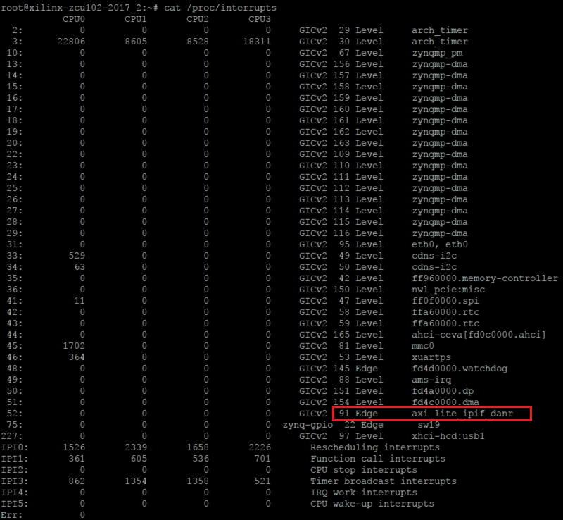

Simple UIO validation:

//Turn on all EVB LEDS (DS38-DS40)
devmem 0x00A0010010 h 0xf
//Read value (return 0xf)
devmem 0x00A0010010
//Turn off all EVB LEDS (DS38-DS40)
devmem 0x00A0010010 h 0x0
//Read value (return 0x0)
devmem 0x00A0010010
//Read FW version
devmem 0x00A0010028

Simple IRQ validation:
- Before triggering the IRQ we will run again “cat /proc/interrupts” command
we will see that our IRQ counter for axi_lite_ipif_danr is 0

CPU0 CPU1 CPU2 CPU3
52: 0 0 0 0 GICv2 121 Edge axi_lite_ipif_danr

- Now we run the follow commands to generate IRQ from PL
//Configure IRQ on time
devmem 0x00A0010018 32 50000000
//Configure IRQ off time
devmem 0x00A0010020 32 50000000

- LED DS42 will start to blink every 1 sec (this is our IRQ indication)

- Run again “cat /proc/interrupts” command
we will see that our IRQ counter for axi_lite_ipif_danr is now 1

CPU0 CPU1 CPU2 CPU3
52: 1 0 0 0 GICv2 121 Edge axi_lite_ipif_danr

Creating Test Application for UIO in User space - With IRQ
- Create new c file uio-irq.c
- Enter the follow code

#include <stdio.h>
#include <stdlib.h>
#include <unistd.h>
#include <stdint.h>
#include <assert.h>
#include <sys/mman.h>
#include <pthread.h>
#include <fcntl.h>

#define MAP_SIZE 0x4000000

pthread_t tid[2];
unsigned char * ptr;

void usage(void) {
printf("usage: uio-irq -d <UIO_DEV_FILE> \n");
}

void* irqOnOff(void *arg)
{
unsigned long i = 0;
pthread_t id = pthread_self();
if(pthread_equal(id,tid[0]))
{
printf("\n IRQ thread processing\n");
}

while (1)
{
printf("\n IRQ On\n");
// Configure HW for IRQ generate
ptr[0x10020] = 0x80;
ptr[0x10021] = 0xF0;
ptr[0x10022] = 0xFA;
ptr[0x10023] = 0x02;

ptr[0x10018] = 0x80;
ptr[0x10019] = 0xF0;
ptr[0x1001A] = 0xFA;
ptr[0x1001B] = 0x02;
sleep (3);
printf("\n IRQ Off\n");
ptr[0x10020] = 0x00;
ptr[0x10021] = 0x00;
ptr[0x10022] = 0x00;
ptr[0x10023] = 0x00;

ptr[0x10018] = 0x00;
ptr[0x10019] = 0x00;
ptr[0x1001A] = 0x00;
ptr[0x1001B] = 0x00;
sleep (3);
}
return NULL;
}

void* uioOnOff(void *arg)
{
unsigned long i = 0;
pthread_t id = pthread_self();

if(pthread_equal(id,tid[1]))
{
printf("\n UIO thread processing\n");
}

while(1)
{
printf("\n LEDs On\n");
ptr[0x10010] = 0xF;
usleep(1000000);
printf("\n LEDs Off\n");
ptr[0x10010] = 0x0;
usleep(1000000);
}
return NULL;
}

int main(int argc, char *argv[])
{
int c, i, direction = 0;
int fd = 0;
char *uiod = 0;

volatile unsigned *gpio;

while ((c = getopt(argc, argv, "d:hg:")) != -1)
{
switch(c)
{
case 'd':
uiod = optarg;
break;
case 'h':
usage();
return 0;
default:
printf("invalid option: %cn", c);
usage();
return -1;
}
}

if (!uiod)
{
usage();
return -1;
}

printf ("Open UIO ...\n");
/* Open the UIO device file */
fd = open(uiod, O_RDWR);
if (fd < 1)
{
perror(argv[0]);
printf("Invalid UIO device file: '%s'n", uiod);
return -1;
}

printf ("Map UIO ...\n");
/* mmap the UIO device */
gpio = (volatile unsigned *)mmap(NULL, MAP_SIZE, PROT_READ|PROT_WRITE, MAP_SHARED, fd, 0);
if (!gpio)
{
perror(argv[0]);
printf("mmapn");
return -1;
}

ptr = (unsigned char *)gpio;

int err;
err = pthread_create(&(tid[0]), NULL, &irqOnOff, NULL);
if (err != 0)
{
printf("\ncan't create irqOnOff thread");
}
else
{
printf("\n irqOnOff Thread created successfully\n");
}

err = pthread_create(&(tid[1]), NULL, &uioOnOff, NULL);
if (err != 0)
{
printf("\ncan't create uioOnOff thread");
}
else
{
printf("\n uioOnOff Thread created successfully\n");
}

while (1)
{
uint32_t info = 1; /* unmask */

ssize_t nb = write(fd, &info, sizeof(info));
if (nb < sizeof(info))
{
perror("write");
close(fd);
exit(EXIT_FAILURE);
}

/* Wait for interrupt */
nb = read(fd, &info, sizeof(info));
if (nb == sizeof(info))
{

printf("Interrupt #%u!\n", info);
}
}

printf ("Unmap UIO ... %d\n", direction);
munmap((void*)gpio, MAP_SIZE);
return 0;
}

- Compile the project by:
export SYSROOT=~/workspace/Xilinx-SDK/SDK/2017.2/gnu/aarch64/lin/aarch64-linux/bin

$SYSROOT/aarch64-linux-gnu-gcc -pthread uio-irq.c -o uio-irq

- Copy the compiled application uio-irq to SD card, mount it and power up the board

- Run the Example
Enter the follow commands to run the test:
cd /mnt
./uio-irq -d /dev/uio0

The example code turn on and off the UIO LEDS every 100msec, and active the IRQ every 3 sec.

