# strPractical Exam – Log Noziroh

You have been tasked to create a simple application that simulates a Log. The application should hold **reports**, which are the main app **entities**. The app is called LogNoziroh.

The functionality of the application should support **creating**, **listing, detailing**, **delete** reports.

The application should **persist** the data into a **database**.

## Overview

Your application should be built on **each one** of the **following technologies**:

### PHP

* **Symfony** framework
* **Twig** view engine
* **Doctrine** ORM
* **MySQL** database

### JavaScript

* **NodeJS** + **ExpressJS** frameworks
* **Handlebars.js** view engine
* **Sequelize**
* **MySQL** database

### Java

* **Spring** framework (**Spring MVC** + **Spring Boot** + **Spring Data**)
* **Thymeleaf** view engine
* **JPA** / **Hibernate ORM** + **Spring Data** data access
* **MySQL** database

### C#

* **ASP.NET Core framework (ASP.NET MVC + Entity Framework Core)**
* **Razor view engine**
* **Entity Framework Core ORM**
* **MySQL database**

## Data Model

The Report entity holds **5 properties**:

* id – technology-dependent identifier (ObjectID for JavaScript, int for all other technologies)
* status – non-empty text (will either be “Normal”, “Warning” or “Critical”).
* message – non-empty text
* origin – non-empty text

## Project Skeletons

You will be given the applications’ skeletons, which holds about **90%** of the logic. You’ll be given some **files** (**controllers**, **models** etc.). The files will have **partially implemented logic**, so you’ll need to write some code for the application to **function properly**.

The application’s views will be given to you fully implemented. You only need to include them in your business logic.

**Each technology** will have its **own skeleton**, and the **different** **skeletons** may **differ** in **terms** of **what is given to you** and **what is to be implemented**.

Everything that has been given to you inside the skeleton is **correctly implemented** and if you write your code **correctly**, the application should work just fine. You are free to change anything in the Skeleton on your account.

## User Interface

This is the user interface or how the application’s pages should look in their final form (fully implemented). You have several pages, described below:

### Index Page

#### Route: **“/”**

Displays **all** the **products** from the database with **options** to **view details about them** or **delete** them.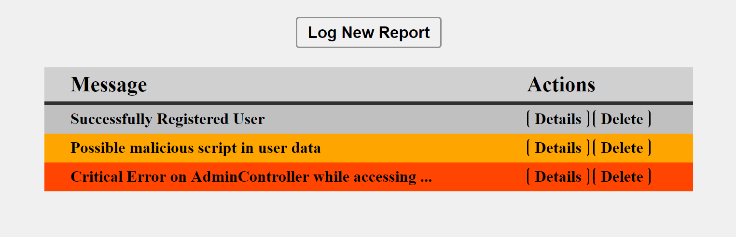

### Create Page

#### Route: **“/create”**

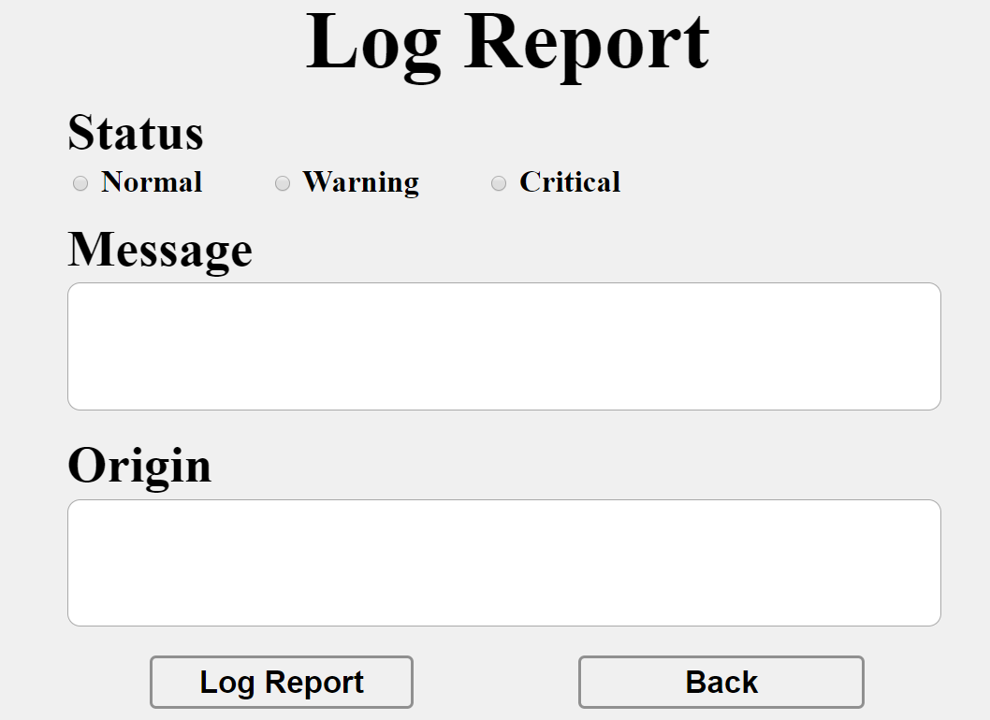

### Details Page

#### Route: **“/details/{id}”**

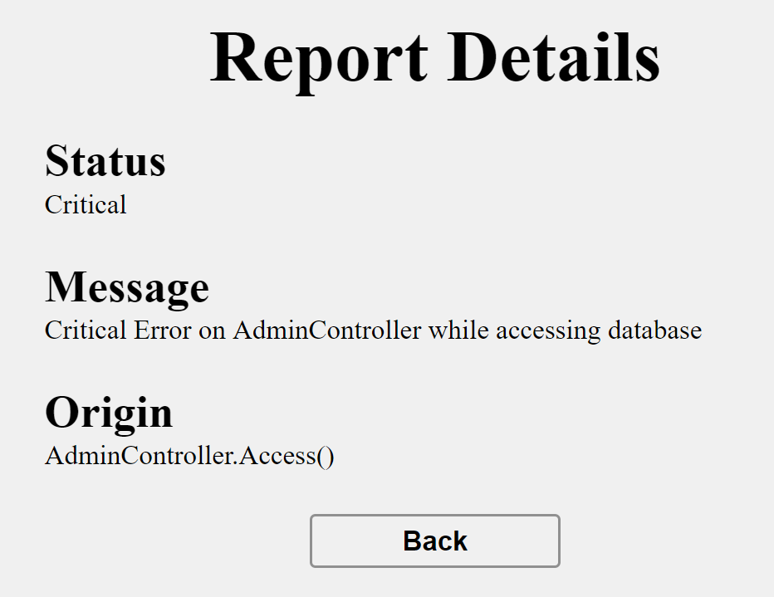

### Delete Page

#### Route: **“/delete/{id}”**

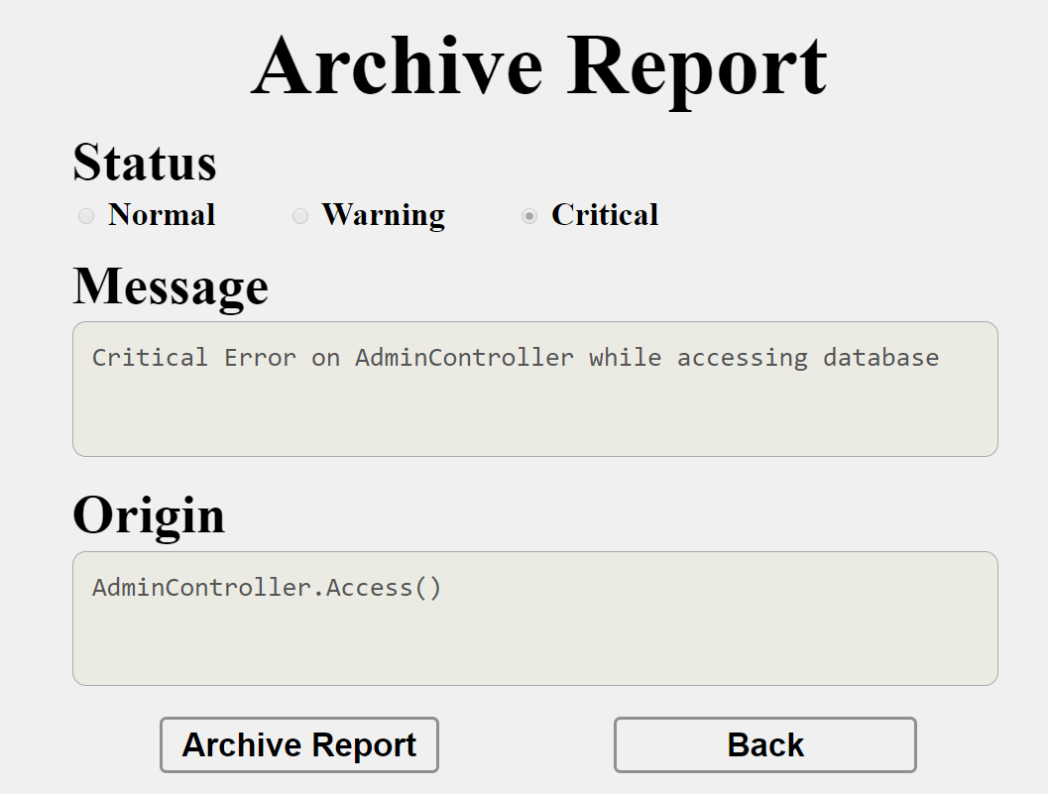

## Problem

As you can see the different pages are on different routes. Most of the routing logic will be given to you in the **Skeleton**, but you should make sure that the application **works properly**.

Implement the “**LogNoziroh” app** using all the above described **4 technologies**.

## Setup

Before you start working, make sure you **download all the dependencies** (packages) required for each technology and **set up** the **databases**! Below are instructions on how to do this:

### PHP and Symfony

1. Go into the **root directory** of the project (where the bin folder resides)
2. Make sure you’ve started your **MySQL server** (either from **XAMPP** or standalone)
3. Open a **shell** / **command prompt** / **PowerShell** window in the **root directory**: [Shift] + [Right click] 🡺 [Open command window here]
4. Enter the “php composer.phar install” command to restore its **Composer dependencies** (described in composer.json)
5. Enter the “php bin/console doctrine:database:create --if-not-exists” command
6. Done!

### JavaScript and Node.js

1. Go into the **root directory** of the project (where the bin folder resides)
2. Create a databse (name: **lognoziroh_js**)
3. Open a **shell** / **command prompt** / **PowerShell** window in the **root directory**: [Shift] + [Right click] 🡺 [Open command window here]
4. Enter the “npm install” command to restore its **Node.js dependencies** (described in package.json)
5. Done!

### C# and ASP.NET Core

The C# project will automatically resolve its **NuGet dependencies** (described in packages.config) using the NuGet package restore when the project is built.

### Java and Spring MVC

The Java project will automatically resolve its **Maven dependencies** (described in pom.xml) when the project is built.