

Runway Redeclaration

User Guide

Table of Contents

1. General Use 2

Running the Program

Basics

Adding a Custom Obstacle

Viewing the Runway in Different Angles

1. Description of Business 3

Company Ownership/Legal Entity

Location

Interior

Hours of Operation

Products and Services

Suppliers

Service

Manufacturing

Management

Financial Management

Start-Up/Acquisition Summary

1. Marketing 4

Market Analysis

Market Segmentation

Competition

Pricing

1. Appendix 4

Start-Up Expenses

Determining Start-Up Capital

Cash Flow

Income Projection Statement

Profit and Loss Statement

Balance Sheet

Sales Forecast

Milestones

Break-Even Analysis

Miscellaneous Documents

# General Use

## Running the Program

1. Once the program consists of a “src” folder and a “SEG7 7.jar” file, the jar file should always be kept in the same folder as “src” or else the program may not function correctly.
2. The program should be ran by double clicking “SEG 7.jar”

## Basics

Once the program has started a selection screen will be shown, this will allow you to input the selected airport and runway that you wish to view.

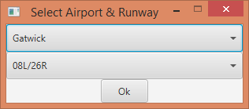

After you press the “Ok” button with a valid airport and runway selected the Redeclaration Window will open, this will allow you to view information about obstacles and runways as well as redeclare a runway view a 3D view of a runway.

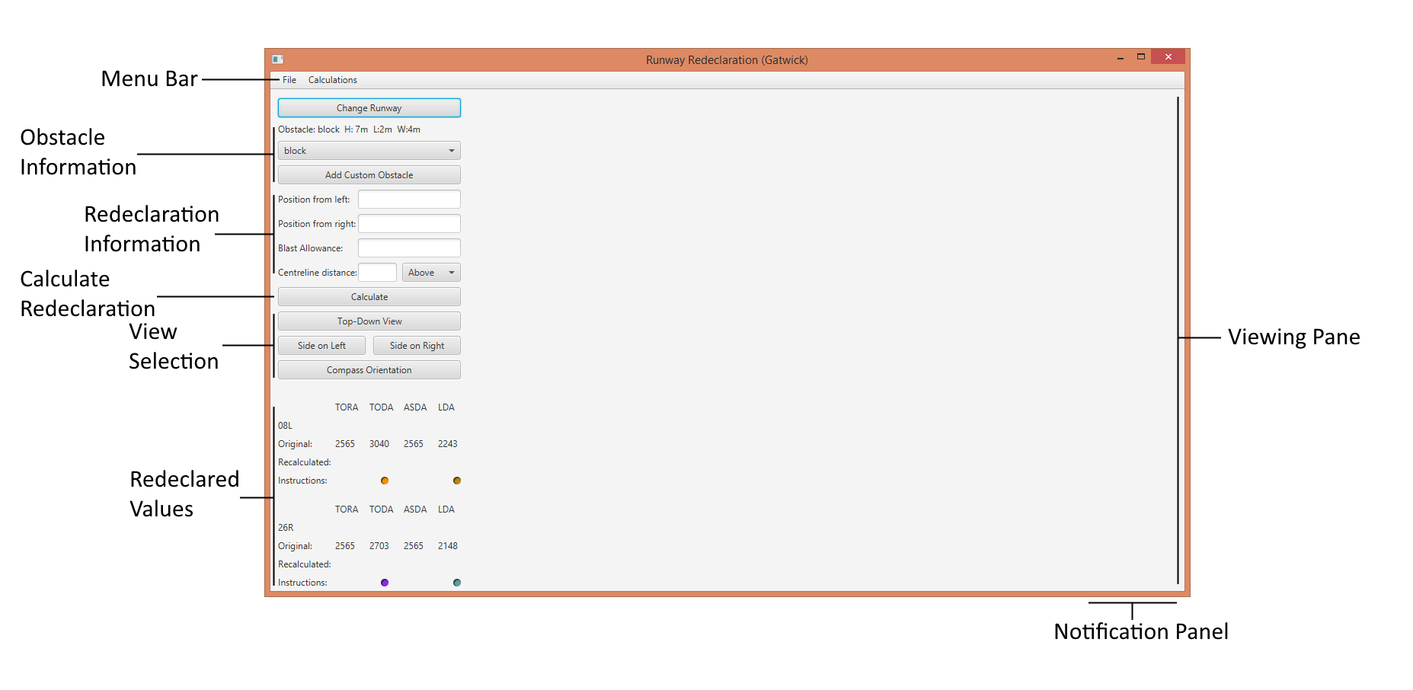

## Adding a Custom Obstacle

This can be done from the redeclaration window after you have selected an airport and a runway

1. Select the button “Add Custom Obstacle” under the ‘Obstacle Information’ section of the window
2. This will bring up the custom obstacle window as shown below

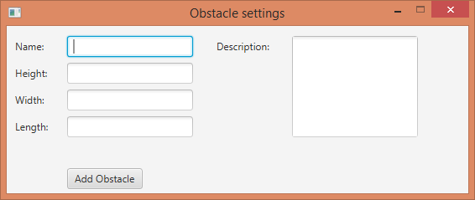

1. Enter in the information of the obstacle in the boxes provided and press the “Add Obstacle” button when finished to return back to the redeclaration window

## Redeclaring a Runway

1. Open up the program and select an airport and the runway that you want to redeclare
2. Press the “Ok” button to bring you to the redeclaration window
3. Select the obstacle that you wish you use from the drop down box in the ‘Obstacle Information’ section
   1. If you wish to add a custom obstacle see “Adding a Custom Obstacle” in this document
4. Enter all the information necessary such as the position of the object from the left, and the right of the runway in the ‘Redeclaration Information’ section
5. Once all information has been entered press the “Calculate” button

Once this is done the information of the redeclared runway will appear in the ‘Redeclared Values’ section of the window and a 3D image will appear in the Viewing Pane area.

## Viewing the Runway in Different Angles

Once the runway has been redeclared the viewing angle in the 3D model can be changed. This can be done in the ‘View Selection’ area of the redeclaration window by selecting the different options.

# Additional Features

## Calculation Breakdown

After a runway has been redeclared a breakdown of the calculations can be viewed.

1. Select Calculations in the Menu Bar at the top of the redeclaration window
2. Click “View Breakdown”
3. A window will appear that details the calculations made

## Notification System

A notification system can be seen if your hover your mouse cursor over the very right of the redeclaration window, this details the actions that the operator has performed while using the system. If the notification panel is clicked then it will remain open on the window.

## Export a Runway Configuration

After a runway has been redeclared the redeclaration values and original values of the runway can be saved as a text file to be printed off.

1. Select File in the Menu Bar at the top of the redeclaration window
2. Click “Export”
3. A window will appear, enter a name to save the file as, or leave it blank for a generated name.
4. Select “OK” to export your file
5. Locate your file at TODO, right click it and select Print, follow your systems instructions on how to print a file

## Help

This document can be viewed inside of the program if help is needed.

1. Select Help in the Menu Bar at the top of the redeclaration window

# Frequently Asked Questions (FAQs)

# Known Issues