Your name and your student number: Petar Paskalev 232725

Your mentor: Jason

Question 1. The student submitted 15 masks: Yes/No, if no, list the missing masks.

1. Name of the image file: val_Jason_232725_im1.png

|  |  |  |  |
| --- | --- | --- | --- |
|  | Shoot Mask | Seed Mask | Root Mask |
| **Req 1** | Pass | Pass | Pass |
| **Req 2** | Pass | Pass | Pass |
| **Req 3** | Pass | Pass | Pass |
| **Req 4** | Pass | Pass | Pass |

**Requirement 5**

* Everywhere your labels are a few pixels smaller than the object you are labeling.

1. Name of the image file: val_Jason_232725_im2.png

|  |  |  |  |
| --- | --- | --- | --- |
|  | Shoot Mask | Seed Mask | Root Mask |
| **Req 1** | Pass | Pass | Pass |
| **Req 2** | Pass | Pass | Pass |
| **Req 3** | Pass | Pass | Pass |
| **Req 4** | Pass | Pass | Pass |

* Missing lateral roots



* These are roots, the roots appear before the shoots

* Missing lateral root



1. Name of the image file: val_Jason_232725_im3.png

|  |  |  |  |
| --- | --- | --- | --- |
|  | Shoot Mask | Seed Mask | Root Mask |
| **Req 1** | Pass | Pass | Pass |
| **Req 2** | Pass | Pass | Pass |
| **Req 3** | Pass | Pass | Pass |
| **Req 4** | Pass | Pass | Pass |

* **Missing lateral root**

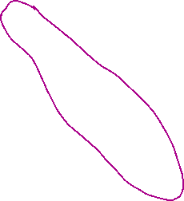

* **Missing seed label**

* **Gaps**

1. Name of the image file: val_Jason_232725_im4.png

|  |  |  |  |
| --- | --- | --- | --- |
|  | Shoot Mask | Seed Mask | Root Mask |
| **Req 1** | Pass | Pass | Pass |
| **Req 2** | Pass | Pass | Pass |
| **Req 3** | Pass | Pass | Pass |
| **Req 4** | Pass | Pass | Pass |

* Missing Lateral root



1. Name of the image file: val_Jason_232725_im5.png

|  |  |  |  |
| --- | --- | --- | --- |
|  | Shoot Mask | Seed Mask | Root Mask |
| **Req 1** | Pass | Pass | Pass |
| **Req 2** | Pass | Pass | Pass |
| **Req 3** | Pass | Pass | Pass |
| **Req 4** | Pass | Pass | Pass |

**Requirement 5**

* **Missing lateral roots**

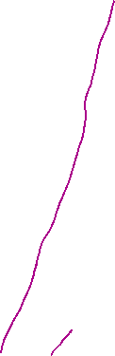

* **Missing seed**

