Softwear Solution for Finding Longest Word in English Dictionary Suitable for 7-segmenth Display

P. Randjelović, A. 2Autorović, A. 3Autorović

Abstract – In ths paper we present interesting softwear solution, that detects all words in English dictionary, that are suitable for presenting on 7-segmenth display, and finds longest one. In first part we give short overview on 7-segemnth displays. In second part we introduce our softwear solution with original source code. In thirs part of paper we give some examples and results.

I. About 7-segmenth displays

U ovom odeljku treba napraviti lagani uvod sa pricom o sedmodegmentnim displayima, kako I zasto se koriste, zasto su dobri, koji su im eventualni nedostaci… mozda i neka ilustracija.
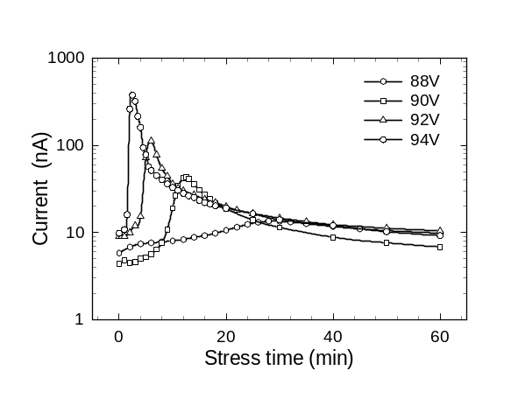
Fig. 1. Ovo je priemr kako se stavlja slika u tekst.

Sve u svemu, ne vise od tri pasusa.
ZA OVAJ ODELJAK JE IDEALNO DA NADJE SNEKOG RADNIKA, KOJI CE TO DA TI NAPISE DOK SI U TURSKOJ

II. Softwear Solution

Ovde opsiujemo softvwrski reseneje, kako se doslo na ideju da se radi, koji su resursi…
Koji je programski jezik koriscen I zasto bas taj...

Moze I neka ilustracija, a I ne mora
OVO OPET TI I JA

OVAJ ODELJAK BI MORAO TI DA ODRADIS
P. Randjelović, A. 1Autorović and A. 2Autorović are students of Faculty of Electronic Engineering, University of Niš, Aleksandra Medvedeva 14, 18000 Niš, Serbia, E-mail: petarrandjelovic66@gmail.com

A. Finding longest 7-segmenth word

Dajes primer kako radi, na primeru baze od 10 reci, od kojih ne mogu sve de s epriakzu na 7-segmentnom,.. .kako on izdravaj aone koje mogu… zatim kako od njih nalazi najduzu.
I OVO

B. Source code

Zatim ide programski kod…. Uskladis lepo nazive promenljicivh da bude sve jasno I konzistentno.

Moze I neki screenshut sa ekrana

ISTO TI

TABLE I
OVO JE PRIMER JEDNE TABELE AKO IH KORISTIS

Paper size | A4
Left margin | 18 mm
Right margin | 18 mm
Top margin | 20 mm
Bottom margin | 43 mm
Column spacing | 5 mm

Fig. 2. Ocvo je priemr kako se stavlja slika u tekst.

III. Results and Conclusions

Ovde idu rezultati. Neki primeri. Sa screenshutovima. Mozda da napravimo poredejenje, koliko mu vremena treba ako mu das imenik sa 100.000, 200.000.... 400.000 reci?

Acknowledgement

Authors would like to thank to Professor Branislav Randjelovic for all suggestions and continues support in work and in research.

References

[1] N. Stojadinovic, S. Djoric-Veljkovic, I. Manic, V. Davidovic, and S. Golubovic, “Effects of Elevated-Temperature Bias Stressing on Radiation Response in power VDMOSFETs”, in Proc. 8th International Symposium on the Physical & Failure Analysis of Integrated Circuits IPFA 2001, Singapore, 2001, pp. 243-248.
[2] Z. Prijic, P. Igic, Z. Pavlovic, and N. Stojadinovic, “Simple method for the extraction of power VDMOS transistor parameters”, Microelectronics Journal, 1996, vol. 27, pp. 567-570.
[3] D. J. Roulston, N. D. Arora, and S. G. Chamberlain, “Modeling and Measurement of Minority-Carrier Lifetime versus Doping in Diffused Layers of n⁺p Silicon Diodes”, IEEE Trans. Electron Devices, vol. ED-29, pp. 284-291, 1982.
[4] S. Dimitrijev, Understanding the Semiconductor Devices, New York, Oxford: Oxford University Press, 2000.
[5] T. Grasser, V. Palankovski, G. Schrom, and S. Selberherr, “Hydrodynamic Mixed-Mode Simulation”, in Simulation of Semiconductor Processes and Devices, K. De Meyer and S. Biesemans, Eds., pp. 247-250, Wien, New York: Springer, 1998.

