Babes-Bolyai University
Service oriented architecture
Flight system
Service oriented architecture system

Student: Petcu Dragos

System diagram

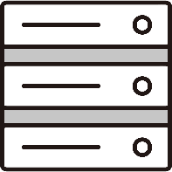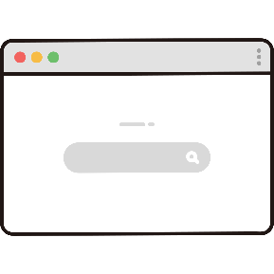
FlightsMicroservice

FlightsDatabase
JDBC
HotelsMicroservice

HotelsDatabase
JDBC
REST
FlightsMicrofrontend

HotelsMicrofrontend

Webpack module federation
REST
RE
WebSocket
RE
ExternalAPI
External
WebSocketServer
External
WebSocket
RE
REST
RE

System information

System was built using Java 18 for the flight microservice and hotels microservice. For the microfrontends React JS was used. The database was constructed in memory with a h2 database.
The system was deployed using docker.

FlightMicroservice
The system shows a list of available flights together with some information about them like cost, duration and available places. The flight model is persisted within a database that the service is connected to. The microservice communicates with the hotel microservice through REST messaging protocol. The microservice also communicates with an external API/microservice, through REST calls, which gets the available “Things to do” inside a city that is provided. It also uses a websocket server which exposes endpoints that broadcasts messages for the clients. The client being the flight microfrontend.

HotelMicroservice
This microservice manages hotels. A hotel has a location, price and number of places left. This microservice exposes a RESTful API where you can get all hotels that are in a certain location. The hotel model is persisted withing a database that the service is connected to.

FlightMicrofrontend
The flight microfrontend presents a login form at the start in order to send secured calls through REST to the flight microservice. After successful authentication the list of flights is shown to the client. The microfrontend communicates with the hotel microfrontend with the help of webpack module federation strategy. It imports its components and uses them. It also listens to a websocket and when information is given it shows notifications.

HotelMicrofrontend
The hotel microfrontend present the hotels giving a certain location. It is used by the flightmicrofrontend. And it communicates with the flight microservice through secured REST calls.

WebsocketServer
It is a system that communicates with its clients through websockets. It is used to notify the clients. Is an intermediary from microservices to microfrontends that can facilitate the communication from the server to the client.

