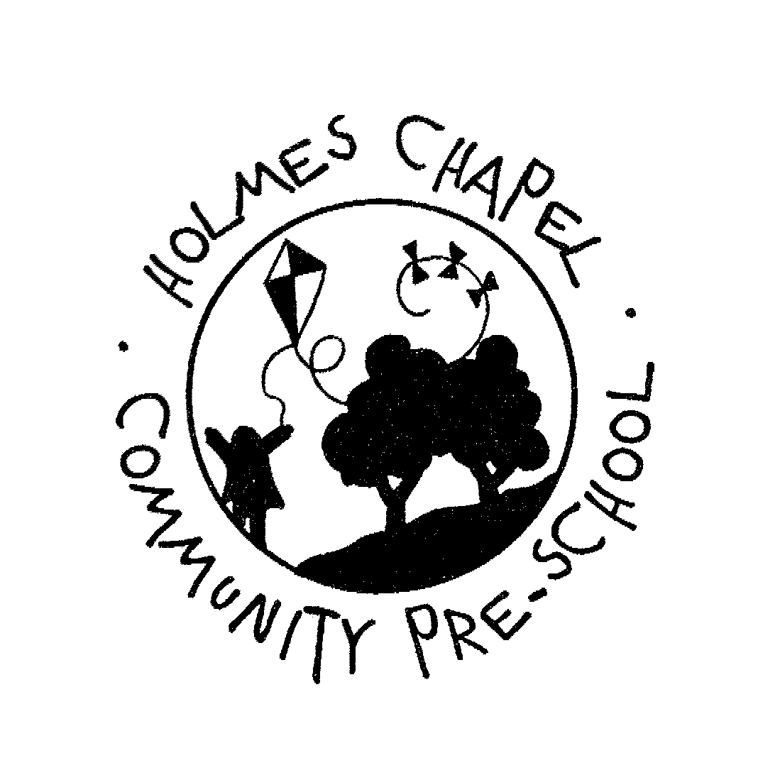
Holmes Chapel Community Pre-school
Holmes Chapel Primary School, Middlewich Road, Holmes Chapel, Cheshire CW4 7EB

Registered Charity Number 1017112
Member of the Pre-school Learning Alliance

E Safety Policy

At Holmes Chapel Community Preschool we believe that computer skills are vital to accessing life-long learning and employment. However, it is important for children to learn to be E-safe from an early age and the Pre-school can play a vital part in starting this process.
There is need to begin to teach them to be aware of and to respond responsibly to possible risks.

Guided educational use
Significant educational benefits can result from internet use at home including access to information from around the world. Internet use at home and at the setting should be carefully planned and targeted within a regulated and managed environment by parents, carers and staff members. Children will not access the internet at Holmes Chapel Community Pres-School without an adult present.

Risk assessment
We have a duty to ensure that children in the Pre-school are not exposed to inappropriate information or materials. We also need to ensure that children know how to ask for help if they come across material that makes them feel uncomfortable.

Website Content
The point of contact on the website should be the Pre-school address, Pre-school email and telephone number. Staff or children’s home information will not be published. Website photographs that include children will be selected carefully and shared with parent/carer in advance for approval. Written permission from parents or carers for featuring their child on the website is requested when each child starts at the Pre-school and parents/carers wishes are followed at all times. Pupils’ full names will not be used anywhere on the website, particularly in association with photographs.

Communication
- Children and staff will not have access to e-mail at Pre-School.
- On-line chat rooms and social networking sites such as Facebook or Twitter will not be used at the Pre-school.
- Staff will not discuss individual children or their setting on Facebook, twitter or any other social networking site.
- Holmes Chapel Community Pre-School Committee may use social media to advertise fund raising events throughout the year and to share weekly learning objectives and special events. See Social Media Policy Document.

Mobile technologies
Mobile phones are not permitted within the Pre-school room. Staff are permitted to use their mobile phones to make and receive phone calls in the office, but the taking of photographs and access to the internet on mobile phones is strictly prohibited anywhere on the Pre-school site.
Any member of staff using their own laptop must adhere to the e-safety policy in all matters relating to the Pre-school.

Parents and E-Safety
Parents’ attention will be drawn to the Pre-school E-Safety Policy.

Internet
Internet access is managed and monitored with secure passwords at all times.
All computers have up to date virus and security programmes built in and are regularly checked.
All staff are expected to remain professional and clearly notify supervisor prior to internet use and the specific purpose of use.
Children will not have direct access to the internet and will only be able to access pre-agreed sites with the presence of a member of staff.
Social Networks
ALL social networking sites are banned and blocked from the workplace
Staff are not permitted to discuss children, staff or families when using social networking sites at home.
Any abuse reported will be recorded and dealt with immediately.
Use of cameras
Personal cameras are prohibited within the setting.
Holmes Chapel Community Preschool keep a camera that is used solely for photographs of special events, educational outings and learning activities within the setting. These photographs are removed from the camera onto the setting PC on a weekly basis for the keyworkers to access. No photographs of the children or staff are held on the camera and are deleted on a termly basis from the PC. These photographs are used to print out and add to that child’s Learning Journey or to display within the settings premises.They do not belong to the preschool or staff but to the parents and carers of the child (permission to take and use these photographs is always obtained in advance using our admission forms).
NO photographs of the children or staff will be transferred onto the internet and social media sites.(The committee may occasionally choose us to photograph their own children (giving written permission) for use on our Facebook site and for advertising/fundraising purposes)
Students and volunteers and visitors will not have access to the internet or camera.

Last Review Date: January 2015
Next Review Date: April 2015

