Creating a website using Code

Fdsc in computing

Peter Hassard

2018

Table of Contents

Introduction 2

The Plan 3

Where to start 4

Terminology 4

House vs Website 4

The Foundation to Building a website 5

Website Builders 5

Squarespace 5

Bibliography 7

# Introduction

I am a 2nd year student of the Ulster University foundation degree in computing.

Before I undertaken the course I have a strong educational background in Mathematics and a working background in Accountancy, Sales and Administration.

My work-based learning was spent using the most cost effective means to create a website.

Using my knowledge gained from [www.codecademy.com](http://www.codecademy.com) which introduced me to HTML, CSS and briefly JAVAscript. I furthered my skills with the help of [www.w3schools.com/](http://www.w3schools.com/) and [www.getbootstrap.com](http://www.getbootstrap.com) to help create professional looking websites which are freely hosted on https://github.com/ . The only real costs came from domain registration which in reality is a very small percentage of the cost of alternative methods of creating and operating a website.

Throughout this project I will be unravelling the jargon above and debunking any thoughts of how constructing a website can be time consuming and costly. I will also show how learning the code behind the make up of a website can help even novices to web development produce top quality work and how creative individuals can get their own ideas onto the web.

## The Plan

I will be structing my project logically.

Firstly, I will talk about the possible ways to create a website.

* The Foundations used to build a website
* The Website Builders
* How to customise Website Builders

Secondly, how websites are viewed.

* Websites from a Browsers point of view
* Focus on Google Chrome

Now comes the explanation on how the coding languages HTML and CSS produce a website.

* Introduction to HTML
  + The key tags and elements
* Introduction to CSS
  + Linking with class names and ID’s

Then I will talk about Google’s development tools, which are vital for helping to edit your own website are replicate others.

* Google’s development tools and how to access them

Using CDN’s to speed up your development

* Introduction to CDN’s
* How and where to use Bootstrap
  + How to customise it to your taste

Now you are ready to put a website together.

* Website hosting
* Github pages

Now your website is online.

* Introduction to domains
  + Registering with 123-reg

# Where to start

When trying to create a website where is the 1st place you go?

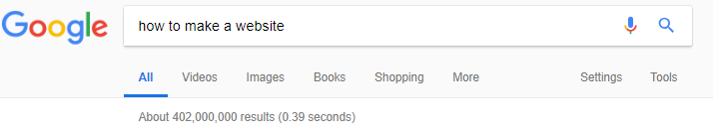If you’re like me, you will turn on your laptop, load up a browser and search the internet until you find a website that tells you, THIS IS HOW TO MAKE A WEBSITE.

As illustrated google can provide 402 million results instantly[1].

The problem which many individuals find is being bombarded with information can be very overwhelming and seeing all these different options, they still do not explain where to start.

Your website project can take months if you were to read all the popular articles and then it may still not be clear which foundation you need to start bringing your idea to reality.

## Terminology

The idea of creating anything of substance is going to take time, there will be new words, technical jargon and much more.

This article from 2009 helped me

<https://www.smashingmagazine.com/2009/05/web-design-industry-jargon-glossary-and-resources/>

but does contain over 50 different words, terms, acronyms and some slang. Most of which won’t be needed for this project.

This is where making a website can start to feel overwhelming. Therefore, I try not to think of it as MAKING but instead think of it as BUILDING. As building anything suggests it can now be as good as you like.

### House vs Website

A house and a website can be though of as comparable, a house needs doors and windows the same way a website needs some way to access it and look appealing. But much like a house a website cannot be made without the proper foundations in place.

# The Foundation to Building a website

Starting from the bottom you have a number of options[2] but I will focus on these 2 options:

1. Using a do-it-yourself website builder
2. Using a pre-made theme or template for an open source content management system (CMS)

## Website Builders

These expensive overpriced limited accessories are not my favourite choice when it comes to building.

These work in a way dragging and dropping the required layout or working from a template and tailoring it specifically to your needs. This process is generally called WYSIWYG[3] which stands for “What You See Is What You Get” software. The most other software using this feature would be Microsoft Word (used to produce this document) or Apple Pages.

The main reason against website builders is cost[4]. I 100% agree that this put me off using website Builders.

I’m going to look at 2 of the most popular for individual use:

* Squarespace
* WIX

Let’s take a look first at Squarespace.com

### Squarespace

A top performing website builder[5]

Here is a break down of their Pricing. Which includes small print.

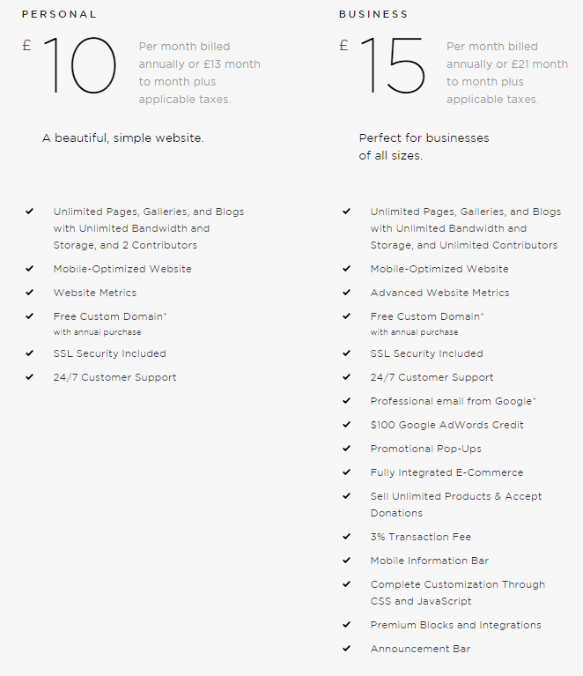These were the 2 provided before signing up, I am also aware of an advance store option.

The small print says the price will be £156 (£13 x 12) in your first bill as an individual user of Square Space. This seems very steep for the service provided. Especially for an individual who may want multiple projects or just a simple page to display without branding.

Also the notable omission from squarespace personal plan is an e-commerce section[6], meaning the £156 already spent can’t be earned back through the website.

Now WIX.com[7]

### WIX

Much to the same to Squarespace, WIX is still very pricey but to be fair, it offers a wider range of options. The small print “Displayed prices are for yearly subscriptions, paid in full at the time of purchase.[8]” Also a big selling point is their free domain which is only for 1 year and will make each one goes up around £10.39[9] depending on the domain name.

Therefore, their cheapest option to *Connect Domain* is £30.60 (£2.55 x 12) for the first year, with an extra 25% increase from the free domain renewal the following year.

From Reviews[10] the *combo* option is most recommended for individuals or beginners. At £93.12 (£7.76 x 12) for the first year, it is cheaper than Squarespace but again does not provide an E-commerce section until you pay £121.20 (£10.10 x 12) for the first year.

Then on top of all these options there’s 241 apps[11]which come at free or premium rates that require individual research and require their own review section.

# Customising Web builders

Even within the payment plans the words are not in plain English and still full of more

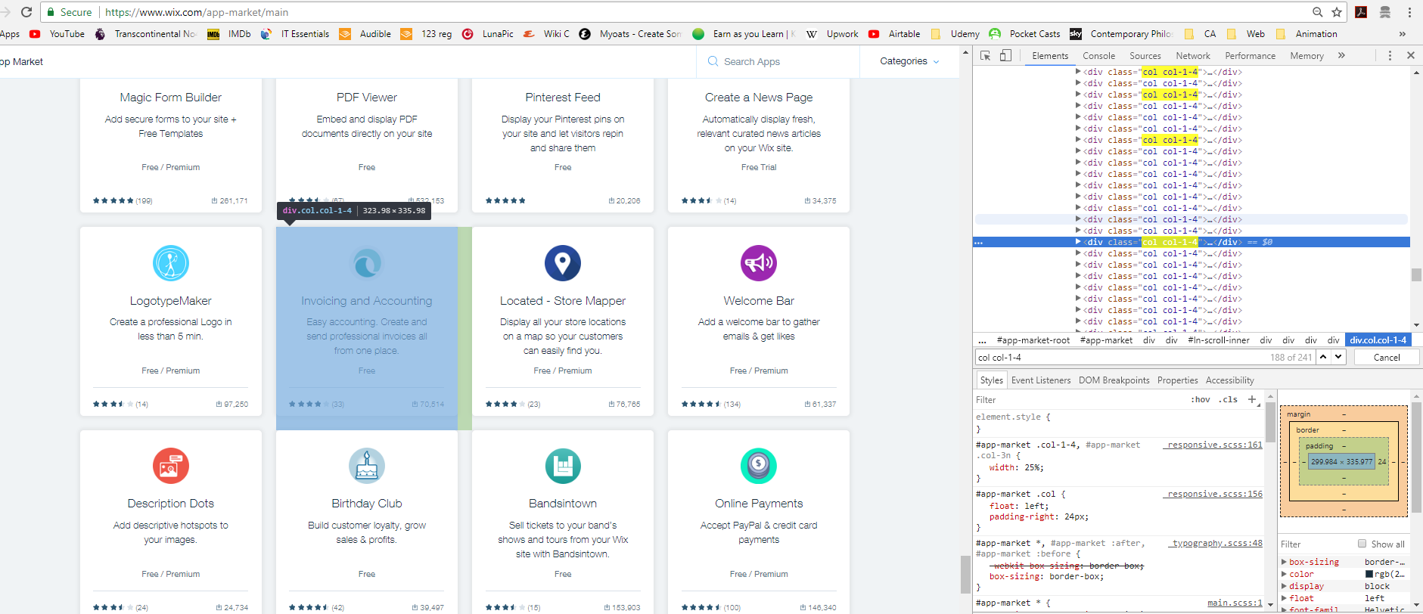

# Bibliography

Cameron Chapman, 21st May 2009, Web Design Industry Jargon and Web Terms: Glossary and Resources.

<https://www.smashingmagazine.com/2009/05/web-design-industry-jargon-glossary-and-resources/>

Amanda Soderlund, 29th July 2015, What are Your Options for Building a Website?

<https://clutch.co/web-designers/resources/options-for-building-a-website>

Steve Benjamins, Website builders review

<https://www.sitebuilderreport.com/>

it’seeze, 19th December 2016,6 Reasons Why You Shouldn't Build Your Own Website

<https://itseeze.com/blog/6-reasons-why-you-shouldn-t-build-your-own-website/>

Websitetooltester, Armin Pinggera, 24th April 2018, Which Squarespace plan is right for you: Personal, Business or Online Stores (Basic/ Advanced)?

<https://www.websitetooltester.com/en/reviews/squarespace-review/pricing/>

Websitetooltester, Armin Pinggera, 28th February 2018, Wix Pricing Guide: Pros and Cons of Each Premium Plan

<https://www.websitetooltester.com/en/reviews/wix-review/prices/>

1. <https://www.google.co.uk/search?q=how+to+make+a+website&oq=how+to+make&aqs=chrome.1.69i57j0l5.2670j0j8&sourceid=chrome&ie=UTF-8>
2. <https://clutch.co/web-designers/resources/options-for-building-a-website>
3. <https://techterms.com/definition/wysiwyg>
4. <https://itseeze.com/blog/6-reasons-why-you-shouldn-t-build-your-own-website/>
5. <https://www.sitebuilderreport.com/>
6. <https://www.websitetooltester.com/en/reviews/squarespace-review/pricing/>
7. <https://www.wix.com/>
8. <https://www.wix.com/upgrade/website>
9. <https://www.websitetooltester.com/en/reviews/wix-review/prices/>
10. <https://www.websitetooltester.com/en/reviews/wix-review/prices/>
11. <https://www.wix.com/app-market/main>