Design

Embedded Systems Development
UFCF4A-20-3

Group E
Members:
Samuel Cox
Peter Hemery
Joey Herbert
Ali Jaffery
James Sleeman
Neville Taylor
Rita Tunde

Revision History
Revision | Date | Author | Comment
1.0 | 07/12/2011 | James, Joe and Pete | Initial draft. Communication section updated.
1.1 | 09/12/2011 | Sam Cox | Added Database Design
1.2 | 09/12/2011 | Sam Cox | Added Customer Registration, Data Backup and Administration Management designs
1.3 | 11/12/2011 | Pete Hemery | Added IGEP design

Table of Contents

1. Purpose 4
2. Tools 4
3. Top Level 5
4. Central Data Distributer 5
4.1 System Diagram 5
4.2 Customer Registration and Payment Handling 6
4.2.1 Data Flow Diagram 6
4.2.2 Finite State Diagram 7
4.2.3 Sequence Diagram 8
4.2.4 Code Structure Chart 9
4.3 Administration Management 10
4.3.1 Finite State Diagram 10
4.4 User Management 11
4.5 Tariff Management 12
4.6 Audio Management 13
4.6.1 Code Structure Chart 14
4.7 Kiosk Application 15
4.7.1 Responsibilities 15
4.7.2 Package Diagram 15
4.7.3 Kiosk Topology 16
4.7.4 Kiosk Class Diagram 16
4.8 Audio Distribution 18
4.9 Data Backup 18
4.10 Finite State Diagram 19
5. Database Server 20
5.1 System Diagram 20
5.2 Entity Relationship Diagram 21
5.3 Data Model 21
5.3.1 Table Name: Audio 22
5.3.2 Table Name: Transaction 23
5.3.3 Table Name: Payment 24
5.3.4 Table Name: Price 24
6. Microcontroller 25
6.1 The IGEP 25
6.2 Operating system 25
6.3 Power management 25
6.4 Finite State Diagrams 26
7. Communication 27
7.1 Protocol 27
7.1.1 Commands 27
7.1.2 Example client server interaction 29
7.2 Networking 30
7.3 GStreamer 31

Purpose
The purpose of this document is to clarify the design choices for implementation.

Tools
​Name | Description
Microsoft Office | The main application to document this project.
StarUML | This free open source software will be used to visually represent our system. This will be in the form of UML and will also include other appropriate Diagrams we feel will add value.
Visio | This software can be obtained via MSDNAA and will be used to visually represent our system.
Qfsm | This open source freeware will be used to create Finite State Machine diagrams.
Java | The main programming language used on the CDD. The kiosk application will be developed using Java J2EE and the java will also be used to communicate with the microcontroller unit via sockets. SQL queries will be embedded within the java code to retrieve information from the database.
CSS, HTML, JSP, XML & JavaScript, JSTL | The GUI Front end of the system will encompass these technologies. JavaScript will be used for validation, html and css for design, JSP an JSP as a presentation layer and XML for configuration.
Eclipse helios/Netbeans 7.1 | These IDE’s will be used to develop the code related to the CDD. We have given the option of two IDE’s as we advised to use Netbeans in university but certain members are more experienced in eclipse due to this being the main IDE used on placement
ZOHO Docs | This will provide version control for our documentation
Github | This will provide source code control.
Apache Ant | Java specific build tool allowing portability of Java code.
Make | Another Build Tool for other languages

Top Level
The top level design of the system shall depend on the sub components of the system. Each of these components have been described below.

Central Data Distributer
The CDD is a major component of the audio distribution system. It will act as an interface to the customers and administration staff via a web application; retrieve audio tracks from the database and stream them to the mobile audio playback unit. It will be connected to a router to allow Wi-Fi connectivity to portable devices. It acts as an interface to all internal sub systems.

System Diagram
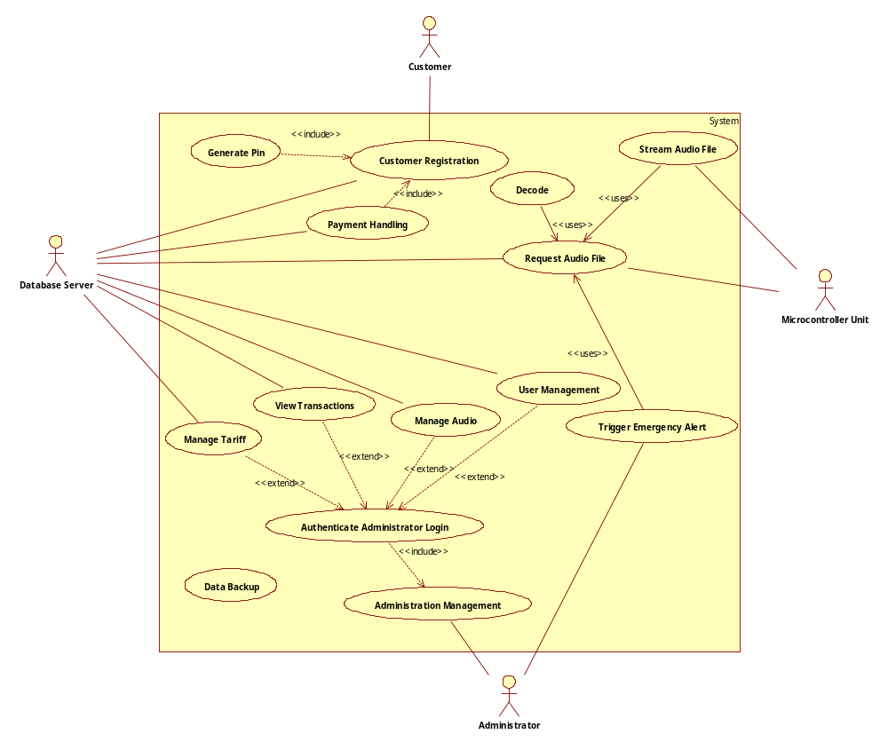

Customer Registration and Payment Handling

Data Flow Diagram

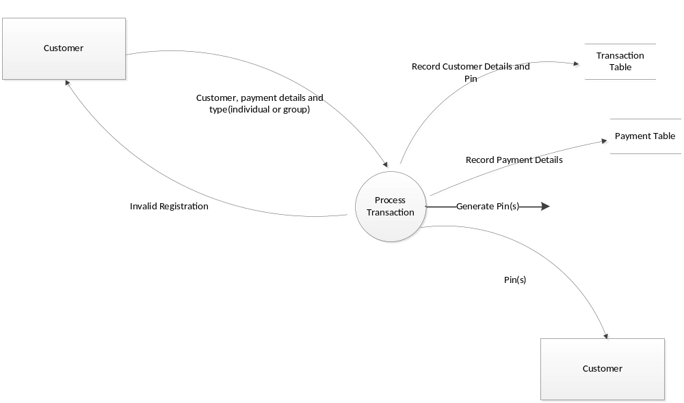

Finite State Diagram

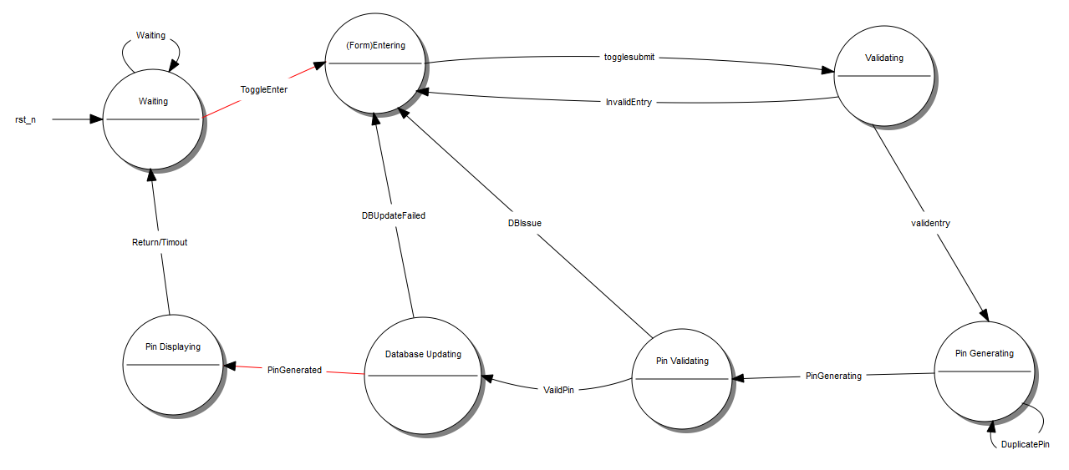

Sequence Diagram

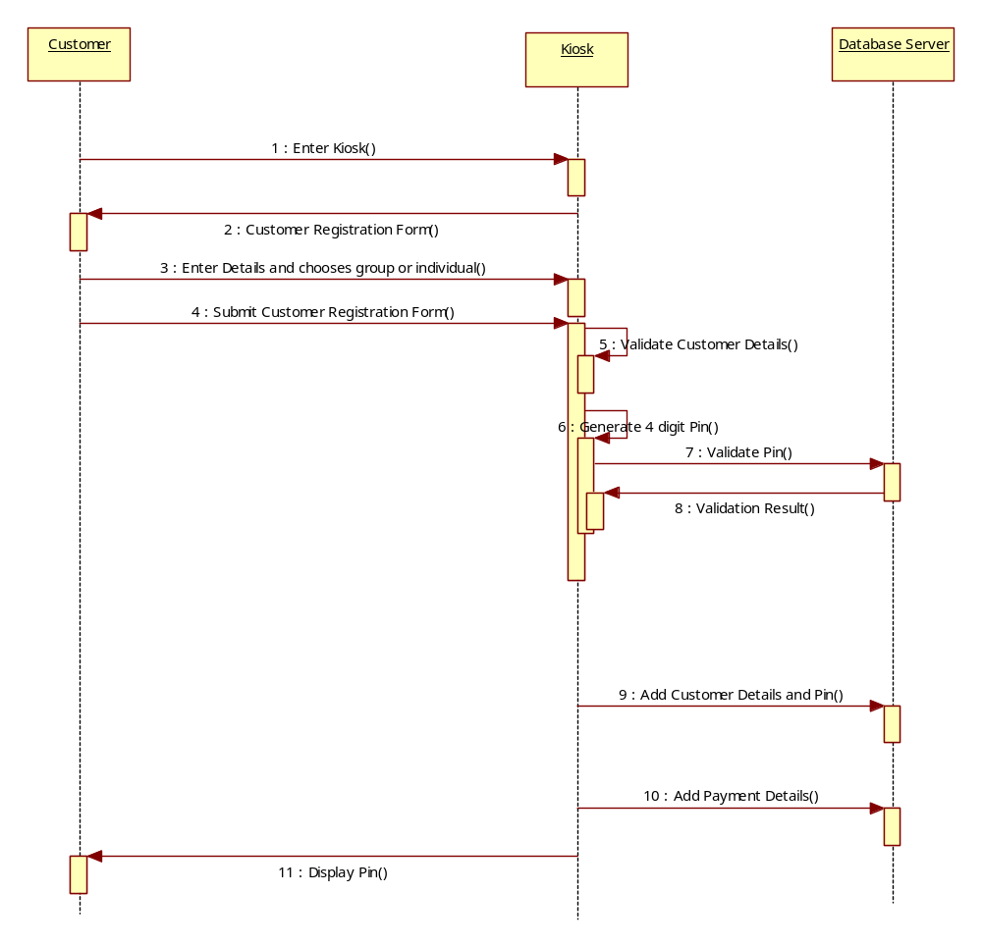

Code Structure Chart

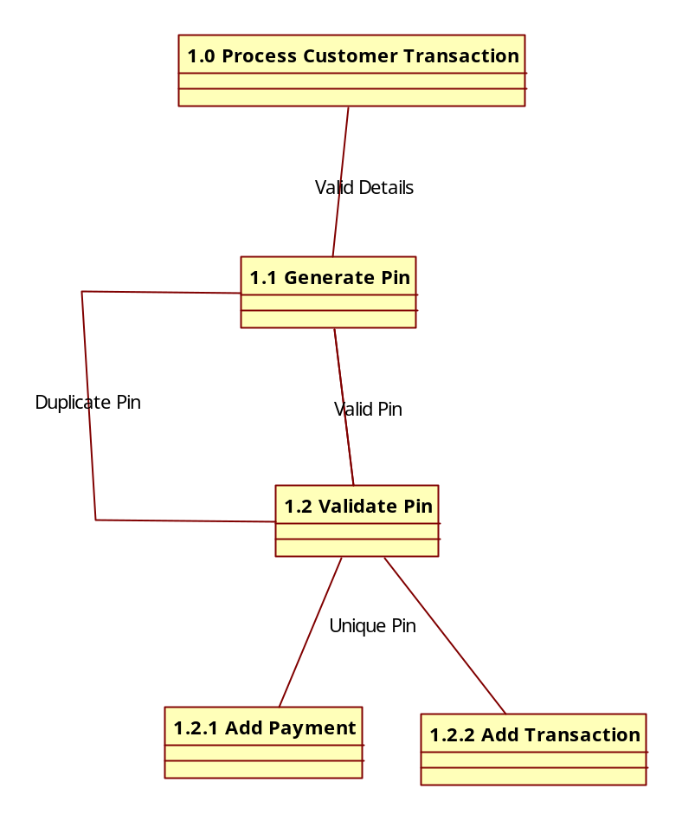

Administration Management

Finite State Diagram
The diagram below explains the states of the system for the Administration Management Requirement.

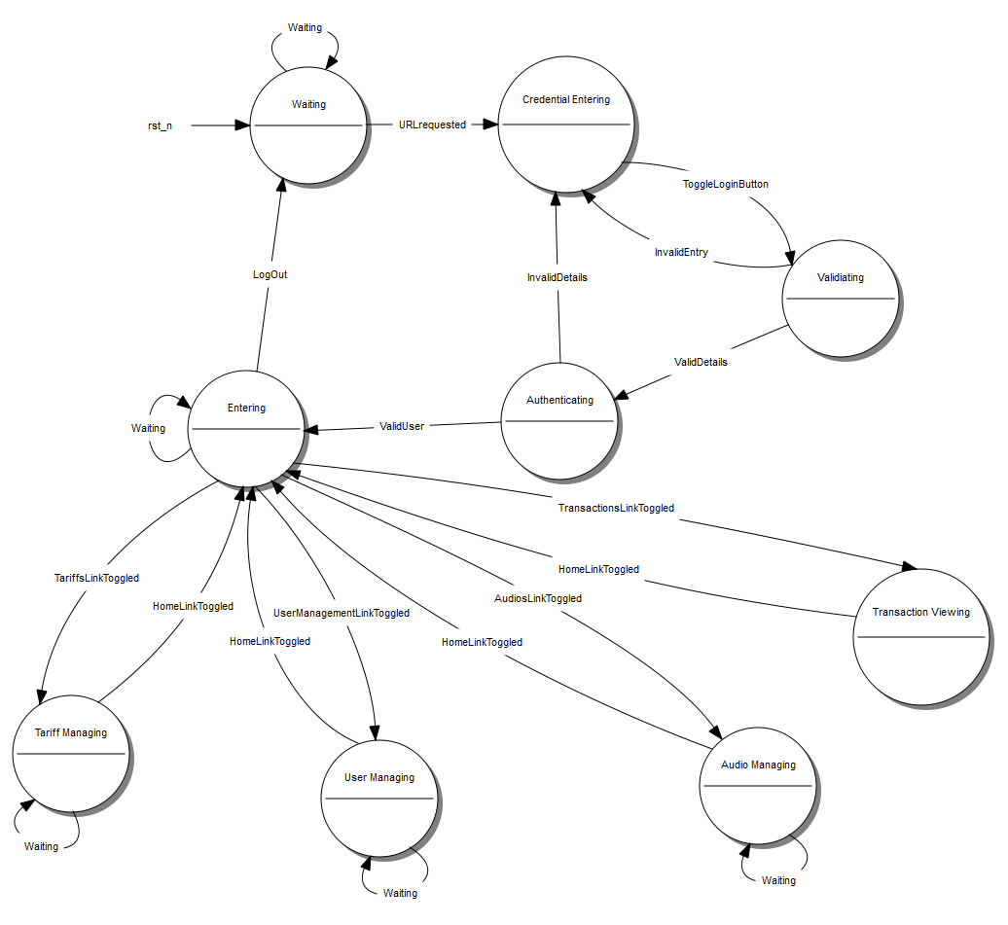

User Management

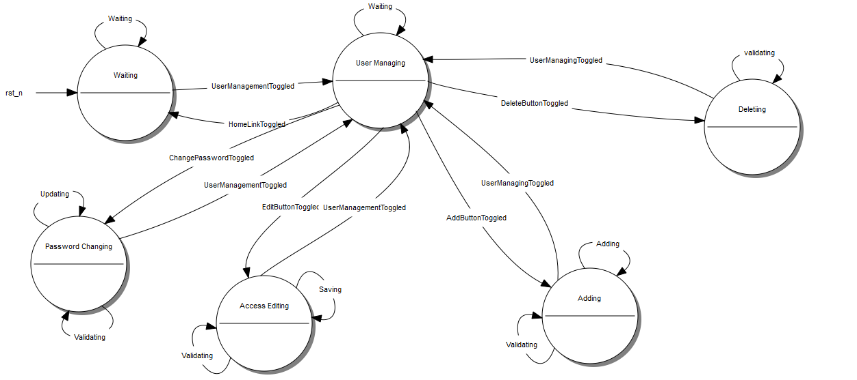

Tariff Management
Below is a Finite State Diagram explaining the states of the system for the Tariff management requirements

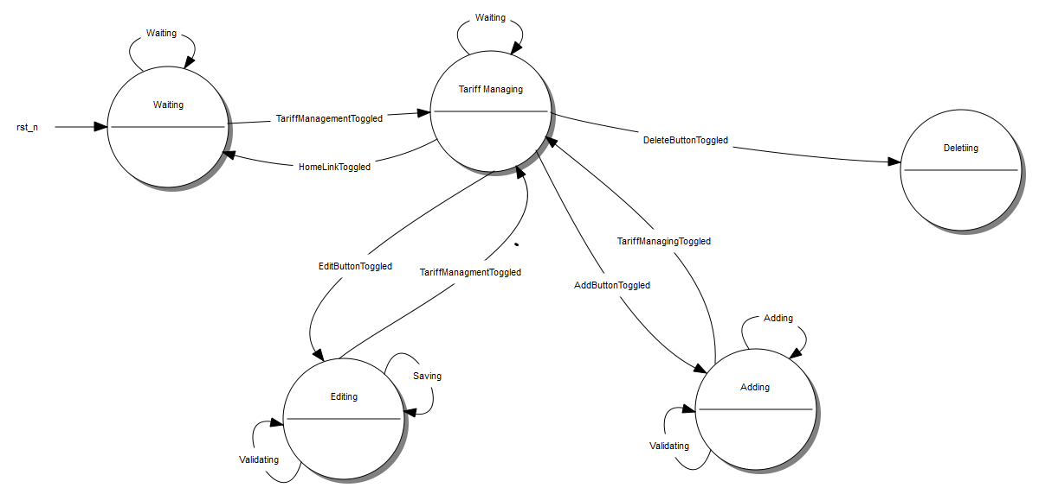

Audio Management
Below is a Finite State Diagram explaining the states of the system for the Audio management requirements

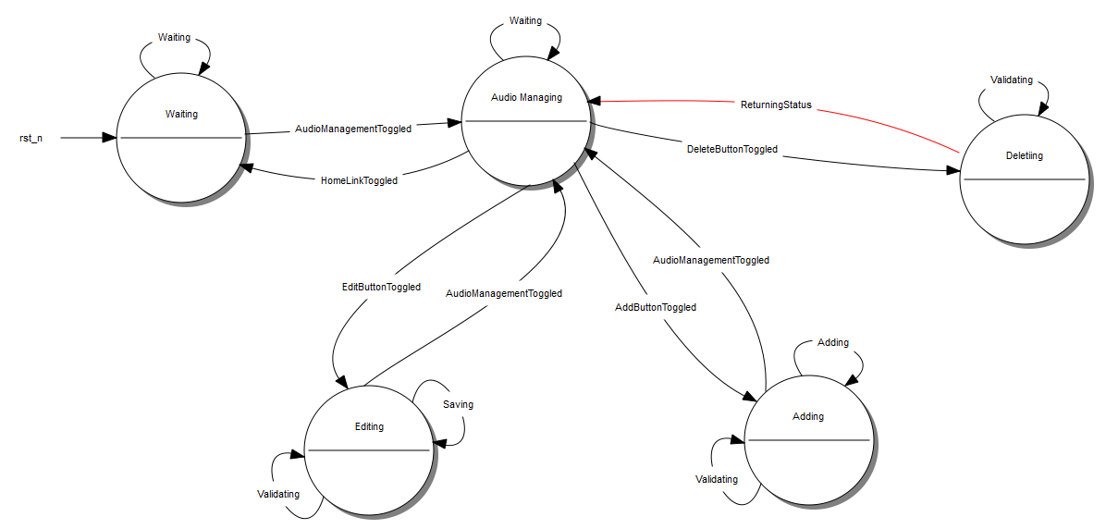

Code Structure Chart

Below is a code structure chart outlining the structure of code for the administration components of the web application that will be developed.

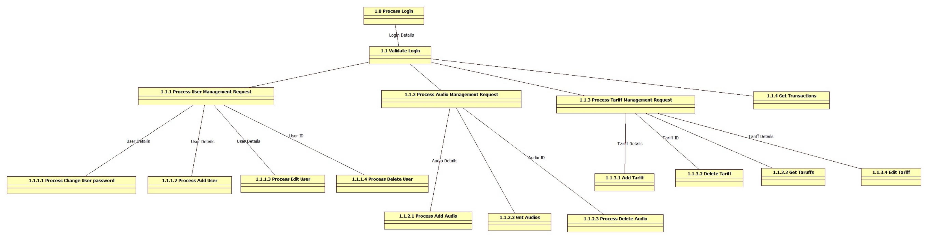

Kiosk Application
To cater for the requirements 8 .1.1(Customer Registration and Payment Handling) and 8.1.2 (Administration Management) we will implement a web application which will provide kiosk functionality to the customer and allow the administrator to perform routine needs upon successful authentication.
We have created an overall class diagram so that components can be reused within the code and it results in only one application being deployed onto the CDD to improve maintainability as only one application will need to be supported.
The application will be developed using Java J2EE and Spring’s web MVC framework connecting to a mySQL database.

Responsibilities
• Model
• View
• Controller

Package Diagram
Below is a package diagram to visually show how the kiosk application will be structured.
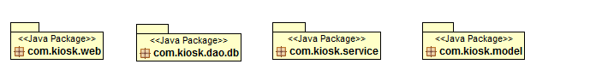

Description
- Com.kiosk.web package – This class contains all the Servlet’s and corresponds to the controller. These classes handle the requests from the view and act as a presentation layer to the application. They provide the object/variables for the view to use.
- Com.kiosk.Service – This class handles the business logic of the application. This is the interface between presentation layer and the database and enforces the routes and methods by which the business objects are accessed and modified.

- Com.kiosk .model - This class stores java beans. These are classes that are reusable and can be passed around.
- Com.kiosk.dao.db – These classes act as an interface between the database and the application. Only classes within these packages query the database. They should do no other task.

Attached is the initial class diagram for the kiosk. It is based on springs MVC framework and incorporates jmesa which allows you to dynamically render html tables which are configured within the controller component.

Kiosk Topology
Below is the kiosk topology. The kiosk will be deployed onto a tomcat application server and accessed via a web browser by the administrator and customers.
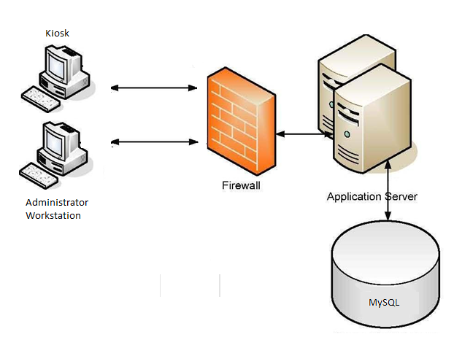

Kiosk Class Diagram
Below is the class diagram of how the kiosk will be modelled.
PRINT IN A3 AND COMPENSATE FOR THIS IN CONTENTS PAGE

Audio Distribution
RITA/NEVILLE et al

Data Backup
To eliminate the risk of data loss we will include backup functionality on the CDD. This will be scheduled to run each day to ensure the database can be re created in the event of
- Data Loss
- Disaster
- Database Server Issues
Below is the simple design behind the data backup requirement.

Finite State Diagram

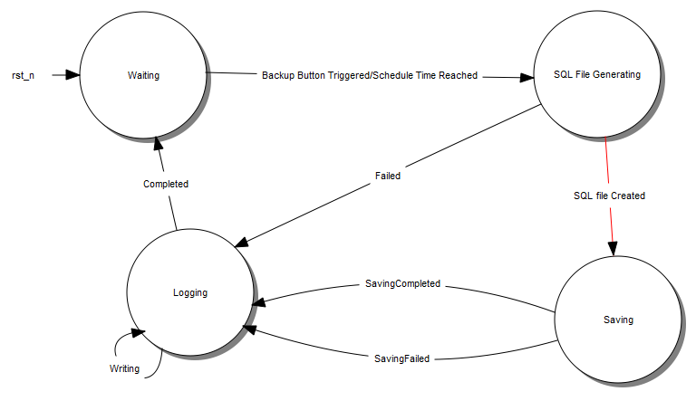

Database Server
To satisfy the requirements relating to the database (section 9 in Requirements document) we will configure a database to be situated on the database server. This will consist of several tables and provide the data source of the system. Below is the design of the database server.

System Diagram

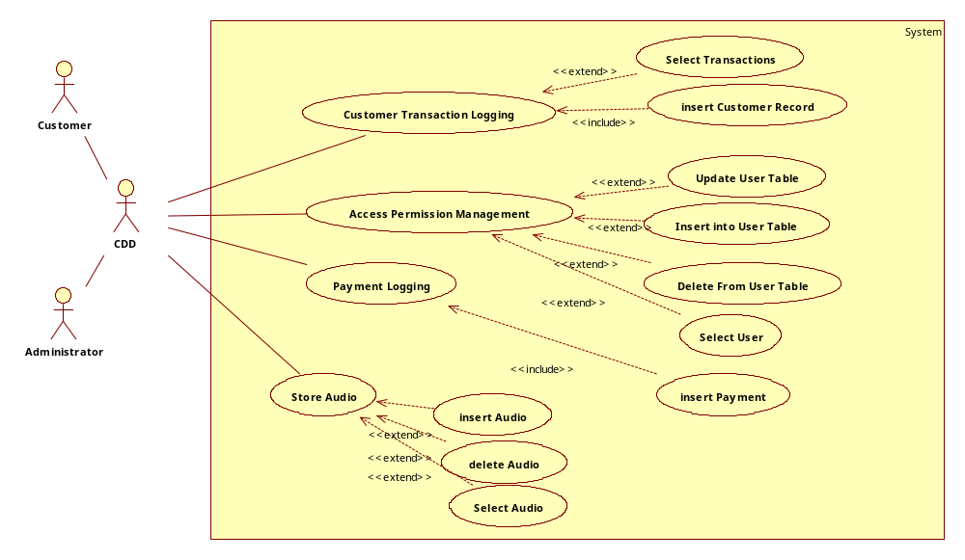

Entity Relationship Diagram
Here is an Entity Relationship Diagram to show the entity relationship model of the audio distribution system and provide the conceptual representation of data. This satisfies the requirements:
- Payment Handling
- Audio Storage
- Customer Transaction Logging
- Access Permission Management

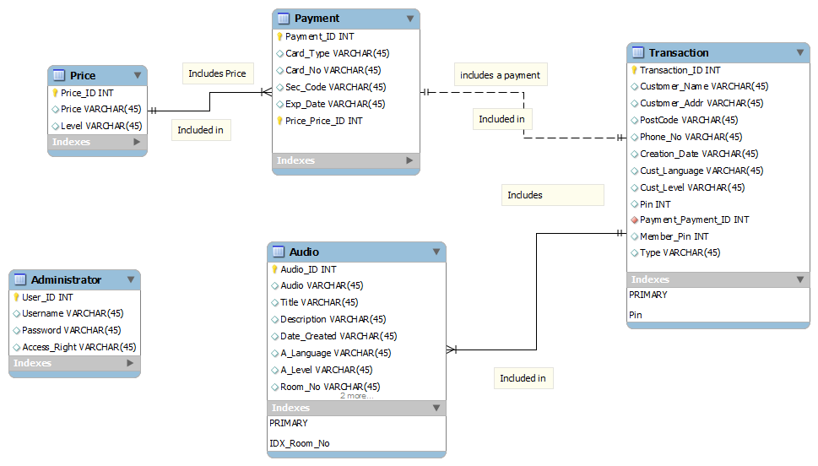

Data Model
This section describes the data structures and a set of operations used to manipulate and validate that data. The database model this system will use is described below.

Table Name: Audio
Description and Use:
This table stores the museums audios. They are stored as long blob’s to help prevent a max size exception and 2 columns are indexed to optimize the database. This table should have access permissions to allow, inserts, update, deletes and select statements.
Column Name | Data type | Indexes
Audio_ID | Int Auto_Increment (PK)
A_Level | Char(20)
Audio | Longblob
Title | Char(200)
Description | Char(200)
Date_Created | Date
A_language | Char(20) | Yes
Room_No | int | Yes

Table Name: Transaction
Description and Use: This table will store customer details and their random pin number generated by the kiosk. It will link to the payment table via the payment ID. This table should have access permissions to allow, insert and select statements.
Column Name | Data type | Indexes
Transaction_ID | Int NOT NULL AUTO_INCREMENT (PK)
TPaymentID | Int NOT NULL
Type | Varchar2(50)
Member_Pin | Int | Yes
Pin | Int NOT NULL | Yes
Customer_Name | Char (50)
Customer_Addr | Char(200)
PostCode | Char(20)
PhoneNo | Char(11)
Creation_Date | Date
Cust_Language | Char(20)
Cust_Level | Char(20)
Payment_Status | Char(20)

Foreign Key (TPayment_ID) references Payment(Payment_ID)

Table Name: Payment
Description and Use: This table will store the customer payment details. This table should have access permissions to allow, insert and select statements

Column Name | Data type | Indexes
Payment_ID | Int NOT NULL AUTO_INCREMENT (PK) | Yes
Card_Type | Char(20)
Card_No | (18)
Sec_Code | Int(4)
Exp_Date | Date
Payment_Amount | Double

Table Name: Price
Description and Use: This table stores price information on audio device hire. It stores the prices dependant on the level and is used to populate the customer details form to advise the customer the price to hire a device based on their knowledge level. This table should have access permissions to allow update, delete, insert and select statements
Column Name | Data type | Indexes
Price_ID | Int NOT NULL AUTO_INCREMENT (PK) | Yes
Price | Double
Audio_Level | Char(20)

Table Name: Administrator
Description and Use: This table is used to satisfy the use case access permission management. Administrators will be authenticated with the application in order to make changes and perform administrative duties. The application will use this table to check for valid users and provide them certain access based on their access rights. This table should allow insert, update, delete and select statements.
Column Name | Data type | Indexes
User_ID | Int NOT NULL AUTO_INCREMENT (PK) | Yes
Username | Char(20)
Password | Char(50)
Access_Right | Int

Microcontroller

The IGEP
Our chosen implementation for the microcontroller is the IGEP v2. The reason for this is that we have access to the hardware and some familiarity with its capabilities.

Operating system
The operating system we have chosen to use is Linux 2.6.35.14 because it is the most up to date known working version.

Power management

Finite State Diagrams

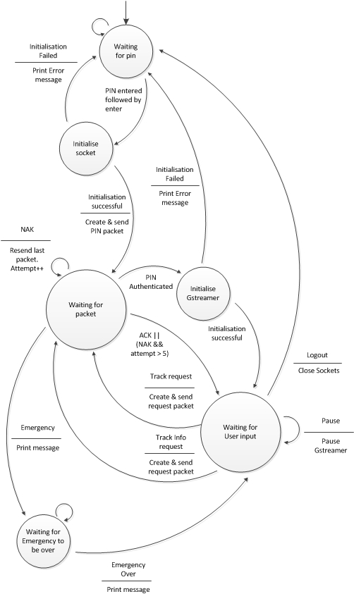

Communication

Protocol
The client and server will have 2 sockets open, one for control and one for data.
The data socket will be written to and read by Gstreamer.
The control socket packets will be made up of bit fields and strings. The string packets will be used for localisation information and track code. The bit fields will contain all the other information in binary so that packet size can be optimised. The packet Format will be <opcode><Information unique to command> followed by padding to the nearest byte, this means the opcode will start on the most significant bit.

Commands
General command format: Opcode followed by other binary information depending on which command is used.
Field | Size | Reason for size
Opcode | 3 bits | Only 3 bits are needed
Pin | 14 bits | To support 9999 possible PINs
Pass/Fail | 1 bit | Only a single bit is needed.
Group | 12 bits | This will give the maximum number of groups ever required with a maximum number of 9999 users since once you go past 5000 there will only be one user in the group
Actions | 3 bits | Only 3 bits are needed
String Size | 8 bits | We feel that 256 characters will be enough for track information.
Track information | Size will be read in from string size field | To save the amount of data sent over the network the size is variable
TrackCode | 18 characters | Mac addresses are 18 characters long including the null.
Actions | 2 bits | Only 2 bits are needed
Port | 16 bits | Maximum port number is 65535
IP | 32 bits | IP addresses are 32 bits in size

Pin Authentication request
The Opcode will be 001 in binary.
If the user wants to join or create a multicast group they'll enter the group number.
Client Packet format: <Opcode><Pin>[Group]
Client Example packet: 00101111010101010 – This packet would send the users pin to the server.
Server Packet format: <Opcode><Pass/Fail>
Server Example packet: 0010– This packet would tell the client the authentication of the pin failed.

Request Packet
The Opcode will be 010 in binary.
Actions | Code
Play | 01
Pause | 10
Track Information | 11
Client Packet format: <Opcode><Action>
Client Example packet: 01001 – This packet would request to play a track, the track code will be sent in the next packet.
Client Packet format: <TrackCode> TrackCode will be used to send a track number or a Mac address to request a track via localisation.
Client Example packet: “01:23:45:67:89:ab”
The server only needs to use the request packet to reply to a request packet when the action is track information.
Server Packet format: <Opcode><string size>
Server Example packet: 010111000 – This would tell the client the string packet they are about to receive is 56 characters.
Server packet: <track information>
Server Example packet: “The Track is about the Mona Lisa it is 4 minutes long”
The client will need send an ACK packet back to the server after both the binary and string packets.

Emergency stop packet
The Opcode will be 011 in binary. This packet will only be able to be sent from the server to the client. The client will respond with an ACK packet.
Server Packet format: <Opcode>[Information about emergency]
Server Example packet: 011

ACK packet
The Opcode will be 100 in binary. An ACK packet will be sent after every packet that does not require a response.
If the multicast controller sends a packet that normally is responded to an ACK packet, the controller will receive an ACK, but the followers of the multicast won’t receive the ACK.
Packet format: <Opcode>
Example packet: 100

NAK packet
The Opcode will be 101 in binary.
Packet format: <Opcode>
Example packet: 101

Multicast packet
The Opcode will be 110 in binary.
The multicast packet will be sent from the server to the client. It will contain the IP address and the port for Gstreamer to listen on.
Packet format: <Opcode><IP>< Port>
Example packet: 110111011110001111111111111111111110000011111010001 – This packet is sending the IP address 239.31.255.255 and port 2001

Example client server interaction
Client: 00101001010101000 – This packet would send the users pin to the server.
Server: 0011– This packet would tell the client the authentication of the pin passed.
Client: 010001 – This packet would request to play a track.
Server: 100 – The server sends back an ACK.
Client: “126” – This packet would select the track.
Server: 100 – The server sends back an ACK packet and it will also start sending the stream down the data socket.
Client: 010001 – This packet would request to play a track.
Client: “01:19:45:12:89:ab” – This packet would select the track using localisation.
Server: 100 – The server sends back an ACK packet and it will also start sending the stream down the data socket.
​Client: 010100 – This would request track information.
Client: “21:19:05:12:49:ac” – This packet would select the track using localisation.
Server: 010111000 – This would tell the client the string packet they are about to receive is 56 characters.
Client: 100 – The client sends back an ACK packet.
Server: “The Track is about the Mona Lisa it is 4 minutes long”
Client: 100 – The client sends back an ACK packet.

Networking
For the users to travel throughout the museum with seamless transition between routers there will need: to be one control router and many repeater routers. This works nicely to allow localisation using the MAC address of the repeater to determine the users’ location.
Wi-Fi routers:
Master
- Connected to the server via Ethernet
- Running DHCP
- Multicast Enabled
- Broadcasting MAC address
Slaves
- Repeaters of master router
- Multicast Enabled
- Broadcasting MAC address

GStreamer
Gstreamer uses a pipeline architecture that allows it to be extremely flexible in its operation. The pipeline setup we’re going to use is shown in the diagram below. The server will read the Ogg file in and will be piped into the socket to stream to the client. Gstreamer on the client will read from the socket and pipe this into the Ogg-demuxer which separates Ogg pages into Ogg packets. The output of Ogg-demuxer will be piped into the Vorbis-decoder where the Ogg packets will be decoded into PCM data. The output of the Vorbis decoder will be piped into the converter which will convert the PCM into the correct PCM format for the output device.
Converter
src
Sink
File-source
src
Sink
Audio-output
src
Sink
Ogg-demuxer
src
Sink
Vorbis-decoder
src
Sink
Socket
src
Sink

