Document Change History
Version Number | Date | Contributor | Description
V1.00 | 14/09/2025 | TBD | 1st Issue

Table of Contents

Radxa X4

RS (UK)
Link | Part No | Cost
https://uk.rs-online.com/web/p/rock-sbc-boards/0329065?gb=s  Raxda X4 | 329-065 | £62.22
https://uk.rs-online.com/web/p/rock-sbc-add-ons/0329071?gb=s  Heatsink | 329-071 | £12.97
Just find one on amazon  Kioxia SSD 256GB M.2 2230 30mm NVMe PCIe Gen3 x4 BG4 Solid State Drive | KBG40ZNS256G | £20.82
https://www.ebay.co.uk/itm/405999860228?_skw=Genuine+LattePanda+Power+Adapter+PD45%2BQC3.0+-+UK+Plug+Supplied&itmmeta=01K53V7W3NECQR2G0DWN4Z6SQS&hash=item5e877a3a04:g:xj8AAOSw165oXTKM&itmprp=enc%3AAQAKAAABAFkggFvd1GGDu0w3yXCmi1c0nYMcFa6qr2GcvbZ6CGjBxw9gOb61esiqsNy30ZGBtWw0PVnnTl4QLwMVESYMASs3tDPzJNhMxjtJd8xI0zbPMfX%2BHWHXCtDDaEcbz8apH3bMbVMTFzL0Q3NtrYBr8bLy0CwmDcQAZkh3n8S0jcwunxZsTR8cdtIqN3w3eeZTa2hJwB8JNnykENmtqNP%2FLZPzaSnxmv46Pnddquls0gLqtc%2B4YnYePQO9a46QnMNl%2B7%2FlkV3IuyfHGZLvI43ojWvfqHGXK6hqEFT0AHbNoL1pqMBQF8XhVwGSWI7NU5sbs4J0A2rJbCSjrHUzWztEmbc%3D%7Ctkp%3ABk9SR47Cn_uoZg  PD45W PSU (I got mine from Ebay) – I’m assuming any PD45 or greater supply will work | Lattepanda XYY-PD45X | £22

Grove Parts
Farnell

https://uk.farnell.com/c/single-board-computers-maker-education?st=Grove
or PiHut

https://thepihut.com/search?q=Grove&narrow_by=Brand%2CSeeed&sort_by=relevency&page=1

Some of the ones I use in my training and examples are listed.

Farnell (one day I’ll put the Pihut list)
I have drivers for lots of parts – just browse by part number.
Link | Part No | Cost
https://uk.farnell.com/seeed-studio/110070025/yellow-wrapper-1-x2-grove-modules/dp/4007853  Lego holders | 110070025 | £1.62
https://uk.farnell.com/seeed-studio/110070021/yellow-wrapper-1-x1-grove-modules/dp/4007848  1x1 Lego holders | 110070021 | £1.82
https://uk.farnell.com/raspberry-pi/raspberry-pi-pico/mcu-board-rpi-pico-264kb-133mhz/dp/3643332  PICO 2040 (might need some header pins) | 3643332 | £3.55
https://uk.farnell.com/seeed-studio/103100142/shield-board-raspberry-pi-pico/dp/4007893  PICO Grove Header | 103100142 | £4.06
https://uk.farnell.com/seeed-studio/104020208/oled-display-board-0-96-arduino/dp/4007806  OLED Screen 64x128 | 104020208 | £5.93
https://uk.farnell.com/seeed-studio/101020083/gesture-sensor-arduino-board/dp/4007691  Gesture Sensor | 101020083 | £10.62
https://uk.farnell.com/seeed-studio/101020557/sensor-array-modul-arduino-raspberry/dp/4007713  Thermal Sensor | 101020557 | £32.10
https://uk.farnell.com/seeed-studio/104030001/grove-lcd-rgb-backlight-display/dp/3932101  RGB Backlit 16x2 LCD | 104030001 | £12.41
https://uk.farnell.com/seeed-studio/110061283/starter-kit-raspberry-pi-pico/dp/4007895  Kit of bits | 110061283 | £38.09

PCB Parts
We got the parts made by SafePCB (https://safe-pcb.com/safe_pcb/) mainly because we had an account already.
The price was £33.10 for 2 (price goes down radically for more!)

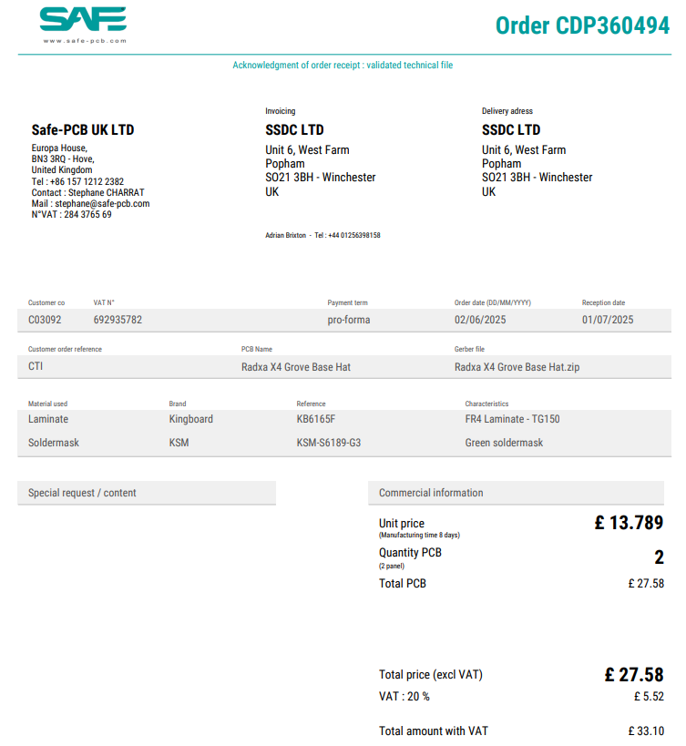

Link | Part No | Cost
https://thepihut.com/products/grove-female-header-dip-4p-2-0mm-10-pack  Grove PCB Connector | SKU: 103317 | £1
https://thepihut.com/products/40-pin-extra-tall-header-push-fit-version-no-shroud  Pi Header pass-thru | SKU: 103608 | £2
https://www.amazon.co.uk/Position-Vertical-Switch-Pieces-Electrical/dp/B0CP95V85G  2 Position DPDT 2P2T 6 Pin PCB Panel Miniature Vertical Slide Switch | Pin Spacing  3 x 2mm/0.24" x 0.16"(L*W)  EAN 712662130963 | Pennies (I have some spare)
Google part??  SPI Connector | 2.54 pitch header | Pennies – I cut up a bigger one

