Each form in Purchase Module requires:
- TIN: changed to ABN
- Can we suppress the time stamp on the forms (DD/MM/YYYY only)

Request for Quotation
- Shipping Address information incorrect. Needs to show Warehouse address only NOT Concept Postal Address. CONTACT NAME and CONTACT Shipping address to be used. Need to look at how this is configured.
- Add heading Supplier Address:
- Supplier address panel information to be sourced from main CONTACT address panel??
- Add ORDER DATE: DD/MM/YYYY to show right justified above line
- Description values to be extracted from <PRODUCT NAME> and <INCI NAME> fields
- Remove Heading EXPECTED DATE as this is not required
- Rearrange the headings to ensure the DESCRIPTION field has sufficient size to show value.
- Remove Banking details as not relevant.
Revised Text to send a Request for Quotation
- Please advise if this is possible???
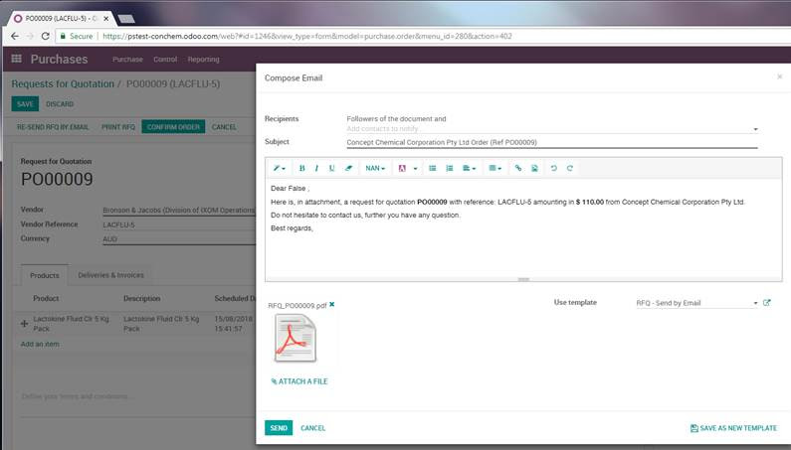
Subject Line: Request for Quotation from Concept Chemical Corporation Pty Ltd <PO NUMBER>
Dear <CONTACT NAME>,

Please find attached our Request for Quotation <PO number> from Concept Chemical Corporation Pty Ltd.
-----------------
Picking Operations (Picking Slip)
- Add name of form – Picking Slip
- Shipping Address information incorrect. Needs to show Warehouse address only NOT Concept Postal Address
- PRODUCT – display values from PRODUCT NAME and INCI NAME fields e.g. Acritamer 2020 20 Acrylates/C10-30 Alkyl Acrylate Crosspolymer
- Change heading LOT/SERIAL NUMBER to LOT/BATCH #
- Remove values of qty to be picked from under this heading e.g. 100.000. We just need to show the Lot/Batch number
- Remove heading DESTINATION and values. This information is provided above in Warehouse address.
- Change order of headings to – PRODUCT, LOT/BATCH #, QUANTITY
- Remove Banking details, on bottom of form, as not relevant.

Delivery Slip – we would use this as an Expected Delivery Advice to warehouse of product from the supplier
- Change name of form to Expected Delivery Slip
- Delivery Address change to Supplier Address:
- PRODUCT – display values from PRODUCT NAME and INCI NAME fields e.g. Acritamer 2020 20 Acrylates/C10-30 Alkyl Acrylate Crosspolymer
- Remove Banking details, on bottom of form, as not relevant.

Purchase Order Confirmation
- Shipping Address information incorrect. Needs to show Warehouse address only NOT Concept Postal Address. CONTACT NAME and CONTACT Shipping address to be used. Need to look at how this is configured.
- Need new Header – Supplier address: above where Rita address details are showing
- Under heading DESCRIPTION show values from <PRODUCT NAME> and <INCI NAME> e.g. Acritamer 980 20 Carbomer. Some INCI Names are long therefore field may need 2 lines to display.
- Change header DESCRIPTION to PRODUCT
- TAXES column and values - please remove
- DATE REQ. column and values – please remove
- UNIT PRICE – change wording to PRICE PER KG
- Taxes heading under Subtotal – change to GST
- Remove Banking details, on bottom of form, as not relevant.
- This form does not show when pricing is different to AUD (Australia dollars). If the Currency field shows a value that does not equal AUD please display the currency value after Subtotal and Total headings. E.g. Subtotal USD and Total USD.

Revised Text to send a Purchase Order Confirmation
- Please advise if this is possible???
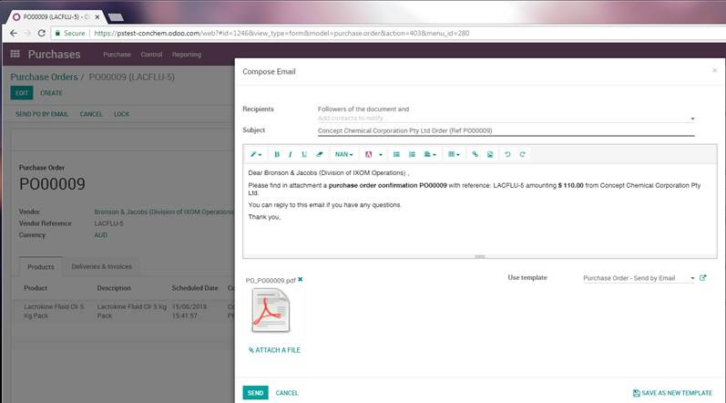
Subject: Purchase Order Confirmation <PO NUMBER> from Concept Chemical Corporation PTY LTD

Dear <VENDOR>,

Please find attached our Purchase Order <PO NUMBER> for Product <PRODUCT NAME>.

Can you advise the expected delivery date into our warehouse.

