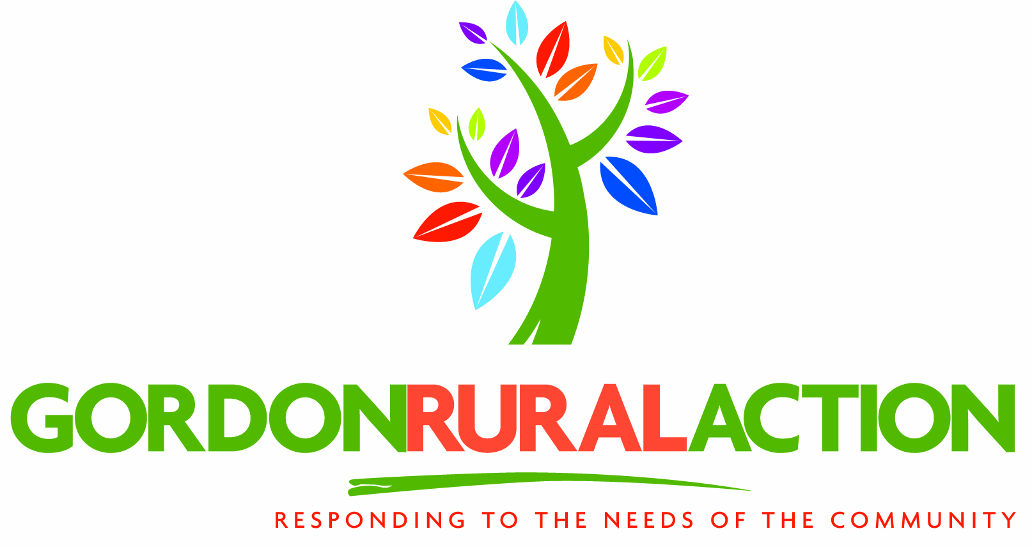
PRIVATE & CONFIDENTIAL

GORDON RURAL ACTION VOLUNTEER APPLICATION FORM

Volunteers play a vital role in ensuring the smooth running of various projects involved in the statutory and voluntary sector, many within the Gordon Rural Action network. Often a volunteer may be given or hear personal details and information in connection with their volunteering. It is important to remember that this should be treated as confidential and not repeated out with the project.

To find the appropriate volunteering opportunity for you, it is helpful to have some more information about yourself, your interests and what you would feel comfortable doing. Not every volunteer has the ability or desire to undertake all the duties required for example in offering “care” in all its aspects. Remember you have choice and you are choosing to be a volunteer.

Where did you hear about Gordon Rural Action?

Newspaper Article □ Poster/Leaflet □ Newsletter □
Personal Contact/Talk□ Word-of-mouth□ Other □

Which Advice Centre are you interested in volunteering for?
Inverurie Ellon
Outreach Huntly

TITLE: Mr Mrs Miss Ms Other ……………………………………………….
(please circle)

FIRST NAMES …………………………………………………………………………

SURNAME …………………………………………………………………………

ADDRESS …………………………………………………………………………
…………………………………………………………………………
…………………………………………………………………………
POSTCODE ………………………………

HOME TELEPHONE ………………………… DAYTIME TEL. NO. ……………………

EMAIL: …………………………………………………………………..

DATE OF BIRTH ………………………………

NAME AND ADDRESS OF AN EMERGENCY CONTACT: ………………………………..
……………………………………………………………………………………………………………………………………………………………………………………………………………….

HEALTH Do you consider yourself to have a disability? YES/NO

Do you have a medical history or ongoing medical condition of which we should be aware? YES/NO

If yes please give full details: ……………………………………………………………………
……………………………………………………………………………………………………………………………………………………………………………………………………………………………………………………………………………………………………………………….

TRANSPORT

Do you have a Driver’s licence? YES/NO
Do you have the use of a car? YES/NO
Would you be willing to use it for volunteering opportunities? YES/NO

MORE ABOUT YOURSELF

Are you new to volunteering? YES/NO

Please indicate your occupation/work experience past and present: ………………………
………………………………………………………………………………………………………………………………………………………………………………………………………………………………………………………………………………………………………………………
………………………………………………………………………………………………………………………………………………………………………………………………………………………………………………………………………………………………………………………

Are you presently: in paid employment □ Not working □ Retired □
Student □ Self-employed □

Have you any training/experience in the care of people? YES/NO
If YES tell us about your experience: …………………………………………………………
………………………………………………………………………………………………………………………………………………………………………………………………………………
………………………………………………………………………………………………………

Your hobbies/interests (past and present) …………………………………………………….
………………………………………………………………………………………………………………………………………………………………………………………………………………

Why do you want to volunteer? ……………………………………………………………….
………………………………………………………………………………………………………………………………………………………………………………………………………………………………………………………………………………………………………………………

Some volunteers like to learn more about the work they are doing and training is possible. This is not compulsory in most cases you can choose. However for advice giving and counselling, ongoing training is necessary.

Would you like to attend training? YES/NO

WHAT DAYS/TIMES ARE YOU AVAILABLE FOR VOLUNTARY WORK?

Any period not suitable? E.g. holidays From: To:
Please send form back to—Gordon Rural Action, Huntly Business Centre, Gordon Street, Huntly, AB54 8FG
01466 793676
Days | Morning  From/to | Afternoon  From/to | Evening  From/to
Monday
Tuesday
Wednesday
Thursday
Friday
Saturday
Sunday
The Rehabilitation of Offenders Act 1974

Within the terms of the rehabilitation of offenders Act 1974 (Exemptions) Order 1965, you are asked to disclose any convictions which have been imposed on you whether they would, in the terms of the Act be classed as “spent”. The Information will, of course, be treated with the strictest confidence. Having a conviction does not automatically stop you from being a volunteer.

Many projects involve working with vulnerable people. Do you have any objection to having a Disclosure Scotland check done? Yes □ No □

Please supply the names and Addresses of two people (not relatives) who would be willing to act as referees.

1. Name ………………………………….. 2. Name ……………………………………

Address ………………………………. Address …………………………………
………………………………. …………………………………
………………………………. …………………………………

Post Code ……………………………… Post Code ………………………………….

You are asked to sign and date the following declaration:

I wish to offer my services as a volunteer indicated by the foregoing. I believe I am medically fit and have the ability to carry out duties for which I have offered my services. I have read and understood the statement about “criminal offences” shown above and have declared any relevant information to Gordon Rural Action. I understand that while carrying out any volunteering duties I agree to abide by the rules of confidentiality.

Signature ………………………………………………………. Date ………………………..

Please return to – Laura Craig, Gordon Rural Action, Huntly Business Centre, Gordon Street, Huntly, Aberdeenshire, AB54 1FG.
Please send form back to—Laura Craig, Gordon Rural Action, Huntly Business Centre, Gordon Street, Huntly, AB54 8FG
01466 793676
Please send form back to—Laura Craig, Gordon Rural Action, Huntly Business Centre, Gordon Street, Huntly, AB54 8FG
01466 793676

