WEEK 4 CAPSTONE PROJECT

Web Application Security
Assessment Report
Mediroza General Hospital
Assessment type | Black-box web application security assessment
Target stated in source report | https://medirozahospital.com
Overall risk reported | CRITICAL — urgent remediation recommended
Findings reported | 7 vulnerabilities (Medium, High, and Critical)
Prepared for | Networkwalks Week 4 Capstone Project
Networkwalks • Batch B083 • Week 4

1. Executive Summary
The supplied Week 4 assessment report documents a black-box security assessment of the Mediroza General Hospital web application. According to that report, seven vulnerabilities were identified across authentication, access control, document protection, metadata handling, server configuration, and backup exposure. The most consequential issues were a SQL injection flaw that reportedly bypassed the patient-portal login, directory listing that exposed an old SQL backup, and sensitive staff and shareholder information stored in that backup in readable form.
The report describes an attack chain in which weak login controls enabled access to patient report PDFs; weak PDF passwords and embedded metadata then exposed a path to a publicly browsable backup directory. The source report rates the overall posture as CRITICAL and recommends immediate remediation, prioritising SQL injection and public backup exposure.
This document summarises the findings and recommendations in the supplied sample report and Week 4 evidence notes. It does not independently validate the target, repeat exploitation, or confirm whether remediation has since occurred.

2. Scope and Methodology
The source report states that the assessment was limited to the target domain below, with social engineering, denial-of-service testing, and testing outside the agreed domain excluded.
Target: https://medirozahospital.com
The documented methodology comprised:
- Reconnaissance using publicly available information and web-based tools.
- Vulnerability identification focused on authentication and input handling.
- Controlled exploitation to demonstrate potential impact, as described in the source report.
- Documentation of findings, evidence, risk levels, and remediation recommendations.
Tools named in the source report include curl, browser developer tools, Networkwalks Hash Calculator and Password Cracker, qpdf, ExifTool, wget, and ChatGPT for converting raw SQL records into readable tables.

3. Findings Summary
# | Finding | Location | Risk | Summary
1 | Username enumeration | patient/login.php | Medium | Different login errors reportedly revealed whether a username existed.
2 | SQL injection login bypass | patient/login.php | Critical | Input handling reportedly allowed authentication to be bypassed.
3 | Patient PDFs accessible after bypass | patient/reports/ | High | Three patient report PDFs were reportedly downloadable after portal access.
4 | Weak PDF passwords | patient_report_*.pdf | High | The source report states all three PDF passwords were recovered using wordlists.
5 | Sensitive PDF metadata | patient_report_3.pdf | Medium | Embedded metadata reportedly disclosed an internal comment pointing to a backup location.
6 | Public backup directory listing | /old/ | Critical | Directory listing reportedly exposed an old SQL database backup.
7 | Sensitive information in backup | /old/mediroza_db_backup_2019.sql | Critical | The backup reportedly contained 30 staff records and 10 shareholder records in readable form.
Risk ratings above are reproduced from the supplied report; they have not been independently reassessed in this summary.

4. Attack-Chain Summary
- Reconnaissance reportedly identified hidden paths, including /patient and /old.
- Different login error messages enabled username enumeration.
- A SQL injection flaw reportedly bypassed patient-portal authentication.
- Three patient report PDFs were accessed through the portal.
- Weak PDF passwords were reportedly recovered using password wordlists.
- PDF metadata disclosed a comment pointing to the old backup directory.
- Directory listing exposed the SQL backup, which reportedly contained staff salary and shareholder information.
The chain demonstrates how individually manageable weaknesses can combine into a wider confidentiality incident. Authentication, document handling, metadata hygiene, server configuration, and backup storage should therefore be treated as connected security controls rather than isolated issues.

5. Business and Security Impact
- Patient confidentiality: unauthorised access to medical report documents was reported.
- Employee privacy: the backup reportedly exposed personal and employment information, including salary data.
- Corporate confidentiality: shareholder names and ownership information were reportedly exposed.
- Operational and compliance risk: a real incident of this nature could trigger investigation, notification obligations, reputational damage, and loss of trust, depending on applicable law and verified circumstances.
- Attack-surface amplification: metadata and directory listing reportedly helped connect the initial application weakness to the backup exposure.

6. Remediation Plan
- Immediate / Critical: Remove the SQL backup from the public web root; disable directory listing; restrict backup access; investigate web logs and determine whether exposed data was accessed.
- Immediate / Critical: Fix SQL injection using parameterised queries or prepared statements. Avoid constructing SQL statements by concatenating user input.
- High priority: Enforce server-side authorisation for every patient report request. Store sensitive documents outside the public web root and serve them only after access checks.
- High priority: Replace weak document passwords with strong, unique protection where encryption is necessary; avoid relying on PDF passwords as the only access-control mechanism.
- Medium priority: Use a generic login error for all failed authentication attempts, apply rate limiting, and monitor repeated login failures.
- Medium priority: Remove unnecessary metadata and internal comments from documents before release; include metadata checks in the document publishing workflow.
- Ongoing: Rotate any credentials or secrets that may have been exposed; review backup retention and access controls; perform a follow-up security test after fixes.

7. Verification Checklist
☐ Prepared statements are used for database queries receiving user input.
☐ Failed login attempts return consistent, generic responses.
☐ Patient documents require server-side authentication and per-record authorisation.
☐ Directory indexing is disabled across the web server.
☐ No database dumps or backups are stored in publicly accessible directories.
☐ Backups are encrypted where appropriate and access is limited and audited.
☐ PDF/document metadata is reviewed and stripped of internal comments before publication.
☐ Security logs have been reviewed for suspicious access; relevant credentials and secrets have been rotated where warranted.
☐ A retest confirms that each reported finding is remediated.

- Evidences

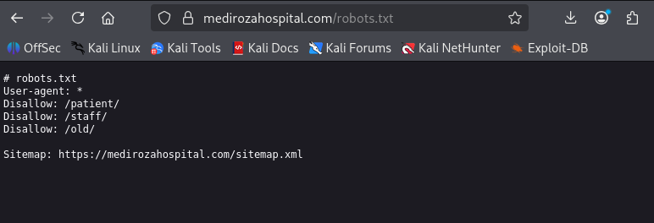

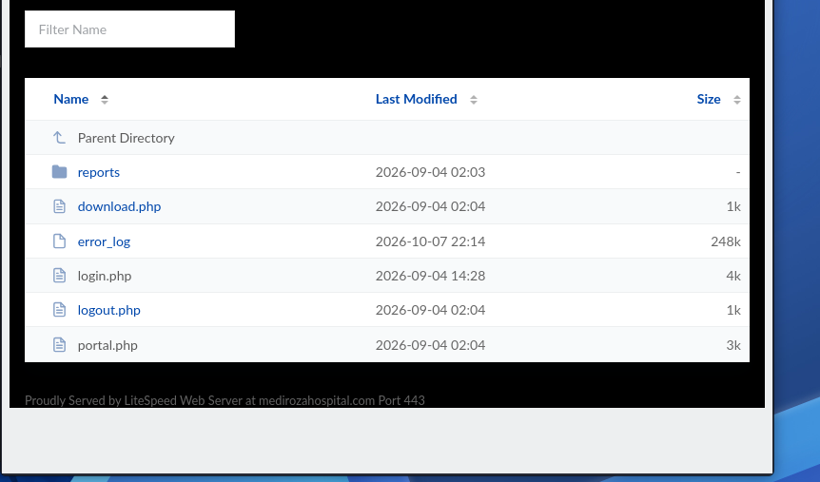

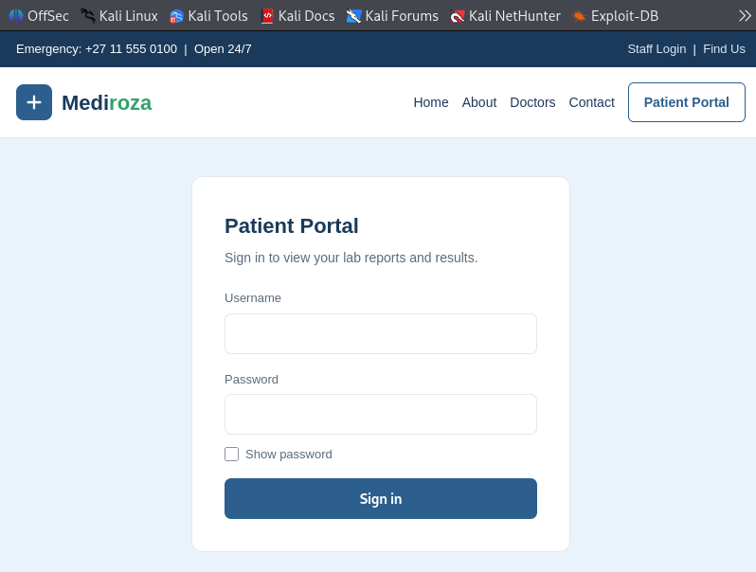

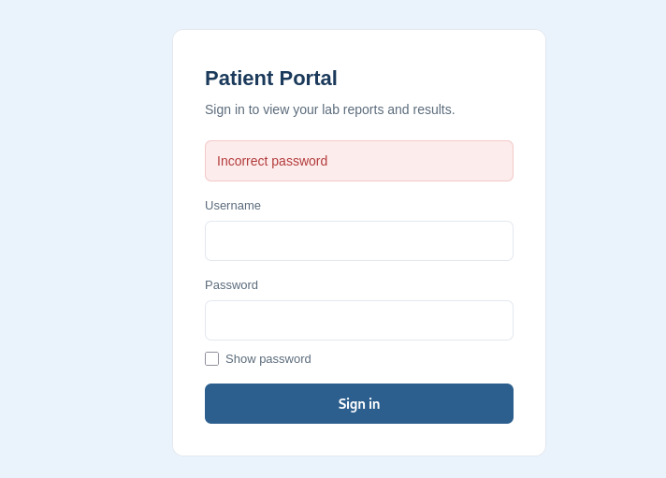

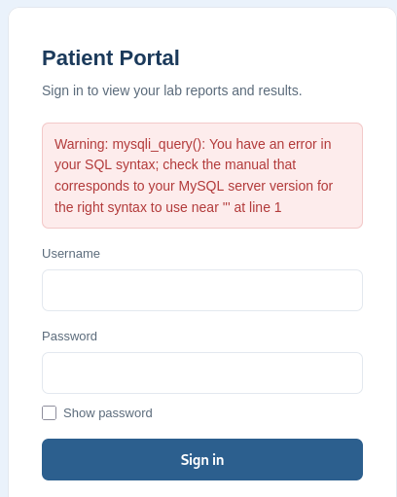

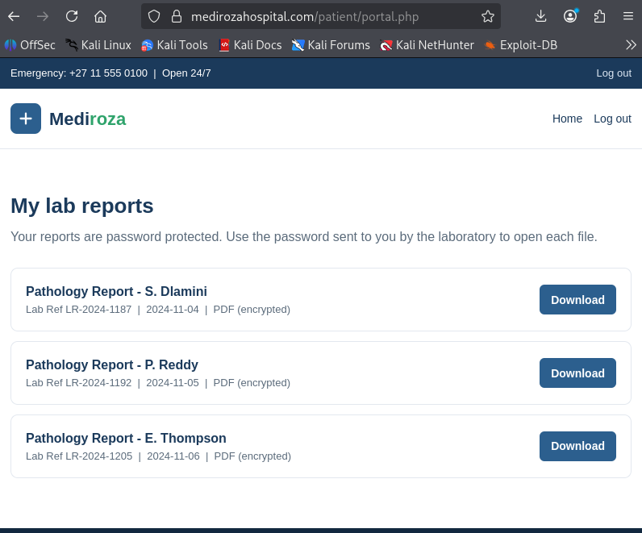

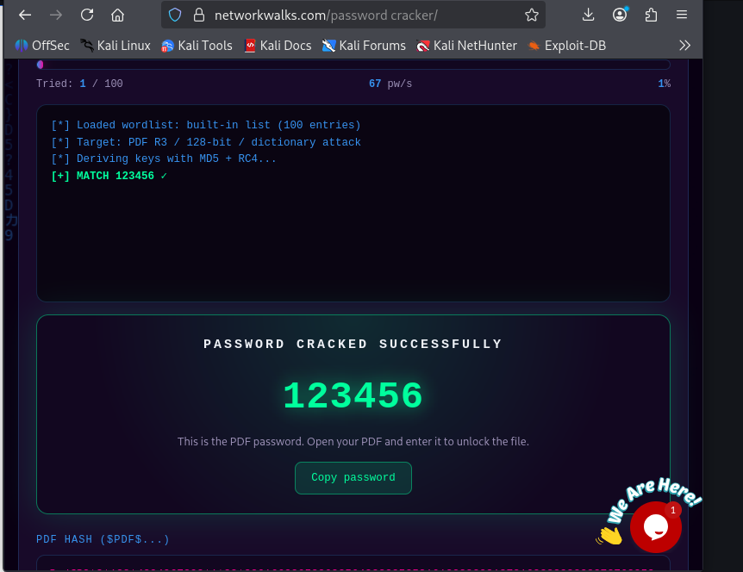

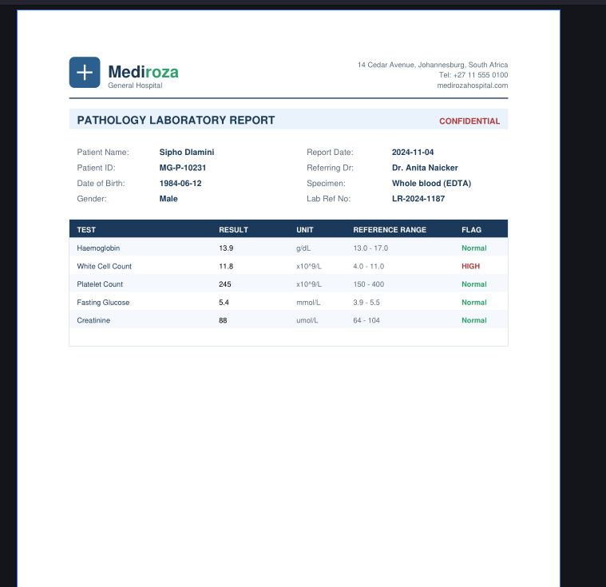

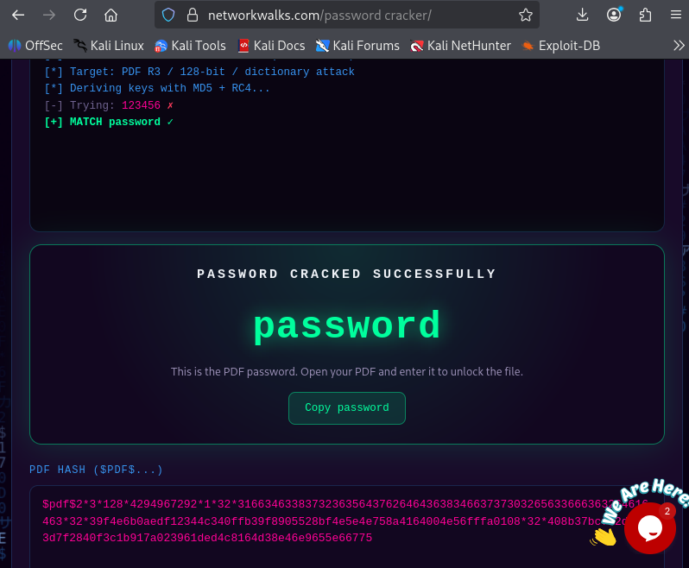

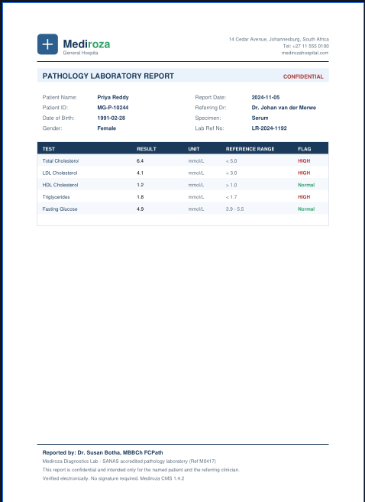

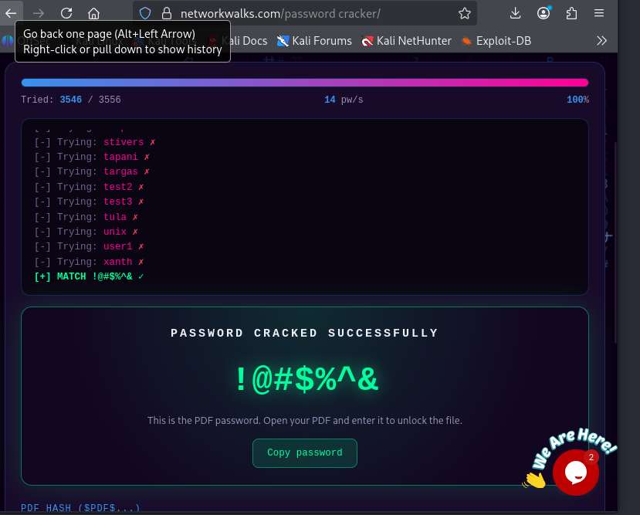

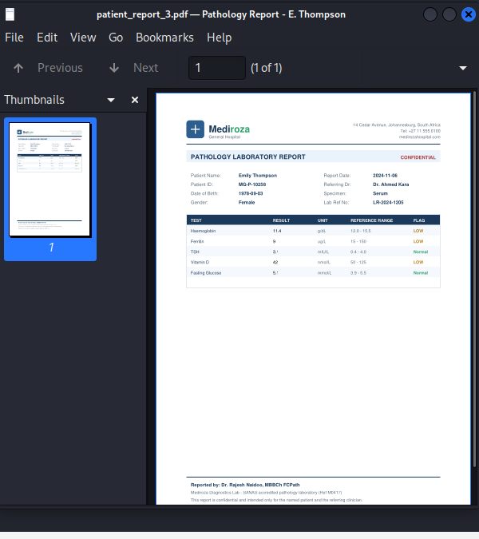

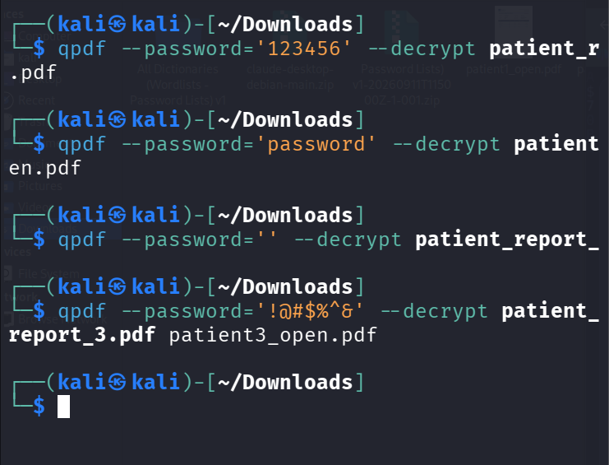

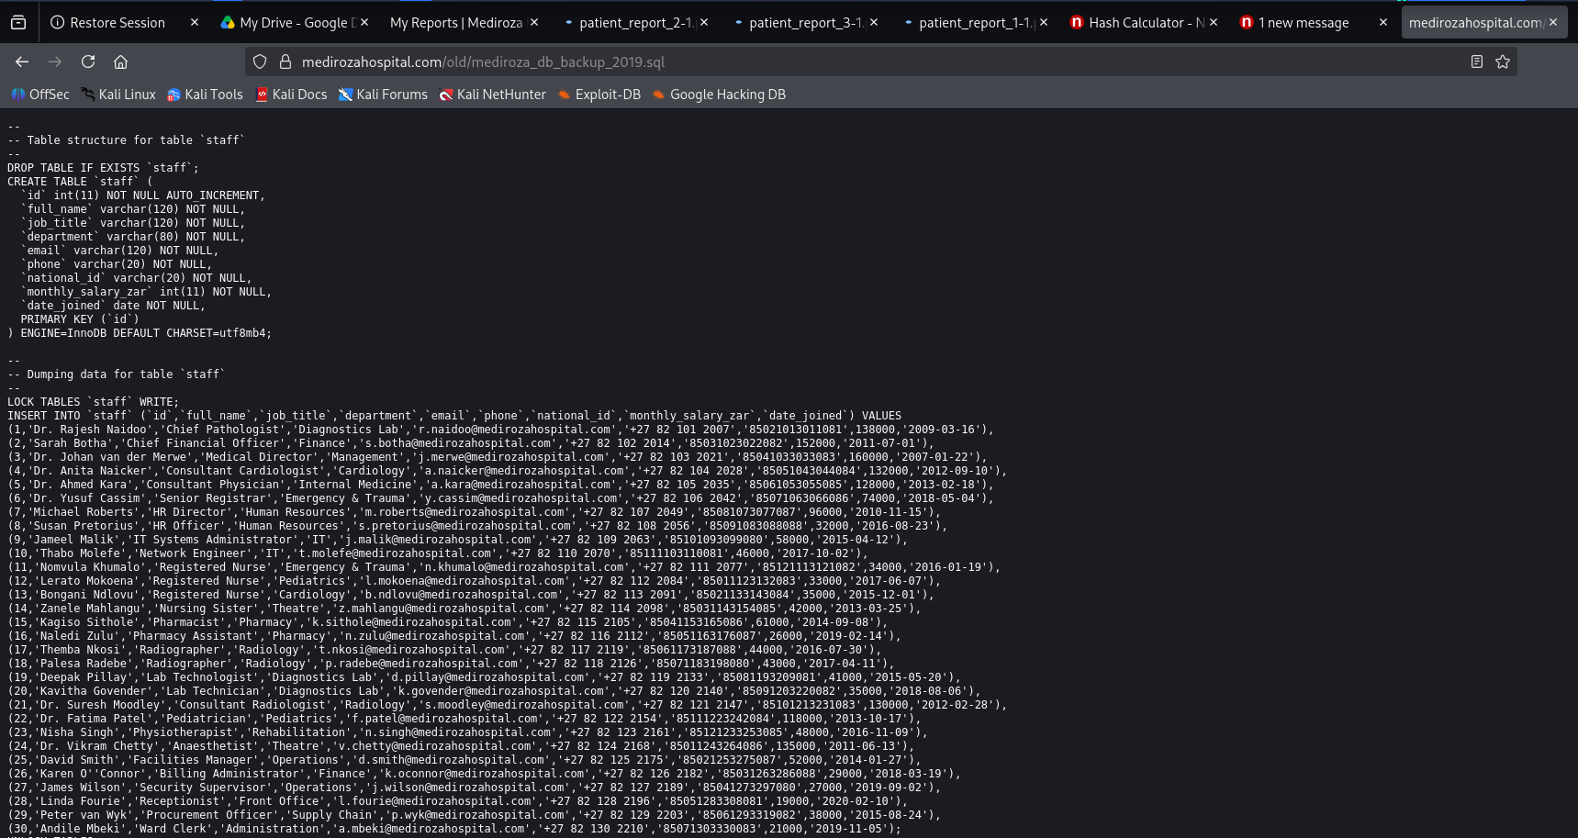

9. Conclusion
The supplied report describes a serious, multi-step exposure path originating in the patient login flow and ending in public access to a database backup containing sensitive organisational information. The reported Critical and High findings should be prioritised, with SQL injection remediation and removal of public backup access addressed first. A controlled retest and documented sign-off should follow. This report is a summary of the provided project materials, not an independent assurance statement about the current security of the target.

10. Project Notes and Responsible Disclosure
This work is presented as a Networkwalks B082 Week 4 educational capstone, based on the supplied source report and evidence notes. Testing should only be performed with explicit written authorisation and within the agreed scope. Do not publish patient records, staff personal data, passwords, database dumps, or other confidential evidence in a public repository or social post. Use sanitised screenshots and redact sensitive values before sharing project materials.

