Florida Institute of Technology

MILESTONE 2

Iterative server supporting UDP and TCP

Klaus Cipi, Peter Banis

School of Computing, Computer Science

10 March 2018

**Introduction**

</introduction>

**Technologies Used**

A list of all the technologies that were used to implement the iterative server:

C language : Programming language used to write the server.

Xcode : IDE used to write and compile C language.

NotePad++ : Code editor.

Github : Online service for collaboration in the project.

Bash scripting : Computer language used to automate compilation, execution, and testing

Sock : Networking tool to test the iterative server.

**Architecture**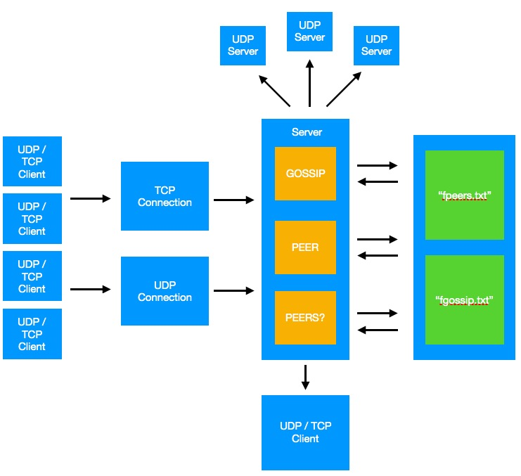

**File Structure**

Files were used as a method of storing data for the server. Two files were sufficient for organizing all the data that had to be stored. One file was used to store gossip messages and the other file was used to store peers.

“Fgossip.txt” file structure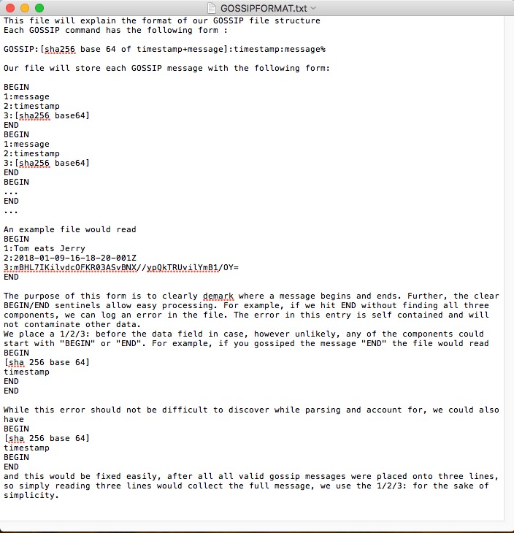

“Fpeers.txt” file structure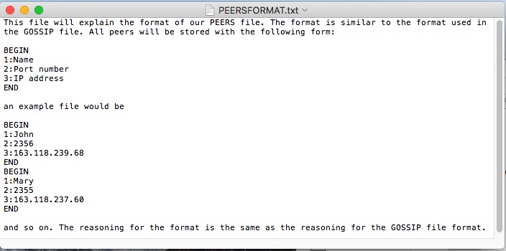

**Program Structure**

**Section A**: Implementation of command line options

Implementation of command line options is found inside of main method in server.c at lines 78-89. Options processed are -p for port and -d for path. Option -p is valid for any port from 0 to 65535. Using an invalid port will cause errors further in the program. Option -d specifies the directory for our PEER and GOSSIP files. The directory is hardcoded inside run.sh, which specifies “testFolder” as the directory (testFolder will be created if it does not already exist).

**Section B**: Initialization of TCP and UDP servers

(all line numbers in this section refer to server.c unless otherwise mentioned)

Initialization of TCP and UDP servers is found inside of main in server.c at lines 91-100 for the TCP server and at lines 104-110 for the UDP server. All connections are handled by a polling mechanism inside of main in server.c, lines 118-145. The TCP server will spawn a new process (see: tcpConnection( int, char *) in next section) to handle the client (lines 126-139). The UDP server will not spawn a new process and will directly handle the connection within the same process (see: udpConnection(int, sockaddr_in, char *) in next section) in lines 141-144. A failure of either server to bind is not a fatal error and a warning will be written to STDERR informing that BIND failed.

**Section C**: Where messages are read from sockets

(all line numbers in this section refer to server.c unless otherwise mentioned)

Whenever the server receives a message the polling mechanism will trigger the proper connection function as defined in Section B.

**tcpConnection(int, char *)**: implemented in lines 731-789, tcpConnection is run by a child process to handle the TCP sockets interactions. A child process is used due to the stream nature of TCP. In tcpConnection we must account for message fragmentation and message concatenation. To accomplish this we define one buffer, here after referred to as BUF_LARGE, to hold the total read messages, and one buffer, here after referred to as BUF_SMALL, to hold each individual read from the socket. Each read is placed into BUF_SMALL and then appended(see bufAppend(char *, char *, int, int)) to BUF_LARGE. This is to handle message fragmentation(lines 738-740). The result of this operation is that a socket receiving:

Read 1: PE

Read 2: ER:Name:port:IP

Read 3:%

will assemble into BUF_LARGE: PEER:Name:port:IP%. The appending operation also allows for message concatenation, a TCP socket receiving:

Read 1: PEER:Name:port:

Read 2: IP%PEERS?

Will result in BUF_LARGE containing PEER:Name:port:IP%PEERS?. After each command is executed it is cleared from the buffer(see Section D, clearBuffer(char *, int, int)).

**udpConnection(int, sockaddr_in, char *):** implemented in lines 711-724, the UDP connection does not spawn a child process. This is because each UDP packet is the full set of data, there does not exist a stream to account for unlike with TCP. The message is read in line 716. Again, because UDP is not a stream there does not exist any need to handle message fragmentation or concatenation. It is assumed that each UDP packet contains one and only one command.

**Section D:** Where messages are parsed

(all line numbers in this section refer to server.c unless otherwise mentioned)

Before messages are pared, the server does a validity test before sending the command into the appropriate methode. That is, all messages sent to the server obey the form

GOSSIP:[sha]:[time]:[message]%

PEER:[name]:PORT=[port]:IP=[ip]%

PEERS?\n

Each message must be parsed in its appropriate protocol handler to determine which helper function to call. After input validation the program determines which function to call:

If the message begins with a G it must be a GOSSIP command, and so we

call GOSSIP(char *, char *).

If the message has ‘:’ in its 5th position it must be a PEER command

If the message has ‘S’ in its 5th position it must be a PEERS?\n command

Otherwise, it is a faulty command.

In tcpConnection() this is in lines: 755, 767, 777. In udpConnection this is in lines: 717, 719, 721

Both tcpConnection() and udpConnection() call the same helper functions which handle the message parsing and execution.

**GOSSIP(char * char *):** first allocates buffers for each of the three GOSSIP string components([sha], [time],[message])(lines 204-209). Then we place the parts of the GOSSIP string into the appropriate buffers in lines 212-220 knowing that ‘:’ divides them. The actual execution of GOSSIP is described in the methods section.

**PEER(char *, char *):** first allocates room for each of the three PEER string components([name],[port],[ip])(lines 433-435). The parsing of the message occurs in lines 450-458, recognizing it follows the same delimiters as GOSSIP with only a need to account for PORT=, IP= in the last parts of the command. The actual execution of PEER is described in the methods section.

**PEERS(int, sockaddr_in, char *, int):** does not parse any string, it only reads from our PEER file and writes it to the querying client. The execution of PEERS is described in the methods section.

**Section E**: Where messages are saved in database

(all line numbers in this section refer to server.c unless otherwise mentioned)

Instead of using a sql server we use fpeers.txt and fgossip.txt (file structure is described above). Only GOSSIP and PEER strings must be saved, so this section will only discuss these two.

GOSSIP:

All GOSSIP strings are composed of [sha], [time], and [message]. Each GOSSIP string is appended to fgossip.txt in lines 228-232, such that the components are saved in the file in [message], [time], [sha] order.

PEER:

All PEER strings are composed of [name], [port], and [ip]. Each PEER string is appended to fpeers.txt in lines 472-476, such that the components are saved in the file in [name], [port], [ip] order.

**Section F:** Where messages are forwarded futher

(all line numbers in this section refer to server.c unless otherwise mentioned)

Only GOSSIP strings are forwarded further, so this section will only discuss GOSSIP strings.

For a message to be forwarded further GOSSIP must connect to each known peer and send the GOSSIP string. This is handled in lines 237-242 and the helper function broadcastToPeers(char *, int, char *). Lines 237-242 are a loop to execute broadcastToPeers() for each peer.

**Method Description**

(Meaning of variable names are specified in the header every method in server.c)

**void tcpConnection(int, char*);** Discussed in details in SECTION C.

**int bufAppend(char*, char*, int, int);** A wrapper for strcat that ensures the source buffer will fit into the destination buffer before execution, otherwise it will return -1. This was primarily used during early testing, however the return value is no longer relevant as of submission build.

**void clearBuffer(char*, int, int);** clearBuffer removes all content up to howFar, shifting down all content past that point. All memory that is shifted down has its original location in the buffer overwritten with ‘\0’ to ensure memory safety and avoid potential errors while processing the buffer in the future.

**int removeNewLines(char*);** is a function that is used by udpConnection and tcpConnection to remove all newline characters ‘\n’ of a given string. Basically, removeNewLines every time it finds a newline character ‘\n’ shifts to the left the entire content of the string after that ‘\n’. Returns the number of ‘\n’ found in the string.

**int commandCount(char*);** is a function used by tcpConnection to determine how many commands are in a given buffer (char * buf). Tcp connection might concatenate two commands together, so this function is used to make sure that every command in the buffer is executed. Returns the number of commands found in the given buffer.

**void udpConnection(int, struct sockaddr_in, char*);** Discussed in details in SECTION C.

**int GOSSIP(char*, char*);** After stripping the relevant parts of the GOSSIP string(already covered) GOSSIP() must determine if a given message is already known. This is done by scanning fgossip.txt for a matching [message] and [time] entry. If this is found we discard the message, otherwise we write it to fgossip.txt and broadcast it to all peers.

**int isKnown(char*, char*, char);** is a function used by GOSSIP and PEER to determine if a given command or peer does already exist in “fgossip.txt” or “fpeers.txt”. IsKnown opens the file specified in the parameters, scans the entire file and returns the line number where the match was found or -1 if any error occurred during execution (i.e. if a file is not properly closed).

**void broadcastToPeersTCP(char*, int, char*);** has the same functionality as broadcastToPeersUDP, but uses TCP instead.

**void broadcastToPeersUDP(char*, int, char*);** is a function use by GOSSIP to send all its peers, using UDP protocol, the gossip that the server received. Inside this function, the server acts as a UDP client and sends a message to the port and ip retired by peerInfo() function. UDP was chosen over TCP as the best alternative for broadcasting because with UDP the server did not had to connect with the servers before sending the message. On the other side, TCP had to connect with the other server before sending the message and when TCP tried to connect with servers that were not available for the moment, it would hang the server for a few of minutes and block other operations.

**int peerInfo(int, char*, char*);** is a function used by broadcastToPeersUDP to retrieve the IP and PORT of a specific peer that is found in the peer file. PeerInfo opens the peer file, finds the port and ip of the desired peer, returns the port, and passes ip by reference. If any error occurs during the execution of the function, it returns -1.

**int peerNumber(char*);** is a function used by GOSSIP to determine the number of peers the peer file. Returns the number of peers in the peer file.

**int PEER(char *, char *);** is a function used by tcpConnection and udpConnection to handle the PEER command. First, this function parses the peer command into three fields: peer’s name, peer’s port, and peer’s address. Then, checks if the peer that was fed to the function was known or not using isKnown() function. If the peer is known to the server, updateFile() function updates peer’s address. If the peer is not known to the server, PEER appends peer’s information into the peer file. Returns 0 if the update or appending was successful or -1 if any error occurred.

**int updateFile(char*, int, char* ,char*);** is a function used by PEER to update a peer’s ip address. Basically, updateFile takes the line number that has to be changed in the peer file, creates a new file named “output.txt”, copies every line of the “fpeers.txt” to the new file until it is at the line that has to be updated, writes the new line in the new file, copies the rest of “fpeers.txt” to “output.txt”, deletes the old file (“fpeers.txt”), and renames “output.txt” to “fpeers.txt”. Returns 1 if the update was successful or -1 if it was not successful.

**int PEERS(int, struct sockaddr_in, char *, int);** The goal of peers is to respond to a query for the known peers of this server. The response has the form PEERS|#peers|PEER:[name]:PORT=[port]:IP=[ip]|… To accomplish this we must collect the number of known peers. Following that is a formula for determining the size of the message. It is easy to discover by counting houw many characters exist inside the file, accounting for additional characters(BEGIN,END,1:,2:,3: = 14 per peer) and the need for an additional (PORT=,IP=, :,:,:,|) in the response. Parses the file, collecting the relevant information from within each BEGIN/END block and put it into the string. Afterwards the function recognizes if the UDP or TCP server called this, and sends a reply appropriately.

**int countDigit(int);** is a function used by PEERS to count the numbers of digit in an integer. Returns the number of digits.

**char* itoa(int, char*, int);** is a function used to convert an integer into a string. Returns the number that is passed in a string form.

**void error(char*);** is a function used to print to standard error.

**void sig_chld(int);** is a function that is used to handle signals by child processes.

**User Manual**

**Compile:** To compile the server in terminal use ./compile.sh script.

**Execute**: To run the server in terminal use ./run.sh <port number>.

NOTE: Run script will also compile the server.

NOTE: Run script will create a folder testFolder (if does not exist) to place “fgossip.txt” and “fpeers.txt”.

**Test:** To test the server use ./script1.sh in another terminal.

NOTE: Test script assumes that server is connected in port 22222.

**Conclusion**

</Conclusions>

**References**

<http://www.strudel.org.uk/itoa/>

GOSSIP

UDP / TCP

Client

“fgossip.txt”

PEER

UDP

Connection

“fpeers.txt”

TCP

Connection

PEERS?

UDP / TCP

Client

UDP / TCP

Client

UDP / TCP

Client

UDP / TCP

Client

UDP

Server

UDP

Server

UDP

Server

Server