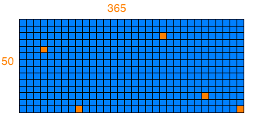

Day to day patterns
(either done subconciously or by habit)

Day to day patterns
(either done subconciously or by habit)

not motivated to try new activities, being lazy
promising yourself to do something next morning

Create a calendar that will allow these patterns to be noticed and help motivate a person to try something new.

Build web app as an experiment.

Research question:
How will this affect a person psychologically?
Good or bad motivation?

