**3D Spatial Metrics Toolbox Tutorial**

Peter Kedrona,b, Yun Zhaoc, Amy Fraziera,b

a School of Geographical Science and Urban Planning, Arizona State University, Tempe, AZ, 85281, United States

b Spatial Analysis Research Center, Arizona State University, Tempe, AZ, 85281, United States

c Department of Environmental Studies, University of Illinois – Springfield, Springfield, IL, United States

**Toolbox Citation:** Kedron P, Zhao Y, and Frazier AE (2019) Three-dimensional spatial metrics. *Landscape Ecology* 34(9): 2123-2132. <https://doi.org/10.1007/s10980-019-00861-4>

This manuscript was compiled on September 30, 2019

**Introduction**

This tutorial demonstrates how to use the 3D Spatial Metrics toolbox developed by Kedron et al. (2019). In addition to this document, the tutorial uses three datasets:

1. **Study_Area.shp** – a shapefile of a single polygon that defines the extent of the study area, a portion of the Arizona State University (ASU) Campus in Tempe, Arizona.
2. **Footprint_Bldg.shp** – a shapefile containing polygons that outline the footprints of all the buildings completely contained within the portion of the ASU campus within the study area.
3. **DSM.tif** – a raster file containing a 1x1 km normalized digital surface model (nDSM) of the study area with a spatial resolution of 0.5 meters. The nDSM raster value reflects lidar heights from terrain surface, such as building height, tree canopy height, etc.

**Preparing Your Working Environment**

Before running this tool, please make sure:

* You have ArcGIS Desktop version 10.4 or later installed;
* You have the Advanced ArcInfo level of licensing;
* In ArcMap, go to “Geoprocessing🡪Geoprocessing Options” and
* **Check** “Overwrite the outputs of geoprocessing operations” box;
* **Enable** “Background Processing”;
* Your input data are in a meter-based projection;
* Your building footprint data file contains a unique ID field in the **integer** format.

**Running the tool**

In this tutorial, we demonstrate how to calculate several 3D spatial metrics using the toolbox and tutorial data. To complete a trial analysis using the data provided, complete the following steps:

1. Download the “3D Spatial Metrics” toolbox and the tutorial data.
2. Unzip the toolbox and the tutorial data into a working directory (e.g., “C:\SpatialMetrics”)
3. Open ArcMap. Establish a folder connection to the working directory. You should be able to see the “Tutorial_Data” folder and the “3D Spatial Metrics.tbx” toolbox.
4. The tutorial data contains the three layers outlined above.

**Note**: *the study area layer is not required to use the tool. If a study area is not provided, the tool will create a minimum bounding, convex hull polygon from your "Patch or Object Footprint" layer and use it as the study area*.

1. Add all three layers from the “Tutorial_Data” into ArcMap.

***Note****: all data must be in a meter-based projection*.

1. In the Catalog pane in ArcMap, expand the “3D Spatial Metrics.tbx” to show the script tool. Double click the tool to open the interface.

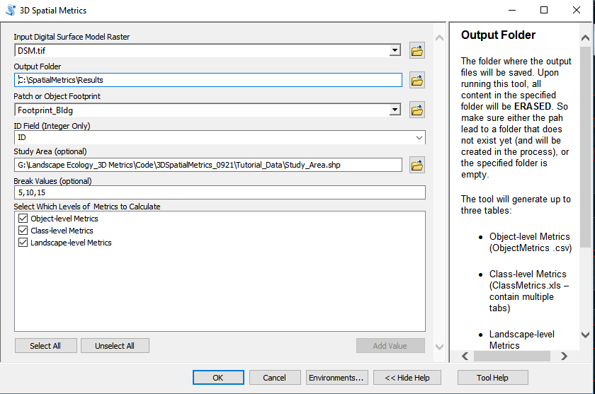

1. Specify the parameters as in the above figure.

**Note:** *you can toggle the tool help on and off by clicking the “Show/Hide help” button at the bottom right of the interface. The help content is dynamic – it will change as you click into different fields.*

* 1. Under “Output Folder”, specify where the output will be saved. A warning sign may pop up if the specified folder already exists. The warning message is to remind you that running this tool will eraseexisting content in the specified folder. If you receive an error message stating such folder already exists, it is likely you did not check “Overwrite the outputs of geoprocessing operations” box by going to “Geoprocessing > Geoprocessing Options”.
  2. Under “ID Field”, specify an integer field from the “Patch or Object Footprint” layer that uniquely identifies each object. Outputs will refer to this ID field when reporting object-level metric results.
  3. A polygon for the Study area is optional. *Note: if a study area boundary is not specified, a minimum bounding, convex hull polygon will be created from your "Patch or Object Footprint" layer as the study area*.
  4. Break values are also optional and are used to calculate class-level metrics according to object height. In the demonstration case above, the values are divided into 4 classes: short buildings (>5 m), medium height buildings (5-10 m), tall buildings (10-15 m), and very tall buildings (15+ m).

**Note:** *break values set the dividing point between classes. Therefore, classes will always outnumber the number of break values by one.*

* 1. Select which metrics the tool will calculate by checking the boxes next to each metric type.

**Accessing and Interpreting the Results**

Once the tool has finished running, you can access the results in the output folder. Metric results are stored in separate .csv (i.e., object-level) and .xls (i.e., class-level, landscape-level) based on the metric levels. All units of the results are meter-based. Please refer to the paper in which the tool is described for a complete explanation of each metric.

* **“ObjectMetrics.csv**” stores the 3D metrics calculated for each individual object as defined by the Patch or Object Footprint file. The “OID” field corresponds to the “ID Field” specified when running the tool. In the worked example, there are 94 buildings, so this table has 94 rows with each row corresponding to a single building. In addition to the object-level metrics the toolbox produces several additional statistics that characterize the distribution of pixel values within an object. These include:
  1. HMIN – the height of the pixel with the smallest height within an object footprint
  2. HMAX – the height of the pixel with the largest height within an object footprint
  3. HRANGE – the range of pixel heights within an object footprint
  4. HAVG – the average height of pixels within an object footprint
  5. HSTD – the standard deviation of pixel heights within an object footprint
  6. OPERM – the perimeter of each object
  7. OAREA – the total area of all pixels within an object footprint
* **“ClassMetrics.xls”** stores the 3D class-level metrics. Class-level metrics aggregate objects into classes based on a shared attribute and can be calculated for each of the metric types created for each object (e.g., volume (VOL), surface area (SURFA)). The “ClassMetrics.xls” file therefore contains four sheets for each of the four metric types. In the worked example, four classes were defined according to maximum height, so each sheet in the results file has four rows with each row corresponding to a single class.
* **“LandscapeMetrics.xls”** stores the 3D landscape-level metrics. Landscape-level metrics aggregate values for all classes into a single metric describing the entire study area (landscape). Like class-metrics, landscape-metrics can be calculated for each of the four types of metric (e.g., volume (VOL), surface area (SURFA)), so the file contains four sheets, one for each metric type. For example in the worked example, within the *Volume Metrics* sheet, VOL_MAX provides the volume, 1,476,033 cubic meters, of the building with the largest volume irrespective of class.

Complete details on the interpretation of individual metrics and their calculation are available with the supplemental materials that accompany Kedron et al. (2019).