Problem 2

(a)

|  |  |  |
| --- | --- | --- |
| Truth  Prediction | 1 | 0 |
| 1 | 1703 | 490 |
| 0 | 110 | 2297 |

Accuracy = 0.8695652173913043

(b)

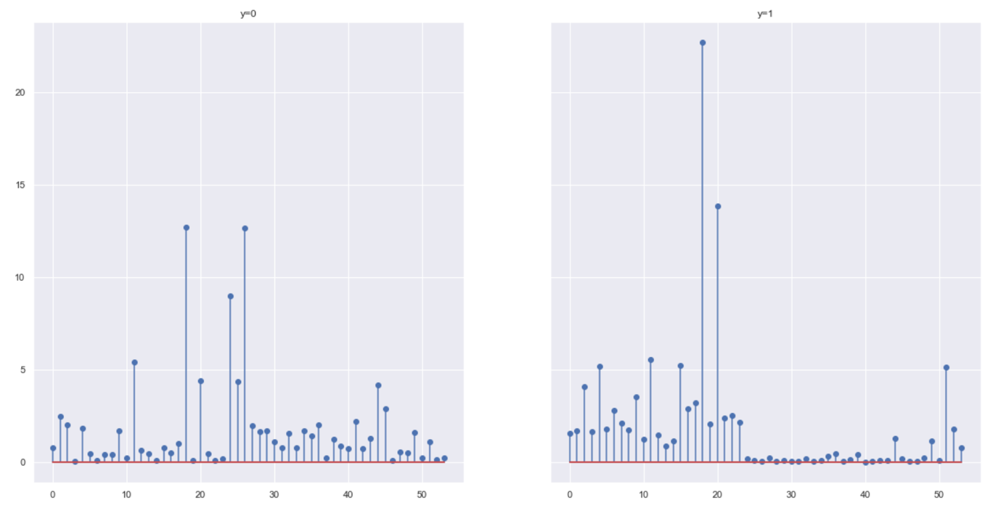

For dimension 16 and 52, the estimated value of lambda for both when y=1 are larger that the counterpart, and y=1 means spam email, which means the word 'free' and character '!' appears more frequently in spam email.

(c)

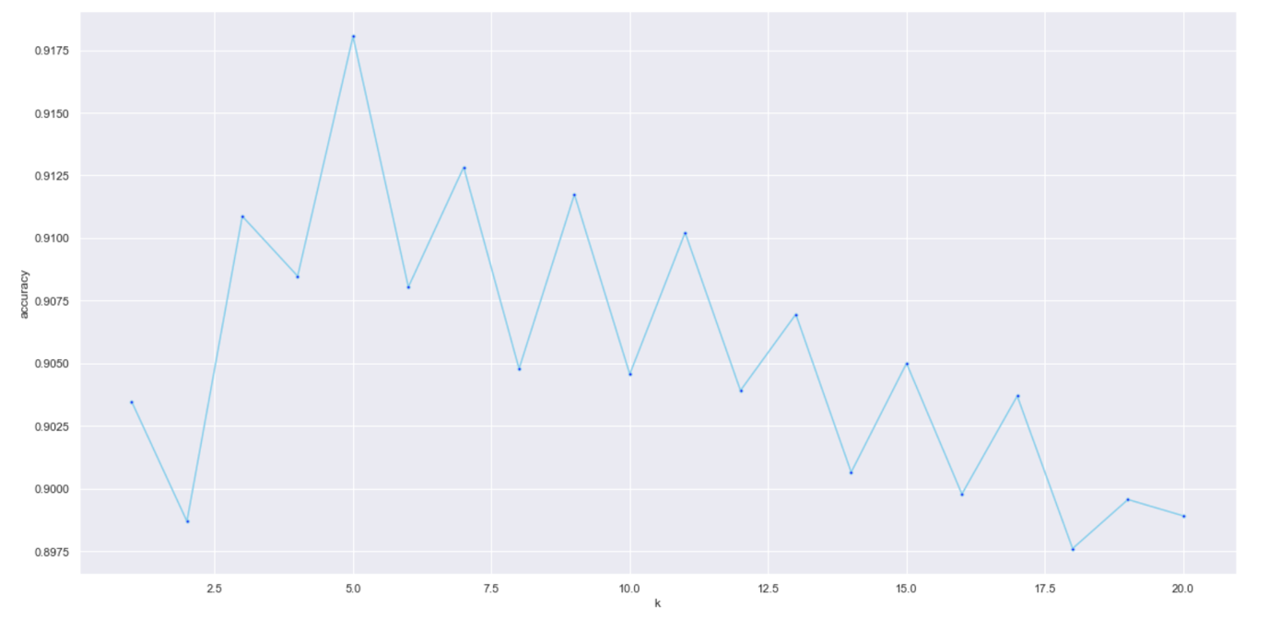

(d)

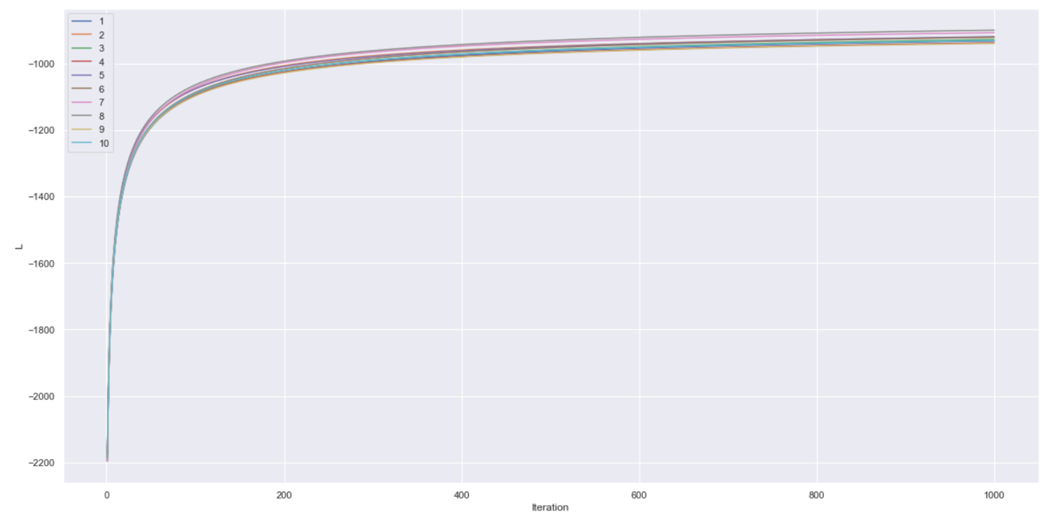

(e)

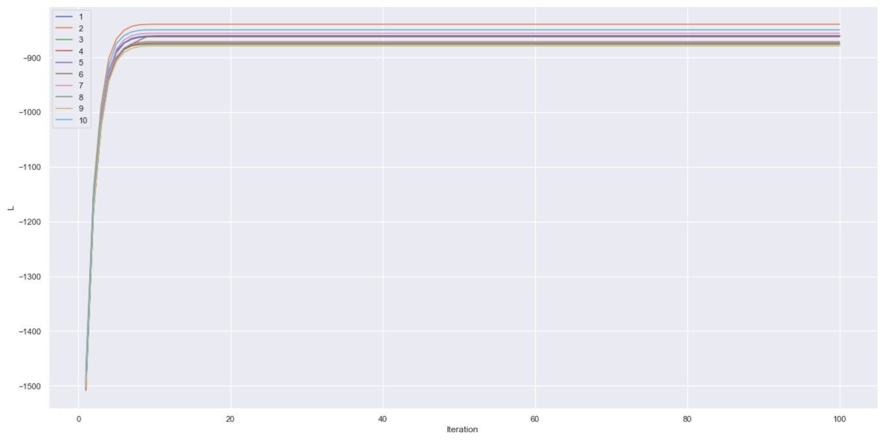

(f)

|  |  |  |
| --- | --- | --- |
| Truth  Prediction | 1 | 0 |
| 1 | 1604 | 144 |
| 0 | 209 | 2643 |

Accuracy = 0.9232608695652174